
MODEL-BASED INSTRUCTION TO IMPROVE 7TH GRADERS’ CONCEPTUAL UNDERSTANDING OF HUMAN ANATOMY USING 5E INSTRUCTIONAL APPROACH
By
Aminat Endris

A Thesis Presented in Partial Fulfillment of the Requirements for the Degree of Master of Education in Educational Sciences

Bahir Dar University
Department of Teacher Education and Curriculum Studies
College of Education and Behavioral Sciences
Advisor
Asrat Dagnew (Ph.D.)

June, 2019

Bahir Dar Ethiopia

MODEL-BASED INSTRUCTION TO IMPROVE 7TH GRADERS’ CONCEPTUAL UNDERSTANDING OF HUMAN ANATOMY USING 5E INSTRUCTIONAL APPROACH

Bahir Dar University
Department of Teacher Education and Curriculum Studies
College of Education and Behavioral Sciences

Approved by Board Examiners
Chairman, Department Graduate Committee
______________________ _____________ ______________
Name Signature Date
Advisor
______________________ _____________ ______________
Name Signature Date
Internal examiner
______________________ _____________ _______________
Name Signature Date
External examiner

Copyright © 2019, Aminat Endres
ALL RIGHTS RESERVED

DECLARATION
This Thesis is my original work and has not been presented for a degree in any other University and that all sources of the material used for the Thesis have been acknowledged.

Name: Aminat Endris
Signature: ____________
Date of submission: June/21/2019

Advisor
Name_____________________ Signature______________ Date ____________

TABLE OF CONTENTS
DECLARATION i
TABLE OF CONTENTS ii
ACKNOWLEDGMENTS v
ABSTRACT vi
LIST OF ABBREVIATIONS vii
LIST OF TABLES viii
LIST OF GRAPHS ix
LIST OF FIGURES x
CHAPTER ONE 1
1. INTRODUCTION 1
1.1 Background 1
1.2. Statement of the Problem 5
1.3 Research Questions 7
1.4 Objectives of the Study 8
1.4.1 General Objectives 8
1.4.2 Specific Objectives 8
1.5 Significance of the Study 8
1.6 Delimitation of the Study 9
1.7 Limitation of the Study 9
1.8 Operational Definitions of Key Terms 10
1.9 Organization of the Paper 10
CHAPTER TWO 11
2. LITERATURE REVIEW 11
2.1. Students’ Misconceptions and Misunderstanding about Human Anatomy 11
2.2. Teaching Methods 12
2.1.1 Traditional Teaching Approaches 12
2.1.2. Student-Center Teaching Approach 13
2.3. The Effectiveness of Model-Based Teaching Approach 14
2.4. Theory of 5E Instructional Model 15
CHAPTER THREE 18
3. RESEARCH METHODOLOGY 18
3.1. Research Design 18
3.2. Source of Data 19
3.3. Population of the Study 19
3.4. Sample Size and Sample Techniques 20
3.5. Intervention 21
3.6 Instrument of the Study 21
3.7. Data Collection Procedure 22
3.8. Data Analysis 23
3.9 Ethical considerations 23
CHAPTER FOUR 24
4. RESULTS 24
4.1Test of Assumptions 24
4.2. Descriptive Statically Analysis of Results and Interpretation 27
4.3. Inferential Statically Analysis of Results and Interpretation 29
4.4. Informal Assessment 30
4.5. Analysis of Classroom Observation 34
CHAPTER FIVE 36
5. DISCUSSION AND IMPLICATIONS OF RESULTS 36
5.1 Discussions of Results 36
5.2 Implications of Results 39
CHAPTER SIX 41
SUMMARY, CONCLUSION AND RECOMMENDATIONS 41
6.1. Summary 41
6.2. Conclusion 42
6.3. Recommendations 42
REFERENCE 44
APPENDICES 48
Appendix-A: Intervention Plan 48
Appendix-B: Pre-test and Post-test Questions 50
Appendix-C: Observation checklists 53
Appendix-D: Students’ Results out of 15% 54
Appendix-E: T-Critical Table 56
Appendix-F: Lesson plans 57

ACKNOWLEDGMENTS
First of all, I would like to thank God the Almighty, for granting me the opportunity to do this research, the commitment and tolerance to pass various obstacles and come up to the accomplishment of this thesis. The starting of this thesis involved kindly contribution, support and encouragement of many people. "I would also like to acknowledge the Norwegian Agency for Development Cooperation (NORAD) for financially supporting my studies at BDU and funding this research work." Space does not permit acknowledgment of the assistance and inspiration of my advisor Dr. Asrat Dagnew, but thanks must go to those who have helped me to do this research. I am eternally grateful to my parents they have played a significant contribution to the successful completion of my study. The role of my beloved, Jemal Mehammed helped me as a weapon to defeat the obstacles which I faced.

ABSTRACT
The purpose of this study was to improve the conceptual understanding of students by using model-based teaching about the human skeletal system in grade seven. Quasi-experimental research was employed pre and post-test, control and experimental group design. Out of 4 sections, two sections (N=132) were selected by using simple random sampling techniques. The first section contained 66 students and was taught using model-based teaching approach. The second had 66 students and was taught using traditional teaching approach. The data were gathered by tests, observation, and informal assessment. The data obtained from tests were analyzed quantitatively through mean, standard deviation, independent t-test and the observation and informal assessment data were analyzed qualitatively. The pre-test results indicated that there was no significant mean difference and p>0.05 between the two groups. Similarly, the result of pre informal assessment showed that students in both groups had common misconceptions about the topic. The post-test results revealed that model-based teaching approach exhibited significant changes compared to the traditional groups of students. From the results of this study, it is possible to conclude that the model-based teaching approach improves students’ conceptual understanding, participations and clear misconceptions compared to the students taught by traditional teaching approach. Based on the finding it was recommended that the model-based teaching approach should be encouraged for teaching and learning biology.
Keywords:-Models, Traditional teaching, Model-based teaching, Conceptual understanding, Human anatomy

LIST OF ABBREVIATIONS
5E-----------E1-Engage, E2- Explore, E3-Explain, E4-Elaborate, E5-Evaluate
MBT---------Model-based Teaching
SPSS--------Statistical Package for Social Studies
TTM---------Traditional Teaching Method

LIST OF TABLES
Table Page
Table 1: Summary of the Bybee 5E Instructional Model 16
Table 2: Population Size 20
Table 3: Samples Size 20
Table 4: Pre-test Results for descriptive analysis 27
Table 5: Post-test Results for descriptive analysis 27
Table 6: Independent Sample t-test for Pre-test 29
Table 7: Independent Sample t-test for Post-test 29

LIST OF GRAPHS
Graph Page
Graph 1: Histogram Normality Test for Experimental and Control Group 24
Graph 2: Bar graph relationship between pre-test and post-test results 28

LIST OF FIGURES
Figures Page
Figure1: Conceptual framework of the research Error! Bookmark not defined.
Figure 2: Observation of human skeletal system models 33
Figure 3: Teaching for the traditional class 33

CHAPTER ONE

1. INTRODUCTION

1.1 Background
The educational process includes methods and techniques that provided the students the basic information in a way that helps them embrace it as easily as possible, facilitate the direct access of the students to different sources and stimulate creativity and teamwork(Pop-pacurar and Tirla, 2009). Especially, learning of science is essential in every educational system that aims to prepare citizens of one's nation for a productive life. In this regard, science education occupies a key position in the school curriculum of Ethiopia (Negassa, 2014).
Science is very essential for the development of technology, which served as a motor for our changing world. Therefore, students must understand science concepts. Because they can solve their problem as well as the problem of the world. Mostly, science teachers in the classroom teach science using the lecture method and less likely teach science using different models (Temitope & Deborah, 2015).. As a result, students struggle to understand the concepts easily. The main purpose of the science courses must be training students to acquire the required learning skills and beliefs towards learning and scientific knowledge to develop a capacity to think scientifically, to analyze critically, daily life, and to integrate theory and practice. Moreover, science courses must be designed with the consideration that learning consists of frequent interactions that take place between students' existing conceptions and their new experiences (Temitope & Deborah, 2015).
Most of the time, model-based teaching is an instructional practice where students explore content by using models and is used extensively in the areas of mathematics and science. Students are at the center of the learning experience and take ownership of their own learning (Gabel, 2003).
The studies shows that teaching by using models have great value in teaching biology, students to explore biological objects and phenomena that are inflexible to perceive directly and they can lead to easily understand the science concepts (Mclachlan,2003). According to Chittleborough & Treagust, (2009), “models are often seen as teaching tools that enhance the visualization of abstract concepts”.
Similarly, Loucaand & Zacharia, (2011), modeling-based learning is an approach for teaching and learning in science whereby learning takes place via student construction of models as representations of physical phenomena that include representations of physical objects and their characteristics, physical entities and physical processes involved in the physical phenomena. This leads to an externalized representation of the underlying mechanism of a physical phenomenon and helps learners build an understanding of that mechanism.
Different researchers define the term models and their uses in science in wide and varied ways. A model is a tool that supports the teaching-learning of human anatomy in the biology classroom. (Quillin & Thomas, 2015, Chittleborough & Treagust, 2009), model is a made up of an impersonator of something it may represent from simple to complex structures and models are very helpful to science teachers. Model is composed of multiple elements that are an abstraction of the real world and appropriate more attention as a scientific process understanding in biology concept. In addition to this, modeling is a key process in the development of scientific knowledge and recognition of the different model based on these attributes. Models are simplified representations of more complex systems that help scientists structure the knowledge they acquire. As such, they are ubiquitous and invaluable in scientific research and communication. Models are helpful tools for representing ideas and explanations and are used widely by scientists to help describe, understand, and predict processes occurring in the natural world.
Others Justi, (2017), says that in order to conduct a more authentic science education, i.e., to make the processes it entails successively approximate to those of science, it is advocated that it should be conducted from a modeling-based perspective. In addition to this Jackson, Dukerich, & Hestenes, (2008), modeling instruction program emphasizes active learning student construction of conceptual knowledge. Modeling instruction expresses an emphasis on the construction and application of conceptual models of physical phenomena as a central aspect of learning and doing science. Similarly Min, Jackman, & Chan, 2014), using a teaching model in the biology classroom helps students develop a better understanding of abstract concepts. Models are visual representations and a powerful tool because they help to make complex biological phenomenal to simple. Model-based teaching is intuitively a powerful tool for conceptual change and inherent to the process of science.
According to Jackson et al., (2008), modeling instruction creates an effective framework for teachers in the U.S. to incorporate many of the national standards into their teaching without having to consciously do so because the method innately addresses many of the various standards. In a certain course, different students may learn the same material, except they never learn it in exactly the same way. This method appeals to all learning styles.
According to Schwartz & Skjold, (2017), multiple representations are used to teach biological phenomena while drawing explicit attention to the development and use of models in the scientific community and in science teaching. Results indicate participants initially considered models to be physical representations of objects to be visualized, the process scientists use to do an experiment, and a chart scientists use to record data. Post-tests indicate increased recognition of models as representations of scientists' ideas and explanations of processes. Despite explicit instruction, few came to understand the role of models in making and testing predictions. Models provide an explanation for a process or phenomenon. There was a shift in ideas about models as simply physical representations to also include models as representations that serve a functional purpose that could provide an explanation for a process of how something works. Similarly, Skjold, (2012), asserts that models allow for multiple representations including physical or structural, functional and analogical.
According to Jancarikova & Jancarik, (2017), models are a broader sense for didactical purposes for the level of abstraction that needed to grasp them adapted models of easily accessible objects, models that allow pupils to see, observe objects that are usually not accessible and that require abstraction.
My study is working on visual models using 5E instructional approach. Because visual models are used in the classroom to encourage students in the learning process and the students easier to understand the concepts. Teachings by using this model are for making effective teaching. Which are used to make the learning experience are more real, more accurate and more active (Shabiralyani, Hasan, Hamad, & Iqbal, 2015).
The Science Education Review, several teacher-developed 5E lesson plans are available. 5E learning cycle requires learning new things, or trying to consider familiar things in a deep way. In learning new things, the students used both their pre-knowledge and newly acquired knowledge from new explorations. The science lesson required several months and weeks to be over. 5E learning models are very flexible and dynamic it leads students through five phases of learning that are easily described using words that begins with the letter 5E: Engagement, Exploration, Explanation, Elaboration and Evaluation. This model was developed by (Bybee, 2009).
The presence of model-based teaching by using 5E instructional approaches in teaching-learning biology classroom supports the process of delivering information from teacher to students. The complex biological phenomenon can be easily explained to students such as human anatomy.

1.2. Statement of the Problem
Students face many challenges as scholars study human anatomy. In my experience, as I discussed with my colleagues using the tradtional teaching only lecture methods, have reduced the understanding of students. Traditional teaching strategies are base on the transmission view which implies that the pupil's role in the learning process is largely passive, knowledge is transfer in one way from the teachers only, while the students are a passive listener (Ivić, Gortan, & Gortana, 2016). But the constructivist theory of learning (Bautista, 2014), suggested that students must participate in the teaching-learning process to construct their own knowledge. The nature of biology contents are required a different active teaching-learning strategy that engages students in activities like problem solving, model-based teaching, demonstration, which improves conceptual understanding. And, the concepts of human anatomy the structure and function of the skeletal system is an abstract and which is not easily understandable by learners. According to James, et al., (2007), students may struggle with this topic based on the following common misconceptions: (1) Humans may only use one or a few organ systems for each activity they do (when, in fact, almost all human body systems are at work constantly); (2) bones are not living tissues because of their solid, rock-like appearance (when, in fact, they contain cells, blood vessels, and marrow); and (3) muscles push on bones when, in fact, muscles don’t move bones directly they contract, pulling on tendons, which attach muscles to bones, and the bones move). In line with, this, due to being a traditional method and being the students unfamiliar with science, it is difficult to teach students human anatomy. In order to overcome the above problem, so this research was done by using model-based active teaching-learning approach during biology class especially the content of the human anatomy classes’ structure and function of the human skeletal system and regarding this method, different researchers have conducted research on human anatomy by using model-based teaching approach. But in some areas, there are not apply using this model-based teaching to teach human anatomy at primary school. For example, (Fokides & Mastrokoukou, 2018), explained that to teach human anatomy for the students how easily they can show their body parts through mobile applications. On his results using mobile applications students are more motivated, and more engaged in the teaching-learning process. It is difficult to implement in some primary schoool because of economic problems and lack of technological infrastructure (desktop computer), so it does not allow the use of pre-school students to use mobile devices. Similarly, Favaron et al., (2017), made on his research, the human circulatory and skeletal systems demonstrate the use of varied species of animals for the students to improve students conceptual understanding. It is difficult to apply in the classroom because it takes time to collect different animals. This study focuses on addressing these problems.
Model-based learning is a great value in the biology classroom to develop a student-centered teaching approach and improve the conceptual understanding of students. Thus, this study can bring the solution for the biology classroom problems, the study focuses on investigating model-based biology teaching instructions to improve students’ conceptual understanding of human anatomy as well as to fill the gaps and to answer the following research questions investgated in Ewket fana primary school for grade seven students.

1.3 Research Questions
- Is there a significant difference between model-based teaching approach and traditional teaching approach when they were taught human anatomy?
- What is the effect of model-based biology instruction on students’ conceptual understanding of human anatomy?
- What is the participation of students’ when they are taught by model-based teaching approach?

1.4 Objectives of the Study

1.4.1 General Objectives
- The main objective of this study is to improve students’ conceptual understanding of human anatomy by using model-based teaching approach in grade seven students.

1.4.2 Specific Objectives
- To measure the effect of model-based teaching approach and the traditional lecture teaching method on the development of scientific skills among students studying human anatomy in grade 7th.
- To compare the effect of model-based teaching approach and traditional lecture method in improving conceptual understanding.
- To observe the participation of students’ when they are taught by model-based teaching approach.

1.5 Significance of the Study
This study may have the following contributions to the school teachers’ and students’
- It is important to make most of the learners’ active participant in each lesson.
- It can help the teachers’ to improve their way of teaching and learning.
- It inspires science teachers’ to create different teaching models.
- It is also expected to invite other scholars and researchers to conduct organized and compressive research with regard to this study.
- It is also considered in designing the curriculum, textbooks, teaching activities and materials and teacher educational processes.

1.6 Delimitation of the Study
In order to make the study more precise, the research was delimited conceptually, geographical, and temporally. Conceptually, the study was delimited on model-based biology instruction on students' conceptual understanding of human anatomy. The human anatomy concept was chosen by the researcher because this topic is very abstract and challenging to understand these concepts. The researcher selects on grade seven reasons the human anatomy concepts starts on at this level. Geographically the scope of this Study was delimited to grade 7th students at Ewket fana primary school in Bahir Dar town in the academic year of 2019. The researcher selects this school so as to make manageable interms of time, resource and distance.

1.7 Limitation of the Study
Some of the major obstacles that the researcher wants to mention as a limitation to the study.
- The models and materials that were needed to deliver the lesson were not easily accessible.
- The class size does not match with the number of students.
- The researcher faced lack of adequate literature related to the topic under study which could have supported the researcher to enrich the study.

1.8 Operational Definitions of Key Terms
Model: is an object is a physical representation that shows what it looks like it works. The model is often smaller than the objects it represents. A model of a system or process is a theoretical description that can help you understand how the system or process works, or how it might work.
Teaching Method: comprises the principle and methods used by teachers to enable student learning. These strategies are determined partly on the subject matter to be taught and partly on the subject matter to be taught and partly by the nature of the learner.
Understanding: is a psychological process related to an abstract or physical object, such as a person, situation, or message whereby one is able to think about it and use concepts to deal adequately with that object.
Conceptual understanding: means knowing what to do and knowing the reason why doing it.

1.9 Organization of the Paper
This study is organized into six chapters. The first chapter deals with the general introduction of the paper. Chapter Two presents a review of the related literature relevant to the study. The third chapter outlines the research methodology. The research results are presented in chapter four. Chapter Five contains discussion and implication of the study. The last chapter draws summary, conclusions and recommendations. Finally, references and appendixes would be attached at the end of the research paper

CHAPTER TWO

2. LITERATURE REVIEW

2.1. Student’s Misconceptions and Misunderstanding about Human Anatomy
Many studies have attempted to gain a perspective on students’ conceptual understanding of human body systems. The studies have shown that students do not fully understand the major concepts of human body systems and have knowledge deficiencies, misunderstanding, and difficulty to interpret the subject. For example, according to Reiss & Tunnicliffe, (2001), most of the primary school students challenging to understanding the concepts of the human body because the concepts are complex and the internal organs are an abstract. For instance, students know that they have bones, but they cannot indicate specifically to show by drawing. Other scholars James et al., (2007), students may struggle with these human anatomy topics based on the following common misconceptions: Humans may only use one or a few organ systems for each activity they do (when, in fact, almost all human body systems are at work constantly); bones are not living tissues because of their solid, rock-like appearance (when, in fact, they contain cells, blood vessels, and marrow); and muscles push on bones when, in fact, muscles don’t move bones directly they contract, pulling on tendons, which attach muscles to bones, and the bones move).
Considering the skeletal system concept, the study conducted by Caravita & Falchetti (2005), implied the perception of students regarding the bones; if the bones of a living organism are also living or nonliving. The data were collected from 189 students ranged in age from 7 to 12 years who visited the Civic Zoological Museum. Each student was interviewed with the following questions: Are bones alive when they are inside the living body? What evidence do you have to this effect? What are bones made of? Can bones grow? How do they grow? And do children or newborn animals have the same bones as adults? The answers of students especially in secondary school level indicated a large frequency of the nonliving statement towards bones. Moreover, students who stated bones as alive mostly failed to express acceptable criteria to justify their answers. Rather, they argued the movement of bones or the presence of bone components like marrow as a criterion. These justification criteria were also observed a student who states the bones as not alive but in an opposite way. They explained, for example, bones are not alive because they cannot move.

2.2. Teaching Methods
The term teaching method refers to the general principles, pedagogy and management strategies used for classroom instruction. Teaching methods in the process of knowledge formation, the traditional teaching method and active learning pedagogies approaches are two major types of teaching approaches (Kolesnikova, 2016).

2.1.1 Traditional Teaching Approaches
In the context of this study, ‘traditional teaching approaches’ refer to the usual methods used by educators to teach science subjects. According to Kolesnikova, (2016), the traditional teaching method, also known as the lecture method is very common in education. Based on this lecture method, the educator can deliver the message via the “chalk-and-talk” method. The traditional teaching method in schools is the teacher focus on the transfer of knowledge from the teacher to the student while students are a passive listener, traditional teaching methods are challenged for students inability to foster critical thinking, holistic learning environment among children (Ivić et al., 2016). Similarly (Richardson, n.d.), the traditional approach of teaching is the transmission model that promotes the traditional approach of teaching is the transmission model there is no interaction between prior and new knowledge. The information acquired from traditional teaching, if acquired at all, is usually not well integrated with other knowledge held by the students. Thus, new knowledge is often only brought forth for school-like activities such as exams and ignored at all other times. The traditional way of teaching encourages poor conceptual understanding and limited comprehension of learned in science concepts and ideas.

2.1.2. Student-Center Teaching Approach
Teachings must have to be responsible for the processes through which students obtain new knowledge. As (Mathias, 2014, and Miller, 2013), states that active learning is a student-centered teaching technique that uses various interactive, multimodal strategies to create a more engaging classroom setting compared with the traditional didactic lecture. Active learning is an instructional method that engages students in the learning process that too many learning styles and allows students to be more engaged in the learning process and increasing understanding. The active learning format allows misconceptions to come up naturally in the learning process and students can recognize the mistakes they are making and correct them which lead to better retention of the material and a deeper understanding. This approach moves the classroom from a teacher-centered to a more student-centered model; teachings must have to be responsive for the processes through which students obtain new knowledge.
In addition, Fernando & Marikar, (2017), states that active teaching advocates a participatory approach in which students actively participate in the learning process, emphasize that the active construction of knowledge by the learner. In modern teaching strategies focus on encouraging students in the teaching-learning process such as problem-solving, constructing knowledge, interpreting ideas, and sharing on the information. Similarly, Ivić et al., (2016), the teacher considers students as partners and therefore determines teaching strategies, ensures different approaches to information and provides help in acquiring new teaching contents. In such an environment, students take over the responsibility for learning, actively seek knowledge, construct it and give it meaning.

2.3. The Effectiveness of Model-Based Teaching Approach
Different scholars research findings, the effectiveness of model-based instructions; over traditional instructions to improving conceptual understanding as well as other scientific disciplines has been the focus of different studies. Most of these studies reported that model-based instructions instruction is an effective way to teach science and it produces better conceptual understanding. For example, (Huda et al., 2010), the study shows that using models (augmented reality) on their study of the human anatomy for students in the biology classroom. By using this method is implementing to teach human anatomy class the students' understanding is also better with model-based teaching approach.
As Min et al., (2014), to investigate the effectiveness of visual models for abstraction concepts towards a better understanding of a junior level undergraduate production systems course in an industrial engineering program. The researchers use a randomized-controlled design research framework implementing the visual models both groups, control and experimental groups administer in a quiz, Pre- and post-surveys on student self-efficacy were used to assess the effects of the visual models. Comparing to students’ results one group is using the visual models and the other group did not use the visual models. Finally, results showed that the visual models did help students understand abstract concepts and improve their self-efficacy.
According to Speth et al., (2014), shows that in the titles of the study introductory biology students’ conceptual models and explanations of the origin of variation based on this study, the researchers used model-based pedagogy to support students understanding that enables students to integrate their understanding of genetics and evolution within multiple case studies. The researchers use student-generated conceptual models to assess understanding of the origin of variation. At semester’s end, a substantial proportion of students significantly to improving their understanding representation of how variation arises. Students’ written explanations of the origin of variation were mostly consistent with their models.
Human anatomy model allows students to touch, feel, and look closely at a model. It is a perfect means of getting a hands-on learning experience. Anatomy models come in all shapes, sizes styles, colors, and materials.

2.4. Theory of 5E Instructional Model
The five E model sequences learning experiences so that students have the opportunity to construct their understanding of a concept during the teaching and learning process particularly that of Bybee theory of constructivism (Bybee, 2009). Bybee model have Five E phases learning experiences so that students have the opportunity to construct their understanding of a concept during the teaching and learning process. It has 5 main stages such as engaging, exploring, explaining, elaborating, and evaluating.
Table 1: Summary of the Bybee 5E Instructional Model
Phase | Summary
Engagement | The teacher or a curriculum task accesses the learners’ prior knowledge and  helps them become engaged in a new concept through the use of short activities  that promote interest and provoke prior knowledge. The activity should make  connections between past and present learning experiences, expose prior  conceptions, and organize students’ thinking toward the learning outcomes of  current activities.
Exploration | Exploration experiences provide students with a common base of activities  within which current concepts (i.e., misconceptions), processes, and skills are  identified and conceptual change is facilitated. Learners may complete lab  activities that help them use prior knowledge to generate new ideas, explore  questions and possibilities, and design and conduct a preliminary investigation.
Explanation | The explanation phase focuses students’ attention on a particular aspect of their  engagement and exploration experiences and provides opportunities to  demonstrate their conceptual understanding, process skills, or behaviors. This  phase also provides opportunities for teachers to directly introduce a concept,  process, or skill. Learners explain their understanding of the concept. An  explanation from the teacher or the curriculum may guide them toward a deeper  understanding, which is a critical part of this phase.
Elaboration | Teachers challenge and extend students’ conceptual understanding and skills.  Through new experiences, the students develop deeper and broader  understanding, more information, and adequate skills. Students apply their  understanding of the concept by conducting additional activities.
Evaluation | The evaluation phase encourages students to assess their understanding and  abilities and provides opportunities for teachers to evaluate student progress  toward achieving the educational objectives.

Figure 1: The 5E Instructional Model

Summary of Literature Review
The literature reviewed showed that the ways science is usually taught (traditional teaching approaches) make science subjects appear irrelevant, uninteresting and difficult to learners. These perceptions could account for the despondency and poor performance apparent in science education. With respect to model-based teaching approaches, the literature suggests that while researchers agree on the motivational effect of these approaches, their effect on learners’ conceptual understanding. The literature also revealed that the models used to develop and implement materials related to the topic.

CHAPTER THREE

3. RESEARCH METHODOLOGY

3.1. Research Design
This study was conducted as design-based research. Design-Based research is a systematic study of designing, developing and evaluating educational interventions. This study used a quasi-experimental design of the study through the application using experimental groups and control groups. All the two groups were taken a pre-test, post-test and observations. The experimental group received the treatment of a model-based teaching approach, while the control groups with the traditional teaching approach as a control variable. Finally, the collected data by using both qualitative and quantitative data, collection instruments were used a pre-test, post-test and classroom observations.
The present study has three main variables. They are explained by categorizing as independent variables and dependent variables.
Independent Variables
Independent variables of the study were the received treatment. The treatment was the mode of instruction namely, model-based teaching approach and 5E instructional approach and traditional teaching approach. The instructions applied to the human skeletal system. On the other hand, consists of three levels in the analysis of conceptual understanding measurements as time1, time2 and time3. At time1, which corresponds to the beginning of the instruction for each topic, the researcher measured understanding level of groups as at pre-test implementation, students were at the onset of the treatment were administered to be able to compare the experimental and control groups‘ prior scores in terms of collective variables and examine the change in their scores during the study . At time2, corresponds to during intervention students assessed classroom observation, conceptual understanding about the topic, their participation, interests, identify misconceptions and fill learning gap of students and all students were instructed human skeletal systems were administered to investigate the effect of treatment. At time 3 which corresponds to the end of the instruction for each topic, a related conceptual understanding, treatment was completed; evaluate the effect of treatments as post-test and related variables.
Dependent Variables
Dependent variables of this study were improved the students’ conceptual understanding on the unit of the human skeletal system (i.e., structure and functions of the skeletal system, bones, bone marrow, tissue, joints and tendons). Students’ conceptual understanding in the unit of human skeletal system was measured by pre-test, post-test and classroom observation.

3.2. Source of Data
The main data source for this study was grade 7thEuketfana primary school students.

3.3. Population of the Study
The populations of this study were grade 7th students in Ewket fana primary school students in the academic years of 2011 E.C. The total population is 260 students. The participant of this study was two sections of grade seven students out of four sections. The researcher chooses for grade 7th students because human anatomy concepts start at each level. Study population as shown in the table below:

Table 2: Population Size
Name of school | Number of students
Ewket fana primary school | Sections | M | F | Total
Ewket fana primary school | A | 33 | 29 | 62
Ewket fana primary school | B | 28 | 38 | 66
Ewket fana primary school | C | 29 | 37 | 66
Ewket fana primary school | D | 27 | 39 | 66
Ewket fana primary school | Total | 117 | 143 | 260

3.4. Sample Size and Sample Techniques
Ewket fana primary school students were taken as a target population of this study. Two sections from grade seven were selected by using simple random sampling techniques out of four sections, Based on this data the researcher selected two sections and grouped into two (the experimental group and the control group). The samples that were used for the purpose of this study composed of 132 students making as shown in the table below.
Table3:
Table 3: Samples Size
Name of school | Groups | Numbers of students
Ewket fana primary school | Sex | M | F | Total
Ewket fana primary school | Experimental | 29 | 37 | 66
Ewket fana primary school | Control | 27 | 39 | 66
Ewket fana primary school | Total | 56 | 76 | 132

3.5. Intervention
This study was conducted for three weeks. The intervention program was three phases these are: Firstly, the researcher started by giving the pre-test to learners in order to determine homogeneity in their knowledge of the topic‚ about ‘Human Anatomy’. Secondly, the intervention was conducted after the administration of the pre-test for three weeks. The experimental group was taught by using the model-based teaching approach for the topic of human skeletal system concepts, during this time lesson plan were applied by using 5E instructional design model while the control groups were receive traditional instructions by using only lecture methods and gathered information using observations and informal assessments’ at the side of teaching. Finally, the researcher gave post-test to assess students’ conceptual understanding. (The table of intervention programs attached in the appendix-A).

3.6 Instrument of the Study
The data gathering tool to achieve the objectives of this study were a conceptual understanding test (pre-test and post-test), classroom observation and informal assessments. This tool was used to get adequate information from the sample of the study. All instruments were described as follows:
3.6.1. Conceptual Understanding Measurement Instrument
These instruments were in the form of a test, which is pre-test, post-tests and classroom observation. The test includes 15 multiple choice items its duration of time one hour and classroom observation were informally assessed students’ progress. (The pre-test and post tests questions in the appendix-B).
3.6.1.1. Pre-Test
The tools were an important tool to assess the students’ prior knowledge and levels of understanding before the intervention started. This test helped to establish the homogeneity of the experimental and control groups.
3.6.1.2 Post-Test
The post-test was similar to the pre-test except for the ordering of the question. After the treatment, the researcher gave the post-test. Because this tool was important to know the progress of the students and measure conceptual understanding capacity through the lesson of human anatomy and the results were compared. The comparison was done between the experimental group and the control group's post-test scores. It was done in order to determine the groups which achieved higher than the other.
3.6.2 Classroom Observation
Observation involves the systematic viewing of pupils’ actions and the recording, analysis, and interpretation of their behavior. For this reason, the researcher observed students during the intervention period by using checklists (see in the appendix-C) and informal assessments which used to evaluate a student's performance, the progress of knowledge and an investigating tool to find what prior knowledge of students, what their misconceptions, confusions what they had and filled the gap within timely feedback. Finally, the results of each observation were interpreted.

3.7. Data Collection Procedure
The data were gathered at three times before, during and after the intervention. First, the researcher has given the pre-test for both groups. The treatments were conducted after the administration of the pre-test for three weeks. The experimental groups were thought by using the model-based teaching approach during this time the lesson plan was applied by using 5E instructional design model while the control groups were thought by using traditional teaching approach the only lecture method and were taken informal assessments and observations at the side of teaching. Finally, the researcher gave post-test to measure students’ conceptual understanding.

3.8. Data Analysis
In this study, based on the nature of the research question, the data collected from the respondents were analyzed by using both qualitatively and quantitatively analysis techniques. The data gathered through pre-test and post-tests were analyzed descriptive statics and inferential statics (independent sample t-test analysis). The SPSS (20 version) application software was employed to analyze quantitative data. In addition to these, observations and informal assessments were also analyzed qualitatively.

3.9 Ethical considerations
The study was reviewed and approved with respect to ethical issues. In the beginning, cooperation letter was received from the department of Teacher Education and Curriculum Studies Bahir Dar University. Then, the letter was given to Ewket fana primary school. Moreover, the study was implemented to 7th-grade students who are young. A brief description of the study was given to all students. Therefore, students were volunteered to participate freely on their own initiative. Above all, each and every source that was used in the study under investigation was acknowledged and confirmed not to harm students.

CHAPTER FOUR

4. RESULTS

4.1Test of Assumptions
The first steps, in using the independent-samples t-test, are to test the assumption of normality test and. Before a t-test was performed the data was firstly tested normally distributed used Histogram test respective.
Normality Test
The easiest and simplest graphical plot is a histogram. The data distribution, in which the observed value, was plotted against their frequency, a visual estimation ball-shaped curve said to have a normal distribution. The smooth curve, on the graph, represents an ideal normal distribution or to be normally distributed of a pre-test for the experimental and control group. It implies that the t-test could be used.

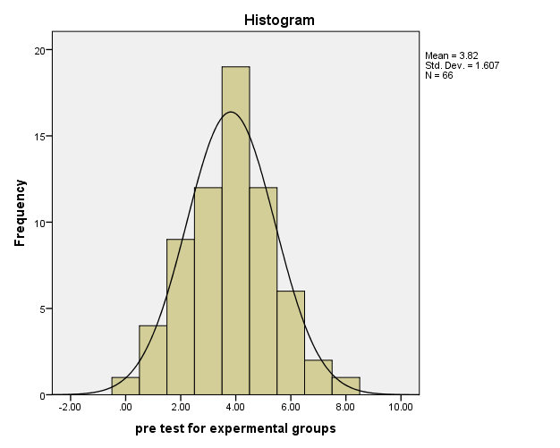
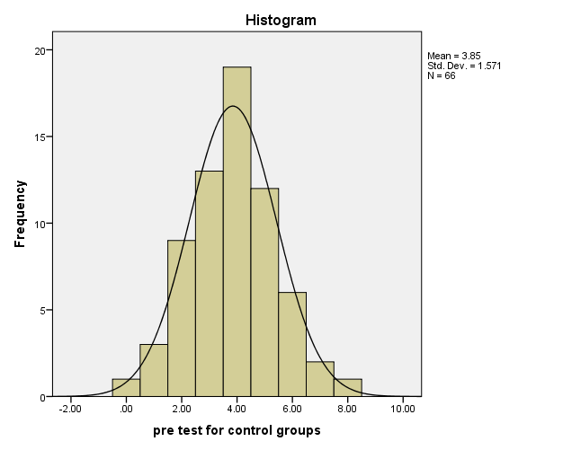

Graph 1: Histogram Normality Test for Experimental and Control Group

4.2. Descriptive Statically Analysis of Results and Interpretation
Table 4: Pre-test Results for descriptive analysis

Pre-test results | N | Mean | Std. deviation | Variance
Control | 66 | 3.84 | 1.57 | 2.469
Experimental | 66 | 3.81 | 1.60 | 2.582

Table 4: shows that the mean scores and variances comparison of the experimental and control group. This indicates that there is no statistical difference in the mean scores and variances of the experimental group (M=3.81, SD=1.60, Var=2.582) and control group (M=3.84, SD=1.57, Var=2.469) and the mean difference in the pre-test between the experimental and control group is 0.03. This means that the experimental and control groups have a very small difference in mean score and variances, indicated that the two groups started at the same level. The students’ results see in the appendix-D.
Table 5: Post-test Results for descriptive analysis
Post-test scores | N | Mean | Std. deviation | Variance
Control | 66 | 7.98 | 1.95 | 2.9
Experimental | 66 | 10.14 | 1.62 | 2.582

Table 5 above shows the mean result experimental (M=10.14, SD=1.62 and Var=3.52) group and Control (M=7.98, SD=1.95 and Var=2.9) group for post-test. This indicates that there is a statistically significant difference in the mean scores and variances of the experimental group differs significantly their mean difference is 2.2. This implies that there was a statistically significant difference in conceptual understanding between the students who instructed with model-based instruction and those instructed with traditional lecture method. This difference is statistically in significant showing that the results could not happen by chance.
4.3. Relationships between Pre-Test and Post-Test Results

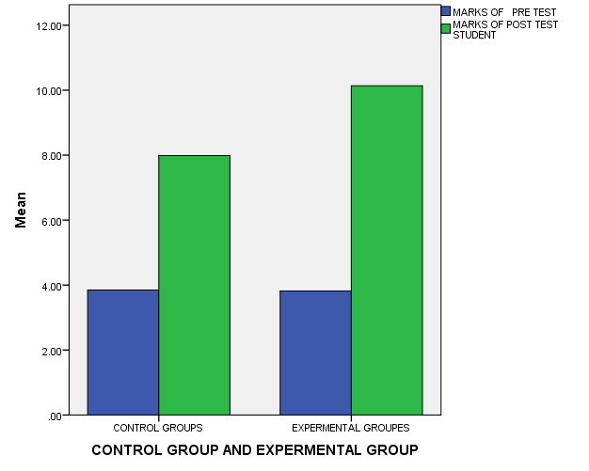
7.98
3.84
3.81
10.13
Graph 2: Bar graph relationship between pre-test and post-test results
In this study it was observed that the experimental group achieved significantly higher performance than that of the control group. The significant difference in mean score between the two groups is an indication of the effectiveness of the use of model-based teaching human anatomy.

4.3. Inferential Statically Analysis of Results and Interpretation
When looks at Levene’s test in table 5, sig significant (sig>0.05), the samples were equal variances assumed.
Table 6: Independent Sample t-test for Pre-test

Groups | T-test for Equality of Means
Experimental &  Control | T | Df | Sig. (2-tailed) | Mean Difference | 95% Confidence Interval of the Difference
 |  |  |  |  | Lower | Upper
Experimental &  Control | -110 | 130 | .913 | .03030 | -57759 | .51699

Table 5 shows that the independent sample t-test does not a significant difference between the mean scores of the experimental group and the control group for the pre-test, before administration of the treatments to the experimental group. There was no significant difference in the pre-test scores at alpha level α=0.05, Sig (2-tailed) > 0.05 indicating that the difference in the mean score was not significant. This result illustrated that both the students in the control and experimental group were similar in abilities before the administration treatment. Hence, the two groups are equivalent.
When we looks Levene’s test in table 6, sig significant (sig<0.05), the samples were equal variances not assumed.
Table 7: Independent Sample t-test for Post-test

Groups | T-test for Equality of Means
Experimental &  Control | T | Df | Sig. (2-tailed) | Mean Difference | 95% Confidence Interval of the Difference
 |  |  |  |  | Lower | Upper
Experimental &  Control | -7.516 | 125.505 | .000 | -2.34848 | -2.96683 | -1.73014

Table 7 shows the t-test comparison of the post-test score to the alpha level (α=.0.05). This indicates that there are statistically significant differences in the mean scores of the experimental group differ significantly. Critical t-value (t-crit= 2.35) in the appendix-E), two-tailed and level of significance (α=.0.05), (t-cal (7.51) > t-cri (2.35), df 125.5, p= (0.001) < 0.05).This shows that the result not existed by chance; therefore, there is a significant difference between the experimental and control group result.

4.4. Informal Assessment
Using an informal assessment is key to determine students understanding and identify their learning difficulty and gap. Using continuous assessments and timely feed back support all groups of students on human biology and health chapter that explores human skeletal systems, the movement focuses on the complexity of the human body, some of its systems, and how they work together to carry out specific functions.
The researcher observed students by informal assessment, to monitor students’ progress interest, participation, understanding and misunderstanding. In order to continue, the monitoring progress of effectiveness of model-based teaching, to support the learning goal of human anatomy.
Pre-Informal Assessment
The researcher first did a pre-informal assessment observation in order to assess what prior knowledge of students about human anatomy. Classroom observation including a 5- minute time segment and a round of the whole class observation with self-observation plus classroom walk-thought observation to collate some qualitative data. The researcher asked different questions both groups of students in order to identify their misconception or misunderstanding, to grow up their participation and to improve their conceptual understanding of human anatomy. Students wrote a response on their notebooks to the following warm-up question as an introduction to human anatomy:
Question1. List human skeletal systems? Most students wrote nothing, but it is unclear whether they were wasting time or they did not know any possible answers. Some students confused with skeletal systems. But only some of the students listed some componenets such as skeleton, bones and muscles. Based on these the students' response, the researcher gives homework referred to exercice books to search additional information’s about the topic, to show the relationship among skeletons, bones, bone marrow, joints, and muscles.
Question 2.Do new born babies have the same bones as adults? Most Students responses showed that, in this question, babies’ bones are similar to adults but some students less than adults and few students greater than adults.
Question 3. Are bones alive when they are inside the living body? The answer of most students’ showed that most of them are nonliving statement towards bones, whereas few who stated bones as alive mostly. Thus the researcher needed to find effective ways to identify students' misconceptions and locate strategies.
Teaching for Experimental Groups
For the experimental group, the researcher employed model-based teaching instructional approaches which involve hands-on and minds-on activities to recall prior knowledge, increase curiosity, engage students to learn, provide them an environment to explain their understanding, apply their knowledge in new situations, connect the content with the human anatomy concepts. In order to improve students’ conceptual understanding about human anatomy, using different skeletal system models, teaching aids and textbooks, arranged students into small groups and observe the skeletal system to discuss it. During this time 5E instructional design model lesson plans were applied based on the constructivist views in learning (see in the appendix-F).
In the first question, the response to the prompt about listing skeletal systems demonstrated students’ prior knowledge they had about how the human body is made up of complex systems that work together to perform functions. After class discussions and observing the models, students are expected to change their ideas about how many organ systems there are and how they work together.
The second question, do new born babies have the same bones as adults? The students’ response based on these questions almost all students were confused, why babies bone greater than adults? After a deep discussion, students are also expected to change their ideas.
The third question, students may have had the idea that bones are not living tissues, or they might not have realized that bones have different functions based on their structures. The class discussion on the skeletal system gave me an idea of whether or not students applied the concepts of the relationship between structure and function and those bones are made of living tissues. By discussing bones, as living tissues, students had to recall the knowledge learned earlier in the chapter about the relationship of the levels of an organism’s structure (cells and tissues inside bones, bones as organs, and the skeletal system as an organ system).
Their writings showed if they have a basic understanding of the structure and the function of the human skeleton system discussed deeply as shown below the picture.

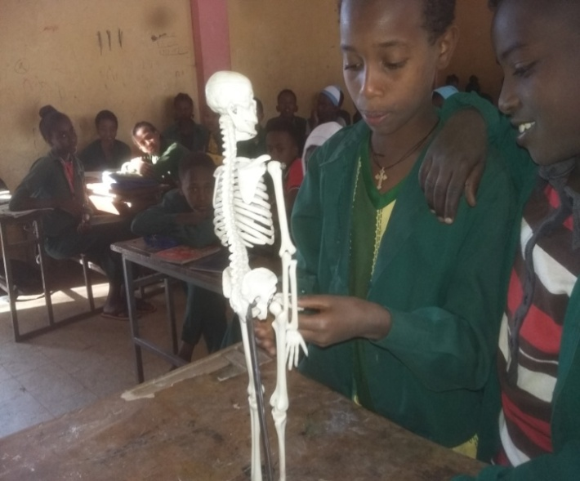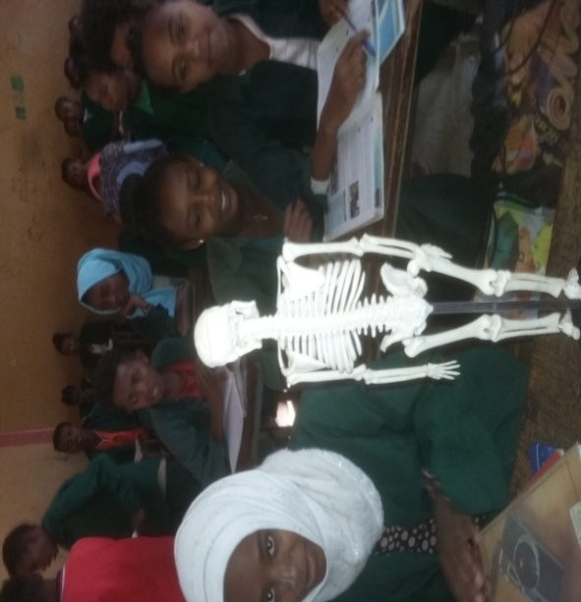

Figure 2: Observation of human skeletal system model

Teaching for Control Groups
On the contrary, the control group was taught tradtional teaching approach based on teacher explanations, questioning, discussion, and knowledge and activities suggested in the textbook. The information and activities were also teacher-centered approaches.
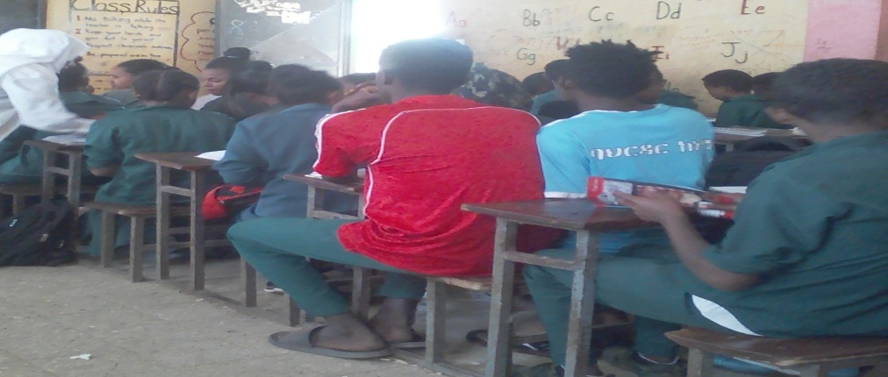
Figure 3: Teaching for the traditional class

Post- Informal Assessment
Finally, the researcher observed students’ in experimental groups improve their conceptual understanding about the topic, the main indication of this, students were paying attention to the lesson, gradually increases their participation, develop interests and clear their misconceptions. According to Mclachlan, (2003), the importance of teaching by using models have great value in teaching biology, it directs students to explore biological objects and phenomena that inflexible to perceive directly and the can easy to understand the science concepts. For control group students less improve their conceptual understanding when compared with expermentla groups. Students in control group less participations, interests and they had difficulty verifies their own ideas with integrate the concepts. Finally, the end of the program after giving post-test the researcher thought control group of students by skeletal models. Then with regard to direction and provided with enough feedback to clear their misconception or misunderstanding did meet as all groups of students were asked again to answer correctly.

4.5. Analysis of Classroom Observation
Classroom observation was employed, as an additional tool, to assess what actually happened in the human anatomy classroom. The focus of the checklist was to check the kind of student's participation, interest and understanding. Classroom observation was analyzed by using qualitative analysis.
- Students Participation
The experimental groups of students were more active than the control groups of students. Students in the experimental group actively participated in all activities such as asking questions and answering questions, attentively observed teaching models, attentively focused on the teaching activity with minimum disruptions and they interact with teaching materials while the control groups were less participation sometimes confused the lessons.
- Students Interest
The experimental group of students (modeling-taught students) was significantly more interested in science than the traditionally taught students.
- Students Conceptual Understanding of the human skeletal system
The model-based teaching was supported significantly higher accuracy on a conceptual understanding for implementing students than traditionally taught students. Overall, the students taught using model-based teaching scored higher on the conceptual understanding that the students taught using more traditional methods. Thus, model-based teaching can enable biology students to engage in modeling practices in order to develop conceptual understanding.

CHAPTER FIVE

5. DISCUSSION AND IMPLICATIONS OF RESULTS

5.1 Discussions of Results
Based on the finding of this study, the researcher demonstrated the following discussion concerning the role of model-based teaching approach how practically they implemented to improve students' conceptual understanding in human anatomy topics. All finding of this study were stated based on the data of pre-test, post-test, informal assessment and classroom observations.
Hence, the research questions of this thesis were:
- Is there a significant difference between model-based teaching approach and traditional teaching approach when they were taught human anatomy?
- What is the effect of model-based biology instruction on students’ conceptual understanding of human anatomy?
- What is the participation of students’ when they are taught by model-based teaching approach?
With regard to the first research question to compare model-based teaching approach and traditional teaching approach on students’ conceptual understanding about human anatomy the data on the pre-test, post-test, and observation revealed. In this study, before an independent sample t-test was carried out to check the normality of the data using histogram test. The results could lead to the researcher to the conclusion that both groups were homogenous and have equal variance terms conceptual understanding before giving the treatment to the experimental group, after checking the normality, independent sample t-test was carried out. There were no significant differences mean scores between the experimental groups and control group on pre-test scores (see Table 4), both groups were similar level before the intervention was administered.
In addition, independent samples t-test was performed to check the differences in the pre-test score at alpha level (p> 0.05). Supported by Field (2009), when the P-value is greater than the level of significance, there were no statistically significant differences in the mean scores of both groups of the pre-test scores.
When see the post-test scores of the experimental and control group are statistically significant difference these confirm the existence of evidence to prove change in the mean score experimental groups while the control groups of mean score (see Table 5) and mean difference was 2.2 due to implementation of model-based teaching of experimental groups. To check differences by another way the independent samples t-test was supported by Field,(2009), when the P<0.05, there were statically significant differences. The t-test results indicated that the experimental group scores were, statistically significant.
The results of the analysis revealed that the experimental groups of students’ performances were better than that of the control group and a significant difference between the mean scores of the two groups was observed. This was due to the use of the model-based instructional approach in the experimental group. According to Jackson et al., (2008), model-based teaching emphasizes active learning student construction of conceptual understanding. Similarly studies (Min et al., 2014), using a teaching model in the biology classroom his finding showed that students develop a better understanding of abstract concepts.
The significant difference between model-based teaching approach and traditional teaching approach when they thought human anatomy is shown in the above it also determined the effect of a model- based teaching. The model-based instructional approach improves their understanding significantly for students in experimental groups, higher than those in the traditional instructional groups of teaching approach about human anatomy. This idea supported by Jancarikova & Jancarik, (2017), teaching models are a broader sense for didactical purposes for the level of abstraction that needed to grasp them adapted models of easily accessible objects, models that allow pupils to see, observe objects that are usually not accessible and that require abstraction.
Through observational assessment learning by using model-based teaching approach the well-known misconceptions of many students was changed. The students' participation as increased in on those experimental groups during the model-based teaching; students clear their misconceptions, were pay attention to the lesson, gradually increase their participation, develop interests. The results of this study revealed that during preparation for model-based teaching human anatomy in particular misconceptions well known from the literature should be included. According to Caravita & Falchetti (2005), each student was interviewed with the following questions: Are bones alive when they are inside the living body? What are bones made of? Can bones grow? How do they grow? The answers of students especially in secondary school level indicated a large frequency of the nonliving statement towards bones.
However, the data obtained from control group observation suggested that, when the researcher observe the students’, the traditional teaching method was didn’t participate or engage students by different activity. The students were a passive participant, less interested for the lesson and teaching method. Therefore, in these approaches students can’t easily understand the concepts. This result was supported by (Ivić, etal,. 2016), traditional teaching strategies are base on the transmission view the pupil's role in the learning process is largely passive, knowledge is transfer in one way from the teachers only, while the students are a passive listener.
On this result indicated that students perform better by discussing those wrong answers and with the help of the teacher they grab successfully the scientific model. One of my roles as a teacher in the classroom to help students, bridge the gap between their prior knowledge and new concepts in order to improve conceptual understanding. One way to do this is informatively assessed students along the way. It is imperative to understand where students' knowledge begins when starting a new unit of study so that teachers can be better, understanding their misconceptions. It is also equally important to continually monitor students’ progress and re-teach concepts to build their conceptual knowledge.

5.2 Implications of Results
The implication of this study was improving and supporting learning education that the teacher uses a model-based teaching with in 5E instructional approach. Students improve their conceptual understanding of human anatomy in case of Ewket fana primary school for grade seven biology classes by applied model-based teaching approach. My finding from the analysis of independent t-test, the study's research question and help to achieve its goals which are model-based teaching approach improved students conceptual understanding. In addition, model-based instruction increases student interest in biology classes. The study was indicated that students competency improved in model-based teaching approach, compared to that of traditional ones. This is most concerning in the classroom if teachers choose to only utilize model-based curricula. The study findings should consider these views in designing the curricula, textbooks, teaching activities and materials, teacher educational processes and similar study must be conducted.

CHAPTER SIX

SUMMARY, CONCLUSION AND RECOMMENDATIONS

6.1. Summary
The main purpose of the study was by using model-based teaching approach to improve students’ conceptual understanding of human anatomy topics for grade seven Ewket fana primary school students. The data collected by tests, classroom observation, and informal assessments’. Based on the analyses, the summary of the findings as follows.
- The mean for the experimental and control group pre-test scores was statistically is not significant and the t-test results (p>0.05). This implied that the control and experimental group started at the same level. No group was superior to the other.
- The mean for the experimental and control group post-test scores was statistically significant and the t-test results (p<0.05). The fact that the control and experimental group started at the same level, then the difference that was observed between the post-test scores of the two groups was due to the treatment. The experimental group outperformed the control group. The use of model-based teaching was, therefore, more successful than the traditional teaching method.
- The informal assessments observational findings showed that students clear their misunderstandings (misconceptions) and increase their interests towards the topic.
- The research using visuals models as a teaching method stimulates thinking and improves the learning environment in a biology classroom.

6.2. Conclusion
In this study, an intervention was applied in two groups carried out for three consecutive weeks. After the intervention, analysis of the results revealed that the experimental group outperformed the control groups in a special conceptual understanding of measurement tests. Due to the significant and meaningful results, the experimental group the better than the control groups. On the other hand, model-based learning instruction has an effect on improved students’ conceptual understanding, participation, interests. The students in experimental groups gradually increase their participation, clear their misconceptions, and were paying attention to the lesson during the model-based teaching. In general, as shown the results of independent t-test learning by using model-based teaching approach better than the lecture method approach.
Finally, the result determined that students' understanding of biology class human anatomy topics can be improved and they became more interested in biology. Thus, from the results of this study, it is possible to conclude that the model-based teaching approach is a more effective method to contribute students’ conceptual understanding when they learn to human anatomy in biology.

6.3. Recommendations
The study's results can also lead to a number of possible recommendations to different concerned bodies regarded by their responsibilities.
- The model-based instructional has a positive effect on students' conceptual understanding hence teachers should be encouraged to employ it more in the teaching biology.
- Teachers may be given importance to the students' opinion regarding the models understanding.
- Teachers should try as much as possible to use these models in the teaching of difficult concepts in biology.
- School principals encourage biology teachers to use models by preparing enough instructional materials like model of skeletal system.
- In addition to their school principals also add additional classroom in order to minimize large class size.
- Studies should consider these views in designing the curricula, textbooks, teaching activities and materials and teacher educational processes.

REFERENCE
Bautista, R. G. (2014). The Convergence of MayerModel and Constructivist Model towards Problem solving in Physics, (May).
Bybee, R. W. (2009). The bscs 5einstructionalmodel and 21stcentury skills, (January).
Caravita and Falchetti. (2005). Are bones a live? Journal of Bilogical Education, 39(4), 163-170
Chittleborough, G. D., & Treagust, D. F. (2009). Why Models are Advantageous to Learning Science, 12–17.
Favaron, A., Ancona, E., Bramuzzo, S., Callegaro, E., Irato, P., & Santovito, G. (2017). An innovative teaching approach to circulatory and skeletal systems based on comparative vertebrate anatomy and and physiology, (August). https://doi.org/10.21125/edulearn.2017.1015
Fernando, S. Y. J. N., & Marikar, F. M. M. T. (2017). Constructivist Teaching / Learning Theory and Participatory Teaching Methods, 6(1), 110–122. https://doi.org/10.5430/jct.v6n1p110
Field, A. (2009). Discovering Statistics Using SPSS (thrid edit). SAGE Publications.
Fokides, E., & Mastrokoukou, A. (2018). Results from a Study for Teaching Human Body Systems to Primary School Students Using Tablets, contemporary educational technology, 9(2), 154–170.
Gabel, D. (2003). Enhancing the Conceptual Understanding of Science Enhancing the Conceptual Understanding of Science, Educational Horizons,81(2), 70–76.
Huda Wahida, R., Fauziah, B., Harryizman, H., Ali Yusny, D., Haslina, M., & Norida, M. D. (2010). Using augmented reality for supporting learning human anatomy in science subject for malaysian primary school. Paper Presented at the Regional Conference on Knowledge Integration in ICT (INTEGRATION2010), (Putrajaya).
Ivić, S., Gortan, V., & Gortana, P. V. (2016). Frequency of Applying Different Teaching Strategies and Social Teaching Methods in Primary Schools, 7(33), 66–71.
Jackson, J., Dukerich, L., & Hestenes, D. (2008). Modeling Instruction: An Effective Model for Science Education, Science Educator, 17.
James, T., Calvo, R., & Kenneth, C. (2007). Human biology teacher’s edition. (Boston & MA, Eds.) (1st ed). McDougal Littell Science.
Jancarikova, K., & Jancarik, A. (2017). Teaching Aids and Work With Models in e-Learning Environments. Electronic Journal of E-Learning, 15(3), 244–258.
Justi, R. (2017). Learning how to model in science classroom : key teacher ’ s role in supporting the development of students ’ modelling skills. Educación Química, 20(1), 32–40. https://doi.org/10.1016/S0187-893X(18)30005-3
Kolesnikova, I. V. (2016). Combined Teaching Method : An Experimental Study, 6(6), 51–59. https://doi.org/10.5430/wje.v6n6p51
Louca, L. T., & Zacharia, Z. C. (2011). Modeling-based learning in science education : Cognitive , metacognitive , social , material and epistemological contributions, (April 2015). https://doi.org/10.1080/00131911.2011.628748
Mathias, A. (2014). Active Learning in the Science Classroom. Honors Projects Paper, 113, 1–32.
Mclachlan, J. C. (2003). Using models to enhance the intellectual content of learning in developmental biology, 229, 225–229.
Miller, C. J., McNear, J., & Metz, M. J. (2013). A comparison of traditional and engaging lecture methods in a large, professional-level course. AJP: Advances in Physiology Education, 37(4), 347–355. https://doi.org/10.1152/advan.00050.2013
Min, K. J., Jackman, J. K., & Chan, J. C. K. (2014). Visual models for abstract concepts towards better learning outcomes and self-efficacy.
Negassa, O. (2014). Ethiopian students ’ achievement challenges in science education : implications to policy formulation, 4(January), 2–18.

Pop-pacurar, I., & Tirla, F. (2009). M odels r ole within a ctive l earning in b iology . A c ase s tudy, 2(2).
Quillin, K., & Thomas, S. (2015). Drawing-to-Learn : A Framework for Using Drawings to Promote Model-Based Reasoning in Biology, 14, 1–16. https://doi.org/10.1187/cbe.14-08-0128
Reiss, M. J., & Tunnicliffe, S. D. (2001). Students Understandings of Human Organs and Organ Systems, (May 2014). https://doi.org/10.1023/A
Richardson, V. (n.d.). Constructivist Teacher Education :
Schwartz, R., & Skjold, B. (2017). Teaching about Scientific Models in a Science Content Course. Educación Química, 23(4), 451–457. https://doi.org/10.1016/S0187-893X(17)30132-5
Shabiralyani, G., Hasan, K. S., Hamad, N., & Iqbal, N. (2015). Impact of Visual Aids in Enhancing the Learning Process Case Research : District Dera Ghazi Khan ., 6(19), 226–234.
Skjold, B. (2012). Teaching about Scientific Models in a Science Content Course, 23(4), 451–457.
Speth, E. B., Shaw, N., Momsen, J., Reinagel, A., Le, P., Taqieddin, R., & Long, T. (2014). Introductory Biology Students ’ Conceptual Models and Explanations of the Origin of Variation, 13, 529–539. https://doi.org/10.1187/cbe.14-02-0020
Temitope, S. B., & Deborah, T. A. (2015). Ordeals of Physics Instruction in Nigerian Secondary Schools : Way Forward for the Attainment of Global Competitiveness, 6(20), 87–97.

APPENDICES

Appendix-A: Intervention Plan

Intervention program | Session | Topics | Time | Learning outcome
Before intervention | Session I | The researcher will be given the pre-test | 1hr | To determine homogeneity in their knowledge of the topic‚ about ‘Human Anatomy’
During intervention | Session II | Introduction human skeletal system | 40’ | Define the skeletal system
During intervention | Session III | Human biology and health: the Axial skeletal system | 40’ | Divide human skeletal into the axial and appendicular skeleton
During intervention | Session IV | The appendicular skeletal system | 40’ | Identify the parts of the skeletal system, how the parts go together, how they depend on each other
During intervention | Session V | The structure and function of the skeleton | 40’ | Describe the structure and functions of the skeletal system  Understand the organization and function of human body structures  Identify the internal organs and how they work together
During intervention | Session VI | Types of bones | 40’ | List types of bones  Identify and explain the purpose of some bones in the human skeletal system  Describe what the outer and inner part of the bone looks like
During intervention | Session VII | Types of joints | 40’ | Identify and explain the purpose of some joints in the human skeletal system
After intervention | Session VIII | The researcher will give post-test | 1hr | To assess students conceptual understanding

Appendix-B: Pre-test and Post-test Questions
Ewuket Fana Primary School for Grade 7th Human Anatomy Pre-test and Post-test
Name ---------------------------------------------Sex ------------------No------------
Choose the Correct Answer
- Which of the following best describes the human skeleton?
A, A strong structure that makes minerals and oxygen
B, The control center of the body
C, A complex solid structure of fused bone
D, The internal framework of the body
- Which of the following is part of the appendicular skeleton?
A, Vertebrae B, Ribs
C, Sternum D, Metacarpals
- Which of the following describes as the bone that makes up the spine and protects the spinal cord?
A, Vertebrae B, Skull
C, Pelvis D, Ribcage
- The bones of the skull are examples of one of the following joints?
A, Ball-and-socket B, Hinge
C, Pivot D, Fixed
- Which of the following bones are found both fore and hind limbs?
A, Wrist B, Phalanges
C, Ankle D, Ribs
- Which of the following NOT the functions of the skeletal system?
A, Support and give shape to the body B, Remove waste from the body
C, Make blood cells D, Protects the organ
- Which part of the bone where blood cells made?
A, Marrow B, Joint
C, Ligament D, Liver
- The shoulders of the human body are protected by
A, Sternum, ribcage and spine B, Clavicle and scapula
C, Carpals and patella D, Tarsal and ileum
- The skeletal system is made of
A, Muscle and water B, Vitreous humor
C, Minerals and fat D, Bone and cartilage
- Among other bones, the axial skeleton system includes the
A, Vertebral column and ribs B, Tarsal and sternum
C, Skull and femur D, clavicle and humerus
- The division of skeleton which is composed of the pelvic girdle, pectoral girdle and bones of lower and upper limps is known as
A, Axial skeleton B, Appendicular skeleton
C, Perpendicular skeleton D, Transcription skeleton
- Which function of the skeletal system would be especially important if you were in a car accident?
A, For blood clotting B, Protection of mineral organs
C, Facilitation of movement D, Fat storage
- The forearm consists of the
A, Radius and ulna B, fibula and tibia
C, Clavicle and scapula D, Clavicle and coccyx

To answer question number 14 and 15 answers below the diagram
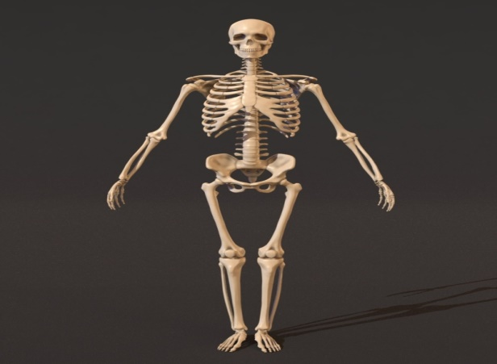
B
A

- From the given diagram letter ‘A’ indicates that
A, Skull B. Rib
C. Sternum D. Pelvis
- From the given diagram letter ‘B’ indicates that
A, Gliding joint B, ball and socket
C, Hinge joint D, the pivot joint

Appendix-C: Observation checklists

No | Observation checklists
Participations:
- Students actively participate in teaching human anatomy
- Students express thoughtful ideas, reflective answers, and questions relevant or appropriate to the learning
- Interaction with the teaching material
Interest:
- Students are interested in using teaching models towards the lesson
Understanding:
- All students able to understand the concepts of the lesson
- Students can describe the purpose of the lesson or unit.

Appendix-D: Students’ Results out of 15%

Student Id | Pre-test for Experimental Group | Post-test for Experimental Group | Pre-test for Control Group | Post-test for Control Group
1 | 2 | 10 | 2 | 5
2 | 2 | 8 | 4 | 6
3 | 4 | 9 | 5 | 8
4 | 4 | 9 | 5 | 8
5 | 3 | 5 | 2 | 8
6 | 7 | 9 | 6 | 10
7 | 3 | 8 | 2 | 6
8 | 5 | 8 | 3 | 10
9 | 2 | 10 | 4 | 9
10 | 3 | 11 | 3 | 8
11 | 5 | 11 | 6 | 5
12 | 3 | 14 | 6 | 7
13 | 1 | 8 | 5 | 9
14 | 4 | 9 | 4 | 7
15 | 5 | 11 | 4 | 11
16 | 5 | 10 | 6 | 8
17 | 5 | 10 | 7 | 8
18 | 4 | 11 | 2 | 7
19 | 4 | 12 | 5 | 7
20 | 6 | 11 | 4 | 9
21 | 6 | 7 | 2 | 5
22 | 3 | 10 | 4 | 8
23 | 4 | 11 | 4 | 6
24 | 5 | 12 | 2 | 7
25 | 2 | 9 | 1 | 8
26 | 2 | 10 | 7 | 11
27 | 4 | 10 | 4 | 8
28 | 7 | 12 | 5 | 8
29 | 6 | 10 | 4 | 8
30 | 6 | 10 | 2 | 6
31 | 5 | 10 | 4 | 8
32 | 4 | 9 | 3 | 6
33 | 2 | 10 | 4 | 8
34 | 4 | 9 | 4 | 10
35 | 6 | 11 | 5 | 10
36 | 6 | 11 | 8 | 11
37 | 3 | 10 | 0 | 8
38 | 5 | 10 | 5 | 9
39 | 1 | 9 | 3 | 10
40 | 4 | 11 | 1 | 10
41 | 4 | 8 | 5 | 9
42 | 4 | 9 | 4 | 10
42 | 5 | 10 | 3 | 9
44 | 4 | 9 | 1 | 5
45 | 3 | 10 | 6 | 7
46 | 4 | 12 | 3 | 8
47 | 3 | 10 | 5 | 9
48 | 3 | 13 | 4 | 8
49 | 4 | 9 | 5 | 10
50 | 1 | 6 | 5 | 12
51 | 8 | 13 | 3 | 9
52 | 4 | 11 | 6 | 7
53 | 5 | 12 | 4 | 9
54 | 4 | 7 | 4 | 7
55 | 5 | 9 | 3 | 6
56 | 4 | 13 | 2 | 8
57 | 3 | 12 | 5 | 8
58 | 2 | 11 | 5 | 8
59 | 1 | 10 | 3 | 4
60 | 3 | 13 | 3 | 11
61 | 2 | 9 | 3 | 6
62 | 0 | 10 | 4 | 9
63 | 5 | 12 | 3 | 7
64 | 3 | 12 | 3 | 6
65 | 4 | 12 | 4 | 7
66 | 2 | 8 | 2 | 7

Appendix-E: T-Critical Table
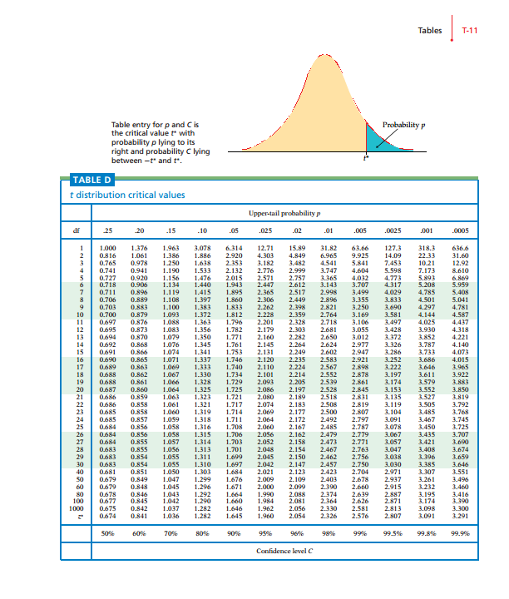

Appendix-F: Lesson plans for Experimental groups
Lesson plan: Using the 5E model
Teacher’s name: Aminat Endris
Lesson topic: human biology and health: types of bones
Time allocated: 80’
Grade and section: 7th
Objectives: at the end of the lesson the students be able to:-
- List types of bones
- Give examples of each type of bone
- Identify and explain the purpose of some bones in the human skeletal system
- Describe what the outer and inner part of the bone looks like
Time | What do you do? | How do you do it? | Why do you choose this strategy? | How do you evaluate?
10’ | Engage | In the beginning, I will check the students exercise book  I introduce the lesson types of bones | To connect prior knowledge’s to the past knowledge | Check their answer and identify their difficulty
20’ | Explore | At this step, I arrange students into groups and distribute different types of bones and observe the bones then discuss for the groups  - Can you list down types of bones in our body?  - Do your bones have the same size and shape? | To examine their understanding | Observing what they are doing and how they are doing?  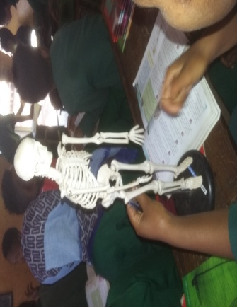
25’ | Explain | In this step, I give a chance for the students to explain their discussions  I will also explain the types of bone | To communicate new understanding  To apply new understanding | Listening to their reflection
10’ | Elaborate | In this step, I will summarize the main point the lesson give additional explanations about the lesson | To promote their application skill  To summarize what they did earlier
15’ | Evaluate | This stage is the assessment stage I give class work:  - How many bones are in the spine?  - What is the center of long bones and its purpose?  - What is bone marrow? | To anticipate their concept  understanding  To find out how much they understand the concept | Write the assignment and give feedback

Lesson plans for Control Groups

Name of teacher- Aminat Endres Grade level &section- 7th C
Name of school –Ewket fana Primary school Time allocated: 40`
Subject – Biology
Topic: Human biology and health: types of bones
Objectives: at the end of the lesson the students will be able to:-
- List types of bones
- Give examples of each type of bone
- Identify and explain the purpose of some bones in the human skeletal system
- Describe what the outer and inner part of the bone looks like

Stage | Time | Teachers activity | Students activity
Introduction | 5’ | Introducing the daily lesson and previous lessons.  Ask questions for brainstorming | Listen attentively to the teacher introduction.  Try to answer the brainstorming question
Main body | 25’ | Give a short note about the topic  Arrange students in to small groups  Explain briefly on bones  - Types of bones  - Function of bones  Ask questions after explanation. | Take the given note  Listen carefully to the presentation of the teacher.  Discuss in groups  Asking questions and answering the question
Conclusion | 10’ | Summarize the main body daily of the lesson  Give homework | Listen to the summary of the main point  Ask questions if they have or not clear  Write the homework

Recommendation of department Head.
Name______________________ signature ____________ date_________
Teacher name _______________ signature _____________date_________

