EFFECT OF ELECTRIC FIELD AND NEUTRAL WIND ON THE FORMATION OF IONOSPHERIC IRREGULARITIES OVER BAHIR DAR, ETHIOPIA

A THESIS SUBMITTED TO
THE SCHOOL OF GRADUATE STUDIES OF
BAHIR DAR UNIVERSITY
IN PARTIAL FULFILLMENT OF THE
REQUIREMENTS FOR THE DEGREE OF
MASTER OF SCIENCE IN PHYSICS

BY
BELETE ACHENEF

BAHIR DAR UNIVERSITY
BAHIR DAR, ETHIOPIA
SEPTEMBER, 2018

Copyright © by BELETE ACHENEF, 2018

Effects of Electric Field and Neutral Wind on the Formation of Ionospheric Irregularities over Bahir Dar
By
Belete Achenef
Department of Physics, College of Science
Bahir Dar University

Approved by Examining Committee:-
Dr Melessew Nigussie (Advisor):-
Dr Tsegaye Kassa (External Examiner):-
Dr Raju (Internal Examiner):-
Dr Amare Binor (Chair person):-

DEDICATION

This work is dedicated to my mother

Acknowledgements
First I would like to give the priority of my great thank to the”Almighty God” for the uncountable gifts I have received from Him throughout my life. The next big contributor for seeing this outcome is my advisor Dr. Melessew Nigussie. I would like to thank him for his invaluable support, encouragement, supervision and useful suggestions throughout this research work. His moral support and continuous guidance enabled me to complete my work successfully. The encouragement and advice of my brothers, Molla Achenef and Muluken Achenef is unforgettable and I would like to thank you deeply from my heart. I would also like to thank to all who supports me in material and other resource, timely help and encouragement.

Table Contents
Contents page
Acknowledgements i
Table Contents ii
Abstract v
CHAPTER ONE 1
1. Background 1
1.1. Thesis Motivation 4
1.2 Thesis Objective 4
2. Earth’s Atmosphere 5
2.1 Neutral Atmosphere 5
2.2 Earth’s Ionosphere 6
2.2.2 Regions of ionosphere 8
2.2.3 Equatorial Ionosphere 11
2.2.4 Ionospheric Irregularities 14
2.2.5 Geographic Regions of the Ionosphere 20
2.2.6 Ionospheric Scintillation 22
2.2.7 Ionosphere Probing Techniques 24
3. Data and Methodology 27
3.1 Data Source 27
3.2 Methodology 27
3.2.1 Total Electron Content in the Ionosphere (TEC) 27
3.3 Data Analysis 30
4. Result and Discussion 32
4.1 Introduction 32
4.1 Daily Variation of irregularity 32
4.2 Monthly Variation of Irregularity 47
5. Conclusions and Recommendations 52
5.1 Conclusions 52
References 54

List of Figures
Figure 2. 1A diagram that shows the different layers of the earth’s atmosphere 6
Figure 2. 2Day and night structure of the ionosphere [Australian Space Weather Agency, 2011] 10
Figure 2. 3The fountain effect and formation of equatorial anomaly. Reproduced from Groves [2004]. 12
Figure 2. 4A graph that shows electron density irregularities (spread F) observed from ionosondes at Jicamarca Peru. 16
Figure 2. 5Schematic diagram used to show irregularity formation with some modification. 19
Figure 2. 6Major geographic regions of the ionosphere (from Attila Komjathy, 1997). 21
Figure 2. 7schematic diagram of ionospheric scintillation and its effects on satellite signals . Signals emerge irregular regions at different phases and interfere at the antenna. 23
Figure 2. 8Ionospheric scintillation 26
Figure 3. 1schematic diagram of the ionosphere with the pierce point and line of sight from receiver to satellite. Source Schaer 1996 with some modification 30
Figure4. 1 The daily variation of irregularity on January 1, 18 and 19 of quite days. 34
Figure4. 2 The daily variation of irregularity on January 4, 8 and 14 of quite days. 36
Figure4. 3 The daily variation of irregularity on March 03, 20 and 23 of quite days. 37
Figure4. 4 The daily variation of irregularity on March 21, 22 and 25 of quite days. 38
Figure4. 5 The daily variation of irregularity on April 03, 19 and 30 of quite days. 39
Figure4. 6 The daily variation of irregularity on April 09, 15 and 16 of quite days. 41
Figure4. 7 The daily variation of irregularity on may 01, 14 and 17 of quite days. 42
Figure4. 8 The daily variation of irregularity on may 02, 26 and 27 of quite days. 44
Figure4. 9 The daily variation of irregularity on June 20, 21, 14 and 13 of quite days. 46
Figure4. 10 A graph that shows the monthly variation of irregularities for January and March in 2012. 48
Figure4. 11 Irregularity variations on April, May and June in 2012. 50

Abstract

In this thesis, we study the effect of neutral wind and zonal electric field on the formation of occurrence of ionospheric irregularity using data from ground based GPS SCINDA , on the horizontal meridional wind model and electric field model at Bahir Dar region in the year 2012. Irregularity strength, horizontal meridional and zonal wind magnitude and direction with magnitude of zonal electric field are computed and analyzed. It is found that zonal electric field which is greater than zero in the time between 18:00LT and 19:00LT and southward horizontal meridional wind and westward zonal wind in the time between 17:00LT and 24:00LT are good conditions for the occurrence of irregularity. The relative difference in the F region irregularity occurrence between the given five months also discussed.

Keywords: Ionospheric irregularity, Scintillation index S4, electric field, neutral wind, Ap index

CHAPTER ONE

1. Background
Equatorial spread F (ESF) is the name given to signatures of ionospheric F region electron density irregularities observed using different types of measurements made at equatorial and low magnetic latitudes (Chapagain et al. 2009). The scale size of these irregularities ranges from a few centimeters to hundreds of kilometers (Basu et al. 1978). Interchange plasma instabilities developing at the magnetic equator around sunset hours are invoked to explain the development of ESF irregularities. The ionospheric generalized Rayleigh-Taylor (GRT) plasma instability finds ionospheric conditions at the magnetic equator around sunset hours leading to positive linear growth rates. The GRT explains most of the features observed during large-scale (greater than tens of kilometers) ESF events and is often referred to as the source of ESF (Sultan, 1996).

Several theoretical and experimental studies have investigated the genesis, development, and decay of ESF. These studies have indicated that the development of ESF is controlled by a number of factors including, in particular, the magnitude of the pre-reversal enhancement (PRE) of the equatorial zonal electric field (Fejer et al.1999), the occurrence/absence of plasma waves in the bottom side equatorial F region (Kelley et al. 1981), and the amplitude of meridional thermospheric winds (Maruyama and Matuura, 1984).
Interchange plasma instability such as the GRT, operating in the Equatorial F region, requires an initial perturbation to be triggered. Some studies suggest that this initial perturbation would be always present and would not affect the day-to-day or longer-term variability in the occurrence of ESF (Retterer et al. 2009). Other studies, however, propose that the amplitude and occurrence of the seed waves is variable and might be important in controlling the variability in ESF. Most of these studies suggest that atmospheric gravity waves play an important role in generating the seed waves. For example, Tsunoda, R.T. (2010) determined that gravity waves are linked to the occurrence/non-occurrence of ESF during solstice months in all longitude sectors. However, other sources of perturbations that could invoke ESF have also been suggested. Some studies have indicated that perturbations in the bottom side F region can be produced by the vertical shear in the zonal plasma flow associated with the evening plasma vortex (Hysell and Kudeki 2004). It has also been proposed that meridional thermospheric winds can affect the development of ESF. This hypothesis is, however, based on theoretical expectations of the long-term (interannual) variability of the winds and climatological studies of ESF occurrence at different longitude sectors. Experimental investigations of the effects of winds on the day-to-day variability of ESF, however, did not find conclusive evidence that meridional winds can suppress or stabilize the ESF growth (Mendillo et al. 2001).

Equatorial F region irregularities have been extensively studied through Multi-instrument observations, such as diffuse echoes in ionograms, backscatter plumes in VHF radar echoes, total electron content (TEC) bite-outs, and pronounced density depletions from in situ satellites (Woodman and LaHoz 1976). From these investigations it is known that most EFIs initiate at Post sunset hours and continue to midnight, with the occurrence rate peaking during pre-midnight hours and decreasing steadily during the rest of the night. Although, from case studies, the EFIs are found to occur also during post-midnight hours, they are generally much weaker and much less frequent than the post sunset events. However, from an examination of the ionograms recorded at Fortaleza, MacDougall (1998) reported a secondary maximum occurrence of EFIs at post-midnight/ presunrise hours. Such EFIs took the form of patches with eastward velocities of about 50 m s⁻¹. In the Indian sector, the peak occurrence of EFIs during post-midnight hours has been observed preceded by an abnormal increase of F region height during the June solstice of solar minimum (Sastri et al.1979). Recently, using the Communications/ Navigation Outage Forecasting System (C/NOFS) satellite in situ observations, Huang et al. (2010) found frequent occurrence of solar minimum EFIs in the midnight to dawn sector. Such kinds of EFIs appear to be different from the decaying EFIs which are initiated during post sunset hours or that associated with the post-midnight Frequency-type spread F in ionograms. The drift velocities were found to be upward and westward and reached 200–400 m s⁻¹, which indicates that these post-midnight EFIs are active and still growing.
It is generally accepted that the Rayleigh-Taylor (R-T) instability mechanism is responsible for the generation and growth of the EFIs. The growth rate of the R-T instability depends on the external driving forces, such as neutral wind, electric and magnetic fields, together with background ionospheric properties, for example, the flux tube integrated Pedersen conductivity and upward plasma density gradients (Sultan, 1996).
The post sunset EFIs are generally thought to be associated with the evening prereversal enhancements (PRE) of vertical drift velocity ( Fejer et al. 1999). Under the action of the PRE, the ionosphere is rapidly elevated to higher altitudes, where collision frequencies are low, favoring the growth of the irregularities by the R-T instability mechanism. The post-midnight EFIs are mainly due to either the passage of fossil plumes generated elsewhere since EFIs can drift eastward or westward MacDougall et al. (1998), that is, the continuation of the generation and dynamics of the post sunset irregularities, or the irregularities freshly generated at post-midnight hours owing to local plasma instabilities. From an investigation of spread F at Trivandrum, Subbaroa et al.(1994) reported that the shift in peak occurrence of spread F from post sunset to post midnight hours can be accounted for by the R-T instability mechanism. They suggested that the increase in F layer height, which precedes the post-midnight onset of spread F, can render the F region unstable to the combined effects of the cross-field and the gravitational terms in the R-T instability growth rate. Later, using the ionogram data obtained at Sastri (1999) reported that the increase in F layer height is not a sufficient condition for the post-midnight onset of spread F. Moreover, using the Gadanki radar observations, Patra et al. (2009) investigated the low-latitude F region field-aligned irregularities (FAIs) during July–August 2008 and found that the FAI echoes were observed on all 20 nights of radar observations and were mostly confined to the post-midnight hours.
Although many studies on the EFIs have been performed in the Indian and Brazilian longitude regions, there are still some open questions on whether the EFIs occur at all longitudes and what processes trigger their development at different longitudes during the June solstice of solar minimum. Interestingly, from the recent C/NOFS satellite observations presented some cases of post-midnight EFIs, and they raised several unresolved questions about the generation of post sunset and post-midnight plasma bubbles. In the present study, we use the GPS SCINDA fluctuations obtained from a global GPS receiver network and ionosonde spread F measured at selected stations, during 2012, to get the occurrence probability of EFIs during the June solstice. In the case of the ionosonde recorded spread F, we only consider the range-type spread F (that do not include the convecting patches from elsewhere) to investigate the localized process triggering the development of the EFIs on geomagnetic quiet days.
In this work we have studied the occurrence of ionospheric irregularities for year 2012 using GPS data of ground station Bahir Dar (Geographic latitude 11.6° N, longitude 37.38° E). This study shows the characteristic of equatorial low latitude ionospheric irregularities. To quantify the irregularities and to show the information about what looks the like effect of neutral wind and electric field on formation of irregularities on the selected region and we have plotted power spectrum of amplitude scintillation index (S4) for selected events in year 2012 .

1.1. Thesis Motivation

Various researchers have to characterized ionospheric scintillation over different regions for example,(Paznukhov et al.2012) characterized the GPS L-band scintillation in the African sector using data from three Scintillation Network Decision Aid (SCINDA) stations namely, Cape Verde 16.7°N, Lagos (Nigeria 6.5°N) and Kampala (Uganda 0.3°N recorded during 2010. They found that overall GPS scintillation were weak with rare occurrence of events with S4 > 0:25. Adewale et al. (2012) studied scintillation and TEC at Lagos 6.5°N, Nigeria during February 2010 and August 2010 and found that the amplitude scintillation events occurred both in the night and day times. They also found that night time amplitude scintillation were always associated with phase scintillation and TEC fluctuations, noting that VTEC depletion between 21:00 and 00:00 LT produced both amplitude and phase scintillation. Their seasonal analysis showed maximum scintillation occurrence in the equinox.
Martin et al. (2017) investigated the amplitude scintillation during the high solar activity at Bahir Dar and we observed that eastward drifting plasma irregularities after sunset by monitoring TEC depletion and enhancements of radio scintillation activity. The previous researchers have characterized the ionospheric scintillation over Bahir Dar using amplitude scintillation index (S4). But in order to characterize ionospheric scintillation using S4 index we should have a GPS SCINDA system installed in that region.

1.2 Thesis Objective
The main objective of this study is to determine the effect of neutral wind and electric field on ionospheric irregularity by using GPS SCINDA.

CHAPTER TWO

2. Earth’s Atmosphere

2.1 Neutral Atmosphere
Atmosphere is defined as the gaseous envelope or blanket surrounding a planet that is retained by the planets gravity. The earth’s atmosphere consists of various gases that protects and allows life to exist on the Earth. The earth’s atmosphere is mostly made of two gases: nitrogen, which comprises 78% of the atmosphere, and oxygen, which accounts for 21% the remaining 1 percent of atmospheric gases consists of argon (0.9%); 0.039% carbon dioxide, and small amounts of other gases. Based on temperature profile, the earth’s atmosphere can be divided into different layers. These are the troposphere, the stratosphere, the mesosphere and the thermosphere (Jursa 1985).
The lower part of the Earth’s atmosphere is called troposphere and it extends up to about 10 km from the surface of the Earth (Goodman, 2005 and Robert et al. 2009 ). Temperature in this region decreases with height at an average of 6.5 ⁰C per km (Jursa, 1985). The temperature in this region decreases with altitude due to the radiation coming from the surface of the Earth and it is the region where all weather related phenomena occur. Above the troposphere is the stratosphere and extends from about 10 to 45km Goodman (2005) and Robert et al (2009). The temperature remains nearly constant with height, but in the upper portion of the region temperature increases rapidly with height due to increased absorption of ultraviolet radiation from sun by the ozone layer. The region beyond the stratosphere is the coldest region of the Earth’s atmosphere, with the temperature getting as low as 180k and is called mesosphere (Robert et al. 2009). This region extends from about 45 to 95km (Goodman, 2005 and Robert et al. 2009).

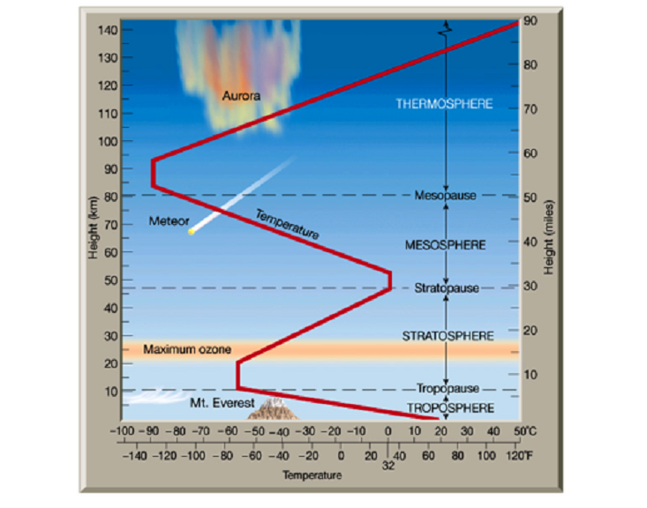
Figure 2.1 A diagram that shows the different layers of the earth’s atmosphere

Finally the region above mesopause (upper boundary of mesosphere) that extends from 95 to 500km is called thermosphere. The temperature in this layer first increase with height because of the existence of ionized plasma and then becomes constant.

2.2 Earth’s Ionosphere

The ionosphere, a part of the Earth’s upper atmosphere, contains partially ionized plasma that is continuously changing under the influence of extreme ultra violet (EUV) radiation, recombination, neutral winds and electric field (Rishbeth and Gariot, 1969). The ionosphere has sufficient electron content to support terrestrial communication up to high frequency (HF) and can disturb the trans-ionospheric communication (Dabas et al. 2006). It extends from a height of above 50 km and overlaps the ozonosphere to over 1000 km (Kelly, 1989). Ionospheric plasma is nonhomogenous, anisotropic, dispersive, weakly ionized, magnetized, cold and collisional. Peak electron densities in the ionosphere vary greatly with time (diurnal, seasonal and sunspot cycle), geographic location (polar, auroral zones, mid-latitudes and equatorial regions), and certain solar related ionospheric disturbances (McNamara, 1985).

2.2.1 Formation of Ionosphere

The main distinction between the ionospheric region and other regions of the atmosphere is that the former contains more charged particles (Kohl and Schleqel, 1996). The formation of the ionosphere depends on the activities of the Sun because the solar extreme ultraviolet EUV light
and X-ray radiation from the Sun are the main sources of plasma and energy for the ionosphere.
The process by which the EUV light and X-ray radiation from the Sun interact with neutral atoms giving rise to free electrons is called photoionization. Because of this process the ionosphere consists of free electrons and ions. The net value of the number of free ions and electrons in the ionosphere is determined by the rate at which specific species of ions combine with electrons to form neutral atoms. This process is known as recombination and it occurs in two stages (McNamara, 1991). The first stage is Radiation recombination and the second one is dissociative recombination. Radiative recombination is the process whereby electrons combine directly with positively charged ions converting them into neutral atoms and emitting a photon.

O⁺ + e− → O + photon
The dissociative recombination process occurs in two stages: In the first stage the positive ions
e.g. N⁺ which formed during the photoionization process interact with a neutral atom forming a
positively charged molecular ion.

N⁺ + O₂ → NO⁺+ O
In the second stage the electrons combine again with a positively charged ion (NO⁺) to produce two neutral atoms.

NO⁺ + e− → N + O
Dissociative recombination is a faster mechanism than radiative recombination to loose electrons from the ionosphere. During sunset the recombination process ceases, which results in a gradual drop in electron density as night progresses. Electron density is at its greatest during the middle of the day when photoionization is high. Because different gas atoms and molecules are more abundant in some regions of the neutral atmosphere than others, ionization and recombination of different species result in a different electron density distribution with in different layers of the ionosphere. These layers are called D, E and F are discussed in the next section.

2.2.2 Regions of ionosphere
Edward Appleton in 1927 discovered the existence of at least two separate ionized layers that he subsequently named E (for electric) and F (for field). The term ionosphere was introduced by Watson and Watt in 1929(Rishbeth and Gariot, 1969). Based on the electron density profile, the ionosphere is divided into D, E, F-regions which occupy the heights varying approximately from 70-90 km, 90-150 km, and 150-1000 or so km respectively. The F-layer is further divided into F1- (150-210 km) and F2- (over 210 km) layers during the daytime (Kelly, 1989). The typical electron density structure of day and night time ionosphere is shown in Figure 2.2.

2.2.2.1 D-region
This region is only present in the day and is the lower most layers extending from 70-90 km from the surface of the Earth. The quiet time D-region is produced by the photo-ionization of NO by the most penetrating Lyman α radiation at a wavelength of 121.5 nm. During active phase of solar activity with 50 or more sunspots, hard X-rays with wavelength < 1 nm ionizes the air (N2, O2). During the nighttime cosmic rays produce ionization and the electron density of this region varies from 10⁸ -10⁹m⁻³. High energy electron precipitation is a source of D-region ionization in the auroral region.

High frequencies (HF = 3-30 MHz) pass through this layer, while the low frequency waves (LF = 30-300 kHz) are absorbed by this layer. The absorption is due to the layer being weakly ionized and having a very high ion-neutral collision frequency (Riberio,2011). Extremely low frequency (ELF = 3 Hz-3 kHz) and very low frequency (VLF = 3-30 kHz) are reflected and also partially absorbed by the D-region.

2.2.2.2 E-region
The signals above 10 MHz as it partially absorb these waves. The E-region extends from 90-150 km and undergoes a large day to-night variations. This has daytime electron density of about 10¹¹m⁻³. The E-region remains throughout the night with decreased electron density of about 5 × 10⁹m⁻³. The most extensively found positive ions in this region are O₂⁺and NO⁺ that are produced by the X-rays with wavelength of 1-10 nm and the UV radiation. In this region strong electric currents are generated by the dynamo effect Ratcliffe (1972). It reflects radio waves with frequencies less than about 10 MHz and deteriorates.

2.2.2.3 F-region

Above the E-region lies the F-region. The plasma density in the F region increases with altitude up to about 300 km and then decreases. The electron density in this region is in order of 10¹²m⁻³ in F-peak. The F-region splits into F1- and F2-regions during the daytime. The F-region plays a vital role in the High frequency (HF) communications since it contains the largest concentration of electrons. The dominant ion is O+. At daytime the F1-layer is able to reflect radio waves up to wavelengths of about 30 m. The F2-layer is characterized by having large electron density with a maximum approximately at 300-400 km altitude. Therefore, F-layer engenders the largest effect on trans-ionospheric communications.
However, a few hours after the sunset, the F1-region becomes very much depleted and the F1- and F2-layers merge to form the F-layer in the nighttime. This condition of high density plasma on top of low density plasma is very unsteady and if the equilibrium is disturbed, then irregularities are generated.
In addition to the variation of the plasma density with altitude, the ionosphere also shows significant variations with time of day, latitude, longitude, season, solar activity, and geomagnetic activity. A distinctive latitudinal variation in the ionosphere is created owing to the geometry of the Earth's dipolar magnetic field lines. The ionosphere, therefore, is classified into three latitude regions, low-latitude or equatorial region (< 20° magnetic latitude), mid-latitude zone (20 - 55°), and high-latitude (auroral) regions (55 - 90°). These regions are controlled by different physical processes and thus considerable different ionospheric conditions exist in these regions. In the following sections, the discussion will be limited to the low latitude ionosphere, since my thesis focuses on this region only.

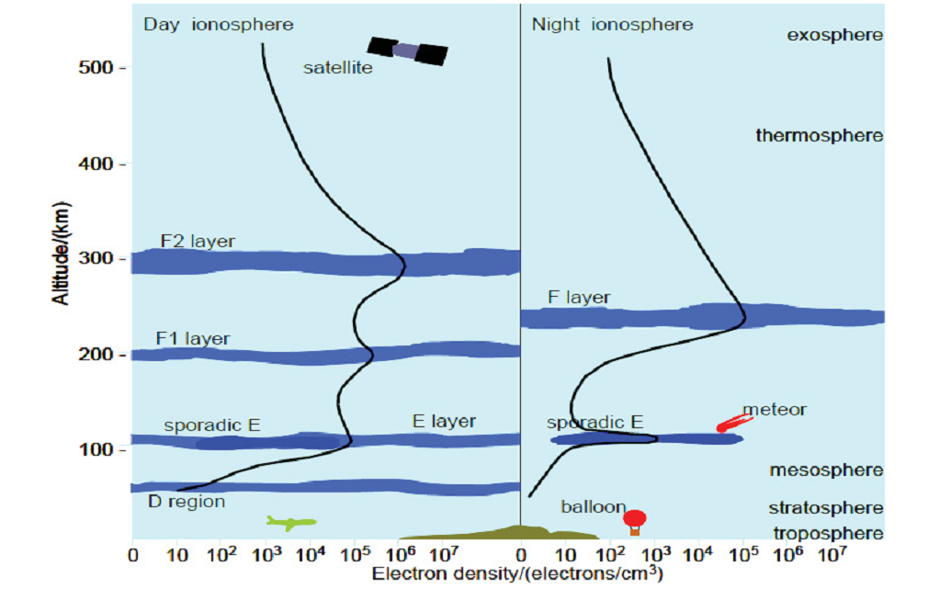

Figure 2.2 : Day and night structure of the ionosphere [Australian Space Weather Agency, 2011]

2.2.3 Equatorial Ionosphere

The equatorial ionosphere is unique in its characteristics since the geomagnetic field is horizontal over it. A number of fascinating phenomena; Equatorial Electrojet (EEJ), Equatorial Spread F (ESF), Equatorial Sporadic E and the Equatorial Ionization Anomaly (EIA) arise in this region.
The equatorial ionospheric electric field E is eastward during the day and westward during the night. Since the geomagnetic field B is northward and horizontal, it gives rise to an E×B drift which is upwards during the day and downwards during night. The upward drift drives the plasma across the magnetic field lines to higher altitude. This physical mechanism is called the “fountain effect” as shown in Figure 2.3. The transfer of plasma takes place from equatorial region to higher latitudes Heredia and Elias (2004) giving rise to the EIA or ‘‘Appleton anomaly’’ (Belly and Alcayde, 2007). This plasma then diffuses downwards along the magnetic field lines under the influence of gravity and pressure gradient forces resulting in ionization enhancements on both sides of the magnetic equator at about ±15° to ±20° in the geomagnetic latitude (Klobuchar 1991). It has often been found that an asymmetry exists between the northern and southern anomaly. Due to an inter-hemispheric wind blowing from the summer to the winter hemisphere, plasma moves upward along the geomagnetic field lines in the summer hemisphere, while plasma moves downward in the winter hemisphere. Therefore, the transport of the lifted plasma toward the winter hemisphere is enhanced, and the plasma transport towards the summer hemisphere is decreased. As a result, the equatorial anomaly in the winter hemisphere is generally larger than in the summer hemisphere (Bhuyan and Bhuyan, 2007 and Hawlitschka, 2009).

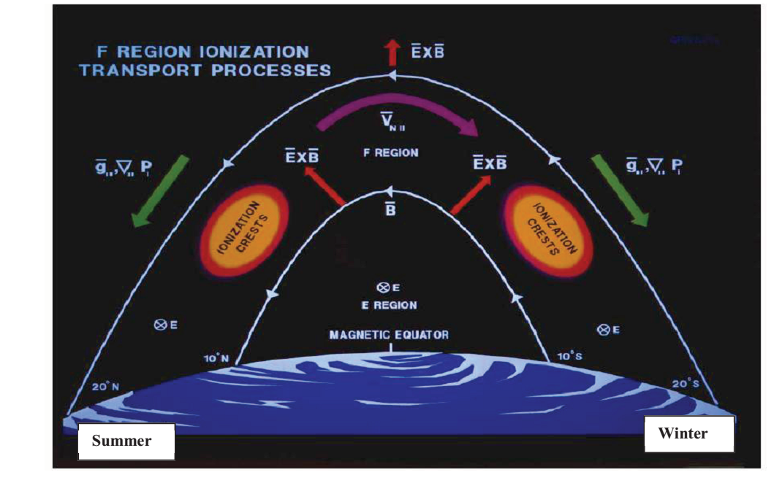
Figure 2. 3: The fountain effect and formation of equatorial anomaly. Reproduced from Groves [2004].

During the night, the electric field is westward and the E×B drift is downward. However, just before this electric field reversal takes place, the upward drift rapidly increases, pushing the F-layer to higher latitudes. This large upward drift is opposed to the gravity and combined with other factors creates a very unstable configuration (Kelly, 2009) which is referred to as pre-reversal enhancement (PRE). During the daytime, the F-region dynamo fields driven by the F-region winds get short circuited. However, near sunset the conductivity decreases suddenly and sets up a large polarization field in the F-region which results from field-aligned currents between the E- and F-regions (Oyekola, 2007). Consequently, this F-region dynamo field induces rapid pre-reversal enhancement in the anomaly gradients. The PRE has been observed during 19:00-22:00 LT and the morning reversal occurs between 05:00-06:00 LT (Ramarao et al.2006b; Oyekola 2007 and Fejer et al. 2008). This morning reversal is conducive for the generation of Equatorial Spread-F (ESF) (Ramarao et al. 2006a).

In addition, the production of ions ceases after sunset and the conduction of the lower ionosphere decreases dramatically, thus in the bottom side of the F-layer, an unstable configuration is created. This triggers the production of “plasma bubbles” Sekar and Chakrabarty (2008) which are regions of large electron density depletions in the equatorial ionosphere (Zalesak, 1983). The development of the plasma bubbles begins on the bottom-side of the ionospheres which buoyantly rise and eventually penetrate to the topside of the ionosphere. These irregularities known as ESF are generated through the collisional Rayleigh-Taylor mechanism driven by gravity (Zalesak, 1983). Through the Generalized Rayleigh-Taylor instability (GRT) mechanism, the bubbles with depleted plasma density are uplifted to higher altitudes and at the same time small scale irregularities grow on large scale gradients in plasma bubbles through secondary instabilities. As the plasma-depleted bubble rises from the bottom-side of the F-layer, they get elongated along the field lines to off equatorial latitudes and extend up to a north-south dimension of the order of 2000 km (Zalesak 1983 and RamaRao et al. 2006a).
When these plasma bubbles come into line-of-sight between the receiver and the satellite, the radio frequency propagating through this undergo the highest disruptive levels of scintillation, both in amplitude and phase levels (Ramarao et al. 2006b).
The ionosphere is highly dynamic and dependent on the input energy from the Sun. It has great temporal variability ranging from minute (during geomagnetic storms) to 11 years solar cycle and remarkable spatial variability that depends on the geometry of the Earth’s magnetic field (Klobuchar, 1991). In addition to this, ionospheric plasma irregularities drifting in front of the satellite radio signals, scintillate the radio wave signals and causes unevenness of the signals at the receiver end. Therefore, the behavior of the ionosphere under different geophysical conditions at different geographical locations needs to be understood carefully. The present study is centered on the behavior of the ionosphere and irregularity during conditions of night.

2.2.4 Ionospheric Irregularities
The ionospheric plasma as discussed earlier is non-homogenous, dynamic, and in continuous motion as a result of neutral winds and electric field. In addition, the plasma in space is also not in its thermo-equilibrium state, so in order to come to a true equilibrium, the plasma needs to shed some of its energy to some wave modes. In doing so, the amplitude of the plasma grows with time and this growing plasma wave is called an unstable mode. In other words, the plasma instability is a process whereby the free energy of the plasma gets converted into a growing mode in a collective way (Bagiya, 2010). These instabilities create fluctuations and structures in the plasma density which is known as irregularity (Guzdar et al. 1981). The irregularities are found at all latitudes of the globe with scale sizes varying from centimeters to kilometers. The ionospheric irregularities have been clustered into E-and F-region instabilities or irregularities.

2.2.4.1 E-region irregularities
The E-region irregularities are commonly known as Sporadic E layer or Es. The Es is characterized by a thin reflecting layer in the ionosphere which comes and goes sporadically at E-region altitudes of 100-120 km where the ion motion is controlled mainly by collisions with neutrals (Bhattacharya, 1991). Es usually consists of metallic ions. Weaker forms of Es consist of cloud of ionization and the most intense forms consist of a thin sheet of ionization some tens or hundreds of meters in thickness which can vary from 0.5-5 km and the horizontal extent can vary from 10-1000 km (Wu et al. 2005). Es is observed on ionograms as an echo at constant height which extends to a higher frequency than usual critical frequency of the E-region.
The Es is observed at all the latitudes, however, the strongest and more frequent layers occur at the mid-latitudes since the two ion convergence mechanisms (zonal wind shear and meridional wind shear) does not work efficiently at the magnetic equator and in the auroral zones. Es occurs through the mechanism of wind shear theory, whereby the East-West winds in the E-region causes a vertical movement, compressing the ions into thin layers of high density. The wind shear theory, proposed by Whitehead (1961) relies on the process of vertical shear in the horizontal wind which in the presence of Earth’s magnetic field forms a layer of ionization. As discussed earlier, the ionosphere over equatorial and low latitudes is very strongly influenced by the Earth's magnetic field. Usually, it is more useful to consider how the ionosphere varies with geomagnetic latitude or with dip angle of the Earth's magnetic field rather than within a geographic framework. Es formed in the equatorial region is known as the Equatorial Sporadic-E (Esq.).Esq has been found to be formed due to plasma instability caused by the high electron drift velocity associated with Equatorial Electrojet (EEJ) Rastogi (1972) and is present during both day and night even when the electron densities are greatly reduced. Generally, Es appears as patchy and mostly transparent region, while sometime it appears in sheet which can completely cover the overlying F-region.
Radar spectral studies have revealed two distinct types of irregularities; Type I and Type II. Type I occurs only when the electrojet current exceeds some minimum value. These irregularities travel with a phase velocity equal to the ion-acoustic speed and are thought to be generated by the excitation of the two stream instability. The Type I irregularities propagate perpendicular to the Earth’s magnetic field at the ion acoustic velocity (McDonald et al. 1974). Type II irregularities are generated by the gradient drift instability and are found to propagate smaller than the ion-acoustic speed (Rastogi, 1972). Type II irregularity also known as cross field or E×B instability because of cross E and B form the driving forces. These irregularities are practically always present both during the day and the night, even when type I irregularities are absent since, Type II irregularities emerge when the electron drift is insufficient to produce type I irregularities (Rastogi, 1972 and Bhattacharya, 1991).
During the daytime the large conductivity of the E-region prevents the growth of equatorial F-region of plasma instabilities by short-circuiting any perturbation electric field associated with plasma wave (Bhattacharya, 1991), however, soon after sunset, these F-region irregularities become visible.

2.2.4.2 F-region irregularities:
The other types of irregularities that have been of great scientific interest are the F-region irregularities. Plasma bubbles or plumes are the terms used to describe the F-region irregularities and were initially reported by Booker (1958). Since then a number of techniques have been used to study these irregularities, such as the topside and bottom-side ionosonde, radio-star scintillations, VHF-backscatter radar, Langmuir probes on board satellites and the GPS scintillations.

The F-region irregularities are associated with equatorial spread-F (ESF) and can be expected at all latitudes. Spread-F generally remains confined around the geomagnetic equator which is 20° on either side of the dip equator. Instabilities can occur in the post-sunset hours at the equatorial latitude of the F-region of the ionosphere (Fejer et al.1999 and Bhattacharya et al. 2006).
Equatorial spread F is instability observed originally by means of ionosondes or it is electron density irregularity region which is observed as diffuse echoes on ionograms (Jayachandran, 1997). Because the trace of F region instability in the ionogram is spread rather than a nicely behaving simple curve, it is called spread F. Spread F observed from ionosondes at Jicamarca Peru is shown below as an example.
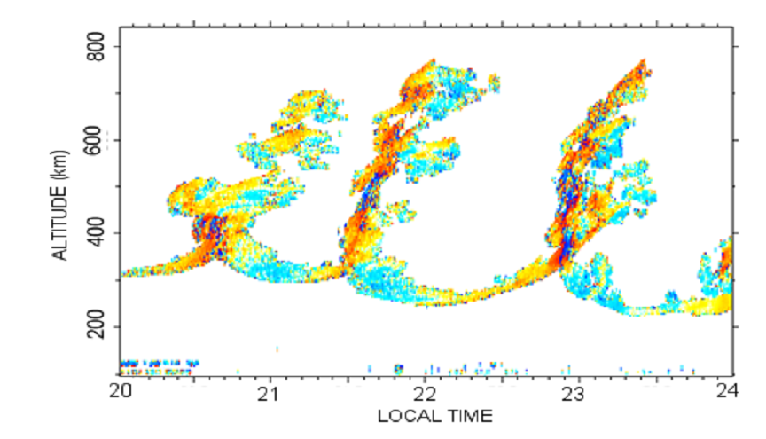
Figure 2. 4: A graph that shows electron density irregularities (spread F) observed from ionosondes at Jicamarca Peru.
It is now accepted that the ESF occurs at the bottom of the F-region due to the Gravitational Rayleigh-Taylor (GRT) instability. The idea of GRT as the physical mechanism for the growth of equatorial plasma bubbles (EPBs) Dungey (1956). The condition for GRT develops after sunset at the geomagnetic equator when the bottom-side of the F-layer recombines with the dense neutral atmosphere (Beer, 1974).
Woodman and LaHoz (1976) proposed that the ionospheric plumes (ESF echoes) measured by the Jicamarcaradar were caused by the plasma Rayleigh-Taylor instability. The numerical simulations of Scannapieco and Ossakow (1976) verified that the ionospheric plasma instability can indeed evolve into plasma bubbles. Sultan (1996) derived the linear growth rate of the Rayleigh-Taylor instability:
γ = $\frac{\sum_{P}^{F}{.}}{\sum_{P}^{E}{+ \sum_{P}^{F}{.}}}$ ($V_{P}$ -$U_{L}^{P}$ -$\frac{g_{e}}{ν_{eff}^{F}}$)$K^{F}$ - ${ R}_{T}$ (2.1)
Where $\sum_{P}^{E }{and}$ $\sum_{P}^{F}{ are}$ the flux tube integrated E and F region Pedersen conductivities, $V_{P}$ is the flux tube integrated plasma velocity perpendicular to the magnetic field, $U_{L}^{P}$ is neutral wind in the geomagnetic meridional plane, $g_{e}$is the effective gravity, $ν_{eff}^{F}$ is the effective F region collision frequency weighted by number density along the flux tube,$K^{F}$ is the F region flux tube electron content height gradient, and $R_{T}$ is the flux tube recombination rate.
As can be seen from Eq. (2.1), the vertical plasma drift contributes to the growth rate of the Rayleigh-Taylor instability through different processes. Besides the direct contribution by $V_{P}$, an upward plasma drift moves the F layer to higher altitudes and increases the growth rate by Causing a decrease in $ν_{eff}^{F}$and in${ R}_{T}$. Other two factors, the neutral wind and the ion-neutral collision frequency, also affect the growth rate of the instability. In Eq. (2.1), the term (−$g_{e}$/$ν_{eff}^{F}$) is positive because of the downward gravity.$K^{F}$ is positive in the bottom side F region and negative in the topside F region. If we do not consider the plasma drift velocity, neutral wind,
and recombination, the linear growth rate of the Rayleigh-Taylor instability is positive in the bottom side F region and negative in the topside F region. Farley et al.(1970) discussed the possible mechanisms for the generation of plasma irregularities in the equatorial topside F region and concluded that none of the linear theories of plasma instabilities (including the gravitational Rayleigh-Taylor instability) that had been put forward to explain the occurrence of ESF could explain the observations. The Rayleigh-Taylor instability must evolve into the nonlinear regime to reach the topside F region, as illustrated by (Woodman and LaHoz, 1976) and simulated by (Scannapieco and Ossakow, 1976).
The Rayleigh-Taylor instability must be initiated in the bottom side F region by some perturbations in the ionosphere or thermosphere before it grows into plasma bubbles or topside ESF irregularities. Two types of seeding perturbations have been proposed. One is atmospheric
gravity wave, and the other is large-scale wave structure, a structure in the ionospheric plasma density. Shear flow in the lower F region of the equatorial ionosphere could be the source of large-scale waves or Kelvin Helmholtz instabilities (Hysell and Kudeki 2004). In numerical simulations, the initial condition is often a perturbation in the plasma density, with an amplitude of 1–5% or a gravity wave. In the simulations of gravity wave seeding Huang and Kelley ( 1996a, 1996b); Krall et al. (2013), the only initial perturbation for the Rayleigh-Taylor instability is a gravity wave, the first-order perturbation in the neutral velocity, and no initial perturbation in the plasma density is required. The gravity wave is to seed the Rayleigh-Taylor instability but does not contribute to the linear growth rate of the instability.
Simultaneously, the pre-reversal enhancement raises the F-region to higher altitude. As a result a sharp vertical gradient in electron density exists. This condition of high density plasma on top of low density plasma is very unstable (Guzdar et al. 1981). Using the analogy of fluid dynamics, it could be modeled by having a less dense fluid supporting a high density fluid, on top, against the gravity. In here, it is the high density F-region (representing the heavy fluid) supported on the lesser dense one by the magnetic field. As this equilibrium is disturbed, the gravitational energy stored in the higher F-region is liberated and the F-layer plunges in.
This electron density irregularity (Spread F) is divided into range spread F (RSF) and frequency spread F (FSF). Spread F is called Range spread when it exists at different altitudes at the same latitude and it is called frequency spread when spread F having different electron density exists at the same altitude and latitude. In equatorial region because of fountain effect RSF is dominant. At high latitudes where no Appleton anomaly is observed, FSF is dominant.
Let us see another way of the formation of plasma irregularity in figure 2.5. As we have said that after the plasma is moved to high altitude at post-sunset due to prereversal enhancement electric field high plasma density lies on top of low dense plasma.
Because the plasma density in the upper region is extremely high with respect to the bottom side region, the bottom region can be considered as vacuum. The bottom side of the night time F region is acted up on by the downward gravitational force and magnetic field which is horizontal in equatorial region (into the picture). As plasma moves down due to gravity, the combined effect of gravity and magnetic field causes positive and negative charges to separate inducing an electric field. Then this electric field creates a downward E × B drift. This forms irregular regions in the upper dense plasma region.
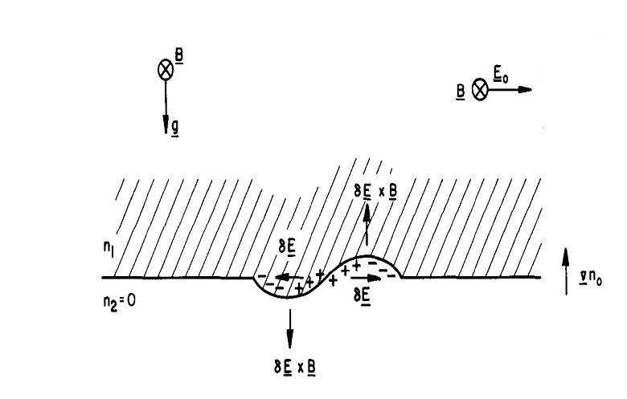

Figure 2. 5: Schematic diagram used to show irregularity formation with some modification.

Consequently, a lump of the low density layer rises causing density irregularities known as equatorial plasma bubbles (EPBs) (Singh et al. 1997 and DasGupta et al. 2006). The growth rate of the GRT instability depends on the density gradient. The gradient becomes steeper after sunset. The EPBs are generated after sunset at the magnetic equator. Due to GRT instability, the EPBs rise to higher altitudes and then travel to higher latitudes due to non-linear evolution of the E×B drift (Guzdar et al. 1981; Fejer et al. 1999 and Unnikrishnan and Ravindran 2010).
Parameters like background electron density gradients, electric fields, zonal winds and vertical winds play a very important role in the growth of GRT instability (Chen et al. 1983). When fully grown these irregularities contain a wide range of scale sizes which have been detected by ground based radio sounders, night airglow measurements, satellite measurements and backscatter radar echoes. Studies have shown that ESF occurs more often in the equatorial region (Beer, 1974; Davies, 1980; Singh et al., 1997; Sastri, 1998; Basu, 2002) which appears to be closely related to the increase in the height of the F-layer at the low latitudes Fejer et al. 1999) and Beaujardiere et al. 2004).
Ionospheric irregularities have also been classified into different categories according to their scale sizes; Planetary (> 1000 km), Medium Scale (10-100 km), Intermediate Scale (0.1-10km), Transitional Scale (10-100 m), and the Short Wavelength Scale (< 10 m) (Livingston et al. 1981). The tendency of these irregularities to interfere with trans-ionospheric communication is quite high. Plasma irregularities cause rapid fluctuations known as scintillations in phase and hence amplitude of signals passing through the ionosphere. Daytime random scintillations occur due to Sporadic E-layer and the night-time predominantly due to the ESF in the low and equatorial latitudes.

2.2.5 Geographic Regions of the Ionosphere
As explained earlier, solar radiation dominates in the formation of the ionosphere. Consequently, the plasma parameters (the electron densities in particular) in the Earth’s ionosphere display a marked variation with latitude, longitude, altitude, universal time, season, solar cycle, and magnetic activity. This variation results not only from the coupling, time delays, and feedback mechanisms that operate in the ionosphere-thermosphere system, but also from the ionosphere’s coupling to the other regions in the solar-terrestrial system, including the Sun, the interplanetary medium, the magnetosphere, and the mesosphere. With respect to latitude the global ionosphere has three major regions. These are the high-latitude, mid-latitude and equatorial regions as shown in Fig. 2.6. In this section we will see the peculiar characteristics of each region.

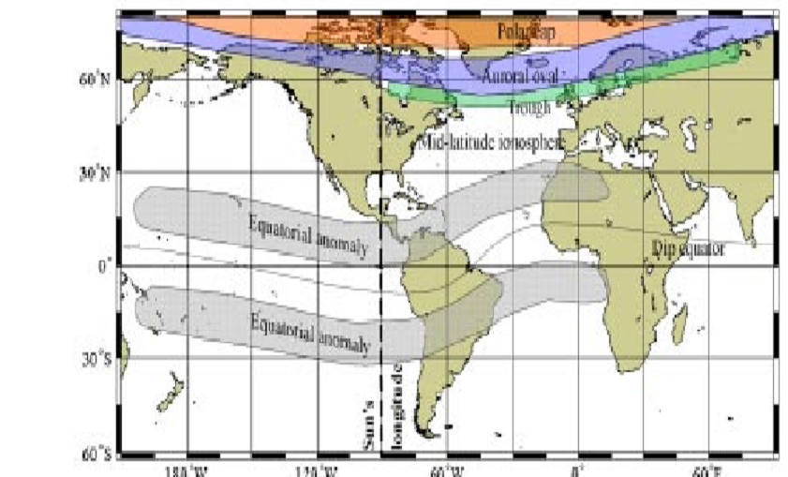

Figure 2. 6: Major geographic regions of the ionosphere (from Attila Komjathy, 1997).

2.2.5.1 Low Latitude Region
This region of the ionosphere is also called the equatorial region and is characterized with the highest values of peak-electron density with the most pronounced amplitude and phase scintillation effects. It usually occurs in the region between 20° S and 20° N in geomagnetic latitude. The Equatorial region is strongly influenced by electromagnetic forces that arise because the geomagnetic field runs horizontally over the magnetic equator. Consequently, this region is characterized by effects like equatorial electrojet which is a narrow ribbon current flowing eastward in the daytime region of Earth’s ionosphere. Another effect is fountain effect formed as a consequence of E × B upward plasma drifts associated with an eastward electric field E and a northward horizontal magnetic field B. The lifted plasma then diffuses downward along the geomagnetic field lines due to the gravitational force and the plasma pressure gradient, and these results in ionization enhancements on both sides of the magnetic equator. The electrons move as far as the geomagnetic latitudes of 10 to 20 degrees on both sides of the geomagnetic equator causing the high concentration of electrons there which are often termed equatorial anomalies, also often called the Appleton anomaly.

2.2.5.2 Middle Latitude Region

The middle-latitude ionosphere is known to be the best understood ionospheric region, largely due to relatively simple physics and reasonably good coverage of ionosphere sensing instruments. It is usually free of the effect imposed by the horizontal geomagnetic field geometry peculiar to the equatorial region.

2.2.5.3 High Latitude Region
In addition to photoionization, collisional ionization is another source of ionization in the high latitude region. This is because geomagnetic field lines are nearly vertical in high latitude region leading to the charged particles descending to E layer altitudes (about 100 km). These particles can collide with the neutral atmospheric gases causing local enhancements in the electron concentration, a phenomenon which is associated with auroral activity. Aurora is the most spectacular effect of the physical processes involved and is the visual manifestation of the interaction between the hot magnetospheric plasma and Earth’s upper atmosphere. The auroral zones are relatively narrow rings situated between the northern and southern geomagnetic latitudes of about 64 and 70 degrees. In general, the intensity and the positions of the auroral ovals are related to geomagnetic disturbances. The ovals expand towards the equator with increasing levels of geomagnetic disturbance.

2.2.6 Ionospheric Scintillation
As the radio wave traverses through the ionosphere the amplitude and phase suffer distortion when the signal encounters the ionospheric irregularities. This fluctuation in the radio wave is called scintillation and is similar to twinkling of stars due to non-homogenous nature of the troposphere. Scintillation occurs when the depleted ionospheric plasma (plasma bubble) also known as irregularities come into the line-of-sight between the satellite and receiver (Aarons and Basu (1985) and Bhattacharyya et al. 2006). These irregularities develop phase fluctuations across the wave front. When the wave emerges out of the irregularity and propagates towards the ground receiver, phase mixing or interference occurs, as a result, both phase and amplitude fluctuations are observed.
The ionosphere produces significant scintillations on the L1 signal transmitted from GPS satellites and may degrade the GPS performance (Thomas et al. 2001).Scintillations can infuse GPS ranging error and if very strong scintillation events crop up then the receiver can experience loss-of-lock as shown in Figure 2.7. Hanslmeier (2004) suggested that the stronger the scintillation the greater is the impact on the communication and navigation systems.
The scintillation measurements have been used as a fundamental tool in analysis of ionospheric irregularities. Scintillation data is imperative in determining the spatial and temporal distribution of ionospheric irregularities as well as in studying the physical processes which lead to the formation of irregularities. In addition, scintillation characteristics can also be used to study the performance and the level of degradation of the radar system and the trans-ionospheric communication links Basu and Basu (1989).
Figure 2. 7: schematic diagram of ionospheric scintillation and its effects on satellite signals . Signals emerge irregular regions at different phases and interfere at the antenna.

The occurrence of scintillations depends upon local time, season, solar cycle, latitude, longitude and geomagnetic activity, but the day-to-day randomness in the occurrence of scintillations makes their predictions still a challenging problem Van-Dierendonck and Rastburg (2005). The low latitude scintillation activity is basically a nighttime phenomenon with high occurrence during high solar activity Basu and Basu (1989). It is lucid that during high solar activity period, scintillations are intense with higher occurrence in auroral and equatorial regions. In mid-latitude region, scintillation is a rare phenomenon and occurs only in cases of extreme levels of ionospheric storms (Datta-Barua et al. 2003). During these ionospheric storms, the active aurora expands both pole-ward and equator-ward, exposing the mid-latitude region to scintillation activity.

2.2.7 Ionosphere Probing Techniques

2.2.7.1 Global Navigation Satellite System (GNSS)
The Global Positioning System (GPS) is a constellation of navigation satellites operated by US Department of Defense (DOD). GPS became operational since 1980 and consists of at least 24 operational satellites distributed in 6 orbital planes with 4 satellites per plane. The satellites are placed at an altitude of 20,200 Km above the earth with 12 hrs orbital period and 550 orbital
inclinations. The time, velocity and position of GPS satellites are continuously monitored by ground based networked radars and up to 12 satellites are visible at a time. GPS satellites transmit their individual ephemeris on two carrier frequencies in the L-band for civilian users f1=1575.42 MHz (L1) and f2=1227.60 MHz (L2). Each GPS signal consists of three components namely carrier, code and navigation data. These three components of the signal are derived coherently from one of the frequencies of the atomic clocks aboard the satellite. The frequency of the atomic standards aboard a satellite is 10.23 MHz GPS signals like other electromagnetic waves are affected by the electrically charged ionized plasma in the upper Atmosphere. GNSS usually consists of three segments such as space segment, control segment and user segment.

2.2.7.1.1 Space Segment

The Space Segment consists currently of 32 GPS satellites (PRN: 1-11, 13-18, 20, 21 and 23-32) arranged in 6 orbital planes located at the altitude of 20,200 km inclined at 55° to the equator. The coverage provided by the GPS constellation which provides information for determining the position of the satellite, its distance from the user and satellite clock error, ensures a minimum of 4 satellites and maximum of 11 satellites visible at anytime, anywhere in the world. The orbital period of satellite is approximately 11 hr 58 min. Therefore a GPS satellite completes 2 revolutions in 23 hr 56 min as a result of this; the satellite appears over the same geographical location on the Earth’s surface every day. Figure 2.8: The three segments that make up the GPS.

2.2.7.1.2 Control Segment
Control segment is responsible for controlling the whole system including the deployment and maintenance of the system, tracking of the satellites in their orbits and the clock parameters
monitoring of auxiliary data and upload of the data message to the satellites. The control segment is also responsible for data encryption and service protection against unauthorized users. Moreover, tracking stations located around the world coordinate the activities for controlling and monitoring the system using bidirectional communication between these stations and GNSS satellites.
2.2.7.1.3 User Segment

User segment consists of GPS receivers able to decode received signals from satellites. GPS
receivers are hand-held radio-receivers/computers which measure the time that the radio signal
takes to travel from a GPS satellite until it arrives at the GPS antenna.

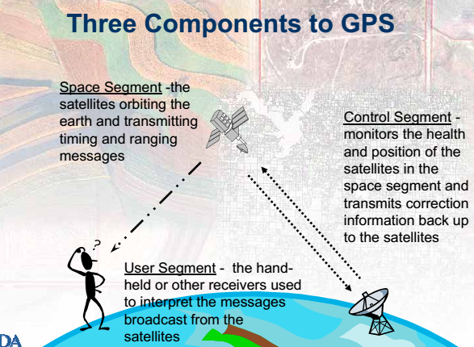
Figure 2.8: Ionospheric scintillation

CHAPTER THREE

3. Data and Methodology

3.1 Data Source
The scintillation Network and Decision Aid (SCINDA) is a network of ground based GPS (Global Positioning System) receivers that monitors scintillations at the UHF and L-band frequencies in the equatorial ionosphere. These networks of receivers are established by the US Air Force Research Laboratory (AFRL) and are monitored by this organization. Because the equatorial and low latitude region experiences the strongest global levels of scintillation, the receivers are positioned between the ionization crests of the Appleton anomaly. The data used in this study was obtained from a dual frequency GPS receiver installed over Bahir Dar, Ethiopia (geographic: 11.60°N, 37.38°E, and geomagnetic: 8.08°N, 111.57°E) and downloaded from UNAVCO website from http://facility.unavco.org/data/gnss/perm-sta.php and www.geo.mag/ models/ PPEFM/RealtimeEF.html.

3.2 Methodology
TEC data was being gathered from UNAVCO website. After the data has received from the source it has been calibrated by using the calibrator software called RENEX (Receiver Independent Exchange)-TEC. Then MATLAB code has been developed to importing the calibrated data. Finally by using MATLAB program data analysis has been done. Then, contour map is produced for each month to show the daily and universal time variation of irregularities.

3.2.1 Total Electron Content in the Ionosphere (TEC)
Total electron content (TEC) is a very important descriptive quantity for the ionosphere of the earth. It is the total number of electrons present along the path followed by a GPS signal from $satellite to receiver through the ionosphere. TEC is measured in TECU (1 TECU = 1 × {10}^{16}$ electrons per m²). The TEC as an indicator of ionospheric variability is measured from satellite radio signals observed at different angles. Usually the measured value of TEC being maximum in the early afternoon and it decays slowly due to recombination of electrons and ions at night and finally minimum just before sunrise.
All satellites in the GPS system broadcast on the same two L-band signals namely L1 (f1=1575.42MHz) and L2 (1227.60MHz) with a fundamental frequency f₀ = 10.23MHz (f1=154f_{0,} f2=120f₀). By measuring the group delay(D) and carrier phase advance imparted by the ionosphere on the two GPS carrier signals L1 and L2, the STEC(slant TEC), which is TEC encountered along the line of sight, can be calculated as follows.
ST EC =$\int_{R}^{S}{Neds}$ (3.1)
Where S and R stands for satellite and receiver respectively. Ne is the ionosphere electron density. In calculating the TEC the ionosphere is considered as a thin shell and the ionosphere pierce point (IPP), which is the point at which the signal from the satellite just inters ionosphere, is at 350km from the Earth’s surface. Ne at IPP is provided in terms of longitude, latitude and altitude. The phase of a radio signal is retarded by an amount proportional to TEC and inversely proportional to the radio frequency. The absolute value of the group and phase delay mathematically can be written as follows.
Iφ, g = $\frac{80.6}{2f 2}\int{Neds}$ =$\frac{40.3}{f2} TEC(m)$ (3.2)

Iφ, g = $\frac{80.6}{2f 2}\int{Neds}$ =$\frac{40.3}{cf2} TEC(s)$ (3.3)
Where Iφ,g represents the group and phase delay. A dual frequency GPS receiver measures the ionospheric delay between the L1 and L2 signal [52]. This can be written as
p₂ − p₁= 40.3T EC (1/f₂²-1/f₁²) (3.4)
Where p1 and p2 are the group lengths of L1 and L2. F1 and f2 are the corresponding frequencies. Rearranging this we get TEC as
TEC =$\frac{1}{40.3}$[f₁²f ₂²/f₁²-f₂² ] (p₂-p₁) (3.5)
STEC can be converted to vertical TEC (VTEC) by assuming the penetration point of the satellite signal with the ionosphere thin shell at a height of 350km (F2 –region peak).
V T EC = cos χ. (STEC) (3.6)
Where χ is the angle of incidence at 350km of the GPS ray path from satellite to ground receiver. An oblique factor cos χ is defined as
cos χ = $\sqrt{1-({\frac{R_{E}COS(e)}{R_{E+h_{m}}})}^{2}}$ (3.7)
Where RE is the radius of the earth, e is satellite elevation angle and hm is the ionosphere penetration height. Therefore the VTEC is now

V T EC = (ST EC. $\sqrt{1-({\frac{R_{E}COS(e)}{R_{E+h_{m}}})}^{2}}$ (3.8)

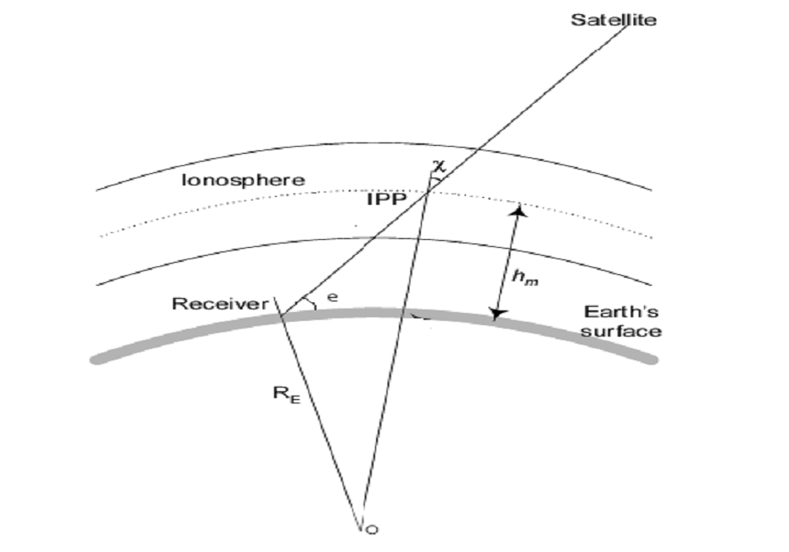
Figure 3. 1: schematic diagram of the ionosphere with the pierce point and line of sight from receiver to satellite. Source Schaer 1996 with some modification.

3.3 Data Analysis
In this study ground based GPS data from Bahir Dar station with horizontal wind and electric field models are used to investigate the effect of ionospheric irregularities by neutral wind and electric field in 2012.The neutral wind data is obtained from HWM14 which is the most comprehensive empirical specification available to date Drob et al.(2015). It has been developed using both space based and ground based data collected from instruments spanning over 60 years Drob et al.(2015). The model calculates meridional and zonal components of the wind for a set of geophysical locations: latitude, longitude, altitude magnetic activity and time. For our study we use both meridional and zonal wind data from this model for Bahir Dar station latitude and longitude ranging from 9 to 12 and 35 to 38 degrees respectively.
Early study by (Crane 1974) has shown that a strong correlation exists between scintillation occurrence and the formation of spread-F irregularities. However, the study indicated a very weak correlation of scintillations with sporadic-E and spread-E type irregularities. This implies that most of the scintillation occurrence is due to F-region irregularities which are found to be at altitudes between 250 and 650 km. (Basu and Basu 1989) found maximum occurrence of amplitude scintillations in the equatorial region. The equatorial scintillations are produced by equatorial plasma density depletions or bubbles caused by the Gravitational Rayleigh-Taylor (GRT) instabilities. GRT instabilities occur after sunset at the base of F-region and rise to higher altitudes due to non-linear evolution of E×B drift.
In this study amplitude scintillation measurements and analysis have been carried out for all the days of 2012 the data that we have and phase scintillation analysis has only been done in instances of strong amplitude scintillation events.

3.3.1 Scintillation data recording
The depth of amplitude scintillation is described by the S4 index. The raw S4 index is de-trended (by normalization) with the measurements averaged over 60 second intervals. This measurement is also done at the rate of 50 Hz as for TEC and then recorded at 60 second intervals. Measured S4 or the total S4 at L1 that is logged by the receiver has the effect of ambient noise and multipath effects. The S4 computation is done using the signal power, as given by the following equation, at one minute intervals.

$s_{4}$ =$\sqrt{\frac{〈I^{2}〉-{〈I〉}^{2}}{{〈I〉}^{2}}}$ (3.8)

CHAPTER FOUR

4. Result and Discussion

4.1 Introduction

In this study we examine the occurrence of ionospheric irregularities of different strengths at Bahir Dar data has been obtained from Bahir Dar GPS station (geographic latitude 11.6°N,longitude 37.4°E) by using GPS receiver for five month of the year,2012.As we have seen from above theoretically, equatorial spread F (ESF) is occurred after sunset about 19:00LT to 21:00LT.The results from the real data are shown below to describe the daily and monthly variation of ionospheric irregularity since 2012.This variation is determined by considering the effect of neutral wind and zonal electric field. The daily scintillation events were inspected and classified into three categories; weak (0.2 ≤ S4 < 0.3), moderate (0.3 ≤ S4 < 0.45) and strong (0.45 ≤ S4) events (RamaRao et al., 2006b). But I peaked up only days which are weak and strong scintillations are occurred.
Based on the result of neutral wind model and electric field model at different local times and longitudinal and latitudinal sectors, the models are employed to study the relative contributions of various physical processes to the occurrence of irregularities. In particular, the present work focuses on effects of horizontal neutral winds and electric fields.

4.1 Daily Variation of irregularity
To see how the irregularity activity varies from day to day, I peaked up some quite days from the data that I have.
In fig 4.1 the left side six plots represent the variation of irregularity with the effect of electric field on January 1, 18 and 19. The right side six plots (from top to down) are zonal and meridional wind components of these three days for latitude 11.6° and longitude 38° at an altitude of 400km of the individual days. The arrows show the direction of the wind (for zonal upward is east and downward is west and for meridional upward is north and downward is south) and the contours shows the strength of the wind as shown on the color bar. The positive on the color bar shows northward and eastward wind magnitude and the negative shows the magnitude of southward and westward wind for meridional and zonal respectively.
From scintillation and electric field plots (see fig. 4.1 left) we can see that on January 1 strong scintillation is seen on the day period around 6:00LT for the rest period weak scintillation values are observed but this irregularity is outliers that mean it maximized due to numerical taking system In this day the strength of electric field is minimum because its value is less than 0.5mV/m. When we see the plots of January 18 and January 19 around from 19:00LT to 24:00LT the scintillation is weak and on January 19 there is strong irregularity around 6:00LT and this irregularity is also outlier, but the strength of electric field is almost minimum. Then in these days also electric field is suppressed the irregularities, because the onset of these irregularities generally occurs far from the time of prereversal enhancement of the evening drift velocity when the F layer reaches its highest altitude and the growth rate of the Rayleigh-Taylor instability is maximum. For the neutral wind plots (see fig.4.1 right) we look the direction of neutral wind blowing for these three days at the time of when ionospheric irregularities occurred. Then for these three days from 17:00LT to 23:00LT zonal wind is blowing to eastward and for that of meridional wind at northern hemisphere and southern hemisphere blowing in different direction on these three days from 17:00LT to 21:00LT. That is the wind is equator ward at southern northern poles . This result shows the consequence of an ionospheric tilt are that the downward F region is moved in to the a region of higher dissociative recombination loss, thus increasing Rayleigh Taylor growth rate. So for these weak scintillation occurrence on January on these three days is due to small effect of neutral wind.

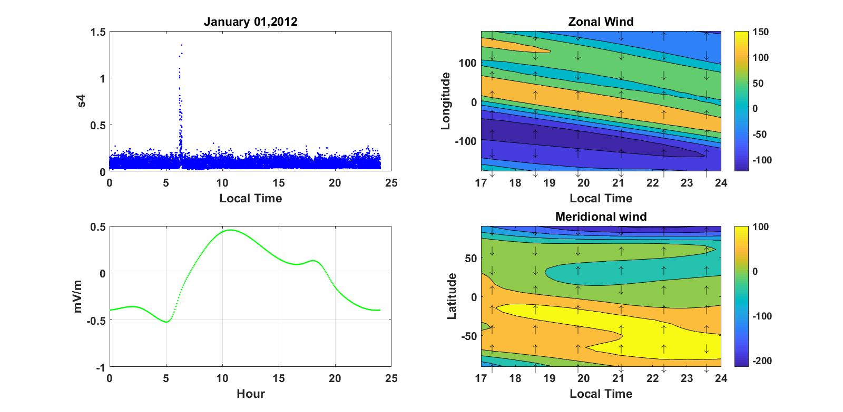
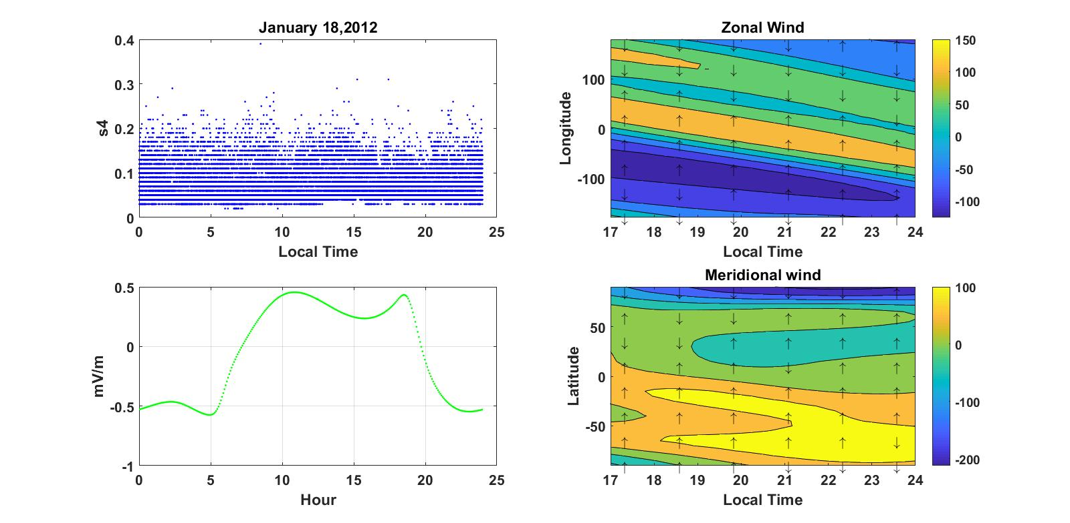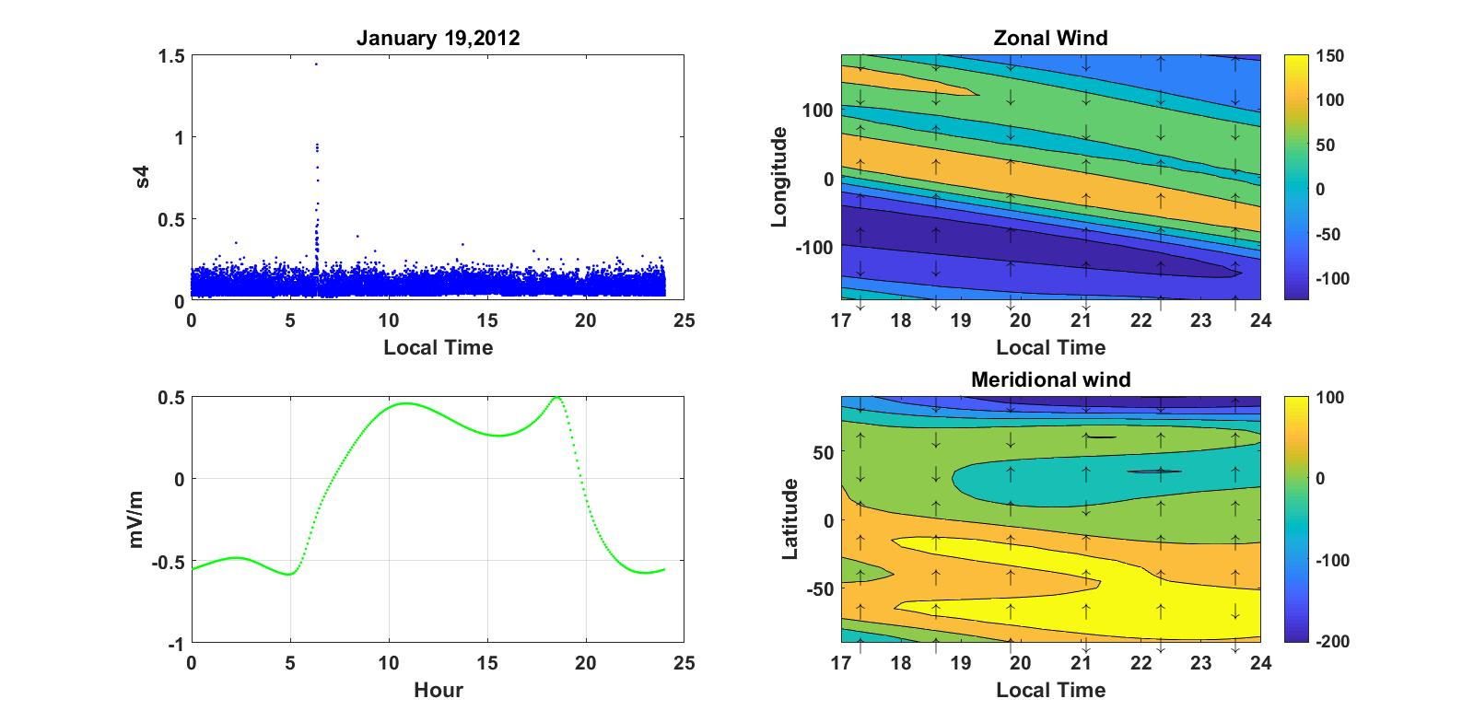Figure4. 1: The daily variation of irregularity on January 1, 18 and 19 of quite days.

Similarly in fig. 4.2 the left side plots show irregularity and electric field of the given three days. When we see the irregularity plot of these days for January 4 and 14 irregularity observed at 23:00-24:00LT with values around 0.4 and for January 8 irregularities observed at 20:00LT and having value around 0.7. But the value of electric field is seen around 19:00LT with magnitude around 0.4mV/m for each day. These results not proportional with the evening upward drift velocities on the generation of spread F and the evolution of the unstable layer can be strongly affected by the drift velocities also after their evening reversal. In addition to these, there is a data outage on January from 9:00LT to 10:00LT and irregularity is also occurred on January 8 at 8:00LT.
When we see the wind pattern of these days (see fig.4.2 right), the patter has clearly seen that zonal wind flows to westward from 20:00LT to 24:00LT and meridional wind blows from pole to equator from 17:00LT-20:00LT. This shows that the occurrence of these scintillations is due to the by zonal wind with greater magnitude and meridional wind in that local time.

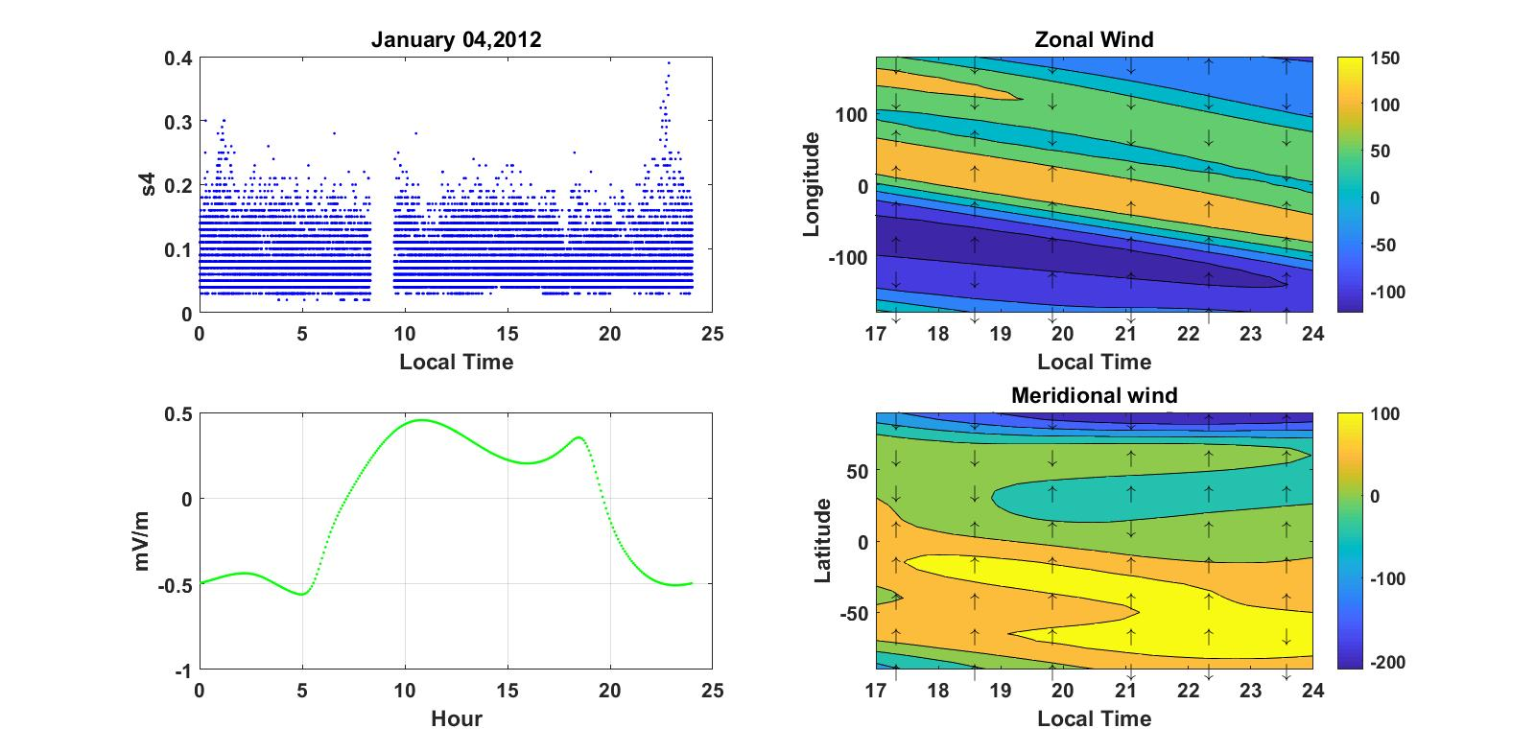
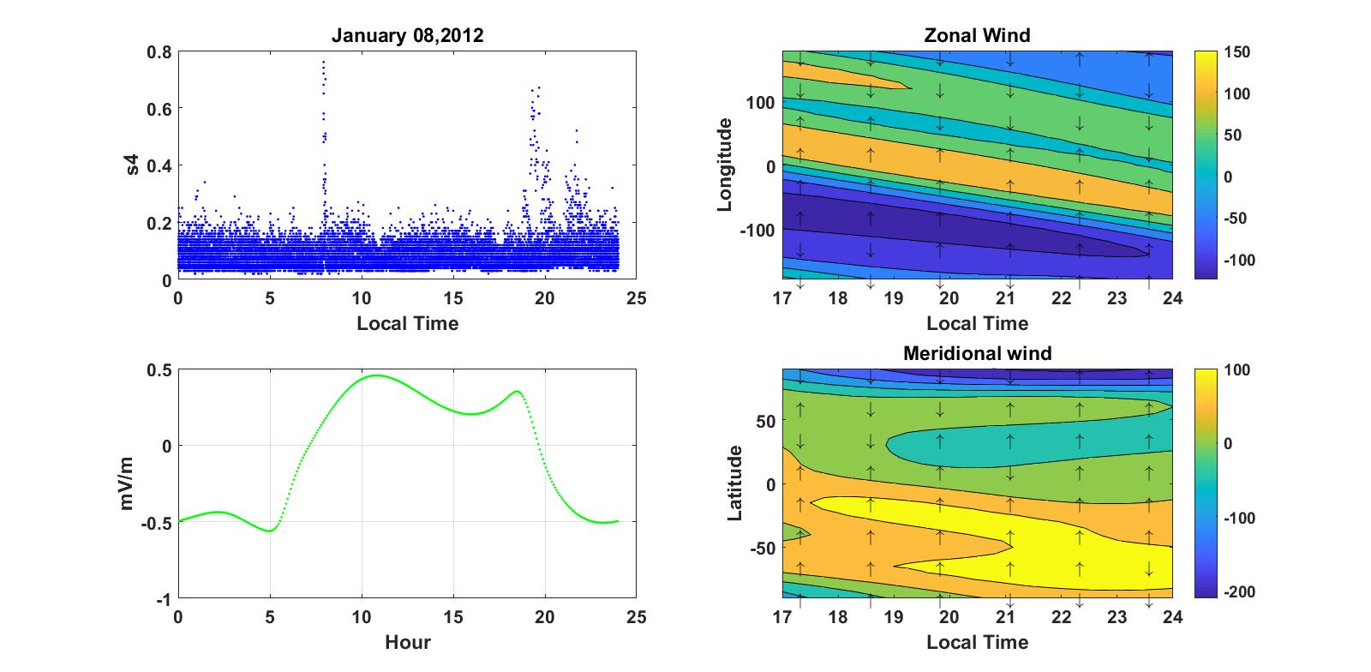
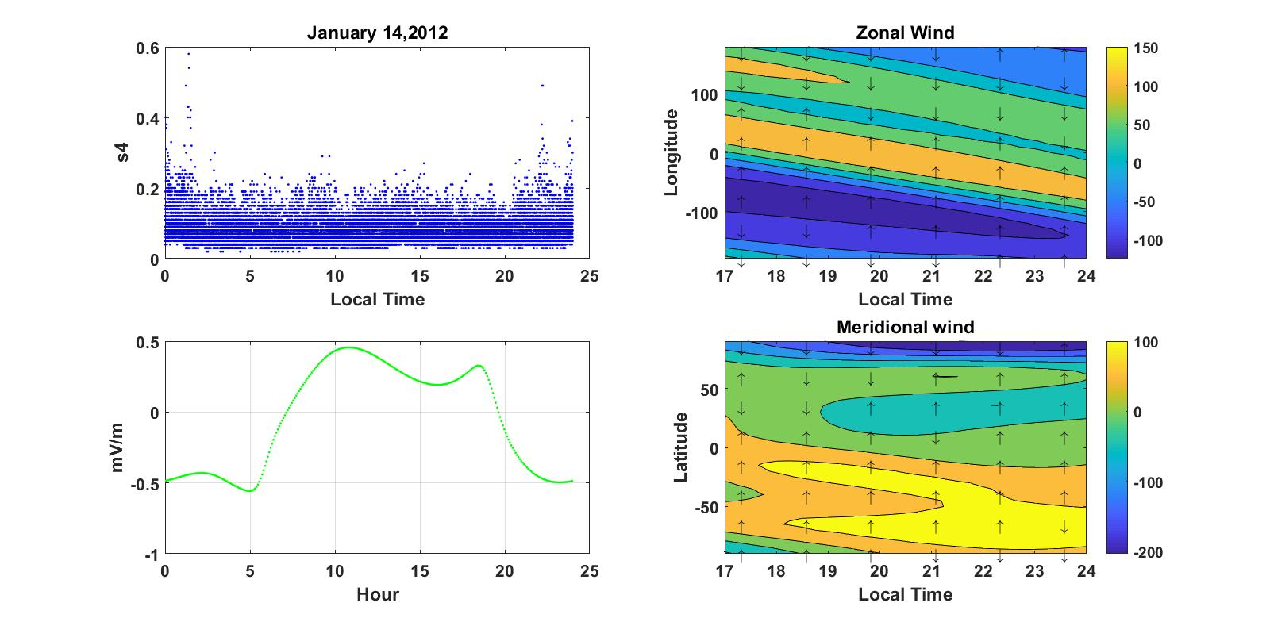
Figure4.2: The daily variation of irregularity on January 4, 8 and 14 of quite days.
In fig 4.3 also take similar path like that of fig 4.1 and fig 4.2. The scintillation pattern seen on March 3 (see fig 4.3 left) is almost weak with value around 0.25 and it is not similar with the rest of the two days scintillation pattern. Because the scintillation plots of March 25 and 26 are the same at the same time that is at 20:00 – 24:00 LT with scintillation value around 1. But at this time the scintillation plot on March 03 is weak. When we see the strength of electric field, they have almost the same magnitude that 0.5 on March 03 and 0.53 on March 20 and 23 at 18:00LT. For the neutral wind case at the time of irregularity occurrence (see fig.4.3 right), zonal wind blows towards west from 22:00LT to 24:00LT and the meridional wind blows to the equator from each poles from 17:00 to 21:00LT. Then, meridional winds have no distribution for the occurrence of irregularity on these three days. Therefore, both zonal electric field and neutral winds have role for the occurrence of irregularities on these days.
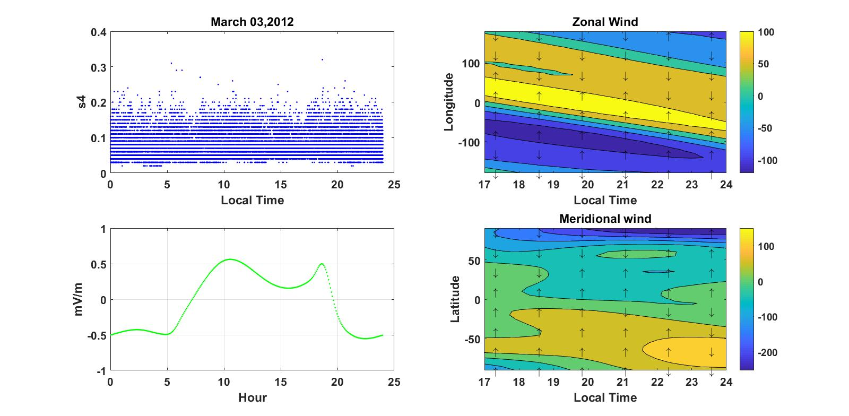
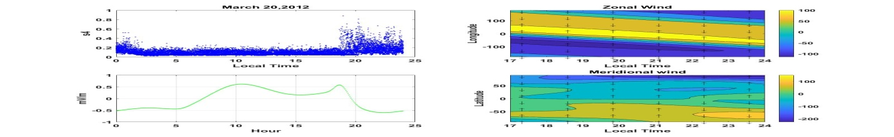
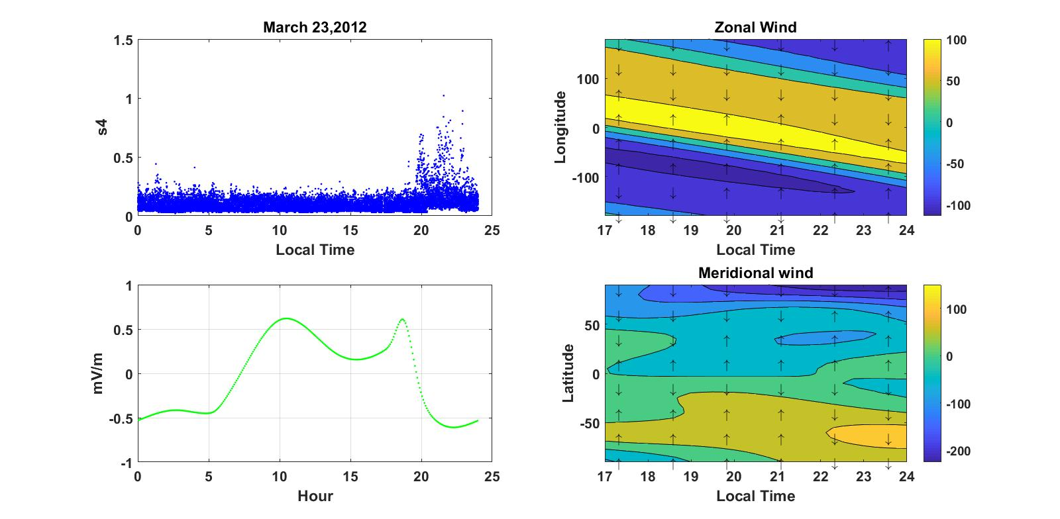
Figure 4.3: The daily variation of irregularity on March 03, 20 and 23 of quite days.
When we look scintillation value of the three days (see fig. 4.4 left) it is constantly weak from 2:00LT to about 19:00LT, but starting from 19:00LT up to about 24:00LT it increased up to 1.This increasing of scintillation is occurred during the post sunset hours where spread F usually observed. The magnitude electric field in these days is strong around 19:00LT with value of around 0.6 for each day. Then, We have a result that examined the relationship of the amplitudes of the peak prereversal velocity enhancements and the occurrence of weak and strong spread F echoes in the pre midnight sector.
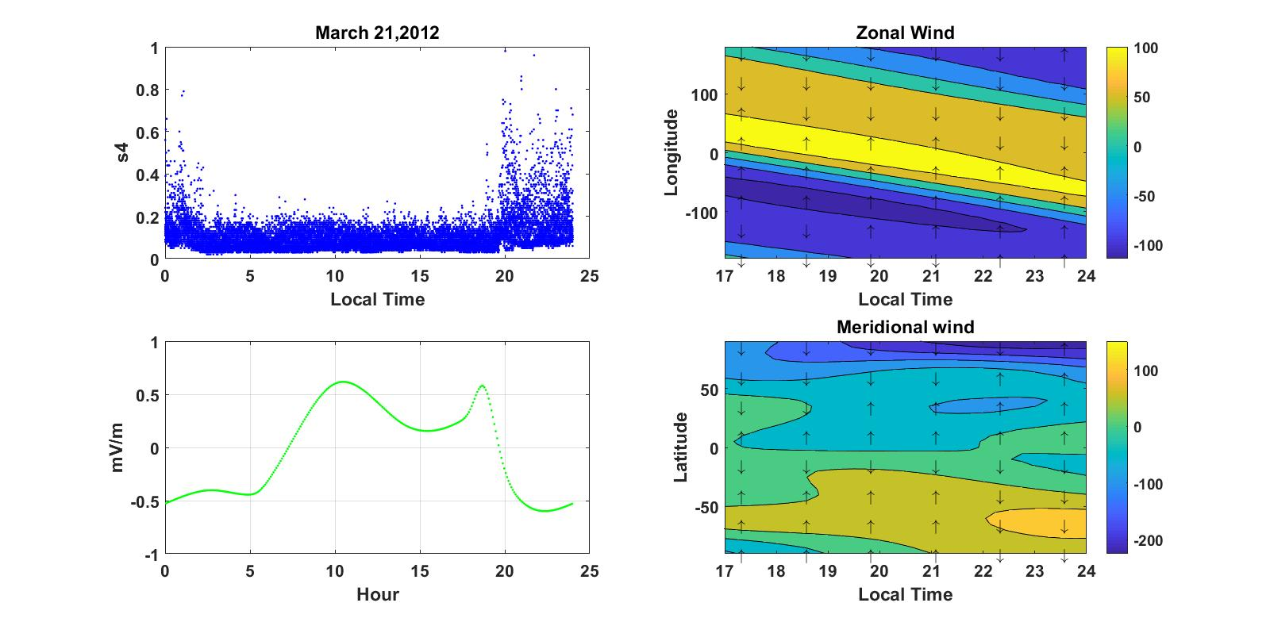
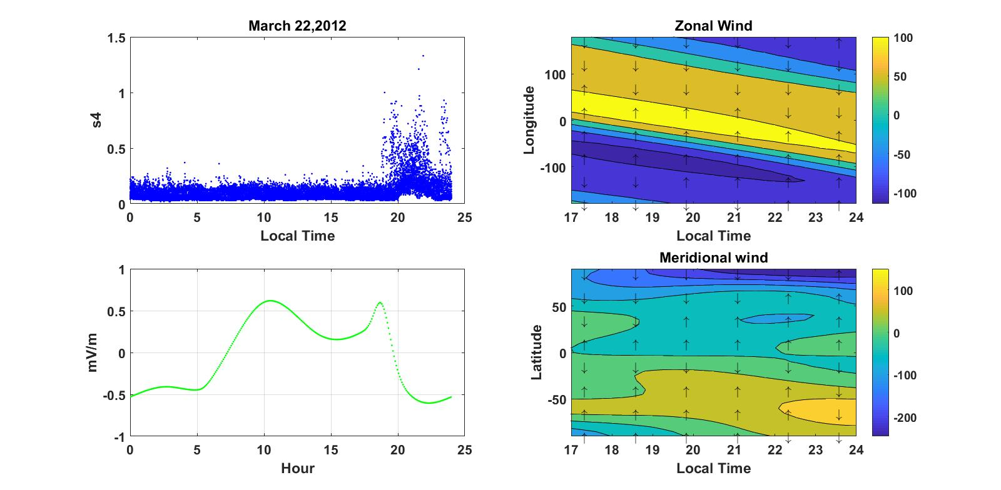
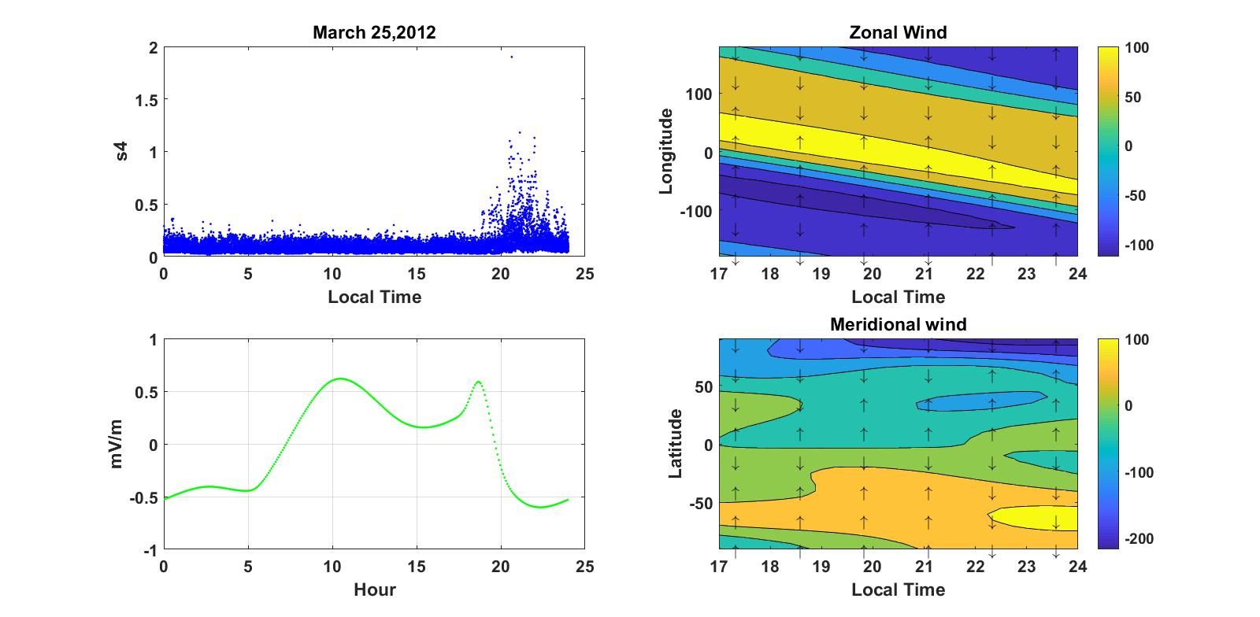
Figure 4.4:The daily variation of irregularity on March 21, 22 and 25 of quite days.
And when we see the neutral wind plots (see fig.4.4 right) the meridional wind flows from northern hemisphere and southern hemisphere to the equator and in some extent around 23:00LT and 24:00LT zonal wind blows westward. Then on these days irregularities are triggered by zonal electric field and meridional winds.
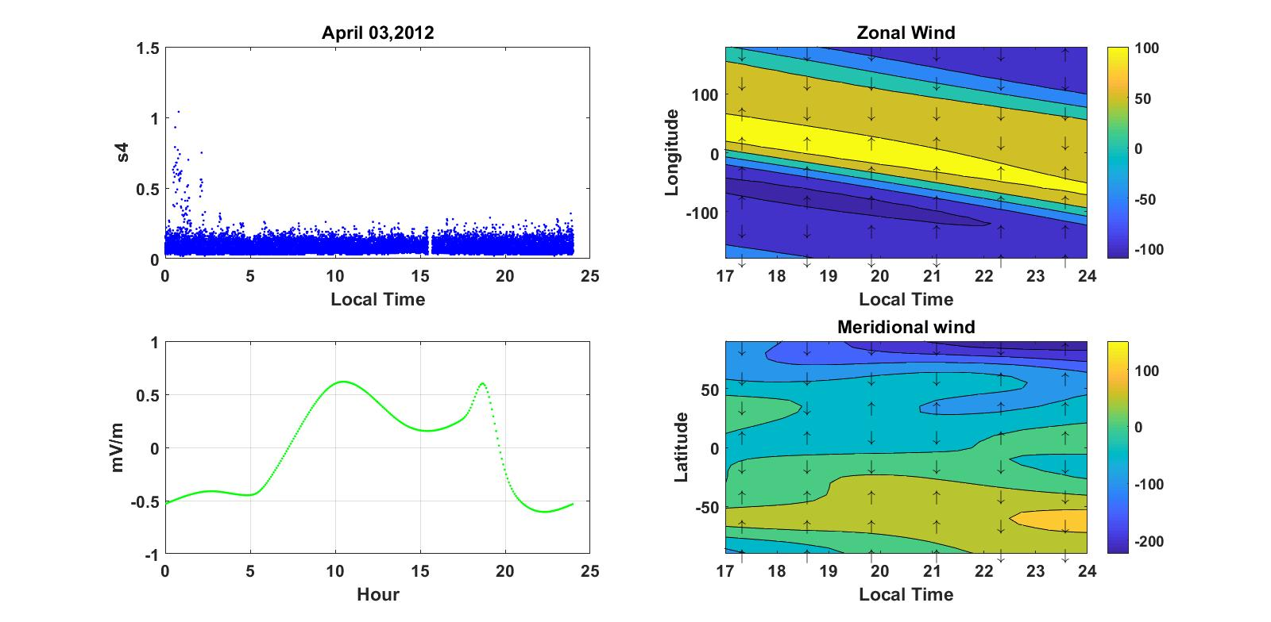
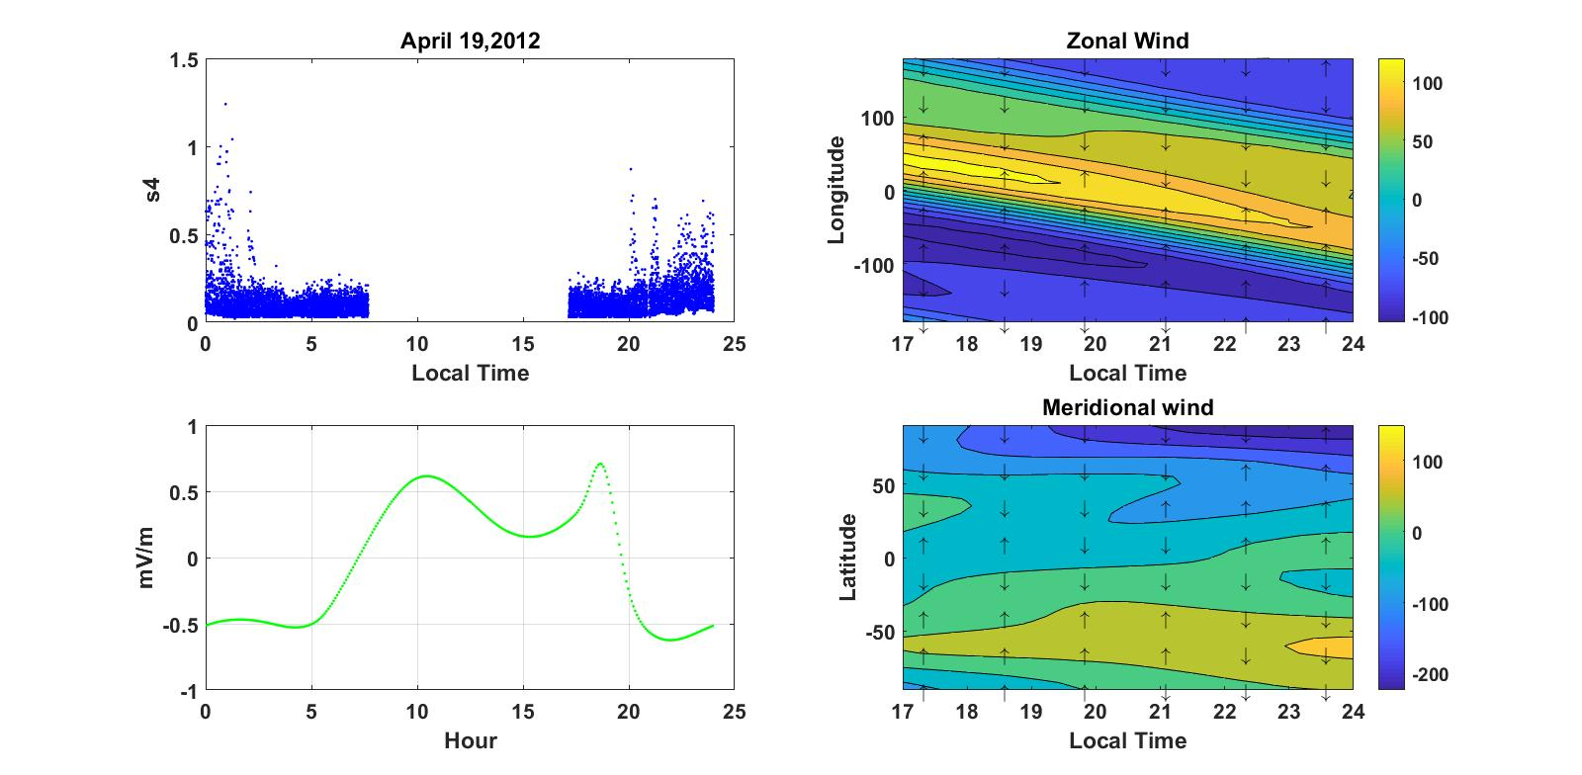
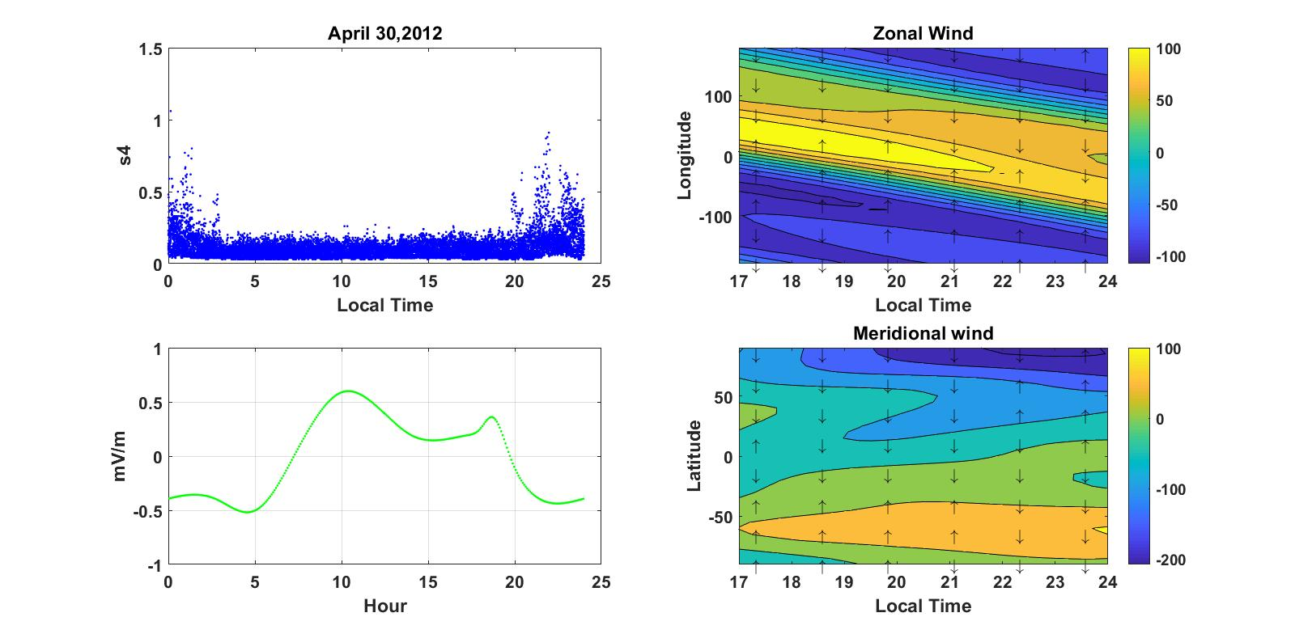
Figure 4.5: The daily variation of irregularity on April 03, 19 and 30 of quite days.
When we see irregularity values from left side plots of fig.4.5, we observe on April 3 the value of irregularity is weak from around 3:00LT to 24:00LT and on April 19 and 30 they have weak scintillation values from 3:00LT up to 20:00LT, after 20:00LT, it increases up to 1. This increment is also shows the occurrence of irregularities is during the post sunset hours where spread F is usually seed. The value of electric field (see fig.4.5 left) maximum about 19:00LT with values around 0.6mV/m on April 3 and 19. There is data outage on April 19 from 6:00LT to 17:00LT and the field strength on April 30 around 0.4mV/m. Then, our result on these days represents the occurrence of ionospheric irregularities without an expected value of zonal electric field. When we look the plots of neutral wind (see fig.4.5 right) the meridional wind blows to the equator from southern hemisphere and northern from 17:00LT to 20:00LT and zonal wind flow in the westward direction around from 23:00LT to 24:00LT. So on these three days the occurrence of irregularities affected by both zonal electric field and mostly by neutral winds.
As seen the irregularity plots (see fig.4.6 left) we have seen that strong scintillation values are observed from 20:00LT to 24:00LT with values around 1. But the values from around 3:00LT to 20:00TL shows weak scintillation and on April 15 around from 14:00LT to 15:00LT and from 16:00LT to17:00LT, there is data outage. When we see electric field plots on these quite days have strong electric field around 19:00LT.This result showed that the prereversal velocity enhancement constitutes an important seeding mechanism for the generation of F region irregularities. And when we look the direction of zonal wind and meridional wind (see fig. 4.6 right) zonal wind blowing towards west around 24:00LT and meridional wind blows to the equator from northern hemisphere from 17:00LT to 24:00LT and southern hemisphere from 17:00LT to 20:00LT.Therefore, on these days most of the time irregularities are suppressed by zonal wind and triggered by meridional wind. So, on April month at Bahir dar station in 2012 there is an event that weak and when electric field is greater than 0.5mV/m between 17 and 19LT, the s4 index found to be strong. Not only these but also zonal electric field strength almost strong on April month.

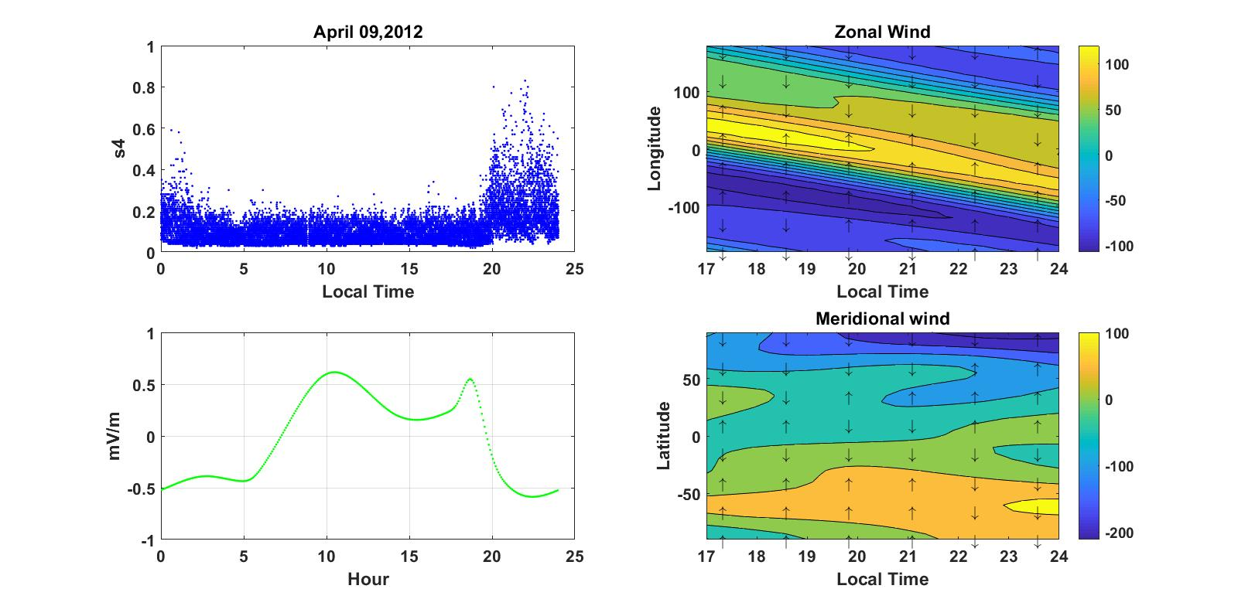
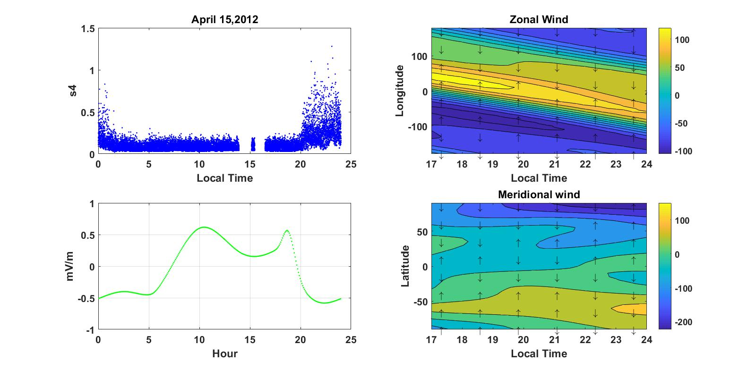
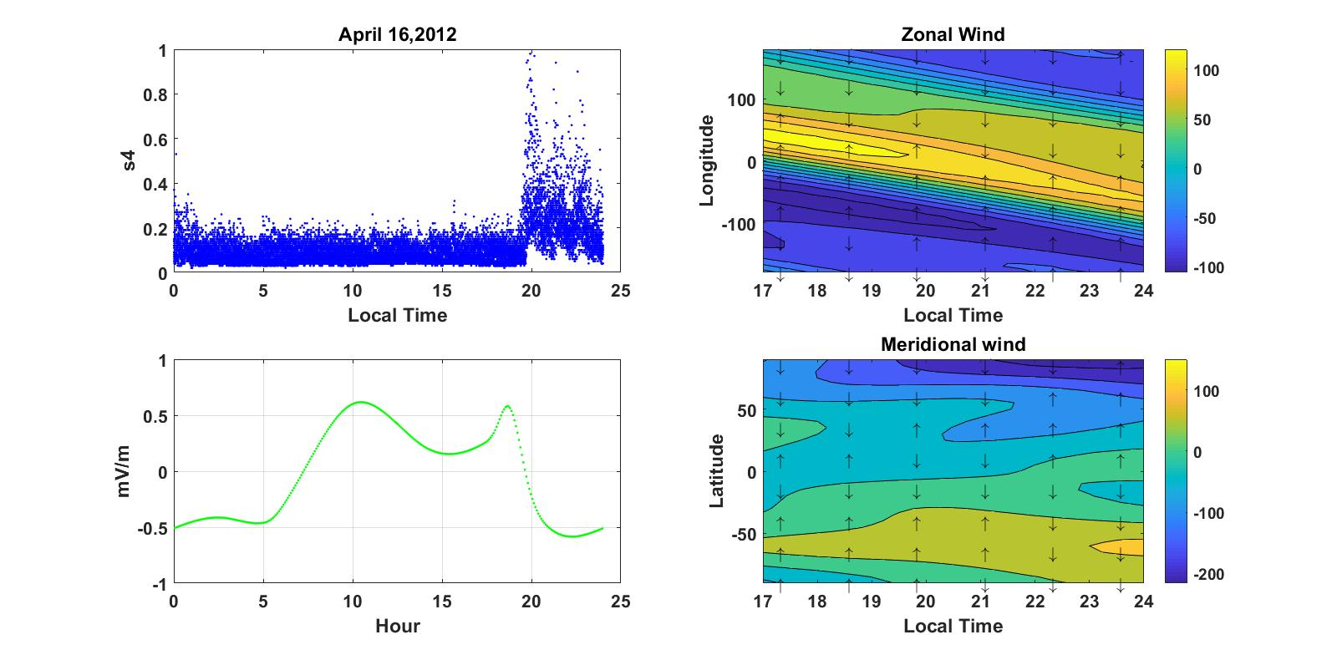
Figure 4.6: The daily variation of irregularity on April 09, 15 and 16 of quite days.

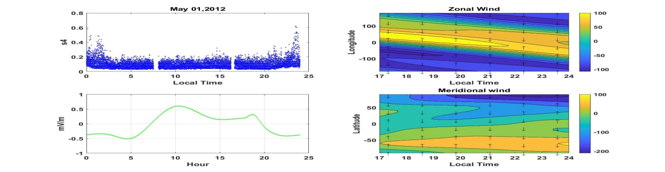
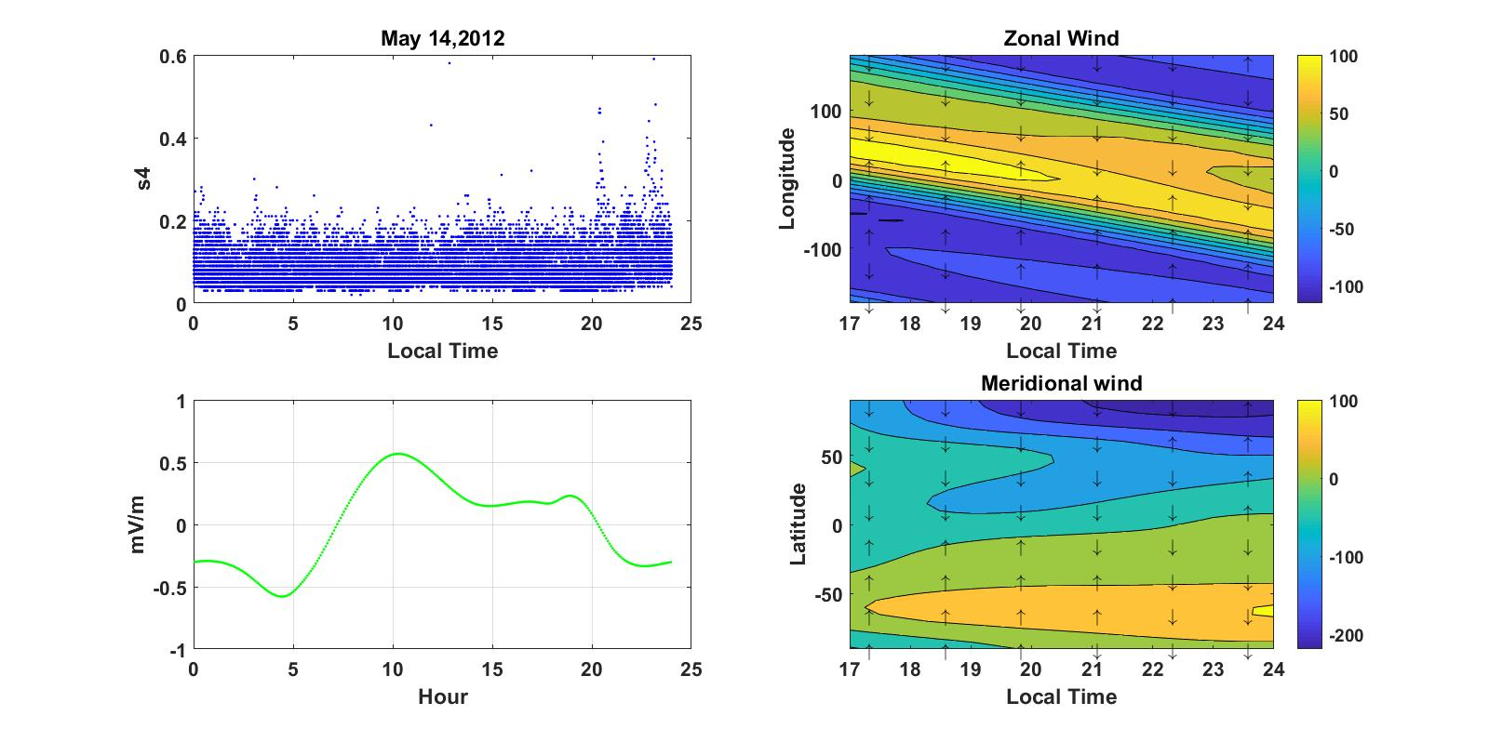
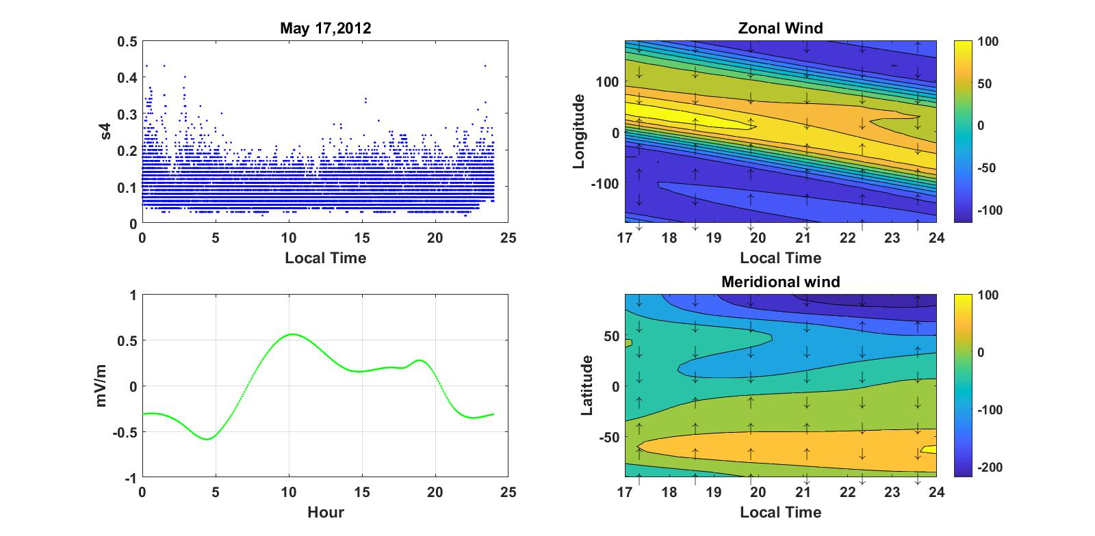
Figure 4.7: The daily variation of irregularity on may 01, 14 and 17 of quite days.

From the scintillation plots (see left of fig. 4.7) we can observe near to weak irregularities from 18:00LT to 24:00LT and these irregularities almost occurred after post sunset. At this time means around the time of irregularities occurred the strength of electric field is weak with maximum values around 0.4mV/m for each day. This result shows almost electric field is the not trigger of irregularities, because it not consistence with Kudeki and Bhattacharyya (1999) showed that the prereversal velocity enhancement constitutes an important seeding mechanism for the generation of F region irregularities. And when we see the plots of neutral wind (see fig.4.7 right) the blowing direction of zonal wind is westward around from 21:00LT to 24:00LT and that of meridional wind is blowing from southern hemisphere from 17:00LT to 20:00LTand from northern hemisphere from 17:00LT to 22:00LT respectively to the equator. Then, instabilities on these days occurred caused by the blowing of neutral winds in direction shown on fig and the distribution of electric field for these day instabilities occurrence is almost less.Then,ionospheric irregularities on these days is mostly contributed by neutral winds because the effect of zonal electric field in these days is minimum.

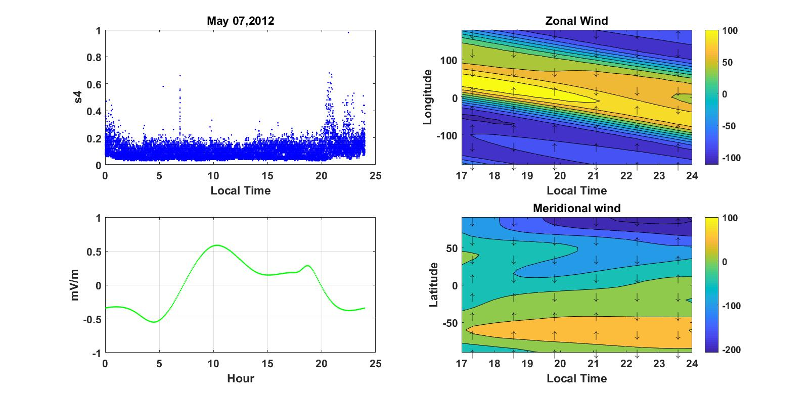
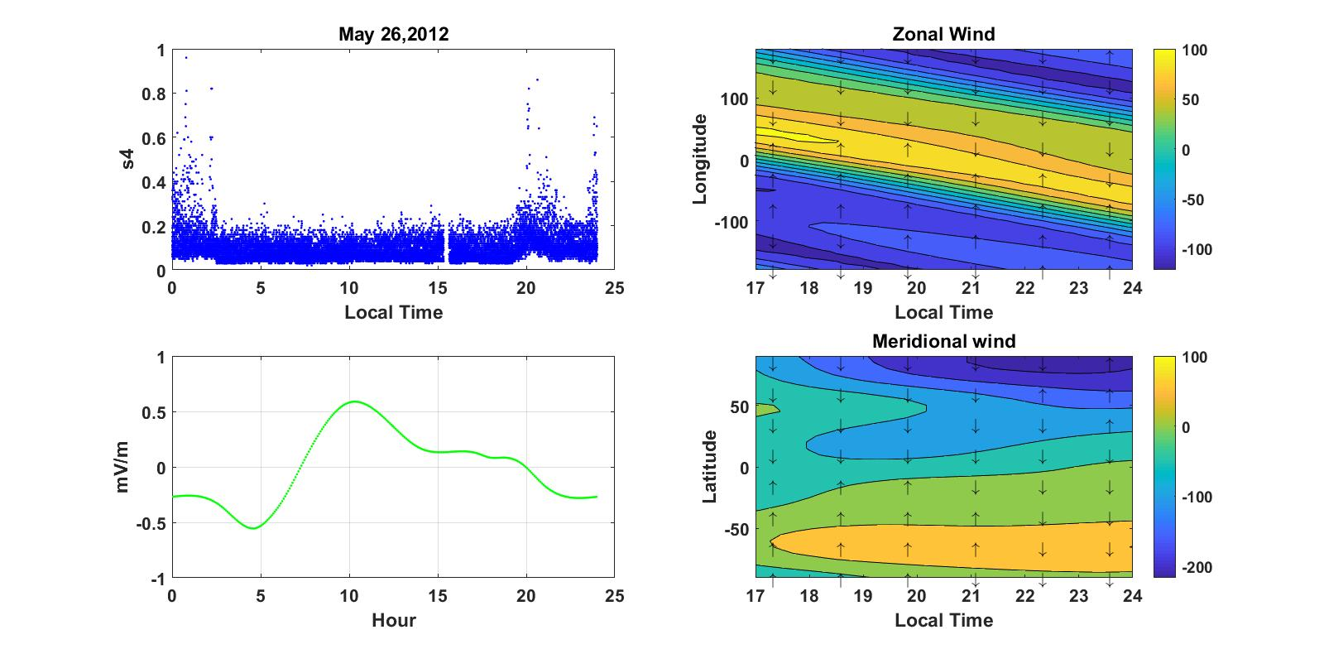
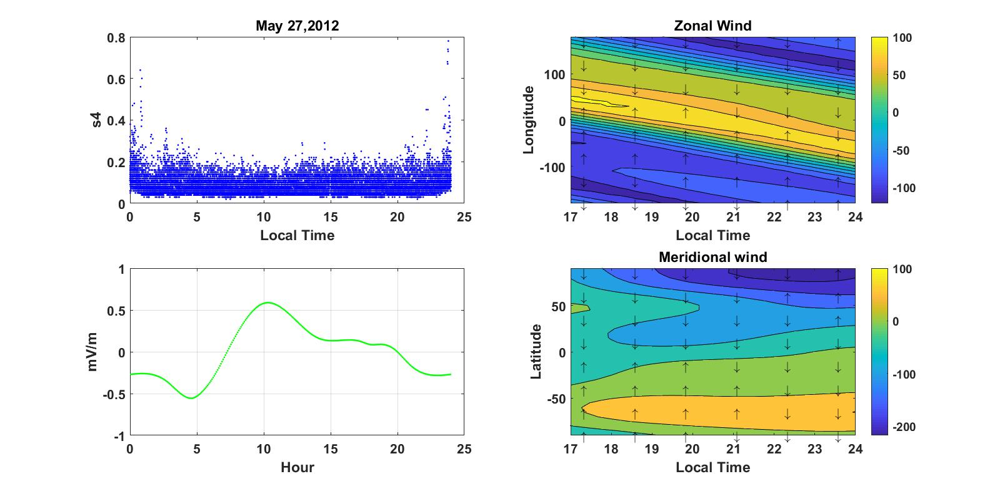
Figure 4.8: The daily variation of irregularity on may 02, 26 and 27 of quite days.

When we look the values of irregularities (see fig.4.8 left) we observe strong scintillation around from 21:00LT to 24:00LT.This time is also time of post sunset irregularities occurring time. Again from this fig. also we have plots of electric field with minimum values. These fields have not any contribution for the occurrence of irregularities. And when we see the direction of meridional winds (see fig. 4.8 right) they blowing to the equator around 17:00LT to 20:00LTfrom southern hemisphere and around from 17:00LT to 23:00LTfrom northern hemisphere respectively. And, zonal wind flow to the west around 23:00LT to 24:00LT. So, these post sunset irregularities are not affected by zonal electric field, because the value of field strengths so minimum and then these irregularities occurred due to along the given direction flow of neutral winds.
Generally for the occurrence ionospheric irregularities on May in 2012 mostly affected by the blowing of meridional wind from pole to the equator. And the strength of zonal electric field is near to zero compared with the field strength of the other months.

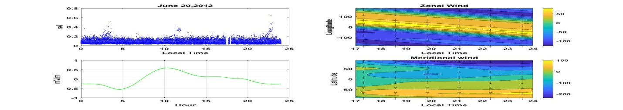
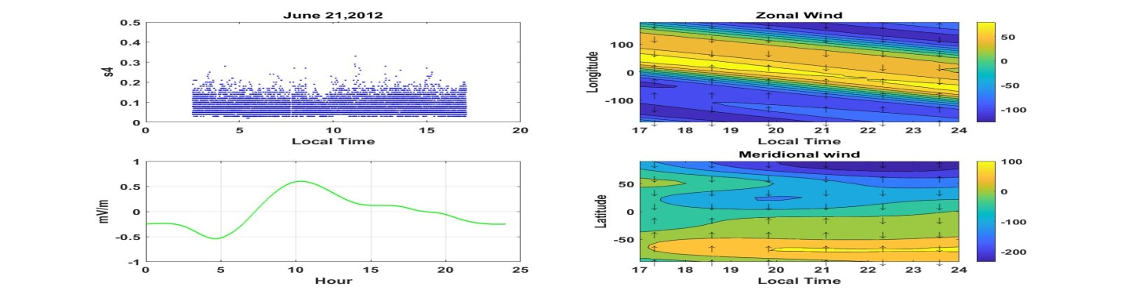
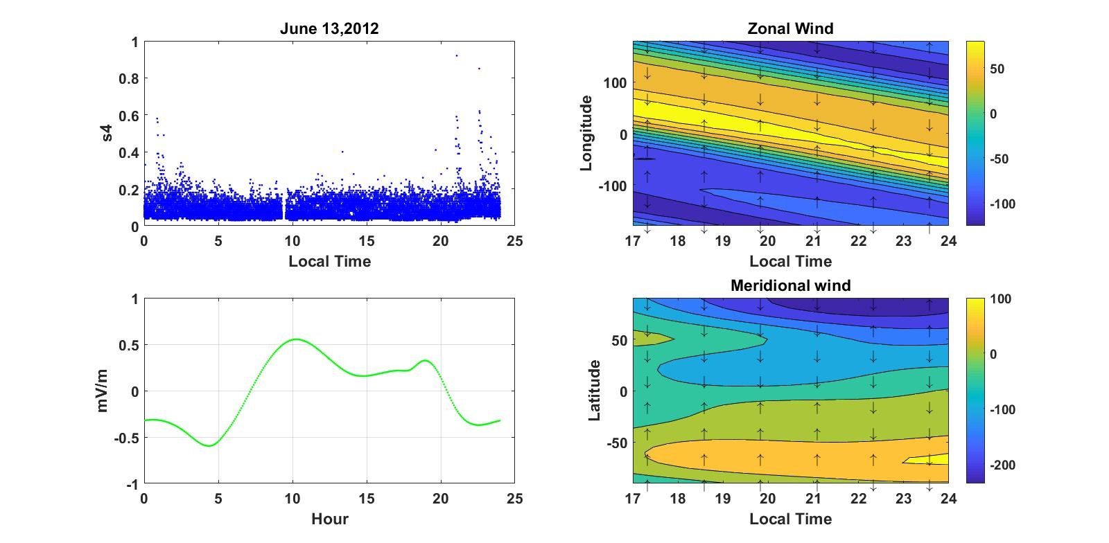
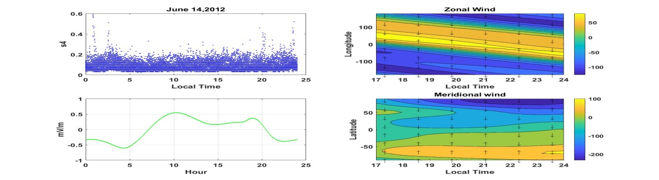Figure 4.9: The daily variation of irregularity on June 20, 21, 14 and 13 of quite days.
When we see the value of scintillation (see fig. 4.9 left) on June 21 minimum irregularity is observed. But on June 13, 14 and 20, there is an irregularity around from 21:00LT to 24:00LT.For these occurrence electric field (see fig. 4.9 left) have not any effect on the formation of ionospheric irregularities because its value is less than 0.5mV/m. Neutral winds plots (see fig.4.9 right) indicates zonal wind flows to westward around at 24:00LT and meridional wind blowing to the equator from southern hemisphere from 17:00LT to 21:00LT and from the northern hemisphere around from 17:00LT and 23:00LT respectively. Then, the occurrence ionospheric irregularities on June in 2012 mostly by effect of blowing of neutral winds along the direction that must flow for the occurring of instabilities.

4.2 Monthly Variation of Irregularity
In this case quite days considered to see the overall activity of scintillation from January 1, 2012 to June 21, 2012. Because of data outage days are included in the graph.

Fig.4.10 shows that the irregularity value with the effect of electric field and neutral winds for selected two days of each which have maximum irregularities on January and March in 2012.
When we see plots of irregularities and electric fields (fig.4.10 left) ,the maximum value of s4 on January 8 and 14 is almost 0.6 and the maximum value electric field for these days at the time producing irregularity is 0.4mV/m. But on March 21 and 22 the maximum value of s4 value is 1 and the maximum value of electric field is 0.6mV/m. when we look the direction wind at the time of irregularities for both January and march, zonal wind blowing to west and the mearidional wind flows to the equator from the poles on both months. Then for these maximum irregularities on January and March due to their electric field and zonal winds. Then the occurrence of irregularities is greater on March compared with January.

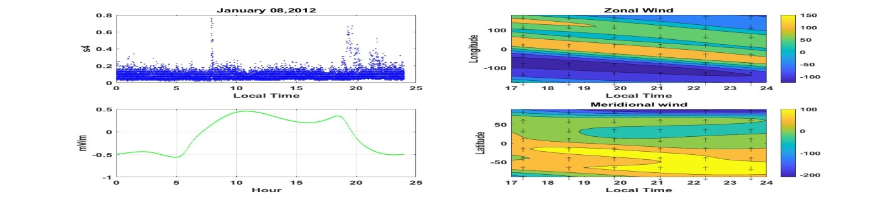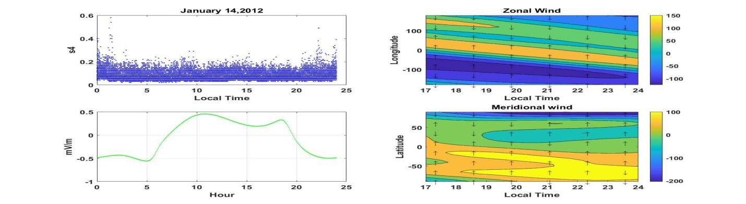
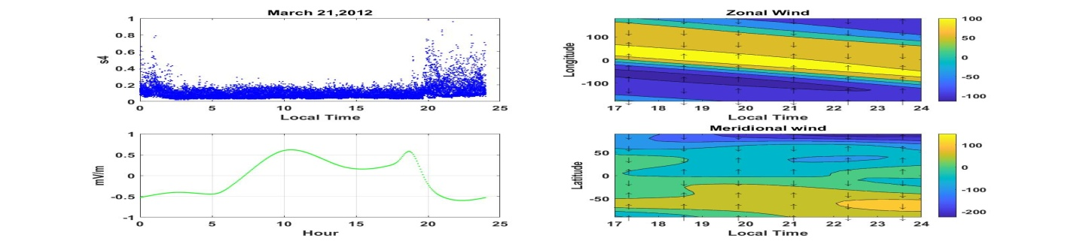
Figure 4.10 : A graph that shows the monthly variation of irregularities for January and March in 2012.

When we look the value of irregularities (see fig.4.11 left) on April maximum s4 value is from 1 to 1.3 on 20:00LT to 24:00LT. On May and June the maximum irregularity value is 0.8 between 20:00LT and 24:00LT.And the value of electric field on this plot on the left side is seen. But the maximum value of electric field on April is around 5.2mV/m on 19:00LT and the field strength on may is around 0.2mV/m and that of June is around 0.4mV/m on 19:00LT.When we see the direction of wind (fig.4.11 right) on April zonal wind blows to westward around 24:00LT for and the direction of meridional wind flow is to the equator from northern hemisphere from 17:00LT - 24:00LT and 17:00LT – 20:00LT. On the other hand zonal wind direction on May and June on the time between 23:00LT and 24:00LT is westward and to the equator for that of meridional wind from northern hemisphere and southern hemisphere on the same time on april. Then the factor for the occurrence of irregularity on April is electric field and zonal neutral wind and the occurrence irregularities on may and June are mostly only wind that means both zonal and meridional wind. So strong irregularity occurred on April compared with May and june.Therefore mostly irregularity is affect by zonal electric field than neutral wind.

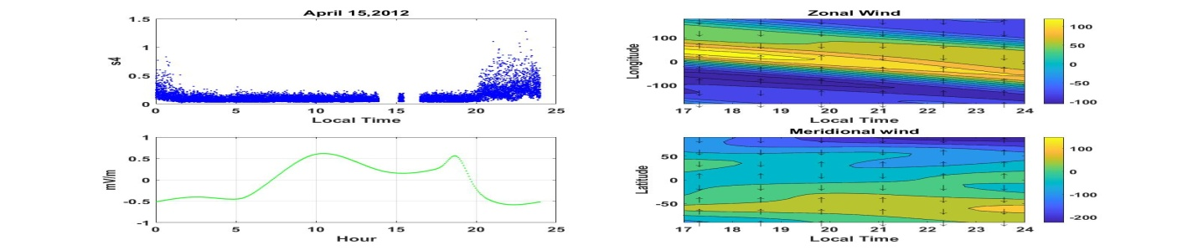
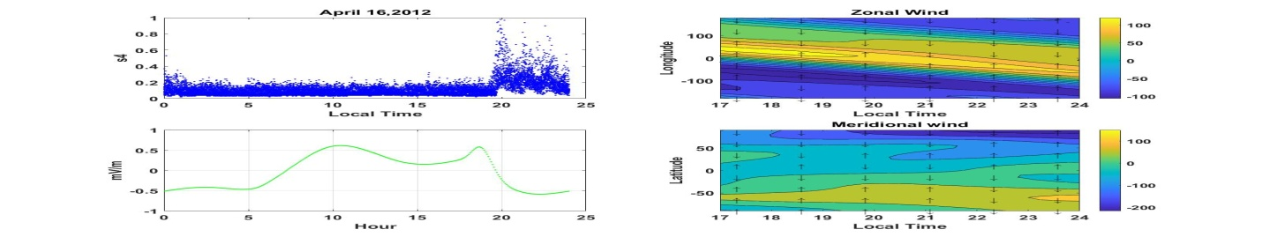
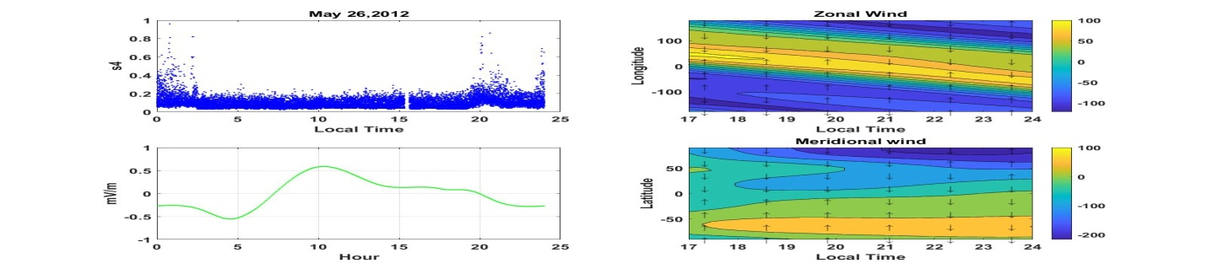
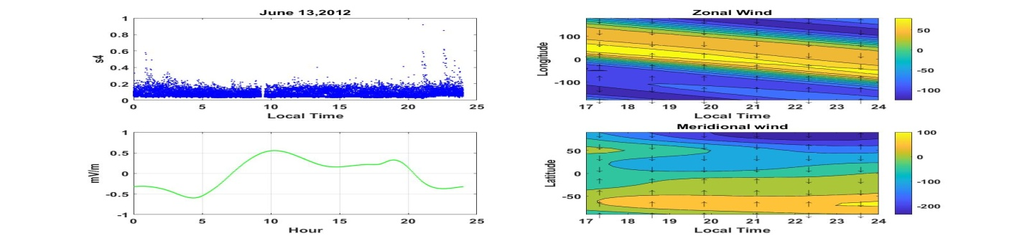
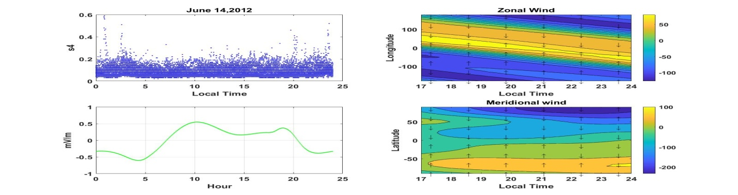
Figure 4.11: Irregularity variations on April, May and June in 2012.
Generally when we see the formation of ionospheric irregularity occurrence in 2012 at Bahir Dar region on January, march April, may and June months, there is an instabilities on each month and their instability occurrence is due to different factors. In this paper we apply only the effect of neutral wind and zonal electric field. And mostly strong irregularity occurred, when zonal electric field on that day is maximum. Due to this on March and April we get strong irregularities that are s4 values from 1 to 1.3 compared with the other months.

CHAPTER FIVE

5. Conclusions and Recommendations

5.1 Conclusions
Our results of effect of neutral wind and zonal electric field on irregularity can be concluded as follow.
• Ionospheric instabilities mostly affected by zonal electric field compared with the effect
of neutral winds.
• Pre-midnight ionospheric irregularities was dominant compared to the other which occur
in the post sunset, post-midnight and day time periods.
• Ionospheric irregularities which occur on the March and April months were very strong
compared to those which occur in the other months.

5.2 Recommendations
Neutral wind and electric field effect on irregularity studies are very limited especially in our region Bahir Dar. The present investigation deals with the occurrence of irregularities study during 2012 only. Long-term occurrence of irregularities at this frequency at our station will be useful in understanding the effect of irregularities over equatorial region and we had some confusion on the information about the direction of blowing of zonal and meridional wind. So, it should be considered in the future works.

References
Aarons, J., & Basu, S. (1985). Ionospheric radio wave propagation. In A. S. Jursa, Handbook of Geophysics and the Space Weather Environment (pp. 10-44 - 10-50). Massachusets: Air Force Geophysics Lab.
Adewale, A. O., Oyeyemi, E. O., Adeloye, A. B., Mitchell, C. N., Rose, J. A., Cilliers, P. J, A (2012) study of L-Band scintillations and TEC at an equatorial station Lagos, Nigeria. Radio Sci., 47, RS2011.
Adolph S.jursa, Hand book of geophysics and the space environment by scientific editor, Air Force Geophysics Laboratory, 1985
Attila Komjathy (1997), Global Ionospheric Total Electron Content Mapping Using the Global Positioning System, PhD Dissertation, University of New Brunswick, Canada.
Bagiya, M. S. (2010), Multi technique Studies of Ionospheric Phenomena. In Thesis- Doctor of Philosophy in Physics. Rajkot: Saurashtra University.
Basu, S. & Basu, S. (1989), Scintillation Techniques for probing ionospheric irregularities. In C. H. Liu, World Ionosphere/Thermosphere Study (WITS) Handbook (pp. 128-136). Illinois: ICSU Scientific Committee on Solar Terrestrial Physics.
Basu, S., S. Basu, J. Aarons, J. P. McClure, and M. D. Cousins (1978), On the coexistence of kilometer- and meter-scale irregularities in the nighttime equatorialFregion,J. Geophys. Res., 83(A9), 4219–4226, doi: 10.1029/JA083iA09p04219.
Beaujardiere, O. D. (2004), C/NOFS: a mission to forecast scintillations. J. Atmos. Sol.-Terr.Phys. 66(17), 1573-1591, doi: 10.1016/j.jastp.2004.07.030.
Beer, T. (1974), On the Dynamics of Equatorial Spread F. Aust. J.Phys., 27, 391-400.Chen, J., Satyanarayana, P., and Ossakow, S. L. (1983), The Morphology of a Multi Bubble system in the ionosphere. In NRL Memorandum Report 5007 (pp. 1-24). Washington, DC: Naval Research Lab.
Beer, T. (1974), On the Dynamics of Equatorial Spread F. Aust. J. Phys., 27, 391-400.
Belly, P. L., & Alcayde, D. (2007), Ionosphere. In Y. Kamide, & A. C. Chian, Handbook of the Solar Terrestrial Environment (pp. 209 - 217). Berlin: Springer Berlin Heidelberg Newyork.
Bhattacharya, (1991) A. Phase and amplitude scintillations due to electrojet irregularities.
J. Atmos. Sol.Terr. Phys., 53, 379 - 387.
Bhattacharya, A.(1991), Phase and amplitude scintillations due to electrojet irregularities. J. Atmos. Sol.Terr. Phys., 53(5), 379 - 387.
Bhattacharyya, A., Engavale, B., Tiwari, D., Bose, S. (2006) Effect of solar variability on the
transionospheric radio wave propagation in the equatorial region. ILWS Workshop, 19-24.
Bhuyan, P., & Bhuyan, K. (2007), The equatorial ionization anomaly at the topside F region of the ionosphere along 75 degrees East. Adv. in Space. Res., 43, 1676-1682, doi: 10.1016/j.asr.2008.09.027.
Booker, H. G. (1958), the use of radio stars to study irregular refraction of radio waves in the ionosphere. Proc. IRE, 46, 298-314.
Booker, H. G. (1985) the use of radio stars to study irregular refraction of radio waves in
the ionosphere. Proc. IRE, 46, 298-314.
Dabas, R. S., Sharma, N., Pillai, M. G., & Gwal, A. K. (2006), Day-to-day variability of equatorial and low latitude F-region ionosphere in the Indian zone. Atmos. Sol. Terr. Phys., 68, 1269-1277, doi: 10.1016/j.jastp.2006.03.009.
Datta-Barua, S. Doherty, P. H., Delay, S. H., Dehel, T., & Klobuchar, J. A. (2003), Ionospheric scintillation effects on single and dual frequency GPS positioning. Institute of Navigation's GPS/GNSS meeting. Portland, 336-346.
Davies, K. (1980), recent progress in Satellite Radio Beacon studies with particular emphasis on the ATS-6 radio beacon experiment. Space Sci. Rev., 25, 357 -430.
Fejer, B. G., L. Scherliess, and E. R. de Paula (1999), Effects of the vertical plasma drift velocity on the generation and evolution of equatorial spread F, J. Geophys. Res.,104(A9), 19,859–19,869, doi: 10.1029/1999JA900271.
Guzdar, P. N., Satyanarayana, P., Ossakow, S. L., & Huba, J. D. (1981), Influence of Velocity Shear on the Rayleigh-Taylor Instability. Washington, DC: Naval Research Laboratory.
Heredia, T., & Elias, A. G. (2004), Diurnal variation of NmF2 associated with ExB drift at the equator during solar maxima. Geophysical International, 43(1), pp. 119 - 124.
Huang, C.S., O. de La Beaujardiere, R. F. Pfaff, J. M. Retterer, P. A. Roddy, D. E. Hunton, Y.J. Su, S.Y. Su, and F. J. Rich (2010), Zonal drift of plasma particles inside equatorial plasma bubbles and its relation to the zonal drift of the bubble structure, J. Geophys. Res., 115, A07316, doi:10.1029/2010JA015324.
Hysell, D. L., and E. Kudeki (2004), Collisional shear instability in the equatorial F region ionosphere. Geophys. Res., 109, A11301, doi:10.1029/2004JA010636.
John M. Goodman, Space Weather And Tele communications, Radio Propagation Services, Znc.,
Kelley, M. C., M. F. Larsen, C. LaHoz, and J. P. McClure (1981), Gravity wave initiation of equatorial spread F: A case study, J. Geophys. Res., 86(A11), 9087–9100,
doi:10.1029/JA086iA11p09087.
Kelly, M (1989), the Earth's Ionosphere: Plasma Physics and Electrodynamics. Academic Press, California, (1-485)
Klobuchar, J. A. (1991), Ionospheric effects on GPS. In Innovation: GPS world, Vol. 2, pp. 48- 51. Air Force Geophysics Lab.
Livingston, R. C., Rino, C. L., McClure, J.P., & Hanson, W. B. (1981), Spectral characteristics of medium-scale equatorial F region irregularities. J. Geophys. Res, 86, 2421-2432.
MacDougall, J., M. Abdu, P. Jayachandran, J.F. Cecile, and I. Batista (1998), Presunrise
spread F at Fortaleza, J. Geophys. Res., 103, 23,415–23,425, doi:10.1029/98JA01949.
Makela, J. J., & Otsuka, Y. (2011), Overview of nighttime ionospheric instabilities at low and mid-latitudes: Coupling aspects resulting in structuring at the mesoscale. Space Sci. Rev. Springer, 168, 419-440, doi:10.1007/s11214-011-9816-6.
Makela, J. J., and Otsuka, Y.( 2011), Overview of nighttime ionospheric instabilities at low and mid-latitudes: Coupling aspects resulting in structuring at the mesoscale. Space Sci. Rev. - Springer, 168, 419-440.
Margaret G.Kilvson and Kristopher T.Russell (1995), Introduction to Space Physics, Cambridge University Press.
Martin Kriegel,Norbert Jakowski,Jens Berdermann, Hiroat suSato and Moges Wassaie.(2017) Ann.Geophyscis.,35, 97-106.
Maruyama, T. and N. Matuura (1984), Longitudinal variability of annual changes in activity of equatorial spread Fand plasma bubbles, J. Geophys. Res., 89, 10,903–10,912.
McDonald, B. E., Coffey, T. P., Ossakow, S., & Sudan, R. N. (1974), Preliminary report on numerical simulations of Type II irregularities in the equatorial electrojet. Washington, DC: Naval Research Lab.
McNamara, L. F. (1985), High frequency radio propagation. In A. S. Jursa, Handbook of Geophysics and the space environment (pp. 10-45 - 10-62). Springfield: Air force Geophysics laboratory.
Mendillo, M., J. Meriwether, and M. Biondi (2001), Testing the thermospheric neutral wind suppression mechanism for day-to-day variability. of equatorial spreadF, J. Geophys.
Michael C. Kelley (2009), the Earths Ionosphere Plasma Physics and Electrodynamics, International Geophysics Series, Academic Press, inc.
Oyekola, O. S. (2007), Seasonal and magnetic activity variations of nighttime ionospheric F region vertical plasma drifts at Ibadan. Indian J. Rad. and Space Phys., 36, 14-19.
Patra, A. K., D. V. Phanikumar, and T. K. Pant (2009), Gadanki radar observations of F Sastri, J. H. (1999), Letter to the Editor: Post midnight onset of spread F at Kodaikanal during the June solstice of solar minimum, Ann. Geophys., 17, 1111–1115, doi:10.1007/s00585-999-1111-4.
Paznukhov, V. V. Carrano, C. S., Doherty, P. H., Groves, K. M., Caton, R. G., Valladares, C. E., Seemala, G. K., Bridgwood, C. T., Adeniyi, J., Amaneshi, L. L. N., Damtie, B., Mutonyi, F. D., Ndeda, J. O. H., Baki, P., Obrou, O. K., Okere, B., Tsidu, G. M. (2012), Equatorial plasma bubbles and L-Band scintillations in Africa during solar Minimum. Ann. Geophys., 30, 675-682.
RamaRao, P. V., Gopi Krishna, S., Niranjan, K., & Prasad, D. S. (2006a), Temporal and spatial variations in TEC using simultaneous measurements from the Indian GPS network of receivers during the low solar activity period of 2004-2005. Ann. Geophys., 24, 3279-3292, doi:10.5194/angeo-24-3279-2006.
Ramarao, P. V., Ram, S. T., Gopi Krishna, S., Niranjan, K., & Prasad, D. (2006b), Morphological Characteristics of L-Band Scintillations and Their Impacts on GPS signals-A quantitative study on the precursors for the occurrence of scintillations. In Characterizing the Ionosphere (pp. 6-1 - 6-22). Meeting Proceedings RTO-MP-IST-056, Paper 6. Neuilly-sur Seine, France: RTO.
Rastogi, R. G. (1972), Equatorial Sporadic E and cross field instability. The proceedings of the Indian Academy of Sciences, (pp. 181-194).
Res., 106(A3), 3655–3663, doi:10.1029/2000JA000148.
Retterer, J. M., and L. C. Gentile (2009), Modeling the climatology of equatorial plasma, bubbles observed by DMSP, Radio Sci., 44, RS0A31, doi:10.1029/2008RS004057.
Riberio, A. J. (2011, August 4), An examination of ionospheric plasma irregularities detected by the mid-latitude Super DARN radars. Masters of Science in Electrical Engineering. Blackburn, Virginia.
Rishbeth, H.,& Gariot, O. K. (1969), Introduction to Ionospheric Physics. New York, USA: Academic Press, Inc.
Robert W. Schunk and Andrew F. Nagy, IONOSPHERES, Physics, Plasma Physics, and Chemistry, Second Edition, 2000(2009)
Sastri, J. H. (1999), Letter to the Editor: Post midnight onset of spread F at Kodaikanal
during the June solstice of solar minimum, Ann. Geophys., 17, 1111–1115, doi: 10.1007/s00585-999-1111-4.
Sastri, J. H., B. S. Murthy, and K. Sasidharan (1979), Range and frequency spread F at Kodaikanal, Ann. Geophys., 35, 153–158.
Sekar, R., & Chakrabarty, D. (2008), Equatorial spread F research in India - A Review. Indian J. Radio and Space Physics, 37, 7-27.
Singh, S., Bamgboye, D. K., McClure, J. P., & Johnson, F. S. (1997), Morphology of equatorial
plasma bubbles. J. Geophys. Res., 102, A9, 20019-20029.
Subbarao, K. S. V. and B. V. Krishnamurthy (1994), Seasonal variations of equatorial spread F, Ann. Geophys., 12, 33–39.
Sultan, P. J. (1996), Linear theory and modeling of the Rayleigh-Taylor instability leading to the occurrence of equatorial spread F,J. Geophys. Res., 101(A12), 26,875–26,891, doi: 10.1029/96JA00682.
Thomas, R. M., Cervera, M. A., Eftaxiadis, K., Manurung, S. L., Saroso, S., Effendy, Ramli, A. G., Hassan, W. S., Rahman, H., Dalimin, M. N., Groves, K. M., Wang, Y. (2001), A Regional GPS Receiver network for monitoring equatorial scintillation and total electron content. Radio Sci.,36 (6), 1545 - 1557.
Tsunoda, R. T. (2010), On seeding equatorial spread Fduring solstices,Geophys. Res. Lett. 37, L05102, doi: 10.1029/2010GL042576.
Unnikrishnan, K., & Ravindran, S. (2010), A study on chaotic behavior of equatorial/low latitude
ionosphere over Indian subcontinent, using GPS-TEC time series. J. Atmos. Sol.Terr. Phys., 72, 1080-1089, doi: 10.1016/j.jastp2010.07.003.
USA JMG Associates, Ltd., USA Alexandria, Virginia, USA 2005 ”Atmosphere.” Micro soft rEncarta r2009 [DVD]. Redmond, WA: Microsoft Corporation, 2008.
Van-Dierendonck, A. J. & Rastburg, B. A. (2005), Measuring Ionospheric Scintillations in the Equatorial Region over Africa. Los Altos: GPS Silicon Valley.
Woodman, R. F. and C. LaHoz (1976), Radar observations of F region equatorial irregularities, J. Geophys. Res., 81, 5447–5466, doi: 10.1029 JA081i031p05447.
Wu, D. L., Chi, A. O., Hajj, G. A., Juarez, M. D., & Manucci, A. J. (2005), Sporadic E morphology from GPS-CHAMP radio occultation. J. Geophys. Res., 110, A01306, doi:10.1029/2004JA010701.
Zalesak, S. T. (1983), Small scale structure in the Earth's Ionosphere: Theory and numerical simulations. In NRL Memorandum Report 5119(pp. 1 - 38). Washington, DC: Naval Research Laboratory.

Declaration
I hereby declare that the Thesis I my original work and has not been presented for a degree in any other university, and that all sources of materials have been duly acknowledged.

Name: Belete Achenef
Signature:________________
Date:______________
This thesis has been submitted for examination with my approval as a university advisor.

Name: Melessew Nigussie (PhD)
Signature:___________________
Date:_________________

