Bahir Dar University
College of Science
Department of Chemistry



Synthesis, Characterization and Photo-catalytic Activity of
Cupper Iron Oxide/Zinc Oxide Nanoparticles for
Degradation ofMethylene Blue dye

By
AddisieAlemayehu

June, 2018
Bahir Dar, Ethiopia
Synthesis, Characterization and Photo-catalytic Activity of Cupper Iron Oxide/Zinc Oxide Nanoparticlesfor Degradation Methylene Blue dye

A Thesis
Submitted to the Department of Chemistry of Bahir Dar University in
Partial Fulfillment of the Requirements for the Degree of
Master of Science in Chemistry

By
AddisieAlemayehu
Advisor
BeleteAsefa (PhD)
Department of Chemistry
Bahir Dar University
Bahir Dar, Ethiopia
Declaration
I hereby declare that, this thesis entitled “Synthesis, Characterization and Photocatalytic Activity of Cupper Iron Oxide/Zinc Oxide Nanoparticlesfor Degradation of Methylene Blue dye”and the work presented in it are my original work and has not been presented for a degree in any other university and that all sources of materials have been duly acknowledged.

Student’s Name: AddisieAlemayehu
Signature: —————–
Date: ————————

This thesis has been submitted for examination with my approval as University advisor.

Advisor’s Name: BeleteAsefa (PhD)
Signature: —————–
Date: ————————-

Approval Sheet
The thesis entitled“Synthesis, Characterization and Photo-catalytic Activity of Cupper Iron Oxide/Zinc Oxide Nanoparticles for Degradation of Methylene Blue dye”byMs.AddisieAlemayehuis approved for the degree of “Master of science in chemistry.”

Board of Examiners

Name Signature Date

Advisor BeleteAsefa (PhD) _____________ ___________
External Examiner ____________________ ________________________ Internal Examiner ________________________________ ___________
Chair person ___________________ _____________ ___________

Place and Date: Bahir Dar University, Bahir Dar, Ethiopia
June, 2018

Dedication

This work is dedicated to my family and friends for their endless love, support and encouragement throughout my graduate and undergraduate schoolyears.

Acknowledgements

First and foremost, I praise God, the almighty, merciful and passionate for giving me the
strength during each and every phase of my life and granting me the capability to proceed
successfully. The research work I am reporting in this thesis would never have been possiblewithout the support of many people who have unselfishly given me their help and supportedme intellectually as well as personally during all my study time.

I would like to acknowledge my instructor and thesis advisor, Dr. BeleteAsefa. I would like to thank for all his help and support throughout theprocess of doing my research work. Ireally appreciate himfor giving me the opportunity to get this degree and explain thingsfrom the beginning.

I have to express my deepest gratitude to Dr.Tsadik K/mariamfor his unreservedsupport and encouragement over the years.

Above all, I would like to thank my family for all their unflagging love and unconditionalsupport and believe in my abilities. Iwill always appreciate their past, on-going and never ending supports. I do not find enough wordswith which I can express my feeling of thanks to my father, Mr. AlemayehuMihiret, mymother, Ms. TirengoWorkeand my brother, Mr. DegsewAlemayehufor their undying selflessness, generosity, patience and love.

I gratefully acknowledge the funding sources that made my MSc study possible. I wouldlike to thank the Department of Chemistry of Bahir Dar University, for giving me the opportunity to study and for the financial andmaterial supports during my studies.

Finally, I would like to forward my heart felt gratitude and appreciation to all the peoplewho gave me their support and moral assistance all over the time.

Abstract
In this research work, synthesis, characterization and photocatalytic activity of CuFeO₂/ZnO nanoparticle for degradation of methylene blue (MB) dyewas studied. The CuFeO₂/ZnO nanoparticles were successfully synthesized via successive ionic layer adsorption and reaction (SILAR) method. The crystal structure, vibrational frequency and optical properties of the synthesized CuFeO₂/ZnO nanoparticles were studied using x-ray diffraction (XRD), Fourier transform infrared (FTIR) and ultraviolet/visible (UV/vis) spectrophotometers, respectively. The structural characterization of CuFeO₂/ZnO nanoparticles has been done by analyzing the results obtained from XRD measurements. The results obtained using the XRD indicates that the desired CuFeO₂ phase was synthesized with crystalline size (D) of 22.59 nm. The results obtained using the FTIR spectrum shows peak in the range of 1340-1390 cm⁻¹, ~530 cm⁻¹ and ~420 cm⁻¹ which corresponds for Cu-Fe, Fe-O and Zn-O bond stretching, respectively. Similarly, the results obtained using the UV/vis measurement indicates a red shift in the absorption spectra of ZnO from ultraviolet to visible light due to coupling of CuFeO₂ nanoparticle.The photocatalytic applicability of the synthesized CuFeO₂/ZnO nanoparticle has been evaluated by photocatalytic removal of MB as a function of time. CuFeO₂/ZnO nanoparticle seems promising photocatalyst for degradation of MB under light irradiation with 85.6 % degradation in 60 min. The photocatalytic degradation of MB follows pseudo-first order kinetics with rate constant (k) value of 2.910⁻² min⁻¹. Furthermore, the trapping experiment was carried out using different scavenger for active species. Among the active species, hole is the most active species which plays a vital role in the degradation of MB.The results obtained in this research work are in broad agreement with previous experimental findings.

Keywords:zinc oxide, cupper iron oxide, methylene blue, photocatalysis, SILAR method,trapping experiment

Table of Contents
Contents page

Declaration ……………………………………………………………………………………………ii
Dedication ……………………………………………………………………………………………iv
Acknowledgements ………………………………………………………………...…………………v
Abstract ………………………………………………………………………………………………vi
List of figures ………………………………………………………………………………………...ix
CHAPTER 1: GENERAL INTRODUCTION ……………………………………………………….1
  - Introduction …………………………………………………………………………………...1
  - Statement of the problem ……………………………………………………………………..4
  - Objectives of the study ………………………………………..………………………………5
    - General objective ……………………………………………………………………….5
    - Specific objectives ……………………………………………………………………...5
  - Significance of the study ……………………………………………………………………...5
CHAPTER 2: LITERATURE REVIEW ……………………………………………………………..7
  - Dyes …………………………………………………………………………………………...6
  - Wastewater treatment method ………………………………………………………………...7
  - Advanced oxidation processes ………………………………………………………………..7
  - Photocatalysis process ………………………………………………………………………...8
  - Mechanism of photocatalysis process ……………………………………………………..….9
  - Semiconductor photocatalysis ……………………………………………………………….10
  - Modification of ZnO semiconductor for harvesting visible light …………………………...11
  - Cupper iron oxide semiconductor photocatalyst …………………………………………….11
  - Synthesis methods of CuFeO₂ on ZnO nanoparticle ………………………………………...12
CHAPTER 3: EXPERIMENTAL DETAIL ……………………………………...…………………14
  - Chemicals and reagents ………………………………………………………………….14
  - Apparatus and instruments ………………………………………………………………14
  - Synthesis of CuFeO₂ on ZnO nanoparticles ……………………………………………..14
  - Characterization of CuFeO₂/ZnO nanoparticles …………………………………………15
  - Measurements of photocatalytic activities ………………………………………………15
  - Trapping experiment …………………………………………………………………….16
CHAPTER 4: RESULTS AND DISCUSSION ……………………………..………………………17
CHAPTER 5: CONCLUSION AND RECOMMENDATION ……………..………………………26
REFERENCE ……………………………………………………………………………..…………28

List of Figures

Figures page
Figure 1.Photocatalytic degradation mechanism with coupled CuFeO₂/ZnO configuration ……….3
Figure 2.Chemical structure of methylene blue ………………………………………………………….6
Figure 3.General mechanism of photocatalysis process by ZnO semiconductor photo-catalyst.…...9
Figure 4.Conduction band and valance band potential of some commonly used semiconductor photocatalysts with the potentials of CO₂ and water redox couples at pH 0 versus vacuum and NHE ……………….……...……………………………………………………………..….10
Figure 5.XRD patterns of CuFeO₂ prepared on ZnO (a) at 400-600 °C and ZnO and (b) at 600 °C for 2 hours in air ………………………………………………………….....…………….18
Figure 6. FTIR spectrum of (a) ZnO and (b) coupled CuFeO₂/ZnO nanoparticle....……………....….19
Figure 7.(a) UV/vis spectrum and (b) optical energy band gap of CuFeO₂/ZnO nanoparticles and (c) optical energy band gap of ZnO …………………………..…………………………....21
Figure8.Photocatalytic degradation profiles of MB (a) with and (b) without CuFeO₂/ZnOphotocatalyst under light irradiation …………………………………..……………….. 22
Figure9.Linear kinetic simulation curves of MB using CuFeO₂/ZnO photocatalyst under light irradiation …..................................................................................................................... 24
Figure 10. Photocatalytic degradation of MB over the CuFeO₂/ZnO alone and in the presence of different scavengers (i.e., AgNO₃, EDTA and IPA) ………………………………..….. 25

List of abbreviations

AOPs | Advanced oxidation process
SILAR | Sequential ionic layer adsorption and reaction
E_{g} | Energy gap
XRD | X-ray diffraction
FTIR | Fourier transform infrared radiation
UV/vis | Ultraviolet/visible
MB | Methylene blue
FWHM | Full width at half maximum
ZnO | Zinc oxide
CuFeO₂ | Cupper iron oxide
Nps | Nanoparticles
Cb | Conduction band
Vb | Valance band
EDTA | Ethylene diamine tetra-acetic acid
IPA | Isopropyl alcohol

CHAPTER ONE

GENERAL INTRODUCTION

Introduction

Currently, a wide variety of dyes are introduced into the aqueous system from various sources, such as industrial effluent, agricultural runoff, municipal wastes and chemical spills. Among these sources of water pollution the wastes from the textile and dye industries are highly hazardous to aquatic living and human beings.About 15–20% of the total global production of dyes is lost during the dyeing process and is released into the environment as textile effluent [1]. According to Ethiopian textile industry development institute (ETIDI), Ethiopian textile processing units consumed about 14,250,406 Kg of various types of dyes and chemicals [2]. Many organic dyes are toxic and carcinogeniclike azo dyes; congo red, methylene blue and methyl orange which may lead to the jeopardizing aquatic organism and also human health. Their toxicity, stability to natural decomposition and persistence in the environment has been the cause of much concern to societies and regulatory bodies around the world. Degradation of these dye pollutants, which have a deleterious effect on the wellbeing of mankind, has easily become the center point of research efforts in today’s scientific world.

Researchers have taken many steps and have suggested many pollutants remediation techniques, (i) physical,such as adsorption, precipitation, air stripping,reverse osmosis and ultra-filtration. (ii) Chemical like, chlorination, ozonation, precipitation and catalyst-chemical oxidation. (iii) Biological such as enzymatic decomposition and biodegradation processes.But each has its own limitations for the application, cost, and effectiveness point of view. The pollutants are being transferred to solid phase from liquid phase by physical techniques hence the pollutants are not destroyed. Chemical oxidation may be slow to moderate in the rate and selective or rapid but nonselective, hence generating oxidant cost. Rests of the techniques are limited due to oxidative potential, economics, or tendency to form harmful by-products. Due to these limitations there may be offered an effective particular process which may be the combination of the available techniques in such a way to exploit their individual strength, thus an appropriate solution obtained within the economic constraints.

Nowadays the most appropriate techniques for the water treatment are advanced oxidation processes (AOPs). Among AOPs, heterogeneous photocatalysis is a best water treatment process and has attracted the interest of researchers due to its ability to completely decompose the target pollutants [3, 4]. Semiconductor heterogeneous photocatalysisis effective way for degradation of organic pollutants in waste water [5]. Photocatalysis, as a “green” and energy saving method to completely eliminate environmental pollutants, has aroused tremendous interest. In this field, a fundamental issue is the construction of highly efficient photocatalysts. Semiconductor hetero-structures with staggered alignment band gaps not only improve the separation of photo-generated charge carriers, but also widen the light absorption when a narrow band gap component is used [6].

There is a great potential for the removal of the toxic chemicals from the polluted water by photocatalytic degradation using nanostructured semiconductors [7]. Currently, the hot issue among the most important challenges faced by science researchers for clean energy, pollutant-free water and air is designing new materials for the maximal harvesting of solar radiation. This photocatalysis system has attracted great interest from science community as the most promising way to solve the environmental problems, especially getting rid of residual dye pollutants from wastewater stream. The most significant advantage of this technique is that it can be used to degrade a wide range of toxic organic compounds especially the recalcitrant ones that are not readily amenable to other conventional treatment processes. The products of the degradation process include relatively innocuous simple molecules such as carbon dioxide (CO₂) and water (H₂O).

An extensive work has been carried out on ZnO for the application of photocatalysis and photovoltaic cells due to its advantage of high stability against photo corrosion, good photovoltaic and photocatalysis efficiencies [8, 9].ZnO is now considered to be the future material for various optoelectronics devices and sensors and as a catalyst. So far, ZnO have been used to degrade the harmful dyes into less harmful chemicals by photocatalytic reaction under light illumination [10]. however, it can only absorb ultraviolet light, which accounts for <5.5 % of solar radiationdue to its large band gap (3.2 eV) and also have high photo generated electron hole recombination.

To overcome these drawbacks, doping transition metals was employed to improve the optical properties of ZnO and to inhibit the recombination of photo-generated charge carriers. Enhancingphotocatalytic performances have been studied previously for ZnO doped with Mn²⁺ and Co²⁺[11], Ni [12], Cu [13], Cr [14] and Mg [15] ions. Furthermore light response range of ZnO can be extended to visible region by coupling with a narrow bang gap semiconductor like Ag₂S [16][24].

In this study CuFeO₂ was used to extend ZnO absorption spectra to visible region and to reduce charge carrier recombination rate.Due to the formation of a favorable p–n junction at the CuFeO₂/ZnO interface, the photo-generated electrons in CuFeO₂ will readily move towards the ZnO, resulting in efficient charge carrier separation. The photo-generated electron and holes will effectively oxidize organic pollutants in to carbon dioxide and water with the mechanism shown below.

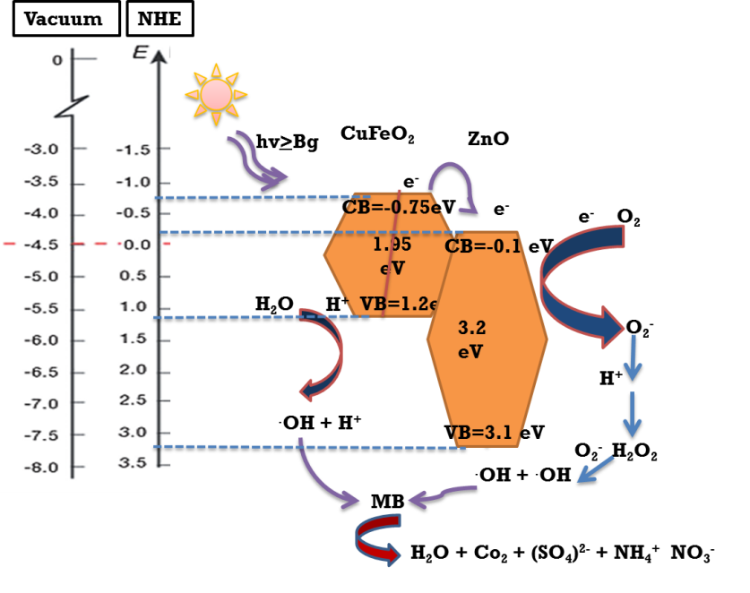

Figure 1.Photocatalytic degradation mechanism with coupled CuFeO₂/ZnO configuration.

Statement of the problem

Since the effluents, gaseous or waste water from various industries, factories, laboratories, etc., are serious problems to the environment i.e. discharged wastes containing dyes are toxic to microorganisms, aquatic life and human beings, degradation of these dyes in industrial wastewaters has received increasing attention and some methods of remediation have been proffered [17].
ZnO is one of the most active catalysts for the degradation of a wide range of organic compounds,however, it can only absorb ultraviolet light, which accounts for <5.5% of solar radiationdue to its large band gap (3.2 eV) and also have high photo generated electron hole recombination. To overcome these limitations, its absorption range can be extended to the visible region and rate of electron-hole recombination can be reduced by coupling with narrow band gap semiconductorphotocatalyst, CuFeO₂.

Many methods have been reported for the synthesis of semiconductor CuFeO₂ nanoparticle both in gas phase methods, such as chemical vapor deposition [18], atmospheric pressure plasma annealing [19] and thermal decomposition [20] and liquid phase methods, such as electrochemical deposition [21], sol-gel [22] and hydrothermal deposition methods[23].In comparison to gas-phase methods, liquid-phase methods have an advantage of providing thin films of large area at low cost but have a disadvantage in terms of difficulty in the control of a precise film structure. Due to limitations of these methods finding simple, low energy and short time consuming method is compulsory.In this study simple, low-energy and short time consuming synthesis method which is successive ionic layer adsorption and reaction (SILAR) were used to gain high crystalline CuFeO₂.

Objectives of the study

General objective
The general objective of this study is to synthesis, characterize and examine photocatalytic degradation activity of CuFeO₂/ZnOnanoparticle.

Specific objectives
The specific objectives of this research work are:
- to synthesis CuFeO₂photocatalyst material on ZnOby SILAR method.
- to study crystalline structure and optical properties of CuFeO₂/ZnO.
- to modify ZnO nanoparticles for inducing visible light photocatalysis.
- toinvestigate the photocatalytic activity of CuFeO₂/ZnO nanoparticle towards degradation ofmethylene blue dye.

Significance of the study

The significance of the study is to keep environmental health by degrading discharged waste water containing dyes which are toxic to microorganisms, aquatic life and human beings. In this research, designing a stable, efficient, and broad solar spectra absorber material was the core issue. In this regard, a new photocatalytic CuFeO₂/ZnOnanoparticle with a broader range of light absorption was synthesized via SILAR method. SILAR method have never been used for growth of CuFeO₂ nanoparticle and rarely used in the synthesis of other metal oxide nanostructures. Hence, the study demonstrates the use of a simple and low cost SILAR synthesis method for the growth of other similar binary and ternary metal oxide nanoparticle for various applications.

The methodology developed in this study can be extended to other ternary metal oxide systems which are used in a wide variety of applications. In addition, the result of the study has an important effect on the design and use of such nanostructures for photocatalytic degradation of organic pollutants and conveys important information about the activity of CuFeO₂/ZnOnanoparticletowards photo-degradation of pollutant in waste water effluents. The results of this research provide useful information for the design of an optimal semiconductor that would combine the ability to dissociate dye molecules with a proper band gap that absorbs solar light while retaining high stability.

CHAPTER TWO

LITERATURE REVIEW
  - Dyes

Potable water is increasingly becoming scarcer due to increased contamination of surface and ground water. The main causes of surface and groundwater contamination are industrial effluents (even in small amounts), excessive use of pesticides, fertilizers (agrochemicals) and domestic waste landfills. Organic pollutants such as dyes (methylene blue, methyl orange, congo red etc.,) that are non-biodegradable and highly toxic pose a great threat to aquatic life and other living organisms [24]. Many of the organic dyes along with their products have a carcinogenic effect on human beings [25]. Consequently, it is a matter of great concern to treat these dyes before discharging them.Among these organic dyes methylene blue (MB), have been extensively used in textiles and printing industry which has some serious harmful effects on humans and animals [26].Methylene blue is a heterocyclic aromatic chemical compound with the molecular formula C₁₆H₁₈N₃SCl. The chemical name according to International Union of Pure and Applied Chemistry (IUPAC) is [3, 7-bis (dimethyl amino) phenothiazin chloride tetra methylthionine chloride].If MB is ingested stimulates the gastro-intestinal tract and leads to nausea, vomiting and diarrhea[27].Because of potential toxicity of MB on humans, animals and aquatic life and its visibility in surface waters, degradation of it have been a matter of considerable interest.
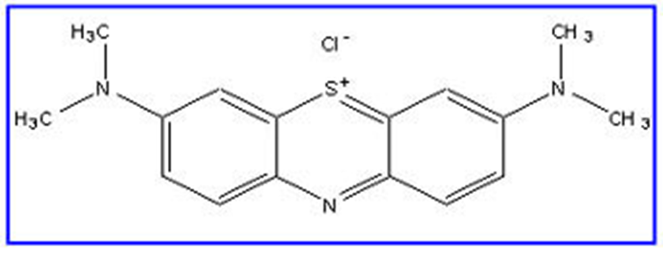
Figure 2.Chemical structure of methylene blue.

Wastewater treatment methods

With the progression of global industrialization, environmental pollution becomes a more serious issue and, thus, has received considerable attention. The improper discharge of untreated industrial waste water contaminated with organic dyes posesenvironmental problems.These dyes do not decompose rapidly through natural processes and are resistant to aerobic degradation. So it is necessary to find an effective method of wastewater treatment methods. Wastewater treatment is usually based on physical and biological processes. After elimination of particles in suspension, the usual process is biological treatment (natural decontamination), but unfortunately, some organic pollutants, classified as bio-recalcitrant, are not biodegradable because of recalcitrant nature of synthetic dyes and the high salinity of wastewater containing dyes [28].Due to this reason conventional biological treatment methods of these pollutants are often very slow and ineffective.

Also traditional physical techniques such as, adsorption on activated carbon[29], ultra filtration[30], reverse osmosis[17], coagulation by chemical agents[31], ion exchange on synthetic adsorbent resins[32], etc. have been used for the removal of dye pollutants. However these methods only succeed in transferring organic compounds from water to another phase, thus creating secondary pollution, this will require a further treatment of solid wastes and regeneration of the adsorbent which will add more cost to the process[33].Therefore a balanced approach is needed to look into the worthiness on choosing an appropriate method which degrades the dye in question.Among these techniques, the advanced oxidation processes appears a promising field of studywhich have been reported to be effective and can provide almost total degradation of soluble organic pollutants from waste water and air [5, 34].

Advanced oxidation processes (AOPs)

Advanced oxidation processes are widely used for the removal of recalcitrantorganic constituents from industrial and municipal wastewater. In this sense, AOP typeprocedures can become very promising technologies for treating wastewater containingnon-biodegradable organic compounds with high toxicity. Theseprocedures are based on generating highly oxidative OH radicals and H₂O₂ in the reaction medium.The AOPs can be successfully used in wastewater treatment to degrade the persistent organic pollutants, the oxidation process beingdetermined by the very high oxidative potential of the OH radicals generated into thereaction medium by different mechanisms.

In this way AOPs becomes themost widely used waste water treatment technologies for organic pollutants not treatable byconventional techniques due to their high chemical stability and/or low biodegradability. AOPs are designated for removal of organic contaminants such as halogenated hydrocarbons, aromatics (benzene, toluene, and xylene), pentachlorophenol (PCP), nitrophenol, detergents, pesticides, etc.AOPs have been also studied extensively through which a broad range of organic dyes can be oxidized quickly and non-selectively. As one of the novel AOPs,the heterogeneous photo-catalytic oxidation process developed in the 1970s is of special interest especially when solar light is used [35].

Photocatalysis process

Photocatalysis process is the most promising way for environmental health protection because of its ability to oxidize organic pollutants into benign products [36]. Photocatalysis utilizes semiconductor photocatalysts to carry out a photo-induced oxidation process to break down organic contaminants and inactivate bacteria and viruses. The word “photocatalysis” is derived from the Greek language and composed of two parts: The prefix photo means light and catalysis which is the process where a substance involves in altering the rate of a chemical transformation of the reactants without being altered at the end. It is the amalgamation of photochemistry and catalysis.

The major advantages of this technology are: (i)it offers a good substitute for the energy-intensive conventional treatment methods with the capacity for using renewable and pollution free solar energy. (ii) unlike conventional treatment methods, which transfer pollutants from one medium to another, photocatalysis leads to the formation of harmless products, such as CO₂ and H₂O. (iii)this process can be used to destroy a variety of hazardous compounds in different waste water streams. (iv)it can be applied to aqueous and gaseous phase treatments, as well as solid (soil) phase treatments to some extent. (v)the reaction conditions for photocatalysis are mild, the reaction time is modest, and a lesser chemical input is required. (vi)secondary waste generation is minimal. (vii)the option for recovery can also be explored for metals, which are converted to their less-toxic/nontoxic metallic states. Generally photocatalysis has proved to be of real interest as efficient tool for degrading both aquatic and atmospheric organic contaminants[37].

Mechanism of photocatalysis process
The basic mechanism of photocatalytic degradation of organic pollutants using UV/photocatalystssystem is activated by absorption of a photon with sufficientenergy (i.e. equals or higher than the band-gap energy (E_{g}) of the photocatalyst). The absorption leads to a charge separation due to promotion of an electron (e⁻) from the valence band of the semiconductor catalyst to the conduction band, thus generating a hole (h⁺) in the valence band.The photo generated holes can oxidize the organic molecule to form R⁺, or react with OH⁻ or H₂O oxidizing them into OH radicals. The resulting OH radical, being a very strong oxidizing agent (standard redox potential +2.8 eV) can oxidize most dyes to the mineral end products. In short photo-catalytic process involves three steps: (1) the absorption of photons with energy larger than the band gap of a photocatalyst, (2) the generation, separation, migration or recombination of photogenerated electron–hole pairs, and (3) the redox reactions on the photocatalyst surface.
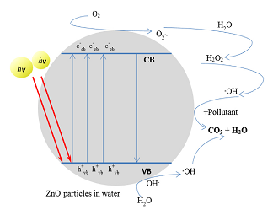
Figure 3.General mechanism of photocatalysis process by ZnO semiconductor
photocatalyst[38].

Semiconductor photocatalysis
Among the various techniques, semiconductor photocatalysisis a popularly employed process to degraded hazardous waste materials especially organic compounds to less toxic or less harmful products. And it involves the acceleration of photoreaction in the presence of semiconductor photocatalystnot conductors or insulators. Semiconducting oxide photocatalysts have been increasingly focused in recent years due to their potential applications in solar energy conversion and environmental purification and it has enormous potential to treat organic contaminants in water and air. In this regard, application of photocatalysis, especially photocatalysis using semiconductor particulate system, appears to be the most appealing mean than the more conventional chemical oxidation methods for decomposition of toxic compounds to non-hazardous product. This is because of the fact that semiconductors are: (i) inexpensive (ii) non-toxic (iii) having high surface area (iv) having broad absorption spectra with high absorption coefficients (v) exhibiting tunable properties which can be modified by size reduction, doping, sensitizers, etc. (vi) affording facility for multi electron transfer process and (vii) capable of extended use without substantial loss of photocatalytic activity[39]. There are various semiconductor photocatalysts as shown in fig. 4 below.
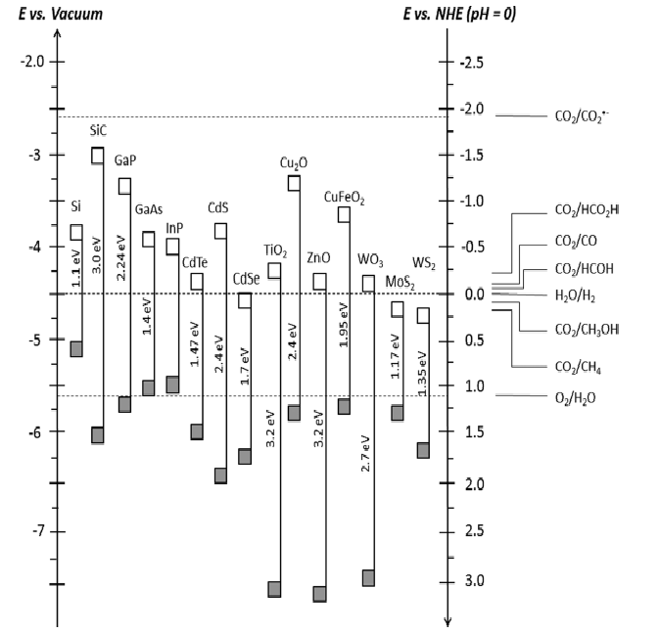
Figure 4. Conduction band and valance band potential of some commonly used semiconductor photocatalystswith the potentials of CO₂ and water redox couples at pH 0 versus vacuum and NHE [21].

Modification of ZnO semiconductor for harvesting visible light

Among manyphotocatalystsas shown in fig. 4, ZnOis an n-type semiconductor with a wide direct bandgap (3.37 eV), is widely used for degrading pollutants in water. Owing to its non-toxic properties, long-term stability, high carrier mobility, low cost and biocompatibility, ZnO also has many applications in other areas, such as gas sensors[40], solar cells [41], H₂ studies [42], field-effect transistors [43], ultraviolet lasers [44]and photocatalysis[45]. However, some drawbacks of ZnO limit its utilization in photocatalysis application. Due to its wide bandgap, ZnO can only be activated in the presence ofUV light, which constitutes only about 5% of the solar light energy reaching earth’s surface. Also, the photo excited electron-hole pairs recombine fast on the surface of ZnO, limiting its photocatalytic properties. This recombination of photo-generated hole (h⁺) in valance band and electron (e⁻) in conduction band is the major disadvantage in ZnO semiconductor photocatalysis which lowers the quantum yield and causes energy wasting. In order to copewith these problems, doping transition metals was employed to improve the optical properties of ZnO and to inhibit the recombination of photo-generated charge carriers. Its enhancement in the visible light photocatalytic performance can be ascribed to the metal ions substituted in the lattices of ZnO, which narrow the bandgap of ZnO and increase the delocalization of electrons in the nanostructure. Enhanced photocatalytic performances have been studied previously for ZnO doped with Mn²⁺ and Co²⁺[11], Ni [12], Cu[13], Cr [14] and Mg [15] ions. Furthermorelight response range of ZnO can be extended to visible region by coupling with a narrow bang gap semiconductor like Ag₂S [16][24].In this study CuFeO₂was used to extend ZnO absorption spectra to visible region and to reduce charge carrier recombination rate.

Cupper iron oxide semiconductor photocatalyst
CuFeO₂ are delafossites, and ternary metal oxides (ABO₂, where A is Cu, Ag, Pd, or Pt and B is a trivalent ion, such as Cr³⁺, Fe³⁺, Co³⁺ or Rh³⁺).Cu¹⁺Fe³⁺O₂ are a stable compound in the Cu–Fe–O system with nonmagnetic monovalent metal cations and magnetic trivalent cations. Distinguished from the wide number of the ternary oxides, CuFeO₂ has received special interests, because it exhibited exceptional electrical, optical and catalytic properties. One of the greatest advantages of CuFeO₂ is its long term chemical stability under neutral and alkaline conditions. Currently CuFeO₂ have received burgeoning attention because of their numerous applications in batteries and super capacitors[46], nano biomedicine[23], catalysis[47] and separations[48].Mostinterestingly, CuFeO₂ has drawn intense interest as photocatalyst because of good light absorption properties (band gap energy ∼1.95 eV), suitable band edge energy positions andgood stability in aqueous medium.The possible mechanism of photocatalysis process using coupled CuFeO₂/ZnOis shown in fig.1 above.

Synthesis methods of CuFeO₂ on ZnO nanoparticle
To synthesize delafossite CuFeO₂ several methods, including solid state reaction[48], atmospheric pressure plasma annealing[19], hydrothermal [23],pulsed laser deposition[49], Chemical solution deposition[50],radio-frequency sputtering technique[51], chemical co-precipitation[52], flux method[21],and sol-gel techniques with high temperature after treatment[22],electrochemical [21] and by simple dip coating method on florin tin oxide (FTO) coated glass substrate followed by post annealing [53] have been used.These methods are energy intensive and the produced thin film is predominantly micron in size[54].
In this study a simple, low-energy and short time consuming successive ionic layer adsorption and reaction (SILAR) synthesis method was used to gain high crystalline CuFeO₂.SILAR employs a similar self-limiting sequential layer-by-layer growth mechanism. It is one of the simplest solution methods, which is based on the sequential reactions at the substrate solution interface for the deposition of thin films. In this method the substrate is immersed separately to a dilute cation/anion precursor solution and rinsed between every immersion with flowing high-purity water. Both adsorptions of the film components and rinsing control the process.

In spite of its simplicity, SILAR has a number of advantages such as:(i) it is ideal for making uniform, compact and crystalline nanoparticles,(ii)it offers extremely easy way to dope film with virtually any element in any proportion by merely adding it in some form of the cationic solution, (iii)the deposition rate can be easily controlled over a wide range by changing the deposition cycles,(v) operating at room temperature can produce films on less robust materials,(vi) unlike high power methods such as radio frequency magnetron sputtering (RFMS), it does not cause local over heating that can be detrimental for materials to be deposited and there are virtually no restrictions on substrate material and dimensions or its surface profile.Moreover, it is relatively inexpensive, simple and convenient for large area deposition[55].
The critical operations for the deposition of thin films by SILAR methods are: (i) adsorption of the cations, (ii) rinsing with appropriate solvent, (iii) reaction of pre-adsorbed cationswith newly adsorbed anions and (iv) again rinsing with appropriate solvent[56], which is called one SILAR cycle.

CHAPTER THREE

EXPERIMENTAL DETAIL

Chemicals and reagents

All of the chemicals used in this study were purchased from available chemical vendors with analytical grade. ([Cu(NO₃)₂.3H₂O]>95%)and ([Fe(NO₃)₃.9H₂O]> 99%)were used as aqueous cation precursor solutions for Cu⁺ and Fe³⁺respectively,([NaOH]> 93%)was used as anion precursor solution, ([ZnO]> 99%)was used as substrate,[methylene blue, C₁₆H₁₈ClN₃S]>1%)was used as a dye anddistilled waterwas used for rinsing and solution preparation.

Apparatus and instruments
Centrifuge for filtration purpose, furnaces for annealing, distiller,electronic balance, magnetic stirrer, hot plate,mortar,XRDdiffractometer, FTIR spectrometer, UV/vis spectrometer, water bath,thermometer,different size volumetric flasks, micropipettes, beakers and other necessary apparatus were used for accomplishment of this work.

Synthesis of CuFeO₂ on ZnO nanoparticles
In this experiment all the chemicals used are of analytical grade and used without further purification. Commercial ZnOwas used to grow CuFeO₂ nanoparticle. 0.1M of[Fe(NO₃)₃.9H₂O]and [Cu(NO₃)₂.3H₂O] (1:1 ratio) were prepared as Fe³⁺ and Cu⁺ precursor solution respectively. 0.2 M of[NaOH]was prepared as anionic precursor solution. Initially 2 g of ZnO and 30ml of [Fe(NO₃)₃.9H₂O]solution were added in to 50ml beaker under magnetic stirring for 5 min whichleads adsorption of Fe³⁺ ions onZnO surface and centrifuged for separation. Thenit was rinsed with distill water to remove loosely bound Fe³⁺species and centrifuged, then 30 ml of anionic precursor (NaOH) solution was added into 50 ml beaker under magnetic stirringandwas heated at (45-48°C)for 5 min resulting theformation of Fe(OH)₃ on ZnO surface and centrifuged.Then it was rinsed with distill water to remove loosely bound Fe(OH)₃species and centrifuged which is called one SILAR cycle and this cycle was repeated up to six cycles.

The same procedure were followed to form Cu(OH)₂ on Fe(OH)₃/ZnO using [Cu(NO₃)₂.3H₂O] precursor solution. Then the produced Cu(OH)₂/ZnO/Fe(OH)₃ was driedat room temperature for 24 hoursand was grained for homogenizing. Then the grained powder was placed in an electric furnace at 400, 450, 500, 550 and 600°C for 2 hours in air and was removed from the furnace to be cooled down to room temperature.

Characterization of CuFeO₂/ZnOnanoparticles

The prepared nanoparticles was characterized by X-ray diffraction (XRD)studies using X-ray diffractometer (Bruker, D-8 Advance) with Cu target Kα radiationof wavelength λ=1.5406 Å,on the instrument operating at a voltage of 40 kV and a current of 30 mA) radiation over a 2𝜃 collection range of 10–80°to obtain crystallinephase information. The vibrational frequency of CuFeO₂/ZnO nanostructure was analyzed using Fourier transform infrared spectroscopy (FTIR) in 400-2000 cm⁻¹region.FTIR measurement was performed with pressed pellets made using potassium bromide (KBr) powder as diluent. The optical properties were studied through absorbance measurements by UV/vis spectrophotometer by recording the spectra over the 200–800 nm range.

Measurements of photocatalytic activities
The photocatalytic activities of synthesized CuFeO₂/ZnOphotocatalyst were evaluated through timedependent photo-degradation of MB solution as a model pollutant under 100 W lamps for 60 min. In a typical photocatalytic activity measurement, 0.05 g of CuFeO₂/ZnOpowder was dispersed in 250 mL of MB solution (40 ppm) under magnetic stirring. Before light irradiation, the suspensions were magnetically stirred in dark for 30 min for adsorption of MB over the photocatalyst surface. Then, the photoreaction vessel was exposed to 100 W lamps under ambient conditions and was stirred. With10 min intervals, 10 ml of the suspension was collected and centrifuged for 5 min to remove the remnant photocatalyst. UV/vis spectrometer recording the spectra over 200–800 nm range was used for the determination of MB concentration to follow its kinetics of disappearance.

Trapping experiment
In order to have insights into the photocatalytic mechanism of the CuFeO₂/ZnOnanocomposite system, trapping experiments were conducted to elucidate the reactive radicals involved in the reaction processes of MB degradation by introducing different trapping agents such as silver nitrate, ethylene diamine tetra-acetic acid and isopropyl alcohol. They were introduced into to the degradation process to trap electrons (e⁻), holes (h⁺) and hydroxyl radicals (·OH) respectively.Allof these trapping agents were prepared in 5 mmol concentration. The detailed experimental protocol was the same as for the photo degradation experiments as discussed above.

CHAPTER FOUR

RESULTS AND DISCUSSION
In this section, presented the results obtained and the discussion we made for the synthesis of CuFeO₂ on ZnO by SILAR method, its characterization using spectroscopic techniques (XRD, FTIR and UV/vis) and photocatalytic activity of the synthesized CuFeO₂/ZnO for degradation of methylene blue.
- XRD studies
The formation of CuFeO₂onZnO was observed with X-ray diffraction patternat different temperatures 400-600 °C for 2 hours in airas shown in fig. 5.The results obtained shows similar patterns at all temperatures but, the intensity of the peak increases as temperature increase from 400 to 600°C which is due to increasing the crystalinity of the nanoparticles. This indicatesbetter crystalline phase of CuFeO₂ is formedat annealing temperature of 600°C.The XRD results show the peaks at 2θ =30.24°, 35.98°, 43.92°, 49.08°, 55.18°, 61.21°, 70.18° and 72.78° which are the diffractions from CuFeO₂ based on standard crystallographic data (JCPDS # 85-0605).The characteristic peaks we have obtained for CuFeO₂are in good agreement with previous experimental findings[57, 58].We have also obtained the peak at 2θ=38.9° which is the diffraction from CuObased on standard crystallographic data (JCPDS card # 75-2146). Similarly,we haveobtained thepeak at 2θ =35.7° dueto thediffraction from Fe₂O₃based on standard crystallographic data (JCPDS card # 89-0597). Moreover, the peaks at 2θ =48.89°, 53.43°and 66.39° are diffractions from CuFe₂O₄based on standard crystallographic data (JCPDS card #34–0425). Furthermore,we have the peaks at 2θ =31.85°, 34.55°, 47.5° and 67.92° are the diffractions from ZnObased on standard crystallographic data(JCPDS card # 79-2205).The broad nature of the diffraction peaks of the CuFeO₂ suggests the nanocrystalline nature of the material.Residues of CuFe₂O₄, CuO and Fe₂O₃wereobserved as impurities. The phase diagram of the bulk Fe–Cu–O ternary system when CuO and Fe₂O₃ react in air, favorably form CuFe₂O₄.Also pure delafossite type CuFeO₂ is converted from spinel type CuFe₂O₄ with residual CuO[59].

The impurities CuFe₂O₄ andCuOare observed due to the presence of oxygen from air because the reaction of CuFeO₂with oxygen leads CuO and CuFe₂O₄.CuFeO₂ powder requires intermediate regrinding during calcination in an oxygen-free atmosphere, such as nitrogen gas [60, 61].The result obtained in this study indicates that the desired CuFeO₂ is synthesized.
The crystallite size (D) of CuFeO₂ nanoparticleswas calculated from the full-width at half-maximum from XRD patterns by using Debye Scherer equation [58].
$$D=\frac{0.9λ}{βcosθ} (1)$$
where D is the crystallite size, λ= 0.15406 nm which is the wavelength of the X-ray for Cutarget Kα radiation, β is the peak width at halfmaximum of an XRD, and θ is theBragg diffraction angle. The most intense peak in the XRD patterns was used to calculatethe crystalline size. The crystalline sizeof CuFeO₂ nanoparticle is 22.59 nm.
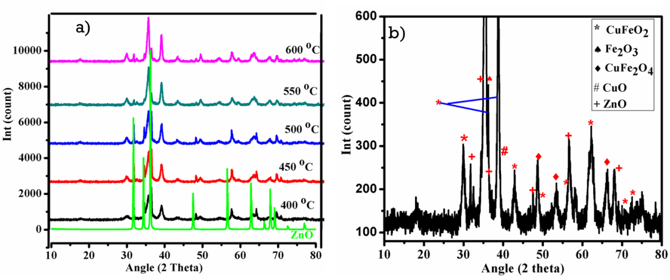
Figure5.XRD patterns of CuFeO₂prepared on ZnO(a) at 400-600 °C andZnO and (b) at 600 °C for 2 hours in air.

- FTIR studies
The FTIR spectrum of mixed phase formation of coupled CuFeO₂/ZnOnanoparticlesand the metal oxide bond present in the compound was analyzed in therange 400-2000 cm⁻¹as shown in fig. 6. The FTIR spectrum shows a significant band in the range 1635-1530 cm⁻¹ which indicates the presence of hydroxyl residue which might be due to the atmospheric moisture. The peak in the range1340-1390 cm⁻¹indicates the presence of Cu-Fe bond. The peak ~530 cm⁻¹ correspond to the presence of Fe-O bond stretching[62] and the peak~420 cm⁻¹ indicate the characteristic stretching mode of Zn-O[63]. The result we have obtainedindicates the presence of Cu-Fe-O bonding system.
Figure 6. FTIR spectrum of (a) ZnO and (b) coupled CuFeO₂/ZnO nanoparticles.

- UV/vis absorption study
The optical absorption spectra of the synthesized photocatalyst CuFeO₂/ZnOnanoparticleweremeasured using UV/vis spectrometer in the range 200–800 nm.UV/vis absorption spectrum primarily represents the available change in the energy band gap. The UV/vis absorption spectra shows remarkably enhanced visible light absorption property of CuFeO₂/ZnOas shown in fig. 7a.ZnO exhibit absorption spectra in UV region with energy band gap 3.2 eV[64], butwe synthesizedCuFeO₂/ZnO nanoparticles which have absorbance in the visible regionwith energy band gap 2.0 eV.The result we have obtained indicates CuFeO₂, has favorable optical band gap energy and is suitable for enhancing visible light absorption of ZnO.
The band gap energy (E_{g}) of CuFeO₂/ZnO nanoparticleswas analyzed by Tauc’s method which can be expressed as,
$$({αhν)}^{m}=hv-E_{g} (2)$$
whereh is the Planck constant, v is the frequency of irradiation light, α is the absorption coefficient and m is 1/2or 2 for direct and indirect allowed transitions respectively. The x-intercept of the tangent to the Tauc plot (αhν)²versushv gives a good approximation of the bandgap energy for this direct bandgap material.The optical direct band gap of CuFeO₂/ZnO nanoparticleswas estimated to be 2.0eV by extrapolating the straightportion of the curve as shown in fig.7b. This indicates that after coupling of ZnO (3.2 eV) with CuFeO₂which have a band gap of 1.95 eV the band gap of CuFeO₂/ZnO is 2.0 eV. Therefore band gap of ZnO is modified from 3.2 to 2.0eV.

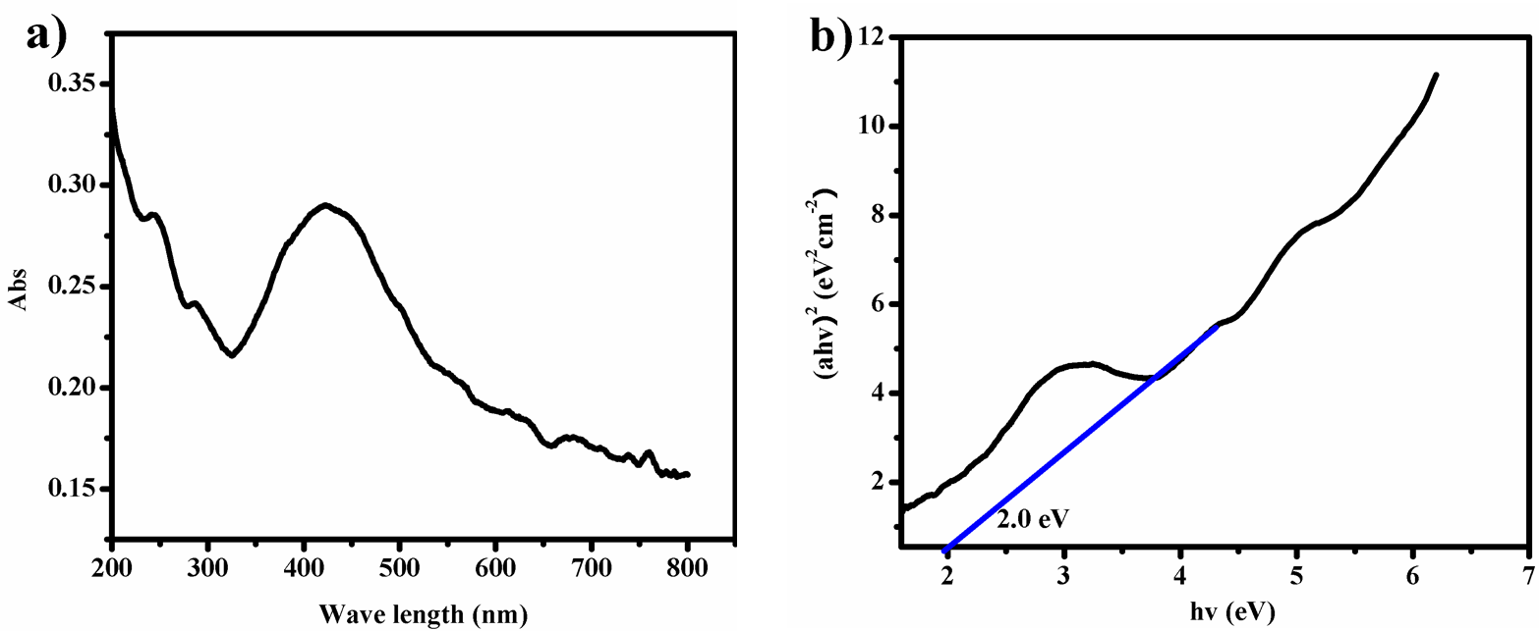
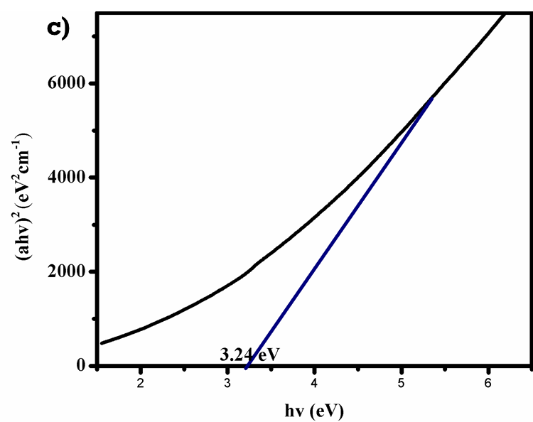
Figure7.(a) UV/vis spectrumand(b) optical energy band gapofCuFeO₂/ZnO nanoparticles and (c) optical energy band gap of ZnO.
- Photocatalytic activity measurements
The photodegradation of MB under simulated light was studied by measuring the decrease in the absorbance of the MB in the presence of synthesizedCuFeO₂/ZnOphotocatalyst. The photocatalytic degradation curves of MB with CuFeO₂/ZnOphotocatalystdecreases with increasing in time of exposure, indicating a decrease in the concentration of MB dye oroccurring of MB degradation. This is because of the enhanced visible light absorption property of ZnO after coupling with CuFeO₂ as shown in fig.7a, which results the generation of large number of charge carriers. The generation of the large number of charge carriers is due to high intensity visible light absorption which makes it most effective with maximum efficiency. Many literatures have been concluded that reducing the probability of charge carrier recombination rate is one the most significant factor that determines the photocatalyticefficiency.
The catalyst degradation efficiency (degradation rate) was calculated using [65],
$$Degradation \left(\%\right)=\left(\frac{C_{o}-C}{C_{o}}\right)*100\%=\left(\frac{A_{o}-A}{A_{o}}\right)*100\% (3)$$
where$C_{o}$ and C are the initial and the final concentrations and A_{o} and A are the initial and final absorbance of organic pollutants respectively.
CuFeO₂/ZnO nanoparticle shows 85.6 % degradation of MB solution in 60 min, and owns the excellent photocatalytic performance in comparison with commercial ZnOas reported by previous reports which hasdegradationefficiency as shown in table1 below. The photocatalytic experiments reveal that the coupled CuFeO₂/ZnO significantly enhances the photocatalytic activity of ZnOphotocatalyst.The high photocatalytic performance of the CuFeO₂/ZnO nanoparticle is mainly attributed to the large specific surface area, small crystal size and enhanced visible light absorption capacity due to coupling of CuFeO₂ onZnO. Almost total disappearance of the color of MB was observed within 60 min, which indicates CuFeO₂/ZnO nanoparticle can efficiently degrade MB dye.
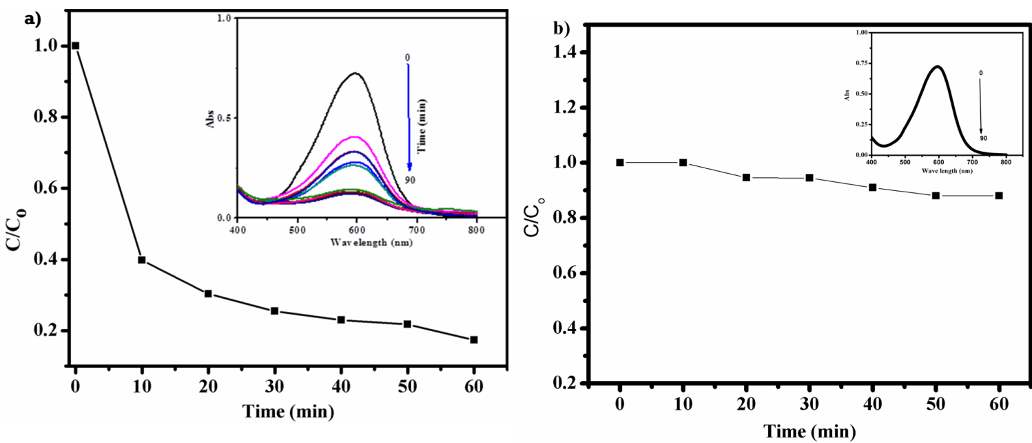
Figure 8.Photocatalytic degradation profiles of MB (a)with and (b) without CuFeO₂/ZnOphotocatalyst under light irradiation.
Table 1: Comparative study on catalytic efficiency and time taken for degradation of different dyes in the presence of bareand modified ZnOphotocatalyst under visible light irradiation.
System | Dye | % Degradation | Time taken for  degradation (min) | References
ZnO | Eosin red Malachite green | 73  67.65 | 60 | [66]
Cu-doped ZnO | Methylene blue | 90 | 480 | [67]
ZnO | Methyl orange | 70 | 90 | [68]
Commercial ZnO  N-doped ZnO | Malachite green | 52  80 | 120  90 | [69]
ZnO/reduced graphite oxide | Methylene blue | 88 | 260 | [25]
CuFeO₂/ZnO | Methylene blue | 85.6 | 60 | Present work
- Kinetics forphotocatalytic degradation of methylene blue dye
The kinetics of degradation of MB under light irradiation on the catalyst surface was studied by plotting ln(C_{o}/C) versusreaction time.The observed kinetic data shows a linear correlation of the ln(C_{o}/C)versustime as depicted in fig. 9whichfits with the pseudo first-order reaction kinetic model.
The rate constant of photo degradation was calculated with the expression given below[38, 70]:
$$ln\left(\frac{C_{o}}{C}\right)=kt (4)$$
where k is the rate constant (min⁻¹), C_{o} is the initial concentration of target dye and C is the concentration of MBat time t.From the linear fitting curves of ln(C_{o}/C) versus irradiation timethe MB degradation rate constant k was calculated to be 2.910⁻² min⁻¹.
Figure 9.Linear kinetic simulation curves of MB usingCuFeO₂/ZnOphotocatalyst under light irradiation.
- Trapping of active species
In order to have insights into the photocatalytic mechanism of the CuFeO₂/ZnOnano-composite system,trapping experiments was conducted by introducing different trapping agents to elucidate the reactive radicals involved in the reaction processes of MB degradation. It can be clearly observed from the bar graphs that with the addition of EDTA and IPA, the % degradation of MB drops to 11.5 and 60.3% respectively indicating the major role is played by hydroxide radical (˙OH) and hole (h⁺). Moreover, in the presence of AgNO₃, the % degradation obtained was almost the same as that in absence of scavenger (around 85.3%) indicating that electrons (e⁻) are not the active species in photocatalytic degradation of MB. Thus from the results we obtained, we can conclude that the hole is the most active species which plays a vital role in the degradation of MB.
Figure 10.Photocatalytic degradation of MB over the CuFeO₂/ZnOalone and in the presence of different scavengers (i.e., AgNO₃, EDTA and IPA).

CHAPTER FIVE

CONCLUSION AND RECOMENDATION
  - Conclusion
In the present study, we have reported the successful synthesis of visible light harvested CuFeO₂/ZnOnanoparticles by usingSILAR method at room temperature.The structural characterization of CuFeO₂/ZnOnanoparticles has been done by analyzing the results obtained from XRD, FTIR and UV/visspectroscopic measurements. The results obtained using the XRDindicates that the desired CuFeO₂/ZnO nanoparticles were synthesized with crystalline size (D) of 22.59 nm. The results obtained from FTIR spectrum shows the peak in the range of 1340-1390 cm⁻¹, at ~530 cm⁻¹ and at ~420 cm⁻¹ which corresponds for Cu-Fe, Fe-O and Zn-O bond stretching, respectively. Similarly, the result obtained fromUV/vis measurement indicates a red shift in the absorption spectra of ZnO from ultra-violentto visible region due to coupling of CuFeO₂ on ZnO nanoparticles.The photocatalytic applicability ofCuFeO₂/ZnO nanoparticle as visible light driven photocatalystfor the degradation of organic dyes has been estimated using MB as test pollutants as a function of time. This result demonstrates the presence of CuFeO₂/ZnOnanoparticleenhances the photocatalytic degradation of MB dye. In this study, we have obtained 85.6 % degradation of MB in 60 minutes of irradiation time by using CuFeO₂/ZnO nanoparticles and this result is higher than the percent degradation of MB obtained by other researchers using ZnO. The improvement of the photocatalytic efficiency for the CuFeO₂/ZnO nanoparticlecan be attributed to the presence of the CuFeO₂. Furthermore, the trapping experiment was carried out using different scavengers for active hole (h⁺), electron (e⁻) and hydroxide radical (˙OH) species. Among the active species, hole is the most active specie which plays a vital role in the degradation of MB.

  - Recommendation
As recommendation, the SILAR method we used in this research work can be further used to synthesize other metal oxide compositesand these materials will find great potential applications in the degradation of organic pollutantsfrom wastewater. The photocatalytic efficiency of ZnO can be enhanced by coupling with narrow band gap semiconductors.

REFERENCE
1. Houas A., H. Lachheb, M. Ksibi, E. Elaloui, C. Guillard, and J. M. Herrmann, Photocatalytic degradation pathway of methylene blue in water. Applied Catalysis B: Environmental, 2001. 31(2): p. 145-157.
2. Guesh K., Á. Mayoral, C. Márquez-Álvarez, Y. Chebude, and I. Díaz, Enhanced photocatalytic activity of TiO2 supported on zeolites tested in real wastewaters from the textile industry of Ethiopia. Microporous and Mesoporous Materials, 2016. 225: p. 88-97.
3. Goswami D.Y., Decontamination of Ventilation Systems Using Photocatalytic Air Cleaning Technology. Journal of Solar Energy Engineering, 2003. 125(3): p. 359-365.
4. Liang Y., H. Wang, H. Sanchez Casalongue, Z. Chen, and H. Dai, TiO2 Nanocrystals Grown on Graphene as Advanced Photocatalytic Hybrid Materials. 2010.
5. Gaya U.I. and A.H. Abdullah, Heterogeneous photocatalytic degradation of organic contaminants over titanium dioxide: A review of fundamentals, progress and problems. Journal of Photochemistry and Photobiology C: Photochemistry Reviews, 2008. 9(1): p. 1-12.
6. Qu Y. and X. Duan, Progress, challenge and perspective of heterogeneous photocatalysts. Chemical Society Reviews, 2013. 42(7): p. 2568-2580.
7. Nouri H. and A. Habibi-Yangjeh, Microwave-Assisted method for preparation of Zn1-xMgxO nanostructures and their activities for photodegradation of methylene blue. Vol. 25. 2014.
8. O'Regan B. and M. Grätzel, A low-cost, high-efficiency solar cell based on dye-sensitized colloidal TiO2 films. Nature, 1991. 353: p. 737.
9. Hoffmann M.R., S.T. Martin, W. Choi, and D.W. Bahnemann, Environmental Applications of Semiconductor Photocatalysis. Chemical Reviews, 1995. 95(1): p. 69-96.
10. Rahman Q.I., M. Ahmad, S.K. Misra, and M. Lohani, Effective photocatalytic degradation of rhodamine B dye by ZnO nanoparticles. Materials Letters, 2013. 91: p. 170-174.
11. Li W., G. Wang, C. Chen, J. Liao, and Z. Li, Enhanced Visible Light Photocatalytic Activity of ZnO Nanowires Doped with Mn(2+) and Co(2+) Ions. Nanomaterials, 2017. 7(1): p. 20.
12. Chen P. Y. and S. H. Yang, Improved efficiency of perovskite solar cells based on Ni-doped ZnO nanorod arrays and Li salt-doped P3HT layer for charge collection. Optical Materials Express, 2016. 6(11): p. 3651-3669.
13. Mohan R., K. Krishnamoorthy, and S. Kim, Enhanced photocatalytic activity of Cu-doped ZnO nanorods. Vol. 152. 2012. 375-380.
14. Meng, A., J. Xing, Z. Li, and Q. Li, Cr-Doped ZnO Nanoparticles: Synthesis, Characterization, Adsorption Property, and Recyclability. ACS Applied Materials & Interfaces, 2015. 7(49): p. 27449-27457.
15. Etacheri V., R. Roshan, and V. Kumar, Mg-Doped ZnO Nanoparticles for Efficient Sunlight-Driven Photocatalysis. ACS Applied Materials & Interfaces, 2012. 4(5): p. 2717-2725.
16. Khanchandani S., P.K. Srivastava, S. Kumar, S. Ghosh, and A.K. Ganguli, Band Gap Engineering of ZnO using Core/Shell Morphology with Environmentally Benign Ag2S Sensitizer for Efficient Light Harvesting and Enhanced Visible-Light Photocatalysis. Inorganic Chemistry, 2014. 53(17): p. 8902-8912.
17. Haydar S. and J.A. Aziz, Coagulation–flocculation studies of tannery wastewater using combination of alum with cationic and anionic polymers. Journal of Hazardous Materials, 2009. 168(2): p. 1035-1040.
18. Li J. and N. Wu, Semiconductor-based photocatalysts and photoelectrochemical cells for solar fuel generation: a review. Catalysis Science & Technology, 2015. 5(3): p. 1360-1384.
19. Chen H. Y. and J.-R. Fu, Delafossite–CuFeO2 thin films prepared by atmospheric pressure plasma annealing. Materials Letters, 2014. 120: p. 47-49.
20. Derbal A., S. Omeiri, A. Bouguelia, and M. Trari, Characterization of new heterosystem CuFeO2/SnO2 application to visible-light induced hydrogen evolution. International Journal of Hydrogen Energy, 2008. 33(16): p. 4274-4282.
21. Read C.G., Y. Park, and K. S. Choi, Electrochemical Synthesis of p-Type CuFeO2 Electrodes for Use in a Photoelectrochemical Cell. The Journal of Physical Chemistry Letters, 2012. 3(14): p. 1872-1876.
22. Chen H. Y. and J. H. Wu, Transparent conductive CuFeO2 thin films prepared by sol–gel processing. Applied Surface Science, 2012. 258(11): p. 4844-4847.
23. Sheets W.C., E. Mugnier, A. Barnabé, T.J. Marks, and K.R. Poeppelmeier, Hydrothermal Synthesis of Delafossite-Type Oxides. Chemistry of Materials, 2006. 18(1): p. 7-20.
24. Moosvi S.K., K. Majid, and T. Ara, Study of Thermal, Electrical, and Photocatalytic Activity of Iron Complex Doped Polypyrrole and Polythiophene Nanocomposites. Industrial & Engineering Chemistry Research, 2017. 56(15): p. 4245-4257.
25. Ahmad J. and K. Majid, Enhanced visible light driven photocatalytic activity of CdO-graphene oxide heterostructures for the degradation of organic pollutants. New Journal of Chemistry, 2018. 42(5): p. 3246-3259.
26. Sheng J., Y. Xie, and Y. Zhou, Adsorption of methylene blue from aqueous solution on pyrophyllite. Applied Clay Science, 2009. 46(4): p. 422-424.
27. Sadasivam S., P. R Varadarajan, K. Porkodi, and C. V Subbhuraam, Adsorption of Methylene Blue onto Jute Fiber Carbon: Kinetics and Equilibrium Studies. Vol. 284. 2005. 78-82.
28. Soon A.N. and B.H. Hameed, Degradation of Acid Blue 29 in visible light radiation using iron modified mesoporous silica as heterogeneous Photo-Fenton catalyst. Applied Catalysis A: General, 2013. 450: p. 96-105.
29. Barakat M.A., New trends in removing heavy metals from industrial wastewater. Arabian Journal of Chemistry, 2011. 4(4): p. 361-377.
30. Zhou M., Q. Tan, Q. Wang, Y. Jiao, N. Oturan, and M.A. Oturan, Degradation of organics in reverse osmosis concentrate by electro-Fenton process. Journal of Hazardous Materials, 2012. 215-216: p. 287-293.
31. Rengaraj S., K. H. Yeon, and S. H. Moon, Removal of chromium from water and wastewater by ion exchange resins. Journal of Hazardous Materials, 2001. 87(1): p. 273-287.
32. Akpan U.G. and B.H. Hameed, Parameters affecting the photocatalytic degradation of dyes using TiO2-based photocatalysts: A review. Journal of Hazardous Materials, 2009. 170(2): p. 520-529.
33. Hachem C., F. Bocquillon, O. Zahraa, and M. Bouchy, Decolourization of textile industry wastewater by the photocatalytic degradation process. Dyes and Pigments, 2001. 49(2): p. 117-125.
34. Rochkind M., S. Pasternak, and Y. Paz, Using Dyes for Evaluating Photocatalytic Properties: A Critical Review. Molecules, 2015. 20(1): p. 88.
35. White J.L., M.F. Baruch, J.E. Pander, Y. Hu, I.C. Fortmeyer, J.E. Park, T. Zhang, K. Liao, J. Gu, Y. Yan, T.W. Shaw, E. Abelev, and A.B. Bocarsly, Light-Driven Heterogeneous Reduction of Carbon Dioxide: Photocatalysts and Photoelectrodes. Chemical Reviews, 2015. 115(23): p. 12888-12935.
36. Srinivasan S.S., J. Wade, E.K. Stefanakos, and Y. Goswami, Synergistic effects of sulfation and co-doping on the visible light photocatalysis of TiO2. Journal of Alloys and Compounds, 2006. 424(1): p. 322-326.
37. Doll T.E. and F.H. Frimmel, Removal of selected persistent organic pollutants by heterogeneous photocatalysis in water. Catalysis Today, 2005. 101(3): p. 195-202.
38. Azmina M.S., R. Md Nor, H.A. Rafaie, N.S.A. Razak, S.F.A. Sani, and Z. Osman, Enhanced photocatalytic activity of ZnO nanoparticles grown on porous silica microparticles. Applied Nanoscience, 2017. 7(8): p. 885-892.
39. Chatterjee D., Visible light induced photocatalytic degradation of organic pollutants. 2015.
40. Liao J., Z. Li, G. Wang, C. Chen, S. Lv, and M. Li, ZnO nanorod/porous silicon nanowire hybrid structures as highly-sensitive NO2 gas sensors at room temperature. Physical Chemistry Chemical Physics, 2016. 18(6): p. 4835-4841.
41. Kumar R., A. Umar, G. Kumar, H.S. Nalwa, A. Kumar, and M.S. Akhtar, Zinc oxide nanostructure-based dye-sensitized solar cells. Journal of Materials Science, 2017. 52(9): p. 4743-4795.
42. Steinfeld A., Solar hydrogen production via a two-step water-splitting thermochemical cycle based on Zn/ZnO redox reactions. International Journal of Hydrogen Energy, 2002. 27(6): p. 611-619.
43. Wang G., Z. Li, M. Li, J. Liao, C. Chen, S. Lv, and C. Shi, Enhanced field-emission of silver nanoparticle-graphene oxide decorated ZnO nanowire arrays. Physical Chemistry Chemical Physics, 2015. 17(47): p. 31822-31829.
44. Johnson J.C., H. Yan, R.D. Schaller, L.H. Haber, R.J. Saykally, and P. Yang, Single Nanowire Lasers. The Journal of Physical Chemistry B, 2001. 105(46): p. 11387-11390.
45. Di Mauro A., M.E. Fragalà, V. Privitera, and G. Impellizzeri, ZnO for application in photocatalysis: From thin films to nanostructures. Materials Science in Semiconductor Processing, 2017. 69: p. 44-51.
46. Viswanathan V., K.L. Pickrahn, A.C. Luntz, S.F. Bent, and J.K. Nørskov, Nanoscale Limitations in Metal Oxide Electrocatalysts for Oxygen Evolution. Nano Letters, 2014. 14(10): p. 5853-5857.
47. Doong R. a., R.S. Varma, V.K. Sharma, D.D. Dionysiou, and H. Kim, eds. Ferrites and Ferrates: Chemistry and Applications in Sustainable Energy and Environmental Remediation. ACS Symposium Series. Vol. 1238. 2016, American Chemical Society. 0.
48. Mugnier E., A. Barnabé, and P. Tailhades, Synthesis and characterization of CuFeO2+δ delafossite powders. Solid State Ionics, 2006. 177(5): p. 607-612.
49. Li S.Z., J. Liu, X.Z. Wang, B.W. Yan, H. Li, and J.M. Liu, Epitaxial growth of delafossite CuFeO2 thin films by pulse laser deposition. Physica B: Condensed Matter, 2012. 407(13): p. 2412-2415.
50. Zhang L., P. Li, K. Huang, Z. Tang, G. Liu, and Y. Li, Chemical solution deposition and transport properties of epitaxial CuFeO2 thin films. Materials Letters, 2011. 65(21): p. 3289-3291.
51. Barnabé A., E. Mugnier, L. Presmanes, and P. Tailhades, Preparation of delafossite CuFeO2 thin films by rf-sputtering on conventional glass substrate. Materials Letters, 2006. 60(29): p. 3468-3470.
52. Omeiri S., Y. Gabès, A. Bouguelia, and M. Trari, Photoelectrochemical characterization of the delafossite CuFeO2: Application to removal of divalent metals ions. Journal of Electroanalytical Chemistry, 2008. 614(1): p. 31-40.
53. Riveros G., C. Garín, D. Ramírez, E.A. Dalchiele, R.E. Marotti, C.J. Pereyra, E. Spera, H. Gómez, P. Grez, F. Martín, and J.R. Ramos-Barrado, Delafossite CuFeO2 thin films electrochemically grown from a DMSO based solution. Electrochimica Acta, 2015. 164: p. 297-306.
54. Zhang Y., Z. R. Tang, X. Fu, and Y. J. Xu, TiO2−Graphene Nanocomposites for Gas-Phase Photocatalytic Degradation of Volatile Aromatic Pollutant: Is TiO2−Graphene Truly Different from Other TiO2−Carbon Composite Materials? ACS Nano, 2010. 4(12): p. 7303-7314.
55. Becker M.A., J.G. Radich, B.A. Bunker, and P.V. Kamat, How Does a SILAR CdSe Film Grow? Tuning the Deposition Steps to Suppress Interfacial Charge Recombination in Solar Cells. The Journal of Physical Chemistry Letters, 2014. 5(9): p. 1575-1582.
56. More A.M., J.L. Gunjakar, C.D. Lokhande, and O.S. Joo, Fabrication of hydrophobic surface of titanium dioxide films by successive ionic layer adsorption and reaction (SILAR) method. Applied Surface Science, 2009. 255(12): p. 6067-6072.
57. Bera A., K. Deb, K.K. Chattopadhyay, R. Thapa, and B. Saha, Mixed phase delafossite structured p type CuFeO2/CuO thin film on FTO coated glass and its Schottky diode characteristics. Microelectronic Engineering, 2016. 162: p. 23-26.
58. Omran Alkhayatt A.H., S.M. Thahab, and I.A. Zgair, Structure, surface morphology and optical properties of post-annealed delafossite CuFeO2 thin films. Optik - International Journal for Light and Electron Optics, 2016. 127(8): p. 3745-3749.
59. Katkov A.E. and A.A. Lykasov, Spinel Phase Relations in the Fe3O4–CuFe2O4 System. Inorganic Materials, 2003. 39(2): p. 171-174.
60. Aktas O., K.D. Truong, T. Otani, G. Balakrishnan, M.J. Clouter, T. Kimura, and G. Quirion, Raman scattering study of delafossite magnetoelectric multiferroic compounds: CuFeO 2 and CuCrO 2. Journal of Physics: Condensed Matter, 2012. 24(3): p. 036003.
61. Chiu T. W. and P. S. Huang, Preparation of delafossite CuFeO2 coral-like powder using a self-combustion glycine nitrate process. Ceramics International, 2013. 39: p. S575-S578.
62. Maji S.K., N. Mukherjee, A. Mondal, and B. Adhikary, Synthesis, characterization and photocatalytic activity of α-Fe2O3 nanoparticles. Polyhedron, 2012. 33(1): p. 145-149.
63. Lavand A.B. and Y.S. Malghe, Synthesis, characterization and visible light photocatalytic activity of carbon and iron modified ZnO. Journal of King Saud University - Science, 2018. 30(1): p. 65-74.
64. Lavand A. and Y. Malghe, Synthesis, characterization and visible light photocatalytic activity of nitrogen-doped zinc oxide nanospheres. Vol. 95. 2015.
65. Hosseini S.M., I.A. Sarsari, P. Kameli, and H. Salamati, Effect of Ag doping on structural, optical, and photocatalytic properties of ZnO nanoparticles. Journal of Alloys and Compounds, 2015. 640: p. 408-415.
66. Meena S., D. VAYA, and B.K. Das, Photocatalytic degradation of Malachite Green dye by modified ZnO nanomaterial. Bulletin of Materials Science, 2016. 39(7): p. 1735-1743.
67. Jongnavakit P., P. Amornpitoksuk, S. Suwanboon, and N. Ndiege, Preparation and photocatalytic activity of Cu-doped ZnO thin films prepared by the sol–gel method. Vol. 258. 2012. 8192–8198.
68. Guo M.Y., A.M.C. Ng, F. Liu, A.B. Djurišić, W.K. Chan, H. Su, and K.S. Wong, Effect of Native Defects on Photocatalytic Properties of ZnO. The Journal of Physical Chemistry C, 2011. 115(22): p. 11095-11101.
69. Lavand A.B. and Y.S. Malghe, Synthesis, characterization and visible light photocatalytic activity of nitrogen-doped zinc oxide nanospheres. Journal of Asian Ceramic Societies, 2015. 3(3): p. 305-310.
70. Zhang N., D. Chen, F. Niu, S. Wang, L. Qin, and Y. Huang, Enhanced visible light photocatalytic activity of Gd-doped BiFeO3 nanoparticles and mechanism insight. Vol. 6. 2016. 26467.

