BAHIR DAR UNIVERSITY
COLLEGE OF SCIENCE
DEPARTMENT OF CHEMISTRY
POSTGRDUATE PROGRAM


Synthesis, Characterization and Photocatalytic Activity of Iron Titanium Oxide/Zinc Oxide Nanostructure for Degradation of Organic Dye in Waste Water

By
Gidena Gebreegziabiher

June, 2018
Bahir Dar, Ethiopia

Title on Synthesis, Characterization and Photocatalytic Activity of Iron Titanium Oxide/Zinc Oxide Nanostructure for Degradation of Organic Dye in Waste Water

A Thesis
Submitted to Chemistry Department in Partial Fulfillment of the Requirement for the Degree of Master Sience of Chemistry (Physical Chemistry) in Bahir Dar University

By
Gidena Gebreegziabiher

Advisor: Belete Asefa (PhD.)

Declaration
I hereby declare that, this thesis entitled “Synthesis, Characterization and Photocatalytic Activity of Iron Titanium Oxide/Zinc Oxide Nanostructure for Degradation of Organic Dye in Waste Water” and the work presented in it are my original work and has not been presented for a degree in any other university and that all sources have been appropriately acknowledged.

Student’s Name: Gidena Gebreegziabiher
Signature:
Date:

Name of adviser: Belete Asefa (PhD.)
Signature:
Date:

Approval Sheet
The thesis entitled “Synthesis, Characterization and Photocatalytic Activity of Iron Titanium Oxide/Zinc Oxide Nanostructure for Degradation of Organic Dye in Waste Water” by Ms. Gidena Gebreegziabiher is approved for the degree of Master of Science in Chemistry.

Board of Examiners

Signature Date

Name of adviser: Belete Asefa (PhD.) ______________ _____________

External examiner: _______________ ________________ _______________

Internal examiner: ________________ ________________ _______________

Chairman: _________________ ________________ _______________

Place and date: Bahir Dar University, Bahir Dar
June, 2018

Acknowledgement
I would like to express my heartfelt gratitude to Dr. Belete Asefa for his continuous support of my MSc study. I could not have asked for a better role model, inspirational, supportive, and patient. Without his warm encouragement and thoughtful guidance, I had no chance to complete this thesis.
I owe my deep gratitude to Dr. Muluken Aklilu whose kindness, as well as their academic experience, has been invaluable to me. The laboratory demonstrating job offered by Dr. Muluken Aklilu and laboratory technicals was a great help for my job, and wonderful chance for me to improve my knowledge.
My sincere gratitude must go to express my deepest love, respect, and admiration to my entire family for their unconditional support, understanding and dedication throughout these years. They poured their love and time to me after their retirement, took good care of me and guided me through my youth. I am also especial grateful to my mother w/o Abeba Tadesse who always encouraged me and praised my work, supported me morally and financially with great pleasure.
I am also thankful to my colleagues and friends, Addise, Eyerusalem, Wubalem and Mestawot who have been always ready to help me for my research without return, given me trainings on various equipment and software.
I would like to thank Chemistry Department, College of Science, and Bahir Dar University for the golden chance to fulfill my second degree and financial support from the Ministry of Education is gratefully acknowledged.

Abstract

Even today the efficient treatment of industrial waste water is not evident. The effluents may contain large amounts of harmful organic compounds that are not easily removed with conventional methods. Several semiconductors can act as photocatalysts but ZnO has been most commonly studied due to its ability to break down organic pollutants. A photocatalytic property of ZnO makes it close to an ideal catalyst due to its reduced toxicity and chemical stability, but its efficiency is limited by its large bandgap absorbs only in the UV light which accounts only 2-5% of the spectrum. Coupling ZnO with FeTiO₃ visible light absorber semiconductor improves the efficiency of photodegradation of organic pollutants. This study focused on the synthesis and characterization of FeTiO₃/ZnO semiconductor nanoparticle for the application of photocatalytic degradation of organic dye in waste water. FeTiO₃ was directly grown on surface of ZnO using the simple and inexpensive SILAR method. UV-Visible spectroscopy was used to characterize the optical property for the investigation of 2.1eV Eg, 3.467*10⁻² min⁻¹ rate constant fitted by a pseudo-first-order reaction and 84.85% photodegradation of Methylene blue (MB) and form the trapping experiment the most active specie was hole with 11.82 % of degradation. Fourier transforms infrared for characterization of particle vibration frequency and X-ray diffraction powder was used to investigate the crystal structure and the average particle size of FeTiO₃/ZnO powder calcined at 550 ⁰C was around 22.8 nm.
Key words: Photodegradation; MB; SILAR; Iron Titanium Oxide/Zinc Oxide

Table of Contents
Abstract vi
List of Table ix
List of Figures x
1. Introduction 1
1.1. Background of the Study 1
1.2. Statement of the Problem 4
1.3. Significance of the Study 5
1.4. Objectives 6
1.4.1. General Objective 6
1.4.2. Specific Objectives 6
2. Literature Review 7
2.1. What are Nanoparticles? 7
2.1.1. Silver Nanoparticles 7
2.1.2. Gold Nanoparticles 8
2.1.3. Alloy Nanoparticles 8
2.1.4. Magnetic Nanoparticles 9
2.2. Semiconductors 9
2.2.1. ZnO 11
2.2.2. FeTiO₃ 11
2.3. Advanced Oxidation Process (AOPs) 12
2.3.1. Classification of AOP on the basis of phase systems 12
2.4. Photocatalysis 13
2.5. Application of Photocatalytic 13
2.5.1. Removal of Organic Compounds 14
2.5.2. Removal of Inorganic Compounds 16
2.6. Different Methods of Synthesizing FeTiO₃ 16
2.7. SILAR Method 17
3. Experimental Part 19
3.1. Materials and Chemicals 19
3.2. Experimental Technique for Synthesis of FeTiO₃/ZnO 19
3.3. Material Characterization 20
3.4. Photocatalytic Degradation Experiment 20
3.5. Trapping Experiment 21
4. Results and Discussion 22
4.1. X-ray Diffraction Analysis 22
4.2. FTIR Analysis 23
4.3. UV-Vis Analysis 24
4.4. Photodegradetion of Methylene Blue 25
4.5. Detection Experiment for Trapping Active Species 29
5. Conclusion 31
6. Recommendation 32
7. References 33

List of Table
Table 1: Percent degradation of different organic pollutants using ZnO nanoparticle and FeTiO₃/ZnO 28

List of Figures
Figure 1: Conduction band (CB) and valance band (VB) of FeTiO₃ and ZnO versus standard hydrogen electrode (SHE) 3
Figure 2: Absolute conduction band and valence band energy levels for some selected semiconductors used for PC versus the standard hydrogen electrode (SHE) and the vacuum energy scale. At pH 1 unless otherwise noted [31]. 10
Figure 3: Chemical structure of MB [51]. 16
Figure 4: A) X-ray diffraction patterns of FeTiO₃/ZnO photocatalysts annealed at different temperatures for 2 hrs on ZnO substrate: a) 650 ⁰C, b) 600 ⁰C, c) 550 ⁰C, d) 500 ⁰C, e) 450 ⁰C and f) substrate ZnO and B) Shows the XRD patterns of FeTiO₃/ZnO annealed at 550 ⁰C 22
Figure 5: FTIR spectra of FeTiO₃/ZnO and ZnO as blank solution 24
Figure 6: A) UV-Vis spectra of FeTiO₃/ZnO, B) Plot of (αhv) ² versus hv of FeTiO₃/ZnO sample C) Plot of (αhv) ² versus hv of ZnO 25
Figure 7: A) the variation of MB concentrations (C/C₀) with irradiation time and B) absorption spectra of 40 ppm MB solution in the presence of FeTiO₃/ZnO under visible light irradiation at different irradiation times 26
Figure 8: A) the variation of MB concentrations (C/C₀) with irradiation time and B) absorption spectra of 40 ppm MB solution without of FeTiO₃/ZnO under visible light irradiation at different irradiation times 27
Figure 9: Plot of reaction time versus ln(C/C₀) by FeTiO₃/ZnO nanostructure photocatalyst 29
Figure 10: Trapping of active species 30

List of Abbreviations
SILAR Successive ionic layer adsorption and reaction
RFMS Radio frequency magnetron sputtering
MOSPs Metal oxide semiconductor photocatalysts
XRD X-ray diffraction
FTIR Fourier transforms infrared
UV-Vis Ultraviolet/visible
FWHM Full width half maximum
Eg Energy band gap
HJ Hetrojunction
MB Methylene blue
PC Photocatalyst
NPs Nanoparticles
hv Photon energy
e⁻ Electron
h⁺ Hole
V_{B} Valance band
C_{B} Conduction band
SHE Standard hydrogen electrode
AOPs Advanced oxidation process
EDTA Ethylenediaminetetraacetate
IPA Isopropyl alcohol
MNPs Magnetic nanoparticles

Introduction

Background of the Study
Water pollution caused by factories and other industries is the most serious problem for environment. The industries produce toxic products, whether it’s the actual product they want to create, a byproduct of its production process, or even just waste, and they dump it, whether legally or not, into bodies of water or onto the land. This pollution can lead to serious human and animal health problems as well as widespread destruction of the natural world. This is a big problem, and sometimes it is so serious it’s impossible to completely clean up, while photocatalytic can play an increasing role in novel technologies for the completely purification of polluted water by organic chemicals. These organic pollutants are strongly adsorbed on the metal oxide photocatalytic semiconductor [1, 2]. Photocatalysis is a technique used for the degradation of organic pollutants in water and air and it is a semiconductor nanoparticle or nanostructured semiconductor film is subjected to bandgap excitation. The most important field in photocatalysis focuses probably on metal oxide semiconductor, such as ZnO, TiO_{2,} CeO₂, CdS, ZnS, MoO₃, ZrO₂ and SnO₂ used for degradation of organic pollutants in water using solar light [3].
Photocatalytic degradation of several organic contaminants using large-bandgap semiconductor particles suspended in aqueous solutions as well as immobilized semiconductor films has been studied extensively and the rate of recombination of photogenerated electrons and holes in the pure semiconductor is quite high significantly reducing its photocatalytic activity. The lifetime of the electron–hole pair can be increased by intense irradiation or strong absorption of photons and by recombination sites in the photocatalyst, which may be various impurities and crystal structure defects [4]. The significant features of the photocatalytic system are the desired band gap, suitable morphology, high surface area, stability and reusability. Having these characteristics follow similar primary photocatalytic processes such as light absorption, which induces a charge separation process with the formation of positive holes that are able to oxidize organic substrates ,the photocatalytic activity of metal oxide comes from two sources: (i) generation of •OH radicals by oxidation of H₂O, (ii) generation of radical O₂•⁻ by reduction of O₂. Both the radicals and anions can react with pollutants to degrade or otherwise transform them to lesser harmful by products. Mechanism of this photocatalytic reaction can be expressed as follows [5].
Photocatalyst + hv e⁻_{CB} + h⁺_{VB}………………………………………………….. (1)
h⁺_{VB} + organic pollutant [intermediates ] CO₂ + H₂O…………………….(2)
H₂O +h⁺_{VB} •OH + H⁺………………………………………………………………. (3)
•OH + organic pollutant [intermediates] CO₂ + H₂O……………………… (4)
e⁻_{CB} + O₂ O₂•⁻………………………………………………………………....(5)
The photogenerated holes and electrons participate in the oxidation and reduction processes at the semiconductor/electrolyte interface. By suitably scavenging one of the charge carriers one can enhance the selectivity of the reduction or oxidation process as shown in figure 1 [6].
A homogeneous (photo) Fenton reaction has been used as an alternative method for the degradation of organic pollutants in water but it is not as much as metal oxide semiconductor photocatalysts to degrade the organic pollutants [7].

Figure 1: Conduction band (CB) and valance band (VB) of FeTiO₃ and ZnO versus standard hydrogen electrode (SHE)
Up to now, many efforts have been devoted to solving ZnO limitation issues, including surface modification with noble metal NPs [8], formation of heterostructures with carbonaceous nanomaterials [9] or other semiconductors [10]. Specifically, by constructing a heterojunction (HJ), the carrier lifetime is expected to be prolonged, leading to higher PC activity and in addition, compared to TiO₂, ZnO is more susceptible to corrosion in acidic or alkaline environments. The corrosion-resistance of ZnO can be improved by coating with a thin TiO₂ or SnO₂ layer, while the visible light harvesting can be enhanced by forming a surface HJ with narrow-bandgap semiconductors like FeTiO₃ [11].
In general, the rapid progress in industrialization, the global environmental problems caused by organic pollutants. These toxic organic matters have been released into the environment, which is greatly hazardous to the health of human beings. For example, water, essential for the subsistence of living beings, has been seriously polluted by various synthetic organic pollutants. These pollutants are usually resistant to biodegradation, other conventional treatment methods, such as, activated carbon adsorption, coagulation and reverse osmosis are not effective for removal of these pollutants. Therefore, it is critical to develop other technique which is able to remove the organic pollutants from water efficiently, photocatalytic degradation by synthesized FeTiO₃/ZnO [12].

Statement of the Problem
Even today the efficient treatment of industrial waste waters is not evident. The effluents may contain large amounts of harmful organic compounds that are not easily removed with conventional methods [13]. This study focused on the synthesis of semiconductor nanomaterials for the application of photocatalytic degradation of organic pollutant in waste water. Metal oxide semiconductors are the most often studied materials in photocatalysis owing to their high photocatalytic activity, nontoxicity, and chemical stability. From these metal oxides well-known metal oxide photocatalyst is ZnO, which has demonstrated usefulness in many photocatalytic applications including hydrogen generation, water treatment, and air purification. However, ZnO is wide gap semiconductor that is only active under ultraviolet light, which only constitutes to approximately 2–5% of total solar power, (a small portion of the solar radiation spectrum) because a large fraction of solar photons are visible photons, it is highly desirable for a photocatalyst to be responsive to visible light irradiation. Coupling FeTiO₃ with ZnO extends the absorption range to the visible region. Another limitation of ZnO is massive photogenerated electron-hole recombination, which limits the efficiency of the photocatalyst [14]. While synthesizing FeTiO₃ on ZnO forms FeTiO₃/ZnO nanostructure with lower electron-hole recombination (high e-h separation efficiency) improves high photodegradation efficiency. Several methods were used for synthesizing FeTiO₃ like sol-gel, hydrothermal, co-precipitate with limitation of long time taken for reaction takes place and high temperature usage. However, successive ionic layer adsorption and reaction (SILAR) has a number of advantages and SILAR synthesis of FeTiO₃/ZnO nanostructure and its photocatalytic activity in the photodegradation of organic pollutants in water have not been investigated. FeTiO₃ exhibited high photocatalytic activity in the removal of organic pollutants.

Significance of the Study
It is a substantial need for innovative environmental technologies and clean, cost-effective and sustainable industrial processes to meet the global efforts on combating pollution. New cost effective and easily usable techniques for water treatment are needed especially in the developing countries. Therefore, this study was focused on studying photocatalyst activity of FeTiO₃/ZnO for the removal of organic pollutants in waste water. In the photocatalytic degradation of organic pollutants in waste water research, designining a stable, efficient, and broad solar spectra absorber materials is the core issue. It is believed that the results of this research can provide useful information for the design of an optimal semiconductor that would combine the ability to dissociate dye molecules with a proper band gap that absorbs solar light while retaining high stability. In this regard, we synthesized a phtotocatalyst FeTiO₃/ZnO nanostructure with a broader range of light absorption. This work demonstrated the use of SILAR synthesis method for a controlled growth of FeTiO₃ on ZnO substrate. FeTiO₃/ZnO nanostructure has lower electron-hole recombination (high e-h separation efficiency) than ZnO and hence high degradation efficiency. This synthesis method have never been used for growth of FeTiO₃ nanocrystal and rarely used in the synthesis of other metal oxide nanostructures. Hence, the study demonstrated the use of a simple and low cost SILAR synthesis method for the growth of other similar binary and ternary metal oxide nanocrystals for various applications. In addition, high optical absorption of FeTiO₃ in the visible spectrum broadens the light absorption range of ZnO. The visible light induced photocatalysis has enormous potential to provide solutions to the most challenging environmental issues, especially to the pollution of water resources by the industrial effluents [15]. The result of the study had an important effect on the design and use of such nanostructures conveyed important information about the activity of FeTiO₃/ZnO towards photodegradation of pollutant in waste water effluents and also showed the influence of direct growth of FeTiO₃ on ZnO surface in the FeTiO₃/ZnO relative to other physically mixed FeTiO₃ with ZnO.

Objectives

General Objective

To synthesis, characterize and to investigate the photodegradation activity of FeTiO₃/ZnO nanostructure.

Specific Objectives
- To synthesis FeTiO₃ on ZnO substrate by successive ionic layer adsorption and reaction method.
- To study the optical, vibration frequency, and crystal properties of FeTiO₃/ZnO.
- To investigate the photocatalytic organic dye degradation efficiency of FeTiO₃/ZnO nanostructure.

Literature Review

What are Nanoparticles?
Nanoparticles are generally defined as particulate matter with at least one dimension that is less than 100 nm. Although it is often tempting to consider nanoparticles as simple molecules, they are in fact complex mixtures. Even in the simplest cases one must consider the interactions of at least two different aspects of the material. One particular subset of nanoparticles is the quantum dot. These are generally particles with diameters of less than 10 nm, although in some cases the particle size may be as large as 50 nm. The term metal nanoparticles are used to describe nanosized metals with dimensions (length, width or thickness) within the size range 1‐100 nm [16, 17].

Presently, different metallic nanomaterials are being produced using copper, zinc, titanium, magnesium, gold, alginate and silver. It can be synthesized chemically or biologically and nanotechnology refers to an emerging field of science that includes synthesis and development of various nanomaterials. There are different types of nanoparticles like silver, gold, alloy and magnetic nanoparticles, and those nanoparticles are more applicable in biological system, in photocatalysis and others [18].

Silver Nanoparticles
Silver nanoparticles are nanoparticles of silver of between 1 nm and 100 nm in size. While frequently described as being silver some are composed of a large percentage of silver oxide due to their large ratio of surface to bulk silver atoms. Silver nanoparticles have attracted increasing interest due to their chemical stability, catalytic activity, localized surface plasma resonance, and high conductivity have attracted significant attention from researchers because of their large number of applications, such as medical imaging, filters, drug delivery, nanocomposites, cell electrodes, and antimicrobial products. Plenty of studies revealed advantageous size and shape depending properties, which can be used in order to achieve complex systems for various purposes [19, 20].

Gold Nanoparticles
Au nanoparticles are increasingly being manufactured from gold chloride solutions using reductive reagents, often biological, to form colloidal suspensions and subsequent deposits of Au and even Au/Ag nanoparticles (bimetallic nanoparticles) have tunable optical and electronic properties and are used in a number of applications including photovoltaic, sensors, drug delivery [21]. Nanoparticles would display electronic structures, reflecting the electronic band structure of the nanoparticles. The resulting physical properties are neither those of bulk metal nor those of molecular compounds, but they strongly depend on the particle shape and size, particle distance, nature of the guarding organic shell [22].

Alloy Nanoparticles
Alloy nanoparticles are much interesting because their properties are flexible and can be very distinct with the particles of their constituents. Optical properties of alloy nanoparticles can differ by size effects and composition of their pure components [23].

Magnetic Nanoparticles

Magnetic nanoparticles (MNPs) are classes of nanoparticle that can be manipulated using magnetic fields. Interest in nanotechnologies and nanoscale materials, particularly MNPs has grown recently and their applications have attracted the attention of both the research and industrial communities in the chemical, environmental and medical sectors. For example, MNPs have shown promising performance in pollutant removal or toxicity mitigation [24]. The synthesized MNPs exhibit superparamagnetism namely, the particles become magnetized up to their saturation level, but after removal of the magnetic field they lose their magnetization. This phenomenon is size dependent and generally arises when the size of nanoparticles is around 10–20 nm. At such a small size they act like single magnetic domains and exhibit high magnetic susceptibility [25].

Semiconductors
Metal oxide semiconductor photocatalysts (MOSPs) offer a number of opportunities for enhancing energy efficiency and reducing environmental pollution through minimizing organic pollutants. Multimetal oxides systems are very applicable in material science. They have been extensively investigated for the development of high performance ceramics and nanocomposites, aiming at applications in optics,electronics,magnetism and catalysis [26]. Several semiconductors (TiO₂, ZnO, Fe₂O₃, CdS, ZnS) can act as photocatalysts, but ZnO is a promising candidate for photocatalysis due to its larger specific surface area-to-volume ratio and higher photocatalytic performance than that of bulk materials. Three-dimensional (3D) hierarchical ZnO nanostructured powder using lower dimension nanocrystals such as nanoparticles, nanorods and nanosheets as the building blocks has exhibited an enhanced photocatalytic performance compared with its initial nanostructure [27]. Semiconductors thin films are always important in materials science due to their outstanding electrical and optical properties, which are useful in various optoelectronic devices. Like chemical bath deposition technique, the successive ionic layer adsorption and reaction technique for the preparation of thin films from aqueous solution is a promising technique because of its simplicity and economics [28]. Thin film materials is the field of functional oxide materials has experienced unprecedented growth in terms of the discovery of new materials systems, characterization and understanding of the fundamental properties and nature of existing systems, and in the control of properties in these materials through elegant changes in crystal chemistry , strain, and other variables. Film growth becomes much like many processes in materials science, in that it is a nucleation and growth process. As film material deposits on the surface of the substrate, nucleation can occur in a number of ways, at step edges and defects [29, 30]. Figure 2 shows the standard potentials of some selected semiconductors for the electron redox of active oxygen species as a function of pH of the solution.
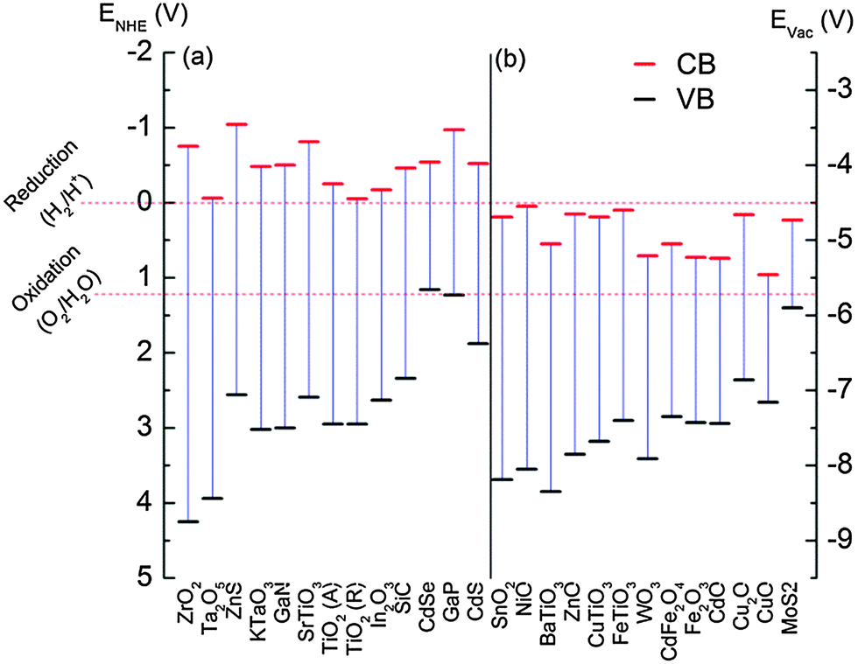
Figure 2: Absolute conduction band and valence band energy levels for some selected semiconductors used for PC versus the standard hydrogen electrode (SHE) and the vacuum energy scale. At pH 1 unless otherwise noted [31].

ZnO
Zinc Oxide is a MOSP of particular interest because of its unique properties, such as a wide energy band gap , its non-toxicity to living organisms, chemically stability, and strong photocatalytic properties when its crystal grain size is reduced to tens of nanometers [32]. It is a semiconductor photocatalyst with a high light sensitivity and high efficiency in the production of electrons. Such characteristics make it a good candidate for the photocatalytic process. The principal advantage of ZnO over TiO₂ is its capability to absorb a wide range of electromagnetic waves has been widely used for photocatalytic or electrocatalytic degradation of organic compounds, due to catalytic active sites on its surface and highly positive potential of the valence band edge [33, 34].

FeTiO₃
Ilmenite the titanium-iron oxide mineral with the idealized formula FeTiO₃, from the commercial perspective; ilmenite is the most advantageous ore of titanium. It is the main source of titanium oxide, which is used in paints, fabrics, plastics, paper, sunscreen, food and cosmetics [35].
Titanates like FeTiO₃ are doping widely used to alter the optical properties and induce visible light absorption and it is also offer good photostability and corrosion resistance in aqueous solutions perovskite structures may offer significant advantages over the corresponding binary oxides for several reasons. For example, perovskites could offer favorable band edge potentials which allow various photoinduced reactions [36].
Currently, titanium based perovskite oxides such as ATiO₃ (A = Zn, Sr, Co, Fe and Ni) have been identified as significant catalysts for the photocatalytic degradation of toxic pollutants, and photocatalytic hydrogen and oxygen production. FeTiO₃ exhibited high visible light photocatalytic activity in the removal of organic pollutants. Due to low density, large surface area and high light harvesting efficiency, it has high potential for photocatalytic application FeTiO₃ has additional magnetic transitions; occurs at sufficiently low temperature that it will not have a significant effect on equilibrium phase relations [37, 38].

Advanced Oxidation Process (AOPs)
The growing interest in the development of new methodologies for the degradation of toxic water pollutants has led to conclusion that the most effective oxidation of organic pollutants can be achieved when a powerful oxidizing agent, especially •OH or another radical, is generated. The advanced oxidation processes (AOP) have been developed, such as photochemical degradation reactions using photodecomposition of hydrogen peroxide (H₂O₂/UV), ozone photolysis (O₃/UV), photocatalysis by semiconductors (TiO₂/UV) [39]. Pointing out its potential prominent role in the wastewater purification, it was shown that AOPs successfully solve the problem of degradation of water pollutants at or near ambient temperature and pressure. The AOPs uses the mechanism of photocatalysis for degradation of organic pollutant [40].

Classification of AOP on the basis of phase systems

Heterogeneous Photocatalysis
Heterogeneous photocatalysis is a discipline which includes a large variety of reactions: oxidations, dehydrogenation, and hydrogen transfer. It can be considered as one of the new advanced oxidation technologies for air and water purification treatment. In the presence of semiconductor to degrade recalcitrant compounds is reported primarily. This mechanism is based on the stimulation of solid semiconductor under the irradiation of light [41].

Homogeneous photocatalysis
In homogeneous photocatalysis, the reactants and the photocatalysts exist in the same phase and it is a special interest since UV irradiation and sunlight can be used as the irradiation source [42].

Photocatalysis

Catalysis under light irradiation, called photocatalysis, is attracting a great deal of attention from view points of fundamental science and applications for practical use. The word photocatalysis is a composite word which is composed of two parts, “photo” and “catalysis”. Catalysis is the process where a substance participates in modifying the rate of a chemical transformation of the reactants without being altered or consumed in the end. This substance is known as the catalyst which increases the rate of a reaction by reducing the activation energy [43]. Photocatalysis is a reaction which uses light to activate a substance which modifies the rate of a chemical reaction without being involved itself, and the photocatalyst is the substance which can modify the rate of chemical reaction using light irradiation. Chlorophyll of plants is a typical natural photocatalyst. The difference between chlorophyll photocatalyst to man-made nano ZnO photocatalyst (here below mentioned as photocatalyst) is, usually chlorophyll captures sunlight to turn water and carbon dioxide into oxygen and glucose, but on the contrary photocatalyst creates strong oxidation agent and electronic holes to breakdown the organic matter to carbon dioxide and water in the presence of photocatalyst, light and water [44, 45].

Application of Photocatalytic
Heterogeneous photocatalysis has been demonstrated as a low cost and sustainable technology for the treatment of a host of pollutants in air and water including organics and heavy metals. Unlike reverse osmosis, nano and ultra filtration, photocatalysis is a cheap and a potential stand alone technology for water treatment. As photocatalysis makes use of sunlight or UV radiation, the technology is inexpensive, environmentally friendly and can be applied worldwide. It requires minimal equipment, is highly deployable and appropriate for developing countries and remote sites with no access to electricity [41, 46].
The major advantages of photocatalytic activity are listed below: (a) Photocatalysis offers a good substitute for the energy-intensive conventional treatment methods with the capacity for using renewable and pollution-free solar energy. (b) Photocatalysis leads to the formation of innocuous products. (c) This process can be used to destroy a variety of hazardous compounds in different wastewater streams. (d) It can be applied to aqueous and gaseous-phase treatments, as well as solid phase treatments to some extent. (e) The reaction conditions for photocatalysis are mild, the reaction time is modest, and a lesser chemical input is required. (f) Secondary waste generation is minimal. (g) The option for recovery can also be explored for metals, which are converted to their less-toxic/nontoxic metallic states [47].
In another way important application of photocatalytic is regarded as a clean and sustainable approach to hydrogen fuel generation because it makes use of renewable resources (i.e., sunlight and water), does not involve fossil fuel consumption, and does not result in environmental pollution or greenhouse gas emission. Another notable application is the photocatalytic degradation of nonbiodegradable dyes, which offers an effective way of ridding industrial wastewater of toxic organic pollutants prior to its release into the environment [48] .The photocatalytic decomposition of organic compounds on TiO₂ modified by iron and carbon is going by the complex reactions of iron with the intermediates, what significantly accelerates the process of their decomposition. The photocatalytic process with using TiO₂ photocatalyst is very promising for application in the water purification because many organic compounds can be decomposed and mineralized by the proceeding oxidation and reduction processes on TiO₂ surface [49].

Removal of Organic Compounds
Photocatalysis has been used for the destruction of organic compounds such as alcohols, carboxylic acids, phenol derivatives, or chlorinated aromatics, into harmless products, for example, carbon dioxide, water, and simple mineral acids. Water contaminated by oil can be treated efficiently by photocatalytic reaction. Herbicides and pesticides that may contaminate water such as 2,4,5 trichlorophenoxyacetic acid, 2,4,5 trichlorophenol, S-triazine herbicides and 1,1,1-trichloro-2,2-di(4-chlorophenyl)ethane (DDT) have also been successfully degraded [50].

Removal of Organic Dyes
Organic dyes is one of the major groups of pollutants widely used in textile, plastic, medicine and many other industries, while the hazardous effects of organic dyes in waste water have been a major concern and now a major threat in the environment due to the substantial pollution problems caused by them. These industries exhausted large quantity of high content color effluents, which are generally more toxic and resistant to destruction by conventional methods. A necessary criterion in the use of these dyes is that they must be highly accumulated in water and stable in light during washing. The accumulation of these dyes in the water bodies causes eutrophication, reduces the reoxygenation capacity and makes severe damage to the aquatic organisms by hindering the infiltration of sunlight. The first two decades of research on the photocatalytic degradation of dyes were characterized by the dominance of un-doped titanium dioxide, a UV active photocatalyst. Generally speaking, the main active species under this mechanism are OH radicals formed by oxidation of water molecules by the photogenerated holes, hence the primary attack of the dye molecules is oxidative Likewise, and irreversible reductive decolarization initiated by electrons or by superoxide formed on the photocatalysis surface can be quite efficient, as was found for azo dyes like Methylene blue (MB) [27]. In this study the organic pollutant is MB with chemical structure of as shown in figure 3.

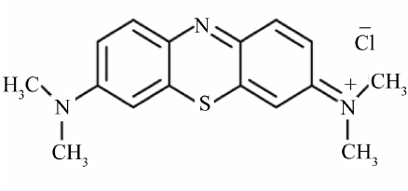
Figure 3: Chemical structure of MB [51].

Removal of Inorganic Compounds
In addition to organic compounds, wide ranges of inorganic compounds are sensitive to photochemical transformation on the catalyst surfaces. Inorganic species such as bromate, or chlorate, azide, halide ions, nitric oxide, palladium and rhodium species, and sulfur species can be decomposed. Metal salts such as AgNO₃, HgCl and organometalic compound (e.g., CH₃HgCl) can be removed from water as well as cyanide, thiocyanate, ammonia, nitrates and nitrites [50].

Different Methods of Synthesizing FeTiO₃
Several methods were used to synthesize FeTiO₃ like sol–gel process combined with a surfactant-assisted template method as reported in the literature [52] similarly, other methods like co-precipitation of mixed metal oxalate [53, 54], a facile hydrothermal method [55], by high energy ball milling method [56]. FeTiO₃, was also prepared by the fusion of an FeC1₂-TiO₂, mixture, by the reaction of FeO and TiO₂, and by the reaction of the iron (II) oxalate and TiO₂ [57, 58]. Differently three techniques were also used to synthesize FeTiO₃ powders. The first method is simple co-precipitation of both Fe and Ti ions under basic conditions using standard ammonia solution from ferric nitrate and titanium oxy chloride. The second method is to digest hydroxide precipitates at 100⁰c to form FeTiO₃ phase. The third technique is to make use of citrate to form FeTiO₃ powders [54].

SILAR Method
In the past, many deposition techniques were used like liquid mix process, citrate gel and hydrothermal, but in this thesis successive ionic layer adsorption and reaction (SILAR) was used because it is low cost, simple and low temperature soft method. Unlike of the above methods SILAR can easily control the deposition rate and thickness of the thin film. It is the most known method of depositing the metal chalcogenide semiconductor layer on the mesoscopic metal oxide films. Successive ionic layer adsorption and reaction method has emerged as one of the solution methods to deposit a variety of compound materials in thin film form. The SILAR method is inexpensive, simple and convenient for large area deposition. A variety of substrates such as insulators, semiconductors, metals and temperature sensitive substrates can be used since the deposition is carried out at or near to room temperature [59, 60]. similarly it is defined as Successive ionic layer adsorption and reaction is a popular method of depositing the metal chalcogenide semiconductor layer on the mesoscopic metal oxide films for designing quantum-dot-sensitized solar cells or extremely thin absorber solar cell [61]. In spite of its simplicity, SILAR has a number of advantages: (i) it offers extremely easy way to dope film with virtually any element in any proportion by merely adding it in some form of the cationic solution, (ii) unlike closed vapor deposition method, SILAR does not require high quality target and/or substrates nor does it require vacuum at any stage, which is a great advantage if the method will be used for industrial application, (iii) the deposition rate and the thickness of the film can be easily controlled over a wide range by changing the deposition cycles, (iv) operating at room temperature can produce films on less robust materials, (v) unlike high power methods such as radio frequency magnetron sputtering (RFMS), it does not cause local over heating that can be detrimental for materials to be deposited and (vi) there are virtually no restrictions on substrate material, dimensions or its surface profile. Moreover, it is relatively inexpensive, simple and con-venient for large area deposition. It can be carried out in glass beakers [59]. SILAR method is mainly based on the adsorption and reaction of the ions from the solution and rinsing between every immersion with deionizer water to avoid homogeneous precipitation in the solution. In general, the growth mechanism involves four most important steps: (1) specific adsorption of the most strongly adsorbed ions of the compound to be grown, by the substrate immersion in a solution of one of its cationic precursor, (2) water rinsing of the excess solution still adhering to the substrate, and (3) chemical reaction between the most strongly specific adsorbed cations and the less strongly adsorbed anions by the subsequent substrate immersion in the solution and (4) water rinsing of the excess solution to avoid the homogeneous precipitation in the solution [14, 59].

Experimental Part

Materials and Chemicals
Materials that were used for this study were mortal , pestle, centrifuge, beakers, conical flasks, magnetic stirrer, thermometer, analytical techniques for characterization such as UV-Vis (Ultraviolet/visible) spectrophotometer, Fourier transform infrared (FTIR), X-ray diffraction (XRD) analysis. The chemicals that were used for this study were zinc oxide (ZnO) as substrate, an aqueous ironsulphate (FeSO₄7.H₂O) solution, sodium hydroxide (NaOH), distilled water, ethanol (CH₃CH₂OH), Titaniumtetachloride (TiCl₄), Methylene blue (C₁₆H₁₈ClN₃S) Ethylenediaminetetraacetate (EDTA), isopropyl alcohol (IPA) and silver nitrate (AgNO₃).

Experimental Technique for Synthesis of FeTiO₃/ZnO
In SILAR synthesis of FeTiO₃ particle on ZnO, a commercial ZnO was used as a substrate for the adsorption of the ions. The experimental technique to grow FeTiO₃ was as follows first, 2g of ZnO was mixed with an aqueous 0.1M FeSO₄7.H₂O solution and stirred for five minutes at room temperature, during this period Fe²⁺ was adsorbed on ZnO surface. Next, the solution was filtered using centrifuged to separate the Fe²⁺/ZnO from the solution. Then it was washed with distilled water to clean the loosely adsorbed Fe²⁺ ions and SO₄²⁻. Then Fe²⁺/ZnO powder was mixed with the anionic solution of 0.2M NaOH and stirred for five minutes under 45-48⁰c, where Fe²⁺/ZnO was converted to Fe(OH)₂/ZnO nanostructure. This solution was filtered and cleaned to get the powder Fe (OH)₂/ZnO. This process is called one SILAR cycle. This process was repeated several times for six cycle until the desired particle size was reached. To deposit Ti(OH)₄ on ZnO, the above procedure was repeated except changing the cationic solution from FeSO₄7.H₂O to 0.1M TiCl₄ and the distilled water used for rinsing to ethanol solution. Finally annealed Ti(OH)₄/Fe(OH)₂/ZnO nanoparticle at 450⁰c - 650⁰c to yield FeTiO₃/ZnO nanostructure.

Material Characterization
The crystalline phase was characterized using powder X-ray diffraction (XRD; voltage current, 40 kV and 30 mA) with Cu wave radiation (λ=1.5406 Å). The data were collected in 2 theta region of 10-80 degree with continuous scanning mode at a scan speed of 3ºmin⁻1 and a step-size of 0.02 degree. The Fourier transform infrared spectroscopy analysis was performed using a Shimadzu-8400 spectrometer to determine the functional group of FeTiO₃/ZnO. UV–vis absorption spectra were acquired by a PerkinElmer Lambda 40 spectrophotometer. This UV-Vis Spectrophotometer was used to determine the energy gap produced by semiconductor from the synthesized FeTiO₃/ZnO solid. Eg values of the resulting semiconductor can affect the performance of the semiconductor in exciting electrons from the valence band to conduction band region. Small Eg values will make it easier for electrons to move from the valence band to the conduction band so that the flow of electrons will get easier, it was also used to measure MB dye concentrations at various time intervals during the reactions and for the detection of active trapping species.

Photocatalytic Degradation Experiment
The photocatalytic activity of the material, FeTiO₃/ZnO was determined by the degradation of Methylene blue in aqueous solution under irradiation of simulated sunlight. The experiment was carried out using a system that was illuminated with a lamp of 100W at room temperature as a source of simulated sunlight; the lamp is settled in the center of the reactor. Then it was tested following this procedure. First 40 ppm of organic pollutant (MB) and 0.05g FeTiO₃/ZnO were added in to beaker, and then the solution was stirred continuously with the help of magnetic stirrer for 30 min, staying in darkness to reach the adsorption equilibrium. Then the lamp was a turned on, then the samples were taken at 10 min time intervals and the solution was filtered to separate the sample and FeTiO₃/ZnO. Then to monitor the progress of the reaction was analyzed by UV-vis spectroscopy. Finally the percentage of photocatalytic degradation of FeTiO₃/ZnO [62].
% degradation = (C₀-C)/C₀* 100
Where C₀ = is initial concentration of dye solution,
C = concentration of dye solution after photo irradiation

Trapping Experiment
The main active species produced in the photodegradation process of MB confirmed by the trapping agents such as EDTA, IPA and AgNO₃. They were introduced into to the degradation process to trap holes (h⁺), hydroxyl (•OH), and electron (e−), respectively. All these trapping agents were in the quantity of 5 mmol and the procedure was the same as photocatalytic degradation experiment.

Results and Discussion

X-ray Diffraction Analysis
The XRD patterns of FeTiO₃/ZnO calcined at different temperatures ranging from 450 to 650 ⁰C is shown figure 4 (A). It can be seen from the diffraction patterns that the starting powders were amorphous with no significant change in structure at 450 ⁰C were observed when it compared to the substrate ZnO and also shows that increase of the calcination temperature to 650 ⁰C improved the crystallinity of the catalyst. However as the crystallinity increases more secondary phases are observed. The XRD pattern of the sample treated at 550 ⁰C for 2 h indicates formation of FeTiO₃/ZnO with crystal structure.
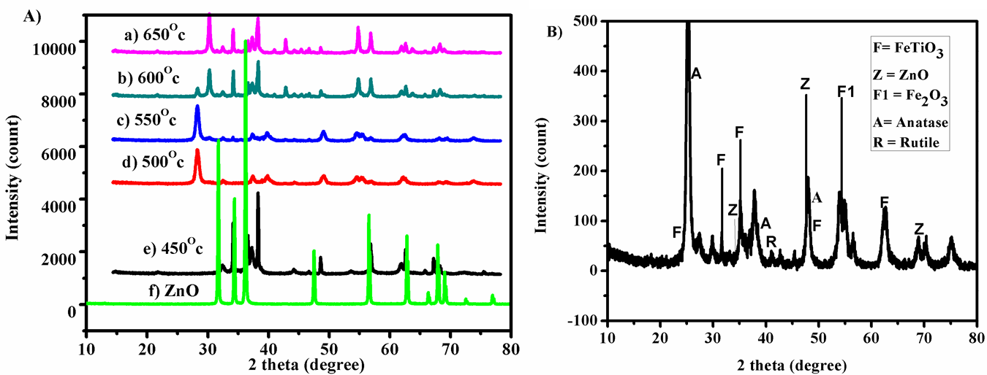
Figure 4: A) X-ray diffraction patterns of FeTiO₃/ZnO photocatalysts annealed at different temperatures for 2 hrs on ZnO substrate: a) 650 ⁰C, b) 600 ⁰C, c) 550 ⁰C, d) 500 ⁰C, e) 450 ⁰C and f) substrate ZnO and B) Shows the XRD patterns of FeTiO₃/ZnO annealed at 550 ⁰C
As it is shown in figure 4(B), the XRD patterns of FeTiO₃/ZnO synthesized by the SILAR method and calcined at 550 ⁰C temperature clearly observable peaks for the FeTiO₃ phase. The diffraction pattern also shows the presence of some impurities phases of rutile, anatase, Fe₂O₃ , ZnO and, the 2 theta values of FeTiO₃ are 24.19⁰, 31.68⁰, 35.36⁰, 48.53⁰ and 62.62⁰ crystal structure according to JCPDS; 75-1207 [35, 52] and the 2 theta values of anatase is also shown as follows 25.28⁰, 38.47⁰ and 48.37⁰ corresponding to TiO₂ anatase phase according to JCPDS file 021-1272 [35]. The 2 theta values of ZnO are also shown as 34.55⁰, 47.5⁰ and 67.92⁰ which are consistent with the values in the standard card (JCPDS 36-145) [63]. X-ray diffraction is used for phase determination and unit cell information of the nanocomposites under investigation. The technique is also frequently employed to determine particle size using Scherrer's formula.
𝐷=𝐾𝜆/𝛽𝑐𝑜𝑠𝜃
Where D (nm) is the mean size of the crystalline domains, K is the dimensionless shape factor which value is close to unity, 𝜆 is x-ray wavelength and β is line broadening referring to FWHM and θ is Bragg angle. The formula is applicable when nanocomposites have definite crystalline structure while in case of amorphous structure this formula is not applicable for particle size [64]. The average particle size of FeTiO₃/ZnO powder calcined at 550⁰C was around 22.8 nm.

FTIR Analysis
Figure 5 shows broad band 3500-3200 cm⁻¹ and sharp peak at 1630 cm⁻¹ are associated stretching and bending vibration of surface adsorbed water and hydroxyl group of ethanol that were used for rinsing and for preparation of solution of all samples. In the FTIR spectrum of FeTiO₃, a wide band from 400 to 650 cm⁻¹ was observed that corresponds to the metal–oxygen bond [52]. In addition, a wide band ranging from 400 to 800 cm⁻¹ was also observed in the FTIR spectra of FeTiO₃/ZnO, which can be assigned to the overlapping peak between the Ti–O–Ti bond and Fe–O bonds, indicating the existence of FeTiO₃/ZnO and the peak at 420 cm⁻¹ is associated to ZnO which was used as blank solution [65].
The surface hydroxyl groups play an important role in the photocatalytic process, as these groups can be trapped by the holes generated under sunlight irradiation to form hydroxyl radicals which can suppress electron–hole recombination, hence increase the photocatalytic efficiency.
Figure 5: FTIR spectra of FeTiO₃/ZnO and ZnO as blank solution

UV-Vis Analysis
Figure 6(A) shows the UV–Vis spectra of FeTiO₃/ZnO nanostructure. FeTiO₃ possesses strong absorption in the whole solar spectrum. Combining the two semiconductors, the absorptions of FeTiO₃/ZnO nanostructure within the visible region remarkably increased. The absorption intensity of FeTiO₃/ZnO nanostructure also increased, which subsequently results in the efficient utilization of visible light for the photocatalytic reaction. The band gap energy was calculated by using the Touc formula Ahv = (hv – Eg)^{/2}, where A is absorbance, hv is photon energy, and Eg is band gap or it was calculated using the formula Eg = 1240/λ. The Eg value was plotted in the equation above to obtain the wavelength area of FeTiO₃ performance and it has been obtained the wavelength at 580.43 nm. Extrapolation of the liner region to zero absorption (Ahv = 0) provides an estimation of band gap energy as shown in figure 6(B). The UV–Vis spectrum of FeTiO₃/ZnO shows an absorption line in the range of 200–800 nm. Then, the energy bandgap of FeTiO₃ may have a value of 2.13 eV as it is shown in figure 6(B) however the energy band gap of ZnO is obtained 3.24 eV as shown in figure 6 (C).
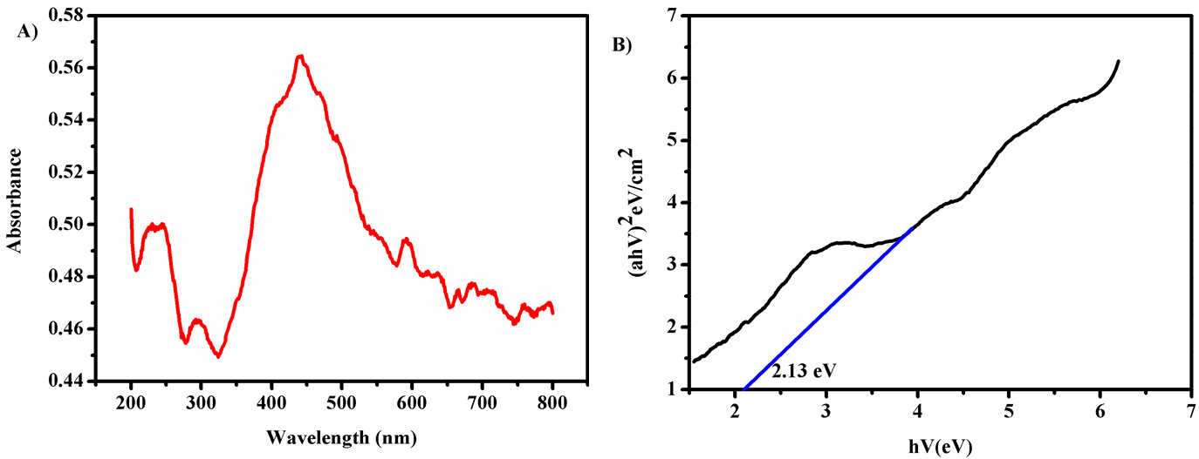
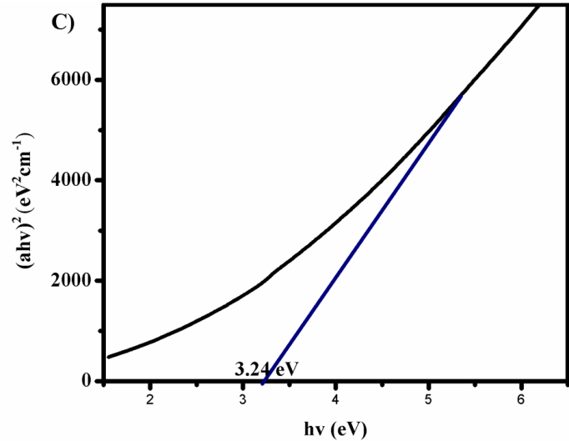
Figure 6: A) UV-Vis spectra of FeTiO₃/ZnO, B) Plot of (αhv) ² versus hv of FeTiO₃/ZnO sample C) Plot of (αhv) ² versus hv of ZnO

Photodegradetion of Methylene Blue
The photocatalytic activities of the FeTiO₃/ZnO nanostructure in decomposing Methylene blue in liquid phase were evaluated. As shown in Figure 7(A), the FeTiO₃/ZnO nanostructure in several compositions showed notably high photocatalytic activity. Coupling of ZnO with other semiconductors has been frequently investigated to improve the photocatalytic activity of ZnO in order to promote the separation of photogenerated charge carriers and/or to extend the absorption wavelength up to the visible region. In the present study, the heterojunction of FeTiO₃/ZnO photocatalytic activity of demonstrated notably high activity. It is deduced that the high efficiency of the FeTiO₃/ZnO nanostructure originates from the unique relative band positions of these two semiconductors. Photocatalysis is a catalyst that can work with the aid of light (photons). The occurrence of MB concentration decreased in photocatalysis method is shown in Figure 7(B) or relative concentration of Methylene blue decreased as a function of time during photocatalytic degradation with FeTiO₃/ZnO photocatalysts.
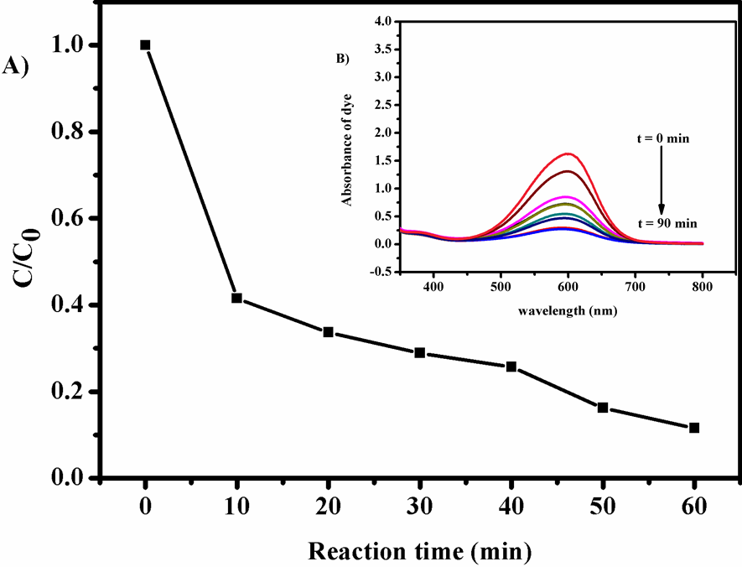
Figure 7: A) the variation of MB concentrations (C/C₀) with irradiation time and B) absorption spectra of 40 ppm MB solution in the presence of FeTiO₃/ZnO under visible light irradiation at different irradiation times
This dye which is MB also shows no degradation without photocatalyst as it is shown figure 8 and this result indicates photocatalytic activity of FeTiO₃/ZnO is highly needed to remove organic pollutants.
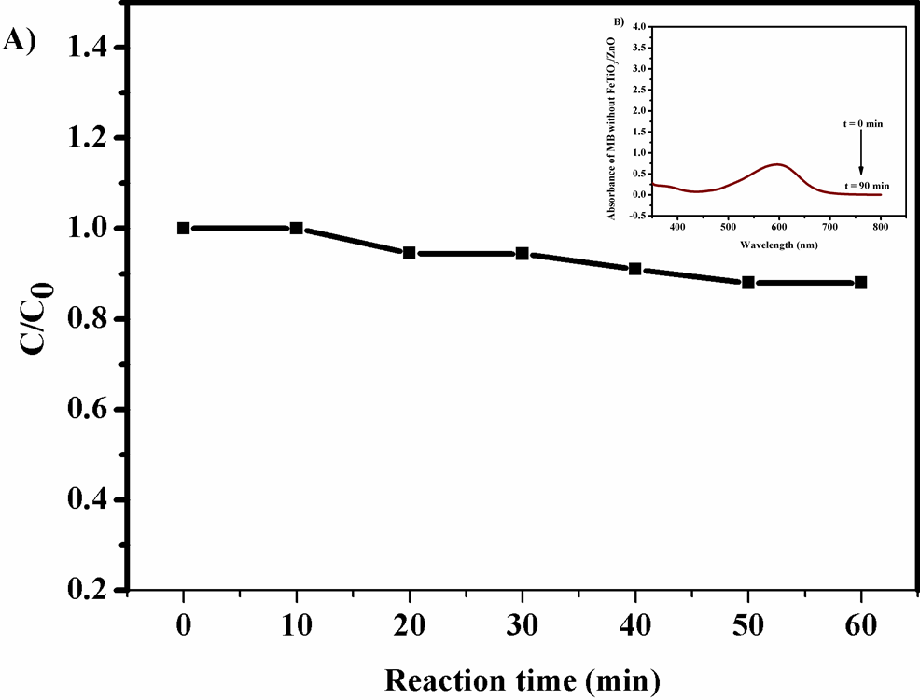
Figure 8: A) the variation of MB concentrations (C/C₀) with irradiation time and B) absorption spectra of 40 ppm MB solution without of FeTiO₃/ZnO under visible light irradiation at different irradiation times
Even though the concentration of MB was almost a linear function of reaction time for the degradation experiments carried out with FeTiO₃/ZnO material as shown in figure 9, the specific reaction rate constant for the experiment was calculated that the photocatalytic degradation reaction followed a first-order reaction rate equation. Therefore, the reaction rate constant was calculated by linear regression of a plot of the natural logarithm of MB concentration as a function of reaction time. To get better understanding of kinetics reaction, the experimental data fitted by a pseudo-first-order reaction. The equation for calculation is as follows:
ln(C₀/C)= kt
Where C₀ is the initial concentration of dye, C is the concentration at desired time interval and K is the apparent first-order rate constant, gives a value of reaction rate constant 3.467*10⁻² min⁻¹. The FeTiO₃/ZnO nanostructure exhibited a notably high photocatalytic activity in the higher decomposition of organic compounds under visible light irradiation and obtained almost about 84.85% degradation and hence it increased the degradation efficiency compared to the literature values as it is shown in table 1. The enhanced photocatalytic activity of FeTiO₃/ZnO nanostructure was attributed to the high separation efficiency of photogenerated electron–hole pairs resulted from the formation of the FeTiO₃/ZnO heterojunction. The calibration curve was obtained by plotting concentration with reaction time.
Table 1: Percent degradation of different organic pollutants using ZnO nanoparticle and FeTiO₃/ZnO
No. | Photocatalyst | Organic pollutant | % of degradation | Reaction time | Reference
1 | ZnO | Phenol | 69.75% | 120 min | [63]
2 | ZnO | Methylene orange | 77% | 90 min | [66]
3 | ZnO | Benzoic acid | 67.98% | 120min | [63]
4 | FeTiO₃/ZnO | Methylene blue | 84.85% | 90 min | Present work

Figure 9: Plot of reaction time versus ln(C/C₀) by FeTiO₃/ZnO nanostructure photocatalyst

Detection Experiment for Trapping Active Species
The active species trapping measurements is significant to examine the active species in the photocatalytic process for a better understanding of photocatalytic mechanism. In degradation of dyes, several active radical species such as hole (h⁺), hydroxyl radicals (•OH), and electron (e⁻) plays major contribution. The active species trapping experiments toward FeTiO₃/ZnO nanostructure was carried out, and the results were shown in Figure 10. Primarily, all the three established species with a photogenerated hole (h⁺), hydroxyl (•OH) radical and electron (e−) are active during the photocatalytic process. This process could effectively improve the separation of photogenerated electron–hole pairs and decrease the possibility of charge recombination further improving the photodegradation efficiency.
In general, the hole (h⁺) and hydroxyl (•OH) radical were a highly reactive species with strong oxidation ability, were considered mainly responsible for the degeneration of pollutant molecules in the photocatalytic reaction. When EDTA used as hole scavenger, a dramatic change in the photocatalytic activity was observed compared with the other scavengers, confirming that the holes generated when light is irradiated to the semiconductor has a clear effect on the photodegradation process under sunlight irradiation. However AgNO₃ that scavenges electron was not active specie for the degeneration of pollutant molecule in the photocatalytic reaction as it is shown in figure 10.

Figure 10: Trapping of active species

Conclusion
In summary, the nanosized FeTiO₃/ZnO nanostructure has been synthesized through a SILAR method, employing TiCl₄ solution cationic precursor as Ti source, FeSO₄.7H₂O as Fe source, ZnO as substrate and NaOH as anionic precursor. The SILAR method is easy route for the fabrication that makes them cost-effective as well. Different techniques to characterize the nanostructure are X-ray diffraction, Fourier transform infrared spectroscopy, ultraviolet/visible spectroscopy that nanostructure is nanocrystalline in size (D=22.8nm). XRD confirms that the prepared nanostructure is FeTiO₃/ZnO. A Photocatalytic property of the FeTiO₃ nanostructures was evaluated by decomposing MB under visible light with homemade photocatalytic apparatus. The reaction rate constant was calculated 3.467*10⁻² min⁻¹ by linear regression of a plot of the natural logarithm of MB concentration as a function of reaction time, data fitted by a pseudo-first-order reaction. The FeTiO₃/ZnO nanostructure exhibited a notably high photocatalytic activity in the higher decomposition of organic compounds under visible light irradiation and obtained almost about 84.85% degradation. The high efficiency of the FeTiO₃/ZnO composite was considered to be caused by the unique relative band positions of these two semiconductors and the profound absorption of visible light by FeTiO₃ with energy band gap of 2.1eV. The close valance band (VB) position of FeTiO₃ to that of ZnO enabled the hole transfer from the VB of FeTiO₃ to that of ZnO and form the trapping experiment the most active specie was hole with 11.82 % of degradation. Therefore, the visible light absorption by FeTiO₃ induced the generation of holes on ZnO, which resulted in the almost complete decomposition of the organic compounds.

Recommendation
SILAR method can be further used to synthesize FeTiO₃/ZnO, metal oxide composites and these materials will find great potential applications in the photodegradation of organic pollutants in waste water treatment.

References
1. Serrano, B. and de Lasa, H., Photocatalytic degradation of water organic pollutants: pollutant reactivity and kinetic modeling. Chemical Engineering Science, 1999. 54(15): p. 3063-3069.
2. Hachem, C., Bocquillon, F., Zahraa, O., and Bouchy, M., Decolourization of textile industry wastewater by the photocatalytic degradation process. Dyes and Pigments, 2001. 49(2): p. 117-125.
3. Zhao, J., Chen, C., and Ma, W., Photocatalytic Degradation of Organic Pollutants Under Visible Light Irradiation. Topics in Catalysis, 2005. 35(3): p. 269-278.
4. Khalyavka, T.A., Tsyba, N.N., Kamyshan, S.V., and Kapinus, E.I., Synthesis and study of physicochemical, sorption, and photocatalytic properties of barium titanate-modified titania powder. High Energy Chemistry, 2015. 49(4): p. 263-266.
5. Khan, M.M., Adil, S.F., and Al-Mayouf, A., Metal oxides as photocatalysts. Journal of Saudi Chemical Society, 2015. 19(5): p. 462-464.
6. Ramesha, G.K., Brennecke, J.F., and Kamat, P.V., Origin of Catalytic Effect in the Reduction of CO2 at Nanostructured TiO2 Films. ACS Catalysis, 2014. 4(9): p. 3249-3254.
7. Ma, W., Huang, Y., Li, J., Cheng, M., Song, W., and Zhao, J., An efficient approach for the photodegradation of organic pollutants by immobilized iron ions at neutral pHs. Chemical Communications, 2003.52(13): p. 1582-1583.
8. Chiu, H.M., Yang, T.H., Hsueh, Y.C., Perng, T.P., and Wu, J.M., Fabrication and characterization of well-dispersed plasmonic Pt nanoparticles on Ga-doped ZnO nanopagodas array with enhanced photocatalytic activity. Applied Catalysis B: Environmental, 2015. 163(9): p. 156-166.
9. Luo, Q.P., Yu, X.Y., Lei, B.X., Chen, H.Y., Kuang, D.B., and Su, C.Y., Reduced Graphene Oxide-Hierarchical ZnO Hollow Sphere Composites with Enhanced Photocurrent and Photocatalytic Activity. The Journal of Physical Chemistry C, 2012. 116(14): p. 8111-8117.
10. Li, C., Ahmed, T., Ma, M., Edvinsson, T., and Zhu, J., A facile approach to ZnO/CdS nanoarrays and their photocatalytic and photoelectrochemical properties. Applied Catalysis B: Environmental, 2013. 138(12): p. 175-183.
11. Wang, X., Liu, G., Chen, Z.G., Li, F., Wang, L., Lu, G.Q., and Cheng, H.M., Enhanced photocatalytic hydrogen evolution by prolonging the lifetime of carriers in ZnO/CdS heterostructures. Chemical Communications, 2009. 67(23): p. 3452-3454.
12. Sun, C., Chen, C., Ma, W., and Zhao, J., Photodegradation of organic pollutants catalyzed by iron species under visible light irradiation. Physical Chemistry Chemical Physics, 2011. 13(6): p. 1957-1969.
13. Fujishima, A., Rao, T.N., and Tryk, D.A., Titanium dioxide photocatalysis. Journal of Photochemistry and Photobiology C: Photochemistry Reviews, 2000. 1(1): p. 1-21.
14. Regulacio, M. and Han, M.-Y., Multinary I-III-VI 2 and I 2 -II-IV-VI 4 Semiconductor Nanostructures for Photocatalytic Applications. Materials Science and Engineering: R: Reports, 2016. 49(5): p. 511-519.
15. Karthikeyan, N., Sivaranjani, T., Dhanavel, S., Gupta, V.K., Narayanan, V., and Stephen, A., Visible light degradation of textile effluent by electrodeposited multiphase CuInSe₂ semiconductor photocatalysts. Journal of Molecular Liquids, 2017. 227(7): p. 194-201.
16. Christian, P., Von der Kammer, F., Baalousha, M., and Hofmann, T., Nanoparticles: structure, properties, preparation and behaviour in environmental media. Ecotoxicology, 2008. 17(5): p. 326-343.
17. Sharma, G., Kumar, A., Sharma, S., Naushad, M., Prakash Dwivedi, R., Alothman, Z.A., and Mola, G.T., Novel development of nanoparticles to bimetallic nanoparticles and their composites: A review. Journal of King Saud University - Science, 2017.34(6): p.256-267.
18. Hasan, S., A Review on Nanoparticles: Their Synthesis and Types. Materials & Design, 2015.78(4): p. 1-3.
19. Vlăsceanu, G.M., Marin, Ş., Ţiplea, R.E., Bucur, I.R., Lemnaru, M., Marin, M.M., Grumezescu, A.M., and Andronescu, E., Chapter 2 - Silver nanoparticles in cancer therapy, in Nanobiomaterials in Cancer Therapy. 2016. 342(56): p. 29-56.
20. Abou El.Nour, K.M.M., Eftaiha, A.a., Al.Warthan, A., and Ammar, R.A.A., Synthesis and applications of silver nanoparticles. Arabian Journal of Chemistry, 2010. 3(3): p. 135-140.
21. Hough, R.M., Noble, R.R.P., and Reich, M., Natural gold nanoparticles. Ore Geology Reviews, 2011. 42(1): p. 55-61.
22. Granmayeh Rad, A., Abbasi, H., and Afzali, M.H., Gold Nanoparticles: Synthesising, Characterizing and Reviewing Novel Application in Recent Years. Physics Procedia, 2011. 22(12): p. 203-208.
23. Rahaghi, S.H.H., Poursalehi, R., and Miresmaeili, R., Optical Properties of Ag-Cu Alloy Nanoparticles Synthesized by DC Arc Discharge in Liquid. Procedia Materials Science, 2015. 11(7): p. 738-742.
24. Hedayatnasab, Z., Abnisa, F., and Daud, W.M.A.W., Review on magnetic nanoparticles for magnetic nanofluid hyperthermia application. Materials & Design, 2017. 123(80): p. 174-196.
25. Hajba, L. and Guttman, A., The use of magnetic nanoparticles in cancer theranostics: Toward handheld diagnostic devices. Biotechnology Advances, 2016. 34(4): p. 354-361.
26. Camargo, P.H.C., Nunes, G.G., Sá, E.L.d., Tremiliosi-Filho, G., Evans, D.J., Zarbin, A.J.G., and Soares, J.F., Synthesis of Fe/Ti oxides from a single source alkoxide precursor under inert atmosphere. Journal of the Brazilian Chemical Society, 2008. 19(9): p. 1501-1512.
27. Tian, C., Zhang, Q., Wu, A., Jiang, M., Liang, Z., Jiang, B., and Fu, H., Cost-effective large-scale synthesis of ZnO photocatalyst with excellent performance for dye photodegradation. Chemical Communications, 2012. 48(23): p. 2858-2860.
28. Raidou, A., Benmalek, F., Sall, T., Aggour, M., Qachaou, A., Larbi, L., and Fahoume, M., Characterization of ZnO Thin Films Grown by SILAR Method. Physical Chemistry Chemical Physics, 2014. 89(1): p.1-9.
29. Martin, L.W., Chu, Y.H., and Ramesh, R., Advances in the growth and characterization of magnetic, ferroelectric, and multiferroic oxide thin films. Materials Science and Engineering: R: Reports, 2010. 68(4): p. 89-133.
30. Lv, H., Li, D., Strmcnik, D., Paulikas, A.P., Markovic, N.M., and Stamenkovic, V.R., Recent advances in the design of tailored nanomaterials for efficient oxygen reduction reaction. Nano Energy, 2016. 29(4): p. 149-165.
31. Babu, V.J., Vempati, S., Uyar, T., and Ramakrishna, S., Review of one-dimensional and two-dimensional nanostructured materials for hydrogen generation. Physical Chemistry Chemical Physics, 2015. 17(5): p. 2960-2986.
32. Kasinathan, K., Kennedy, J., Elayaperumal, M., Henini, M., and Maaza, M., Photodegradation of organic pollutants RhB dye using UV simulated sunlight on ceria based TiO₂ nanomaterials for antibacterial applications. Journal of Alloys and Compounds, 2016. 85(6): p. 38-64.
33. Koo, M.S., Cho, K., Yoon, J., and Choi, W., Photoelectrochemical Degradation of Organic Compounds Coupled with Molecular Hydrogen Generation Using Electrochromic TiO₂ Nanotube Arrays. Environmental Science & Technology, 2017. 51(11): p. 6590-6598.
34. Martínez, C., Vilariño, S., Fernández, M.I., Faria, J., L, M.C., and Santaballa, J.A., Mechanism of degradation of ketoprofen by heterogeneous photocatalysis in aqueous solution. Applied Catalysis B: Environmental, 2013. 142(21): p. 633-646.
35. Zarazú.-Morín, M.E., Torres.Martínez, L.M., Moctezuma, E., Juárez-Ramírez, I., and Zermeño, B.B., Synthesis, characterization, and catalytic activity of FeTiO3/TiO2 for photodegradation of organic pollutants with visible light. Research on Chemical Intermediates, 2016. 42(2): p. 1029-1043.
36. Kanhere, P. and Chen, Z., A Review on Visible Light Active Perovskite-Based Photocatalysts. Molecules, 2014. 19(12): p. 19995.
37. Han, T., Chen, Y., Tian, G., Wang, J.Q., Ren, Z., Zhou, W., and Fu, H., Hierarchical FeTiO3-TiO2 hollow spheres for efficient simulated sunlight-driven water oxidation. Nanoscale, 2015. 7(38): p. 15924-15934.
38. Huo, J. and Zeng, H., Silver nanoparticles-sensitized cobalt complex for highly-efficient photocatalytic activity. Applied Catalysis B: Environmental, 2016. 199(67): p. 342-349.
39. Cieśla, P., Kocot, P., Mytych, P., and Stasicka, Z., Homogeneous photocatalysis by transition metal complexes in the environment. Journal of Molecular Catalysis A: Chemical, 2004. 224(1): p. 17-33.
40. Mahamuni, N.N. and Adewuyi, Y.G., Advanced oxidation processes (AOPs) involving ultrasound for waste water treatment: A review with emphasis on cost estimation. Ultrasonics Sonochemistry, 2010. 17(6): p. 990-1003.
41. Herrmann, J.M., Heterogeneous photocatalysis: fundamentals and applications to the removal of various types of aqueous pollutants. Catalysis Today, 1999. 53(1): p. 115-129.
42. Jamil, T.S., Roland, H., Michael, H., and Jens-Uwe, R., Homogeneous photocatalytic processes for degradation of some endocrine disturbing chemicals under UV irradiation. Journal of Water Process Engineering, 2017. 18: p. 159-168.
43. Fujishima, A. and Honda, K., Electrochemical photolysis of water at a semiconductor electrode. Nature, 1972. 238(5358): p. 37-38.
44. Bhatia, S. and Verma, N., Photocatalytic activity of ZnO nanoparticles with optimization of defects. Materials Research Bulletin, 2017. 95(37): p. 468-476.
45. Boyjoo, Y., Sun, H., Liu, J., Pareek, V.K., and Wang, S., A review on photocatalysis for air treatment: From catalyst development to reactor design. Chemical Engineering Journal, 2017. 310(78): p. 537-559.
46. Ong, C.B., Ng, L.Y., and Mohammad, A.W., A review of ZnO nanoparticles as solar photocatalysts: Synthesis, mechanisms and applications. Renewable and Sustainable Energy Reviews, 2018. 81(110): p. 536-551.
47. Kabra, K., Chaudhary, R., and Sawhney, R.L., Treatment of Hazardous Organic and Inorganic Compounds through Aqueous-Phase Photocatalysis: A Review. 2004. 43(4) :p. 56-78.
48. Fan, F.J., Wu, L., and Yu, S.H., Energetic I-III-VI2 and I2-II-IV-VI4 nanocrystals: synthesis, photovoltaic and thermoelectric applications. Energy & Environmental Science, 2014. 7(1): p. 190-208.
49. Tryba, B., Increase of the Photocatalytic Activity of TiO2 by Carbon and Iron Modifications. International Journal of Photoenergy, 2008.78(34): p. 1-15.
50. Bekbölet, M., Boyacioglu, Z., and Özkaraova, B., The influence of solution matrix on the photocatalytic removal of color from natural waters. Water Science and Technology, 1998. 38(6): p. 155-162.
51. Yang, S.T., Chen, S., Chang, Y., Cao, A., Liu, Y., and Wang, H., Removal of methylene blue from aqueous solution by graphene oxide. Journal of Colloid and Interface Science, 2011. 359(1): p. 24-29.
52. Gambhire, A.B., Lande, M.K., Rathod, S.B., Arbad, B.R., Vidhate, K.N., Gholap, R.S., and Patil, K.R., Synthesis and characterization of FeTiO₃ ceramics. Arabian Journal of Chemistry, 2016. 9(1): p. S429-S432.
53. Kumar Sharma, Y., Kharkwal, M., Uma, S., and Nagarajan, R., Synthesis and characterization of titanates of the formula MTiO₃ (M = Mn, Fe, Co, Ni and Cd) by co-precipitation of mixed metal oxalates. Journal of Alloys and Compounds, 2009.28(2): p. 579–585.
54. Mona, J., Kale, S.N., Gaikwad, A.B., Murugan, A.V., and Ravi, V., Chemical methods to synthesize FeTiO₃ powders. Materials Letters, 2006. 60(11): p. 1425-1427.
55. Zhang, X., Li, T., Gong, Z., Zhao, H., Wang, L., Wan, J., Wang, D., Li, X., and Fu, W., Shape controlled FeTiO₃ nanostructures: Crystal facet and photocatalytic property. Journal of Alloys and Compounds, 2015. 653(123): p. 619-623.
56. Rasidhar, L., Krishna, A., and Rao, C.S., Fabrication and investigation on properties of Ilmenite (FeTiO₃) based al-nanocomposite by stir casting process. Arabian Journal of Chemistry, 2013. 66(5): p. 193-199.
57. Andreozzi, G., Cellucci, F., and Gozzi, D., High-temperature electrical conductivity of FeTiO₃ and ilmenite. The Journal of Physical Chemistry Letters, 1996. 6(3): p. 390-405.
58. Ribeiro, R.A.P., Camilo, A., and de Lazaro, S.R., Electronic structure and magnetism of new ilmenite compounds for spintronic devices: FeBO₃ (B = Ti, Hf, Zr, Si, Ge, Sn). Journal of Magnetism and Magnetic Materials, 2015. 394(101): p. 463-469.
59. Pathan, H.M. and Lokhande, C.D., Deposition of metal chalcogenide thin films by successive ionic layer adsorption and reaction (SILAR) method. Bulletin of Materials Science, 2004. 27(2): p. 85-111.
60. Sankapal, B.R., Mane, R.S., and Lokhande, C.D., Successive ionic layer adsorption and reaction (SILAR) method for the deposition of large area (∼10 cm2) tin disulfide (SnS2) thin films. Materials Research Bulletin, 2000. 35(12): p. 2027-2035.
61. Becker, M.A., Radich, J.G., Bunker, B.A., and Kamat, P.V., How Does a SILAR CdSe Film Grow? Tuning the Deposition Steps to Suppress Interfacial Charge Recombination in Solar Cells. The Journal of Physical Chemistry Letters, 2014. 5(9): p. 1575-1582.
62. Barka, N., Qourzal, S., Assabbane, A., Nounah, A., and Ait-Ichou, Y., Photocatalytic degradation of an azo reactive dye, Reactive Yellow 84, in water using an industrial titanium dioxide coated media. Arabian Journal of Chemistry, 2010. 3(4): p. 279-283.
63. Benhebal, H., Chaib, M., Salmon, T., Geens, J., Leonard, A., Lambert, S.D., Crine, M., and Heinrichs, B., Photocatalytic degradation of phenol and benzoic acid using zinc oxide powders prepared by the sol–gel process. Alexandria Engineering Journal, 2013. 52(3): p. 517-523.
64. Lateef, A. and Nazir, R., Metal Nanocomposites: Synthesis, Characterization and their Applications. Journal of Alloys and Compounds, 2017. 345(69): p. 239-256.
65. Dadigala, R., Reddy, B., Bandi, R., Ayodhya, D.D., and Guttena, V., Synthesis and Characterization of C–TiO₂/FeTiO₃ and CQD/C–TiO₂/FeTiO₃ Photocatalysts with Enhanced Photocatalytic Activities Under Sunlight Irradiation. Materials Letters, 2015. 451(29): p.123-125.
66. Sanna, V., Pala, N., Alzari, V., Nuvoli, D., and Carcelli, M., ZnO nanoparticles with high degradation efficiency of organic dyes under sunlight irradiation. Materials Letters, 2016. 162(23): p. 257-260.

