
BAHIR DAR UNIVERSY
INSTITUTE OF LAND ADMINISTRATION

THE IMPACT OF WATERSHED DEVELOPMENT ACTIVITIES ON THE SOCIO ECONOMIC AND ENVIRONMENTAL WELLBEING: THE CASE OF GARA MOYE WATERSHEDE WEST HARERGHE ZONE OROMIA REGION, ETHIOPIA
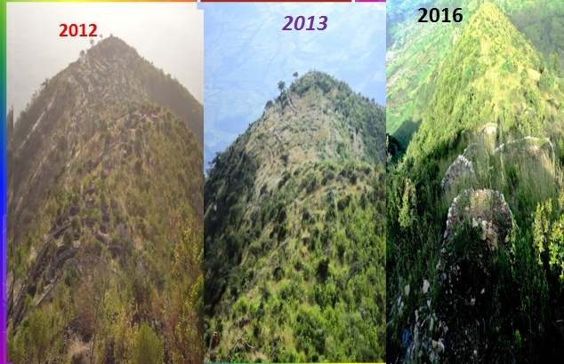

BY
NADI ABRAHIM MOHAMMED
ADVISER: -BERHANU.K (PHD.)
ATHESIS SUBMITTED INPARTIAL FULFILLMENT OF THE REQUIREMENTS FOR THE DEGREE OF MASTEROF SCIENCE INLAND ADMINISTRATION AND MANAGEMENT

Sept, 2017
Bahir Dar, Ethiopia.

THE IMPACT OF WATERSHED DEVELOPMENT ACTIVITIES ON THE SOCIO-ECONOMIC AND ENVIRONMENTAL WELLBEING: THE CASE OF GARA MOYE WATERSHEDE WEST HARERGHE ZONE OROMIA REGION, ETHIOPIA

BY
NADI ABRAHIM MOHAMMED

A THESIS SUBMITTED IN PARTIAL FULFILLMENT OF THE REQUIREMENTS FOR THE DEGREE OF MASTER OF SCIENCE IN LAND ADMINISTRATION AND MANAGEMENT

ADVISER: BERHANU.K (PHD.)

DEPARTMENT OF LAND ADMINISTRATION AND SURVEYING
INSTITUTE OF LAND ADMINISTRATION

BAHIR DAR UNIVERSITY
Sept, 2017

APPROVAL SHEET
BAHIRDAR UNIVERSTY
INSTITUTE OF LAND ADMINISTRATION
As a thesis research advisor, I hereby certify that I have read and evaluated this thesis prepared, under my guidance, by Nadi Abrahim Mohammed, entitled the impact of watershed development activities on the socio economic and environmental wellbeing of Gara Moye micro watershed. I recommend that it be accepted as fulfilling the thesis requirement.

------------------------------ ------------------------------ ---------------
Name of Advisor Signature Date

As a member of the examining board of this thesis, we certify that we have read and evaluated the thesis prepared by Nadi Abrahim Mohammed, entitled: the impact of watershed development activities on the socio economic and environmental wellbeing of Gara Moye micro watershed and it is accepted as fulfilling the thesis requirements for the degree of masters of science in land administration and management.

------------------------------ ------------------------------ ---------------
Name of Internal Examiner Signature Date
------------------------------ ------------------------------ ---------------
Name of External Examiner Signature Date

AUTHORS’ DECLARATION
First, I declare this Thesis was my original work and that all sources used were duly acknowledged. This Thesis would be submitted in partial fulfillment of the requirement for MSC degree at BDU.I solemnly declare thesis that was not been presented for any other institutions anywhere for the award of any academic Degree, Diploma or Certificate University.

Declared by:
Name: ____________________________
Signature: __________________________
Date: ______________________________

ACKNOWLEDGMENT
First and for most I would like to thank the Almighty God for helping me successfully to complete this thesis and for all achievements which I have been able to attain in my entire life. Many individuals have contributed to the success of my thesis. I would like to express heartfelt gratitude to my Supervisor Dr. Birhanu kefale for his commitment, intellectual guidance and constructive comment at every stage of this study. He was being kind enough to give advice and respond to all my frequent inquires by devoting his precious time. I would also thank for their compassion and Keenness whenever I need their support. I extend my special thanks to Dr. Tadesse Amsalu, Dr.Gebeyehu Belay and Dr. Belachew yirsaw whose gave me the critical and constructive comments during my study, whose unreserved support and professional Comments were quite instrumental in shaping the study as well as to all Bahir Dar University ILA Lectures.
My gratitude also goes to ORLAEP Bureau for granting me study leave and the partial cost of my study was covered by ORLAEP Bureau. My deepest gratitude also goes to WHZRLA&EP offices that gave this chance and help me by the technical and financial support.
Moreover, I would like to give warmest thanks to WHZRLA&EP members (experts) for their welcoming approach, hospitality and support study thesis I would also highly grateful to thank for the valuable contributions and supports of Ato Tadela Diriba, Dr. Faruk Aliyi and Ato Mohammed Ahmed were Leaders of WHZ.RLA&EP office for their Advice by moral and material (financial) support.
My heartfelt thanks and appreciations are extended to my parents Ato Abrahim Mohammed and W/ro Nayima Yusuf, that enrolled me to school at my very young age and have been offering me to do this opportunity and it is impossible to achieve this without the continuous support of them and heartfelt thanks and appreciations’ also extends to my wife Halima Adam, and also my brothers, and sisters for their morality and financial supports.

ABSTRACT
For several decades, integrated and sustainable watershed management has been suggested and tried in several countries in the world, as an effective way to address complex water and land resource challenges. However, its implementation has not been successful in most cases, due to various barriers. In Ethiopia, this approach is new and requires appropriate strategies to overcome the barriers and practice effective integrated and sustainable watershed development. This research therefore examines watershed development intervention in GaraMoye and its impact on the socio-economic development and environmental wellbeing. The study has given prime focus on exploring the prospects, approaches and barriers to integrated and sustainable watershed development of GaraMoye micro- watersheds, by examining the existing complex set of biophysical and socio economic conditions, stakeholders‟ attitudes and perceptions, arrangements for participation of communities, available institutional structures and recent policy of land certification. In addition, a land use land cover change analysis was carried out to see the trends in land use change. For the socioeconomic study data was gathered from official documents, direct observations, using semi-structured interviews with key informants, and Focus group discussion with watershed committees and households of the three kebeles in GaraMoye micro watershed development. The result indicated that effective and sustainable watershed management can be effectively realized when the watershed community participate from the beginning, by changing ownership of communal lands into private or association holdings, integration of multidisciplinary team, by enabling the local community to generate income within the short run from on farm and off farm activities, and when there is active, community watershed management institution supported by legislation. To evaluate watersheds development and management strategy the study applied supervised classification-maximum likelihood algorithm in ERDAS imagine to detect land cover/land use changes observed in Gara Moye watershed, using the image of land sat obtained from 2002,2012 and2016. The land use land cover classification of the study area was classified into five classes such as cultivated land, Grazing /Grass land, water body, settlement and Forest lands by using unsupervised and supervised classification by RS software. The land use land cover change matrix between 2012 and 2016 showed that during the indicated period there was much more significant land use land cover change. About area of grass land was 415.395 ha, 136.732ha, 343.553 ha and 6.120ha converted to cultivated, settlement and Waterbody. Forest cover, grazing land, water body, were converted into cultivated and settlement area respectively. Hence, proper management of the watershed is required or else these resources will soon be lost and no longer be able to play their role in the socioeconomic development of the area.

Key Words: - Watershed management, land use land cover change, Land management’s activities, Integrated land use plan sustainable use of land resources

LIST OF ABBREVIATION
ASTER Advanced Spaceborne Thermal Emission and Reflection Radiometer
DA Development Agent
DEM Digital Elevation Model
ERDAS Earth Resource Data Analysis System
ETM Enhanced Thematic Mapper
FAO Food Agricultural Organization
GIS Geographic Information Systems
GPS Global positioning system
HH Households head
ICRISAT International Crops Research Institute for the Semi-Arid Tropics
IWM Integrated Watershed Management
LULCC Land Use and Land Cover Changes
MOARD Ministry of Agricultural and Rural development
NGO Non-Government Organization
NRM Natural Resource Management
NWDPRA National Watershed Development Programme for Rain-fed Areas
OLI_TIRS Operating Land Imager and Thermal Infrared Sensor
ORLA&EPB Oromia Rural Land Administration and Environmental Protection Bureau
PRA Participatory Rural Appraisal
RS Remote Sensing
SWC Soil and Water Conservation
USGS United State Geological Survey
WDP Wasteland Development Programme
WFP World Food Programm
WHZRLA&EP West Harerghe Zone Rural Land Administration and Environmental protection office
WSW Watershed of Woreda

Table of Contents
Contents Page
AUTHORS’ DECLARATION ii
ACKNOWLEDGMENT iii
ABSTRACT iv
LIST OF ABBREVIATION v
LIST OF TABLES ix
LIST OF FIGURES ix
CHAPTER ONE 1
INTRODUCTION 1
1.1 Back Ground 1
1.2 Statement Of The Problem 4
1.3 Objective Of The Study 5
1.3.1 General Objective 5
1.3.2 Specific objective 5
1.4 Research Questions 5
1.5 Significance Of The Study 5
1.6 Scope Of The Study 6
1.7 Organization Of The Study 6
1.8 Constraints And Limitations Of The Study 6
CHAPTERTWO 7
LITERATURE REVIEW 7
2.1 Characteristic Of Watershed 7
2.2. Principle Of Watershed Management 7
2.3. History Of Watershed Management In Ethiopia 9
2.3.1. Watershed delineation in Ethiopia 9
2.3.2 The major drivers of land use land cover change 10
2.4. The Major Impacts Of The Watershed Development 11
2.4.1 Bio-physical Impacts 12
2.4.2 Environmental Impacts 13
2.4.3 Socio-economic Impacts 13
2.4.4. Socio economic and bio-physical impact in Watershed 13
2.5. The Concept Of Sustainable Water Shed Management Approach 14
2.5.1. The Role of Policy on Livestock Production and the Environment 14
CHAPTER THREE 16
RESEARCH METHODOLOGY 16
3.1 Description Of The Study Area 16
3.1.1 Agro climatic Zone the study 17
3.1.2 Temperature and Rain fall of the study area 18
3.1.3 General Land Use Pattern in the Area 19
3.1.4 Socio-economic characteristic of the area 19
3.1.5 Biodiversity and eco-tourism of the water shade community 19
3.2 Research Design 19
3.2.1 Field survey 20
3.2.2 Study site selection and determining sample size 20
3.2.3 Selection of respondent households 22
3.2.4 Design of household questionnaires 22
3.2.5 Key informant interviews 22
3.2.6 Primary data sources 23
3.2.7 Secondary Data sources 23
3.2.8 Material Used 23
3.2.9 Description of Land Use and Land Cover Classes 24
3.2.9.1 Steps in analysis of satellite images for land cover change 25
3.2.9.2 Data summarizing and analysis 28
3.2.9.3 Extraction of the study area 29
CHAPTER FOUR 33
RESULT OF DISCUSSION 33
4.1. Water Shed Analysis Of The Study Area 33
4.1.1 Land Use Land Cover Change analysis of the study area 33
4.1.2 Status of land use land covers distribution in 2002 33
4.1.3 Status of land use land covers distribution in 2012 36
4.1.4 Status of land use land covers distribution in 2016 38
4.1.5 Accuracy assessment 40
4.1.6 Kappa Statistics 41
4.1.7 Land use land cover change between 2002 and 2012 41
4.1.8 Land use land cover change between 2012 and 2016 44
4.1.9 Land use land cover change between 2002 and 2016 46
4.1.9.1 Change in Forest land 48
4.1.9.2 Change in grass/grazing land 48
4.1.9.3 Change in Cultivated land 49
4.1.9.4 Change in Settlements/bare Land 50
4.1.9.5 Change in Water body 50
4.2. Socioeconomic Analysis 52
4.2.1 Analysis of land resources and distribution of plot of land 52
4.2.2 Plots that give the highest yields value 53
4.2.3 Crop production before and after watershed development 54
4.2.4 Grazing land 54
4.2.5 Tree planting 55
4.2.6 Major source of House hold wood in the watershed 56
4.2.7 The participation of households in the soil and water conservation 57
4.2.8 Responsibility of collecting fuel for home 58
4.2.9 Impact on Crop Production and diversification 59
4.3. Watershed Management Practices 60
4.3.1 Result of Watershed Management Practices in the study area 60
4.4 Impact of Watershed Management on Economic, Social and Environment 64
4.4.1 Impact on Livestock Production 64
4.4.2 Livelihood Diversification 65
4.4.3 Impact on Employment Opportunity and migration 65
4.4.4 Impact in Social Interaction 66
4.4.5 Impact on Water Availability and Qualities 66
4.5 Biological Soil And Water Conservation Measures 67
4.6 The Result Of Focus Group Discussion And Key Informants 70
4.7. Challenges In The Watershed Development 71
4.8. The Lesson Is Drawn From The Success Of Watershed Development 72
4.9 The Effect of forest Cover change 73
CHAPTER FIVE 76
CONCLUSIONS AND RECOMMENDATIONS 76
5.1 Conclusions 76
5.2 Recommendations 77
REFERENCE 78
APPENDIX: Household questionnaire 82

LIST OF TABLES
Table 3. 1: Sample distribution of respondents in Kebele 21
Table 3. 2: Description of Software used 23
Table 3. 3: Description of Satellite Images 26
Table 3. 4: Satellite Images description 31

Table 4. 1: Area and percentage coverage of LULC (2002) 34
Table 4. 2: Area and percentage coverage of LULC (2012) 36
Table 4.3: Area and percentage coverage of LULC (2016) 38
Table 4.4: Confusion matrix and accuracy assessment classification 40
Table 4.5: Land use land cover change matrix of between 2002 and 2012 in Hectare 43
Table 4. 6: Land use land cover change matrix of between 2012 and 2016 in Hectare 45
Table 4.7: Land use land cover change matrix of between 2002 and 2016in Hectare 47

LIST OF FIGURES
Fig.3. 1: The Description map of the study are 17
Fig.3. 2: Temperature of the study area (LUPWHZ, 2012) shape file 18
Fig.3. 3: Model of watershed builder 30
Fig.3. 4: Flow of Research Frame work 32

Fig. 4. 1: Land use land cover map of the study area in the 2002 35
Fig. 4. 2: Land use land covers change 2012 37
Fig.4. 3: land use land cover change 2016 39
Fig.4. 4: Land use plan of West Harerghe Zone (Source W. H. Rural Land Administration and Environmental Protection Bureau (2012) 51
Fig.4.5: Response of Head of household on distribution of agricultural plots 52
Fig.4. 6: Response of household head on agricultural plots gives the highest yield 53
Fig.4.7: Shows that the responses of households of crop production 54
Fig.4. 8: Shows the respondents grazing land 55
Fig.4.9: Shows that the respondent of household’s tree planting 56
Fig.4.10: Shows the response of household’s source of fuel wood 57
Fig.4.11: Shows the participation of households in the soil and water conservation 58
Fig.4.12: The responses of the household’s responsibility of collecting fuel for home 59
Fig.4.13: Shows that the response of households increasing in crop production 60
Fig.4.14: Shows the change in water shed managements activities 61
Fig.4.15: Integrated watershed managements works in the study area 62
Fig.4.16: The images show the change in land management’s in the watershed development Guba Qoricha WARD Office 63
Fig.4.17: The image of the soil and water conservation activity done by the watershed community from Guba Qoricha Woreda ARD office image taken. 63
Fig.4. 18: The bull fattening by cut and carrying from the forest managements grass in Choba kebele image taken 1/15/2016 (Guba Qoricha WARD Office). 65
Fig.4.19: Shows the micro basin watershed management activity image taken 1/15/2016source (Guba Qoricha WARD Office) 68
Fig.4.20: The stone bunds structure used under Choba kebele image taken 1/15/2016Source (Guba Qoricha WARD Office) 68
Fig.4.21: Households Participation of watershed managements in Hardim kebele image taken 1/15/2016. Source (Guba Qoricha WARD Office). 69
Fig.4.22 Herring bones by women in the watershed management activities image taken 1/15/2016 sources: Guba Qoricha WARD Office. 69
Fig.4. 23: Show the method of Soil and water conservation taken in the watershed 74
Fig.4.24: Shows result of watershed management activity in the study image taken March, 4/30/2017 own survey 75

CHAPTER ONE

INTRODUCTION

1.1 Back Ground
Changes in land use can be categorized by the complex interaction of structural and behavioral factors associated with Technological capacity, demand, and social relations that affect both environmental capacity and the demand, along with the nature of the environment of interest (Verburg et al, 2004). Ecologists pay considerable attention to the land use change impacts predominantly with respect to its effects on biodiversity and aquatic ecosystems (Turner et al., 2001).

Changes in the land use in a watershed can affect water quality and supply. For instance, land use patterns change due to watershed development frequently resulting in increased surface runoff, reduced groundwater recharge and transfer of pollutants (Turner et al., 2001). Thus, the assessment of land use patterns and their changes at the watershed level is crucial to planning and management of water resources and land use of the particular watershed. As a consequence of global population increase, the land for agriculture and water for food production is becoming an increasingly scarce resource, and the situation is further aggravated by climate change(Pradesh, 2012).

In many countries, the human population is expanding fast and the demands on land resources are increasing. Under this pressure, significant land degradation is taking place and land productivity is reducing from time to time. The application of watershed management is the most modern and recently developed method of land rehabilitation. The role of watershed management contributes to the sustainable use of natural resource related to all sectors of human activity such as agriculture including crop production and livestock, water availability and quality, health, ecosystem service, socio economic and all human livelihood activities are direct or indirect chain between different sectors (MOARD, 2005).

According to Getachew (2014) Land characteristics like terrain, slope, and formation, depth, texture, moisture, and infiltration rate and soil capability are the major determinants of land management activities in a watershed. The broad category of land management interventions can be as follows: structural measures, vegetative measures, production measures, and protection measures. The situation in many countries is not sustainable, even though strenuous efforts have been made to halt degradation. Cultivation techniques, pasture management, agricultural drainage, and forestry practices influence the health of land resources in a given watershed. The Poor land use decisions can result in big changes to the total land resource of the watershed area. The impact of water shade development activities is more intense and Sevier in developing countries than developed nations especially sub-Saharan Africa including Ethiopia. Ethiopia is one of the poor countries where its economy depends on agricultural activities. Watershed development planning in Ethiopia was started in the 1980’s. Since then the government, non-governmental organizations and local community efforts on rural development have been based on watershed development program(Meaza, 2015).

In the past history of the nation, environmental degradation as the result of poor land management practices caused so many biophysical and socioeconomic impacts. The Oromia regional state is one of the regional states of the country where there is a much diversified natural resource. The potential of the region is not still exploited properly due to different social and economic factors. The region is known for its forest resources, suitable agricultural land, mineral and water resources, wild life and cattle population (Berkat and Tazi, 2006) But as a result of the drivers of land use land cover change, the magnitude and extent of watershed development impact is negatively increasing and the natural resources of the region are being degraded from time to time more significantly in the region.

According to (Bezuayehu.et, al, 2002), the major physical agent in environmental degradation in Oromia region is Soil erosion which has contributed to the low yield of crops and livestock of the region, and the immediate causes are topography, rainfall, lack of vegetation cover, soil properties, and land use and management practices.

The government and nongovernmental institution take major development program in micro watershed development activity in the region. Large scale effort remained mostly unsatisfactory Darolabu District Land and Environmental Protection Office Joint with ASSP program; micro watershed survey and assessment plan (2011). Due to lack of effective community participation, limited sense of responsibility for assets created, and unmanageable planning units. Thus, support agencies like FAO’S to initiate pilot watershed planning approaches on bottom-up basis, using smaller units and following community-based approaches. It’s practiced focusing mostly on integrated NRM intervention, productivity intensification measures, and small scales community infrastructure such as water pond, school, health, and feeder roads. West Harerghe is one of the most environmentally troubled and degraded zones from other zones of Oromia region. Obviously, large scale effort remained mostly unsatisfactory, due to lack of effective community participation, limited sense of responsibility for assets created, and unmanageable planning units of land resources Darolabu District Land and Environmental Protection Office Joint with ASSP program; micro watershed survey and assessment plan (2011).

The study area GaraMoye micro watershed is found in Oromia region, western Harerghe, in Guba Qoricha woreda and it is characterized by a diversity of land forms especially mountains and sloppy areas which the area more vulnerable to natural resource degradation. In the past years’ poor land use practice, deforestation, soil erosion, and over grazing caused the above environmental degradation. The population growth and the scarcity of land for economic activities imposed massive pressure in the study area. Flooding, soil erosion, drought, and loss of soil productivity are the major problems in the study area. In addition to agricultural, and other activities, the human activities also affect climate through changes in land use (activities taking place on communal, private and state lands, like growing food, cutting trees, or building houses) and land cover (the physical characteristics of the land surface, including grain crops, trees,). Because human’s activities affect land resource, to a large extent, land resource managements, individuals, businesses, non-profit organizations, and governments can make land decisions to adapt and reduce the effects of climate change.

So the present study focuses on identifying the major problems that related to land resources uses and managements and knowledge gap that exist before related with managements, monitoring and evaluation then to suggest for future sustainable development through participatory land use planning integrated watershed management approach so as to improve the environmental well-being of the community.

1.2 Statement Of The Problem
The Ethiopian government and nongovernmental institution take major development program in the micro watershed developmental plan in the region. The aim of the program was mostly for implementing natural resources conservation and development programs in the catchment. Large scale effort remained mostly unsatisfactory, due to lack of effective community participation, limited sense of responsibility for assets created, and unmanageable planning units. It’s practiced focusing mostly on integrated NRM intervention, productivity intensification measures, and small scales community infrastructure such as water pond, school, health, and feeder roads. Watershed projects in Ethiopia implemented by Food and Agricultural Organization (FAO) were focused on the institutional strengthening and capacity building of the Ministry of Natural Resources‟ technicians and experts and development agents in the highland regions of the country. The projects used the sub-watershed as the planning unit and sought the views of local technicians and members of the farming community to prepare land use and capability plans for soil and water conservation. This approach was tested at the pilot stage through FAO technical assistance under Ministry of Agriculture (MoA) during 1988-1991. This was the first step in the evolution of the participatory planning approach to watershed development. By late 1990, watershed development was considered the focal point for rural development and poverty alleviation in Ethiopia.

According to (Alemu et al., 2013) an excess use of lands for cultivation (even in hilly areas) resulting in the reduction of land resource. The reduction of forest coverage in the up lands and lack of proper conservation measures in the hillside areas have resulted in the formation of big and active gullies. Therefore, the increase in human population would reduce land holding per household and would create pressure on limited land for agricultural purpose. So the study area, GaraMoye watersheds have the Slope variation, different slope class, intensive land use and different land use practice, and high population density were the common characteristics of the watershed. On the other hands, the watershed has great potential in land resources.

Therefore, the decision of land use and management in this watershed affect the life and sustainability of the socio economic diversity and the overall health of watershed land resources. Based on these general facts when we would be focused the pattern of water shade development practices in the study area, the availability of biophysical, socioeconomic, and institutional and administrative problems in governing the proper use of land resource in the study. As a result, the community is exposed to seasonal food shortage and health problems. So, the present study focused to identify major problems and knowledge gaps to suggest for better and sustainable management through participatory land use planning integrated watershed management approach so as to improve the wellbeing of the community.

1.3 Objective Of The Study

1.3.1 General Objective
The General Objective of this research is to assess the implementation of the watershed development through land use planning and integrated watershed management approach in GaraMoye micro- watershed West Harerghe Zone, Ethiopia.

1.3.2 Specific objective
1. To examine the land use pattern by using GIS and RS
2. To assess the socio economic interactions and bio physical characteristics of the watershed development in the study area
3. To analyze the major problems related to watershed development practices in the study area
4. Assess the role of different stake holders and the factor behind the success or failure of the watershed.

1.4 Research Questions
1. What are the major socio economic, biophysical problems and land use pattern observed in the study area caused by water shade development practices?
2. What are the major drivers land use pattern and land use land cover changes in the study area?
3. What are customary and formal remedies are taken by the community and the local government to solve the problems?
4. How the community perceived the impact of watershed development activities on their livelihood?

1.5 Significance Of The Study
The major importance of this research could be seen in four basic perspectives. First and foremost, it can investigate the major challenges and problems that faced the local community in the management of natural resources of the study area. Second, the research when finally presented to the decision makers will nourish the necessary input that helps them to take timely remedy in solving the problems related to the watershed management’s activities on improving the environmental well-being of community in the study area. Third, the study will add knowledge on the existing watershed management world by providing additional stalk of knowledge. Finally, the research will generate good experiences and practices in the study area to be adopted and scaled up to the macro level of the region and the country.

1.6 Scope Of The Study
The delimitation of the study in this research focuses on the investigation of the potential and existing socio economic, biophysical and practical gaps in the sustainable management of land and natural resources of the study area by analyzing primary and secondary data from different sources and by providing the possible findings and possible recommendations to decision makers at different level. Therefore, the research is spatially limited to GaraMoye micro-water shade to study the research problems.

1.7 Organization Of The Study
The research would be organized into five chapters. Chapter one introduction which contains general background, statement of the problem, objectives of the study, significance, research questions, research methodology and scope of the study; Chapter two deals with the review of variously related literature relevant to the research topic. Chapter three focuses on, research methodology; research design and data collection, Chapter four Data analysis, and result of discussion were presented. Chapter five conclusions and recommendation of the study were represented. Finally, References and the appendix are listed at the end of the thesis.

1.8 Constraints And Limitations Of The Study
This study has some limitations and faced some constraints: The data collection time (March to April) was found to be inconvenient for most of the farming population in the study areas as it was peak agricultural activity season. Most farmers were reluctant to spare their scarce time for an interview. The time allocated for the survey was found to be insufficient to digest some of the questions in the questionnaire and to make proper follow-up and control of the data collection process. Finally, even though the household questionnaire interviewed to each household was designed to be concise, it was lengthy and in some areas, some of the questions were not understood by interviewees.

CHAPTERTWO

LITERATURE REVIEW

2.1 Characteristic Of Watershed
A watershed is defined as any surface area from which runoff resulting from rainfall is collected and drained through a common confluence point. The term is synonymous with a drainage basin or catchment area (Gashaw, 2015). It is a hydrologic unit that has been described and used both as a biophysical unit and as a socio-economic unit for planning and implementing resource management activities (Solomon et al., 2013 as cited in Gashaw, 2014). On the other hand, the bio-physical unit in a watershed includes its water, soil, and vegetation. While, the socioeconomic unit includes people, their farming system (including livestock) and interactions with land resources, coping strategies, social and economic activities and cultural aspects (Lakew et,al.,2005).Similarly, the geo-hydrological unit draining to a common point by a system of drains. All lands on earth are part of one watershed or other. Watershed is thus the land and water area, which contributes runoff to a common point. In other words, the watershed is a topographically delineated area draining into a single channel. Watershed is considered as a biological, physical, economic and social system too. Viewed in another angle, a watershed is a natural unit of land, which collects water and drains through a common point by a system of drains (Birhanu, 2011)

2.2. Principle Of Watershed Management
Watershed management means different things to different people. Watershed management is the process of formulating and carrying out a course of action involving the manipulation of resources in a watershed to provide goods and services without adversely affecting soil and water resources. Usually, it considers the social, economic, institutional and political factors operating within and outside watershed areas. Watershed management has emerged as a new paradigm for planning, development, and management of land, water, and biomass with a focus on social and environmental aspects following a participatory approach. It is a comprehensive approach to natural resources management. It involves the use of a natural resource with the active participation of institution, organizations, in harmony with the ecosystem.
The following principles may be considered in watershed management. Participation of local people in the identification, prioritization of key problems and potentials, in defining appropriate solutions and strategies, in their implementation and monitoring and evaluation of results, to obtain maximum sustain production from a given area of land whilst maintaining soil loss below threshold values (below soil formation rate),to increase land productivity (forest, crop, grazing, water, etc.), Conserve, develop and utilize land/soil, water, forest, by improving the livelihood of households and communities in a given hydrological geographical area. It may entail soil conservation, reforestation, hydrological flow regimes, or natural resources management. The watershed management concept allows for the consideration of linkages that are usually ignored. In the first place, natural and human interactions are highlighted. In the second place, upstream-downstream effects are recognized. A watershed approach allows for the development of institutional frameworks that can effectively promote the wise use and conservation of resources. In addition, there is a need to consider water and the hydrological services provided by a watershed from an economic perspective (Getachew, 2014).
Watershed management is the process of guiding and organizing land and other resources use in a watershed to provide desired goods and services without adversely affecting land resources. Thus, watershed management implies the judicious use of natural resources such as land, water, biodiversity and biomass in a watershed to obtain optimum production with minimum disturbance to the environment(Alemu and Kidane, 2014).
Similarly, Soil and water conservation practices are the primary steps of the watershed management program. Conservation practices can be divided into two main categories: 1, in-situ and 2, ex-situ management. Land and water conservation practices, those made within agricultural fields like the construction of contour bunds, graded bunds, field bunds, terraces building, broad bed and furrow practice and other soil-moisture conservation practices, are known as in-situ management. These practices protect land degradation, improve soil health, and increase soil-moisture availability and groundwater recharge. Moreover, construction of check dam, farm pond, gully control structures, pits excavation across the stream channel is known as ex-situ management. Ex-situ watershed management practices reduce peak discharge in order to reclaim gully formation and harvest the substantial amount of runoff, which increases groundwater recharge and irrigation potential in watersheds (ICRISAT).

2.3. History Of Watershed Management In Ethiopia
The origins of modern watershed management can be traced back to the 19th century. However, the approach first achieved prominence in developing countries in the1970s in programs designed to protect downstream resources and infrastructure through improvements in upland natural resource management (Darghouthet al., 2008). In Ethiopia, planning the development of watersheds has started in the 1980’s (Lakewet al., 2005). It was concentrated on selected large watersheds located mainly in the highly degraded parts of the highlands of Ethiopia (Gete, et. al., 2006). The purpose was mostly for implementing natural resource conservation and development programs through its Food-for-Work land rehabilitation project (Gete, et, al.2006).
However, the unmanageable watersheds (too large to monitor and manage) with the top-down planning methodology was less effective than had been hoped (Gete, et.al, 2006 and Lakewet al., 2005). The major part of the initiative was supported by the World Food Programme (WFP Hobson, 2013). Similarly (Lakew, et, al. 2005) stated that watershed development has been problematic when applied in a rigid and conventional manner. This is true when applied without community participation and using only hydrological planning units, where a range of interventions remained limited and post rehabilitation management aspects were neglected. The lessons learned from this experience encouraged Ministry of Agriculture (MoA) and support agencies like FAO to initiate pilot watershed planning approaches on a bottom-up basis, using smaller units and following community-based approaches(Berhanu,2004).

2.3.1. Watershed delineation in Ethiopia
A watershed can be defined as the catchment area or a drainage basin that drains into a common outlet. Simply, the watershed of a particular outlet is defined as an area, which collects the rainwater and drains through gullies, to a single outlet. Delineation of a watershed means determining the boundary of the watershed i.e. ridgeline. GIS uses DEMs data as input to delineate watersheds with the integration of Arc SWAT (Soil and Water Assessment Tool) or by hydrology tool in Arc GIS spatial analysis (Srinivasan, et.al 2010)according to this literature a given watershed contains deferent elements. First, the watershed is bounded spatially to a limited homogeneous feature of part of the earth which has a common pattern of slope orientation and flow of water in the same direction and different magnitude. The second watershed exhibits asset of attributes such as soil nature, climate, vegetation cover, and land form, the relative location of the sun and the earth or the earth’s surface. Third, a given watershed has a common feature in terms of bio physical and socio economic patterns that characterize this watershed. The fourth watershed has common rules and systems of management conducted by the local government or the community. Finally, water shed requires the involvement of asset of technical matters to manage the socio economic and bio-physical nature of the area. In Ethiopia, the land use pattern is mostly complex because of the diversity in agro ecological pattern and land forms. Therefore, the above elements of the watershed should be organized and managed by the common co-operation of the community, the government and the private sector. Therefore, the primary task in this contest is the formulation of land use plans which is participatory and transparent.

2.3.2 The major drivers of land use land cover change
Globally, land cover today is altered principally by direct human use: by agriculture and livestock raising, forest harvesting and management and urban and suburban construction and development. There are also incidental impacts on land cover from other human activities such as forest and lakes damaged by acid rain from fossil fuel combustion and crops near cities damaged by troposphere ozone resulting from automobile exhaust (Meyer, 1995 as Cited in Zubair, 2006).
The land is the most basic and important of usable resources for human beings, it is where our energy, food, water and raw materials come from and it is also the habitat for wildlife resources, it is a scarce commodity. However, as population increases and the pace of economic development quickens, nowadays the world is being confronted with great threats of land destruction and depletion. Land use is the way in which, and the purposes for which, human beings employ the land and its resources. Land cover describes the physical state of the land surface: as in cropland, mountains, or forests. Land use information is critical for a variety of developmental activities, wasteland development, urban planning, highway routing, and village transportation network, tourism planning and management, facility planning and other developmental activities. Land cover is affected by natural events, including climate variation, flooding, vegetation succession, and fire, all of which can sometimes be affected in character and magnitude by human activities. Both globally and in the India, though, land cover today is altered principal forest harvesting and management, and construction (T.Phanidra et al. 2014).

Based on this literature the major land use land cover drivers in Ethiopia can be divided into three main categories. In the first instance, the socio economic activities of the community such as grazing, farming, urbanization and settlement, irrigation, deforestation and investment activities and the like if not managed properly can cause a series negative impact on the natural environment of the country. The other incidence of land use land cover change in Ethiopia is related to the natural and bio physical nature of the country which includes land form, rain fall pattern, temperature, vegetation pattern, soil nature, location and the like discussed in Impact assessment study studies, (Phanidra et al. 2014)

Likewise, land cover is defined by the attributes of the earth’s land surface captured in the distribution of vegetation, water, desert and ice and the immediate subsurface, including biota, soil, topography, surface, and groundwater, and it also includes those structures created solely by human activities such as mine exposures and settlement (Hussien,2009).On the other hand, land use is the intended employment of land management strategy placed on the land cover by human agents, or land managers to exploit the land cover and reflects human activities such as industrial zones, residential zones, agricultural fields, grazing, logging, and mining among many others (Zubair, 2006).

2.4. The Major Impacts Of The Watershed Development
The watershed development programs involving the entire community and natural resources influence(i) Productivity and production of crops, changes in land use and cropping pattern, adoption of modern Technologies, increase in milk production, etc., (ii) Attitude of the community towards project activities and their participation at different stages of the project,(iii) socio-economic conditions of the people such as income, employment, assets, health, education and Energy use, (iv)Impact on environment,(v) Use of land, water, human and livestock resources, (vi ) Development of institutions for implementation of watershed development activities, and (vii) Ensuring sustainability of improvements. It is thus clear that watershed development is a key to the sustainable production of food, fodder, fuel wood and meaningfully addresses the social, economic and cultural status of the rural community. Recognizing the importance of watershed development Programme large number of studies has assessed the impact of watershed development over a period of time. These studies vary in purpose, regions, and domain of impacts(Joshi et al., 2004) and others have reviewed different dimensions of watershed management. These studies while addressing several issues have also focused the positive impact of watershed management on cropping, agricultural productivity, employment generation and increase in income amongst others(Wani and Sidhu, 2009)(Wani et al., 2011)(Wani and Garg, 2008) has shown significant impact on watershed management on crop production, increase in ground water level, reduction in runoff water, increase in income, etc. Similarly, ICRISAT has reported various benefits of the watershed development programs in the country.

Kshirsagar, et.al, (2003) as cited in Suhas P Wani et al., 2011 and many others have acknowledged that the watershed development program is potential to augment income and reduce poverty among the watershed communities. These studies have focused that there is a positive change in crop yielding and productivity, cropping intensity and optimum use of farm implements despite some odds. Bio-physical aspects of watershed development are studied by a large number of researchers from both science and social sciences. Kerr et.al (2002) noticed that many studies have revealed that watershed development interventions were successful in controlling soil erosion, runoff reduction, etc. Most of the studies on watershed management in India have reported significant changes in bio-physical aspects than in social and institutional aspects. Farrington et al. (1999) also noted that the successful watersheds have in fact reduced runoff water and recharged ground and surface water aquifers, improved drinking water supply, increased agricultural intensification and crop productivity. When we consider the watershed development program they have covered policy related issues, institutional drawbacks, implementation issues, community and participation issues.

2.4.1 Bio-physical Impacts
The watershed development activities have significant positive impacts on various bio-physical aspects such as investment on soil and water conservation measures, soil fertility status, soil and water erosion, expansion in cropped area, changes in cropping pattern, cropping intensity, production, and productivity of crops. The watershed treatment activities improve conservation of soil and moisture; improve and maintain the fertility status of soil (Palanisami and Kumar, 2006) ,(Palanisami and Kumar, 2009)and reduce soil and water erosion.

2.4.2 Environmental Impacts
The watershed development activities generate significant positive externalities which have a bearing on improving the agricultural production, productivity, socio-economic status of the people who directly or indirectly depend on the watershed for their livelihood. The environmental indicators include water level in the wells, changes in irrigated area, duration of water availability, water table of wells, surface water storage capacity, differences in the number of wells, number of wells recharged, differences in Irrigation intensity and Watershed Eco Index (WEI).

2.4.3 Socio-economic Impacts
The watershed development programmes influence bio-physical and environmental aspects and thereby bring changes in the socio-economic conditions of the people (Palanisami and Kumar, 2009). The socioeconomic indicators like changes in household income, per capita income, consumption expenditure, employment, migration, peoples’ participation, household assets and wage rates at the village level were considered for the impact assessment. The watershed intervention was found to help the rural farm and non-farm households in enhancing their income level.

2.4.4. Socio economic and bio-physical impact in Watershed
Human activities have modified the environment for thousands of years. Significant population increase, migration, and accelerated socioeconomic activities have intensified these environmental changes over the last several centuries. The climate impacts of these changes have been found in local, regional, and global trends in modern atmospheric temperature records and other relevant climatic indicators. An important human influence on atmospheric temperature trends is extensive land use/land cover change (LULCC) and its climate forcing. Studies using both modeled and observed data have documented these impacts. Thus, it is essential that we detect LULCCs accurately, at appropriate scales, and in a timely manner so as to better understand their impacts on climate and provide improved prediction of future climate. The National Research Council (NRC 2005) has recommended the broadening of the climate change issue to include LULCC processes as an important climate forcing(Palanisami and Kumar, 2009).

2.5. The Concept Of Sustainable Water Shed Management Approach
Watershed management implies the wise use of natural resources like land, water and biomass in a watershed to obtain optimum production with minimum disturbance to the environment (Habtamu, 2011). Managing watersheds for sustainable rural development in developing countries is a relatively new concept. In many ways, it is much more complex than the old concept. It is concerned not only with stabilizing soil, water, and vegetation, but also with enhancing the productivity of resources in ways that are ecologically and institutionally sustainable (Farrington et al., 1999).

FAO (1986) defines watershed management as the process of formulating and carrying out a course of action involving manipulation of natural, Agricultural and human resources on a watershed to provide resources that are desired by and Suitable to society, but under the condition that soil and water resources are not adversely affected. Watershed management must consider the social, economic and institutional factors operating inside and outside the watershed. Sustainable development as defined by the Brundtland Commission (WCED, 1987) as “development that meets the needs of the present generation without compromising the ability of future generations to meet their own needs”. However, this definition is unclear for operational purpose and ordinary in nature due to three reasons: firstly, it does not specify human needs, secondly, it does not clarify the timeframe for the analysis of future generations‟ needs, and thirdly it does not mention the environment as a key concern in sustainability. According to Bartelmus (1997) defined as “the set of development programs that meet the target of human needs satisfaction without violating long-term natural resource capacities and standards of environmental quality and social equity.” But, to attain sustainability, an integrated approach is essential.

2.5.1. The Role of Policy on Livestock Production and the Environment
Livestock and the environment interact (directly or indirectly) resulting in either positive or negative externality. Positive externalities include enhancement of soil fertility and nutrient balance associated with the use of animal manure, improved biodiversity, and potential for alternative energy.

On the other hand, negative externalities include water and air pollution, trampling on the riparian zone and loss of biodiversity associated with overgrazing. Thus, through these aspects, livestock production can result in positive and negative impacts on the economy, society, environment, and public health. If conditions are conducive, livestock can be beneficial to the environment.

However, without proper management and coordination of livestock production, the result can be negative effects on the environment (Oram, 2000). To study the interactions between livestock and crop systems (Baltenwek et al., 2003) used the crop–livestock interactions and intensification model and also the theory of induced innovation model developed by (Hayami and Ruttan1985cited in Baltenwek et al, 2003).

CHAPTER THREE

RESEARCH METHODOLOGY

3.1 Description Of The Study Area
Guba Qoricha Woreda is one of the woreda in West Harerghe Zone of Oromia Region. Approximately located between 8°49' 59.99“N to 40° 19' 60.00"E The district is located 391 km far away from Addis Ababa to the Eastern direction. It has 22 rural kebele and covers total area of 46331.95hectars with total population around 101863 out of which male is 50987, while female is 50876 live in the rural area source Guba Qoricha WRLAEP office. The major crops that grow in the woreda include cash crops like chat, coffee, fruits (mangos, papaya, bananas) and vegetable (onion, potatoes), wheat, oats, Barley, maize and sorghum and its land form is mountainous.

The study area GaraMoye micro- watershed site is located within Guba Qoricha woreda in west Harerghe zone. It is located at 40 km far away in south west direction from the capital city of the woreda (Which known as Komona town) and around 1km far away in east direction of Hardim town.

The study area has three kebeles Choba(1490.362hectare), Hardim (1313.824hectare) and Cafe Jalala (2401.596 hectare) and population in terms of HHs 641 out of which (536 males and 105female), 393 out of which (336 males and 57 female) and 850 out of which (761 males and 89 female) respectively. while the area is covered by indigenous and local tree species due to intensive deforestation by human interference for the purpose of Charcoal making and selling, construction wood demand, farm land expansion and shifting cultivation. Currently the vegetation cover of the district is insignificant and at irreversible level. At some part of the district, there are some wood lots, acacia, wood lands, reverie forest bush and shrubs slightly remain there.

The study area watershed found in Guba Qoricha woreda in west Harerghe zone Oromia region. It surrounded by mountainous Landforms and intensive Land use such as forest, grass land/grazing, cultivation, and settlement for housing development. The map of the study area is as follows; See (Figure: 3.1)

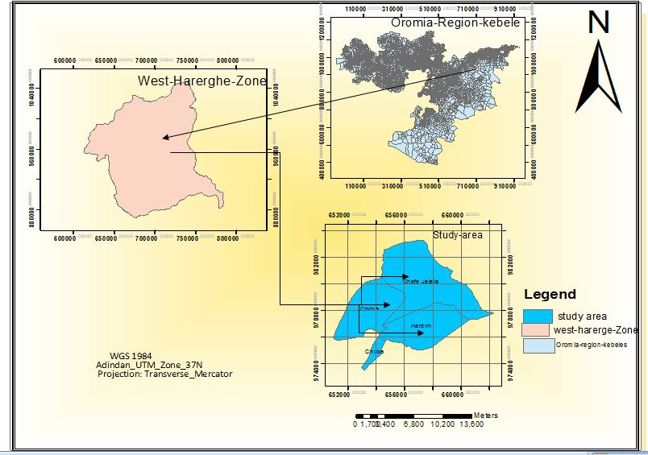
Fig.3. 1: The Description map of the study are

3.1.1 Agro climatic Zone the study
The agro ecology zone of the study area is categorized in sub-tropical type of climate. So the woreda climatic temperatures are Dega (10%), Weina Dega (30) and 60%arecovered by arid.

3.1.2 Temperature and Rain fall of the study area
The study area has ranged between 220c°_240c°and Rainfall ranges from 600mm_900mm while the relief of the study area is characterized by undulating plains of light plateaus ranging from 1200m_2800m above mean sea level. (OCATB, 2013)see (Fig: 3.2) bellow
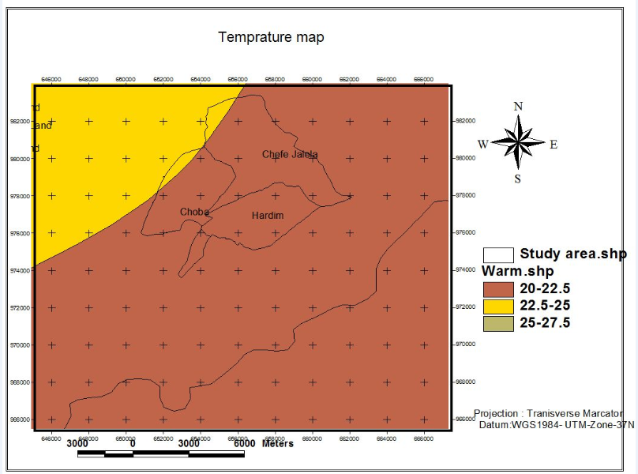
Fig.3. 2: Temperature of the study area (LUPWHZ, 2012) shape file

Most of the study area was laid under the temperature 25-27.5degree Celsius cover all the study area and around 90% of the total area were 20-22.5C° at warm temperature whereas the 22.5-25 C° temperature cover the 10% of the study area see(Figure3.2)

3.1.3 General Land Use Pattern in the Area
The principal categories of land use in the area are crop cultivation, grass land/pasture (grazing), forestry settlements, water body and production of vegetable and fruits. The different bird habitat and grazing land is the typical characteristics of the lower catchment along river, forest and plantation in upper catchment while crop cultivation and grazing are more or less in all parts of the watershed.

3.1.4 Socio-economic characteristic of the area
The economic base of the community in the area to the watershed is agriculture (crop production and animal husbandry). Farmers grow crops including maize, potato, and onion, wheat, peas, beans, and carrot in sub-watershed. This area is one of the main producer and supplier of cash crops such as Chat and coffee while the other activities like vegetation such as particularly onion, carrot, cabbage to the capital city Hardim and Gelemso (which is the capital city of Habro woreda). Most of the people of the kebeles are engaged in off-farm activities because of their proximity to the nearby town of Hardim. Some of the off- farm activities of the people are, selling fuel wood and small scale trade on animal sand quarried from some streams of rainy season and rivers beach, and daily labor both in the City. Crops, which are dominantly growing, in the study area, cash crops such as Chat and coffee while vegetables crops like fruits, maize, and sorghum are the common activity of the area.

3.1.5 Biodiversity and eco-tourism of the water shade community
The GaraMoye micro-watershed support different species of fauna and flora type of diversity in the area. The study area is also major species of different type of wild life and much type of birds.

3.2 Research Design
In order to examine the impact of Watershed Development activity of the Gara Moye watershed a cross sectional research design is used. To generate appropriate information from the local community, local administration and municipality as well as satellite image of different years would be use. To maximize the generation of reliable data for analysis, the research design was compliment by proper research methods and techniques for data generation and collection. To address the stated objectives, broad based information would be gathering. In the process of data collection and generation multiple sources of evidence such as survey questionnaire, semi- structured interview, focus group discussion, field observation and satellite image would be used. To strengthen the data acquisition, triangulation or the combination of methodologies including qualitative and quantitative approaches would be used

3.2.1 Field survey
The nature of the field work was conducted in the study area to assess and gather the necessary primary data would be conducted starting from March 6/ 2017. The type of field activities planned to be conducted include, transect walk to observe the socio economic and bio- physical nature of the area supported by audio visual information gathering techniques such as video and photography, the gathering of data based on the available data sources at local and level, the gathering of data by using questionnaire and interview of the local people, data acquired through the measurement of some variables in the field such as area, altitude, slope, rainfall, temperature and the like and other required socio economic and bio physical data. The data gathered in the field would be organized in to different data acquisition techniques such as camera, video, audio and data digital and analogue data gathering techniques.

3.2.2 Study site selection and determining sample size
The researcher has selected GaraMoye micro- watershed due to the following reasons. First the researcher knows the area and is interested about it. Second the bio physical and socio economic nature of the area is comfortable for the research problem. Finally, the area is much reasonable in the point of view of proximity and convenience. Hence the selection of sample which was determined to be familiar with the nature of the study is systematic random sampling. The total population of the study is the total number of household’swere1884 households out of which 1633 male and 251 females in terms of socio economic aspects and the bio physical variables in the case of watershed development activity on socio economy and environmental wellbeing of the community study. Therefore, the three kebeles namely, Hardim, Choba and Café jalala were randomly selected in GaraMoye micro watersheds would be the sample targets which would be selected based on the diversity and mix of socio economic and bio physical attributes observed in the area. The total number of the household which live in the three kebeles 1884 Households out of which 1633 male and 251 females (source Guba Qoricha WRLAEP office). The sample frame for socio economic analysis and out of which 120 households would be studies as a sample target for the study.
Accordingly, the sample size from three kebeles household will draw and 95 heads of farm households will randomly have selected. Key informant were 10 experts from different government institutions and focus group desiccation 15 by using purposive sampling and use purposive random sampling technique for HHS interview questionnaire, the total participant would be 120 individuals.
The total population of the households found in the selected Kebele is 1884 household heads. Out of these total populations, based on the Cochran (1977) formula, the sample size of the study was calculated as follows
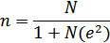

Wheren= represents the sample size the researcher used
N= represents the total number of households in the study area
e= represents maximum variability or marginal error (10%)
1= represents the probability of the event occurring.
n = 1884/1+1884(0.1)²
n = 1884/1+1884*0.01
n = 1884/19.85
n = 95
n = 95 Households from above selected kebeles.
Table 3. 1: Sample distribution of respondents in Kebele
Sex | Kebele |  |  | Total
Sex | Hardim | Choba | Cafe jalala | Total
Male | 17male (17.89%) | 28 (29.47%) | 38(40%) | 87.37%
Female | 3(3.15%) | 4 (4.2%) | 5(5.26%) | 12.61%
Total | 20(21.05%) | 32(33.68%) | 43(45.26%) | 100%
Source: Own survey2017

3.2.3 Selection of respondent households
Respondents would be selected from the three kebele watersheds and they would be stratified in sub-kebele and got level. Stratification of the respondents would be made in terms of income level, social status gender, age, land holding, institutional, service, energy source, livestock production, crop production, land use pattern, conservation measure and the like.

3.2.4 Design of household questionnaires
The number of questionnaire was determined based on the required data for household interview, focus group discussion and key informant interviews. Structured questionnaire and interview is believed to be the best tool of data collection for the research purpose since the data requires more involvement and standardization by the researcher.

3.2.5 Key informant interviews
Attempts to explore facts on the ground makes it a rational approach to include key informant interviews by involving selected group of individuals who were likely to provide needed information, ideas, and insights on the proposed research. Key informants would be selected with the help of the land administration and environment protection woreda office, from woreda Rural Agricultural Development office and from Kebele administration leader and land administration and environment protection kebele experts together with agricultural development agents (DA) and supper visor of three kebele. Three key informants were asked in each three Kebele which is (3*3*3=9) and a check list of open ended questions would be prepared and presented to them in a simple and understandable manner. The total key informants were 10 experts would be selected. The time and place for key informant interview would be guided by the key informants themselves.

3.2.6 Primary data sources
The primary data source was collected from Focus group discussion for the research would be conducted with religious leaders, selected elder, poor people and women and vulnerable society to acquire the relevant data through open discussion. The researcher would be record and gather the data from group discussion would lead the discussion as moderator. The number of participants would be 5 arranged in one group in each three kebele.

3.2.7 Secondary Data sources
The secondary data for this research was west Harerghe existing land use land cover and proposed land use plan shape file, published and unpublished secondary documents, government and non-government reports and population census of the watershed. These data were acquired from different sources such as browsing the internet and Guba Qoricha woreda rural land administration and environmental protection (WRLAEP) office.

3.2.8 Material Used
To collect, organize and analyze the relevant data the following Materials and software as presented in Table 3.2 is used.

Table 3. 2: Description of Software used
S/N | Material and Software used | Description of usage
1 | ERDAS Imagine 2014 | Used for image pre-processing, stacking single bands, supervised maximum likelihood classification of land classes and accuracy assessment of the classification
2 | Arc GIS 10.3 | Used for data analysis, management, and spatial referencing, Geo-referencing and makes a layout for final mapping. Moreover, watershed delineation and clipping process were operated by Arc GIS software.
3 | HandheldGPS | (Garmin Marine GPS Receiver or GPS72H) has been used to collect ground control points (GCPs) used to conduct ground accuracy assessment.

3.2.9 Description of Land Use and Land Cover Classes
Based on field observation and general historical information gained from participants during the survey, it was decided to focus on the following major land use and land cover classes summarized below

1. Forest/Shrub/Bush Lands
The category includes areas covered with different species of shrubs and bushes with widely varying density from one locality to another, and often found in hilly areas. In three kebeles the areas that are not closed as part of the watershed management program serve as a communal grazing and free access resource with very few above ground biomasses. In GaraMoye micro -watershed area closure is practiced, as the result of closed the bare land area can be covered with bush and shrub lands water shed activities they were done. Hence, the vegetated areas upslope are well protected and are not being accessed freely to serve as grazing land.

2. Grass Land/Grazing land
Grasslands are areas dominated by grasses and forbs, and have few or no trees. Grazing and roaming animals occur in abundance. Before the influence of humans, grasslands filled with billowing grasses, colorful wild flowers and the hum of insects were only found in natural clearings in woodlands, above the tree line and at the coast. But once people began clearing woodlands for farming, grasslands flourished and were used for grazing livestock and crop production. Grazing land refers to those land units allocated as a source of animal feed, including privately and communally owned grazing areas. There is variation in their management schemes, from those which are open to access year round, those accessed only during selected months of the year, and those completely closed year round. In the latter feed is made available through the cut and carry system, whereby grazers are expected to cut and haul away the fodder to the animals.

3. Cultivated Land
Cultivated land includes most flat areas and also some steep slopes where various food crops are grown, either on a rain-fed basis or using irrigation. Irrigation is commonly practiced in some parts of three kebeles, which is located in lower part of watershed catchment.

4. Settlement/Bare Land
The category of bare land denotes areas that are without any vegetation cover at the time of satellite image acquisition but could be categorized in one of the land use and land cover types mentioned above. They are not covered by any type of crops, grass or any other shrub or tree species. According to a classification scheme developed for woody biomass Inventory and strategic planning project (WBISPP), bare land meant to include those areas with exposed sand/soil, salt flats, and exposed rock as well (WBISPP, 2002).

In addition to the land use and land cover classes described above, it is also apparent that there are areas that serve as settlements, most of which are made of up of traditional huts and very few with metal roofs, scattered around. There was a one urban built up areas in three study areas. Hence, because it was possible to easily identify such features in the satellite images. So the decision was made to consider settlements among the land use classes.

5. Water Body/wet land
The category of wetlands encompasses those areas located down in the watershed along revering plain which experience frequent flooding and immersion in water and are covered by wetland vegetation including grasses. The ultimate use of such land was as an irrigation vegetation and fruit production. Currently, such areas have been converted to cultivated land for growing chat and other cash crops.

3.2.9.1 Steps in analysis of satellite images for land cover change
In order to cover the intended period of study, different type of images originating from different types of sensors were used. Hence, land sat Thematic Mapper(TM) and Enhanced Thematic Mapper Plus (ETM+) and operating land Imager (OLI/TIRS) satellite imagery were used. From beginning of 2002- 2012 and 2012-2016 respectively along with ASTER image of 2011 were used for a time series of images for the land use/cover change study. The image would be acquired for consecutive years to observe the longitudinal variation in land use land cover change. The image would be acquired in October, March, and Jun. see (Table 3.3).

Table 3. 3: Description of Satellite Images
Land sat types | Sensor | Resolution | Acquisition date | Sources/ website
ASTER DEM |  | 30by30 | 6/17/2011 | USGS/Free
Land sat Band7 | ETM+ | 30m by30 | 03/07/2002 path167,Raw54 | USGS/Free
Land sat Band 7 | ETM+ | 30m, 15m pan | 10/12/2012 path167,Raw54 | USGS/Free
Land sat Band 8 | OLI/TIRS | 30m,15m pan | 6/9/2016 path167,Raw54 | USGS/Free

Layer stacking
During layer stacking, the Universal Traverse Mercator (UTM) system with WGS84 as a datum was assigned as a preference as far as projection is concerned. All seven bands of ETM+, and OLI/TIRS were considered for Layers stacking. The nature of these different bands had to be considered to make a decision as to which seven band combination would be most helpful for classification and visual interpretation.

Image classification
ASTER image was the very recent image available for study areas and served as a reference image. Hence, it was possible to undertake field visit and collect GPS coordinate and supervised classification was preferred. The two land sat images; ETM+ and OLI images were also included to meet the preferred time horizon of study. But, due to lack of fine details, unsupervised classification was selected to classify land sat images. Meanwhile, it must be noted that effort has been made to integrate few historical information acquired from surveys to minimize complete reliance on spectral information and solve mystery of spectral similarity of different land cover classes in order to improve classification accuracy.

Unsupervised classification
This classification does not utilize training data as the basis for classification. Rather, this kind of classification involves algorithms that examine the unknown pixels in an image and aggregate them into a number of classes based on the natural groupings or clusters present in the image values. The basic assumptions in this classification are that values within a given cover type should be close together in the multi-dimensional spectral space, whereas data in different classes should be comparatively well separated. The classes that found from unsupervised classification are spectral classes. Because they are solely based on the clusters in the image values, the identity of the spectral classes is not initially known. For the study the researcher has classify the images into5classes. After getting the classes comparability of the classified data with the false band color composition of the reality was done.

Supervised Classification of ASTER Image
Once geo-referencing is accomplished and the positional accuracies of features on images from different time are checked, supervised image classification of the ASTER image was done. Hence, selected coordinate (X, Y) points that include the major land use and land cover classes were sampled to create a signature file to help train the software to classify the entire study areas. Care was taken to minimize error by avoiding mixed pixels, and an effort was made to include areas relatively uniform in spectral pattern.
Moreover, attention was also paid during collection of X; Y coordinates in the field by taking GPS measures at the center of relatively large and uniform sampling unit representing each land cover class type. As opposed to unsupervised classification, decision as to the number of classes expected in that particular area is the first important step to be made. Following that, as part of the interpretation process, information was provided by taking sample signature points so as to supervise and help the computer accomplish the classification process in the whole study area based on samples provided.

Particularly, parametric decision rule with maximum likelihood classifier was selected as it allows classification of all the pixels in scenes, and avoids the probability of assigning a single pixel in more than one class. Moreover, the maximum likelihood decision rule is based on the probability that a pixel belongs to a particular class and its basic equation assumes that these probabilities are equal for all classes, and that the input bands have normal distributions.

Based on comparison of the different algorithms of supervised classification to monitor landscape changes in Abuja, findings revealed that the maximum likelihood algorithm performed better than the others (Hussien, 2009).
Accuracy assessment
Accuracy assessment is a post-classification step in the LULC analysis and it is mainly the most common method for an estimation of classification approach execution. The acceptable accuracy values are relative, determined generally by the users themselves depending on the type of application they used. Accuracy values that are acceptable for specific application may be unacceptable for others.

The method of accuracy assessment used in this study was based on the pixel scale to derive the accuracy of classification in the remotely sensed data, which resulted from the calculation of the error/confusion matrix. The kappa coefficient is used in order to evaluate the overall accuracy of the classified images. It is generally known as a precision measure since it is considered as a measure of agreement in the absence of chance. With Minimum 5 and maximum of10 points per each class, 30 the total point Random samples are used to assess the classification accuracy. The minimum point used for land cover class type water boy while the maximum point used for land cover class type like forest, grass land, cultivated and settlement /bare land. The reference data were collected from theground using handheld GPS.

3.2.9.2 Data summarizing and analysis
In this research both qualitative and quantitative data would be generated, and this requires carrying out a combination of data analysis methods. Data collected from group discussions would be immediately summarized through discussion with an assistant note taker. Outstanding and prominent issues would be screened by checking how many of the speakers have reiterated the same issue in the process of the discussion.
Both diverging and converging issues on particular issues would be identified and used for analysis, in the context of the research objectives. Most of the dependent and independent variables collected in the questionnaire and used in the analysis would be categorical, nominal or ordinal and the numeric or measurement dependent and independent variables would not often normally have distributed. Hence, by using Microsoft excels 2007. The data analysis techniques would be ERDAS Imagine 2013, and Arc GIS 10.3. Similar data would be collected and summarized by using the above analysis tools and techniques.

3.2.9.3 Extraction of the study area
The Extraction of the watershed through the use of the digital elevation model data sets was done by using the DEM data from ASTER in 30m spatial resolution. Data was imported to the ArcGIS 10.3 and delineation of the watershed boundary, generation of topographic maps and location map of the watershed is done. The process followed included downloading an ASTER image, mosaicking Digital elevation model, fill, watershed flow directions, watershed flow accumulation, Stream network, streamlink and finally the watershed have been delineated using the Advanced Spaceborne Thermal Emission and Reflection Radiometer (ASTER) remote sensing images and Arc GIS model builder. The workflow to analyze the watershed using model builder is presented. See (figure 3.3)

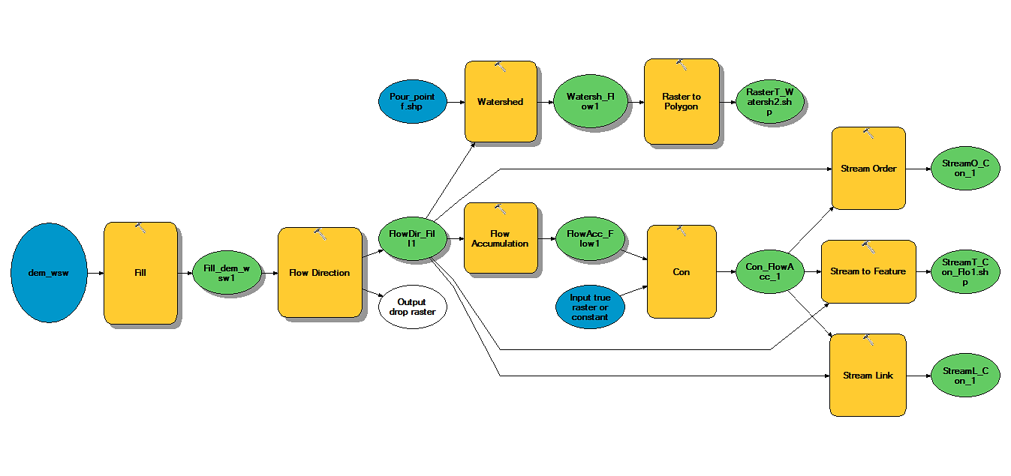
Fig.3. 3: Model of watershed builder

Table 3.4 present the summary of information for all images of the selected year. The next step the researcher undertook in the processing of remotely sensed data was deciding which software to use. So ERDAS IMAGINE 2013 was used for this analysis. Converting single panchromatic band to the multispectral image was done using the layer stacking method.
Table 3. 4: Satellite Images description
Information | 2002Image | 2012 Image | 2016 Image
Space craft ID | LANDSAT_7 | LANDSAT_7 | LANDSAT_8
Sensor ID | ETM+ | ETM+ | OLI_TIRS
WRS_PATH | 167 | 167 | 167
WRS_ROW | 54 | 54 | 54
Date acquired | 03/07/2002 | 10/12/2012 | 6/9/2016
Map projection | UTM | UTM | UTM
Datum | WGS1984 | WGS1984 | WGS1984
Ellipsoid | WGS1984 | WGS1984 | WGS1984
UTM Zone | 37 | 37 | 37
Panchromatic grid cell size |  | 15 | 15
Reflective Grid cell size | 30 | 30 | 30
Thermal grid cell size | 30 | 30 | 30

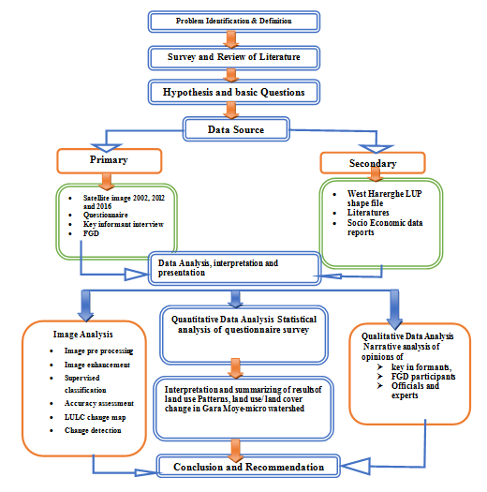
Fig.3. 4: Flow of Research Frame work

CHAPTER FOUR

RESULT OF DISCUSSION
In this chapter the result on socio economic and biophysical characteristics of watershed development actives of respondent households and the perception of HHs in land management activities land use land cover changes are presented and discussed. Also the impact of watershed management activities on livelihoods of the local community and institutional issues affecting the effectiveness of the watershed development are analyzed.

4.1. Water Shed Analysis Of The Study Area

4.1.1 Land Use Land Cover Change analysis of the study area
The four major LULC types identified in the study watershed were forest land, farm or cultivated land, grazing land /grass land, settlement/bare land, and Water body. The description for the LULC types was that trees include trees grown, including indigenous tree species and exotic trees such as eucalyptus and Juniper’s trees. Tree plantations mainly refer to eucalyptus trees. Lands that are used for growing annual crops such as wheat and barley including fallow land and homestead area (including settlement), Water body were categorized in this study watershed. The proportions and distributions of LULC types in hectare and percent for 2002, 2012 and 2016years

4.1.2 Status of land use land covers distribution in 2002
Table 4.1 and Figure 4.1 shows land useland cover of the study area in terms of quantity and thematic map respectively. In 2002 cultivated land, Grass/Grazing land, settlement /bare land forest, and water body showed the highest coverage in the study area. Each of them constituted relatively larger proportions covering 1661.53ha (31.77%), 1233.97ha (23.59%) and1157.69 ha (22.14%) of the total area respectively. Besides, a relatively considerable amount of the area was covered by forest cover769.32ha (14.71 %). In 2002water body covered the smallest share of the total area which was 407.205ha (7.79%). These conditions were considered as a baseline for change detection over the study years.

Table 4. 1: Area and percentage coverage of LULC (2002)
S/N | Class Name | Area in hectare | Area in %
1 | Forest land | 769.32 | 14.71
2 | Grazing Land /Grass land | 1233.97 | 23.595
3 | Cultivated land | 1661.53 | 31.77
4 | Settlement Land/bare land | 1157.69 | 22.136
5 | Water body | 407.205 | 7.786
 | Total | 5229.715 | 99.997

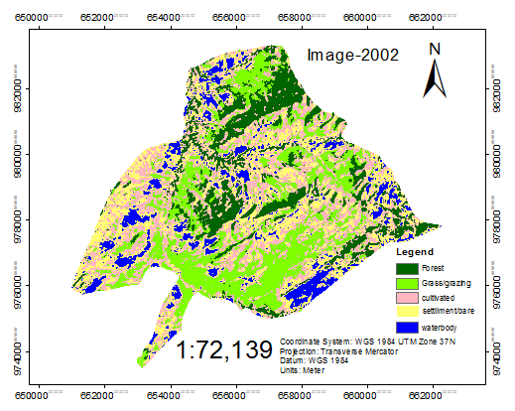
Fig. 4. 1: Land use land cover map of the study area in the 2002

4.1.3 Status of land use land covers distribution in 2012
In 2012, the land use land cover classes that covered the highest share of total area where grazing land /Grass land, settlement/bare land, cultivated land, and forest land were observed in the area. However, the trend from 2002 showed a relative increase in area coverage in most of the land use type classes’ which shares of grassland/ grazing land, settlement/bare land, and water body were 30%, 24% and 9% respectively. While some land use type was relatively decreasing from 2002 cultivated and forest land use types constituted 23% and 11% respectively of the total land area in 2012 respectively. Water body area coverage was the smallest i.e. 9%. However, when it was compared with that of 2002 LULC (Table: 4.1), the study area has undergone significant changes and conversions in 2012(Table: 4.2). This is because cultivated land and forest changed into other LULC classes. About 7%% and 3% of the total area of cultivated land, and forest cover area respectively changed into other LULC classes (Table4.6).
On the other hand, grazing/grass land, settlement/bare land and water body were increased by 7%, 2% and 2% from 2002 to 2012 respectively. There is no relatively constant through the two years. In general, in this year cultivated land and forest showed a considerable decrease while Grass /grazing land and settlement /bare land and water body showed increment compared to the LULC setting of 2002.see(Fig:4.2)
Table 4. 2: Area and percentage coverage of LULC (2012)

S/N | Class Name | Area In hectare | Area %
1 | Forest land | 625.86 | 11.897
2 | Grazing Land /Grass land | 1581.03 | 30.054
3 | Cultivated land | 1262.16 | 23.99
4 | Settlement Land/bare land | 1309.68 | 24.896
5 | Water body | 481.77 | 9.1582
 | Total | 5229.717 | 99.9952

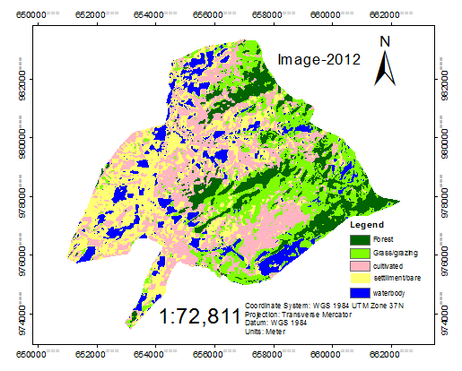
Fig. 4. 2: Land use land covers change 2012

4.1.4 Status of land use land covers distribution in 2016
After 14years (in 2016) grass land /grazing and cultivated land and settlement/bare land constituted the highest share of the total area coverage. Table (4.3) and figure (4.3) shows that land use the land cover of the study area in quantity and thematic map respectively. Grass land /grazing and cultivated land and settlement/bare land covered 75.044% of the total area in 2016. Forest cover and water body covered the medium part of the area by 15.76% and 9.19% of area coverage respectively. In this study year grasses/grazing land, cultivated land and settlement /bare land dramatically increased from 77.05% in 2002 to 78.94% in 2012. On the other hand, the forest cover and water body area coverage at 2002to 2012 decreased from 22.49% and 21.05% See the (Table 4.1and 4.2) and increased from 2012 to 2016 by 21.05% to 24.956% Se the (Table 4.2 and 4.3). While grass land /grazing and cultivated land and settlement/bare land covered decreased from 2012 to 2016 by 78.94% to 75.044%respectively, Se the (Table 4.2 and 4.3). The change in the second study period (2012-2016) was much more significant compared with the first one (2002-2012).

Table 4.3: Area and percentage coverage of LULC (2016)
S/N | Class Name | Area In hectare | Area %
1 | Forest land | 824.107 | 15.758
2 | Grazing Land /Grass land | 1399.34 | 26.757
3 | Cultivated land | 1363.12 | 26.064
4 | Settlement Land/bare land | 1162.1 | 22.22
5 | Water body | 481.05 | 9.198
 | Total | 5229.717 | 99.997

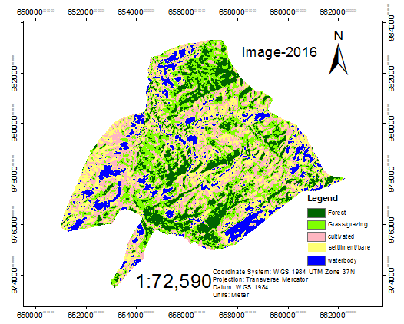
Fig.4. 3: land use land cover change 2016

4.1.5 Accuracy assessment
The study focused on relatively large geographic units. Hence, much variability is not expected within a short distance and some of the changes might not be captured due to image resolution. GCP is collected from the ground survey. Generally, classification accuracy could be affected by the lack of fine details and resolutions of images used (Jianya et al., 2008).
Due to the need to make generalizations, and errors are always expected accordingly. To assure wise use of land cover maps and accompanying statistics derived from remote sensing analysis, the errors must be quantitatively explained. The most common and typical method used by researchers to assess classification accuracy is the use of an error matrix. See (table: 4.4)
Table 4.4: Confusion matrix and accuracy assessment classification
Classified data | Forest | Grass/grazing land | Cultivated | Settlements/ Bare land | Water body | Row total | User Accuracy
Forest | 3 | 0 | 0 | 0 | 0 | 3 | 100%
Grass/grazing land | 0 | 2 | 0 | 0 | 0 | 2 | 100%
Cultivated | 0 | 0 | 3 | 0 | 0 | 3 | 100%
Settlements/ Bare land | 0 | 0 | 1 | 3 | 1 | 6 | 50%
Water body | 0 | 0 | 0 | 0 | 0 | 0
Column Total | 3 | 2 | 4 | 3 | 1 | 30
Producer Accuracy | 100% | 100% | 75% | 100%
Overall accuracy | 90%

4.1.6 Kappa Statistics
The Kappa statistics, which is a measure of agreement, can also be used to assess the classification accuracy. It expresses the proportionate reduction in error generated by a classification process compared with the error of a completely random classification. The Kappa statistic incorporates the off-diagonal elements of the error matrices (i.e., classification errors) and represents agreement obtained after removing the proportion of agreement that could be expected to occur by chance. Conditional Kappa statistics(K^) for each Category were 1.000, 1.000, 1.000,0.444 and 0.000 forest, grass/grazing, cultivated, settlement/bare land and water body respectively and the overall kappa statistics was 0.8462 with the overall classification accuracy 90.00%. Since the results obtained from classification and the validation statistics for this study were higher than the minimum validation threshold, it was reasonable to employ the derived maps for further land use land cover change assessment in the watershed.

4.1.7 Land use land cover change between 2002 and 2012
Since the accuracy assessment results indicate supervised classification with maximum likelihood classifier is an accurate method for this study; the map derived from the classification were used for the watershed land use land cover changes analysis. Change detection is the process used in remote sensing to determine the change in land use land cover between different times periods to determine the watershed land use land cover change, post classification change analysis was employed in ERDAS Imagine for the study area. The “post-classification” is a common and suitable method for land cover change detection. This method compares two independently classified images to produce a change map of a matrix of changes (Singh, 1989).

The LULC in the study area has undergone significant modifications and conversions between the 2002 and 2012 course of the study years (Table 4.5). In 2002 after 10years, the Grass/grazing land, settlement/bare land, and Water body increased into 30.096 %, 24.88% 9.153% respectively. Whereas cultivated land and forest cover decreased to 23%, 11%, respectively. Grass/grazing land, settlement land, and water body showed increment in 2012 while the other has experienced a relatively small decline. Relatively the change in the area coverage of the different LULC classes during this period (2002-2012) was shown (Table 4.6); though there was a continuous change among them.

Between 2002 and 2012 cultivated and forest land changed to other land use land cover class is loose about 800.843ha, 350.955ha and gained about 709.15ha, and 203.783 ha from other land use land cover class. The net decreasing change observed in the forest is 147.172 ha. The gained change observed on grass land /grazing and settlement land/bare land 881.573ha, 767.025ha and 186.007ha from other land use land cover class respectively.

The total loss observed in this class to other land use land cover class is about 542.25ha. The net increasing change observed in this class is about 339.323 ha when compared to the 2002 coverage. Forest cover gained and lost 203.783ha and 350.955ha respectively. There is a decreasing change observed in the forest cover by 147.172ha. Increasing change observed in grass land,settliment and water body between the year 2002 and 2012. The total gain observed by grass land is about 881.573ha. The total loss observed in this class is 542.25ha. The net increasing change observed in this class is about 339.323ha.

Table 4.5: Land use land cover change matrix of between 2002 and 2012 in Hectare
2002 Year
2012 Year | LULCC | Forest | Grazing/Grass land | Cultivated land | Settlement/bare | Waterbody | total | % | total gain | total loss | Net change
2012 Year | Forest | 417.667 | 77.985 | 97.425 | 27.09 | 1.283 | 621.45 | 11.883 | 203.783 | 350.955 | -147.172
2012 Year | Grazing/Grass land | 226.08 | 689.58 | 529.043 | 122.67 | 3.78 | 1571.153 | 30.096 | 881.573 | 542.25 | 339.323
2012 Year | Cultivated land | 98.483 | 314.37 | 450.27 | 323.775 | 64.215 | 1251.113 | 23.96 | 800.843 | 709.15 | 189.119
2012 Year | Settlement | 24.075 | 142.965 | 55.705 | 531.832 | 44.28 | 1298.857 | 24.88 | 767.025 | 623.318 | 143.707
2012 Year | Waterbody | 2.317 | 6.93 | 26.977 | 149.783 | 291.825 | 477.832 | 9.153 | 186.007 | 113.558 | 62.449
2012 Year | Total | 769.32 | 1233.968 | 661.535 | 1157.692 | 407.205 | 5220.405 | 100

4.1.8 Land use land cover change between 2012 and 2016
After 14 years, the grass land /grazing land, cultivated and settlement/bare land dramatically increased by 26.758 %, 26.076 % and 22.216%, respectively. Forest cover and water body also showed a considerable amount of increment into 11.49% and 3.41% respectively. On the other hand, the bushland, grazing land, and water body decreased 15.7 %, and 9.174% see (Table 4.6).

The change in this second period (2012-2016) was much more significant compared with the first (2002-2012). The land use land cover change matrix between 2012 and 2016 showed that during the indicated period there was much more significant land use land cover change. About area of grass land was 415.395 ha, 136.732ha, 343.553 ha and 6.120ha converted to cultivated, settlement and Waterbody. Forest cover, grazing land, water body, were converted into cultivated and settlement area respectively.

With regard to forest 187.132ha, 67.095ha, 173.542ha, 29.813ha, and 1.958ha of forest converted into grass/ grazing land, cultivated and settlement, and water body respectively (Table 4.6). In general, total net change in the area indicated that grazing land, and settlement showed decrement while forest cover, cultivated land, and water body showed increment between 2012 and 2016 see (Table:4.6).

Table 4. 6: Land use land cover change matrix of between 2012 and 2016 in Hectare
2012 Year
2016 Year | LULCC | Forest | Grazing/Grass land | Cultivated land | Settlement | Waterbody | Total | % | total gain | total loss | Net change
2016 Year | Forest | 335.452 | 343.553 | 117.720 | 24.570 | 2.160 | 823.455 | 15.7 | 487.548 | 218.903 | 268.645
2016 Year | Grazing/Grass land | 187.132 | 669.352 | 357.660 | 173.542 | 9.225 | 1396.911 | 26.758 | 727.559 | 901.8 | -174.241
2016 Year | Cultivated land | 67.095 | 415.395 | 365.107 | 491.287 | 22.432 | 1361.316 | 26.076 | 996.209 | 886.005 | 110.204
2016 Year | Settlement | 29.813 | 136.732 | 324.315 | 544.568 | 124.358 | 1159.786 | 22.216 | 615.218 | 754.289 | -139.071
2016 Year | Water body | 1.958 | 6.120 | 86.310 | 64.890 | 319.657 | 478.935 | 9.174 | 159.278 | 158.175 | 1.103
2016 Year | Total | 625.815 | 1580.715 | 1262.115 | 1309.590 | 481.770 | 5220.403 | 100

4.1.9 Land use land cover change between 2002 and 2016
Between 2002 and 2016 study year cultivated land was declined from 31.77% to 26.07% and grazing land showed a considerable increased by 23.59 to 26.75%. See (Table 4.7). Between 2002 and 2016 cultivated land showed the highest declination of all the other previous study years. On the contrary, grass land, forest cover, settlement land, and water body increased. See (Table 4.7).

The LULC change matrix between 2002 and 2016 showed the change in the forest to grass land and cultivated land about 263.160ha, 0.270 ha respectively. Whereas 318.22ha and 9.54ha of grass land were converted into the forest and cultivated land. While; cultivated land was converted to other land use classes about 229.97ha and 78.26ha to grass land and settlement respectively. About 73.845ha of settlement converted into the water body in 2002 and2016.see (table4.7).

Although the net increment of the total area of forest and grazing land was high, a considerable amount of area of cultivated and settlement land was changed into other LULC class. In general, water body and settlement were slightly increased in the period between 2002 and 2016.see (table 4.7).

Table 4.7: Land use land cover change matrix of between 2002 and 2016in Hectare
2002 Year
2016 Year | LULCC | Forest | Grazing/Grassland | Cultivated land | Settlement | Water body | Total | % | Total gained | Total loss | Net change
2016 Year | Forest | 505.890 | 318.217 | 0.000 | 0.000 | 0.000 | 824.107 | 15.758 | 318.217 | 263.43 | 54.787
2016 Year | Grazing/Grassland | 263.160 | 906.210 | 229.973 | 0.000 | 0.000 | 1399.343 | 26.7575 | 493.133 | 327.757 | 165.376
2016 Year | Cultivated land | 0.270 | 9.540 | 1353.307 | 0.000 | 0.000 | 1363.117 | 26.0648 | 9.81 | 303.818 | -294.008
2016 Year | Settlement | 0.000 | 0.000 | 78.255 | 1083.847 | 0.000 | 1162.102 | 22.22 | 78.255 | 73.845 | 4.41
2016 Year | Waterbody | 0.000 | 0.000 | 0.000 | 73.845 | 407.205 | 481.05 | 9.19 | 73.845 | 407.205 | -333.36
2016 Year | Total | 769.320 | 1233.968 | 1661.535 | 1157.692 | 407.205 | 5229.719 | 100

4.1.9.1 Change in Forest land
Forest land Gara Moye watershed occupied 14.71% of the watershed in 2002 and this value decreased to 11.897% by 2012.Later in 2012 it showed increment by 15.758% by 2016. The improvement in coverage of forest found during the third period of analysis (2012-2016) more likely related to the introduction and expansion of area closure introduced by the government and community participation in 2012. See (Table: 4.5), (Table: 4.6) and (Table: 4.7)
The LULC change matrix in Table 4.7 between 2002 and 2016 showed that Forest land gained 318.217ha of land from other land use land cover class and lost 263.43ha of land. The net increasing change observed in forest land is about 54.787ha, forest land gains318.217ha from grass/grazing land. The total conversion observed in forest land between 2002 to 2016 is 263.160ha to Grass land/grazing land, 0.270ha of cultivated land. The result showed that major conversion of forest land is to grass land shows that the area closure by the government. See (Table: 4.7) and Fig 4.9
These changes were attributed to population growth which forced the farmers to till and expand their lands to a greater extent than before to cope up with the conditions and to sustain their life. The survey results also confirmed the land use land cover change in the watershed. Based on the survey result agricultural land showed increasing change through study time. All of the respondents indicated this result. In the contrary, forest and water body declining change over the study year. The major reason indicated by the respondents for the decline of grass, forest land and water body in terms of the rank order was an illegal expansion of cultivated land, Settlements and cutting of trees for fuel and construction.

4.1.9.2 Change in grass/grazing land
Grass/grazing land occupied 23.595% in 2002 and increased to 30.054% in 2012 later the area coverage of grass/grazing land decreased by 26.757% in 2016. Grass/grazing land gained 493.133ha of land from forest and cultivated land use land cover class and lost 327.757ha of land. The net increasing change observed in this class is about 165.376ha between the year 2002 and 2016. Grass/grazing gain 263.160ha and 229.973ha from the forest and cultivated land respectively between 2002 to 2016.See (Table: 4.7).

Throughout the study year, it is observed that the net gain of Grass/grazing land from cultivated and water body shows a negative result. This means that in the study year some part of cultivated land or water land was converted to gain from grass land cover. This result is more likely related to the trend of tree plantation by farmers for commercial purpose in their crop land. Population growth and declining crop productivity were the most important underlying driving forces to LULC change in the study area. Farmers suggested that the declining crop productivity was attributed mostly to recurrent drought, erratic rainfall, lack of credit to invest in fertilizers and improved seeds, lack of plowing oxen, declining soil fertility and a shortage of cropland. The communal grazing land was to provide the increasing number of household’s livestock production to increase the income of the community and to compensate low crop productivities. See Fig: (4.9).

The result of the study shows most of the HHs in the watershed have no their own grazing land 28%, 27% and 19% in café Jalala, Choba and Hardim kebeles. The result shows that the most of the respondent in water shed have the problem of the grazing land for livestock production. See (Fig: 4.8)

4.1.9.3 Change in Cultivated land
Between the year 2002 and 2016 cultivated land showed great change of decreasing and increasing. The total gained area by cultivated land constituted 9.81ha from another type of land use land cover class. The loss and net increasing change observed in this class are about 303.818ha and -294.008ha respectively.

Cultivated land showed a decrement in size between 2002 and 2012 study year (Table 4.7). The relative decrement in cultivated land is more likely related to the restriction posed by the government on farmer not plow on the hilly area closed and planting a tree around the private and communal land. On the other hand, the farm land gives production before and after watershed intervention was different that means the production income decreased before and increased after watershed intervention and the plot on the valley side and on the hilly side are given less production than the level plot. See (Fig: 4.6) and (Fig: 4.7).

4.1.9.4 Change in Settlements/bare Land
Settlements/bare Land showed increment and decrement between2002 to 2012 and 2012 to2016 respectively in the study year. The total gained area by Settlements/bare Land constituted78.255 ha and lost 73.845ha. The net decreasing change observed in this class is about 4. 41ha.The change matrix table in 4.7 shows that Settlements/bare Land78.255ha of land from cultivated. This result shows us the scarcity of farmland and illegal cultivation of grazing land related to population growth and lack of well-planned management in the area.

The main driving forces ranked by the respondents are illegal encroachment for agriculture, overgrazing leads to barren land, distributing grazing land to landless and construction of infrastructure on communal grazing lands. Explained by most of the respondent’s response and from focus group discussion result, there is an improvement made on the management grazing land. These results revealed that the change of grazing land is a factor of population growth, heavy livestock rate (overgrazing), expansion of farmland and lack of responsible organization for natural resource keeping in the area.

4.1.9.5 Change in Water body
Even if water body showed a considerable amount of increment in the year between 2002 and 2016(Table 4.3), its area is no change or small increment in the study year between 2012 and 2016. The total area gained by water from other land use land cover class is about 73.845ha and the loss observed is about 407. 205ha.The net decreasing change observed in this class is about-333.36ha. There were farm ponds made by the farmers. Constructing an embankment across a water resource and excavation of a pit and conserving rainwater using technology is the recent phenomenon practiced in the watershed. This is more likely the main reason for the increase of water body between 2002 and 2016.
Fig.4. 4: Land use plan of West Harerghe Zone (Source W. H. Rural Land Administration and Environmental Protection Bureau (2012)

The above fig: 4.4 showed that the proposed lands use planning of the study area based on the proposed land use planning the study area classified into different land use classification such as protective forestry, productive forestry, Highland maize, Highland sorghum, low land maize and sorghums, wheat, barley and different types of cattle like Goat, camel, and cows .In addition to these the built up area for settlement and buffer area were able to identify but the proposed land use planning until know all in all not implemented on the land more financial and man power were investigated by the government the area were more researchable for future sustainability of watershed development to improve the lively hood of community. See (Fig: 4.4)

4.2. Socioeconomic Analysis

4.2.1 Analysis of land resources and distribution of plot of land
Land resources not only refer to the soil but also to landform, climate, hydrology, flora and fauna, including land improvement measures such as terrace and drainage works. In the three Kebeles the households have a combination of field that are level, sloping and gully side (Figure: 4.5)
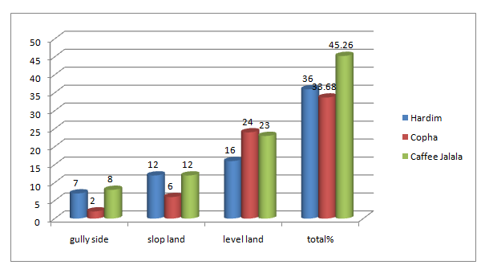
Fig.4.5: Response of Head of household on distribution of agricultural plots

The response showed that the distribution of Agricultural plot of the households of the three kebeles was represented in the above figure 4.1 that shows the plot distributed in the gully, slop land and level land Cafe Jalala, Hardim, and Choba were from the total 45.26%, 36%, and 33.68% the gully side, 8%, 7%, 2%, slop land were 12%, 12%, 6% and level land were 23%, 16% and 24% in three kebele respectively. Therefore the gully side plot 17%, the slop land 30% and the level land were 63% .See (Fig4.5)

4.2.2 Plots that give the highest yields value

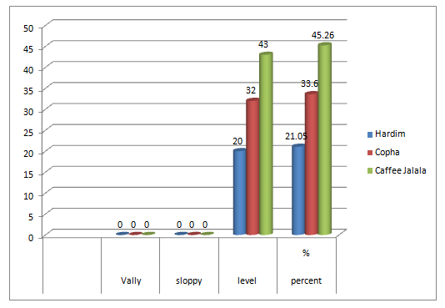
Fig.4. 6: Response of household head on agricultural plots gives the highest yield

In addition, the watershed community was asked about the productivity of the fragmented agricultural plot they cultivate. The result shows that majority of the respondents said that the level plots gave the highest yield in three kebeles café Jalala, Choba and Hardim 45.26%, 33.6% and 21.05% respectively. The result shows the plot in the valley and sloppy side were give the lowest yield when compare with level land plots. See (Fig.4.6) above.

4.2.3 Crop production before and after watershed development

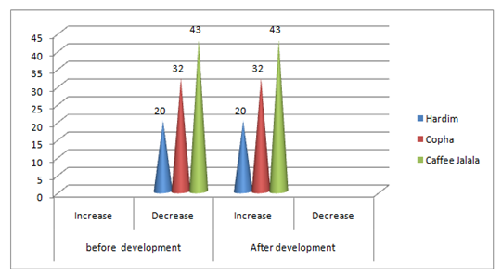
Fig.4.7: Shows that the responses of households of crop production

The above figure 4.7 Shows that the response of Head of household on the distribution of agricultural production before and after watershed development. The figure above shows the level of income of agricultural production before and after watershed intervention shows that most of the respondents of three kebeles income of production before intervention were decreased Cafe Jalala, Choba, and Hardim were 43%, 32% and 20% and after production was increased by 43%, 32%and 20% respectively. The result shows after watershed intervention the crop production from the cultivated land ware increased. See (Fig: 4.7) above. In addition to this the crop production in 2014 were 534130/8008 ku/ha and in 2016 the crop produced were 763719.75/7862 Ku/ha (Guba Qoricha Woreda Rural Agricultural Development Office).

4.2.4 Grazing land
According to the responses of the respondents the HHs who have their own grazing land in the watershed was from the larger to the smaller 15%, 5% and 1% in café Jalala, Choba, and Hardim kebele while, Most of the HHs in watershed have no their own grazing land 28%,27% and 19% in café Jalala, Choba and Hardim kebeles(Fig: 4.8).
The result shows that the most of the respondent in water shed have the problem of the grazing land for livestock production. Grass/grazing land occupied 23.595% in 2002 and increased to 30.054% in 2012 later the area coverage of grass/grazing land decreased by 26.757% in 2016 (Table:4.7).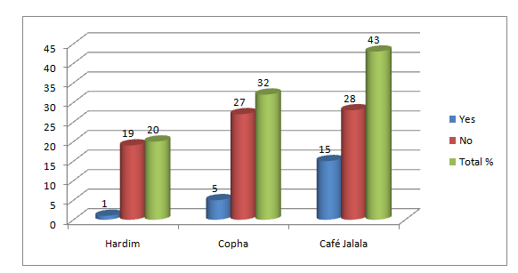
Fig.4. 8: Shows the respondents grazing land

4.2.5 Tree planting
Farmer’s plant trees for producing fuel wood, construction wood, and fodder for domestic use and commercial purposes. Most of the HHs, in all watersheds, planted trees mainly for construction and fuel wood production purpose. This might be due to the absence of natural forests in the vicinity where one can easily get construction wood. According to the respondents, the engagement and not engaged in tree planting of respondents in three kebeles were 34%, 27% and 19% engaged in Cafe Jalala, Choba, and Hardim kebeles respectively. Whereas the respondent not engaged in tree planting were 9%, 6% and 1% in Cafe Jalala, Choba, and Hardim kebeles respectively. The result shows almost all of the respondents were engaged in tree planting in the study area. See (Fig: 4.9)
The size of tree planted in the watershed started from 2012 were 8.27 million in 98 ha, in 2013 were 8.9 million cover the 5200 ha, in 2014 the tree planted 18.01million which cover the 5728 ha and in 2015 were 21.8 million cover the area11812.5ha were planted by house hold(Guba Qoricha Woreda Rural Agricultural Development Office).
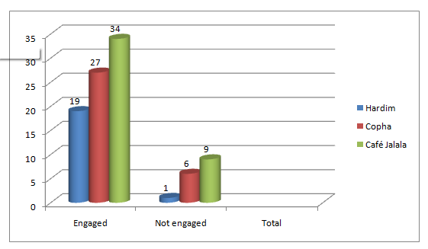
Fig.4.9: Shows that the respondent of household’s tree planting

4.2.6 Major source of House hold wood in the watershed
Watershed households acquire fuel wood from different sources: own plantation, community forest, natural forest, and state. In this research, households were asked about the sources of fuel wood from which they get for domestic consumption in all intervention period. Before watershed development the respondent’s households used for the source of fuel from the own plantation, community forest, natural forest, and state but now after Watershed management they gate only from buying and own private land households in three kebeles in watersheds. The result shows they have no other optional source for fuel for domestic consumption. Seethe (fig4.10)

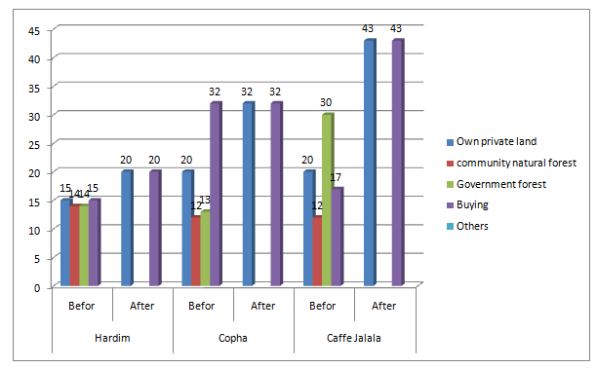
Fig.4.10: Shows the response of household’s source of fuel wood

The above fig4.10 showed that the source of HHs fuel wood consumption for construction, fuel Most of the respondent used before watershed intervention on government forest 57%, community natural forest 38% and others but after watershed intervention most of them used by buying 95%, from the own private land 95% and others(charcoal, crop residue and plastic). See(Fig:4.10) the result showed that most of the respondent have the problem of fuel wood for food preparation and for construction after watershed intervention there is no biogas and fuel saver (stove).

4.2.7 The participation of households in the soil and water conservation
In this survey, an attempt was made to see the participation of rural households in SWC activities on their holdings by their own initiatives as well as by external forces. On the average, almost 75.78% of the respondents have SWC measures on SWC whereas the response not participated were 24.21 See (Figure 4.11).
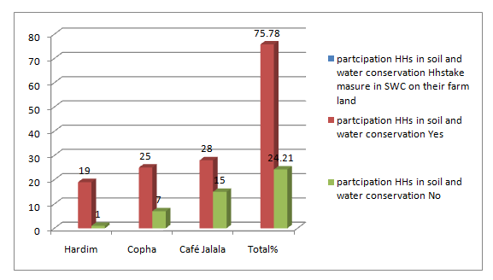
Fig.4.11: Shows the participation of households in the soil and water conservation

4.2.8 Responsibility of collecting fuel for home
Watershed inhabitants spend a lot of their time in collecting fuels (fuel wood, dung, crop residues). In Ethiopian culture, the kitchen is the domain of women and girls. A significant percentage of their working time and energy involves obtaining and using firewood. The responsibility of collecting fuel and the time required to arrive at the fuel source were asked. The survey results clearly indicated that the burden of collecting fuel is mainly that of women’s (wives) and children’s (males or females) responsibility. As shown in (Fig 4.12) about 26%percent of women (wives), and 84%percent of female children and1.05% percent of male children have the task of collecting fuel in all three kebeles watersheds whereas the men (husbands)any share in this responsibility. See (fig: 4.12)
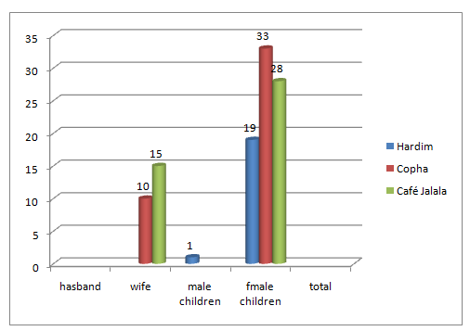
Fig.4.12: The responses of the household’s responsibility of collecting fuel for home

4.2.9 Impact on Crop Production and diversification
The crop is the most important source of household income in the study area. The main crops in the study area were barley, wheat, maize, and sorghums. This indicates that most of the households were dependent on crop production as a primary source of their income. Due to the different watershed interventions the productivity of most of the crops were increased and in turn increased the household’s income see (Fig: 4.13) from the three kebeles respondents the responses that say YES were 35%22%, 17%, in Cafe Jalala, Choba, and Hardim respectively while, who say NO were 10%,8%, and 3% were Choba, Café jalala and Hardim respectively see(Fig:4.13). In 2012 the crop production 6 Ku/ha due to the farmer used improved seed and fertilizers 2784.5 DAP and 68 Urea while in 2016 the amount of the fertilizer used to improve crop production were increased 3685DAP and 1420 UREA the crop production ware 26.35Ku/ha (Guba Qoricha Woreda ARD office). Also, the crop productivity increased the food is not satisfactory for house hold in the watershed throughout the year the source of this is until today they take aid.

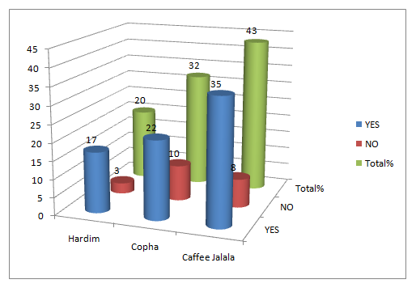
Fig.4.13: Shows that the response of households increasing in crop production

4.3. Watershed Management Practices

4.3.1 Result of Watershed Management Practices in the study area
Since 1980, the government of Ethiopia was initiated watershed development to supported rural land rehabilitation, through well utilization and conservation natural resource (MOARD, 2005). Farmers were familiar with traditional soil and water conservation practices in their day to day activities. However, currently technically supported physical and biological conservation measures were widely implemented to prevent soil erosion, land degradation and environmental managements in the study area. The main purposes of mechanical/structural/physical soil and water conservation measures were to control the movement of water over the soil surface and limit its erosive capacity.

As the data from the farmers, the main physical conservation measures implemented in the study area were soil bound deep trench, terraces, hill side terrace, haring bounce, half moon, gabion, gully cutting and stone bund. Moreover, plantation of indigenous forest species is widely implemented in the study area. Similarly, the various water harvesting structures constructed at Gara Moye micro-watershed are shallow well Shallow excavation for household consumption, river diversion, and motor pumping. According to the data from the group discussants and interviewees, the above physical and biological soil and water conservation were implemented on private and communal land.

According to the group discussants, the households participated in the implementation of the conservation measures. They were contributing free labor yearly (20-40 days) on communal land management. In the survey, an effort was made to see the participation of households in soil and water conservation. According to the survey data, 75.78%of the households were implemented construction of soil bound and stone trace, crop rotation, check dam construction, planting, and protection of forest, gully reshaping, cut and carry system, grazing land rehabilitation, irrigation practices, using improved agricultural input, compost preparation and water development practices.

As the key informants mention communal land and private land and resource managements to rehabilitate and benefit livestock production and income production for two to three years and to decrease unemployment for male and female of the area. This is by means of animal fed (cut & carry) livestock production and fattening. See the following (Fig.4.14), Table 4.3 and Fig 4.3LULC in 2016.
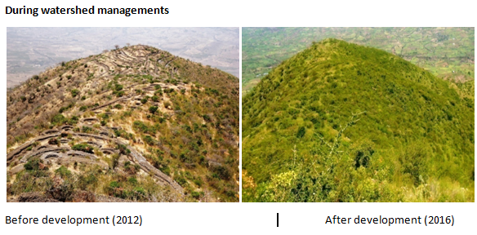
Fig.4.14: Shows the change in water shed managements activities
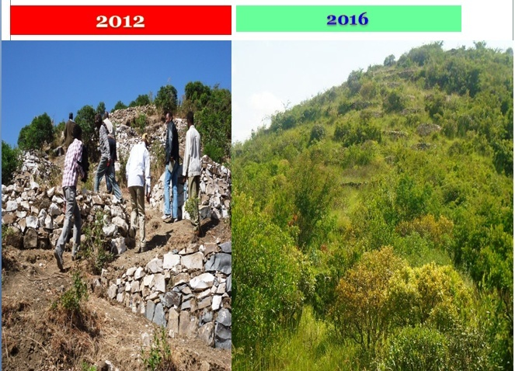Before development (Nov, 8/2012) taken after development (sep17, 2016) taken
Fig.4.15: Integrated watershed managements works in the study area
The integrated watershed managements works are not only biophysical work but also the socio economic activities are done by community participation. The works are providing all problems that describe the community in that watershed. The fig above shows that SWC activities and after the watershed intervention taken and the result shows that the conservations were many activities decreased runoff, soil erosion, and the area closer can be rehabilitated much wild lives that migrated before was in habited. See (Fig: 4.15), Fig (4.16) and Fig (4.17).

Fig.4.16: The images show the change in land management’s in the watershed development Guba Qoricha WARD Office

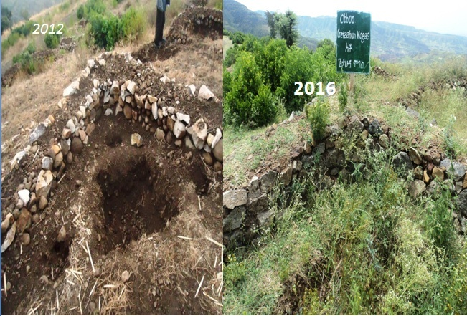
Fig.4.17: The image of the soil and water conservation activity done by the watershed community from Guba Qoricha Woreda ARD office image taken.

4.4 Impact of Watershed Management on Economic, Social and Environment
Considering the potential impacts of watershed management is indicating the watershed contribution to cope with climate change risks and hazards. Watershed management contributes to all sectors (agriculture such as crop production and livestock, water availability and quality, health, ecosystem service, socio economic and all human livelihood activities) directly or indirectly through chain reaction available between sectors (MOARD, 2005).

4.4.1 Impact on Livestock Production
Livestock is an integral part of the farming systems and they are particularly important for increasing the resilience of vulnerable poor people subjected to climatic and income shocks. This is possible through spreading risk and increasing assets. The loss of livestock, especially on bullock is critical as it not only ruins the asset base but also deprives the general productive capacity of the households. Thus, the ownership of livestock is often used as an indicator for wealth and food security.
The majority of sample households have different types of livestock. The major Livestock’s in the study area includes cattle, sheep, goats, donkeys, camels, and poultry. Watershed management has an impact on livestock size and type. From the survey, household size and type were decreased after watershed management. As the discussants and interviewees revealed, there were decreasing in livestock size and type due to food shortage as a result of the zero grazing. Almost all households have not owned grazing land in the study area. The availability of communal grazing land after watershed management was decreased. Even though carry and cut system were used it is not sufficient for all. See (Fig: 4.18)
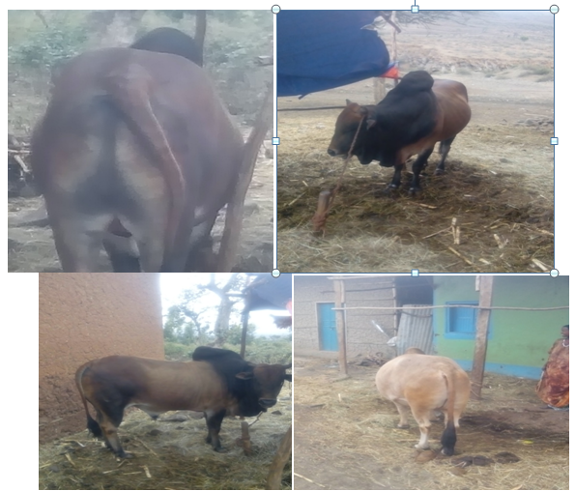
Fig.4. 18: The bull fattening by cut and carrying from the forest managements grass in Choba kebele image taken 1/15/2016 (Guba Qoricha WARD Office).

4.4.2 Livelihood Diversification
Surface and groundwater availability increased due to the various water storage structures and biological and physical soil conservation resulted in increased cropping intensity and helped households to find new ways to raise incomes and reduce environmental risk. The watershed management helped households to diversify their livelihood activity. Income or livelihood diversity is important to cope with climatic risks. If one income source were lost then still have other sources of income which make households and communities better able to cope with hazards and therefore make them resilient (Adger, 1998).

4.4.3 Impact on Employment Opportunity and migration
The different watershed management practices were provoked households with different employment opportunity. The farmers in the watershed are well organized and increased working duration as far as they are confluent to get a good return. Households were involved in irrigation, trade, and bee keeping activities and to start-up new businesses. Working culture of households was changed. For example, before the intervention households were harvested their land ones only before sowing but after intervention, most of the households were harvesting minimum 2 times before sowing as a result, the impact of pesticide was reduced. The involvement of households in different activities reduced household’s migration in the study area.

The relationship between watershed management and migration were complex. The implementation of watershed management can affect migration through an increase in short-term employment as well as long-term productivity gains. Due to the different activities in the watershed management migration was reduced in the study area.

4.4.4 Impact in Social Interaction
Enhancing Social network of households was also the main objective of the watershed. The government introduced 1 to 5 household’s network which has a great contribution to enhancing household’s social interaction and adoption of new technologies. This was worked on the assumption that if one farmer adopts a technology successfully, other farmers may learn the improvement from him/her, and share with others, thereby developing a multiplier effect Social network was from key farmers who acted as teachers or advisers to the other farmers. Likewise, the discussant and interviewees affirmed that this network improves household’s participation in different activities by making competition each other. Similarly, the female household discussants confirmed that the introduction of such networks provided us an opportunity to access information and exchange ideas and experience. Therefore, households and communities were better able to watershed managements.

4.4.5 Impact on Water Availability and Qualities
The major impact of watershed interventions was seen in improving the surface and groundwater availability. Increased water availability resulted in increased cropping intensity and diversification to more remunerative land use systems involving livestock, horticultural and vegetable production (ICRISAT, 2007).

4.5 Biological Soil And Water Conservation Measures
Water and land are managed at multiple scales and levels, such as farm plots, small or micro watersheds nested in larger watersheds, and ultimately large river basins. At all of these levels, integrated management of land, crops, livestock, water, forestry, Agro forestry, and watershed communities are essential.

Based on concepts of integrated natural resource management, the term integrated watershed management‟ (IWM) is the conceptual foundation of most modern programs to improve water and land management, especially in highland areas characterized by sloping. The willingness of farmers to invest in land improvement, the number and proportion of participating farmers in a watershed and the success of land management programmes depend on different conditions within the watershed. Farmers who are most dependent on crop production for their livelihoods appear to be more willing to invest in better land management and conservation.
This is usually the case in densely populated areas with a concentration of smallholdings and where land is highly valuable, like in the highlands of Ethiopia. Low crop productivity and severe soil erosion, mainly caused by low soil fertility and absence of efficient and sustainable soil fertility management practices, land ownership, human capital, water availability and resource tenure are the major constraints contributing to the food shortage in Ethiopia.

The study area the use of appropriate soil management practices such as inorganic fertilizers; compost, cropping systems, vegetation cover, and conservation tillage at the farm level and eventually at the watershed scale have been suggested to be among the best approaches to address this problem. See (Fig: 4.19)

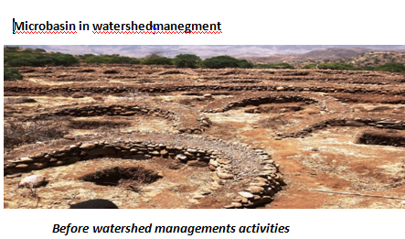
Fig.4.19: Shows the micro basin watershed management activity image taken 1/15/2016source (Guba Qoricha WARD Office)

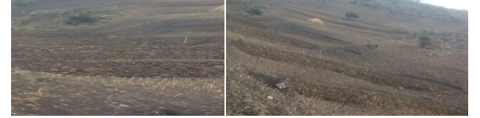
Fig.4.20: The stone bunds structure used under Choba kebele image taken 1/15/2016Source (Guba Qoricha WARD Office)

The undulating terrain nature and the high potential of rainfall in the study area were responsible for the formation of runoff following heavy rain. Following roads, furrows and rill erosion, there were a number of gullies being formed in the study watershed. See (fig4.21).

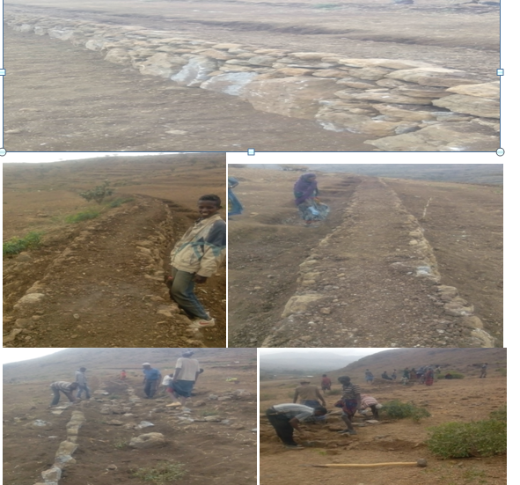
Fig.4.21: Households Participation of watershed managements in Hardim kebele image taken 1/15/2016. Source (Guba Qoricha WARD Office).

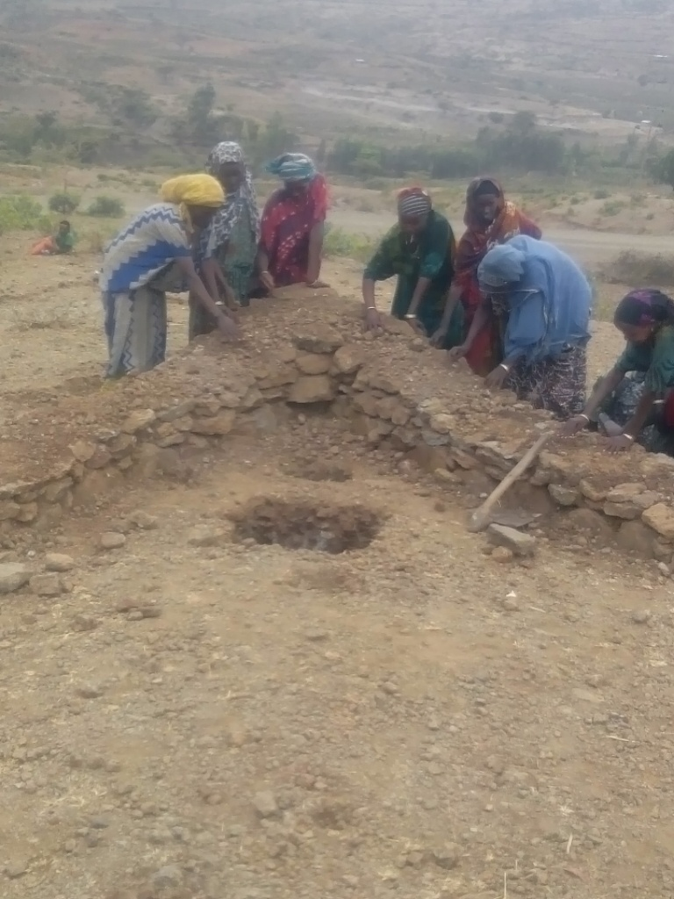
Fig.4.22 Herring bones by women in the watershed management activities image taken 1/15/2016 sources: Guba Qoricha WARD Office.
The Figure above shows that the involvement of women in the watershed development activities of SWC methods in the watershed. As the Result of SWC activities decrease soil erosion, sedimentation, deposition, increase soil fertility and increase crop production. See (Fig: 4.22)

4.6 The Result Of Focus Group Discussion And Key Informants
Firstly, the question started from the name of the watershed of GaraMoye was started in the 2012 and completed in2015. The Water shed can be developed by three kebele which called Hardim, Choba and café Jalala and the area coverage were500hectares in each kebele totally 1500hectars.So the major work done in the watershed were the deferent structures such as soil bunds, stone bunds, hydrobasine, micro basins, Gabions made by tree and stone and tree plantings. See (Fig.4.19, 4.20, 4.21, and 4.22)

In other ways the type of structures was constructed to conserve the soil and water in arable and non-arable land are herringbone, Hydro basins, micro basins and have the moon, improve pit and trench are the major work done by the participation of watershed community as the key informant and focus group discussed in the field survey. While the participants were containing the male and female which above 18 years old category of villagers could be participated in developing of the structure at the communal land and the private lands by free service with Governmental organization and NGOs. Likewise, the type of benefit was the direct and indirect benefits such as animal fattening by using cut and carrying grasses while indirect was increased in surface and ground water, soil fertility, increased in crop production, increased in natural rain fall and reduce soil erosions, etc. As consequences of forest area were increased the different species of wild animals inhabited such as monkey, apes, Hyenas, Tigers and different species of birds were the result of the watershed management activities of the present day.

The structures were maintained where the land rehabilitation project with World Food Programme (WFP, 2005) and Food-for-Work assistance was aimed at addressing the problems of food insecurity through the construction of soil conservation structures, community forestry and rural infrastructure works. The current status of the structure was at good managements employing the guard from the three kebele 1500ETB in a month. Besides the benefit of watershed, structure shared: water, fodder, fuel wood and drinking water shared with fairly to the villager’s unemployment and the income of the majority of farmers increased due to watershed management’s activities. The group of unemployment of farmers (men and women) and land fewer laborers improved as consequences of structured introduced in the watershed developments. The watershed program helps in improving the quality of life in the watershed and the watershed association /watershed committees, user group/self-help group constituted for planning/execution /monitoring /maintenance. The watershed activities are not adapted to the neighboring village because of the area are very threatening.

4.7. Challenges In The Watershed Development
According to the data from the group discussants and interviewees, the implementations of watershed management practices were faced with social, economic and natural limitations/ challenges. Accordingly, the major challenges in the watershed management were shortage of land, lack of awareness in resource management, disagreement between the households and local leaders, unwillingness of youngsters to participate in conservation practices due to landlessness, climate variability, lack of follow up, lack of knowledge and means of utilizing the available resource, water scarcity, low skill of using agricultural technologies and inputs, lack of integration between sectors.

A substantial proportion of farmers indicated that shortage of land and erodible nature of the soil, bare and steeply topography are the major challenges in the area. Farmers were not volunteers to implement soil and water conservation in their farmland since their farmland size was too small. Likewise, the farmers were also not interested in adapting improved seeds and fertilizers. Suggest that the distribution of fertilizers was not matched to the land size of households and in turn affects productivity. Shortage of natural rain fall strongly affects the successes of watershed management practices. For an instant, some of the shallow wells (water tabs) were dried during the dry season and non-functional due to a shortage of natural rain fall.

Another challenge in the implementation of the watershed was a lack of awareness of households in the intervention. For instance, the communities were conflicted with the guard hired to accessing the area closure. They tried to access the area closure at night time by hitting the guard. Trees planted in the area closure were cut illegally. Similarly, lack of integration between sectors is also a main challenge in watershed management. Moreover, lack of technology, information, and skills, infrastructure also affected the watershed management implementation.

Another challenge facing in watershed management is a lack of sufficient capacity at all levels of government structures at district and kebele to implement the new and sustainable approaches, while the intervention needs of the watersheds. The other most important challenges of watershed management in the study are excessively steep slopes of the watershed and small land holding system.

4.8. The Lesson Is Drawn From The Success Of Watershed Development
The success of watershed development activity is determined by the environmental services offered by the poor people (reducing the off-site effect of erosion) to the rich farmers who live downstream. The term “environmental services” is defined as “the conditions and processes through which ecosystems sustain and fulfill human life, including the provision of food and other goods” Watershed has been recognized as a unit for integrated resource management, where management is not only limited to land, water, and biomass but also concerned with integration for self-reliance and holistic development of the rural poor. In an operational context, this would mean integrating different uses and management of resources, different Departments with sectorial interest through an inter-disciplinary approach, and towards the alleviation of poverty and asset building.

All collective efforts reside in institutions, and without institutional change, we will not move purposefully towards sustainability Sustainable development is defined by the Brundtland Commission (1987) as “development that meets the needs of the present generation without compromising the ability of future generations to meet their own needs”. However, this definition is unclear for operational purpose and ordinary in nature due to three reasons; (1) it does not specify human needs; (2) it does not clarify the timeframe for the analysis of future generation’s needs; and (3) it does not mention the environment as a key concern in sustainability.

According to Bartelmus sustainable development (1997) defined as “the set of development programs that meet the target of human needs satisfaction without violating long-term natural resource capacities and standards of environmental quality and social equity”. To achieve sustainable development, ecologically friendly and locally acceptable technologies need to be developed, transferred and adopted. Natural resources can potentially be used in a sustainable way through appropriate technology. Following the sustainability pattern, “appropriate”, would require that a technology should be ecologically protective, socially acceptable, economically productive, and viable and reduces risk. Management of watersheds can be made possible by using a variety of technologies such as vegetation conservation like grass contours, alternative tillage techniques and physical structures including terraces, micro basins, stone and soil bunds, fanyajuus(throw up hill), gabion box, etc. But the essence is to achieve sustainable development that can be replicated by the inhabitants of the watershed after the end of the intervention.

4.9 The Effect of forest Cover change
The presence of forest has many functions in that it protects soil from erosion problems by reducing surface runoff and increasing the infiltration of rain water into the soil profile. Forest cover also prevents soil erosion by the wind. Besides these, it also serves as sources of food and as dwelling home for different kinds of animals and birds. Despite these facts, almost all area of natural forest has been disappeared before 14 years in the study watershed leading to the over the flow of most of the rain water carrying soil particles and a significant amount of minerals and nutrients. This has resulted in yield decline and more rills and gullies formation followed by land fragmentation. The other effect of forest cover change was the reduction of the water flowing in the form of springs and streams from the area leading to the reduction of drinking water to human and livestock. So stream flow reduction and drying was the main impact of reduction or absence of natural forest in the study area. The information from field survey, key informants, and field observation also supported this idea. On the other hand, after water shed managements by government and community participation the forest covers the land that the soil erosion reduced the home of deferent type species of animal and birds are inhabited today. See the (fig: 4.23) and see (fig: 4.24).

4.9.1 The major Method of Soil and Water conservation in the watershed

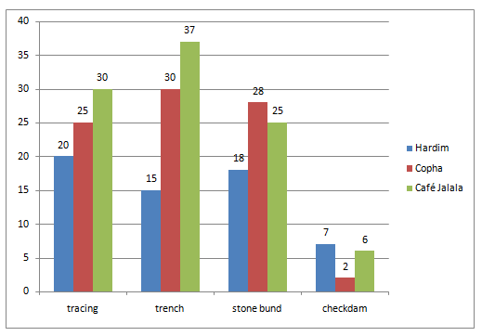
Fig.4. 23: Show the method of Soil and water conservation taken in the watershed

The figure (4.23) above shows that the watershed development activities of SWC taken by community participation and involvement of different stakeholders in the watershed the tracing ,trench, stone bund and check dam by 30%,25% and 20% tracing in Café Jalala, Choba and Hardim where as trench were 37%,30% and 15% respectively. While the stone bund were 25% , 28% ,18% and the check dam were 6%, 2% ,7% in Café Jalala, Choba and Hardim respectively.
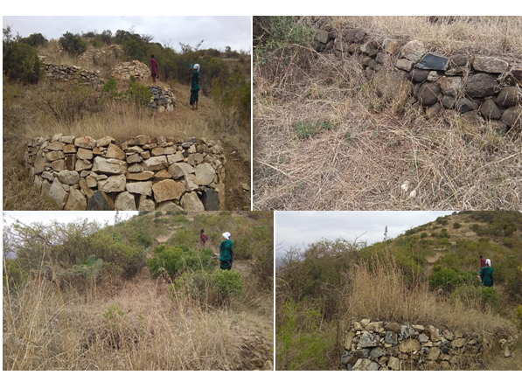
Fig.4.24: Shows result of watershed management activity in the study image taken March, 4/30/2017 own survey

The figure above shows the existing land use land cover change after watershed intervention measure taken these lands before water shed intervention was degraded could be rehabilitated after five years by a government institution and community participation and nongovernmental institutions. See (fig: 4.24)

CHAPTER FIVE

CONCLUSIONS AND RECOMMENDATIONS

5.1 Conclusions
The focus of this research was analyzing the impact of watershed management activities in socio economic and environmental well-being of the community in Guba Qoricha woreda Gara Moye watershed and utilizing the data collected from 95 households randomly selected from Hardim, Cafe Jalala, and Choba kebeles. The government together with NGOs and local communities perform many activities in the study area to support the local communities to enhance the environment, such as; Physical soil and water conservation measures such as soil bund, deep trench, terraces, hill side terrace, check dams, and water diversions, compost preparation (organic fertilizer compost and manure), area closure protection and management, water management (water harvesting and groundwater recharging structures such as check dam, Shallow excavation for house hold consumption and irrigation, irrigation practices, cut and carry system as discussed in the above.
On the average, almost 75.78% of the respondents have SWC measures on SWC whereas the response not participated were 24.21.The different interventions were enabled to improve crop productivity In 2012 the crop production 6 Ku/ha due to the farmer used improved seed and fertilizers 2784.5 DAP and 68 Urea while in 2016 the amount of the fertilizer used to improve crop production were increased 3685DAP and 1420 UREA the crop production ware 26.35 Ku/ha (Guba Qoricha Woreda ARD office). Also, the crop productivity increased the food is not satisfactory for house hold in the watershed throughout the year the source of this is until today they take aid. In light of this finding, involving secondary data, GIS and remote sensing in LULCC stands an update to current literature on watershed management in the study area.

The change in this second period (2012-2016) was much more significant compared with the first (2002-2012). The land use land cover change matrix between 2012 and 2016 showed that during the indicated period there was much more significant land use land cover change. About area of grass land was 415.395 ha, 136.732ha, 343.553 ha and 6.120ha converted to cultivated, settlement and Waterbody. Forest cover, grazing land, water body, were converted into cultivated and settlement area respectively.

5.2 Recommendations
Based on the findings of this study, the following recommendations were sought for better success of the watershed development programs in improving the livelihoods of the community which it targets.
- The study finding showed that in the treated area the SWC measures constructed on the private and communal land have resulted in increased land productivity. More over these structures induced increased water discharge.
- The study results have shown that the area closures can bring remarkable impacts towards achieving the desired environmental impact.
- To this regard in order to have sustainable area closures should be established based on good will and full participation of the targeted community.
- The economic benefits out of area closures should be clear and maintained to the beneficiaries. The study result implies there is not bee keeping activities in side area closures that has more sustainable for the futures and this should be encouraged so that area closures should give multiple benefits to the targeted community.
- The study finding of the integrated watershed development program in GaraMoye has shown remarkable achievement in improving the lively hood of the targeted households.
- To address some of the concerns that were identified in the current research were to adopt Land use plan with integrated watershed management considering the widespread growth and the pressure on the area’s environmental indicators such as forest cover, Grass land, cultivated, Settlement and Water body LULC changes.
- The study area watershed should adopt an Integrated watershed management based integrated GIS and remote sensing watershed management approach in order to quicken the periodic monitoring of the interaction between human activities and the environment in the area.
Generally, the study also suggests that the impact of the watershed is more focused towards physical and biological achievement, but the focus on social aspects is limited. There are certain positive trends towards the growth of land use pattern, cropping pattern and soil and water conservation activities. However, social achievements have not been properly addressed with the implementation of the watershed development.

REFERENCE
Adger, W. N. (1998) ‘Seventh Conference of the International Association for the Study of Common Property, Simon Fraser University, Vancouver, Canada, 10-14 June 1998.’, Global Environmental Change, pp. 1–17.
Alemu, B., & Kidane, D. (2014) The implication of integrated watershed management for rehabilitation of degraded lands: case study of Ethiopian highlands. Journal of Agriculture and Biodiversity Research, 3(6), 78–90.
Alemu, W. G., Amare, T., Yitaferu, B., Selassie, Y. G., Wolfgramm, B., & Hurni, H. (2013) Impacts of soil and water conservation on land suitability to crops : the case of Anjeni Watershed, Northwest Ethiopia. Journal of Agricultural Science, 5(2), 95–109. https://doi.org/10.5539/jas.v5n2p95
Baltenweck, I and Ibrahim, M (2003) Demand-Driven Crop–Ruminant Intensification: Trans Regional Analysis to Understand Patterns of Change Using Village Level Data from Three Continents. Nottingham University Press, Nottingham.
BartelmusP.Whithereconomics?From optimality to sustainability? Environ Develop Econ, 1997; 2: 323-345.
Berkat, O., & Tazi, M. (2006) Country pasture / forage resource profiles: Morocco. FAO,6–28. https://doi.org/http://www.fao.org/ag/agp/agpc/doc/counprof/PDF%20files/SouthAfrica_English.pdf
Bezuayehu, T, Gezahegn A., Yigezu A., Jabbar M.A. and Paulos D, (2002) Nature and causes of land degradation in the Oromia Region: A review Socio-economic and Policy Research Working Paper 36.
Birhanu, A. (2011) Assessment of major problems and potentials for sustainable management of rain water through integrated watershed management approach in Mejawatershed; MSc thesis, Department of Environmental Sciences, Ambo, Ethiopia.
Cochran, W. G., (1977) Sampling techniques. 3rd ed. New York: John Wiley & Sons.
DarolabuDistrtict Land and Environmental Protection Office Joint with ASSP Programme; micro watershed survey and assessment plan (February, 2011) Edited by; Birhanu Yazachew Deresa (Regional Expert) ORLEPB, 2004.
Darghouth, S, Ward, C., Gambarelli, G., Styger. E., Roux, J. (2008) Watershed management approaches, policies, and operations: lessons for scaling up, Water sector board discussion paper series. Paper No.11.The World Bank, Washington, DC. (11), pp. 1–164.
Farrington, John Cathrynturton & A.J. James (Eds) (1999): ‘Participatory Watershed Development’, Challenges for the Twenty – First Century‟, Oxford University Press, Delhi.
Gashaw, Temesgen; Bantider, Amare; G/Silassie,H.(2014) Land Degradation in Ethiopia: Causes, Impacts and Rehabilitation Techniques’, Journal of Environment and Earth Science,4(9),pp.98–105.
Gashaw, T. (2015). The implications of watershed management for reversing land degradation in Ethiopia, 4(1), 5–12.
Getachew Ayele (2014) Impacts of Upstream Watershed Management Activities on Downstream Water Users and Users Willingness to Pay by Contingent Valuation Method :The Case of Gumera River Watershed , Ethiopia
Gete, Z., Menale, K., Pender, J. and Mahmud, Y. (2006) Stakeholder Analysis for Sustainable Land Management (SLM) in Ethiopia: Assessment of Opportunities, Strategic Constraints, Information Needs, and Knowledge Gaps. Environmental Economics Policy Forum for Ethiopia (EEPFE), Ethiopia.
Guba QorichaWoreda Rural Land Administration and Environmental Protection Office(2016)
Habtamu, T. (2011) Assessment of Sustainable Watershed Management Approach; A Project Paper Presented to The Faculty of the Graduate School of Cornell University.
Hussien.A. (2009) land use and land cover change ,drivers and its impact: a Comparative study from kuhar michael and lenche dima of Blue nile and awash basins of Ethiopia ,Thesis master degree Presented to the Faculty of Cornell University. thesis .
Jianya, G. et al. (2008) A Review of Multi-Temporal Remote Sensing Data Change Detection’, Remote Sensing and Spatial Information Sciences., 37, pp. 757–762.
Joshi, P. K., Pangare, V., Shiferaw, B., Wani, S. P., Bouma, J., & Scott, C. (2004)Watershed development in India: synthesis of past experiences and needs for future research. Indian JOurnal of Agricultural Economics, 59(3), 303–320.
Kerr, J., Pangare, G. and Pangare, V. L. (2002) Watershed Development Projects In India: An Evaluation, Washington, D.C. pp. 86.
LakewDesta, Carucci, V., AsratWendem Ageňehu and Yitayew Abebe eds., 2005. Community-Based Participatory Watershed Development: A Guideline, Ministry of Agriculture and Rural Development. 1st ed, Addis Ababa, Ethiopia.
Meaza, H. (2015). The Role of Community Based Watershed Management for Climate Change Adaptation in Adwa, Central Tigray Zone. International Journal of Weather, Climate Change and Conservation Research, 1(1), 11–35.
Meaza, H. (2014) The Role of Community Managed Watershed for Climate Variability Adaptation; The Case ofMariamshewito’ Watershed In Adwa Woreda, Thesis On Degree Of MA (Climate Change And Adaptation) Addis Ababa University Addis Ababa, Ethiopia
MOARD (2005) Guide line for integrated watershed management, Addis Ababa, Ethiopia.
Oram, P. (2000). The Influence of Government Policies on Livestock Production and the Environment in West Asia and North Africa (WANA) IFPRI, Washington D.C., USA
Oromia Culture and Tourism Bureau (2013)https://youtu.be/lZRztJ_C4uQ
Palanisami, K. And Suresh Kumar, D. (2009) Participatory Watershed Development Programmes: Institutional and Policy Issues, Paper Presented at The Workshop On Rain fed Agriculture in Asia: Targeting Research for Development, 2-4 December, ICRISAT, Patancheru, India.
K. Palanisami, et.al, (2009) Evaluation of Watershed Development Programmes in India Using Economic Surplus Method Agricultural Economics Research ReviewVol. 22 July-December 2009 pp 197-207.
Palanisami, K., & Kumar, D. S. (2009). Impact of Watershed Development Programs in Tamil Nadu. Strategic Analyses of the National River Linking Project (NRLP) of India Series 5, 335–353.
Palanisami, K., & Kumar, D. S. (2009). Impacts of Watershed Development Programmes : Experiences and Evidences from Tamil Nadu. Agricultural Economics Research Review, 22, 387–396.
Pradesh, M. (2012). Impact of Watershed Development Programmes on Farm-specific Technical Efficiency : A Study in Bundelkhand Region of, 25(2), 299–308.
Singh, A., 1989. Review Article Digital change detection techniques using remotely-sensed data. International Journal of Remote Sensing, 10, (6): 989-1003.
Srinivasan, R., Zhang, X. and Arnold, J. (2010) ‘Swat Ungauged: Hydrological Budget and Crop Yield Predictions in the Upper Mississippi River Basin’, American Society of Agricultural and Biological Engineers, 53(5), pp. 1533–1546.
T Phanidra et al, (2014) Impact assessment study studies, Hyderabad, 3(1) 392-399
Turner, M.G., Gardner, R.H., O’Neill, R.V., (2001) Landscape Ecology in theory and Practice Pattern and Process. Springer Verlag, New York.
United Nations Environment Program (UNEP), (1999) Unsafe Water: 3.3 Billion Illnesses and 5.3 Million deaths. New York: United Nations Environment Program.
Verburg, P.H., van Eck, J.R., de Hijs, T.C., Dijst, M.J., Schot, P., (2004). Determination of land use change patterns in the Netherlands. Environ. Plan. B: Plan. Des. 31, 125–150.
Voinov, A. and Costanza R (1999) Watershed Management and the Web. J Environ Manage 56:231–245
WCED (World Commission on Environment and Development) our common future. Oxford University Press, UK, 1987.
WFP (2005) Draft report on the cost-benefit analysis and impact evaluation of soil and water conservation and forestry measures, Addis Ababa, Ethiopia
Wani S.P and Garg K.K International Crops Research Institute for the Semi-Arid Tropics (ICRISAT) Patancheru 502 324, Andhra Pradesh, India.
Wani, S. P., & Garg, K. K. (2009). Community watersheds for improved livelihoods through consortium approach in drought prone rain-fed areas. Journal of Hydrological Research and Development, 23, 55–77.
Wani, S. P., & Sidhu, G. S. (2009). Land Use Planning in Integrated Watershed Development Program for Improving Livelihoods. Soil Science in Meeting the Challenges to Food Security and Environmental Quality, 154–164. Retrieved from http://www.isss-india.org/other publications.html
Wani, S. P., Anantha, K., Sreedevi, T., Sudi, R., Singh, S., & D’Souza, M. (2011). Assessing the Environmental Benefits of Watershed Development: Evidence from the Indian Semi-Arid Tropics. Journal of Sustainable Watershed Science and Management, 1(1), 10–20.
Woody Biomass Inventory and Strategic Planning Project (WBISPP), 2002.Report on natural grazing lands and livestock feed resources, Amhara National Regional State. Addis Ababa.
Zubair, A. (2006). Change detection in land use and Land cover using remote sensing data and GIS (A case study of Ilorin and its environs in Kwara State), Msc Thesis, University of Ibadan, Nigeria

APPENDIX: Household questionnaire
In this section you need to have an instruction to the respondents. Please see the following sample!!!!!!
The purpose of this questionnaire is to collect relevant information for academic purpose for the fulfillment of MSc degree in Land Administration and management. I, am Nadi Abrahim: student in Bahir Dar University. Objective of this research is to critically analyze the challenges prevailed, the problems exhibited and opportunities available in the watershed development practices in GaraMoye micro- watershed and to pride constructive recommendations and suggesting possible solution to the decision makers for sustainable management and integrated watershed development in the same .Your response is very important to the study, hence you are kindly requested to give your answer for the questions provide below. I would like to thank you in advance for your invaluable time devoted to the following questions.
Appendix Part I
A) Background Information
Zone: ___________________ Woreda/District_____________________
Name of Watershed: ________________Village/Community: _________________
Kebele: ___________________________ Date of Interview (dd/mm/yy): _________
Name of Household Head: ___________________
Name of Respondent’s__________________( not less than 20 years)
B. Wealth, Income, Land holding and Land productivity
1. How do you evaluate your land productivity before watershed managements and after watershed managements? Before watershed managements 1. Increased2. Decreased 3.the same
After watershed managements 1. Increased 2. Decreased 3.the same
2. Did the conservation measures on your land accompanied with moisture holding and then better productivity? 1. Yes 2. No3. Do you use improved seeds for better productivity? 1. Yes 2. No
4. In your area did the project participants own wealth or increases income because of their participation in watershed management activities? 1. Yes 2.No. If yes, how explain by more discussion?

C) Soil and Water Conservation Aspect
_________1. Do you have agricultural plots in low valley or gully? 1. Yes 2. No
_________ 2. Do you have plots at slope lands? 1. Yes 2. No
_________ 3. Do you have plots in level lands? 1. Yes2. No
_________ 4. Which plots give the highest yield? 1. Sloping land 2. Valley 3. Level land
__________5. Is there soil erosion problem in your land? 1. Yes 2. No
__________6. If yes to question 5, in your opinion, what is the main cause of soil erosion in your land?1. Improper tillage 2. Slope/terrain 3. Deforestation
4. High rainfall 5. Absence of protection measures 6. Over grazing
7. Others (specify, if any) ______________________________________
_________7. Which problem exaggerated in your land?
1. Erosion 2. Sedimentation 3. Don’t know
8. Do you use any of the following methods to control soil erosion? (If “No” skip to Q.9)
8.Do you use any of the following methods to control soil erosion?(If “No” skip toQ.9) S.N | 8.1.Methods used | 8.2. Did  You use this method?  1.Yes  2.No | 8.3.Ifyes to 9.2,  When did you start?  1.Beforetheproject  2.During the project  3.After project phased out | 8.4.Ifyesto9.1,howwelldiditreduceerosion?1. None  2.Some  3. Much | 8.5.Ifyes to9.2,howDidyoulearn these methods?  1.From parents(inherited)  2.From neighbors  3.From extension agents (training)  4.From NGOs  5.From school  6.Others(specify, if any)
1 | Terracing
2 | ditches/trenches
3 | Contour planting
4 | stone bunds
5 | check dams
6 | Soil bunds
7 | strip-cropping
8 | Contour farming
9 | Mulching
10 | Minimum(zero) tillage
11 | Tree planting
13 | Others

________9. If no to question 8, why didn’t you take measures?
1. It is costly 2. High labor demanding 3. I don’t know 4. The land is not mine (rented)
5. I have no land right 5. Other reasons (specify) ___________________________________________________
_______10. Have you ever participated in any soil conservation work initiated by government or NGOs? 1. Yes 2. No
_______11. If yes to question 10, what was the drive that initiated you to participate?
1. Myself 2. Extension agents (government) 3. NGOs4. Payment 5. Others (specify, if any)
_______12. Do you have soil and water conservation measure on your farm land? 1. Yes 2. No (If “No” skip to part D)
_______13. In your opinion, was the soil conservation measures implemented on your land demand driven? 1. Yes 2. No
_______14. Who did soil conservation measure in your land?
1. Myself alone 2. Myself and my family 3. Neighbors4. Community 5. Others (specify, if any) __

1. Are any of livestock reared in the household before and after watershed project intervention?
2. What are the major problems of the household for livestock rearing? (Mention up to six problems in decreasing order of severity, with the most serious problem first)
Rank before Rank during Rank after phase out
1. Shortage of grazing land 1st______ 1st_______ 1st________
2. Shortage of forage 2nd______ 2nd_______ 2nd________
3. Disease of livestock and lack of
Veterinary clinics 3rd_____ 3rd_______ 3rd________
4. Decrease in productivity 4th_____ 4th_______ 4th_______
5. Shortage of water 5th______ 5th_______ 5th________
6. Market-related problem: sale of
Livestock 6th______ 6th_______ 6th________
7. Lack of improved varieties 7th_____ 7th ______ 7th________
8. Lack of training 8th______ 8th_______ 8th________
9. Others (specify, if any) 9th______ 9th_______ 9th________
3. What type of grazing system do you use most of the time for livestock?
_______Before the project _______During the project ________ after the project phased out
1. Free grazing 1. Free grazing 1. Free grazing
2. Zero grazing 2. Zero grazing 2. Zero grazing
3. Tethering (tie) 3. Tethering (tie) 3. Tethering (tie)
4. Both 4. Both 4. Both
________ 4. Do you have your own grazing land? 1. Yes 2. No (If “No” skip to Q.6)
________ 5. If yes to question 4, is your grazing land enough?
1. Very plenty 2. Adequate 3. Scarce 4. Very scarce
6. Which type of pasture do use?
___________Before the project _________During the project _________ after the project phased out
1. Local 1. Local1. Local
2. Improved 2. Improved 2. Improved
3. Local and Improved 3. Local and improved 3. Local and Improved
_________7. If improved Pasture (forage), how much was the importance of using it?
1. Not helpful 2. Helped a little 3. Helped a lot 4. Helped very much
_________8. In your opinion if not helpful for question 7, why are not helpful?
1. Not adaptable 2. Not palatable 3. There is no reliable sources of seeds 4. The seeds are expensive
5. It invade farm land (difficult to demolish after establishing) 6. Have side effect 7. Other (specify, if an)
_________9. If you are faced a shortage of forage, what was the measure taken to reduce the problem?
1. Planting indigenous grass species 2. Planting indigenous tree and shrub species
3. Protecting grazing land
4. No measure taken 5. Other (specify, if any) _______________________________
D) Fuel Wood/Construction Wood Aspect
_____1. Who fetches wood for the household?
1. Male adult 2. Female adult 3. Female adult assisted by male adult 4. Female assisted by children
2. Does the household experience fuel or construction wood problems?
_________ 2.1. Before project 1. Yes 2. No If yes, how do you fixit_______________________
_________ 2.2. During project 1. Yes 2. No If yes, how do you fix it______________________
_________ 2.3. After project 1. Yes 2. No If yes, how do you fix_________________________

3. What is the major source of fuel or construction wood?

S.N | Major Sources | Before Project  Intervention |  | During Project  Intervention |  | After Project Intervention
S.N | Major Sources | Fuel  1.Yes  2.No | Construction  1.Yes2. No | Fuel  1.Yes  2.No | Construction  1.Yes2. No | Fuel  1.Yes  2.No | Construction  1.Yes 2. No
1 | Own(private) land  plantation
2 | Village(community)  plantation
3 | Natural Forests/Government
4 | Buying
5 | Institutional  forests(church)

4. How was the trips changed to collect wood?
______ 4.1. Before project 1. Decreased2. Same 3. Increased a lot 4. Increased a little
______ 4.2. During project 1. Decreased2. Same3. Increased a lot 4. Increased a little
_______4.3. After project 1. Decreased2. Same3. Increased a lot 4. Increased a little
5. If decreased, what was the major reason?
1. Using fuel saving stove 2. Number of household become small
3. Using alternative cooking option 4. I don’t know 5. Others (specify, if any) _____
6. Do you have your own methods of reducing fuel wood consumption? 1. Yes 2. No
7. If yes to question 6, what is (are) the method(s) of reducing the problem?

8. What was your major source of energy? (Rank from 1-6)
S.N | Major Source of fuel | Before Project Intervention | During Project Intervention | After Project phase out
1 | Firewood
2 | Charcoal
3 | Cow dung
4 | Crop residue
5 | Biogas
6 | Others(specify, if any)

______ 9. Do you use fuel saving stoves? 1. Yes 2. No
______10. If yes to question 9, where do you get? 1. Support from the project 2. Support from the government 3. Buying 4. Making myself ______
11. What benefit does the household get from using the fuel saving stoves? (You can select more than one benefit)
1. Save time 2. Improve health condition 3. Save fuel wood 4. No major benefit obtained
F. Water Coverage and Related Indicators
1. Did the project improve water supply in the area?1. Yes2.No
2. Explain how your activities of your daily life have changed since having the new water points? 1.yes. 2. No what is different from before the community had the new Water points? Explain
3. Explain all of the uses being made of the water? Are there different uses being made for water points? 1. Yes ‘2 No Explain how?
4. How is the water borne disease before and after the project? 1. Decreased, 2. Increased 3The same
5. How do the constructed water points function? Free system? Maintenance? Can the community manage the water supply without help from the government or other? Explain how?
6. Is there now more extra time which was used in water collection? And how use it?
7. How has the water system affected women and girls in particular?
G. Environmental Impact (Natural Resources Management)
1. How do see the Environmental change over the last 14years? Explain
2. What change did the watershed management project made to your area? Explain
3. Are there more conservation measures done by the project on communal and private land? 1.yes2. No
4. What proportion of communal land that need treatment has been covered with protection measure since the past five years? If not all, why not? Who is responsible to maintain the constructed natural resource conservation measures, especially the one which was constructed in the communal land?
Did the communities have undertaken any maintenance work in natural conservation structures so far?
5. How do you manage the communal land or enclosure in your area? What are the mechanisms to share the benefits from the conserved communal land among the communities? In your opinion do you think the benefit sharing system is providing equitable benefits? If yes, how? If not, why?
6. What impact do you observed after the construction of soil and water conservation measures?
7. Is there any benefit that is gained from the natural resource conservation to the community?
8. Are there additional direct or indirect benefits to the households in the community, apart from cash or food income from wage payment, derived from the natural resource conservation activities? Probe the group to explain in terms of house hold income and overall household benefit including other benefits such as grass cut- carry ground water recharge, wildlife, microclimate improvement, etc….
9. In your opinion, do the NRM activities of the project contribute to the food security in the watershed? 1. Yes 2No If yes, how? If no, why?
10. Do you or anybody in your localities built assets (at household level) due to the involvement of natural resource conservation activities or the benefit obtained from the conserved areas? 1. Yes 2No
11. Would you please tell us the any improvement in the lives of your community and households (in terms of increase income, increase productivity) due to the natural resource conservation measures compared with the previous years? If there any benefits do you think these benefits will continue in the future? 1. Yes 2No Why? How?
12. Are there any unintended negative impacts of the watershed interventions? 1. Yes 2No

H. Problems Associated with Watershed Management Approach and Possible Solutions
1. What type of problems did you observe in the water shed management approach?
Code | Possible Problems for Discussion | Tick on confirmed points
1 | It excludes administrative boundaries
2 | It lacks data on given watershed base
3 | It is not yet institutionalized
4 | It is difficult to monitor
5 | It is expensive (needs industrial inputs )
2. On your opinion, what are the possible solutions to the problems associated to the watershed management approach? (It is open-ended question)
- __________________________________________________________________
- __________________________________________________________________
- _________________________________________________________________
- _______________________________________________________________
- ______________________________________________________________
Checklist of Issues and Questions for Focus Group Discussions
1. Name of water shed ______________________
2. Starting year for water shed development__________
3: Year of completion________________________
4. Water shed area______________________
5. Water shed work______________________
6. What type of structures were constructed to conserve the soil and water in arable andnon-arable land
7. How villagers participate in developing the structure
8. Which category of villagers participate in developing the structure
9. How was cost shared?
10. What type of benefit were realized
11. How the cropping pattern changed
12. Has ground water resource improved as result of water resource development?
13. Did surface water improved
14. Did arable area increased as consequence of watershed development activity
15. Did irrigated area increased/ if yes how the additional irrigation used?
16. Has the rate of siltation in reservoir/ tank changed?
17. Have the forest area increased
18. Have crop yield increased
19 how are the structures maintained
20. Who bears the cost of maintenances?
21. In the case of any breach in structures how are repairers made? Who bears the cost?
22. If the structure is not constructed how would it affect irrigated area and cropping pattern?
23. What is current status of structure?
24. How the benefit of watershed structure shared: water, fodder, fuel wood and drinking water
25. Has income of majority of farmers increased? If yes which group benefited? How has watershed activity increased income?
26. has employment of farmers (men and women) and land less laborers improved as consequences of structured introduced
27. Has migration of laborer /landless farmers changed?
28. Has the net of income of farmers changed? If yes, How much
29. Did watershed program help in improving the quality of life?
30. Are watershed association /watershed committees, user group/self-help group constituted for planning/execution /monitoring /maintenances? Yes, or No
31. If yes, how do they function? What is their present status?
2. Why watershed activities are not adapted to the neighboring village?
33. What was the problem was encountered in maintaining watershed structure?
34. What problems were faced in sharing and cost benefits within the community?
35. How conflict and social problem were solved?
36. What mechanism has been developed for withdrawal/exit policy from the watershed? Yes, or No
37. If yes, how does it function? Who manage it?
38, If not what is the impact of lack of proper exit policy?
39. In your opinion, how should the water shed programs be developed, monitored and managed? What should be the mechanism of distributing cost and benefit?
40. Are farmers, landless laborers, women and other stakeholders are satisfied with watershed development? If yes, Why?

