

BAHIRDAR UNIVERSITY
INSTITUTE OF DISASTER RISK MANAGEMENT AND SUSTAINABLE FOOD SECURITY STUDIES
POST GRADUATE PROGRAM
CHARACTERIZING THE PAST AND FUTURE RAINFALL OF THE MAIN RAINY SEASON OVER WESTERN AMHARA, ETHIOPIA
MSc THESIS
BY
TEWABECH TESEMA

OCTOBER 2024
BAHIR DAR, ETHIOPIA
BAHIRDAR UNIVERSITY
INSTITUTE OF DISASTER RISK MANAGEMENT AND SUSTAINABLE FOOD SECURITY STUDIES
DEPARTMENT OF DISASTER RISK MANAGEMENT AND SUSTAINABLE DEVELOPMENT

CHARACTERIZING THE PAST AND FUTURE RAINFALL OF THE MAIN RAINY SEASON OVER WESTERN AMHARA, ETHIOPIA
M. Sc. Thesis
By
Tewabech Tesema

A Thesis Submitted in Partial Fulfillment of the Requirements for the Degree of Master of Science (MSc) in “Climate Change and Development”

Advisor: Gashaw Bimirew (Ph.D.)

October 2024
Bahir Dar, Ethiopia

©2024 Tewabech Tesema

APPROVAL SHEET
As a member of the Board of Examiners of the Master of Science (M.Sc.) thesis open defense examination, we have read and evaluated this thesis prepared by Ms. Tewabech Tesema entitled “Characterizing the past and future rainfall of the main rainy season over Western Amhara, Ethiopia”. We hereby certify that the thesis is accepted for fulfilling the requirements for the award of the degree of Master of Science (M.Sc.) program in “Climate Change and Development’’.
Board of Examiners
_____________________ _______ ___________
Name of External Examiner Signature Date
___________ ________ ________
Name of Internal Examiner Signature Date
___________ ________ __________
Chair person’s name Signature Date

DECLARATION
This is to certify that the thesis prepared by Tewabech Tesema Aemero (ID. No BDU1500057), entitled: “Characterizing the past and future rainfall of the main rainy season over Western Amhara, Ethiopia” and submitted in partial fulfillment of the requirements for the Degree of Masters of Science in “Climate Change and Development” complies with the regulation of the University and meets the accepted standards with respect to originality and quality. This thesis is my work and has not been presented for a degree in any other university or any other award.
Tewabech Tesema  ____________
Name of student Signature Date
Gashaw Bimirew ____________ _________
Name of advisor Signature Date

ACKNOWLEDGMENTS
My first thanks extend to the All-Powerful God, who has given me good health throughout this study and my entire life. I sincerely thank Dr. Gashaw Bimirew, who served as my thesis advisor, for his assistance and direction throughout the thesis research process.
I gratefully thank the Ethiopian Meteorological Institute for offering the opportunity to learn, paying the necessary expenses, and supplying long-term gauge rainfall data. I'm also grateful to the creators of the CMIP6 GCMs model datasets for making the information available without charge.
I would like to express my sincere gratitude to my family for their support and morale-boosting encouragement throughout my research project. Finally, but not least, all coworkers, staff members, and MSc candidates in the Disaster risk management and Sustainable Development, Climate Change and Development program are also gratefully recognized, for their encouragement and assistance throughout the research process.

DEDICATION
This thesis is dedicated to my lovely family for their concern, prayer, and unwavering support and encouragement throughout my whole academic career and life.

ABBREVIATIONS AND ACRONYMS
CD | Cessation Date
CDT | Climate Data Tool
CMIP5 | Coupled Model Inter-comparison Project phase 5
CMIP6 | Coupled Model Inter-comparison Project phase 6
CSA | Central Statistical Agency
CV | Coefficient of variation
DOY | Day of the year
EMI | Ethiopian Meteorology Institute
ENSO | El Nino Southern Oscillation
GCMs | Global Climate Models
GDP | Gross domestic product
LGP | Length of growing period
MK | Mann Kendal
MMK | Modified Mann Kendal
OD | Onset Date
RCP | Representative Concentration pathway
SD | Standard deviation
SSP | shared socioeconomic pathway
SSPs | Shared Socioeconomic Pathways
WMO | World Meteorological Organization

Table of Contents
Contents Page
APPROVAL SHEET ii
DECLARATION iii
ACKNOWLEDGMENTS iv
DEDICATION v
ABBREVIATIONS AND ACRONYMS vi
LIST OF TABLES x
LIST OF FIGURES xi
LIST OF APPENDIX TABLE xii
LIST OF APPENDIX FIGURE xiii
ABSTRACT xiv
CHAPTER 1. INTRODUCTION 1
1.1. Back ground of the Study 1
1.2. Statement of Problem 3
1.3. Objective of the Study 4
1.3.1. General Objective 4
1.3.2. Specific Objectives 4
1.4. Research Questions 5
1.5. Significance of the Study 5
1.6. Scope of the Study 6
1.7. Conceptual Frame Work of the Study 7
CHAPTER 2. LITERATURE REVIEW 8
2.1. Definition and Terminologies of Key words 8
2.2. Seasons of Ethiopia 9
2.3.Regional Climate Dynamics 9
2.4.Methodologies for rainfall analysis 10
2.5. Historical rainfall patterns in Ethiopia 11
2.6.Rainfall Variability and Climate Change 11
2.7. Socioeconomic Impacts of Rainfall Variability 12
2.8.Adaptation Strategies for Agriculture 13
2.9. Techniques for Characterizing the OD,CD, and LGP 14
2.10. Patterns of rainfall characteristics in the neighboring countries of Ethiopia 14
2.11. The implications of previous findings on the rainfall characteristics in Ethiopia 15
2.12. Global Climate Models (GCMs) 15
2.13.Performance of Climate Models (CMIP6 GCMs) 16
2.14. Future Projection of Rainfall in Ethiopia 18
CHAPTER 3. MATERIALS AND METHODS 19
3.1. Descriptions of the Study Area 19
3.1.1. Climate 20
3.1.2. Economic Activity 20
3.1.3. Population 20
3.1.4. Topography 20
3.2. Research design and Methods 21
3.3. Data Collection and Methods of Analysis 21
3.3.1.Determination of Past Rainfall Characterstics 21
3.3.2.Performance Evaluation of CMIP6 GCMs 26
3.3.3.Determination of Future Rainfall Charactersics 30
CHAPTER 4. RESULTS AND DISCUSIONS 31
4.1. Analysis of the Past rainfall Characterstics of the main rainy Season 31
4.1.1.Analysis the onset of the main rainy season 31
4.1.2.Analysis of Cessation date 34
4.1.3. Analysis of length of growing season 37
4.1.4.Analysis of daily rainfall (mm) of the main rainy season 40
4.1.5. Analysis of monthly rainfall of the main rainy season 41
4.1.6. Analysis of Seasonal rainfall of the main rainy season 42
4.2.Performance Evaluation of CMIP6 GCMs for future rainfall Analysis 45
4.3.Analysis of the future rainfall characterstics of the main rainy season 46
4.3.1.Analysis of onset date 46
4.3.2.Analysis of cessation date 51
4.3.3.Analysis of length of growing season 56
4.3.4.Analysis of daily rainfall total 62
4.3.5.Analysis of monthly and seasonal rainfall total 65
CHAPTER 5. CONCLUSIONS AND RECOMMENDATIONS 72
5.1. Conclusions 72
5.2. Recommendations 73
REFERENCES 75
APPENDIX 85

LIST OF TABLES
Table 3. 1. The list of CMIP6 GCMs employed for performance evaluation and their characteristics. 27
Table 4. 1. Satation based and regional onset date analysis for the period 1991-2020………...31
Table 4. 2. Station wise and regional trend analysis of onset date for the period 1991-2020. 33
Table 4. 3. Station based and regional cessation date analysis for the period 1991-2020. 36
Table 4. 4. Station wise and regional trend analysis of cessation date for the period 1991-2020. 37
Table 4. 5. Station based and regional length of growing season analysis for the period 1991-2020. 39
Table 4. 6. Station wise and regional trend analysis of length of growing season for the period 1991-2020. 40
Table 4.7. Station wise and regional mean kiremt season rainfall and PCI for the period 1991-2020. 44
Table 4. 8. Performance of CMIP6 GCMs for simulating rainfall over Western Amhara at daily temporal scales. 46
Table 4. 9. Onset date analysis of Western Amhara for the period 2021-2100 under different SSP. 47
Table 4. 10. Onset date trend analysis of Western Amhara region for the period 2021-2100 under different SSP. 51
Table 4. 11. Cessation date analysis of Western Amhara for the period 2021-2100 under different SSP. 52
Table 4. 12. Cessation date trend analysis of Western Amhara region for the period 2021-2100 under different SSP. 56
Table 4. 13. Season length analysis of Western Amhara for the period 2021-2100 under different SSP. 57
Table 4. 14. Season length trend analysis of Western Amhara region for the period 2021-2100 under different SSP. 62
Table 4. 15. mean monthly and seasonal rainfall (mm) analysis of Western Amhara region for the period 2021-2100 and its departure from baseline (1991-2020) under different SSP. 66

LIST OF FIGURES
Figure 1. 1. Conceptual Frame Work of the Study 7
Figure 3. 1. Location Map of WesternAmhara from Ethiopia…………………………....................19
Figure 4. 1. Mean onset date of west Amhara region for the period 1991-2020……………… 33
Figure 4. 2. Mean cessation date of west Amhara region for the period 1991-2020. 35
Figure 4. 3. Mean length of growing season length of west Amhara region for the period 1991-2020. 38
Figure 4. 4. Box and whiskers plot representation of daily rainfall at western Amhara region for the period 1991-2020. 41
Figure 4. 5. Monthly rainfall (mm) analysis of west Amhara region for the period 1991-2020. 42
Figure 4. 6. Seasonal rainfall (mm) analysis of west Amhara region for the period 1991-2020. 43
Figure 4. 7. Kiremt rainfall anomaly of West Amhara region for the period 1991-2020. 44
Figure 4. 8. Line graph representation of onset date for western Amhara region for the period 2021-2100 under SSP2-4.5. 48
Figure 4. 9. Line graph representation of onset date for western Amhara region for the period 2021-2100 under SSP3-7.0. 49
Figure 4. 10. Line graph representation of onset date for western Amhara region for the period 2021-2100 under SSP5-8.5. 50
Figure 4. 11. Line graph representation of cessation date for western Amhara region for the period 2021-2100 under SSP2-4.5. 53
Figure 4. 12. Line graph representation of cessation date for western Amhara region for the period 2021-2100 under SSP3-7.0. 54
Figure 4. 13. Line graph representation of cessation date for western Amhara region for the period 2021-2100 under SSP5-8.5. 55
Figure 4. 14. Line graph representation of season length for western Amhara region for the period 2021-2100 under SSP2-4.5. 59
Figure 4. 15. Line graph representation of season length for western Amhara region for the period 2021-2100 under SSP3-7.0. 60
Figure 4. 16. Line graph representation of season length for western Amhara region for the period 2021-2100 under SSP5-8.5. 61
Figure 4. 17. Box and whiskers plot representation of daily rainfall for western Amhara region under SSP2-4.5 for the period 2021-2050 (a),2051-2080 (b),and 2081-2100 (c). 63
Figure 4. 18. Box and whiskers plot representation of daily rainfall for western Amhara region under SSP3-7.0 for the period 2021-2050 (a),2051-2080 (b),and 2081-2100 (c). 64
Figure 4.19. Box and whiskers plot representation of daily rainfall for western Amhara region under SSP5-8.5 for the period 2021-2050 (a),2051-2080 (b),and 2081-2100 (c). 65
Figure 4. 20. Kiremt rainfall anomaly of West Amhara region for the period 2021-2050 (a),2051-2080 (b),and 2081-2100 (c) under SSP2-4.5. 68
Figure 4. 21. Kiremt rainfall anomaly of West Amhara region for the period 2021-2050 (a),2051-2080 (b),and 2081-2100 (c) under SSP3-7.0. 70
Figure 4.22. Kiremt rainfall anomaly of West Amhara region for the period 2021-2050 (a),2051-2080 (b),and 2081-2100 (c) under SSP5-8.5. 71

LIST OF APPENDIX TABLE
Appendix Table 1. Sample meteorological station for the study 85
Appendix Table 2. Conversion of date-month to DOY (day-of-the year) format. 85

LIST OF APPENDIX FIGURE
Appendix Figure 1. Outlier detection of daily observed rainfall data for Adet (a),Yetnora (b),Metema (c),and Shahura (d). 88
Appendix Figure 2. Homogeneity test result of observed rainfall breaks for Yetnora (a),Shahura (b),and mean adjusted for Yetnora (c),and Shahura (d). 89

ABSTRACT
Rainfall is an important hydrological cycle and has major influence on the environment and agricultural productivity all over the world.Western Amhara,heavily relies on agriculture,making rainfall variability a critical concern.There is not recent study on characterization of past and future main rainy season (Kiremt/June-September) over Western Amhara region,Ethiopia.Hence,this research investigates historical and projected changes in rainfall during Kiremt season (June-September) to understand the implications for water resources and agricultural productivity.We analyzed observational data from 1991-2020 and projected future rainfall (2021-2100) using Coupled Model Inter comparison Project phase 6 Global Climate Models (CMIP6 GCMs),by evaluating their performance against ground observations for the period 1995-2014.Applying appropriate statistical metrics for model performance evaluation,and the ensemble mean of top three best performing CMIP6 GCMs were selected separately for future daily,monthly ,and seasonal rainfall study under different Shared Socioeconomic Pathways (SSPs).Our findings reveal a statistically significant increase in the cessation date of the kiremt season during the past period.Future projections indicate that,under various SSP scenarios,the onset date of the kiremt season will be delayed,while the cessation date will advance,resulting in a shorter growing period.Interestingly,despite the shortened season,projections suggest an increase in total seasonal rainfall under most scenarios.These findings highlight the need for adaptation strategies to mitigate the potential impacts of changing rainfall patterns on agriculture and water resources in Western Amhara region,Ethiopia.
Keywords: Onset date, Cessation date, Length of growing period, Rainfall

CHAPTER 1. INTRODUCTION

1.1. Back ground of the Study
Rainfall is an important hydrological cycle and the major influence on the environment and agricultural productivity all over the world (Ayehu et al., 2018). It has a significant effect on rainfed agriculture, hydropower, socioeconomic development and human activities (Degefu & Bewket, 2023).The schedule of agricultural activities, such as land preparation, crop selection and planting, and post harvesting activities for Africa is rainfall dependent (Alaminie et al., 2021).Hence, the variability and change in the rainy season onset, cessation, and duration was the major socio economic and developmental challenges those leads to food insecurity and poverty in Africa (Kwawuvi et al., 2022).
Ethiopia's climate is typified by significant seasonal and regional variations in the volume and distribution of rainfall (Zeleke et al.,2023). Because of this, the majority of the country's highlands in the center and east have a coefficient of variability (CV) of less than 30% values in millimeters of rainfall, while the lowlands in the north, north-east, and south-east have a CV of 70% or more (Zeleke et al.,2023). In general, the country's rainfall coefficient of variation values ranges from 10% to 70%. Rainfall is very unpredictable, due to its unpredictability in both space and time, and this variance in the distribution of rainfall over space and time generates major hydrological issues (Mensah et al., 2016).The threat posed by climate variability and change has grown, endangering not just national food security and sustainable development but also human existence as a whole (Taye et al., 2013).Ethiopia’s topography is composed of massive highlands, complex mountains, and dissected plateaus divided by a great rift valley running generally southeast to northeast. This great terrain diversity in the country determines wide variations in climate, soil, natural vegetation, and settlement patterns ( Degefu et al.,2017).
Due to its tropical location, Ethiopia is subject to a wide range of weather systems, from large-scale ENSO-related phenomena to mesoscale phenomena like thunderstorms. The intertropical convergence zone (ITCZ) is the main rain-bearing system for the main rainy season, which runs from June to September (Degefu et al., 2022). Inter-Tropical Convergence Zone (ITCZ) is the area in which the northeast trade wind and the southeast trade wind met (Degefu et al., 2022). Conversely, during the small rainy season Belg (February to May), the eastward-moving mid-latitude troughs will facilitate the interaction between the mid-latitude cold air and the tropical warm air, creating unstable conditions for the moisture that enters Ethiopia from the Arabian Sea (Evangelista et al., 2013).
For planting and other agricultural activities during the main rainy season (Kiremt), it is also highly crucial that there is a relationship between the onset date, cessation dates and the length of the season. Long-term daily rainfall data for 58 locations in the West African climate zones were analyzed by Lotfie et al. (2018).The results of the study demonstrated a strong correlation between the length of the growing season and the arrival of rainfall. They found that the length of the growing season is more dependent on the start of the rainy season than it is on its cessation. Planting (sowing) dates, crop development, yield, and food production are all impacted by the unpredictability of rainfall's onset, cessation, and length of growing season (Amekudzi et al., 2015; Mensah et al., 2016; Owusu et al., 2009). In responsive farming, a less hazardous planting date, planting technique, or sowing of less hazardous crop types or varieties require accurate rainfall and characteristic prediction, particularly the onset date (Mensah et al., 2016).
A wide area of approximately 15 million hectares in Amhara region is available for crop cultivation, which is entirely dependent on rainfall (Taye et al., 2013).The western part of the region is more favorable for crop cultivation,but have mono modal rainfall pattern (only kiremt rainfall benefiting area).In fact,these regions span several climate zones with varying amounts of rainfall as well as varying start and end dates. The amount and distribution of rainfall vary, and this affects both the yearly planted areas and crop yields (Eldin et al., 2015). Accurate information on the start and end dates, trend, and variability of the rainy season as well as its duration is crucial for ensuring optimum and sustained agricultural productivity in conjunction with effective water management (Zeleke et al., 2023).
Over Western Amhara Region, there is limited study on the past and future rainfall characteristics. In fact, analysis the past and predict the future daily to seasonal climate can help to minimize the possible occurrence of climate in order to reduce impacts to social welfare and ecosystems (Ayalew et al., 2012).Therefore, Understanding the characteristics of past and future rainfall characteristics will help for increasing crop productivity and other socio-economic development by buffering situations where increased stresses are likely to occur. This study will, therefore designed to characterize past and future rainfall characteristics of the main rainy season over Western Amhara Region.

1.2. Statement of Problem
There was climate variability in the past on different temporal scales. In recent times, climate variability has increased and climate has changed (Alemu & Bawoke, 2020;Taye et al.,2013).This has generated a lot of interest and concern among Agro-meteorologists and Agro-climatologists. Changes in rainfall characteristics (rainfall amount, onset date, cessation date, length of growing season) in the tropical region have been studied particularly in the arid-regions (Mensah et al., 2016).
Agriculture would be seriously affected by increased variability and trends in characteristics of rainfall in an environment where one of the major limiting factors of agricultural production is the amount of water available through rainfall (Taye et al., 2013; Zeleke et al., 2023). Agriculture is a vibrant occupation in the study area and anything affecting agricultural yields will affect the livelihood of the people (Mensah et al., 2016).
Hence, proper and timely characterization of the past and future onset date, cessation date, length of growing season, variability, and trend of the main rainy season for the region is a crucial issue. In the past study, the rainfall characteristics over few small-scale areas of Western Amhara were analyzed by few authors. For instance, a study by Zeleke et al. (2023), evaluate the onset date, cessation date and length of growing season for Mecha district for the time period 1987 to 2018. A study by Taye et al. (2013), was determine the rainfall characteristics (onset date, cessation date and length of growing season) of Western Amhara (East Gojjam, West Gojjam, and Awi zones) using only five stations data for the period 1979-2011. In addition, the study was done in small scale woreda level and in some cases by using a small number of sample stations. Moreover, there is not recent study on the past and future rainfall situation at the area as well. In fact, the study region has different climatic zones, as a result different rainfall characteristics.
But now a time and during the past few decades, there was significant climate change and variability, as a result there will be a change and variability in rainfall characteristics (onset date, cessation date, and length of growing season, anomaly, trend, variability) for the coming decades on the study area.
According to Ayalew et al.,(2012), with a 10% decrease in seasonal rainfall from the long-term average generally translates into a 4.4% decrease in the country’s food production.Recent finding over Amhara region also showed,the contraction of length of growing period due to early cessation of rainfall and also the decrease in the annual rainfall and number of rainy days for the period 2081-2100 (Ayalew et al., 2012). More than 88.7% of the population links their livelihood from farming and related industries. The agricultural activity is mainly rainfall dependent, moreover the major share of the annual rainfall (80%) was received in kiremt season (June to September) (Ayalew et al., 2012).Hence, deficit or loss of this rainfall directly or indirectly affects the livelihood of the population.
Therefore, characterizing the past (1991-2020) and future (2021-2100) rainfall characteristics of the main rainy season (kiremt) using historical rainfall data obtained from meteorological station distributed across entire Western Amhara Region was projected the future rainfall characteristics using CMIP6 GCMs for near future (2021-2050),mid future (2051-2080),and far future (2081-2100) under different scenario is crucial to optimize positive impacts and to mitigate negative impacts for different decision-making process.

1.3. Objective of the Study

1.3.1. General Objective
The general objective of this research was to analysis the past and future rainfall of the main rainy season (Kiremt/June-September) over Western Amhara Region, Ethiopia starting from the benchmark time period of 1991-2020.

1.3.2. Specific Objectives
To achieve the main objective, the following specific objectives were carried out:
- To determine the past and future rainfall characteristics (onset date,cessation date,LGP,rainfall total,anomally) variability of the main rainy season over Western Amhara Region.
- To evaluate the performance of CMIP6 GCMs using most recommended performance metrics (PBIAS, RMSE, r and ranking using CRI) at daily,monthly,and seasonal temporal scale for future rainfall projection of the main rainy season over Western Amhara region,Ethiopia.
- To analyse the past and future rainfall characteristics (onset date,cessation date,LGP,rainfall total, anomaly) trend of the main rainy season over Western Amhara Region,Ethiopia.

1.4. Research Questions
- How have the variability and characterstics of rainfall (onset date,cessation date,LGP,rainfall total,anomally) during the main rainy season (kiremt) changed in the Western Amhara region,both historically and in future projections?
- Which CMIP6 General circulation model (GCMs) demonstrate the best performance in accurately estimating daily ,monthly,and seasonal rainfall for the main rainy season over Western Amhara region,Ethiopia?
- What trends have been observed in the past and projected for future regarding rainfall characterstics (onset date,cessation date,and LGP) during the main rainy season (kiremt) in the Western Amhara region,Ethiopia.

1.5. Significance of the Study
The findings of this study will provide critical insights for decision makers in agricultural sector,enabling the formation of effective agricultural advisories aimed at optimizing positive impacts and mitigating negative conseqeences associated with rainfall variability.By characterizing both past and future rainfall partterns,this research will equip stakeholders with the necessary information to enhance agricultural resilieance and productivity in the Western Amhara region.More over,the study will serve as a valuable resource for hydrologists in estimating surface and ground water potential,which is essential for sustainable water resource management.understanding rainfall characterstics (onset date,cessation date,LGP,rainfall total,anomally) will aid in predicting water availability,thereby facilitating better planning for irrigation and water dependent activities.Additionally,this research will be instrumental for environmentalists,researchers,and policy makers by providing a roboust framework for developing strategies that address climate variability and its impacts on agriculture and ecosystems.The data generated will act as a reference point or baseline for future studies,fostering a deeper understanding of climate dynamics in the region.

1.6. Scope of the Study
The study was covered all Western Amhara region by selecting 20 purposively selected representative meteorological stations those have long year and qualified rainfall data for the base period 1991-2020 for the past analysis of rainfall characteristics (onset date,cessation date,LGP,rainfall total,anomally). In addition, the future rainfall characteristics (onset date,cessation date,LGP,rainfall total,anomally) for near future (2021-2050), mid future (2051-2080),and far future (2081-2100) was studied using the ensemble mean of best performing CMIP6 GCMs after evaluation for daily,monthly,and seasonal timescale under different scenarios. CMIP6 GCMs those evaluate and recommended by other researchers in different areas of Ethiopia and other global areas are selected for evaluation.Among many performance metrics,this research use the most used for evaluation recommended performance metrics (PBIAS,RMSE,and r) and ranking using CRI to select the best model for future projection over Western Amhara region,Ethiopia.Due to the wide area of the study region,only 20 sations were selected as a result of discontinuity and absence of gauge stations.

1.7. Conceptual Frame Work of the Study

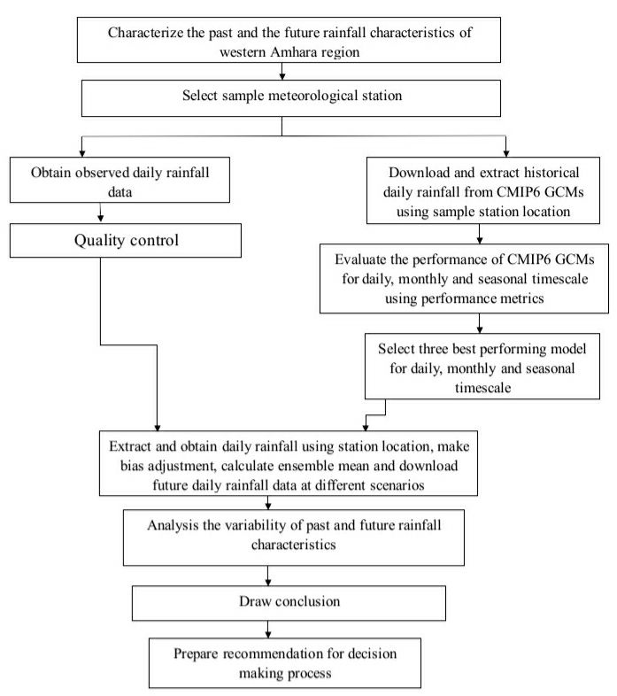
Figure 1. 1. Conceptual Frame Work of the Study

CHAPTER 2. LITERATURE REVIEW

2.1. Definition and Terminologies of Key words
Onset date: is the day in which the start of the rainy season (Zeleke et al., 2023).
Cessation date: is when the stored soil water and its availability to the crop after the end of the rainy season drops to zero. The length of the growing period is the average time it takes for rain to fall between the beginning and the cessation date (Taye et al., 2013 ;Mensah et al., 2016).
Growing season: The time of year when annual crops as a whole and perennial crops like pasture and forages can reach maturity is known as the growing season (Lupi Edao et al., 2018).
Length of growing season: It is the number of days between onset date and cessation date (Taye et al., 2013).
Climate: Climate is typically defined in terms of 30-year means, and higher-order moments about those means which implicitly assumes stationarity of a given climate state. Climate is what you expect, for instance, if you expect that the future Kiremt will be dry that is climate (Masson-Delmotte et al., 2023)
Climate variability: variation in the mean state and other statistics (such as standard deviations, occurrence of extremes, etc.) of climate on temporal and spatial scales beyond that of individual weather events. Variability may be due to natural processes within the climate system (internal variability), or due to anthropogenic forcing (external variability)(Masson-Delmotte et al., 2023)
Climate change: A change in the state of the climate that can be identified by changes in the mean and/or the variability of its properties and that persists for an extended period, typically decades or longer. Climate change may be due to natural internal processes or external forcing or to persistent anthropogenic changes in the composition of the atmosphere or in land use systems (Masson-Delmotte et al., 2023).
Climate change scenario: a description of possible actions or events in the future (Masson-Delmotte et al., 2023).
Global Climate Models (GCMs): Global Climate Models (GCMs) describe the global climate system, representing the complex dynamics of the atmosphere, oceans, and land with mathematical equations that balance mass and energy (Solomon et al., 2007).

2.2. Seasons of Ethiopia
Ethiopians refer to the three distinct seasons as belg (February–May),kiremt (June–September), and bega (October–January). Specifically, the kiremt, belg ,and bega seasons are characterized by heavy rains, small rainy and dry conditions respectively (Alemayehu & Bewket, 2016). Most agricultural activities took place during the entire main rainy season (kiremt).Early planted crops will suffer and animal feed shortages will result from delaying the start of the kiremt season (Asfaw et al.,2018;Eggen et al.,2019).The major share of the annual rainfall (80%) was received in kiremt season (June to September) (Alemayehu & Bewket, 2016).

2.3.Regional Climate Dynamics
The spatial and temporal distribution of climatological rainfall in Ethiopia is largely controlled by the annual north -south migration of the Inter Tropical Convergence Zone (ITCZ) (Kassahun, 1987;Degefu et al.,2017). The ITCZ moves between an extreme northward location of 15°N in July and an extreme southward location of 15°S in January (Kassahun, 1987; Segele et al., 2009), and with the topographic interaction this results in a spatially complex annual rainfall cycle across Ethiopia. The Belg rainfall (March–May) is restricted to the east, southeast and southern parts of Ethiopia due to orography (Degefu et al., 2017). The northward migration of the ITCZ produces orographic rains in March–May over southwestern, south to central, and east to central Ethiopia. Low pressure over South Sudan draws in a moist flow from the Indian Ocean and Gulf of (Kassahun, 1987; Segele et al., 2009), producing the main rains in southern and southeastern Ethiopia and the secondary rain for the eastern, east to central and northeastern parts of Ethiopia (Segele et al., 2009).Additionally, a meridional division of the ITCZ, induced by the difference in heat capacity between the land surface and the Indian Ocean produces rainfall over the southwestern Ethiopia in February and March (Kassahun, 1987; Degefu et al., 2017). During Kiremt (June–September), the Arabian and the Sudan low pressure ITCZ moves to the extreme northern Ethiopia along 15°N due to mountainous topography over central part of Ethiopia (Degefu et al., 2017). This causes moisture fluxes to most parts of Ethiopia from the Atlantic and Indian Oceans through westerly wind systems ,and results in rainy conditions over most parts of Ethiopia except for drier condition over the southern and southeastern lowlands (Segele et al., 2009). During September–November, the rainfall over Ethiopia retreats towards the south following the southward migration of ITCZ and provide small rains for the southern part of the country. During Belg (December–February), the ITCZ is located well south of Ethiopia and the country predominantly falls under the influence of dry warm and cool northeasterly winds (Degefu et al., 2017). These dry air masses originate either from the Saharan anticyclone and/or from the ridge of high pressure extending into Arabia from a large high over central Asia (Siberia) (Kassahun, 1987).
Hence, based on the climatological annual cycle, Ethiopia has previously been divided into three major subregions; the northern and central-western part of the country has a single rainy season with a peak in July/August, central and eastern Ethiopia has two rainy periods February/March–May (Belg) and June–September (Kiremt), and southern Ethiopia has two rainy seasons, the Long Rains (March–May) and the Short Rains (September–November) (Degefu et al., 2017). Interannual rainfall variability during kiremt season (June –September) is also ultimately controlled by large-scale Sea Surface Temperature anomalies over the equatorial east Pacific (the El Niño–Southern Oscillation; ENSO) and the Indian Ocean, where warming/cooling events are associated with deficit/excess of rainfall over the central and northern half of the country. A few of these studies, such as Segele and Lamb (Segele et al., 2009) also reported the presence of some correlation between Sea Surface Temperatures over the southern Atlantic Ocean and Gulf of Guinea and Ethiopian June–September rainfall.

2.4.Methodologies for rainfall analysis
Time series analyses for climatic factors are important to analyze the past and future climate patterns of an area. Rainfall is being one of the most important climatic factors in today’s concern. So, many researchers analyze the data series for identifying potential past and future rainfall trends ( Belay et al., 2019;Rathnayake, 2019). Literature showed that, several methods in identifying rainfall patterns of an area. For instance,the pattern of an area rainfall can be analyzed by statistical trend analysis method using Mann–Kendall equation and Sen’s slope estimator and using graphical visualization the two widely used (Belay et al., 2019;Rathnayake, 2019). More over,the past,current and future rainfall variability of an area can be analyzed using graphs, anomaly,coefficient of variation,standard deviation and others .Past and future situation of an area can also analyzed and interpreted using climate Models and tools.For instance Dinku et al. (2022), analyzed the OD,CD,and LGP using CDT tool.A study by Stern et al determine the OD,CD,and LGP using INSTAT Markove Simulation model and Box and Whiker plot (Taye et al., 2013).More over,the spatial distribution of rainfall of an area can be analyzed using geographic Information System (Taye et al., 2013).

2.5. Historical rainfall patterns in Ethiopia
Ethiopia has diverse rainfall regiems,as a result of topographical variation.The trends of annual rainfall for Ethiopia, showed non-signifcant decreases as much as –1.39 mm per year ,and increases of as much as +1.22 mm per year over approximately 27% and 48% of the country from 1901 to 2020 temporal period respectively (Berihun et al., 2023). However, statistically significant rainfall trends (α = 0.05) were observed in some areas (22%) of the country at annual and seasonal timescales.The implication indicates that rainfall was highly seasonaland space dependent throughout the the considered time of the year (Berihun et al., 2023).
The rainfall pattern of Amhara region which was analyzed by Alemu & Bawoke, (2020) using CHIRPS data for the period 1981-2017. Amhara region were characterized by high seasonal rainfall distribution variation with longer dry season. The trend analysis presented both decreasing and increasing trends depending on the the considered temporal scales (1981-2017). There were an overall upward in the annual and seasonal rainfall (except winter) in the region during the study period (Alemu & Bawoke, 2020).

2.6.Rainfall Variability and Climate Change
Now a time climate variability and Climate change are global issues.The main cause for those are mainly natural and human induced activity,but man made activities account high percentage. Human activities cause climate change mainly due to fossil fuel burning and removal of forests (Belay Zerga & Getaneh Gebeyehu, 2016).
Abay basin (which includes much of Western Amhara), receives its main rainfall during the summer (June to September) (Mohamed et al., 2022).The Kiremt season rainfall of the last three decades has decreased on average by 115.5 mm, when compared to the first quarter of the last century.In Successive years,the area were attacked by drougnt.Furthermore, the number of moderate concentration years (89.9%) has been increasing based on PCI value through time (Mohamed et al., 2022). Over the area, decreasing trend were detected for Kiremt season rainfall were statistically significant at 95 % confidence level.The coefficient of variation of Kiremt season rainfall is lower as comapared with Bega and belg season. The results of the Mannkendal test for trend analysis found a statistically significant declining trend in Kiremt rainy season. Irregular rainfall and long periods of drought during the Kiremt rainy season have been reported as major phenomena negatively affecting agricultural activity (Mohamed et al., 2022). The trend analyses of annual and summer rainfall were declining and statistically significant while the Bega season trend was decreasing but a non-significant trend. The results showed that the annual, Bega, Belg, and Kiremt precipitation over the whole of Abay basin is significantly decreasing except Bega season with a magnitude of 36.4, 3.8, 7.8, and 24.7 mm per decade respectively. The rainfall in the study area is characterized by a high CV. Moreover, prolonged droughts have become common which adversely affects the agricultural system (Mohamed et al., 2022).

2.7. Socioeconomic Impacts of Rainfall Variability
Ethiopia is one of the most vulnerable countries experiencing drought and floods as a result of climate variability and change (Tegegn, 2015). Climate change in the form of higher temperature, reduced rainfall, and increased rainfall variability affects by reducing crop yield and threatens food security in low income and agriculture-based economies (Tegegn, 2015). Climate change negatively affects agriculture, nutrition, ground water availability, soil organic matter and soil quality, health conditions, growth and poverty (Gezie, 2019).
Research from different parts of Ethiopia showed a connection between agricultural productivity and the beginning, middle, and end of the growing season (Ayalew et al., 2012). The length of the growing season was more responsive to the beginning than the end of the rainy season (Ayalew et al., 2012).
Rainfall in most areas of the country is often erratic and unreliable.In history, rainfall variability and associated droughts have been major causes of food shortages and famines (Tegegn, 2015). According to Ayalew et al.,(2012), with a 10% decrease in seasonal rainfall from the long-term average generally translates into a 4.4% decrease in the country’s food production. It was further declared that in a study conducted in Oromiya region at Debre Zeit and Kulumsa areas (Ethiopia), using wheat as a model crop, a 24 to 33% crop yield reduction was observed due to rainfall and temperature variation (Ayalew et al., 2012).
Inter-annual and seasonal variability of rainfall is a major cause of fluctuations in production of cereals in the Amhara region (Bewket, 2009) . Over the 1994-2003, for which crop yield data are available, the patterns of inter-annual variability in productions of the six major cereals (tef, barley, wheat, maize, sorghum and millet) cultivated in the region show similar patterns of inter-annual variability in the seasonal or annual rainfall amounts. Productions of tef, barley and wheat show stronger correlations with the kiremt rainfall while sorghum production is more strongly correlated with belg rainfall. Cereal yield also showed statistically significant correlations with each other, suggesting that rainfall is the common yield-limiting factor as use of chemical fertilizers and other agricultural inputs is limited. The fact that there are high correlations between cereal production and rainfall in the region proposed that farmers are vulnerable to food insecurity related to rainfall variability (Bewket, 2009).

2.8.Adaptation Strategies for Agriculture
Ethiopia as part of the East Africa is frequently known by a high degree of vulnerability to climate change and climate variability (M. Bekele et al., 2020).Climate models suggest that Ethiopia will see a further warming of 0.7°C and 2.3°C by the 2020s and between 1.4°C and 2.9°C by the 2050s (Nega, 2022).Ethiopia is extremely vulnerable to the impacts of climate change. The impact may potentially suppress economic progress or reverse the gains made in development, and thus intensifies social and economic challenges (Nega, 2022). The country’s vulnerability to climate change is further increased by high levels of poverty, rapid population growth, and reliance on rain fed agriculture. In addition, high levels of environmental degradation, chronic food insecurity, frequent natural drought cycles and others may also be other factors that can contribute to the country’s vulnerability to climate change (Nega, 2022).
To overcome the impact as a result of climate change and variability,different adaptation mechanisms are employed for small holder farmers in different parts of Ethiopia.For instance,a survey of 355 smallholder households at Konso district revealed that, farmers utilize various indigenous techniques, including terracing, agroforestry, intercropping, and traditional irrigation practices, to adapt to climate change (Gashure, 2024). The acceptance of these strategies is influenced by factors such as education level, landholding size, income level, access to climate information, credit, and extension services. Despite these efforts, smallholder farmers in Konso continue to face challenges in ensuring food security due to recurrent droughts and unpredictable rainfall patterns (Gashure, 2024). Overall, crop diversification, tree planting, practice of off-farm activities and soil and water conservation were also the climate change adaptation strategies commonly used in Ethiopia (Nega, 2022).
Climate Smart Agriculture (CSA) is an exercise aimed at increasing agricultural productivity and income while reducing greenhouse gas emissions and strengthening agricultural resilience against climate change (Hussein, 2024). In Ethiopia, the agricultural sector is being impacted by climate change, and different mechanisms are implemented to enhance sustainability and food security. Those includes promoting climate resilient crop breeds, integrating conservation agriculture techniques, using advanced livestock management practices, and establishing effective water management systems. Climate Smart Agriculture (CSA) programs also aimed to improve access to credit, extension services, and markets for smallholder farmers (Hussein, 2024).

2.9. Techniques for Characterizing the OD,CD, and LGP
In previous study, different authors characterize the onset date, cessation date, and length of growing period differently. For instance, Amekudzi et al. (2015), studied the variability of rainfall onset, cessation, and length of growing season over the country by using the rainfall amount and rainy day approach. Similarly, researchers like Olaniran (1983), Adejuwon et al. (1990), Odekunle (2006), determined the onset and cessation of the rainfall season from only gauge data. Le Barbé et al.(2002), also studied the onset of rains over west Africa with annual oscillations of weather zones characterizing the west African climate. Cochemé & Franquin (1967) and Benoit (1977) ,determined the onset and cessation date of the growing season from the relationship between rainfall and evapotranspiration. Alternatively, Omotosho (2002), used the Theta-E technique, which depends on the equivalent potential temperature.

2.10. Patterns of rainfall characteristics in the neighboring countries of Ethiopia
On Western Kenya, the OD, CD, and LGP were determined by Mugalavai et al.(2008).In their analysis, they found that there exists an organized progression of rainfall onset with in the study area with long rains showing southerly progression while short rains show south westerly progression. On the other hand, the cessation date of rainfall showed local influences by Lake Victoria, forested area and topographic features. For stations that have a long length of growing season, the length varies more than the onset date. Similarly, a study in Kenya showed that, most of stations onset month to be march and few stations February, few other April ( Nairobi et al., 2016). Lotfie et al. (2018), also studied the onset and cessation date in Gedarif /Sudan. On their result they showed that, consistent trend of starting dates of growing seasons regardless of high seasonal variability and variation in amount and distribution of rainfall. Length of growing season increases with the early start of the season and in wetter years.

2.11. The implications of previous findings on the rainfall characteristics in Ethiopia
In different areas of Ethiopia, the characterization of OD, CD, and LGP was done using different number of sample stations, and study time period. For instance, a study by Zeleke et al.(2023),characterize the OD, CD, and LGP for decision making purpose regarding the climate resilient capacity of maize over Mecha district/Western Amhara for the study period 1987 to 2018.On their analysis, they conclude that, the rainy season begins between May 8 and June 3and finishes between October 26 and November 16. Moreover, they indicated that, the LGP during the rainy season ranges from 94 to 229 days. The OD, CD, and LGP of the study area was also determined by Taye et al. (2013). From their conclusion, the onset date showed variation through all observation years in the study area. In addition, the end date of the region ranged from September 13 to December 19 at Motta station in 1998.For determining the OD, CD, and LGP the criteria applied were ,20 mm of total rainfall in three consultive days that were not followed by greater than ten days of dry spell length within 30 days from planting by Raman (1974) as a rainy season. Another Study over Eastern Ethiopia/West Hararge zone, showed that, mean onset was observed from first meteorological dekade of July to last meteorological dekade of July (Siferet al., 2016). In ddition, the end date was from second meteorological dekade of September to first meteorological dekade of October. The LGP obtained over west Harerge during the main rainy season ranged from 85 to 116 days. Hence, different areas of Ethiopia have different OD, CD, LGP, variability, and trend even with in short distances.

2.12. Global Climate Models (GCMs)
Global Climate Models (GCMs) referes the global climate system, representing the complex dynamics of the atmosphere, oceans, and land with mathematical formula that balance mass and energy (Solomon et al.,2007). By simulating interactions among sea ice, land surface, atmospheric chemistry, vegetation, and the oceans, they predict future climate characterized by temperature, air pressure, and wind speed (Alaminie et al., 2021).Because these models are so computationally intensive, they can only be excute on supercomputers at large institutes (F. Bekele, n.d.). However, the results are open acess to the general scientific community and have been used for studies of climate change and its impacts on natural, social, and economic systems (Jones & Thornton, 2013).Global Climate Models (GCMs) are currently the most widely used tools for simulating the global climate systems (Kamruzzaman et al., 2023). The most recent state-of-the-art climate model experiments are now becoming available as part of the Coupled Model Intercomparison Project Phase 6 (CMIP6) ensemble (Alaminie et al.,2021; Kamruzzaman et al., 2023). CMIP6 models are running a number of new and updated emission pathways that explore a much wider range of possible future outcomes than were included in CMIP5. CMIP6 represents a substantial expansion over CMIP5, in terms of the number of modelling groups participating, the number of future scenarios examined and the number of different experiments conducted (Alaminie et al., 2021). The CMIP6 GCMs differ from previous generations, including high spatial resolutions, enhanced parameters of the cloud microphysical process, additional earth system processes and components such as biogeochemical cycles and ice sheets (Alaminie et al., 2021).The major difference between CMIP5 and CMIP6 is the future scenarios. CMIP5 projections are available on the basis of 2100 radiative forcing values for four GHG concentration pathways (Alaminie et al., 2021) .In contrast, CMIP6 uses socioeconomic pathways (SSPs) which are considered as more realistic future scenarios (Almazroui et al., 2020; Alaminie et al., 2021). Another update of CMIP6 is the development and support of the intercomparison model, focusing on biases, processes, and climate model feedbacks (Kawai et al., 2019). The SSPs are based on five narratives describing alternative socio-economic developments, including sustainable development, regional rivalry, inequality, fossil-fueled development, and middle-of-the-road development (Alaminie et al., 2021).

2.13.Performance of Climate Models (CMIP6 GCMs)
Statistical metrics are normally used for assessing the differences between model simulations and observed datasets, and each metric can show the overall (relative) performances differently for the model simulations (Moriasi et al., 2007;Gleckler et al., 2008). Additionally, statistical metrics are often found in the comparison of the climate simulation results between GCMs and observed datasets (Kamworapan & Surussavadee, 2019). Continuous statistical metrics have been employed over different study areas to evaluate the performance of rainfall products rainfall total at different spatial and temporal scales (Nashwan et al., 2019).The continuous statistical indices most commonly employed by most studies are: Root mean square error (RMSE), Mean error (ME), Mean absolute error (MAE), Pearson correlation coefficient (r) and Coefficient of determination (R²),Kling-Gupta Efficiency (KGE), Nash-Sutcliffe Efficiency (NSE), Percent bias (PBIAS), RMSE-observations standard deviation ratio (RSR) and Mean square error (MSE) (Moriasi et al., 2007).Those performance metrics used to select the best performing model for further climate analysis.The model is said to be best or optimal when the value of RMSE,ME, MAE,r, R², KGE,NSE,PBIAS are 0,0,0,1,1,1,1,0 respectively.
The simulation performances of CMIP6 GCMs have been evaluated in different areas of the world for different applications. Literatures showed that different researchers used different number of gauge stations, study time period, and also type and number of continuous statistical metrics used as well as study area coverage and evaluation timescale. For instance, a study by Berhanu et al.(2023),evaluate the performance of GFDL-CSM4 and other 36 CMIP6 GCMs over Ethiopia for the period 1981-2014 and study time scales of monthly, seasonal ,and annual by compared with gridded rainfall of Ethiopia data (ENACTs) for reference. Another study conducted over Abay Basin (Ethiopia), also evaluate the performance of BCC-CSM2-MR and other seven datasets for the period 1988 to 2014 using correlation coefficient, root mean square error, bias percentage, Kling-Gupta efficiency and Nash-Sutcliffe efficiency and visual compare on using graphs to simulate the performance of annual and seasonal rainfall totals of models (Mohammed, 2024).A study by Omay et al.(2023),also evaluate the performance of CMIP6 GCMs over East Africa for the period 1981-2014 to simulate monthly rainfall climatology of East Africa countries. Omay et al.(2023) evaluated ACCESS-ESM1-5 and other 22 models to simulate seasonal rainfall pattern of the region. The authors find that, most models capture monthly, seasonal, and annual rainfall total, but there is overestimation and underestimation problem. In addition, the performance of CMIP6 GCMs differs from place to place and time to time. Moreover, the climate model which is suitable for temperature may be worst to detect rainfall in the same region and time period (Gashaw et al.,2024).

2.14. Future Projection of Rainfall in Ethiopia
Like in most other parts of Africa, human-induced greenhouse gas emissions would bring further change in Ethiopia’s climate over the next century (Tegegn, 2015). Although the level of change and associated impacts depend on the extent of emission scenarios and the climatic models used to predict the future scenarios, there are high levels of confidence that unlike temperature and rainfall is highly variable and uncertain (Ayalew et al., 2012; Tegegn, 2015).
In Ethiopia, a study conducted by Arndt et al. (2011) showed decreasing Kiremt and Belg seasons’ rainfall by 20% and 5-6%, respectively by 2080s. The same study conducted by Ayalew et al. (2012) indicated that by the years 2080s the amount of annual rainfall and number of rainy days will decrease in the Amhara Nations Regional State of Ethiopia. Moreover, future projection of rainfall suggests a forward shifting for Kiremt season, and conversely decreases for Belg rainfall in some places of northern Ethiopia (Hadgu et al., 2015). According to the authors in some places, the Belg rainfall is expected to shift from its current range of February to May to April to June. However, the pattern of its distribution, timing and intensity over the country is uncertainty (Ayalew et al., 2012; Tegegn, 2015).

CHAPTER 3. MATERIALS AND METHODS

3.1. Descriptions of the Study Area
The Amhara Region is located between latitudes of 8°45'N and 13°45' N and longitudes of 35° 46' E and 40° 25' E. Whereas Western Amhara region located between latitudes of 9°50' N and 13°45'N and longitudes of 35° 16' and 38° 44' E (Figure 3.1). The total area of the Amhara region is estimated to be 156,960 km² (Taye et al., 2013).Based on altitude,mean annual rainfall,and mean annual temperature, the Western Amhara region's climate is divided into four climatic zone categories. The Kola/tropical (hot zone) covered 31% of the region, which is located below 1500 m.a.s.l. Whereas, Woyina Dega/sub-tropical (warm zone), covered 44%, which is between 1500 - 2500 meter above sea level. The remaining, Dega/temperate (cold zone) covered 24%, which is located between 2500 -3200 m.a.s.l., and around 1% is covered by wurch/alpine ( kur zone) (Taye et al., 2013).
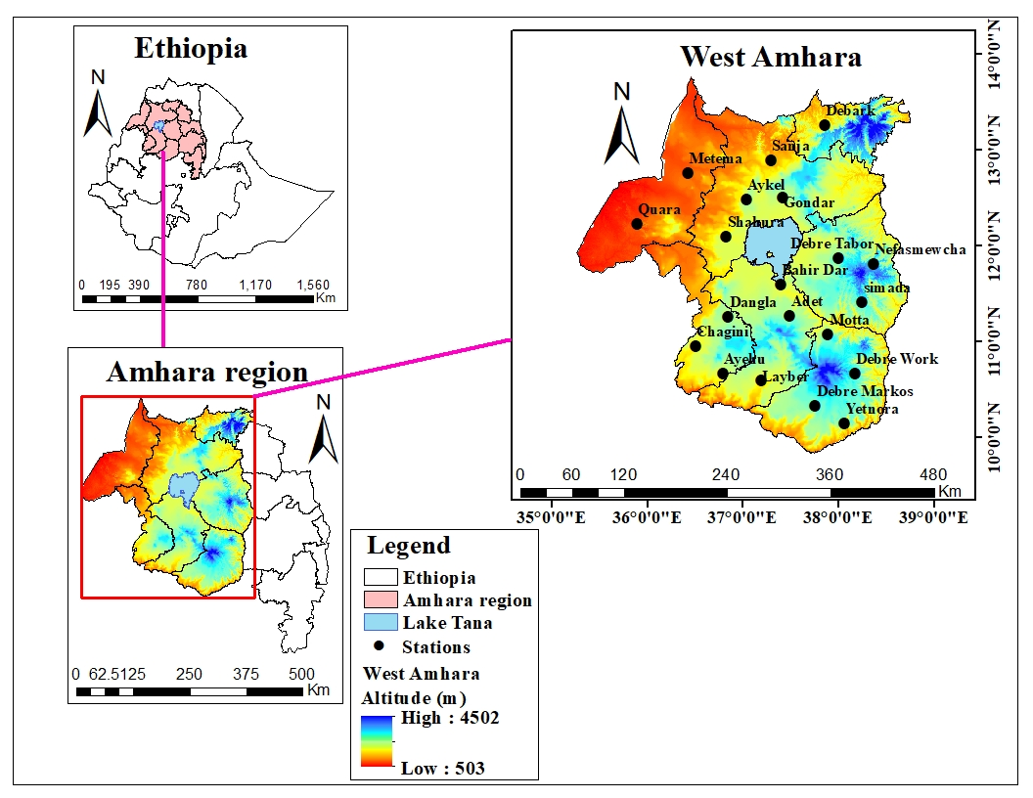
Figure 3. 1. Location Map of Western Amhara from Ethiopia.

3.1.1. Climate
Western Amhara experienced heavy rainfall during June, July, August, and September months. This season contributes 77.05% of the mean annual rainfall of western Amhara. The mean annual rainfall of western Amhara was 1054.2 mm. The mean annual temperature of the study area is 18.0 °C. But in the valleys and marginal areas, the temperature exceeds 27 °C (Taye et al., 2013).

3.1.2. Economic Activity
In terms of economic activity, agriculture continues to be the predominant industry in the area. In terms of structure, it contributes, on average, 55.8% of the regional GDP, and 88.7% of the population makes their living from farming and related industries (Taye et al., 2013). It is the main supplier of food, raw materials, and revenue from exports for the close industries. The area is home to a variety of flora and fauna species due to its unique agro-ecology.

3.1.3. Population
While the region makes up only 15.4% of the country's total area, its population accounts for approximately 25.5 percent of that total (CSA, 2006; Taye et al., 2013).This means that, should the current trend of population growth continue, the region's size will double in 25 years. In terms of settlement pattern, the vast majority of the population early 89 percent lives in rural areas and works primarily in agriculture; the highlands are densely populated than the lowlands. 86percent of the population is under 14 years old, and 6.2 percent of the population is 65 years of age or older. As a result, the age dependency ratio reaches 86.8%. This simply demonstrates that there is an additional person to shoulder the socioeconomic burden for each individual (CSA, 2006).

3.1.4. Topography
The geographical features of the Amhara region show a range of elevations, from over 4600 meters above sea level (m.a.s.l.) in the northwest to 700 meters above sea level (m.a.s.l.) in the eastern edge. According to the Salinger & Stryker, (2001) assessment report, the majority of the Amhara region is on the highland plateau, which is defined by craggy mountains, hills, plateaus, valleys, and gorges. As a result, the area's landscapes are diverse, with eroded landforms in the north, virtually flat plateaus and mountains in the center, and high fault slopes and nearby lowland plains in the east. A level plain that extends into the Sudan lowlands makes up the majority of the western portion. Roughly half of the region's total area is thought to be potentially arable for agricultural production. According to Bazezew (2012),60% of the entire area is currently used for agriculture and grazing (30% each), 17% is covered in woods, woodlands, and shrub lands, 4% is water, 3% is inhabited by communities, and 16% is wasteland.

3.2. Research design and Methods
The study research design is quantitative research design. Characterization of rainfall characteristics (OD, CD, anomaly, trend, variability, PCI, and LGP) of the main rainy season were focus on quantitative data for observed (1991-2020) and GCMs rainfall of daily timescale for the period 2021-2100 over Western Amhara Region, Ethiopia.

3.3. Data Collection and Methods of Analysis

3.3.1.Determination of Past Rainfall Characterstics
Data Collection: to characterize the past rainfall of the main rainy season (Kiremt ) over western Amhara, sample meteorological stations was purposively selected based on the availability of daily rainfall data and fair distribution of the station for the period 1991-2020.Hence, based on their relative quality and long timeseris, 20 meteorological stations was selected. The 30-year records of daily rainfall data was collected from Ethiopia Meteorology Institute (EMI) of Ethiopia (Appendix Table 1).
Quality Control was the primary task before any further analysis.Prior to analysis, the observed rainfall data of all station was plotted against time (DOY format) and subjected to visual examination for the presence of discontinuities and special codes for missing values (Tegegn, 2015). The primary issues that meteorological analysts frequently face are missing data (Taye et al.,2013). These issues can include observer absence or brief observations interrupted by a variety of circumstances.There are several techniques for estimating data that is missing.The missing data was filled and evaluated in this work utilizing the INSTAT Markov chain simulation model (Stern et al., 2006). This is because of the fact that first order doesn`t exaggerate the result and more-over, it gives an accurate model estimate as explained by Stern et al. (2006).
The Outlier detection of the daily observed rainfall data for the period 1991–2020 was done. The method that was used to identify outliers was the quartile outlier detection technique using climate data tools (CDT) (Dinku et al.,2022). The quartile outlier test indicated (Appendix Figure1a-d) that daily rainfall data of few stations had some very small numbers of outliers in the main rainy season (Kiremt), which are Adet June (1993,2014,2016,and 2018),Yetnora July (1992 and 2020),Metema August (1997,2015,2017,and 2020),Debre Tabor September (1995,2006,2013,and 2018).These outliers in the given years were checked with hardcopy of Western Amhara Meteorological Service center.Hence, the so-called outliers of the main rainy season were tolerated and taken as normal data.
The common Standard Normal Homogeneity Test (SNHT) was used to check daily observed rainfall data using Climate Data Tool (CDT) packages (Dinku et al.,2022). As illustrated in Appendix Figures 2a and 2b, the daily rainfall has some breaks for few stations. For example, Yetnora has two breaks in 2001,and 2020; Shahura has 3 breaks in 1994, 2017, and 2019. These were adjusted using the mean adjusted method using CDT (Appendix Figure 2c and 2d). Other stations have no significant change points or inhomogeneity that would require mean adjustments, so the original data series was used for further analysis.
Determination of OD, CD, and LGP: The quality-controlled rainfall data was organized used in Ms-excel 2010 spread sheet following the days of the year (DOY) entry format.Then, the daily rainfall data was subjected for detail analysis using sequences of statistical packages.The appropriate OD, CD, and LGP was calculated and simulated by using CDT tool (Dinku et al.,2022). The onset date was calculated based on the criteria that, the day that recorded 20mm of rainfall over five consecutive days without being followed by a dry spell longer than seven days within 21 days of planting day and with at least three rainy days on which threshold for rainy day (>=0.85mm) (Dinku et al.,2022).This was done so as to capture both the early start and the late start.The condition that there should be no 7-day dry period is to ensure there is no false start (Dinku et al., 2022). End of the growing season is the first occasion when the water balance drops to zero after the end of rains (Zeleke et al.,2023).In this study the end of the rainy season was calculated by using CDT tool with the criteria that,when water balance drops below 5mm for a period of three days (Dinku et al., 2022).The length of the growing season for the main rainy season was determined the number of days between the rainfall onset and cessation dates using equation (1).
$Length of growing period (LGP)=end of rain-start of rain$ (1)
Trend analysis: After investigating /determining the OD, CD, LGP of the kiremt season by using CDT tool,for the study area and for study time period (past and future) the timeseries pattern was analyzed by using Sen’s slope estimator and modified Mann-Kendal test (non-parametric trend test) using R-statistical Software at 5% significance level.The Mk trend test is the most suitable and favorable non parametric test for identifying trends in timeseries climate data. This method is less influenced by missing values and uneven distribution and it is less sensitive to outliers, because it considers the ranks of observations rather than their actual numbers (Belay et al., 2019).
S-statistic was applied to check for an increasing, decreasing or no-change trend on OD, CD, and LGP data series in each of the selected meteorological station data in the MK t- test statistic, which is given as:
$Sign\left(x\right)=\left\{\begin{aligned}+1,if\left(Xj-Xk\right)>0 \\ 0,if\left(Xj-Xk\right)=0 \\ -1,if\left(Xj-Xk\right)<0\end{aligned}\right.$ (2)
The values Xj and Xk in Equation (2) are measurements corresponding to a time j and k, and n is the number of events. To estimate the variance of S: -
$Var(S)=\frac{n\left(n+1\right)\left(2n+5\right)-\sum_{i=1}^{m}{ti(ti-1)(2ti+5)}}{18}$ (3)
In Equation (3), n: number of observations; m: number of data pairs in the series; ti : number of ti’s at the timestep i (Silva, 2017; Tadese et al., 2019). Hamed and Ramachandra Rao (Hamed & Ramachandra Rao, 1998) proposed a modified version of the MK test (MMK), which is a better alternative than the original MK test for detecting trends in time series exhibiting autocorrelation, a common characteristic in hydrological time series. The difference is in the formula to calculate the variance, which for the MMK test:
$Var\left(s\right)*=Var(s)\frac{n}{n*}$ (4)
where Var(S)* is the modified variance. With r R k corresponding to the lag-k autocorrelation coefficient of the ranks of the data, the correction factor n/n* is:
$n/{n*=1+\frac{2}{n(n-1)(n-2)}\sum_{j=1}^{n-1}{\left(n-k\right)\left(n-k-1\right)\left(n-k-2\right)r\begin{matrix}R \\ k\end{matrix}}}$ (5)
To determine the significance of the trend, both MMK and MK follow what is presented in Equation (10):
$\left\{\begin{aligned}z=\frac{s-1}{\sqrt{var\left(s\right)*}},if s>0 \\ z=0,if s=0 \\ z=\frac{s+1}{\sqrt{var\left(s\right)*}},if s<0\end{aligned}\right.$ (6)
The trend analysis employs the Theil–Sen slope estimator (SS), a nonparametric metric that approximates the trends’ magnitude (Arrieta-Castro et al., 2020). This metric is determined by the slopes of the lines (Qi) connecting the data pairs (N), with their values obtained through the following equation:
$Qi=\frac{Xj-Xk}{j-k} for i=1,…,N$ (7)
Finally, the arrangement of the Q values in ascending order allows for the computation of the median using the equation:
$\left\{\begin{aligned}Qmed=Q\left|(n+1)/2\right|,if N is odd \\ Qmed=\frac{Q\left|(N/2)\right|+Q\left|(N+2)/2\right|,}{2}\end{aligned}\right.ifN is even$ (8)
The trend of OD, CD, LGP, and kiremt season rainfall total for all sample stations and study time periods were easily calculated using R statistical package.
Variability analysis: The coefficient of variation (CV) is one of a relative measure of variability, displays the amount of standard deviation relative to its mean (Morales-Acuña et al., 2021). As a result, the coefficient of variation (CV), was used to determine the variability of Western Amhara region OD, CD, LGP, and seasonal rainfall total for the past (1991-2020) using equation (9).
$CV\left(\%\right)=100\%*\frac{S}{µ}$ (9)
Where: -
CV (%) is the coefficient of variation of OD,CD, LGP,and kiremt season rainfall total for sample stations, S is the standard deviation of OD, CD, LGP, and kiremt season for stations,µ is the mean of OD,CD, LGP, and kiremt season for stations during 1991-2020 time periods.The CV (%) can be interpreted as follows (Morales-Acuña et al., 2021).
When 0≤CV(%) <20, there is low variability between the given data of the given time scale.
When 20≤CV(%) <30, moderate variability between the given data of the given time scale.
When CV(%) ≥30, There is high variability between the given data of the given time scale. Due to this the magnitude of CV (%) of selected stations and regional scale compare each other.
Standardized Anomaly Index ( SAI) is one measure of variability, which used to detect the variability and nature of the trend (Asfaw et al., 2018). It is determined as using equation (10).
$Z=\frac{X-\overline{X}}{SD}$ (10)
Where, Z is number of standard deviations of the observation deviated from the normal, x is an observed rainfall value and $\overline{X}$is mean rainfall and SD is the standard deviation. This statistic enables us to determine the dry (negative values) and wet (positive values) years in the observation.The rainfall anomaly value less than -1.65 is considered extremely drought,whereas rainfall anomaly index greater than 1.65 considered to be extremely wet.The kiremt rainfall total for the past (1991-2020) were calculated and identified as wet and dry years.
Precipitation Concentration Index (PCI) is used to examine the variability (heterogeneity pattern) of rainfall at different scales (annual or seasonal). The PCI value can help to identify periods of high rainfall that may lead to flooding as well as dry spells that can contribute to drought conditions.The PCI values were computed, as given by Oliver (1980) and modified by De Luis et al. (2011). PCI can be calculated using equation (11).
${PCI}_{Kiremt=}\frac{\sum_{i=6}^{9}{{Pi}^{2}}}{{\left(\sum_{i=6}^{9}{Pi}\right)}^{2}} ×33.3$ (11)
where: PCI is the precipitation concentration of kiremt season, Pi is the rainfall amount of the i^{th} month. According to Oliver (1980), PCI values of less than 10 indicates uniform monthly distribution of rainfall (low precipitation concentration), values between 11 and 15 denote moderate concentration, values from 16 to 20 indicates high concentration, and values of 21 and above indicate very high concentration (Asfaw et al., 2018).
Analysis of Rainfall Amount: In a Box and whiskers plotting, the box represents the middle 50% of the whole data set, while whiskers represent the magnitude of the spread of the rest of the data set about the median or mean (Stern et al.,2006).The minimum,maximum,and mean daily rainfall total were summarized by using Box and Whiskers plot using CDT tool (Dinku et al., 2022).More over, the monthly and seasonal rainfall total were spatialy interpolated in ArcGIS software using inverse distance weight interpolation technique for the past (1991-2020).

3.3.2.Performance Evaluation of CMIP6 GCMs
Data collection:to evaluate CMIP6 CMs both observed gauge and CMIP6 GCMs historical was used.Among the observed data for 1991-2020 collected for 20 stations,for performance evaluation purpouse,the rainfall data of each station for the period 1995-2014 was organized.Similarly Site-specific historical daily rainfall data was downloaded from CMIP6 GCMs for rainfall for the period 1995-2014. The daily data of those GCMs obtained from the Earth System Grid Federation (ESGF) database at https://esgf node.llnl.gov/projects/cmip6/.There are numerous CMIP6 GCMs which can project the future climate under different SSP (Gashaw et al., 2024). But, the performance of GCMs differ from region to region. Hence performance evaluation is crucial before use for any application.The selection of the GCMs for performance evaluation was based on the availability of daily data, their best performance in different parts of Ethiopia (Gashaw et al.,2024),East Africa (Gebrechorkos et al.,2023) ,and else where in the world (Iqbal et al., 2021).The models were also selected based on their wider applications in their earlier versions (CMIP5) in different parts of Ethiopia (Worku et al.,2020).For example, the inclusion of BCC-CSM2-MR was based on their best performance for simulating rainfall in the Upper Blue Nile Basin of Ethiopia (Alaminie et al., 2021).EC-Earth3 and EC-Earth3-Veg were selected since they demonstrated best performance in mainland southeast Asia (Iqbal et al.,2021).The inclusion of MPI-ESM1-2-LR and GFDL-ESM4 for evaluation was due to their relatively good performance in representing monthly rainfall total over Bale eco region in Southern Ethiopia (Gashaw et al., 2024). A study conducted over Upper Blue Nile basin,Ethiopia recommend BCC-CSM2-MR for simulation of annual,kiremt,and Belg rainfall season,whereas MRI-ESM2-0 for bega season rainfall simulation (Mohammed, 2024).GFDL-ESM4 was selected as it recommended by Berhanu et al.(2023) for monthly and seasonal rainfall simulation,after evaluating the performance of 37 CMIP6 GCMs. A study by Omay et al.( 2023), recommend BCC-CSM2-MR,and GFDL-ESM4 was selected,as those are recommended for seasonal rainfall simulation of East Africa after validate 23 CMIP6 GCMs with observed .MRI-ESM2-0 was recommended over Nigeria among 13 CMIP6 GCMs evaluation (Shiru & Chung, 2021).Astudy by Lebeza et al.(2024) evaluate 7 CMIP6 GCMs models and recommend Ec-Earth3,BCC-CSM2-MR,and BCC-CSM2-MR for simulation of daily,monthly,and annual rainfall total over Lake Tana sub-basin,Ethiopia respectively.
Table 3. 1. The list of CMIP6 GCMs employed for performance evaluation and their characteristics.
Model | Institution | country | Vibrant label | resolution
BCC-CSM2-MR | Beijing Climate Center | China | r1i1p1f1 | 1.1º*1.1º
EC-Earth3 | Consortium of European Research Institution and Researchers | Europe | r1i1p1f1 | 0.70 º *0.70 º
Ec-Earth3-Veg | Consortium of European Research Institution and Researchers | Europe | r1i1p1f1 | 0.70 º *0.70 º
MPI-ESM1-2-LR | Max Planck Institute for Meteorology | Germany | r1i1p1f1 | 1.9 º *1.9 º
GFDL-ESM4 | Geophysical Fluid Dynamics Laboratory | USA | r1i1p1f1 | 1.25 º *1.00 º

CMIP6 GCMs Performance evaluation Criteria: Performance evaluations of CMIP6 models in this research were undertaken after extracting the five CMIP6 GCMs daily data (Table 3.1) for the 20 meteorological stations of the study area (Appendix Table 1) for the period 1995-2014. Then after, the stations (point) data and each CMIP6 GCMs data were areal average for Western Amhara scale.The evaluation was made by comparing historical CMIP6 GCMs against observed rainfall data at daily,monthly ,and seasonal timescale separately. The performance of CMIP6 models under different Shared Socio-economic Pathways (SSPs) were evaluated in simulating future rainfall characterstics in the Western Amhara region based on efficiency criteria found under “hydroGOF” R package (Gashaw et al., 2024).There are numerios performance efficency criteria for model evaluation (Gashaw et al., 2024).But most authors prefer to use performance efficiency criteria’s include the root-mean-square errors (RMSE), percent of bias (PBIAS), and Pearson correlation coefficient (r) (Alaminie et al.,2021; Gashaw et al., 2024). RMSE measures the average magnitude of the deviation of rainfall products from the ground based observed data (Equation 12). A smaller RMSE value indicates that rainfall products are closer to observed rainfall data. The optimum value of RMSE is 0 (Ageet et al., 2022). PBIAS measures the average tendency of rainfall products data to be larger or smaller than the observed data. The percent bias (PBIAS) is a statistical metric that spans from -∞ to ∞, with an ideal value of zero. A low magnitude of PBIAS suggests that the rainfall products accurately estimate the observed data. Negative values of PBIAS indicate a bias of overestimation in the rainfall products, while positive values of PBIAS indicate a bias of underestimation in the rainfall products when compared to the observed data (Gupta et al., 1999). Rainfall products are said to be a reliable rainfall measurement source where PBIAS value ranging between -10% and 10% (Dangol et al., 2022). PBIAS can be calculated using (Equation 13). Correlation coefficient (r) is used to measure the goodness of fit and linear association between variables, in this case the linear association between observed rainfall and rainfall products data (Equation 14). The values of r ranges from -1 to 1, with r = 0 no linear relationship, r = -1 or 1 indicates a perfect negative or positive score (Dinku et al., 2018; Ageet et al., 2022;Aniley et al., 2023).
$RMSE=\sqrt{\frac{\sum{{(G-S)}^{2}}}{N}}$ (12)
$PBIAS=\frac{\sum{(G-S)}}{\sum{(G)}}$ ×100% (13)
$r=\sqrt{\frac{\sum{(G-\overline{G})(S-\overline{S})}}{\sum{{(G-\overline{G)}}^{2}}(S-{\overline{S)}}^{2}}}$ (14)
where G is observed rainfall total at a gauge station, $\overline{G}$ is the mean of observed rainfall total at gauging station, S is rainfall total for CMIP6 GCMs rainfall product, $\overline{S}$ is the mean of CMIP6 GCMs rainfall total, N is the number of data pairs compared and r is Pearson’s correlation coefficient.The overall ranking of the five GCMs considering all statistical metrics (i.e., r, RMSE, and PBIAS) were undertaken following the Comprehensive Rating Index (CRI) method using equation (equation 15).
$CRI=1-\frac{1}{nm}*\sum_{i=1}^{n}{{Rank}_{i}}$ (15)
Where n is the number of statistical performance measures used in this study for evaluating the models (5), m is the number CMIP6 GCMs that are evaluated in the study (eq.4), and Ranki is the rank of the CMIP6 GCMs for each performance measures, which ranges from 1 to 5 for best and low performing models, respectively.The closer the values of CRI to 1 indicates the better performance of the model (Gashaw et al., 2024).
Bias Correction of CMIP6 GCMs: Bias corrections of global dataset was by Distribution Mapping (DM) technique. Distribution Mapping (DM), which is available in the Climate Model data for hydrologic modeling (CMhyd) tool (Gashaw et al.,2024), used for bias correction of best performing GCMs projections at different climate change scenarios.The selection of DM for bias correction of GCMs for rainfall was based on the suggestion of Worku et al.(2020), who compare several bias-correction techniques available in CMhyd in Jemma sub-basin, Upper Blue Nile Basin of Ethiopia and suggested the applications of DM for bias correction of rainfall and temperature products. Other study in the Awash Basin of Ethiopia has also found that DM is suitable for bias correction of climate models for temperature (Tadese et al., 2020). This study bias corrected best performing CMIP6 GCMs (top three ranked) after extracting the data for each stations, and hence bias correction was performed by providing the daily observed historical (1995–2014), raw GCMs historical (1995–2014) and future raw GCMs (2021–2100) data of each stations in text file. In this study, the analysis of future climate for near future (2021–2050), mid-century (2051–2080) and late-century (2081–2100) periods (Belazreg et al., 2023) were made at SSP2-4.5, SSP3-7.0 and SSP5-8.5 climate change scenarios for Western Amhara level. The SSP2-4.5, SSP3-7.0 and SSP5- 8.5 scenarios are representing the medium-forcing, medium to high forcing and high-end-forcing pathways, respectively. The main reason why this study did the future climate change analysis in these scenarios is that three of them are possible climate change trajectories. On the other hand, the one that is not considered in this study (i.e., SSP1-2.6, representing the low climate forcing pathway) is unlikely happen considering the current global actions undertaking to mitigate climate change based on the Paris agreement. Due to this fact, future climate change analysis as well as bias corrections of global dataset were performed mainly for SSP2-4.5, SSP3-7.0 , and SSP5-8.5 climate change scenarios (Gashaw et al., 2024).

3.3.3.Determination of Future Rainfall Charactersics
For determination of future rainfall charactersrtics,the ensemble mean of top three best performing CMIP6 GCMs were used for daily,monthly,and seasonal temporal scales.Each rainfall characterstics were analyzed by dividing future time period as 2021-2050,2051-2080, and 2081-2100 for each SSPs for Western Amhara region.The future rainfall characterstics (OD,CD,LGP,rainfall amount) variability ( using Standard deviation,coefficient of variation,Standardized anomaly),trend analysis (using Mankendal trend test and Sen’s slope estimator) ,and daily rainfall total (using Box and Whiskers plot) were analyzed and interpretated similar to past rainfall analysis by using methodology described under sub heading (3.3.1). More over,the departure of future (2021-2100) monthly and seasonal rainfall total under different SSPs from the past (1991-2020) were summarized in tabular form as Gashaw et al.(2024), also follow similar approach over Bale Eco region in Southern Ethiopia.

CHAPTER 4. RESULTS AND DISCUSIONS

4.1. Analysis of the Past rainfall Characterstics of the main rainy Season

4.1.1.Analysis the onset of the main rainy season
The mean onset dae of Western Amhara for the main rainy season was showed in Table 4.1.In the region,the earlet and latest onset date for the period 1991 to 2020 was 124 DOY(3-May) and 164 DOY(16-June) respectively.The mean onset date ranged from 136 DOY(15-May) at Ayehu station to 159 DOY(7-June) at Simada and Nefas Mewucha stations.But the mean onset date of Western Amhara region was 138 DOY(17-May) for the specified study time period.A study by Ayalew et al. (2012) reported ,167 DOY (15-June) as the mean date of onset for Kiremt rainfall in the Amhara National Regional State.The standard deviation of onset date ranged from 10 days at Chagni to 24 days at Webre Work with region based standard deviation onset date of 14 days.On the other hand,the coefficient of variation varies from 7% at Chagni to 15% at Motta,Nefas Mewucha,and Debre Work stations,which is less variable.The overall coefficient of variation for the onset date in the region was 10%. A study by Wasihun et al.(2017) showed that, the coefficient of variation of the onset date,cessation date,and length of growing period for the study time period 1988-2017 as 23%,7%,and 16% respectively. Overall,the start of the rainy season varies from place to place.In addition,earlier onset date recorded at Western part of the study area (Chagni),than eastern part of the region (Simada and Nefas Mewucha). The result conveyed that,the start of the rainy season becomes latter as we go from western to Eastern of the study region.Previous study by Taye et al.(2013) also noted,the variability of onset date among stations. According to Taye et al.(2013) ,on average the Kiremt rainfall at Bahir Dar, Motta, Debre Markos and Dangla stations begins on 153 DOY (01-June),151 DOY (30-May),144 DOY (23-May), and 132 DOY (11-May) respectively.A study by Zeleke et al.(2023), over North West Ethiopia for the period 1987 to 2017 also showed that,the rainy season begins between 129 DOY (08-May) and 155 DOY (03-June).
Table 4. 1. Satation based and regional onset date analysis for the period 1991-2020.
Year | Early onset date (DOY) | Late onset date (DOY) | Mean (DOY) | SD (day) | CV (%)
Chagini | 125 | 156 | 137 | 10 | 7
Adet | 124 | 174 | 143 | 17 | 12
Ayehu | 124 | 160 | 136 | 12 | 9
Aykel | 124 | 166 | 139 | 13 | 9
B/Dar | 124 | 180 | 154 | 17 | 11
Dangla | 124 | 156 | 137 | 11 | 8
Debark | 124 | 182 | 146 | 18 | 12
D/Markos | 124 | 168 | 140 | 15 | 11
D/Tabor | 124 | 180 | 153 | 17 | 11
Gondar | 125 | 172 | 144 | 13 | 9
Layber | 124 | 176 | 143 | 16 | 11
Metema | 124 | 199 | 149 | 16 | 11
Motta | 124 | 186 | 151 | 23 | 15
N/Mewcha | 124 | 191 | 159 | 24 | 15
Shahura | 124 | 190 | 150 | 20 | 13
Simada | 124 | 186 | 159 | 20 | 13
Yetnora | 124 | 176 | 144 | 19 | 13
Quara | 124 | 174 | 151 | 13 | 9
D/Work | 124 | 189 | 154 | 24 | 15
Sanja | 124 | 178 | 152 | 15 | 10
West Amhara | 124 | 164 | 138 | 14 | 10

Figure 4.1 showed the line graph representation of onset date for the period 1991-2020 at regional level.The graph showed that,most onset date over the region was recorded between 01-May and 21-May.The earliest onset date of the main rainy season was recorded 124 DOY (3-May) and late onset date of 164 DOY(12-June) during the year 2005 and during 2002 respectively.Astudy by Wasihun et al.(2017), over West Harerghe,Ehiopia found as the earliest possible onset date 61 DOY (01-March) ,latest onset date 143 DOY (22-May) and mean onset date of 88 DOY (28-March) for Belg rainy season.
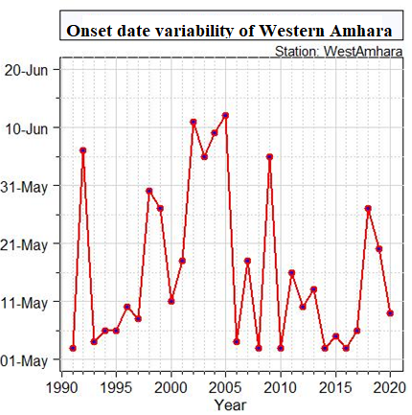
Figure 4. 1. Mean onset date of west Amhara region for the period 1991-2020.
Station wise and regional onset date trend for the period 1991-2020 was given in Table 4.2.The result showed a decreasing trend of onset date for most of stations and regional level,except at Chagni,Simada,and Quara stations,Onset date showed decreasing trend means,the rainy season starts earler from year to year.But the trend is statistically significant at 95% confidence level only at Ayikel and Debre Work stations with Sen’s slope estimator of 0.40 day/year and 1.0 day/year respectively.A study by Wasihun et al.(2017) also showed that,increasing and significant onset date at 95% confidence level with Sen’s slope estimator of 0.16 day/year for the period 1988-2012 over Gelemso,West Harerghe.
Table 4. 2. Station wise and regional trend analysis of onset date for the period 1991-2020.
Station | Z-Value | Sen's slope | S | Var(S) | P-value | Tau
Chagini | 0.27 | 0.00 | 16 | 3119 | 0.788 | 0.04
Adet | -0.91 | -0.30 | -52 | 3128 | 0.362 | -0.12
Ayehu | -0.11 | 0.00 | -7 | 3110 | 0.914 | -0.02
Aykel | -2.13 | -0.40 | -120 | 3132 | 0.033* | -0.28
B/Dar | 0.79 | 0.36 | 45 | 3133 | 0.432 | 0.10
Dangla | -1.16 | -0.33 | -66 | 3117 | 0.244 | -0.15
Debark | -1.30 | -0.45 | -74 | 3135 | 0.192 | -0.17
D/Markos | -0.95 | -0.22 | -54 | 3128 | 0.343 | -0.12
D/Tabor | -1.13 | -0.50 | -64 | 3135 | 0.260 | -0.15
Gondar | -1.25 | -0.38 | -71 | 3131 | 0.211 | -0.16
Layber | -0.05 | 0.00 | -4 | 3115 | 0.957 | -0.01
Metema | -0.11 | -0.05 | -7 | 3136 | 0.915 | -0.02
Motta | -0.68 | -0.25 | -39 | 3135 | 0.497 | -0.09
N/Mewcha | 0.00 | 0.00 | -1 | 3129 | 1.000 | 0.00
Shahura | -0.87 | -0.33 | -50 | 3137 | 0.382 | -0.11
Simada | 0.07 | 0.00 | 5 | 3136 | 0.943 | 0.01
Yetnora | -1.34 | -0.40 | -76 | 3120 | 0.179 | -0.17
Quara | 1.00 | 0.27 | 57 | 3128 | 0.317 | 0.13
D/Work | -2.34 | -1.00 | -132 | 3130 | 0.019* | -0.30
Sanja | -0.45 | -0.14 | -26 | 3136 | 0.655 | -0.06
West Amhara | -0.97 | -0.15 | -55 | 3116 | 0.333 | -0.13
* represents significance at 95% confidence level.

4.1.2.Analysis of Cessation date
Figure 4.2 showed the cessation date variability of the main rainy season (kiremt).The cessation date variability of Western Amhara varies from year to year. The earliest cessation date was recorded during 2001,1997,and 2009 with cessation date of 247 DOY(03-Sept),251 DOY (07-Sept),and 253 DOY (09-Sept) respectively.Moreover,most of cessation date of the main rainy season was after 289 DOY (after 15-oct) at the regional scale. A study by Zeleke et al.(2023), over North West Ethiopia for the period 1987 to 2017 also showed that,the rainy season ends between 300 DOY (26-oct) and 321 DOY (16-Nov).

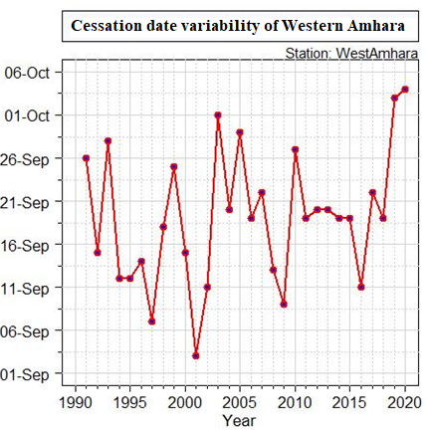
Figure 4. 2. Mean cessation date of west Amhara region for the period 1991-2020.
Table 4.3 was summary of station based and regional cessation date of the main rainy season (Kiremt).During the period 1991-2020,the earliest cessation date ranged from 254 DOY(02-September) at Debark, Metema, Layber, Shahura, Yetnora, Quara, and Debre Work to 289 DOY (15-October) at Debre Markos.But the late cessation date was recorded as 305 DOY (31-October).Moreover,the mean cessation date ranged from 276 DOY (2-October) at Debre Work to 303 DOY (29-October) at Chagni with regional mean cessation date of 297 DOY (23-October).As Ayalew et al. (2012) indicated, the average date of end of rainy season ranged from 246 DOY (2-September) at Mahil Meda (Eastern Amhara) to 304 DOY (30-October) at Debark (Western Amhara) in Amhara region.A study by Wasihun et al.(2020) also showed that, the average cessation date of kiremt rainfall for Gelemso was 302 DOY (28 October) with CV of 7%. A study by Lupi Edao et al.(2018), over Central rift valley also found that, the mean start, end of rainy season and length of growing period (LGP) are found to be May 26, September 14, and 99 days at Mieso site; 148 DOY (May 27), 275 DOY (01-Oct),and 97 days at Melkassa site; 147 DOY (26-May),255DOY (11-Sept), and 109 days in Adami Tulu site respectively.The average deviation of cessation date from the mean ranged from 6 days to 16 days with mean regional standard deviation of 8 days.In addition,station based and regional cessation date variability was less,which ranged from 2% to 6%.
Table 4. 3. Station based and regional cessation date analysis for the period 1991-2020.
Station | Early cessation date (DOY) | Late cessation date (DOY) | Mean cessation date (DOY) | SD (day) | CV(%)
Chagini | 281 | 305 | 303 | 6 | 2
Adet | 272 | 305 | 295 | 11 | 4
Ayehu | 272 | 305 | 297 | 11 | 4
Aykel | 277 | 305 | 297 | 8 | 3
BahirDar | 273 | 305 | 296 | 11 | 4
Dangla | 283 | 305 | 299 | 8 | 3
Debark | 254 | 305 | 286 | 13 | 5
D/Markos | 289 | 305 | 301 | 5 | 2
D/Tabor | 277 | 305 | 296 | 8 | 3
Gondar | 260 | 305 | 280 | 11 | 4
Layber | 254 | 305 | 285 | 14 | 5
Metema | 254 | 305 | 283 | 13 | 5
Motta | 274 | 305 | 298 | 10 | 3
N/Mewcha | 270 | 305 | 285 | 11 | 4
Shahura | 254 | 305 | 283 | 12 | 4
simada | 265 | 305 | 288 | 10 | 3
Yetnora | 254 | 305 | 284 | 14 | 5
Quara | 254 | 305 | 277 | 16 | 6
D/Work | 254 | 305 | 276 | 14 | 5
Sanja | 257 | 305 | 279 | 11 | 4
West Amhara | 279 | 305 | 297 | 8 | 3

Trend analysis of cessation date (Table 4.4) showed that,there was increasing trend of cessation date for most of stations,except at Ayehu,Debre Markos,Debre Tabor,Gondar,Simada,and Yetnora stations,which means that the cessation of the main rainy season becomes late.But increasing trend of cessation date was significant at 95% confidence level only at Chagni,Dangila,Shahura,Quara ,and Sanja stations (p<0.05).Moreover,the mean cessation date of Western Amhara showed significant and increasing trend at 95% significance level (p<0.05),with Sen’s slope estimator of 0.36 days/year.Overall,the regional cessation date of the rainy season becomes late significantly. A study by Wasihun et al.(2020), also showed that, increasing ,but not significant cessation date at 95% confidence level for the period 1988-2012 over Gelemso,West Harerghe.
Table 4. 4. Station wise and regional trend analysis of cessation date for the period 1991-2020.
Station | Z-Value | Sen's slope | S | Var(S) | P-value | Tau
Chagini | 2.86 | 0.00 | 84 | 841 | 0.00* | 0.19
Adet | 1.19 | 0.00 | 65 | 2873 | 0.23 | 0.15
Ayehu | -1.63 | 0.00 | -86 | 2729 | 0.10 | -0.20
Aykel | 0.41 | 0.00 | 23 | 2918 | 0.68 | 0.05
B/Dar | 0.72 | 0.00 | 39 | 2805 | 0.47 | 0.09
Dangla | 2.24 | 0.00 | 114 | 2551 | 0.03* | 0.26
Debark | 1.35 | 0.40 | 76 | 3094 | 0.18 | 0.17
D/Markos | -0.02 | 0.00 | -2 | 2722 | 0.98 | 0.00
D/Tabor | -0.46 | 0.00 | -26 | 3008 | 0.65 | -0.06
Gondar | -0.11 | 0.00 | -7 | 3128 | 0.91 | -0.02
Layber | 0.97 | 0.36 | 55 | 3130 | 0.33 | 0.13
Metema | 1.04 | 0.35 | 59 | 3136 | 0.30 | 0.14
Motta | 0.21 | 0.00 | 12 | 2729 | 0.83 | 0.03
N/Mewcha | 1.41 | 0.38 | 80 | 3123 | 0.16 | 0.18
Shahura | 2.92 | 0.60 | 164 | 3121 | 0.00* | 0.38
simada | -0.18 | 0.00 | -11 | 3115 | 0.86 | -0.03
Yetnora | -0.09 | 0.00 | -6 | 3125 | 0.93 | -0.01
Quara | 3.29 | 1.15 | 185 | 3124 | 0.00* | 0.43
D/Work | 1.36 | 0.42 | 77 | 3134 | 0.17 | 0.18
Sanja | 2.31 | 0.56 | 130 | 3128 | 0.02* | 0.30
West Amhara | 2.29 | 0.36 | 125 | 2920 | 0.02* | 0.29
* represents significance at 5%.

4.1.3. Analysis of length of growing season
The number of days between the start and end of rainy season was given in figure 4.3.The line graph depicted that,the length of the rainy season varies for the period 1991 to 2020.But for most of the study time period the season length was between 150 and 175 days. A study by Zeleke et al.(2023), over North West Ethiopia for the period 1987 to 2017 also showed that, the length of the growing period (LGP) during the rainy season ranges from 94 to 229 days.On the other hand,the year 2019 and 2002 have short length of growing season.The year 1991,1992,2010,and 2020 have long length of growing season,since the rainy season started at the begning of May and extends up to end of October.
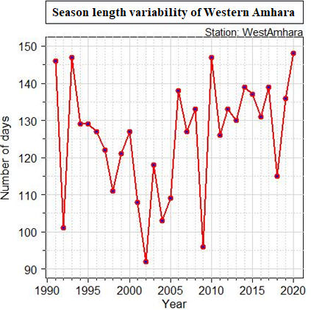
Figure 4. 3. Variability of length of growing season length of west Amhara region for the period 1991-2020.
Table 4.5 showed station wise and regional length of growing season for the period 1991 to 2020.The result indicated that the minimum length of growing season ranged from 67 days (Metema) to 149 days (Chagni).More over,the maximum length of growing season ranged from 164 days (Sanja) to 181 days (Shahura, Motta, Debre Markos, Debark, Dangila, and Ayikel).The minimum and maximum length of growing season for the region was 122 and 181 days respectively.On the other hand,the mean length of growing season ranged from 122 days (Debre Work) to 167 days (Chagni),with regional mean length of growing season of 142 days. In another study by (Hadgu et al.(2015), reported that the average length of growing period in northern Ethiopia varies from 66 to 85 days depending on the location of the study area.Astudy by Gebremichael et al.(2014) reported that, the LGPs period in Hosaina area ranges from 124 to 253 days with a mean of 193 days, CV and SD of 8% and 35 days respectively. A sudy by Oguntunde et al.(2014) conclude ,a decrease in length of growing period ,but increase in rainfall amount over Nigeria for study time period 1971-2005.The average deviation of length of growing season ranged from 10 (Chagni) to 28 (Debre Work),with regional standard deviation of 16 days.The coefficient of variation of the length of growing season ranged from 6% (less variable) to 23% (moderately variable).Overall,the Western part of the study area has long length of growing season than the eastern part of the study area,which means that,the season starts earlier and ends late on the western part of the region.
Table 4. 5. Station based and regional length of growing season analysis for the period 1991-2020.
Stations | Minimum length of days | Maximum length of days | Mean length of days | SD (days) | CV (%)
Chagini | 149 | 180 | 167 | 10 | 6
Adet | 116 | 180 | 152 | 20 | 13
Ayehu | 112 | 179 | 161 | 15 | 9
Aykel | 133 | 181 | 158 | 16 | 10
Bahir Dar | 100 | 180 | 143 | 19 | 13
Dangla | 133 | 181 | 163 | 14 | 9
Debark | 104 | 181 | 143 | 19 | 14
D/Markos | 128 | 181 | 160 | 16 | 10
D/Tabor | 105 | 177 | 143 | 18 | 13
Gondar | 108 | 173 | 135 | 17 | 13
Layber | 106 | 176 | 148 | 18 | 12
Metema | 67 | 173 | 133 | 22 | 16
Motta | 96 | 181 | 147 | 25 | 17
N/Mewcha | 89 | 162 | 125 | 22 | 18
Shahura | 68 | 181 | 133 | 25 | 19
simada | 93 | 169 | 128 | 19 | 15
Yetnora | 99 | 179 | 140 | 19 | 14
Quara | 85 | 166 | 126 | 19 | 15
D/Work | 72 | 173 | 122 | 28 | 23
Sanja | 91 | 164 | 128 | 19 | 15
West Amhara | 122 | 181 | 142 | 16 | 10

Table 4.6 showed trend analysis of the length of growing season for the period 1991 to 2020.The result showed that,the length of the growing season of most stations showed an increasing trend ,but Ayehu,Bahir Dar,and Simada showed decreasing trend.The increasing and significant trend of the length of the growing season was detected at Dangila, Debark, Shahura, Debre Work, Sanja, and at regional scale.A study by Tegegn, (2015), for the period 1992-2012 showed that decreasing trend for length of growing seasons.Overall,the length of the growing period of the main rainy season increased by 0.75 day/year at regional level significantly at 95% significance level.A study by Wasihun et al.(2020), also showed that,decreasing and significant length of growing period at 95% confidence level with Sen’s slope estimator of 0.07 day/year for the period 1988-2012 over Gelemso,West Harerghe.A study by Berhe et al.(2023) over eastern Zone of Tigray for the period 1980-2009, also found that trends of growing season characteristics for kiremt season (June-September) have not changed signifcantly at the 5% signifcant level.
Table 4. 6. Station wise and regional trend analysis of length of growing season for the period 1991-2020.
Station | Z-Value | Sen's slope | S | Var(S) | P-value | Tau
Chagini | 1.38 | 0.25 | 78 | 3129 | 0.17 | 0.18
Adet | 1.63 | 0.74 | 92 | 3132 | 0.10 | 0.21
Ayehu | -1.00 | -0.35 | -57 | 3126 | 0.32 | -0.13
Aykel | 1.09 | 0.39 | 62 | 3134 | 0.28 | 0.14
B/Dar | -0.14 | 0.00 | -9 | 3131 | 0.89 | -0.02
Dangla | 2.02 | 0.71 | 114 | 3129 | 0.04* | 0.26
Debark | 2.15 | 0.88 | 121 | 3126 | 0.03* | 0.28
D/Markos | 0.80 | 0.27 | 46 | 3132 | 0.42 | 0.11
D/Tabor | 0.48 | 0.21 | 28 | 3136 | 0.63 | 0.06
Gondar | 0.00 | 0.00 | -1 | 3133 | 1.00 | 0.00
Layber | 0.64 | 0.20 | 37 | 3130 | 0.52 | 0.09
Metema | 1.02 | 0.29 | 58 | 3134 | 0.31 | 0.13
Motta | 0.73 | 0.48 | 42 | 3139 | 0.46 | 0.10
N/Mewcha | 0.82 | 0.41 | 47 | 3140 | 0.41 | 0.11
Shahura | 2.05 | 1.25 | 116 | 3137 | 0.04* | 0.27
simada | -0.39 | -0.17 | -23 | 3138 | 0.69 | -0.05
Yetnora | 1.57 | 0.67 | 89 | 3138 | 0.12 | 0.20
Quara | 1.68 | 0.80 | 95 | 3133 | 0.09 | 0.22
D/Work | 2.50 | 1.62 | 141 | 3140 | 0.01* | 0.32
Sanja | 1.82 | 0.80 | 103 | 3136 | 0.07 | 0.24
West Amhara | 2.16 | 0.75 | 122 | 3129 | 0.03* | 0.28
*represents significance at 5%.

4.1.4.Analysis of daily rainfall (mm) of the main rainy season
The mean daily rainfall total of Western Amhara for the period 1991-2020 was given in figure 4.4.The Box and Whiskers plot showed that,the mean daily rainfall total was higher during July and August months.The mean daily rainfall recorded for July and August was approximately 9mm/day.During July and August ,the mean daily maximum rainfall recorded reached to 35 mm/day.
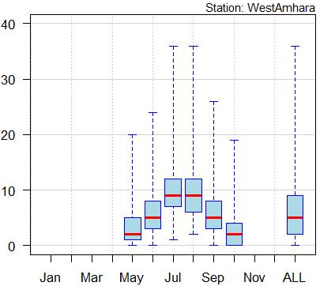
Figure 4. 4. Box and whiskers plot representation of daily rainfall at western Amhara region for the period 1991-2020.

4.1.5. Analysis of monthly rainfall of the main rainy season
Figure 4.5 showed the spatial analysis of monthly rainfall for the period 1991 to 2020.During June,most areas of Western Amhara received from 125 to 200 mm rainfall,but western part acquires from 200 to 300 mm rainfall.During,July and August the rainfall distribution increased in amount and reached peak.Hence,the amount of rainfall recorded reached up to 450mm/month in July and August.The findings of Taye et al.(2013) reveal that, the Amhara National Regional State receives much of the rainfall in June, July, August and September.The mean monthly rainfall of June,July,August,and September for the period 1991-2020 over Western Amhara region was 163.6mm,302.3mm,291.4mm,and 169.5mm respectively.Among the 20 sample stations in the Western Amhara ,Debre Tabor,Bahir Dar,and Dangila acquires better rainfall amount than others.Starting from September,the rainfall amount becomes decrease from eastern part of the region and shifts towards western part gradually,as the rain bring meteorological systems during the season becomes weaken.Overall,Western tip of the region acquires better rainfall amount than northern and eastern part of the region.
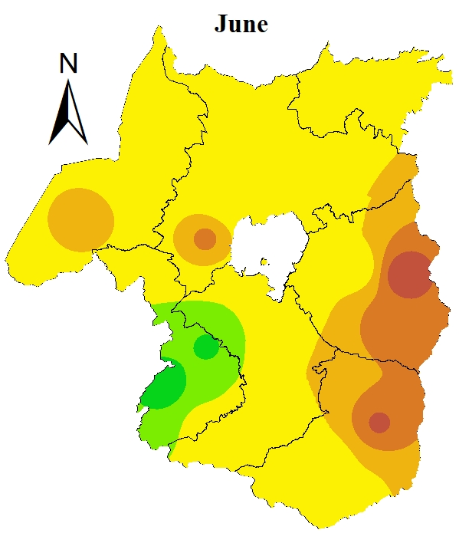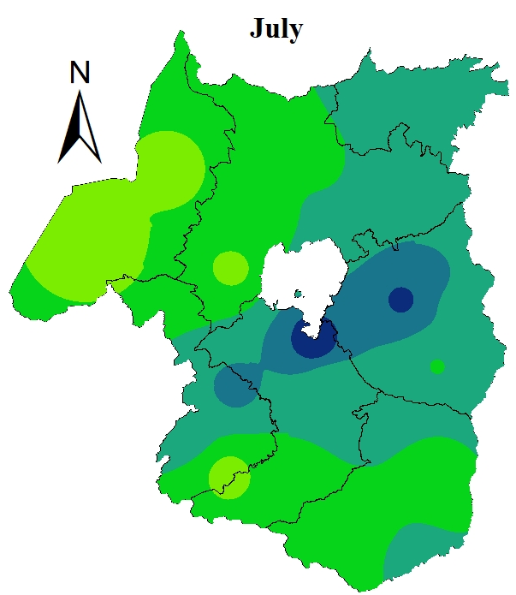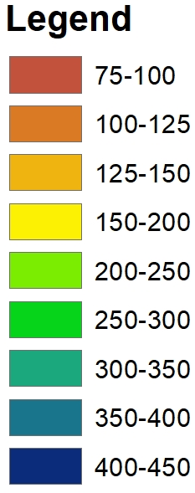
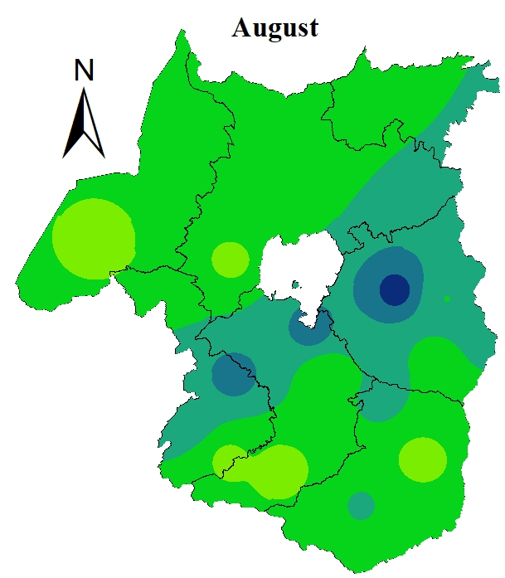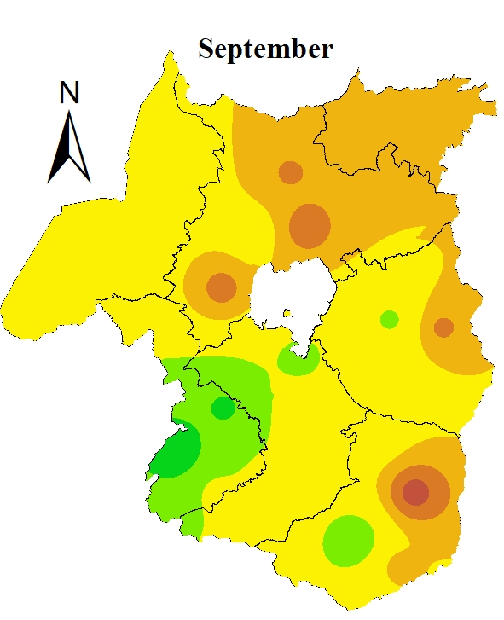
Figure 4. 5. Monthly rainfall (mm) analysis of west Amhara region for the period 1991-2020.

4.1.6. Analysis of Seasonal rainfall of the main rainy season
Figure 4.6 and Table 4.7 showed the kiremt season rainfall distribution of the Western Amhara.The spatial distribution indicated that,there was variation in rainfall distribution and amount.Among the 20 sample stations,low amont of rainfall was recorded at Debre Work and Shahura with seasonal rainfall total of 650 to 750 mm/kiremt season.But high kiremt rainfall total was recorded at Dangila from 1250 to 1350 mm .Most of the region recorded from 850 to 950 mm during the kiremt season.The mean kiremt rainfall of Western Amhara for the period 1991-2020 was 926.8mm.Overall,Western and central part of the region acquire better mean kiremt rainfall for the period 1991-2020.A study by Taye et al.(2013) over small scale areas of Western Amhara for the period 1979 to 2008 showed that, the mean annual rainfall of kiremt season in western Amhara was 1054.2mm.
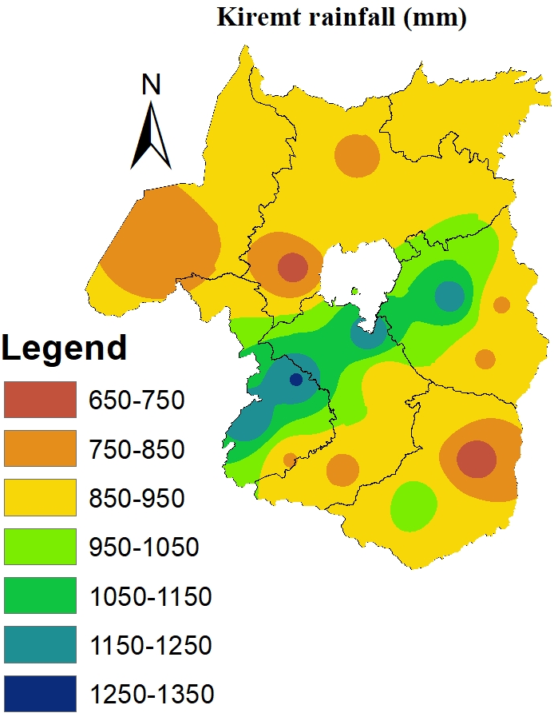
Figure 4. 6. Seasonal rainfall (mm) analysis of west Amhara region for the period 1991-2020.
Figure 4.7 showed the kiremt season rainfall anomaly of the west Amhara region for the period 1991-2020.The result depicted that most of the years showed negative kiremt rainfall anomaly,which showed a decrease rainfall as compared with mean rainfall and an indication of rainfall deficiet.Rainfall anomaly index less than -1.65 is considered to be extremely drought.On the otherhand rainfall anomaly greater than 1.65 is refered to be extremely wet.The years 1995,1997,and 2015 was the driest years .But,the year 2006,2019,and 2020 was the most wettest years.Astudy by Wasihun et al.(2020), indicated that,the years 1996,2002,and 2015 the driest years while the years 2007,2003,and 2012 as the wettest years for the study time period 1988-2017 over their study area.For years those have positive anomalies,there was relatively early onset date ( Table 4.1 and Figure 4.7).Astudy by Nairobi et al.(2016) showed that, positive (negative) rainfall anomaly was associated with early (late) onset.

Figure 4. 7. Kiremt rainfall anomaly of West Amhara region for the period 1991-2020.
The PCI values of kiremt rainfall was indicated in table (4.7).The result indicated that,the PCI value of kiremt rainfall ranged from 8.4 to 10.8,with regional mean PCI value of 9.2%.Overall,the PCI value was less than 10 for regional and for most stations during the study time period,which indicated that there was uniform monthly rainfall distribution of kiremt rainfall.But at Nefas Mewucha and Debre Work stations ,there was moderate concentration of monthly rainfall for the kiremt season.A study by Taye et al.(2013) indicated that, Precipitation Concentration Index (PCI) value indicates that western Amhara is characterized by high to very high monthly rainfall concentration.
Table 4.7. Station wise and regional mean monthly and seasonal rainfall (mm) and PCI (%) for the period 1991-2020.
Station | June | July | August | September | Kiremt | PCI (%)
Chagini | 286.4 | 333.4 | 342.8 | 284.4 | 1247.0 | 8.4
Adet | 153.3 | 299.9 | 256.4 | 158.2 | 867.8 | 9.0
Ayehu | 185.6 | 224.5 | 235.4 | 193.6 | 839.0 | 8.4
Aykel | 199.2 | 291.8 | 274.7 | 170.4 | 936.1 | 8.7
BahirDar | 195.2 | 450.5 | 379.5 | 212.3 | 1237.6 | 9.4
Dangla | 259.5 | 368.7 | 376.9 | 255.8 | 1260.9 | 8.6
Debark | 157.2 | 329.8 | 296.2 | 125.7 | 909.0 | 9.6
Debre Markos | 178.9 | 281.9 | 304.9 | 229.1 | 994.9 | 8.6
Debre Tabor | 175.1 | 411.6 | 426.7 | 204.9 | 1218.3 | 9.5
Gondar | 174.7 | 302.4 | 297.0 | 110.4 | 884.6 | 9.5
Layber | 171.7 | 254.5 | 221.2 | 169.9 | 817.3 | 8.6
Metema | 182.9 | 226.9 | 264.5 | 193.2 | 867.5 | 8.5
Motta | 127.4 | 324.1 | 313.1 | 169.3 | 933.9 | 9.5
Nefas Mewucha | 74.0 | 343.8 | 299.6 | 120.7 | 838.2 | 10.8
Shahura | 116.4 | 235.0 | 234.9 | 114.6 | 700.8 | 9.3
simada | 101.2 | 297.6 | 287.7 | 150.9 | 837.4 | 9.7
Yetnora | 153.4 | 309.3 | 288.8 | 143.2 | 894.6 | 9.3
Quara | 135.6 | 214.2 | 231.4 | 172.2 | 753.4 | 8.7
DebreWork | 93.7 | 271.3 | 223.6 | 87.8 | 676.4 | 10.2
Sanja | 151.1 | 274.6 | 272.5 | 122.6 | 820.8 | 9.3
West Amhara | 163.6 | 302.3 | 291.4 | 169.5 | 926.8 | 9.2

4.2.Performance Evaluation of CMIP6 GCMs for future rainfall Analysis
The performance of the five CMIP6 GCMs in simulating the main rainy season future rainfall characterstics of Western Amhara region showed in Table (4.8).Acording to CRI, EC-Earth3 is the best performing CMIP6 GCMs model over Western Amhara at daily time scale.Followed by EC-Earth3, Ec-Earth3- Veg, MPI-ESM1-2-LR, and GFDL-ESM4 are the second and third best performing models for simulating rainfall characterstics of the region.But at monthly timescale, GFDL-ESM4, EC-Earth3,and Ec-Earth3-Veg are the first,second,and third best performing CMIP6 GCMs to detect rainfall total respectively. MPI-ESM1-2-LR is the poorest performing model to detect rainfall total over Western Amhara region at monthly time scale.At seasonal (kiremt) timescale, BCC-CSM2-MR, GFDL-ESM4,and EC-Earth3 are first,second,and third best performing CMIP6 GCMs to detect kiremt rainfall total respectively.Moreover, MPI-ESM1-2-LR underestimate (positive PBIAS) the daily,monthly,and kiremt rainfall total over Western Amhara by 25.20%,but EC-Earth3 and Ec-Earth3-Veg overestimate (negative PBIAS) over the region at all temporal scales.In addition, GFDL-ESM4 and BCC-CSM2-MR underestimate daily to kiremt rainfall toal by 6.70% and 11.10% respectively.
In general,models have different performance in different temporal scale.The top ranked four models those demonstrate relatively best performance for simulating future rainfall charactersics over Western Amhara region at daily time scale are EC-Earth3, Ec-Earth3-Veg,-MPI-ESM1-2-LR,and GFDL-ESM4.Similar with my finding, the MPI-ESM1-2-LR, EC-Earth3, and Ec-Earth3-Veg are the best performing models in simulating daily rainfall total in the Bale Eco Region ,in Southern Ethiopia by Gashaw et al.(2024). Moreover,this study used the ensemble mean of the best performoing four models EC-Earth3, Ec-Earth3-Veg, MPI-ESM1-2-LR,and GFDL-ESM4 for simulating future rainfall characterstics over Westren Amhara region at daily time scale.On the other hand,the ensemble mean of GFDL-ESM4, EC-Earth3,and Ec-Earth3-Veg were used for future monthly rainfall analysis and BCC-CSM2-MR, GFDL-ESM4,and EC-Earth3 for future kiremt rainfall analysis over Western Amhara region. Inline with my study, Gashaw et al., (2024) also used similar approach to study future rainfall characerstics over Bale Eco Region ,Southern Ethiopia.A study by Kamruzzaman et al.(2023) also used the ensemble mean of bias corrected CMIP6 GCMs for future rainfall and temperature projection of Bangladish for the period 2015 to 2100 under different SSPs.
Table 4. 8. Performance of CMIP6 GCMs for simulating rainfall over Western Amhara at daily,monthly,and seasonal temporal scales.
Spatial/temporal scale | CMIP6 GCMs | Continious metrics |  |  | CRI | Rank
Spatial/temporal scale | CMIP6 GCMs | RMSE | PBIAS | r | CRI | Rank
West Amhara (Daily) | BCC-CSM2-MR | 10.73 | 11.10 | 0.08 | 0.20 | 5
West Amhara (Daily) | EC-Earth3 | 5.86 | -21.30 | 0.34 | 0.53 | 1
West Amhara (Daily) | Ec-Earth3- Veg | 6.14 | -12.90 | 0.25 | 0.47 | 2
West Amhara (Daily) | GFDL-ESM4 | 7.74 | 6.70 | 0.14 | 0.40 | 3
West Amhara (Daily) | MPI-ESM1-2-LR | 5.55 | 25.20 | 0.20 | 0.40 | 3
West Amhara (monthly) | BCC-CSM2-MR | 82.28 | 11.10 | 0.60 | 0.27 | 4
West Amhara (monthly) | EC-Earth3 | 78.58 | -21.30 | 0.83 | 0.53 | 2
West Amhara (monthly) | Ec-Earth3- Veg | 96.57 | -12.90 | 0.65 | 0.33 | 3
West Amhara (monthly) | GFDL-ESM4 | 66.31 | 6.70 | 0.65 | 0.73 | 1
West Amhara (monthly) | MPI-ESM1-2-LR | 79.14 | 25.20 | 0.64 | 0.20 | 5
West Amhara (kiremt) | BCC-CSM2-MR | 145.73 | 11.10 | 0.22 | 0.67 | 1
West Amhara (kiremt) | EC-Earth3 | 207.18 | -21.30 | 0.19 | 0.47 | 3
West Amhara (kiremt) | Ec-Earth3- Veg | 244.46 | -23.20 | 0.14 | 0.20 | 4
West Amhara (kiremt) | GFDL-ESM4 | 142.93 | 6.70 | -0.06 | 0.53 | 2
West Amhara (kiremt) | MPI-ESM1-2-LR | 243.59 | 25.20 | 0.13 | 0.13 | 5

4.3.Analysis of the future rainfall characterstics of the main rainy season

4.3.1.Analysis of onset date
The earliest,latest,mean,standard deviation,and CV of onset date was given in Table (4.9).The earliest onset date will be 124 DOY for the time period 2021-2050.The earliest onset date ranged from 124 DOY to 174 DOY for the period 2021-2100 under SSP2-4.5, SSP3-7.0,and SSP5-8.5 scenarios.High shift of onset date will be expected under SSP3-7.0 for the time period 2051-2080.The mean onset date under SSP2-4.5 will be 148 DOY,151 DOY,and 153 DOY for 2021-2050, 2051-2080, and 2081-2100 respectively.In the case of SSP3-7.0, the mean onset date projected to be 160 DOY,181 DOY, and 172 DOY for the period 2021-2050,2051-2080,and 2081-2100 respectively.In sddition, the mean onset date under SSP5-8.5 projected as, 144 DOY,141 DOY,and 153 DOY for the period 2021-2050,2051-2080,and 2081-2100 respectively.In opposite with my finding, Tegegn, (2015) conclude the expectation of early onset of kiremt rainfall for the future over North Eastern Amhara.The CV of onset date will be less than 20,which means less variable from one season of the year to the other under all considered SSPs and time period.According to SSP3-7.0 scenario,late start of rainy season will be observed as of 202 DOY for the period 2081-2100.A study by Kwawuvi et al.(2022) revealed that, there will be an increase on the onset date for the period 2021-2050 from 8 May (128 days) to about 24 May (144 days) under the RCP4.5 and RCP8.5 emission scenarios in the Oti River Basin, West Africa.
Table 4. 9. Onset date analysis of Western Amhara for the period 2021-2100 under different SSP and departure from the mean onset date of base period (1991-2020).(Observed Mean onset date was 138 DOY).
SSP | Year | Onset date Characterstics
SSP | Year | Early onset date (DOY) | Late onset date (DOY) | Mean onset date (DOY) | SD (day) | CV (%)
SSP2-4.5 | 2021-2050 | 124 | 179 | 148 (10) | 14 | 9
SSP2-4.5 | 2051-2080 | 124 | 178 | 151 (13) | 15 | 10
SSP2-4.5 | 2081-2100 | 125 | 181 | 153 (15) | 19 | 13
SSP3-7.0 | 2021-2050 | 125 | 190 | 160 (22) | 20 | 13
SSP3-7.0 | 2051-2080 | 174 | 198 | 181 (48) | 7 | 4
SSP3-7.0 | 2081-2100 | 139 | 202 | 172 (34) | 16 | 9
SSP5-8.5 | 2021-2050 | 125 | 166 | 144 (6) | 14 | 10
SSP5-8.5 | 2051-2080 | 125 | 176 | 141 (3) | 12 | 9
SSP5-8.5 | 2081-2100 | 125 | 181 | 153 (15) | 19 | 13
Figure 4.8 showed the line graph representation of onset date for Western Amhara region for the period 2021-2050 (a),2051-2080 (b),and 2081-2100 (c) under SSP2-4.5.The earliest onset date projected to be 02-May for the year 2044,2065,and 2090.On the other hand,the late onset date will be for the year 2035,2068,and 2092 under SSP2-4.5.
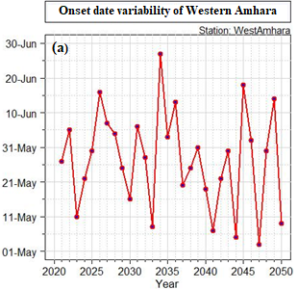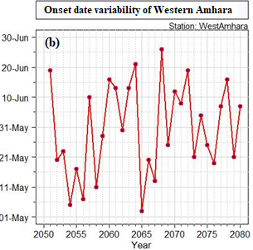
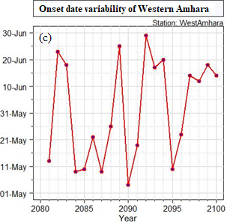
Figure 4. 8. Line graph representation of onset date for western Amhara region for the period 2021-2100 under SSP2-4.5.
Figure 4.9 showed the line graph reperesentation of onset date for Western Amhara region for the period 2021-2100 under SSP3-7.0.According to SSP3-7.0 scenario,there will be delay of onset date for the year 2035 to 2050 in general and during 2036 in particular with onset date of 09-July (Figure 4.9 a). In the case of SSP3-7.0,onset date will vary between 01-May to 10-July (2021-2050), between 02-July and 16-July (2051-2080), and between 15-May and 19-July (2081-2100).
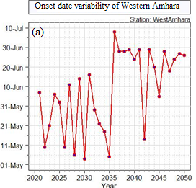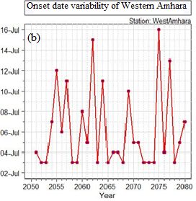
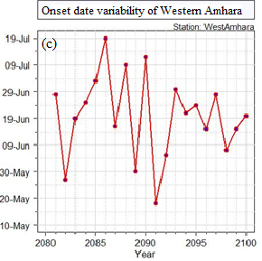
Figure 4. 9. Line graph representation of onset date for western Amhara region for the period 2021-2100 under SSP3-7.0.
Figure 4.10 depicted the line graph representation of onset date for Western Amhara region for the period 2021-2100 under SSP5-8.5.According to SSP5-8.5,the onset date will be vary between 01-May and 15-June for the period 2021-2050,between 01-May and 30-June for the period 2051-2080,and between 01-May and 30-June for the period 2081-2100.Most onset date for the period 2021-2100 will be recorded between 01-May and 20-June under SSP5-8.5 scenario.
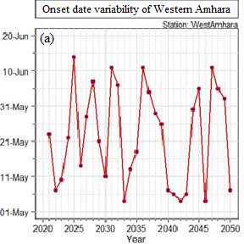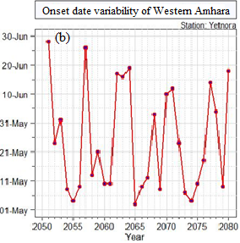
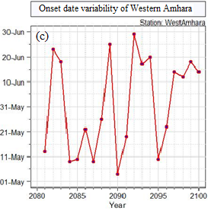
Figure 4. 10. Line graph representation of onset date for western Amhara region for the period 2021-2100 under SSP5-8.5.
Summary of Mankendall trend test statistics for the mean onset date of Western Amhara region for the time period 2021-2100 under SSP2-4.5,SSP3-7.0,and SSP5-8.5 scenario are given in Table (4.9).The result revealed that,there will be delay of onset date (trend increase) under SSP2-4.5 for the period 2051-2080 and 2081-2100,under SSP3-7.0 for the period 2021-2050,under SSP5-8.5 for the period 2081-2100.But the delay onset date will be significant at 95% confidence level under SSP3-7.0 for the period 2021-2050 (P<0.05) by 1.08 day/year.On the otherhand,for most of projected time period and for SSP2-4.5,SSP3-7.0,and SSP5-8.5 there will be earliest onset date (decreasing trend) ,but insignificant at 95% confidence level.A study by Wasihun et al.(2020) , showed that,increasing and significant onset date at 95% confidence level for the period 2018-2047 over Gelemso,West Harerghe in Ethiopia.
Table 4. 10. Onset date trend analysis of Western Amhara region for the period 2021-2100 under different SSP.
SSP | Year | MKttest trend analysis
SSP | Year | Z-value | Sen’s slope | S | Var (S) | P-value | Tau
SSP2-4.5 | 2021-2050 | -0.88 | -0.27 | -50 | 3136 | 0.38 | -0.11
SSP2-4.5 | 2051-2080 | 0.91 | 0.44 | 52 | 3135 | 0.36 | 0.12
SSP2-4.5 | 2081-2100 | 0.02 | 0.09 | 1.00 | 3135 | 0.37 | 0.01
SSP3-7.0 | 2021-2050 | 2.61 | 1.08 | 147 | 3132 | 0.01* | 0.34
SSP3-7.0 | 2051-2080 | -0.29 | 0.00 | -17.0 | 3105 | 0.77 | -0.04
SSP3-7.0 | 2081-2100 | -0.62 | -0.39 | -20 | 948 | 0.54 | -0.11
SSPP5-8.5 | 2021-2050 | -0.27 | -0.006 | -16 | 3129 | 0.79 | -0.04
SSPP5-8.5 | 2051-2080 | -0.75 | -0.25 | -43 | 3136 | 0.45 | -0.10
SSPP5-8.5 | 2081-2100 | 0.94 | 1.17 | 30 | 946 | 0.35 | 0.16
*represents significance at 5%.

4.3.2.Analysis of cessation date
Table 4.10 showed result of early,late,mean,standard deviation,and CV of cessation date for Western Amhara region for the period 2021-2100 under SSP2-4.5, SSP3-7.0, and SSP5-8.5.The result revealed that,the early cessation date ranged from 248 DOY to 261 DOY under SSP2-4.5,233 DOY to 238 DOY under SSP3-7.0,and 246 DOY to 261 DOY under SSP5-8.5 for the period 2021 to 2100.The cessation date will be extended up to 288 to 303 DOY under SSP-4.5,from 266 to 282 DOY under SSP3-7.0,and from 283 to 288 DOY under SSP5-8.5 for the period 2021-2100.The projected mean cessation date of Wesern Amhara region will be earlier from baseline mean cessation date by 29 days for the period 2021-2050,by 27 days for the period 2051-2080,and by 32 days for the period 2081-2100 under SSP2-4.5.In the case of SSP3-7.0,the cessation date projected to be earlier by 36 days ,52 days,and 52 days for the period 2021-2050,2051-2080,and 2081-2100 respectively.On the otherhand ,the cessation date will be earlier by 28 days, 18 days,and 33 days under SSP5-8.5 for the period 2021-2050, 2051-2080, and 2081-2100 respectively.A study by Kwawuvi et al.(2022) in the Oti River basin, West Africa, indicated that,Cessation date which was on 29 October (302 DOY) in the historical period (1981-2010) could decrease to 7 October (280 DOY) under both RCP4.5 and RCP8.5 scenarios in 2021-2050. The CV of mean cessation date for the period 2021-2100 and for all considered scenarios in this study projected to be less than 10,which implied that less variable from one season of the year to the other.
Table 4. 11. Cessation date analysis of Western Amhara for the period 2021-2100 under different SSP and departure from the mean cessation date of base period (1991-2020).
SSP | Year | Cessation date Characterstics
SSP | Year | Early cessation date (DOY) | Late cessation date (DOY) | Mean cessation  date (DOY) | SD (day) | CV (%)
SSP2-4.5 | 2021-2050 | 254 | 300 | 268 (-29) | 8 | 3
SSP2-4.5 | 2051-2080 | 261 | 303 | 270 (-27) | 10 | 4
SSP2-4.5 | 2081-2100 | 248 | 288 | 265 (-32) | 9 | 4
SSP3-7.0 | 2021-2050 | 238 | 282 | 261 (-36) | 13 | 5
SSP3-7.0 | 2051-2080 | 233 | 273 | 245 (-52) | 11 | 5
SSP3-7.0 | 2081-2100 | 235 | 266 | 245 (-52) | 10 | 4
SSP5-8.5 | 2021-2050 | 261 | 283 | 269 (-28) | 5 | 2
SSP5-8.5 | 2051-2080 | 261 | 285 | 271 (-18) | 7 | 3
SSP5-8.5 | 2081-2100 | 246 | 288 | 264 (-33) | 11 | 4
Line graph representation of mean cessation date for Western Amhara region for the period 2021-2100 under SSP2-4.5 given by Figure (4.11).The result indicated that,the earliest and lettest projected cessation date to be 10-September (2044) and 7-October (2049) during the period 2021-2050 respectively.For the perojected study time period (2051-2080) under SSP2-4.5,the earliest and lettest cessation date will be 18-September (2071) and 06-October (2074) respectively.Moreover,the earliest and lettest cessation date projected as 03-September (2084) and 14-October (2086) for the period 2081-2100 under SSP2-4.5.For most season of the year ,the cessation date projected to be September (September15-30) (Figure 4.11).

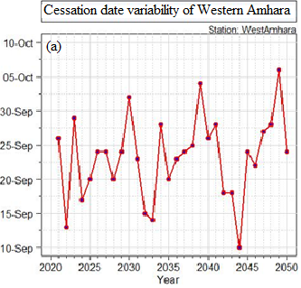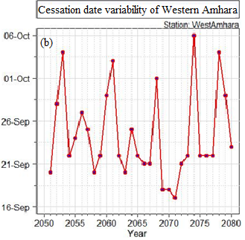
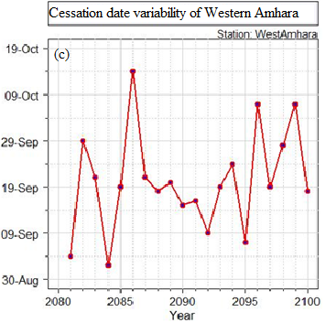
Figure 4. 11. Line graph representation of cessation date for western Amhara region for the period 2021-2100 under SSP2-4.5.
Figure 4.12 Showed the line graph representation of cessation date for the time period 2021-2050, 2051-2080, and 2081-2100 under SSP3-7.0 for Western Amhara region.According to SSP3-7.0 scenario,the cessation date of western Amhara region projected to be earlier after 2036 of the study time interval 2021-2050.The earliest and latiest projected cessation date will be 25-August (2045 and 2050),and 09-October (2021) for the period 2021-2050.During the period, 2051-2080,most cessartion date of the rainy season of the region projected to be between 01-September and 24-September.In addition to this,for the period 2081-2100,most cessation date of the year projected as between 01-sepetmber and 21-september (Figure 4.12c).
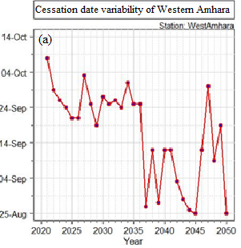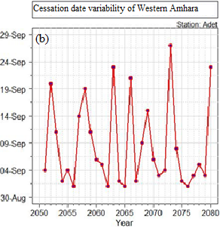
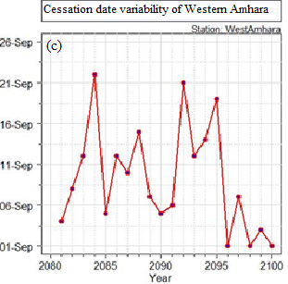
Figure 4. 12. Line graph representation of cessation date for western Amhara region for the period 2021-2100 under SSP3-7.0.
Figure 4.13 represents the line graph representation of mean cessation date of Western Amhara region for the period 2021-2100 under SSP5-8.5 scenario.The finding showed that,the earliest and latiest projected cessation date will be 17 September (2021,2043,and 2046) and 08-October (2048) during the specified study time period 2021-2050 respetively.For the period 2051-2080 under SSP5-8.5,the earliest and latiest cessation date projected as 01-September (2071) and 03-October (2064) respectively.On the other hand,the mean cessation date of Western Amhara region of earliest and latiest cessation date projected as 01-September (2081) and 14-October (2086) for the study time period 2081-2100 under SSP 5-8.5 scenario.In most of the rainy season of the study time period,the mean cessation date of Western Amhara region projected to be from 01-30 September (Figure 4.13).
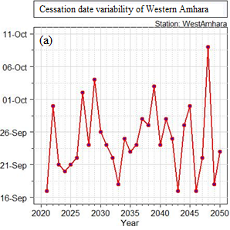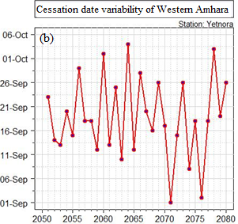
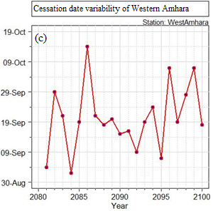
Figure 4. 13. Line graph representation of cessation date for western Amhara region for the period 2021-2100 under SSP5-8.5.
Table 4.12 showed modified mankendal trend test analysis of mean cessation date of Western Amhara region for the period 2021-2050,2051-2080,and 2081-2100 under SSP2-4.5,SSP3-7.0,and SSP5-8.5 scenarios.From the analysis,the mean cessation date of Western Amhara region for the period 2021-2050 under SSP2-4.5,for the period 2051-2080 and 2081-2100 under SSP 3-7.0,and for the period 2021-2050 under SSP5-8.5 scenario showed increasing trend (becomes late),but it is not significant at 95% confidence level.On the other hand,the mean cessation date of Western Amhara region, showed decreasing trend (cessation becomes earlier),during the period 2051-2080 and 2081-2100 (under SSP2-4.5),during 2021-2050 (under SSP3-7.0),and during 2051-2080 and 2081-2100 (under SSP5-8.5).But the trend significant and decreasing only for the period 2021-2050 under SSP3-7.0 scenario with Sen’s slope estimator of 0.54 day/year.
Table 4. 12. Cessation date trend analysis of Western Amhara region for the period 2021-2100 under different SSP.
SSP | Year | MKttest trend analysis
SSP | Year | Z-value | Sen’s slope | S | Var (S) | P-value | Tau
SSP2-4.5 | 2021-2050 | 0.32 | 0 | 19 | 3103 | 0.75 | 0.04
SSP2-4.5 | 2051-2080 | -0.65 | 0.00 | -37 | 3065 | 0.52 | -0.09
SSP2-4.5 | 2081-2100 | -0.17 | 0.00 | -9 | 3084 | 0.64 | -0.03
SSP3-7.0 | 2021-2050 | -1.99 | -0.54 | -112 | 3119 | 0.05* | -0.26
SSP3-7.0 | 2051-2080 | 0.43 | 0.04 | 25 | 3119 | 0.67 | 0.06
SSP3-7.0 | 2081-2100 | 0.95 | 0.41 | 30 | 937 | 0.34 | 0.16
SSP5-8.5 | 2021-2050 | 0.70 | 0.08 | 40 | 3119 | 0.48 | 0.09
SSP5-8.5 | 2051-2080 | -1.58 | -019 | -89 | 3118 | 0.11 | -0.20
SSP5-8.5 | 2081-2100 | -0.62 | -0.18 | -20 | 943 | 0.54 | -0.11
* Represents significant at 5%.

4.3.3.Analysis of length of growing season
Table 4.13 showed the mean length of growing period for the study time interval 2021-2100 under SSP2-4.5,SSP3-7.0,and SSP5-8.5 scenario for Western Amhara region.The result revealed that,the minimum length of growing period for the period 2021-2050, 2051-2080, and 2081-2100 projected to be 93, 93, and 72 under SSP2-4.5 respectively,for the period 2021-2050 (60),2051-2080 (35),2081-2100 (35) under SSP3-7.0,and for the period 2021-2050 (99),2051-2080 (89),and 2081-2100 (72) under SSP5-8.5 scenario.On the other hand the maximum length of growing period projected to be during 2021-2050 (147),during 2051-2080 (143),during 2081-2100 (145) under SSP2-4.5.In the case of SSP3-7.0,The maximum length of growing period extends to 146 (2021-2050), 95 (2051-2080), and 108 (2081-2100).Moreover,in the case of SSP5-8.5 scenario,the maximum length of growing period projected as 125 (2021-2050),148 (2051-2080),145 (2081-2100).The mean season length of Western Amhara region for the base line (1991-2020) was 142 days (Table 4.5).For projected time period under different scenario,the length of growing period will shorten by 23 days (2021-2050), 25 days (2051-2080),31 days (2081-2100) under SSP2-4.5.In addition the main rainy season length expected to be shorten by 41 days (2021 to 2050) ,78 days (2051 to 2080), and 69 days (2081 to 2100) under SSP3-7.0 scenario.Moreover,the mean length of growing season for Western Amhara region projected to be 17 days (2021-2050),12 days (2051-2080),and 31 days (2081-2100) under SSP5-8.5. Models projection have also shown moderate reduction (< 20%) in the length of the growing period across Africa including Ethiopia (Thornton et al., 2009).Another study by Kwawuvi et al.(2022) in the Oti River Basin, West Africa, indicated that, season length would decrease from 173 days to about 136 days under both RCP4.5 and RCP8.5 scenarios in 2021-2050. The average deviation of length of growing period from the mean length of growing period ranged from 13 days during 2051-2080 under SSP5-8.5 to 29 days during 2021-2050 under SSP3-7.0.The season length of Western Amhara region was moderately variable (CV<30%) under SSP3-7.0 during study time period 2021-2050,2051-2080,and 2081-2100. But,the season length projected to be less variable for SSP2-4.5 and SSP5-8.5 for all considered study time period.
Table 4. 13. Season length analysis of Western Amhara for the period 2021-2100 under different SSP and departure from observed mean LGP.
SSP | Year | Season length Characterstics
SSP | Year | Minimum LGP (day) | Maximum LG (day) | Mean LGP (day) | SD (day) | CV (%)
SSP2-4.5 | 2021-2050 | 93 | 147 | 119 (-23) | 14 | 12
SSP2-4.5 | 2051-2080 | 93 | 143 | 117 (-25) | 15 | 13
SSP2-4.5 | 2081-2100 | 72 | 145 | 111 (-31) | 19 | 17
SSP3-7.0 | 2021-2050 | 60 | 146 | 101 (-41) | 29 | 29
SSP3-7.0 | 2051-2080 | 35 | 95 | 64 (-78) | 14 | 22
SSP3-7.0 | 2081-2100 | 35 | 108 | 73 (-69) | 20 | 28
SSP5-8.5 | 2021-2050 | 99 | 146 | 125 (-17) | 14 | 11
SSP5-8.5 | 2051-2080 | 89 | 148 | 130 (-12) | 13 | 10
SSP5-8.5 | 2081-2100 | 72 | 145 | 111 (-31) | 19 | 17

Figure 4.14 showed the mean season length of Western Amhara region for the period 2021-2100 under SSP2-4.5.The lowest and highest length of growing period projected for SSP2-4.5 for study time period 2021-2050,2051-2080,2081-2100 will be 94 (2034) and 157 (2047),93 (2051)and 143 (2056),and 75 (2092) and 148 (2086) respectively.Mostly,the length of the main rainy season of the study time period projected to be between 90 and 140 days.
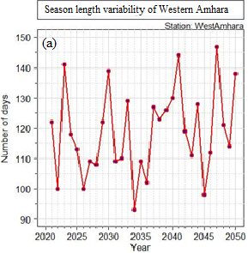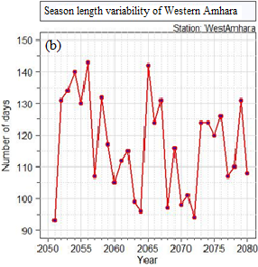
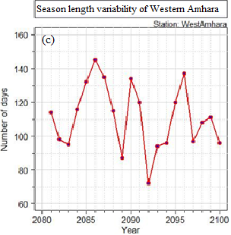
Figure 4. 14. Line graph representation of season length for western Amhara region for the period 2021-2100 under SSP2-4.5.
Figure 4.15 showed the mean length of growing period for Western Amhara region under SSP3-7.0 for the period 2021-2100.According to SSP3-7.0 scenario,the season length will be shorten to 60 days during 2037, 2039, 2043, and 2050.Inaddition for the projected year 2075 and 2086, the most shortest season length will be recorded as 35 days only.
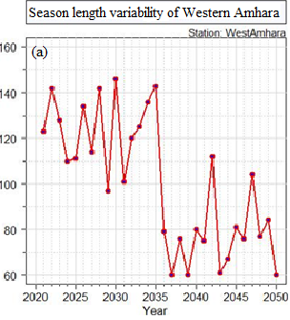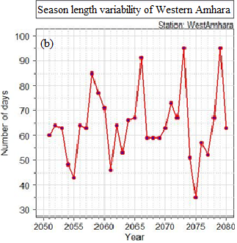
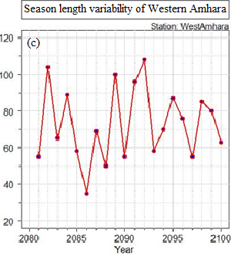
Figure 4. 15. Line graph representation of season length for western Amhara region for the period 2021-2100 under SSP3-7.0.
Figure 4.16 showed, the length of growing season variability of Western Amhara region under SSP5-8.5 scenario for the period 2021-2100.The shortest and longest length of the season projected as 98 (2025) and 146 days (2022) for the period 2021-2050.In addition for the period 2051-2080 under SSP5-8.5,the lengh of the season varies from 80 days (2071) to 145 days (2060).Moreover, the season length during 2081-2100 will ranged from 71 days (2092) to 147 days (2086) under SSP5-8.5 scenario.Generally,for most of the rainy season during projected time period ,the lengh of the season will be between 100 and 140 days under SSP5-8.5.
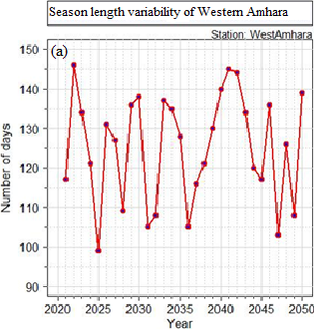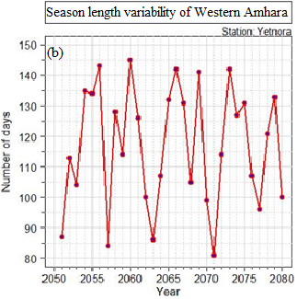
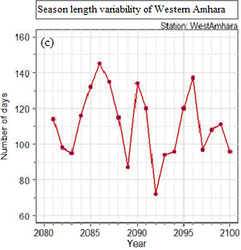
Figure 4. 16. Line graph representation of season length for western Amhara region for the period 2021-2100 under SSP5-8.5.
Table 4.14 showed the Mankendall trend test analysis of mean season length of Western Amhara region for the period 2021-2100 under SSP2-4.5,SSP3-7.0, and SSP5-8.5 scenarios.Th result showed that there will be increasing trend of season length for the period 2021-2050 and 2081-2100 under SSP2-4.5 scenario, during 2051-2080 and 2081-2100 under SSP3-7.0 Scenario, and during 2021-2050 and 2051-2080 under SSP5-8.5 scenario.But the increasing trend of mean season length is not significan at 95 % confidence level (p>0.05).On the other hand,the mean season length of Western Amhara region projected to be decreasing during 2051-2080 under-SSP2-4.5,during 2021 to 2050 under SSP3-7.0,and during 2081 to 2100 under SSP5-8.5 scenario.But,the decreasing trend (Shorten of season length) would significant during 2021-2050 under SSP3-7.0 with Sen’s slope estimator of 2.17 days/year. A study by Hadgu et al.(2015) also reported a decreasing change in LGP in the northern Ethiopia.

Table 4. 14. Season length trend analysis of Western Amhara region for the period 2021-2100 under different SSP.
SSP | Year | MKttest trend analysis
SSP | Year | Z-value | Sen’s slope | S | Var (S) | P-value | Tau
SSP2-4.5 | 2021-2050 | 1.34 | 0.36 | 76 | 3136 | 0.18 | 0.17
SSP2-4.5 | 2051-2080 | -1.05 | -0.40 | -60 | 3133 | 0.29 | -0.14
SSP2-4.5 | 2081-2100 | 0.15 | -0.02 | 8 | 3134 | 0.23 | 0.02
SSP3-7.0 | 2021-2050 | -3.19 | -2.17 | -180 | 3136 | 0.001* | -0.41
SSP3-7.0 | 2051-2080 | 0.43 | 0.12 | 25 | 3121 | 0.67 | 0.06
SSP3-7.0 | 2081-2100 | 0.36 | 0.41 | 12 | 945 | 0.72 | 0.06
SSP5-8.5 | 2021-2050 | 0.18 | 0.09 | 11 | 3136 | 0.86 | 0.03
SSP5-8.5 | 2051-2080 | 1.18 | 0.40 | 67 | 3127 | 0.24 | 0.15
SSP5-8.5 | 2081-2100 | -0.49 | -0.33 | -16 | 948 | 0.63 | -0.08
*Represents significance at 5%.

4.3.4.Analysis of daily rainfall total
Figure 4.17 showed the Box and Whiskers plot representation of mean daily rainfall under SSP2-4.5 during the time period 2021-2100.The result depicted that,the daily mean rainfall projected to be 4mm /day (June),10mm/day (July),11mm/day (August),and 7mm/day (September) for the period 2021-2100. Moreover, for the period 2051-2080,the daily mean rainfall projected to be 4mm/day (June),10.5mm/day (July),11mm/day (August),and 7mm/day (September) under SSP2-4.5.But,during 2081-2100 under SSP2-4.5 the mean daily rainfall projected for July and August months will be diminished to under 10mm/day.A study by Lee et al.(2011), showed that in the 21st century the annual number of rainy days in the Hong Kong is expected to decrease while the daily rainfall intensity will increase.
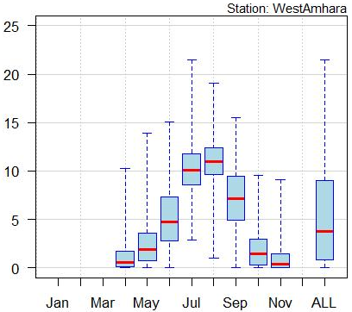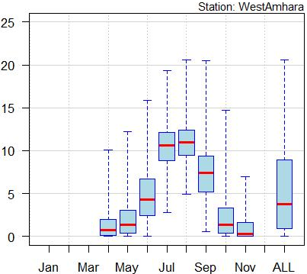
b
a
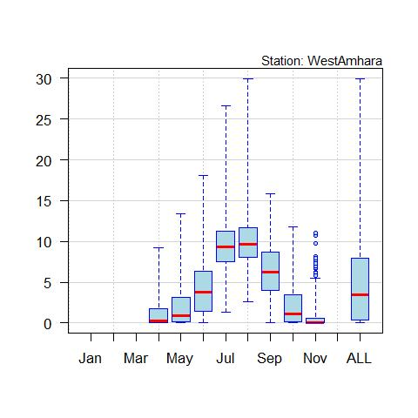
c
Figure 4. 17. Box and whiskers plot representation of daily rainfall for western Amhara region under SSP2-4.5 for the period 2021-2050 (a),2051-2080 (b),and 2081-2100 (c).
Figure 4.18 dpicted the box and Whiskers plot representation of mean daily rainfall for the period 2021-2100 under SSP3-7.0 for Western Amhara region.The result showed that,the projected mean daily rainfall for the period 2021-2100 will be diminished under 10mm/day including July and August months of the season.But,under such scenario,here will be probability for the occurrence of un seasonal rainfall before and after the start of the main rainy season.
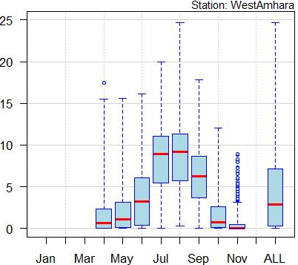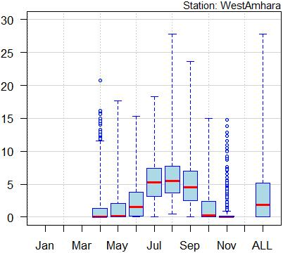
b
a
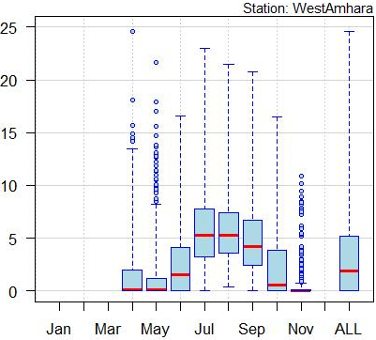
c
Figure 4. 18. Box and whiskers plot representation of daily rainfall for western Amhara region under SSP3-7.0 for the period 2021-2050 (a),2051-2080 (b),and 2081-2100 (c).
Figure 4.19 showed Box and Whiskiers plot representation of mean daily rainfall for the period 2021-2100 under SSP5-8.5.The result depicted that,the projected mean daily rainfall will be higher than 10mm/day during July and August months for time period 2021-2050 and 2051-2080.But the mean daily rainfall of July and August projected to diminish under 10mm/day for the period 2081-2100 under SSP5-8.5 scenario. Overall,the mean daily rainfall will be higher during July and August months of the season and reached extreme during August than July over Western Amhara region for the projected time period and for all considered scenarios.
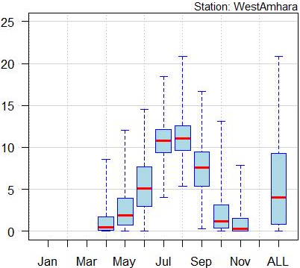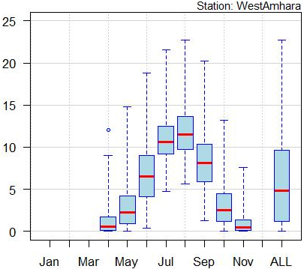
b
a
c
Figure 4.19. Box and whiskers plot representation of daily rainfall for western Amhara region under SSP5-8.5 for the period 2021-2050 (a),2051-2080 (b),and 2081-2100 (c).

4.3.5.Analysis of monthly and seasonal rainfall total
Table 4.15 showed the projected mean monthly and seasonal rainfall of Western Amhara region for the period 2021-2100 under SSP2-4.5,SSP3-7.0,ans SSP5-8.5 scenarios.The result showed that,the mean monthly and seasonal rainfall for the period 2051-2080 projected to be better than the period 2021-2050 and 2081-2100 under SSP2-4.5 scenario.But According to SSP3-7.0 scenario,mean monthly and seasonal rainfall of Western Amhara region expected to be good during 2021-2050 as compared with 2051-2080 and 2081-2100.On the other hand the mean monthly and seasonal rainfall of the main rainy season projected to be better for the period 2051-2080 under SSPP5-8.5 scenario.A study by Tegegn, (2015) for the period 1992-2012 ,also showed the average agreed of GCM models in increasing kiremt seasonal rainfall total by 2030s under RCP 4.5 (Representative Concentration Pathways 4.5) emission scenario.Overall,Western Amhara region projected to acquire better rainfall amount during July and August than June and September months under all considered scenarios and projected time periods.More over,the highest projected seasonal rainfall will be 1036.5mm/year for the period 2051-2080 under SSP2-4.5 scenario.For the period 2081-2100,the seasonal kiremt rainfall expected to decrease as compared with baseline seasonal rainfall under SSP2-4.5, SSP3-7.0, and SSP5-8.5 scenario.In line with my study , a study conducted by Arndt et al.(2011) showed decreasing of Kiremt rainfall by 5-6% by 2080s in Ethiopia.A study by Wasihun et al.(2020) also showed ,the decrease projected kiremt season rainfall amount in West Harerghe,Oromia Ethiopia.Another study by Alaminie et al.(2021) ,found that,there will be slight increasing trend of rainfall over Abay basin under low (SSP1-2.6) to strong (SSP5-8.5) forcing scenarios for the period 2031 to 2100.A study by Ayalew et al.(2012) showed that, the amount of annual rainfall and number of rainy days also decreased in the North Western Ethiopia in the 2080s. A study by Wasihun et al.(2020) showed that,the kiremt rainfall amount will be decreased by about 0.16 mm per year during the study period 2018 to 2047.A study by Bekele, (n.d.) also showed the the expectation of slight decrease in kiremt rainfall for Robe and Sinana stations for the period 2020-2049.
Table 4. 15. mean monthly and seasonal rainfall (mm) analysis of Western Amhara region for the period 2021-2100 and its departure from baseline (1991-2020) under different SSP.
SSP | Year | Mean monthly and seasonal rainfall
SSP | Year | June | July | August | September | Kiremt
SSP2-4.5 | 2021-2050 | 155.0 (-8.6) | 317.6 (15) | 341.6 (50.2) | 212.0 (42.5) | 1022.2(95.4)
 | 2051-2080 | 143.5(-20.1) | 328.0 (25.7) | 342.4 (51) | 222.6 (53.1) | 1036.5(109.7)
 | 2081-2100 | 125.8(-37.8) | 294.1 (-8.2) | 311.7 (20.3) | 191.7 (22.2) | 919.3(-7.5)
SSP3-7.0 | 2021-2050 | 113.4(-50.2) | 261.9(-40.4) | 273.3(-18.1) | 188.1 (18.6) | 832.7(-94.7)
 | 2051-2080 | 78.2 (-85.4) | 172.4(-129.9) | 192.0(-99.4) | 150.3(-19.2) | 588.9(-337.9)
 | 2081-2100 | 78.5 (-85.1) | 177.5(-124.8) | 182.9(-108.5) | 142.8(-26.7) | 578.7(-348.1)
SSP5-8.5 | 2021-2050 | 163.7 (0.1) | 337.2(34.9) | 348.6 (57.2) | 222.2 (52.7) | 1067.7(140.9)
 | 2051-2080 | 201.4 (40.5) | 339.3 (37) | 366.6 (75.2) | 247.4 (77.9) | 1150.7(223.9)
 | 2081-2100 | 125.8(-37.8) | 294.1(-8.2) | 311.7 (20.3) | 191.7 (22.2) | 919.3(-7.5)

Figure 4.20 showed the kiremt rainfall anomalies over western Amhara region for the period 2021-2050 (a),2051-2080 (b),and 2081-2100 (c) under SSP2-4.5 scenario.The rainfall anomalies for the period 2021-2050 showed the absence of inter-seasonal variability of rainfall ,but for projected time period of 2044 the highest negative anomalies (-1.19) will be observed.In addition to this, negative anomalies will be observed for the year 2042 (-0.04).But positive anomalies for the rest years in the considered time period.But for the perojected time period 2051-2080,negative anomalies will be dominated than positive anomalies.Hence ,highest negative and positive anomalies will be observed during 2073 (-1.58) and 2056 (2.28) respectively under SSP2-4.5.Moreover,both negative and positive kiremt rainfall anomaly will be observed for the period 2081-2100. During 2081-2100 ,the highest negative and positive anomalies will be recorded during 2085 (-2.15) and 2087 (1.74) respectively.A study by Wasihun et al.(2020) showed that,over Gelemso and surrounding area there will be expectation of unusual both wet and dry years than the climatological condition of kiremt rainfall between the period 2018 to 2047.

Figure 4. 20. Kiremt rainfall anomaly of West Amhara region for the period 2021-2050 (a),2051-2080 (b),and 2081-2100 (c) under SSP2-4.5.
Figure 4.21 showed kiremt rainfall anoamlly of Western Amhara region for the projected time period from 2021 to 2100 under SSP3-7.0.During the period 2021-2050,the rainfall anomaly projected will be positive from 2021-2035 and negative from 2036 to 2050 (Figure 4.21a).A study by Wasihun et al.(2020) over Gelemso in West Harerghe showed that, the positive kiremt rainfall anomaly from the year 2025 to 2040 ,but negative for the year 2018 to 2023 and 2041-2047.But for the period 2051-2080 (4.21b),both negative and positive rainfall anomaly will be observed according to SSP3-7.0 scenario.During this time period,the highest positive and negative rainfall anomaly projected will be 1.94 (2068) and -3.0 (2075) under SSP3-7.0.In addition for the period 2081-2100 (Figure 4.21c),the projected rainfall anomaly will be negative and positive with almost equal occurrence probability in the considered study time period.Over all highest negative anomaly will be obsereved during 2086 (-2.1) and high positive anomaly during 2092 (2.2) under SSP3-7.0 scenario.A study by Kamruzzaman et al.(2023) noted that,winter precipitation will decrease by 11.12% in the 2045-2075 time period under SSP3-7.0 scenario over Bangladish.

Figure 4. 21. Kiremt rainfall anomaly of West Amhara region for the period 2021-2050 (a),2051-2080 (b),and 2081-2100 (c) under SSP3-7.0.
Figure 4.22 showed the kiremt rainfall anomaly of Western Amhara region for the period 2021-2100 under SSP5-8.5 scenario.During all considered projected time period,under three scenarios,both negative and positive seasonal rainfall anomalies projected to occur.Under SSP5-8.5 for the period 2021-2050,2051-2080,and 2081-2100 the highest negative anomalies projected to be -2.5 (2043),-2.1 (2051),and -2.2 (2085) respectively.On the other hand,the highest positive anomaly will be 2.1 (2049),1.7 (2060),and 1.7 (2096 and 20870) for the period 2021-2050,2051-2080,and 2081-2100 respectively.

Figure 4.22. Kiremt rainfall anomaly of West Amhara region for the period 2021-2050 (a),2051-2080 (b),and 2081-2100 (c) under SSP5-8.5.

CHAPTER 5. CONCLUSIONS AND RECOMMENDATIONS

5.1. Conclusions
This study concerns the characterization of past and future rainfall characterstics of the main rainy season (Kiremt) over Western Amhara region.The onset date,cessation date,and length of growing period of observed rainfall varies from place to place.Western part of the study area acquire early start of rainy season ,late cessation of the rainy season ,and have long season length than the eastern part of the region.The start of the rainy season for observed rainfall (1991-2020) showed non significant decreasing trend (early onset) for most selected stations.The cessation date of Western Amhara showed increasing and significant trend at 95% confidence level with Sen’s slope estimator of 0.35 day/year.But for most areas of Western Amhara region,the mean onset date and cessation date of the rainy season was May and October months respectively.Hence,the mean onset date and cessation date of Western Amhara region for the period 1991-2020 was 138 DOY (17-May) and 297 DOY (23-October) respectively.Due to this,the mean season length of the region was 142 days.The region acquires better rainfall amount during July and August months.The western and central part of the study area recorded better daily,monthly,and seasonal rainfall amount than the rest part of the region.Most areas of Western Amhara recoreded from 850 to 950 mm during the period 1991-2020.In addition,the years 2020,2022,and 2019 was the most wettest years.On the other hand,the years 1995,1997,and 2015 was the driest years.
The future rainfall characterstics of Western Amhara for the main rainy season was determining under the sixth phase coupled model intercomparision project phase 6 (CMIP6) Socio Economic Pathways (SSPs) scenario projection.Performance evaluation result of CMIP6 GCMs showed that,the ensemble mean of EC-Earth3,Ec-Earth3-Veg,MPI-ESM-2 -LR ,and GFDL-ESM4, GFDL-ESM4, EC-Earth3,and Ec-Earth3-Veg,BCC-CSM-2-MR, GFDLESM4,and EC-Earth3 were used for future daily,mothly and seasonal rainfall study respectively under different Shared Socioeconomic Pathways (SSPs),that means SSP2-4.5,SSP3-7.0,and SSP5-8.5 scenarios for the period 2021-2100 after appropriate bias correction.
The mean onset date of Western Amhara region will be late from baseline mean onset date by 10 days,13 days, and 15 days for the period 2021-2050,2051-2080,and 2081-2100 respectively under SSP2-4.5.In addition,the projected mean onset date will be delay from 22 to 48 days under SSP3-7.0 scenario and from 3 to 15 days under SSP5-8.5 scenario.According to SSP3-7.0 scenario,the future start of the rainy season will be late.Regarding to this scenario,radical shift of srart of rainy season will be recorded from May (mostly baseline onset) to June.In the considered projected time period and scenario,the trend of onset date showed both early and late start in different areas of the region.But statistically significant and delay onset date at 95 % confidence level will be recorded for the period 2021-2050 with Sen’s slope estimator of 1.08 day/year.The mean cessation date will be earlier from baseline mean (1991-2020) by 29 days,27 days,and 32 days for the period 2021-2050,2051 2080,and 2081-2100 respectively uder SSP2 4.5.Moreover,the mean cessation date will be earlier by 36 days,52 days and 52 days for the period 2021-2050,2051-2080,and 2081-2100 under SSP3-7.0 respectively.In the case of SSP5-8.5,the mean cessation date of the rainy season will be earlier by 28 days,18 days,and 33 days for the period 2021-2050,2051-2080, and 2081-2100 respectively.In few considered time period,cessation date will late,but significant and decreasing cessation date at 95% confidence level will be observed for the period 2021-2050 under SSP3-7.0 with Sen’s slope estimator of 0.54 day/year. As aresult of late onset and early cessation date expectation over Western Amhara region,the season length expeted to be shorten by 23 to 31 days under SSP2-4.5 Scenario,41 to 78 days under SSP3-7.0 scennario,and 12 to 31 days under SSP5-8.5 scenario.But significant and short season length will be record for the period 2021-2050 under SSP3-7.0 with Sen’s slope estimator of 2.17 days/year.The months of July and Agust will have high contribution for kiremt rainfall total like their contribution for the past.For projected time period except for SSP5-8.5 during 2051-2080,the mean rainfall total of June decrease as compared with baseline.But the overall mean seasonal rainfall total of the main rainy season will incrase as compared with baseline under SSP2-4.5 and SSP5-8.5,but not according to SSP3-7.0 scnario.According to SSP3-7.0,main rainy seasons from 2036 to 2050 will be drier season.

5.2. Recommendations
Due to the expectation of late onset date,early cessation date ,and short season length of the main rainy season over the study area,design possible adaptation and mitigation strategies effectively among farmers,researchers,decision makers ,and others is crucial.In addition attention should be paid to new and emerging water conservation and supplement irrigation system should be implemented to overcome failure of agricultural production during eratic and dry spell condition sine the livelihood of the study region mainly agriculture based.
Eventhouth,the future season of the main rainy season expected to be shorten,the amount of rainfall obtained with in the season will increase according to some scenarios.Hence,ground and underground water harvesting should be practiced (accomplished effectively).In addition improved seed selection for short season length should be practiced effectively.Moreover, the result of any model depend on the quality of input data.Therefore,to increase the reliability of future rainfall study more reliable,complete, suitable for design adaptation strategies,and specific for decision making process,it is recommended to conduct similar studies with large number of meteorological station and CMIP6 GCMs models over Agroecological zones of Western Amhara.

REFERENCES
Adejuwon, J., Balogun, E., & Adejuwon, S. (1990). On the annual and seasonal patterns of rainfall fluctuations in sub-Saharan West Africa. International Journal of Climatology, 10(8), 839–848.
Ageet, S., Fink, A. H., Maranan, M., Diem, J. E., Hartter, J., Ssali, A. L., & Ayabagabo, P. (2022). Validation of Satellite Rainfall Estimates over Equatorial East Africa. JOURNAL OF HYDROMETEOROLOGY, 23.
Alaminie, A. A., Tilahun, S. A., Legesse, S. A., Zimale, F. A., Tarkegn, G. B., & Jury, M. R. (2021). Evaluation of Past and Future Climate Trends under CMIP6 Scenarios for the UBNB (Abay), Ethiopia. Water, 13(15), 2110. https://doi.org/10.3390/w13152110
Alemayehu, A., & Bewket, W. (2016). Vulnerability of smallholder farmers’ to climate change and variability in the central highlands of Ethiopia. Ethiopian Journal of the Social Sciences and Humanities, 12(2), 1–24.
Alemu, M. M., & Bawoke, G. T. (2020). Analysis of spatial variability and temporal trends of rainfall in Amhara region, Ethiopia. Journal of Water and Climate Change, 11(4), 1505–1520. https://doi.org/10.2166/wcc.2019.084
Almazroui, M., Saeed, F., Saeed, S., Nazrul Islam, M., Ismail, M., Klutse, N. A. B., & Siddiqui, M. H. (2020). Projected change in temperature and precipitation over Africa from CMIP6. Earth Systems and Environment, 4, 455–475.
Amekudzi, L. K., Yamba, E. I., Preko, K., Asare, E. O., Aryee, J., Baidu, M., & Codjoe, S. N. (2015). Variabilities in rainfall onset, cessation and length of rainy season for the various agro-ecological zones of Ghana. Climate, 3(2), 416–434.
Aniley, E., Gashaw, T., Abraham, T., Demessie, S. F., Bayabil, H. K., Worqlul, A. W., van Oel, P. R., Dile, Y. T., Chukalla, A. D., Haileslassie, A., & Wubaye, G. B. (2023). Evaluating the performances of gridded satellite/reanalysis products in representing the rainfall climatology of Ethiopia. Geocarto International, 38(1), 2278329. https://doi.org/10.1080/10106049.2023.2278329
Arndt, C., Robinson, S., & Willenbockel, D. (2011). Ethiopia’s growth prospects in a changing climate: A stochastic general equilibrium approach. Global Environmental Change, 21(2), 701–710.
Arrieta-Castro, M., Donado-Rodríguez, A., Acuña, G. J., Canales, F. A., Teegavarapu, R. S. V., & Kaźmierczak, B. (2020). Analysis of Streamflow Variability and Trends in the Meta River, Colombia. Water, 12(5), 1451. https://doi.org/10.3390/w12051451
Asfaw, A., Simane, B., Hassen, A., & Bantider, A. (2018). Variability and time series trend analysis of rainfall and temperature in northcentral Ethiopia: A case study in Woleka sub-basin. Weather and Climate Extremes, 19, 29–41.
Ayalew, D., Tesfaye, K., Mamo, G., Yitaferu, B., & Bayu, W. (2012a). Outlook of future climate in northwestern Ethiopia. Agricultural Sciences, 03(04), 608–624. https://doi.org/10.4236/as.2012.34074
Ayalew, D., Tesfaye, K., Mamo, G., Yitaferu, B., & Bayu, W. (2012b). Variability of rainfall and its current trend in Amhara region, Ethiopia. African Journal of Agricultural Research, 7(10), 1475–1486.
Ayehu, G. T., Tadesse, T., Gessesse, B., & Dinku, T. (2018). Validation of new satellite rainfall products over the Upper Blue Nile Basin, Ethiopia. Atmospheric Measurement Techniques, 11(4), 1921–1936. https://doi.org/10.5194/amt-11-1921-2018
Bazezew, A. (2012). Determining Food Security Indicators at Household Level in Drought Prone Areas of the Amhara Region of Ethiopia: The Case of Lay Gaint District, Amhara Regional State. Ethiopian Journal of Environmental Studies and Management, 5(4), 422–434.
Bekele, F. (n.d.). CHARACTERIZING CURRENT AND FUTURE RAINFALL VARIABILITY AND ITS EFFECT ON WHEAT AND BARLEY PRODUCTION IN SINANA DISTRICT, SOUTH EASTERN ETHIOPIA.
Bekele, M., Bezabih, M., Elias, H., Fisker, P., Gebrehiwot, T., Kuma, T., Mekasha, T., Mekonnen, A., Tarp, F., & Teklewold, H. (2020). Development Economics Research Group.
Belay, A. S., Fenta, A. A., Yenehun, A., Nigate, F., Tilahun, S. A., Moges, M. M., Dessie, M., Adgo, E., Nyssen, J., Chen, M., Griensven, A. V., & Walraevens, K. (2019). Evaluation and Application of Multi-Source Satellite Rainfall Product CHIRPS to Assess Spatio-Temporal Rainfall Variability on Data-Sparse Western Margins of Ethiopian Highlands. Remote Sensing, 11(22), 2688. https://doi.org/10.3390/rs11222688
Belay Zerga & Getaneh Gebeyehu. (2016). Climate Change in Ethiopia Variability, Impact, Mitigation, and Adaptation. https://doi.org/10.13140/RG.2.2.16782.46408
Belazreg, N. E. H., Hasbaia, M., Şen, Z., & Ferhati, A. (2023). Historical evaluation and future projections of monthly precipitation and temperature under CMIP6 GCMs, case of Hodna basin (central Algeria). Arabian Journal of Geosciences, 16(1), 39.
Benoit, P. (1977). The start of the growing season in Northern Nigeria. Agricultural Meteorology, 18(2), 91–99.
Berhanu, D., Alamirew, T., Taye, M. T., Tibebe, D., Gebrehiwot, S., & Zeleke, G. (2023). Evaluation of CMIP6 models in reproducing observed rainfall over Ethiopia. Journal of Water and Climate Change, 14(8), 2583–2605. https://doi.org/10.2166/wcc.2023.502
Berhe, A. G., Misgna, S. H., Abraha, G. G.-S., & Abraha, A. Z. (2023). Variability and trend analysis of temperatures, rainfall, and characteristics of crop-growing season in the eastern zone of Tigray region, northern Ethiopia. Theoretical and Applied Climatology, 152(1–2), 25–43. https://doi.org/10.1007/s00704-023-04364-w
Berihun, M. L., Tsunekawa, A., Haregeweyn, N., Tsubo, M., Yasuda, H., Fenta, A. A., Dile, Y. T., Bayabil, H. K., & Tilahun, S. A. (2023). Examining the past 120 years’ climate dynamics of Ethiopia. Theoretical and Applied Climatology, 154(1–2), 535–566. https://doi.org/10.1007/s00704-023-04572-4
Bewket, W. (n.d.). Rainfall variability and crop production in Ethiopia Case study in the Amhara region.
Camberlin, P., & Philippon, N. (2002). The East African March–May rainy season: Associated atmospheric dynamics and predictability over the 1968–97 period. Journal of Climate, 15(9), 1002–1019.
Cochemé, J., & Franquin, P. (1967). An agroclimatology survey of a semiarid area in Africa south of the Sahara. (No Title).
D. N. Moriasi, J. G. Arnold, M. W. Van Liew, R. L. Bingner, R. D. Harmel, & T. L. Veith. (2007). Model Evaluation Guidelines for Systematic Quantification of Accuracy in Watershed Simulations. Transactions of the ASABE, 50(3), 885–900. https://doi.org/10.13031/2013.23153
Dangol, S., Talchabhadel, R., & Pandey, V. P. (2022). Performance evaluation and bias correction of gridded precipitation products over Arun River Basin in Nepal for hydrological applications. Theoretical and Applied Climatology, 148(3–4), 1353–1372. https://doi.org/10.1007/s00704-022-04001-y
De Luis, M., Gonzalez-Hidalgo, J. C., Brunetti, M., & Longares, L. A. (2011). Precipitation concentration changes in Spain 1946–2005. Natural Hazards and Earth System Sciences, 11(5), 1259–1265.
Degefu, M. A., & Bewket, W. (2023). Drought monitoring performance of global precipitation products in three wet seasons in Ethiopia: Part I—Quasi-objective examination. Meteorological Applications, 30(4), e2143.
Degefu, M. A., Rowell, D. P., & Bewket, W. (2017). Teleconnections between Ethiopian rainfall variability and global SSTs: Observations and methods for model evaluation. Meteorology and Atmospheric Physics, 129(2), 173–186. https://doi.org/10.1007/s00703-016-0466-9
Department of Meteorology, University of Nairobi, Mugo, R. M., Ininda, J., Department of Meteorology, University of Nairobi, & Okoola, R. (2016). Inter Annual Variability of Onset and Cessation of the Long Rains in Kenya. Journal of Meteorology and Related Sciences, 9, 30–47. https://doi.org/10.20987/jmrs.3.05.2016
Dinku, T., Faniriantsoa, R., Islam, S., Nsengiyumva, G., & Grossi, A. (2022). The climate data tool: Enhancing climate services across Africa. Frontiers in Climate, 3, 787519.
Dinku, T., Funk, C., Peterson, P., Maidment, R., Tadesse, T., Gadain, H., & Ceccato, P. (2018). Validation of the CHIRPS satellite rainfall estimates over eastern Africa. Quarterly Journal of the Royal Meteorological Society, 144(S1), 292–312. https://doi.org/10.1002/qj.3244
Eggen, M., Ozdogan, M., Zaitchik, B., Ademe, D., Foltz, J., & Simane, B. (2019). Vulnerability of sorghum production to extreme, sub-seasonal weather under climate change. Environmental Research Letters, 14(4), 045005.
Evangelista, P., Young, N., & Burnett, J. (2013). How will climate change spatially affect agriculture production in Ethiopia? Case studies of important cereal crops. Climatic Change, 119(3), 855–873.
Gashaw, T., Worqlul, A. W., Taye, M. T., Lakew, H. B., Seid, A., Ayele, G., & Haileslassie, A. (2024). Performance evaluations of CMIP6 model simulations and future projections of rainfall and temperature in the Bale Eco-Region, Southern Ethiopia. Theoretical and Applied Climatology. https://doi.org/10.1007/s00704-024-04904-y
Gashure, S. (2024). Adaptation strategies of smallholder farmers to climate variability and change in Konso, Ethiopia. Scientific Reports, 14(1), 19203.
Gebrechorkos, S., Taye, M. T., Birhanu, B., Solomon, D., & Demissie, T. (2023). Future changes in climate and hydroclimate extremes in East Africa. Earth’s Future, 11(2), e2022EF003011.
Gebremichael, A., Quraishi, S., & Mamo, G. (2014). Analysis of seasonal rainfall variability for agricultural water resource management in southern region, Ethiopia. Journal of Natural Sciences Research, 4(11), 56–79.
Gezie, M. (2019). Farmer’s response to climate change and variability in Ethiopia: A review. Cogent Food & Agriculture, 5(1), 1613770.
Gleckler, P. J., Taylor, K. E., & Doutriaux, C. (2008). Performance metrics for climate models. Journal of Geophysical Research: Atmospheres, 113(D6).
Gupta, H. V., Sorooshian, S., & Yapo, P. O. (1999). Status of automatic calibration for hydrologic models: Comparison with multilevel expert calibration. Journal of Hydrologic Engineering, 4(2), 135–143.
Hadgu, G., Tesfaye, K., & Mamo, G. (2015). Analysis of climate change in Northern Ethiopia: Implications for agricultural production. Theoretical and Applied Climatology, 121, 733–747.
Hamed, K. H., & Ramachandra Rao, A. (1998). A modified Mann-Kendall trend test for autocorrelated data. Journal of Hydrology, 204(1–4), 182–196. https://doi.org/10.1016/S0022-1694(97)00125-X
Hussein, A. (2024). Climate smart agriculture strategies for enhanced agricultural resilience and food security under a changing climate in Ethiopia. Sustainable Environment, 10(1), 2345433.
Imad-eldin, A., El-Hag, F. A., Abdelkarim, A. M., & Abdalla, A. K. (2015). Changing Climate and Farming Productivity in the Drylands of Eastern Sudan. Sudan Academy of Sciences Journal Special Issue (Climate Change), 56.
Iqbal, Z., Shahid, S., Ahmed, K., Ismail, T., Ziarh, G. F., Chung, E.-S., & Wang, X. (2021). Evaluation of CMIP6 GCM rainfall in mainland Southeast Asia. Atmospheric Research, 254, 105525.
Jones, P. G., & Thornton, P. K. (2013). Generating downscaled weather data from a suite of climate models for agricultural modelling applications. Agricultural Systems, 114, 1–5.
Kamruzzaman, M., Wahid, S., Shahid, S., Alam, E., Mainuddin, M., Islam, H. M. T., Cho, J., Rahman, M. M., Chandra Biswas, J., & Thorp, K. R. (2023). Predicted changes in future precipitation and air temperature across Bangladesh using CMIP6 GCMs. Heliyon, 9(5), e16274. https://doi.org/10.1016/j.heliyon.2023.e16274
Kamworapan, S., & Surussavadee, C. (2019). Evaluation of CMIP5 global climate models for simulating climatological temperature and precipitation for Southeast Asia. Advances in Meteorology, 2019, 1–18.
Kassahun, B. (1987). Weather systems over Ethiopia. Proc. First Tech. Conf. on Meteorological Research in Eastern and Southern Africa, Nairobi, Kenya, UCAR, 53–57.
Kawai, H., Yukimoto, S., Koshiro, T., Oshima, N., Tanaka, T., Yoshimura, H., & Nagasawa, R. (2019). Significant improvement of cloud representation in the global climate model MRI-ESM2. Geoscientific Model Development, 12(7), 2875–2897.
Kwawuvi, D., Mama, D., Agodzo, S. K., Hartmann, A., Larbi, I., Bessah, E., Abraham, T., Dotse, S.-Q., & Limantol, A. M. (2022). An investigation into the future changes in rainfall onset, cessation and length of rainy season in the Oti River Basin, West Africa. Modeling Earth Systems and Environment, 8(4), 5077–5095. https://doi.org/10.1007/s40808-022-01410-w
Le Barbé, L., Lebel, T., & Tapsoba, D. (2002). Rainfall variability in West Africa during the years 1950–90. Journal of Climate, 15(2), 187–202.
Lebeza, T. M., Gashaw, T., Bayabil, H. K., van Oel, P. R., Worqlul, A. W., Dile, Y. T., & Chukalla, A. D. (2024). Performance of specific CMIP6 GCMs for simulating the historical rainfall and temperature climatology of Lake Tana sub-basin, Ethiopia. Scientific African, e02387.
Lee, T., Chan, K., Chan, H., & Kok, M. (2011). Projections of extreme rainfall in Hong Kong in the 21st century. Acta Meteorologica Sinica, 25(6), 691–709. https://doi.org/10.1007/s13351-011-0601-y
Lotfie, A. Y., Abdelrahman, A. K., Faisal, M. E.-H., Ahmed, M. A., Hussain, S. A., Abdelhadi, A. W., Yasunori, K., & and, I. A. A.-B. (2018). Length of the growing season for dry rainfed farming under Monsoon climate in Gedarif, Sudan. African Journal of Agricultural Research, 13(42), 2311–2323. https://doi.org/10.5897/AJAR2018.13449
Lupi Edao, A., Kibert, K., & Mamo, G. (2018). Analysis of Start, End and Length of the Growing Season and Number of Rainy Days in Semi-Arid Central Refit Valley of Oromia State, Ethiopia. Advances in Crop Science and Technology, 06(04). https://doi.org/10.4172/2329-8863.1000386
Macro, O. (2006). Central Statistical Agency Addis Ababa, Ethiopia. Central Statistical Agency Addis Ababa, Ethiopia.
Masson-Delmotte, V., Zhai, P., Pirani, A., Connors, S. L., Péan, C., Berger, S., Caud, N., Chen, Y., Goldfarb, L., Gomis, M., & others. (2023). IPC 2021. Summary for Policymakers. Climate Change 2021: The Physical Science Basis. Contribution of Working Group I to the Sixth Assessment Report of the Intergovernmental Panel on Climate Change.
Mensah, C., Amekudzi, L. K., Klutse, N. A. B., Aryee, J. N. A., & Asare, K. (2016). Comparison of Rainy Season Onset, Cessation and Duration for Ghana from RegCM4 and GMet Datasets. Atmospheric and Climate Sciences, 06(02), 300–309. https://doi.org/10.4236/acs.2016.62025
Mohamed, M. A., El Afandi, G. S., & El-Mahdy, M. E.-S. (2022). Impact of climate change on rainfall variability in the Blue Nile basin. Alexandria Engineering Journal, 61(4), 3265–3275.
Mohammed, J. A. (2024). Performance evaluation and ranking of CMIP6 global climate models over upper blue nile (abbay) basin of Ethiopia. Natural Hazards Research, S2666592124000532. https://doi.org/10.1016/j.nhres.2024.06.004
Morales-Acuña, E., Linero-Cueto, J. R., & Canales, F. A. (2021). Assessment of Precipitation Variability and Trends Based on Satellite Estimations for a Heterogeneous Colombian Region. Hydrology, 8(3), 128. https://doi.org/10.3390/hydrology8030128
Mugalavai, E. M., Kipkorir, E. C., Raes, D., & Rao, M. S. (2008). Analysis of rainfall onset, cessation and length of growing season for western Kenya. Agricultural and Forest Meteorology, 148(6–7), 1123–1135. https://doi.org/10.1016/j.agrformet.2008.02.013
Nashwan, M. S., Shahid, S., & Wang, X. (2019). Assessment of Satellite-Based Precipitation Measurement Products over the Hot Desert Climate of Egypt. Remote Sensing, 11(5), 555. https://doi.org/10.3390/rs11050555
Nega, M. (2022). Climate Change Adaptation Strategies in Ethiopia: Major Barriers and Impacts. ST. MARY’S UNIVERSITY.
NMSA. (1996). Climatic and agroclimatic resources of Ethiopia. Natl. Meteorol. Serv. Agency of Ethiopia, Meteorol. Res. Rep. Ser., 1(1), 1–137.
Odekunle, T. (2006). Determining rainy season onset and retreat over Nigeria from precipitation amount and number of rainy days. Theoretical and Applied Climatology, 83, 193–201.
Oguntunde, P. G., Lischeid, G., Abiodun, B. J., & Dietrich, O. (2014). Analysis of spatial and temporal patterns in onset, cessation and length of growing season in Nigeria. Agricultural and Forest Meteorology, 194, 77–87. https://doi.org/10.1016/j.agrformet.2014.03.017
Olaniran, O. (1983). The onset of the rains and the start of the growing season in Nigeria. Nigerian Geographical Journal, 26(1), 81–88.
Oliver, J. E. (1980). MONTHLY PRECIPITATION DISTRIBUTION: A COMPARATIVE INDEX. The Professional Geographer, 32(3), 300–309. https://doi.org/10.1111/j.0033-0124.1980.00300.x
Omay, P. O., Muthama, N. J., Oludhe, C., Kinama, J. M., Artan, G., & Atheru, Z. (2023). Evaluation of CMIP6 Historical Simulations over IGAD region of Eastern Africa. https://doi.org/10.21203/rs.3.rs-2747422/v1
Omotosho, J. (2002). Synoptic meteorology: Pathway to seasonal rainfall prediction for sustainable agriculture and effective water resources management in West Africa but Nigeria in particular. Journal of the Nigerian Meteorological Society, 3(2), 82–88.
Owusu, K., Waylen, P., & others. (2009). Trends in spatio-temporal variability in annual rainfall in Ghana (1951-2000). Weather, 64(5), 115.
Raman, C. & others. (1974). Analysis of commencement of Monsoon rains over Maharashtra State for agricultural planning.
Rathnayake, U. (2019). Comparison of Statistical Methods to Graphical Methods in Rainfall Trend Analysis: Case Studies from Tropical Catchments. Advances in Meteorology, 2019, 1–10. https://doi.org/10.1155/2019/8603586
Salinger, L., & Stryker, D. (2001). Comparing and evaluating poverty reduction approaches: USAID and the evolving poverty reduction paradigm. Associates for International Resources and Development, Cambridge, MA.
Segele, Z. T., Lamb, P. J., & Leslie, L. M. (2009). Large-scale atmospheric circulation and global sea surface temperature associations with Horn of Africa June-September rainfall. International Journal of Climatology, 29(8), 1075.
Shiru, M. S., & Chung, E.-S. (2021). Performance evaluation of CMIP6 global climate models for selecting models for climate projection over Nigeria. Theoretical and Applied Climatology, 146(1–2), 599–615. https://doi.org/10.1007/s00704-021-03746-2
Sifer, K., Yemenu, F., Kebede, A., & Quarshi, S. (2016). ANALYSIS OF RAIN FALL ONSET AND RECESSION FOR DECISION MAKING IN RAINFALL WATER MANAGEMENT IN THE WEST HARAREGAE ZONE, ETHIOPIA. 5(2).
Silva, A. T. (2017). Introduction to Nonstationary Analysis and Modeling of Hydrologic Variables. In M. Naghettini (Ed.), Fundamentals of Statistical Hydrology (pp. 537–577). Springer International Publishing. https://doi.org/10.1007/978-3-319-43561-9_12
Solomon, S., Qin, D., Manning, M., Chen, Z., Marquis, M., Averyt, K., Tignor, M., Miller, H. L., & others. (2007). IPCC, 2007: Climate change 2007: The physical science basis. Contribution of Working Group I to the fourth assessment report of the Intergovernmental Panel on Climate Change. SD Solomon (Ed.).
Stern, R., Rijks, D., Dale, I., & Knock, J. (2006). INSTAT climatic guide. Statistical Services Centre, The University of Reading, UK.
Tadese, M. T., Kumar, L., & Koech, R. (2020). Climate change projections in the Awash River basin of Ethiopia using global and regional climate models. International Journal of Climatology, 40(8), 3649–3666.
Tadese, M. T., Kumar, L., Koech, R., & Zemadim, B. (2019). Hydro-Climatic Variability: A Characterisation and Trend Study of the Awash River Basin, Ethiopia. Hydrology, 6(2), 35. https://doi.org/10.3390/hydrology6020035
Taye, M., Zewdu, F., & Ayalew, D. (2013). Characterizing the climate system of Western Amhara, Ethiopia: A GIS approach. American Journal of Research Communication, 1(10), 319–355.
Tegegn, M. G. (2015). Analysis of Past and Future Intra-Seasonal Rainfall Variability and its Implications for Crop Production in the North Eastern Amhara Region, Ethiopia.
Thornton, P. K., Jones, P. G., Alagarswamy, G., & Andresen, J. (2009). Spatial variation of crop yield response to climate change in East Africa. Global Environmental Change, 19(1), 54–65.
Wasihun, G. F., Mengistu, M., & Lisanework, N. (n.d.). CHARACTERIZATION OF PAST AND FUTURE CLIMATE VARIABILITY OF HABRO DISTRICT, WEST HARERGHE ZONE, OROMIA, ETHIOPIA. 7.
Worku, G., Teferi, E., Bantider, A., & Dile, Y. T. (2020). Statistical bias correction of regional climate model simulations for climate change projection in the Jemma sub-basin, upper Blue Nile Basin of Ethiopia. Theoretical and Applied Climatology, 139, 1569–1588.
Zeleke, A., Tesfaye, K., Tadesse, T., Alem, T., Ademe, D., & Adgo, E. (2023). Spatiotemporal analysis of rainfall and temperature variability and trends for climate resilient maize farming system in major agroecology zones of northwest Ethiopia. International Journal of Agricultural Sustainability, 21(1), 2255450. https://doi.org/10.1080/14735903.2023.2255450

APPENDIX
LIST OF APPENDIX TABLE
Appendix Table 1. Sample meteorological station for the study
No | Station name | Latitude | Longitude | Elevation (meter) | Daily Missing rainfall (%)
1 | Chagini | 10.95 | 36.5 | 1614 | 0.2
2 | Adet | 11.2681 | 37.48692 | 2179 | 1.8
3 | Ayehu | 10.66 | 36.79 | 1771 | 2.3
4 | Aykel | 12.48 | 37.03 | 2254 | 1.2
5 | Bahir Dar | 11.58972 | 37.3875 | 1800 | 0.2
6 | Dangla | 11.25278 | 36.8375 | 2116 | 0.6
7 | Debark | 13.26 | 37.85 | 2836 | 1.2
8 | Debre Markos | 10.33 | 37.75 | 2446 | 0.2
9 | Debre Tabor | 11.8666 | 37.9954 | 2613 | 0.7
10 | Debre Work | 10.6605 | 38.165 | 2508 | 0.6
11 | Gondar | 12.50556 | 37.40833 | 1973 | 0.6
12 | Layber | 10.58783 | 37.18497 | 1707 | 3.9
13 | Metema | 12.76 | 36.417 | 790 | 7.2
14 | Motta | 11.07722 | 37.8875 | 2417 | 1.7
15 | Nefasmewcha | 11.81 | 38.36 | 3098 | 12.1
16 | Sanja | 12.89 | 37.29 | 2100 | 7.1
17 | Shahura | 12.09 | 36.82 | 2205 | 0.1
18 | simada | 11.41 | 38.24 | 2400 | 1.1
19 | Yetnora | 10.14 | 38.06 | 2424 | 1.7
20 | Quara | 12.229 | 35.886 | 648 | 13.0
Appendix Table 2. Conversion of date-month to DOY (day-of-the year) format.
Date-Month | DOY | Date-Month | DOY | Date-Month | DOY | Date-Month | DOY
1-Jan | 1 | 16-Feb | 47 | 2-Apr | 93 | 18-May | 139
2-Jan | 2 | 17-Feb | 48 | 3-Apr | 94 | 19-May | 140
3-Jan | 3 | 18-Feb | 49 | 4-Apr | 95 | 20-May | 141
4-Jan | 4 | 19-Feb | 50 | 5-Apr | 96 | 21-May | 142
5-Jan | 5 | 20-Feb | 51 | 6-Apr | 97 | 22-May | 143
6-Jan | 6 | 21-Feb | 52 | 7-Apr | 98 | 23-May | 144
7-Jan | 7 | 22-Feb | 53 | 8-Apr | 99 | 24-May | 145
8-Jan | 8 | 23-Feb | 54 | 9-Apr | 100 | 25-May | 146
9-Jan | 9 | 24-Feb | 55 | 10-Apr | 101 | 26-May | 147
10-Jan | 10 | 25-Feb | 56 | 11-Apr | 102 | 27-May | 148
11-Jan | 11 | 26-Feb | 57 | 12-Apr | 103 | 28-May | 149
12-Jan | 12 | 27-Feb | 58 | 13-Apr | 104 | 29-May | 150
13-Jan | 13 | 28-Feb | 59 | 14-Apr | 105 | 30-May | 151
14-Jan | 14 | 29-Feb | 60 | 15-Apr | 106 | 31-May | 152
15-Jan | 15 | 1-Mar | 61 | 16-Apr | 107 | 1-Jun | 153
16-Jan | 16 | 2-Mar | 62 | 17-Apr | 108 | 2-Jun | 154
17-Jan | 17 | 3-Mar | 63 | 18-Apr | 109 | 3-Jun | 155
18-Jan | 18 | 4-Mar | 64 | 19-Apr | 110 | 4-Jun | 156
19-Jan | 19 | 5-Mar | 65 | 20-Apr | 111 | 5-Jun | 157
20-Jan | 20 | 6-Mar | 66 | 21-Apr | 112 | 6-Jun | 158
21-Jan | 21 | 7-Mar | 67 | 22-Apr | 113 | 7-Jun | 159
22-Jan | 22 | 8-Mar | 68 | 23-Apr | 114 | 8-Jun | 160
23-Jan | 23 | 9-Mar | 69 | 24-Apr | 115 | 9-Jun | 161
24-Jan | 24 | 10-Mar | 70 | 25-Apr | 116 | 10-Jun | 162
25-Jan | 25 | 11-Mar | 71 | 26-Apr | 117 | 11-Jun | 163
26-Jan | 26 | 12-Mar | 72 | 27-Apr | 118 | 12-Jun | 164
27-Jan | 27 | 13-Mar | 73 | 28-Apr | 119 | 13-Jun | 165
28-Jan | 28 | 14-Mar | 74 | 29-Apr | 120 | 14-Jun | 166
29-Jan | 29 | 15-Mar | 75 | 30-Apr | 121 | 15-Jun | 167
30-Jan | 30 | 16-Mar | 76 | 1-May | 122 | 16-Jun | 168
31-Jan | 31 | 17-Mar | 77 | 2-May | 123 | 17-Jun | 169
1-Feb | 32 | 18-Mar | 78 | 3-May | 124 | 18-Jun | 170
2-Feb | 33 | 19-Mar | 79 | 4-May | 125 | 19-Jun | 171
3-Feb | 34 | 20-Mar | 80 | 5-May | 126 | 20-Jun | 172
4-Feb | 35 | 21-Mar | 81 | 6-May | 127 | 21-Jun | 173
5-Feb | 36 | 22-Mar | 82 | 7-May | 128 | 22-Jun | 174
6-Feb | 37 | 23-Mar | 83 | 8-May | 129 | 23-Jun | 175
7-Feb | 38 | 24-Mar | 84 | 9-May | 130 | 24-Jun | 176
8-Feb | 39 | 25-Mar | 85 | 10-May | 131 | 25-Jun | 177
9-Feb | 40 | 26-Mar | 86 | 11-May | 132 | 26-Jun | 178
10-Feb | 41 | 27-Mar | 87 | 12-May | 133 | 27-Jun | 179
11-Feb | 42 | 28-Mar | 88 | 13-May | 134 | 28-Jun | 180
12-Feb | 43 | 29-Mar | 89 | 14-May | 135 | 29-Jun | 181
13-Feb | 44 | 30-Mar | 90 | 15-May | 136 | 30-Jun | 182
14-Feb | 45 | 31-Mar | 91 | 16-May | 137 | 1-Jul | 183
15-Feb | 46 | 1-Apr | 92 | 17-May | 138 | 2-Jul | 184
3-Jul | 185 | 18-Aug | 231 | 3-Oct | 277 | 18-Nov | 323
4-Jul | 186 | 19-Aug | 232 | 4-Oct | 278 | 19-Nov | 324
5-Jul | 187 | 20-Aug | 233 | 5-Oct | 279 | 20-Nov | 325
6-Jul | 188 | 21-Aug | 234 | 6-Oct | 280 | 21-Nov | 326
7-Jul | 189 | 22-Aug | 235 | 7-Oct | 281 | 22-Nov | 327
8-Jul | 190 | 23-Aug | 236 | 8-Oct | 282 | 23-Nov | 328
9-Jul | 191 | 24-Aug | 237 | 9-Oct | 283 | 24-Nov | 329
10-Jul | 192 | 25-Aug | 238 | 10-Oct | 284 | 25-Nov | 330
11-Jul | 193 | 26-Aug | 239 | 11-Oct | 285 | 26-Nov | 331
12-Jul | 194 | 27-Aug | 240 | 12-Oct | 286 | 27-Nov | 332
13-Jul | 195 | 28-Aug | 241 | 13-Oct | 287 | 28-Nov | 333
14-Jul | 196 | 29-Aug | 242 | 14-Oct | 288 | 29-Nov | 334
15-Jul | 197 | 30-Aug | 243 | 15-Oct | 289 | 30-Nov | 335
16-Jul | 198 | 31-Aug | 244 | 16-Oct | 290 | 1-Dec | 336
17-Jul | 199 | 1-Sep | 245 | 17-Oct | 291 | 2-Dec | 337
18-Jul | 200 | 2-Sep | 246 | 18-Oct | 292 | 3-Dec | 338
19-Jul | 201 | 3-Sep | 247 | 19-Oct | 293 | 4-Dec | 339
20-Jul | 202 | 4-Sep | 248 | 20-Oct | 294 | 5-Dec | 340
21-Jul | 203 | 5-Sep | 249 | 21-Oct | 295 | 6-Dec | 341
22-Jul | 204 | 6-Sep | 250 | 22-Oct | 296 | 7-Dec | 342
23-Jul | 205 | 7-Sep | 251 | 23-Oct | 297 | 8-Dec | 343
24-Jul | 206 | 8-Sep | 252 | 24-Oct | 298 | 9-Dec | 344
25-Jul | 207 | 9-Sep | 253 | 25-Oct | 299 | 10-Dec | 345
26-Jul | 208 | 10-Sep | 254 | 26-Oct | 300 | 11-Dec | 346
27-Jul | 209 | 11-Sep | 255 | 27-Oct | 301 | 12-Dec | 347
28-Jul | 210 | 12-Sep | 256 | 28-Oct | 302 | 13-Dec | 348
29-Jul | 211 | 13-Sep | 257 | 29-Oct | 303 | 14-Dec | 349
30-Jul | 212 | 14-Sep | 258 | 30-Oct | 304 | 15-Dec | 350
31-Jul | 213 | 15-Sep | 259 | 31-Oct | 305 | 16-Dec | 351
1-Aug | 214 | 16-Sep | 260 | 1-Nov | 306 | 17-Dec | 352
2-Aug | 215 | 17-Sep | 261 | 2-Nov | 307 | 18-Dec | 353
3-Aug | 216 | 18-Sep | 262 | 3-Nov | 308 | 19-Dec | 354
4-Aug | 217 | 19-Sep | 263 | 4-Nov | 309 | 20-Dec | 355
5-Aug | 218 | 20-Sep | 264 | 5-Nov | 310 | 21-Dec | 356
6-Aug | 219 | 21-Sep | 265 | 6-Nov | 311 | 22-Dec | 357
7-Aug | 220 | 22-Sep | 266 | 7-Nov | 312 | 23-Dec | 358
8-Aug | 221 | 23-Sep | 267 | 8-Nov | 313 | 24-Dec | 359
9-Aug | 222 | 24-Sep | 268 | 9-Nov | 314 | 25-Dec | 360
10-Aug | 223 | 25-Sep | 269 | 10-Nov | 315 | 26-Dec | 361
11-Aug | 224 | 26-Sep | 270 | 11-Nov | 316 | 27-Dec | 362
12-Aug | 225 | 27-Sep | 271 | 12-Nov | 317 | 28-Dec | 363
13-Aug | 226 | 28-Sep | 272 | 13-Nov | 318 | 29-Dec | 364
14-Aug | 227 | 29-Sep | 273 | 14-Nov | 319 | 30-Dec | 365
15-Aug | 228 | 30-Sep | 274 | 15-Nov | 320 | 31-Dec | 366
16-Aug | 229 | 1-Oct | 275 | 16-Nov | 321
17-Aug | 230 | 2-Oct | 276 | 17-Nov | 322

LIST OF APPENDIX FIGURES
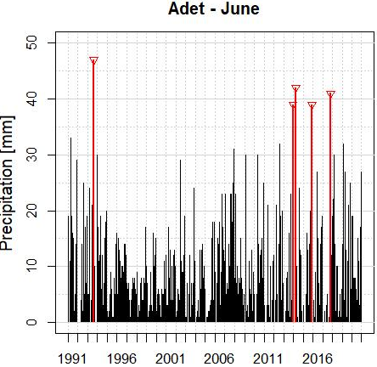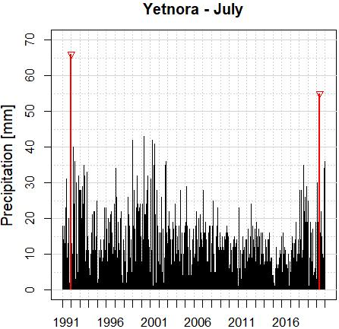
b
a

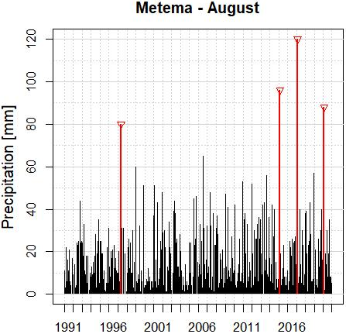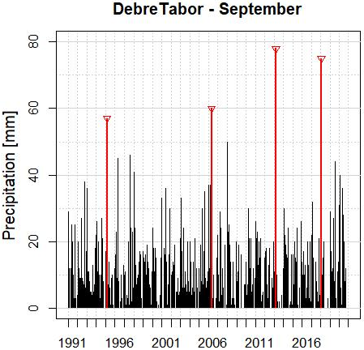
d
c
Appendix Figure 1. Outlier detection of daily observed rainfall data for Adet (a),Yetnora (b),Metema (c),and Shahura (d).
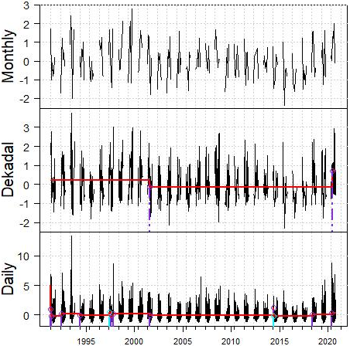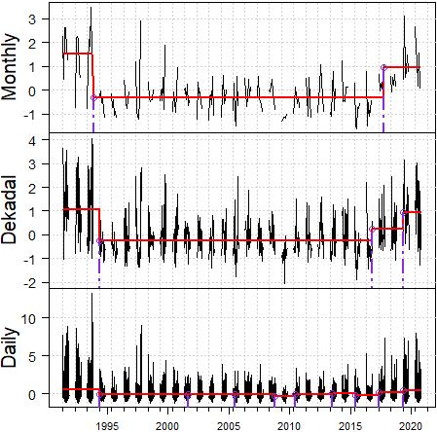
b
a
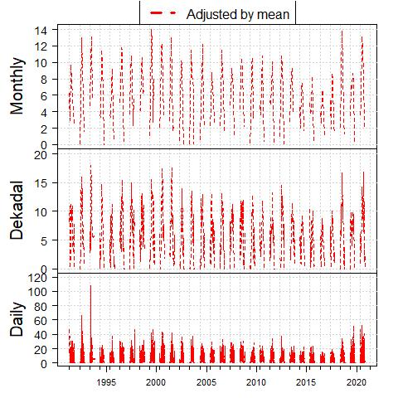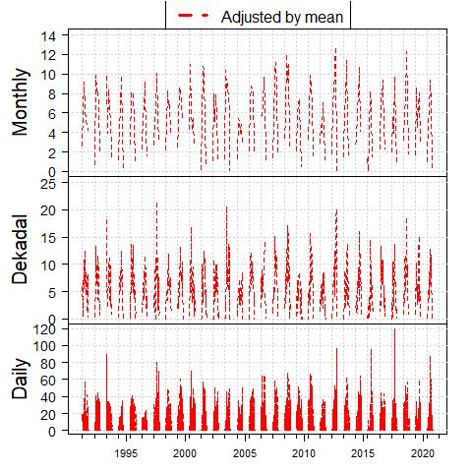
c
d

Appendix Figure 2. Homogeneity test result of observed rainfall breaks for Yetnora (a),Shahura (b),and mean adjusted for Yetnora (c),and Shahura (d).

