
BAHIR DAR UNIVERSITY
College of Agriculture and Environmental Sciences
Department of Plant Sciences

Water and Nutrient Management Technologies for Sustainable Enhancement of Tef (Eragrostis tef (Zucc) Trotter) Productivity under Irrigation in Northwest Ethiopia

By
Mekonnen Gebru Tekle

August, 2024
Bahir Dar
BAHIR DAR UNIVERSITY
College of Agriculture and Environmental Sciences
Department of Plant Sciences

Water and Nutrient Management Technologies for Sustainable Enhancement of Tef (Eragrostis tef (Zucc) Trotter) Productivity under Irrigation in Northwest Ethiopia

By
Mekonnen Gebru Tekle

A Dissertation Submitted in Partial Fulfillment of the Requirements for the Degree of Doctor of Philosophy in Agronomy

Advisory Board Members:
Principal Advisor’s Name: Prof. Getachew Alemayehu Damot
Co-advisor’s Name: Dr. Yayeh Bitew Bantie

August, 2024
BAHIR DAR

DECLARATION

This is to certify that the dissertation entitled “Water and Nutrient Management Technologies for Sustainable Enhancement of Tef (Eragrostis tef (Zucc) Trotter) Productivity Grown under Irrigation in Northwest Ethiopia”, submitted in partial fulfillment of the requirements for the degree of Doctor of Philosophy in Agronomy, Department of Plant Sciences, Bahir Dar University, is a record of original work carried out by the candidate and has never been submitted to this or any other institution to get any other degree or certificates. The assistance and help I received during the course of this investigation have been duly acknowledged.

Mekonnen Gebru Tekle  August 23, 2024
Name of the Candidate Signature Date

BAHIR DAR UNIVERSITY
College of Agriculture and Environmental Sciences
Department of Plant Sciences

Approval of Dissertation of Defense

We hereby certify that we have supervised, read, and evaluated this dissertation titled “Water and Nutrient Management Technologies for Sustainable Enhancement of Tef (Eragrostis tef (Zucc) Trotter) Productivity Grown under Irrigation in Northwest Ethiopia” by Mekonnen Gebru Tekle prepared under my guidance. We recommend the dissertation to be submitted for oral defense.

Getachew Alemayehu (Prof.)  August 23, 2024
Principal Advisor’s Name Signature Date

Yayeh Bitew (PhD)  August 23, 2024
Co-advisor’s Name Signature Date

_______________________ ______________ _____________
Department Head Signature Date

BAHIR DAR UNIVERSITY
College of Agriculture and Environmental Sciences
Department of Plant Sciences

Approval of Dissertation Defense Result


As members of the board of examiners, we examined this dissertation/thesis entitled “Water and Nutrient Management Technologies for Sustainable Enhancement of Tef (Eragrostis tef (Zucc) Trotter) Productivity Grown under Irrigation in Northwest Ethiopia” by Mekonnen Gebru Tekle. We hereby certify that the thesis/dissertation is accepted for fulfilling the requirements for the award of the degree of “Doctor of Philosophy (Ph.D.) in Agronomy”.

Board of Examiners:
____________________________ ______________ _______________

External Examiner’s Name Signature Date

____________________________ ______________ _______________
Internal Examiner’s Name Signature Date

____________________________ ______________ _______________
Chair Person’s Name Signature Date

DEDICATION

This dissertation is dedicated to all innocent civilians who were assassinated, displaced, and being homeless across different parts of Ethiopia.

ACKNOWLEDGEMENTS

First and for most I thank the Almighty God as he gave me physical and mental health and strength during the course of time.

My heart felt gratitude will go to my principal supervisor Prof. Getachew Alemayehu for his relentless support in terms of teaching valuable courses, framing and conceptualization of the proposal, grant seeking, supervision, editing the manuscript, and fatherhood advice at all stages of this rigorous working periods. This may not be happen without his selfless effort. I just want simply pray for God to give him long life and bless his family.

I am grateful to Dr. Yayeh Bitew, who gave me extra energy, motivation, and unreserved all round support including guidance, supervision, and editing such rigorous document. He will have always place in my whole life as a positive contributor. God bless him and his beloved family.

Moreover, I have to give a lot of credit and admiration for my beloved wife Lense Haile and my lovely kids: Vensiya Mekonnen, Barkot Mekonnen, and Lielte Mekonnen, who gave me unlimited love and patience for such lengthy period of time. I just want to say I love you and proud of you!

Furthermore, I would like to say thank you and I love you to my family as it is always difficult without your support in all aspect; my strength has been sourced from your presence.

My dearest friend Tsedalu Jemberu, it is shame not to mention your name and contribution in this work, and I do not have any better situation to express my heart felt appreciation as your presence and support were beyond a class mate or any ordinary friend do. You were always on my side to put a lot of positive energy through motivation, valuable advice, material and moral support. I just can say thank you and God bless you and your beloved ones.

At the end, it is my pleasure to acknowledge to College of Agriculture and Environmental Sciences of Bahir Dar University for providing grant support, dormitory, office, internet access, and enthusiasm, Wolkite University for academic tuition fee and grant support, Adet agricultural research center particularly Dr. Tadele Amare, Mr. Atenkut Fentahun, and Mr. Bantalem Zeleke for their kind input and material support. It is not possible to mention all the names of individuals and organizations but I am thankful for your all round supports.

TABLE OF CONTENTS
Contents Page
DECLARATION ii
DEDICATION v
ACKNOWLEDGEMENTS vi
LIST OF TABLES xii
LIST OF FIGURES xiv
LIST OF APPENDIX TABLES xvi
LIST OF APPENDIX FIGURE xvii
ABBREVIATIONS AND ACRONYMS xviii
GENERAL ABSTRACT 1
Chapter 1: GENERAL INTRODUCTION 4
1.2 Hypothesis 7
1.3 Objectives 8
1.5 Organization of the Dissertation 8
Chapter 2. GENERAL MATERIALS AND METHODS 10
2.1 Description of experimental sites 10
2.2. Method of Data Collection 11
2.3. Data Analysis 13
Chapter 3. YIELD AND LODGING RESPONSE OF TEF [Eragrostis tef (Zucc) Trotter] VARIETIES GROWN UNDER IRRIGATION TO NITROGEN AND SILICON APPLICATION RATES IN NORTHWEST ETHIOPIA 14
Abstract 14
3.1. Introduction 15
3.2 Materials and Methods 18
3.2.1 Description of Study Site 18
3.2.2 Planting Materials 19
3.2.3 Treatments and Experimental Design 19
3.2.4 Agronomic Practices and Planting Procedures 19
3.2.5 Data Collection 20
3.2.6 Data Analysis 21
3.3. Results and Discussion 23
3.3.1 Effect of Nitrogen and Silicon on Selected Traits of Tef Varieties 23
3.3.2 Yield and Yield Components of Tef varieties 29
3.3.3 Chlorophyll Content 36
3.3.4 Partial Budget Analysis 37
3.5 Conclusion 39
Chapter 4. YIELD, LODGING, AND WATER USE EFFICIENCY OF TEF [Eragrostis tef (zucc) Trotter] IN RESPONSE TO CARBONIZED RICE HUSK APPLICATION UNDER VARIABLE MOISTURE CONDITION AT KUDMI, NORTHEAST ETHIOPIA 40
Abstract 40
4.1. Introduction 41
4.2. Materials and methods 44
4.2.1. Site description 44
4.2.2. Experimental planting material 46
4.2.3. Experimental design and layout 46
4.2.4. Agronomic practices 47
4.2.5. Data collection 47
4.2.6. Data analysis 49
4.3. Result and discussion 49
4.3.1. Lodging and leaf area indices 49
4.3.2. Plant height 51
4.3.3. Relative growth rate 53
4.3.4 Panicle length 54
4.3.5. Number of tillers per plant 54
4.3.6. Grain and straw yields 55
4.3.7. Harvest index 56
4.3.8. Water use efficiency and chlorophyll content of tef 57
4.4 Conclusion 59
Chapter 5. WATER USE EFFICIENCY, LODGING AND YIELD OF TEF [Eragrostis tef (Zucc) Trotter] AS INFLUENCED BY CARBONIZED RICE HUSK APPLICATION TIMING AND SOIL AMENDMENTS IN NORTHWEST ETHIOPIA 61
Abstract 61
5.1. Introduction 62
5.2. Materials and Methods 64
5.2.1. Study site description 64
5.2.2. Soil and amendment sampling and analysis 65
5.2.3. Experimental Materials 66
5.2.4. Treatments and Design 67
5.2.5. Crop management 67
5.2.6. Data Collection on Agronomic attributes 67
5.2.7. Statistical analyses 68
5.3. Result and Discussion 68
5.3.1. Plant height, panicle length and number of plants per unit area 68
5.3.2. Chlorophyll content of tef 70
5.3.3. Water use efficiency, lodging and leaf area indices 72
5.3.4. Yield and yield components 74
5.4. Conclusion 76
CHAPTER 6. GENERAL SYNTHESIS AND RECOMMENDATION 77
REFERENCES 79
7. APPENDICES 95
7.1. Appendix Tables 96
7.2. Appendix Figures 100
BIOGRAPHY OF THE AUTHOR 106

LIST OF TABLES

Table 3. 1. Pre-planting soil physical and chemical characteristics 18
Table 3.2. The effect of nitrogen on stem diameter (SD), plant Height (PH), NP, and its variability over the two years 25
Table 3.3. The main and interaction effect of variety, nitrogen, and silicon on tef panicle length (cm) and its variability over the years 26
Table 3.4. The interaction effect of nitrogen, silicon and variety on lodging index of tef 27
Table 3.5. The main and interaction effect of silicon, variety, nitrogen on grain and biomass yield of tef 31
Table 3.6. The effect of silicon and nitrogen application on the harvest index of tef varieties 35
Table 3.7. The main and interaction effect of nitrogen, silicon, and variety on the chlorophyll content (SPAD unit) of tef leaf 36
Table 3.8. The economic feasibility of silicon and nitrogen application on the net return and marginal rate of return from tef grown in Mecha district combined over the two years 38

Table 4. 1. Pre-planting characteristics of water, soil, and post-planting crop management data 46
Table 4. 2. Main- and sub-plot treatments used in a split-plot design 47
Table 4. 3. The interaction effect of soil moisture depletion level and carbonized rice husk rate on lodging and leaf area index of tef 51
Table 4. 4. The effect of soil moisture depletion on tef plant height (cm) 52
Table 4. 5. The effect of soil moisture depletion level and rate of carbonized rice husk on tiller number of tillers per plant of tef crop for the 2022 production season 55
Table 4. 6. The combined and individual analysis result of two year experiment showing the effect soil moisture depletion levels on the harvest index of tef 57

Table 5. 1. Physical properties of soil over the three layers (0-20 cm) during pre-sowing time 65
Table 5. 2. Chemical properties of compost, carbonized rice husk, and pre-sowing soil collected by layer (0-20 cm) 66
Table 5. 3. The main effect of soil amendments on the plant height (cm) of tef 70
Table 5. 4. The effect of soil amendments and carbonized rice husk application timing on water use efficiency, lodging, leaf area indices of tef crop grown under irrigation 73
Table 5. 5. The effect of soil amendments and carbonized rice husk application timing on the yield and yield components of tef 75

LIST OF FIGURES

Figure 2. 1 Map of the study site 11
Figure 2. 2. Total monthly rainfall (mm), mean monthly maximum (ºC) and minimum temperatures (ºC) averaged over 29 years’ weather data (1994-2022) and specifically to the growing season 2021 (*) and 2022 (**) (Source: Merawi Meteorological Station, 2022). 11

Figure 3. 1. The fitted linear regression showing the relationship between rate of nitrogen and mean yields of tef crop: A) nitrogen versus grain yield in 2021 growing season, B) nitrogen versus biomass yield in the year 2021, C) nitrogen versus grain yield in 2022 growing season, D) nitrogen versus biomass yield in 2022, E) nitrogen versus grain yield based on the pooled mean over the two growing seasons (2021/22), F) nitrogen versus biomass yield based on the pooled mean over the two growing season (2021/22); GY is Grain yield; BY is Biomass yield; R² is coefficient of determination; x and y represents the values of independent and dependent variables, respectively for the corresponding graph. 33

Figure 4. 1. The effect of moisture depletion levels on the relative growth rate of tef. The 20% MDL, 35% MDL, 55% MDL, and 75% MDL are percentage of moisture depletion levels; DAP is days after planting; RGR is relative growth rate 53
Figure 4.3. Bar chart showing the effect of moisture depletion level and carbonized rice husk on chlorophyll content of tef. (A) MDL1, MDL2, MDL3, and MDL4 with 20, 35, 55, and 75%; (B) CRH1, CRH2, CRH3, and CRH4 with 0, 291, 582, 873 kg ha⁻¹, respectively; the interaction of MDL and CRH was not significant (P>0.05) 58

Figure 5. 1. Effect of carbonized rice husk time on the chlorophyll content of tef at different growth period; Treatments (within the same date group) that are connected with the same letter(s) are not significantly different at p=0.05; The coefficient of variation for the four chlorophyll measurement periods: 16, 31, 46, and 61 days after planting were 7.4, 8.6, 17.1, and 19.7% respectively. CRHT1, CRHT2, CRHT3, and CRHT4 are the carbonized rice husk application timings: no application, full at sowing, half at sowing and half at tillering stage, full at tillering stage, respectively 70

Figure 6. 1. The relationship between experimental treatments that are assumed to improve the grain yield of tef and lodging resistance of tef 77

LIST OF APPENDIX TABLES

Appendix Table 1. Correlations between nitrogen treatment, growth and yield related traits of tef 95
Appendix Table 2. Pair wise correlation from the soil amendment and carbonized rice husk application timing experiment 96
Appendix Table 3. The effect of carbonized rice husk application timing on the harvest index (%) of tef over the two irrigation growing seasons of 2021 and 2022 98

LIST OF APPENDIX FIGURE

Appendix Figure 1. Carbonized Rice Husk preparation procedures from well dried rice husk. Phase I to III shows heating process and change in the color of the husk yellow to black; phase IV is the final stage indicated by complete conversion of rice husk to black color, thus cooling takes place by spraying water to avoid conversion to the ash form 100
Appendix Figure 2. Land Preparation (A) Clod breaking (B) preparation of ridge and furrow 101
Appendix Figure 3. Broadcast incorporation of carbonized rice husk: a) application by broadcasting; b) manual mixing up with the soil (Original photo taken by Mekonnen Gebru on 01/21/2021) 101
Appendix Figure 4. Lime application through broadcast incorporation: a) broadcast application b) incorporation of lime with soil 102
Appendix Figure 5. Preparation of rows for planting 103
Appendix Figure 6. Post plant Crop Management Practices: (a) Can Sprinkler irrigation from planting to early establishment stage (Seedling emergency); (b) Controlled Flooding (c) Hand Weeding 104
Appendix Figure 7. Plant growth performance in the field during early (a) and grain formation (b) stages 105

ABBREVIATIONS AND ACRONYMS

AARC | Adet Agricultural Research Center
ANOVA | Analysis of Variance
CEC | Cation Exchange Capacity
CIMMYT | Centro Internacional de Mejoramiento de Maíz y Trigo
CSA | Central Statistical Agency
DZARC | Debre Zeit Agricultural Research Center
EC | Electrical Conductivity
ETB | Ethiopian Birr
FAO | Food and Agriculture Organization of the United Nations
FC | Field Capacity
IFAD | International Fund for Agricultural Development
KIS | Koga Irrigation Scheme
LAI | Leaf Area Index
MASL | Meter Above See Level
MDL | Moisture Depletion Level
MRR | Marginal Rate of Return
OC | Organic Carbon
OM | Organic Matter
NR | Net Return
PSD | Particle Size Density
PWP | Permanent Wilting Point
SPAD | Soil Plant Analysis Development
TNR | Total Net Return
TSP | Triple Super Phosphate
TVC | Total Variable Cost
USD | United States Dollar
WUE | Water Use Efficiency

WATER AND NUTRIENT MANAGEMENT TECHNOLOGIES FOR SUSTAINABLE ENHANCEMENT OF TEF (Eragrostis tef (Zucc) Trotter) PRODUCTIVITY GROWN UNDER IRRIGATION IN NORTH WEST ETHIOPIA

Mekonnen Gebru^{a,b*}, Getachew Alemayehuª, Yayeh Bitewª
ªBahir Dar University, College of Agriculture and Environmental Sciences, Plant Sciences, P.O. Box 5501, Bahir Dar, Ethiopia
^{b}Wolkite University, Horticulture Department, P.O. Box 07, Wolkite, Ethiopia,

GENERAL ABSTRACT

Sustainability of natural resources and agricultural production in the world has been challenged by fast population growth, urbanization, and climate change that results degradation, scarcity, and reduced agricultural land and water productivity. Proper management of scarce natural resources is essential to sustain life of the future generation. Among those management practices, the use of improved and sustainable nutrient and water management technologies and climate resilient crops should be given due considerations. Specifically, an expansion of tef, which has wide ecological adaptation, with multiple benefits both for the producers and consumers under rainfed and irrigation production system will play a positive role. However, lodging, low fertilizer input, extreme drought, and lack of adequate seeds of improved varieties have contributed to the reduction of tef productivity in Ethiopia. Therefore, the overall objective of this research was designed to optimize the nutrient and water management practices for sustainable enhancement of tef productivity in the northwestern. The study was conducted at Koga Irrigation Scheme, north-western Ethiopia with three specific objectives of assessing: 1) the yield and lodging responses of tef varieties to the application of nitrogen and silicon supplement, 2) the productivity and lodging responses of tef to varying soil moisture content and silicon supplement, and 3) the effect of soil amendments and carbonized rice husk application timing on lodging responses, water use efficiency and productivity of irrigated tef. For the first objective a 4×2×2 factorial field experiment was conducted in randomized complete Block design on fixed experimental plot for two consecutive dry season with four nitrogen levels: 0, 23, 46, and 92 kg N ha⁻¹, two Si levels in the form of carbonized rice husk (CRH): 0 and 485 kg ha⁻¹, and two improved varieties: Hiber-1 and Quncho treatment combinations, which were replicated four times. For the second objective a 4*4 factorial experiment with four soil moisture depletion levels [20% (no water stress), 35%, 55%, and 75%] and four levels of silicon in the form of carbonized rice husk (0, 291, 582, and 873 kg ha⁻¹) laid out in a split-plot design with four replications. For the third objective a total of 16 treatment combinations of four levels of CRH application timing and soil amendments: compost, lime and their combination were used and laid out in Randomized Complete Block Design with four replications. To test the effect of treatments of each experiment, data on physiological growth, yield, and economic parameters of tef were collected, which could vary across the experiment. R-Software was deployed to analyze the data with appropriate packages specifically designed to the experimental design (RCBD or Split-plot designs). The result showed that interaction of nitrogen, silicon, and variety significantly (p<.001) affected lodging index, with a minimum lodging index of 0% from Heber-1 variety without silicon and nitrogen and a maximum lodging index (71.9%) from Quncho without silicon and kg ha⁻¹ application. The highest net return of 2552.61 USD was obtained from Hiber-1 with 92 kg N ha⁻¹ without silicon application, while the highest marginal rate of return (2668.4%) was found from the same variety with 23 kg N ha⁻¹ without silicon addition. The lowest LI (19.7%) was obtained from the application of 873 kg CRH ha⁻¹, followed by 20.6% from 582 kg CRH ha⁻¹ in 2022. The pooled mean analysis result showed that, though there was no significant difference in yield, tef irrigated at 55% moisture depletion level provided a maximum HI of 33.8%, which was 6.21% more than the control. An increased level of lodging resistance was also obtained from 55% moisture depletion level with a LI of 31.9%, which was next to 75% moisture depletion level with 582 kg ha⁻¹ carbonized rice husk. Half split application of carbonized rice husk during sowing and tillering showed an improvement of leaf chlorophyll content by 8.1% during the initial, development and mid-season stages. Application of Compost+Lime significantly improved tef grain, above-ground biomass and straw yields by 12.1, 14.5, and 15.2% compared to lime, and 12.3, 9.3, and 8.4% compared to the control treatment, respectively, but it increased sensitivity to lodging. The authors suggested that the research on lodging response of tef to silicon from different fertilizer sources should further be verified for across locations for wide application.

Key words: Compost, Lime, Silicon, Soil Amendments, Tef varieties

Chapter 1: GENERAL INTRODUCTION

1.1 Background and Justification

Population growth and climate change continue to challenge the natural resource and agricultural production and adequacy of food supply. The world population continue to increase significantly from about 0.978 billion in 1800 to reach an estimates of around 7.794 billion in 2020 and expected to reach over 11 billion in the 2100 (Sadigov, 2022); In the year 2020 undernourishment was estimated between 0.72 and 0.811 billion. This figure showed an increment from 8.4 in 2019 to 9.9% in 2020 (FAO, 2021). From the total number of undernourished people about 36.7% was from Africa. The same report showed that about 1/3 of the world population did not have access to adequate food in 2020. The unbalanced growth of world population compared to the food supply results an increment of the food price (Fukase & Martin, 2020). An increase in urbanization in the world has also created pressure on the total area of agricultural lands. The share of urban population has reached to 56% in 2020 compared to 43% in 1993 (Gu et al., 2021).

Ethiopia has an estimated total population of over 120 million in the year 2024 (Group, 2022; UNDESA, 2022). The current GDP of the country is estimated around 126.78 billion US$ (World Bank Group, 2022). From the total GDP the share of the agriculture sector was estimated around 37.64% followed by the service sector (36.56%), and industrial sector (22.72%) (O’Neill, 2024). About 82% of the farm household depends on crop-livestock mixed farming system (ESS, 2023). In the 2021-22 main season about 72% of the total land holdings of 17.77 million ha was occupied by temporary crops operated by 19.4 million householders (ESS, 2022). Though agriculture sector particularly the crop domain took the lion share for the Ethiopian economic growth, it is characterized by subsistent smallholder rainfed farming system, which is vulnerable to climate change in the form of drought, intra- and inter-annual weather variability and low productivity due to minimum input use; land degradation due to improper crop cultivation (Yigezu Wendimu, 2021).

Ethiopia has huge potential for the improvement of agricultural production and productivity. The presence of diverse agro-ecologies from cool, humid highlands to warm lowlands, make the country suitable for the production of various agricultural crops. The elevation stretches from 136 mbsl to above 4620 masl, which are located in Afar and Amhara regional states, respectively (CSA, 2011). However, crop production is mainly concentrated in the central highlands of the country (CSA, 2011). These areas are characterized by their dense population, small size of land holdings (Yigezu Wendimu, 2021), heavy crop cultivation, which is prone to land degradation (Dibaba Wakjira et al., 2020).

The northwest Ethiopia, where our study was conducted is among those areas of Ethiopia that are moderately to highly suitable to cultivate different crops including tef, maize, wheat and other cereals, vegetables and fruit crops (Werkneh Abebe et al., 2022), however, soil acidity due to rain water erosion and an intensive cultivation of land without adequate maintenance of the soil fertility is the major limitation of crop production. The majority of crops harvested in these areas come from rainfed farming system (CSA, 2022), which is significantly influenced by seasonal weather variability, which influences the yield of crops (Osman et al., 2021).

Though not sufficiently developed, the government has established irrigation structures to increase the total annual quantity of crop produces and increase the income of farmers in the study area. Koga irrigation scheme is among the major ones to be mentioned in the study area that is used to cultivate more than 6000 ha of land (Solomon Awulachew et al., 2007). The scheme was mainly developed for the production of high value crops. Currently, an increased sedimentation in the reservoir and improper farm level irrigation practices have being resulting water shortage during the peak water demand periods of the cropping season (Tesfaw Adugna and Dessie Cherie, 2021). Therefore, it is imperative to seek the right options, which are potentially useful to properly exploit the scarce water resource. Selection of drought tolerant crops, application of proper depth and interval of irrigation water along with proper fertilization is crucial to ensure sustainability of crop production and to feed the rapidly growing population.

Tef [Eragrostis tef (Zucc) Trotter] is a warm season cereal crop. The crop belongs to the unique, but underutilized crops of the world (Cheng et al., 2017; Lee, 2018) which has a potential towards food security (Werkneh Abebe et al., 2022). This crop is adapted to marginal areas, where water logging, drought and soil acidity are the major problems of crop production (Werkneh Abebe et al., 2022). It has multiple uses including production of healthy food free of gluten (Barretto et al., 2021), alcoholic beverage (Gelaw and Qureshi, 2020), livestock feed, and traditional house construction (Fikadu Asmiro et al., 2019), and extraction of organic silica nanoparticles from its straw (Amibo et al., 2022). Additionally, the long storability of grains (Barretto et al., 2021) has provided the farmers huge relief from unpredictable fall in market price.

In Ethiopia tef has accounted for 29.3% of the overall area covered under cereals followed by maize (25.6%) in the 2021-22 cropping season (CSA, 2022). Nearly all tef grain production in country is obtained from smallholder rainfaid farming system. Tef is second in terms of total volume of production next to maize. More than 5 million tons were produced in the above mentioned year (CSA, 2022). Tef consumed more than 30% of the total fertilizer input used by the farm holders (CSA, 2020). In recent years, there is an increased interest of tef consumption in Europe for livestock feed and human food (Yenesew Yihun et al., 2013).

Although tef is an important crop, its productivity is still low due to climate variability, drought, poor genetic potential, lodging, soil degradation and inefficient production practices (Werkneh Abebe et al., 2022). Therefore, our study was focused on addressing the demand for improved varieties, soil fertility improvement, and increase in lodging resistance of tef in the study area.

There were previous efforts to improve tef productivity and lodging resistance, through crop variety improvement (Kebebew Assefa et al., 2011; Zeid, et al., 2011) and use of growth hormones (Plaza-Wüthrich et al., 2016), reducing nitrogen application, and seed rates. However, with either due to farmers’ preference long plant height or reduction in yield these approaches are not successful. Therefore, it is essential to look for other ecofriendly, low-cost, and locally available nutrient and water management technologies that has the capacity to improve the sustainable productivity improvement of tef.

Evidences showed the significance of calcium in the form of lime, compost and/or silicon to lodging resistance under optimum irrigation production system. This could be a plus for the crop in addition to improvement of soil properties. Therefore, they authors claimed that with the application of calcium containing materials such as gypsum or lime in optimum amount could reduce lodging effect because of its structural role in plants cell (Dordas, 2009; Meriño-Gergichevich et al., 2010), or an external application of silicon to plants could result in increasing yield and enhancing resistance to lodging (Idris et al., 1975), water stress tolerance, acidity and salinity tolerances, which were evident on various crop like rice (Chen et al., 2011), sugarcane (Meena et al., 2014), Phaseolus vulgaris in saline soils (Zuccarini, 2008). Compost, which contains various nutrients and other properties, could also be used as an option to the aforementioned technologies. Moreover, selection of lodging resistant and high yielding varieties with improved water use efficiency could play a part towards improving productivity of tef in the study area.

1.2 Hypothesis

Optimizing the nutrient and water application, use of appropriate variety can generally enhance the productivity of tef
- Nitrogen application, silicon supplement and variety, or their combination can significantly improve tef yield and lodging resistance
- Soil moisture depletion level and silicon supplement can significantly influence the yield, lodging, water use efficiency of tef
- Tef yield and its lodging resistance could be significantly be affected by the application timing of carbonized rice husk and compost and lime, or their combination

1.3 Objectives

Improving the growth development, and lodging resistance of tef for maximum productivity through improved water and nutrient management technologies, is the general objective of the study, with the following specific objectives:
- To examine the yield and lodging responses of tef varieties to the application of nitrogen and silicon supplement
- To assess the yield, lodging, and water use efficiency of tef to varying soil moisture content and silicon supplement
- To determine the effect of soil amendments and silicon application timing on lodging, and productivity of irrigated tef

1.5 Organization of the Dissertation

This dissertation contains five different chapters which are briefly overviewed as follows.

Chapter 1– introduces the theoretical details of the subject (tef) of the study. In this chapter the primary challenges causing food insecurity in the world in general and in Ethiopia in particular were discussed. Major crop production constraints including soil acidity, improper crop cultivation, climate change and inter-annual temperature and rainfall variability effects on crop production specifically to tef crop were presented. In addition, the short and long term efforts to reduce those challenges are precisely explained. Finally the research hypothesis and the objectives are explained.

Chapter 2 – pointed out the general materials and methods, which are common to all the three experiments, were discussed in detail. This includes experimental site descriptions, planting materials, method of data collection and analysis procedures that are common to all the experiments are explicitly mentioned in this chapter.

Chapter 3 to 5 – comprised the three experiments. Each chapter holds the theoretical background information that supported the necessity of the particular experiment. Additionally, the specific methods, planting materials, experimental design and treatments applied, data parameters, analysis procedures, and the key findings are briefly presented.

Chapter 6 – This chapter generally provided the key findings and achievements of the research. In addition, based on the results of this study the future research directions were specified.

Chapter 2. GENERAL MATERIALS AND METHODS

2.1 Description of experimental sites

Three different field experiments were conducted in two dry seasons of 2021 and 2022 at Kudmi, Bahir Dar University Agricultural Research Site, Koga Irrigation Scheme (KIS). The site is located at 11º23’31’’ to 11º23’33’’ N latitude and 37º6'42'' to 37º6'43'' E longitude. The detailed map of the experimental site is presented below in Figure 2.1.
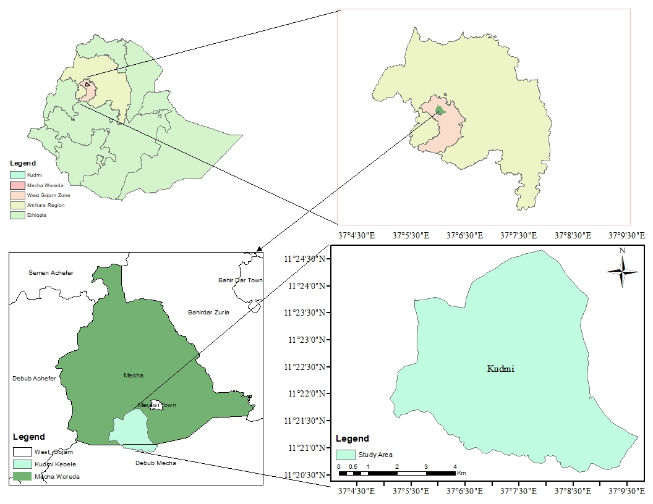
Figure 2. 1 Map of the study site

A long-term weather data (29 year) collected by Bahir Dar Branch of the National Meteorological Agency at Merawi station indicated that the average annual rainfall in the study area is 1768 mm, which was concentrated mainly between May to September, whereas its dry season is extended from November to April and characterized by significant inter annual variability. The average minimum and maximum temperatures of Koga are reported as 10.7 ºC and 27.7 ºC, respectively. The seasonal variability of minimum and maximum temperatures, and rainfall over the two growing seasons and historical data was presented below (Figure 2.2). The missing values of weather data were filled by calculating based on the means and variance of the observed data through DSSAT WeatherMan Version 4.8.0.0 (Hoogenboom et al., 2019).

Figure 2. 2. Total monthly rainfall (mm), mean monthly maximum (ºC) and minimum temperatures (ºC) averaged over 29 years’ weather data (1994-2022) and specifically to the growing season 2021 (*) and 2022 (**) (Source: Merawi Meteorological Station, 2022).

2.2. Method of Data Collection

The soil of the study site was analyzed for its physical and chemical characteristics. To characterize the soil property of the experimental site, soil samples of disturbed and undisturbed were collected in a zigzag fashion just prior to planting from three different soil layers (0-20, 20-40, and 40-60 cm). During pre-plant sample collection, a total of 60 sample spots were considered to prepare three composite samples for each soil layer, while for post-harvest sampling, three spots were considered on an individual plot basis from 64 plots.

The undisturbed soil samples were used to determine the dry bulk density (BD_{d}), field capacity (FC) and permanent wilting point (PWP) and total available water (TAW), while the disturbed ones were used to analyse parameters, which were particle size distribution (PSD), soil pH, electrical conductivity (EC), total nitrogen (TN), available phosphorus, organic carbon (OC), organic matter (OM), cation exchange capacity (CEC) analysis.

The particle size distribution was analyzed by Bouyuocos hydrometer after dispersing the soil sample with sodium hexametaphosphate solution (Bouyoucos, 1962). The BD_{d} was determined by the core method (Blake, 1965), after drying a defined volume of soil in an oven at 105 °C for 24 h, and then calculated as the ratio of the mass of oven-dried soil to the volume of the sampling core. The FC and PWP were determined gravimetrically with the help of a pressure plate extractor and oven drying as special apparatus (Cassel and Nielsen, 1986). From FC and PWP, the total available water was calculated (Equation 1).

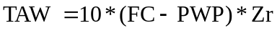 1
where, TAW is total available soil moisture content (mm m⁻¹); FC is field capacity (m³ m⁻³), PWP is permanent wilting point (m³ m⁻³); Zr is depth of root zone (m).

Soil pH was determined in water at 1:2.5 v/v soil/water (Peech, 1965). The EC soil was measured in 1:5 supernatant solutions (Sonmez et al., 2008). Total nitrogen content was determined by the Kjeldahl method (Bremner, 1996). Available phosphorus (AP) was extracted with a 0.5 M NaHCO₃ solution at pH 8.5 and determined colorimetrically (Olsen, 1954). The organic carbon (OC) was determined by the Walkley–Black method (Gelman et al., 2012), whereas organic matter (OM) was determined by multiplying the OC with 1.9 (Pribyl, 2010). Cation exchange capacity (CEC_{pH7}) was calculated as the sum of positively charged cations (Ross & Ketterings, 1995).

The soil of the study site is generally characterized as acidic clay soil. The detailed values of each physicochemical characteristic are presented independently in the following two chapters (Chapter 3 and 4).

The data parameters and the respective procedures of each growth, physiological, and yield parameters are given in detail from chapter 3 to 5.

2.3. Data Analysis

Data analysis was carried out using R statistical software version 4.1.1 (Team, 2021). Before making the analysis of variance (ANOVA), data were checked for normality of the data distribution following the Shapiro-Wilk testing procedure (Hanusz & Tarasińska, 2015). Homogeneity of variances among the traits across the two growing seasons was done using Levene’s Test (O' Neill and Mathews, 2002). The ANOVA was performed based on the procedure of the general linear model, whenever it showed a significant difference; mean separation was done using the least significant difference procedure at 0.05 probability level. However, when the number of means to be compared reached six and above, a comparison was made by the Tukey-Kramer Honestly Significant Difference test when the F-test indicated factorial effects at a 0.05 significant level. One-, two-, and three-way ANOVA models were fitted to the corresponding design of the experiment.

Chapter 3. YIELD AND LODGING RESPONSE OF TEF [Eragrostis tef (Zucc) Trotter] VARIETIES TO NITROGEN AND SILICON APPLICATION RATES UNDER IRRIGATIONS IN NORTHWEST ETHIOPIA

Mekonnen Gebru^{a,b*}, Getachew Alemayehuª, Yayeh Bitewª
ªBahir Dar University, College of Agriculture and Environmental Sciences, Plant Sciences, P.O. Box 5501, Bahir Dar, Ethiopia
^{b}Wolkite University, Horticulture Department, P.O.Box 07, Wolkite, Ethiopia, mekugebru@gmail.com
*Corresponding author: mekugebru@gmail.com
Published by Elsevier Ltd, Cell Press, Heliyon
https://doi.org/10.1016/j.heliyon.2023.e22576

Abstract

Lodging, poor crop varieties and nitrogen management are among the main tef cultivation problems of northwestern Ethiopia. Though Si has been shown to improve crop yield and lodging resistance, knowledge of its effect on tef along with genotypes and nitrogen is yet to be uncovered. Therefore, a 4×2×2 factorial field experiment was conducted on fixed experimental plot at the Koga irrigation scheme to assess yield and lodging responses of tef varieties to nitrogen and silicon fertilizer rates during two consecutive years of 2021 and 2022. The experiment comprised four nitrogen levels: 0, 23, 46, and 92 kg N ha⁻¹, two Si levels: 0 and 485 kg ha⁻¹ carbonized rice husk, and two improved varieties: Heber-1 and Quncho treatment combinations, which were replicated four times. Results showed that regardless of silicon supply and variety, nitrogen had a significant effect (p<.0001) on agronomic attributes of tef grain yield, biomass yield, harvest index, chlorophyll content, plant height, panicle length, leaf area index, and the number of plants m⁻² over the two years. Application of 92, 46, and 23 kg N ha⁻¹ had improved grain yield by 166.9, 126.2, and 75.2% over control, respectively. The harvest index showed a declining trend with nitrogen rates, which ranged from 36.1 to 26.5% from 0 to 92 kg N ha⁻¹. Heber-1 showed a significantly (p<.01) higher panicle length than Quncho. The interaction of nitrogen, silicon, and variety significantly (p<.001) affected lodging index, with a minimum lodging index of 0% from Heber-1 without silicon and nitrogen application and a maximum lodging index (71.9%) from Quncho variety with 92 kg N ha⁻¹ and no silicon application. Maximum net return (2552.61 USD) was obtained from Heber-1 variety with 92 kg N ha⁻¹ without silicon application, while the highest marginal rate of return (2668.4%) was from Heber-1 with 23 kg N ha⁻¹ without silicon application. Therefore, it can be concluded that variety Heber-1 and nitrogen rate of 23 kg N ha⁻¹) can provide economically feasible yield and lodging resistance of tef, while silicon in the form of carbonized rice husk results no significant effect on tef lodging.

Key words: leaf area index, lodging index, net return, marginal rate of return, chlorophyll content

3.1. Introduction

Tef [Eragrostis tef (Zucc) trotter] is one of the C₄ crop species in the Poaceae (formerly Gramineae) family, which is adapted to wider soil and climatic conditions (Solomon Chanyalew et al., 2019). It is the staple food crop for millions of people in Ethiopia, where the crop was first cultivated. It has been consumed in multiple ways, such as in pan-like flatbread called ‘Injera’, porridge, and fermented alcoholic drinks (Gelaw and Qureshi, 2020). The high nutritional content, free of gluten, long storability of grains (Barretto et al., 2021), wide use of the straw, including as livestock feed, traditional house construction (Fikadu et al., 2019), and extraction of organic silica nanoparticles (Amibo et al., 2022), make the crop among the unique but underutilized crops of the world (Cheng et al., 2017; Lee, 2018).

Tef has continued to dominate the total proportion of cultivated land in Ethiopia. In the 2021-22 cropping season, there was about 3.08 million ha of cultivated land, which accounted for 29.3% of the overall area covered under cereals (nearly 10 million ha), followed by maize: 25.6% (CSA, 2022). The area covered by tef in 2021-22 showed a decrement of 5.4% and 6.23% compared to the 2019-20 and 2020-21 growing seasons, respectively (CSA, 2022, 2020). Nearly all the tef grain production in the country is obtained from a smallholder rainfed farming system, which is vulnerable to crop failure caused by drought and nutrient loss.

Though there has been a growing interest in tef grain and straw both in the local and international markets, their productivity is low, with 1700 kg ha⁻¹ of grain (Solomon Chanyalew et al., 2019). This may be attributed to erratic rainfall (Desale Asmamaw et al., 2021), poor fertilizer and seed management, and a lack of appropriate varieties (Workineh Ejigu et al., 2022). Lodging, a permanent displacement of the stem or root, is also major factor that has significantly affected yield and yield-related traits. Although there are many causes of lodging, lodging associated with environmental conditions (Dahiya et al., 2018) and morphological plant traits (Ben-Zeev et al., 2020; Bizuwork Tafes et al., 2022) is causing significant yield loss to the crop, accounting for up to 35% of yield losses (Vos et al., 2013). According to the above authors, high levels of soil nitrogen or nitrogen applied before the start of stem extension also produce longer internodes and weaker stems, which in turn cause lodging. A review from Solomon Chanyalew et al. (2019) showed that lodging under natural conditions could cause up to 22% tef yield loss, 35% of 1000-kernel weight loss, and 51% of grain yield per panicle. In addition to the inherently weak stem, heavy rainstorms or flooding could induce lodging of tef (Kebebew Assefa et al., 2016). Other researcher (Tesfahun Wakjira, 2018) also indicated that tef lodging is attributed to plant height, mainly as the result of increased nitrogen fertilization.

There were efforts to improve the productivity of tef through the use of nitrogen and phosphorus fertilizers, gene editing (Solomon Chanyalew et al., 2019; Numan et al., 2021), and other agronomic practices like tillage (Fikremariam Mihretie et al., 2021), seed rate, and method of planting (Yechale Mengie et al., 2021) under the rainfed production system. However, the applicability of any technology varies significantly over the location, season, crop, variety, and management and production systems; thus, the majority of the farmers were forced to use blanket recommendations made at the national level for the rainfed system. This has been especially common for fertilizer management, which causes loss of nutrients, increases the cost of fertilizer, and hampers the productivity of the crop. For instance, an increased rate of N application resulted in the lodging of tef and, in turn, a reduction in yield. Researcher (Tewelde Berhe et al., 2020) stated that the application of 300 kg ha⁻¹ urea increased the lodging of tef by about 99%. Other reports also showed that application of 90 kg N ha⁻¹ resulted in about 60% of tef plant lodging (Tamirat Wato, 2021). According to Solomon Chanyalew et al. (2019) lodging could cause up to 22% total grain yield loss, 35% of 1000-kernel weight, and 51% of grain yield per panicle. Thus, further research was required to optimize nutrient use, particularly nitrogen, for the tef crop under irrigated conditions.

On the other hand, much literature has presented the beneficial effects of silicon on various crops, particularly monocots, towards reducing lodging and other biotic and abiotic stresses (Naik et al., 2022). Application of commercially available calcium silicate positively affected the yield of sugarcane and wheat (Majumdar and Prakash, 2020) and beneficial soil microbes (Hafez et al., 2021) in highly weathered acid soils and counteracted aluminum (Azman et al., 2023) and Mn toxicity (Mahmad-Toher et al., 2022) in acid sulfate soil. Crops in the Poaceae family get mechanical strength and inhibitory effects due to the deposition of silicon in their leaves (Garg et al., 2020). Recently, an experimental study on pot revealed that the lodging tolerance of tef increased with the addition of sodium silicate (Ligaba-Osena et al., 2020). Despite these facts, the knowledge of lodging reduction due to Si application on tef under field condition has been poorly documented. In addition, inorganic silicon fertilizers are either expensive, harm the environment, or not available in the local market (Liang et al., 2015). Therefore, searching for locally available, inexpensive and eco-friendly materials such as carbonized rice husk, which contains 60-90% silica (Moayedi et al., 2019; Shen et al., 2014), or diatomaceous earth with 80% silicon content (Gokavi et al., 2021) could replace the role of inorganic silicon fertilizers.

Generally, many researchers claimed that the application of nitrogen and silicon could affect the yield and lodging (Hong et al., 2022) of tef either independently or interactively. Genotypic variation could also have a potential difference in terms of the yield and lodging response to various inputs like nitrogen and silicon (Subudhi et al., 2020). Furthermore, the treatments that provide significant effect might not be economical for practical use by the smallholder farmers (Ekero et al., 2020). However, there have been limited empirical evidences toward this information specifically in the study area and generally in Ethiopia. Therefore, this study was designed to assess the main and interaction effect of nitrogen and silicon supplement on growth, yield and lodging of tef varieties, to select economically feasible treatments to small holder farmers.

3.2 Materials and Methods

3.2.1 Description of Study Site

A two-year field experiment was conducted at Kudmi, Bahir Dar University experimental site, Koga Irrigation Scheme, Mecha district in 2021 and 2022 under irrigation condition as an alternative option to rainfed system. The site is located at 11º23'33'' N latitude and 37º6'43'' E longitude at an altitude of 1983 m.a.s.l. The area represents mid-highland agro-ecology (CSA, 2012). The minimum and maximum temperatures and mean annual rainfall for both historical and the growing season data are presented above in section 2.1 of Figure 2.2. The physical and chemical analysis results of this experiment before planting was analyzed and are summarized below (Table 3.1). The details of the analysis procedure for each soil physical and chemical properties were presented previously in section 2.1.

Table 3. 1. Pre-planting soil physical and chemical characteristics

Zr |  | BD_{d} ª |  | Sand |  | Silt |  | Clay |  |  | FC |  | PWP | TAW
cm |  | g cm⁻³ |  | % |  |  | % |  | % | % |  | % |  | mm m⁻¹
0-20 |  | 1.23 |  | 17 |  | 30 |  | 53 |  |  | 54.3 |  | 24.2 | 300.5
20-40 |  | 1.13 |  | 17 |  | 28 |  | 55 |  |  | 37.2 |  | 20.4 | 168.1
40-60 |  | 1.10 |  | 13 |  | 28 |  | 59 |  |  | 31.4 |  | 20.2 | 111.6
 | pH (H2O) |  | EC (µS) |  | AP (ppm) |  |  | TN (%) |  |  | OC (%) |  | OM (%) | CEC^{b} (Cmol_{c}kg⁻¹)
0-20 | 5.3 |  | 48.2 |  | 12.36 |  |  | 0.28 |  |  | 1.88 |  | 3.58 | 30.0
20-40 | 5.5 |  | 30.0 |  | 12.95 |  |  | 0.20 |  |  | 1.54 |  | 2.92 | 28.2
40-60 | 5.7 |  | 35.8 |  | 10.31 |  |  | 0.18 |  |  | 1.23 |  | 2.34 | 33.0

ªdata averaged over 60 samples; Zr, root zone depth; BD_{d}, dry soil Bulk Density; FC, field capacity; PWP; Permanent Wilting Point; TAW, Total Available Soil Water; EC, Electrical Conductivity of Soil; TN, Total Nitrogen; AP, Available Phosphorus; Organic Carbon; OM, Organic Matter; CEC, Cation Exchange Capacity; Available silicon.

3.2.2 Planting Materials

Seeds of Quncho (Dz-CR-387 RIL-355), which has been widely cultivated by farmers and recently released Heber-1 (Dz-Cr-419), were collected from the Adet Agricultural Research Center (AARC). The earlier variety was released in 2006 by the Debre Zeit Agricultural Research Center (DZARC) and the latter was released in 2017 by AARC. Both varieties were characterized as having very white-colored seeds and high yields, the first being moderately tolerant to lodging, while the second is sensitive to lodging and early-set (Solomon Chanyalew et al., 2019).

3.2.3 Treatments and Experimental Design

A 2*2*4 factorial experiment was arranged in a Randomized Complete Block Design (RCBD) consisting of two tef varieties (Heber-1 and Quncho), two levels of Si in the form of carbonized rice husk (0, 485 kg ha⁻¹), and four levels of nitrogen (0, 23, 46, and 92 kg ha⁻¹), with a total of sixteen treatment combinations to assess the main and interaction effect of nitrogen, silicon supplement and tef varieties. Each treatment combination was replicated four times on a gross plot area of 2 m by 3 m and a net plot of 1 m by 1m. The space between adjacent plots and blocks was 0.5 m and 1 m, respectively. Each treatment combination was applied to a fixed experimental unit over two consecutive years to include the residual effect of treatments.

3.2.4 Agronomic Practices and Planting Procedures

All the vegetation was removed and three days before the first tillage, the land was soaked with water, which helped facilitate the practice of tillage. It was then tilled three times, with an oxen-driven tillage method and digging hoe in 2021 and 2022, respectively. The use of digging hoes as a tillage method helped to control treatment contamination due to the mix-up of soils from adjacent plots. The clods were broken, and plot leveling was carried out to create favorable conditions for tef seeding. Bunds were made surrounding each plot, and furrows were constructed below each plot to control the overtopping of water and contamination. Prior to seeding, a carbonized rice husk was then broadcast and mixed with hand hoes for each randomly assigned plot in each block. Further leveling was done by hand, and tiny furrows at a spacing of 20 cm were made for fertilizer application and seed sowing.

Seeds of the Heber-1 and Quncho varieties were sown at a rate of 15 kg ha⁻¹ and left uncovered. The N treatment levels were also applied to each furrow in a split application; with 1/3 at sowing and 2/3 during stem elongation (about 6 weeks after planting). Additionally, the recommended rate of phosphorous (60 kg ha⁻¹) was applied uniformly for all experimental plots. Urea and Triple Super Phosphate (TSP), which are nutrient-specific fertilizers, were used as sources of N and P, respectively, with both fertilizers containing 46% of the respective nutrient. Moreover, irrigation water was applied uniformly to all experimental plots on a regular basis: from 1 to 2 days during sowing to 8 DAP and every 7 days during the latter stages, considering the soil moisture status. Weeding was done manually twice, at 35 and 50 DAP. Diazinon was sprayed during panicle initiation (41 DAP) to control aphids.

3.2.5 Data Collection

The growth parameters of plant height, panicle length, and stem diameter were measured when 90% of the plants turned yellow on ten randomly selected plants from net plot area with a meter tape. Plant height was measured from the ground level to the tip of the panicle, while panicle length was measured from the node, where the first panicle branch emerges, to the tip of the panicle. The stem diameter was measured at the second internode of the stem using a digital caliper with 0.01 mm accuracy. Leaf area index) was measured once during the grain filling stage by a canopy analyzer (LI-COR Biosciences, LAI-2250, PCH-4750, Made in USA). The lodging index was evaluated just prior to harvest by observing the degree of stem inclination towards the ground on the whole plot level with a scale of zero to five, where 0 represented 0% and 5 represented 100% plant lodging (Tesfahun Wakjira, 2018; Tamirat Wato, 2021).

Grain yield and above-ground biomass yield were measured after harvest, which was done by placing 1m by 1m quadrants randomly, excluding border rows. The GY was measured by taking the weight of the grains from the net plot area and converting it to kg ha⁻¹ after adjusting the moisture content of the grain to 12.5% (Equation 2). To quantify grain yield, samples were sun-dried for one week until a constant dry weight was obtained, and then they were manually threshed, where grains were separated from husks and adjusted to 12.5% moisture content. The grains were separated manually from the straw and husk. The GY and ABY were measured using portable digital balance with 0.01 measurement accuracy and converted to hectare basis. The harvest index (HI) for each treatment was obtained by dividing the economic yield by the above ground biomass yield.

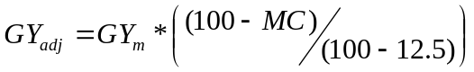 2

where GYadj is adjusted grain yield (kg ha⁻¹) at 12.5% moisture content; GY_{m} is the actual grain yield; MC is the actual moisture content of measured grain yield (%). The BY was measured by weighing the sun-dried plant sample and converted to kg ha⁻¹. The harvest index (HI) was also calculated as the ratio of GY to BY and expressed as a percentage.

Chlorophyll content (CC) was measured using a Chlorophyll meter (SPAD-502 Plus, KONICA MINOLTA, INC, Made in Japan). Five plant samples were selected randomly from internal rows, and measurements were taken from flag leaves (one leaf from each plant).

3.2.6 Data Analysis

3.2.6.1 Statistical analyses

Data analysis was carried out using R statistical software version 4.1.1 (Team, 2021). The detail analysis procedure was provided above in section 2.2. The data for this study were analysed with variety, silicon, and nitrogen as fixed effects and year and replication as random effects. The association between traits was determined by the Pearson correlation method (Gomez and Gomez, 1984). Simple linear regression was applied to define the mathematical relationship between variables.

. Partial budget analysis

A partial budget analysis of treatments was performed following the procedure provided by (CIMMYT, 1988) to estimate the net return (NR) and marginal rate of return (MRR) from the variable input cost of urea, rice husk, and seed and the sale of grain and straw. Additional costs of labor for loading and unloading, transportation, preparation, and application were considered for the analysis of input cost. Other production costs, such as labor for land preparation, harvesting, and threshing, were considered uniform across treatments (fixed costs). The partial budget analysis was performed using the prevailing costs of inputs during sowing and farm-gate prices for outputs during the harvest period. All costs were calculated as the average value of 2021 and 2022 on a per hectare basis. The costs of urea, rice husk, grain, and straw yields kg⁻¹ were 0.5235, 0.0532, 0.8508, and 0.2694 USD, respectively, averaged over the two consecutive years of 2021 and 2022. Grain and straw yields were adjusted down by 10% (CIMMYT, 1988). The total variable cost (TVC) collected in Ethiopian birr was converted to USD and calculated as the sum of the costs of inputs during sowing. Gross return (GR) was calculated as the sum of income obtained from the sale of grain and straw. The net return (NR) was calculated by subtracting TVC from GR. After treatments were arranged in ascending order by TVC value, treatments with a high NR and a lower TVC than the preceding treatment were selected for further analysis; treatments with a lower NR value and a greater TVC than the preceding were excluded. Selected treatments were subjected to marginal rate of return (MRR) analysis, which was calculated as the ratio of change in NR to change in TVC of two consecutive treatments (Equation 3). The final decision of the profitable treatment was made using two criterions: First, the treatments having equal and above the minimum MRR (=100%) was chosen, then second, among the chosen, the one having higher NR was recommended as the ranked as a first treatment.

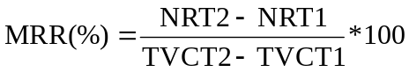 3
where, MRR is marginal rate of return ($US); NRT1 and NRT2 are the total net return ($US) of the first and the second consecutive treatments, respectively; TVC1 and TVC2 are the total variable costs ($US) for the first and second consecutive treatments, respectively.

3.3. Results and Discussion

3.3.1 Effect of Nitrogen and Silicon on Selected Traits of Tef Varieties

The main and interaction effects of nitrogen, silicon, and variety on stem diameter, plant height, number of plants m⁻², and leaf area index are presented below (Table 3.2). The combined analysis over years showed that stem diameter was significantly influenced by the main effect of nitrogen (p<.001). The supply of nitrogen has also significantly influenced tef plant height (p<.0001), number of plants m⁻¹ (p<.01), leaf area index (P<.0001), and panicle length (p<.0001). However, the main or interaction effects of variety and Si did not significantly (p>.05) affect all those traits except PL, which was significantly (p<.01) influenced by varietal difference (Table 3.3). The ANOVA results also showed that the LI of tef was significantly affected by the main effects of nitrogen (p<.0001) and silicon (p<.05) irrespective of the variety. The interaction of variety, silicon, and nitrogen was also significant (P<.001) (Table 3.4).

The highest stem diameter (1.73 mm) was recorded from the application of 92 kg ha⁻¹, while the lowest one (1.51 mm) was from 0 kg ha⁻¹ nitrogen. The measured stem diameter showed a declining trend with the decrease in the rate of N application (Table 3.2). The highest plant height of 114.5 cm, followed by 108.3 cm, was recorded from the application of 92 and 46 kg ha⁻¹ nitrogen, respectively, during the first production year. The lowest PH 59.8 cm followed by 81.7 cm was measured at 0 and 23 kg ha⁻¹ nitrogen, respectively, during the second season. The pooled mean indicated that the highest LAI (3.67) was measured from the application of 92 kg ha⁻¹ nitrogen, while the lowest (1.23) was obtained from 0 kg ha⁻¹ nitrogen. The application of 92 kg ha⁻¹ nitrogen consistently provided the longest panicle length of any other nitrogen treatment level, with 43.5 and 37.7 cm in 2021 and 2022, respectively (Table 3.3). The shortest panicle length of 23.9 cm, followed by 38.3 cm, was recorded from 0 kg ha⁻¹ nitrogen in 2022 and 2021, respectively. Highest lodging of 71.9%, followed by 65.6%, was observed from Quncho variety with the application of 92 kg N ha⁻¹ and no silicon supplement. The lowest LI (0%) was recorded from Heber-1 variety without silicon and nitrogen application, but it was not statistically different from V1Si1N2, V2Si1N1, V2Si1N2, V2Si2N1, and V1Si2N1. A medium level of lodging index was recorded from V1Si1N3 (25.0%), followed by V2Si1N3 (31.3%).

Table 3.2. The effect of nitrogen on stem diameter (SD), plant Height (PH), NP, and its variability over the two years

Nitrogen (kg ha⁻¹) | SD (mm) |  |  | PH (cm) |  |  | NP (N m⁻²) |  |  | LAI
Nitrogen (kg ha⁻¹) | 2021 | 2022 | COY | 2021 | 2022 | COY | 2021 | 2022 | COY | 2021 | 2022 | COY
0 | 1.513 | 1.510^{c} | 1.51^{c} | 94.8^{c} | 59.8^{d} | 77.3^{d} | 1162.8^{c} | 2137.5^{b} | 1650.1^{b} | 1.44^{d} | 1.03^{d} | 1.23^{d}
23 | 1.47 | 1.732^{b} | 1.60^{bc} | 105.0^{b} | 81.7^{c} | 93.3^{c} | 1203.0^{bc} | 2228.8^{ab} | 1715.9^{b} | 2.21^{c} | 1.78^{c} | 1.99^{c}
46 | 1.52 | 1.733^{b} | 1.63^{b} | 108.3^{b} | 93.8^{b} | 101.0^{b} | 1445.8^{ab} | 2570.8ª | 2008.3ª | 2.75^{b} | 2.53^{b} | 2.64^{b}
92 | 1.58 | 1.88ª | 1.73ª | 114.5ª | 105.3ª | 109.9ª | 1492.5ª | 2508.3ª | 2000.4ª | 3.86ª | 3.47ª | 3.67ª
Mean | 1.52^{b} | 1.71ª | 1.62 | 105.7ª | 85.1^{b} | 95.4 | 1326.0^{b} | 2361.3ª | 1843.7 | 2.57ª | 2.20^{b} | 2.38
SE | 0.05 | 0.04 | 0.04 | 1.27 | 1.68 | 1.06 | 113.8 | 113.8 | 80.5 | 0.15 | 0.12 | 0.10
LSD_{0.05} |  | 0.11 | 0.10 | 3.61 | 4.80 | 2.97 | 64.0 | 88.1 | 56.5 | 0.42 | 0.34 | 0.29
N | ns | *** | *** | *** | *** | *** | * | . | ** | *** | *** | ***
Y | - | - | *** | - | - | *** | - | - | *** | - | -
V | ns | ns | ns | ns | ns | ns | ns | ns | ns | ns | ns | ns
Si | ns | ns | ns | ns | ns | ns | ns | ns | ns | ns | ns | ns
Y*V | - | - | ns | - | - | ns | - | - |  | - | -
Y*Si | - | - | ns | - | - | ns | - | - |  | - | -
Y*N | - | - | * | - | - | *** | - | - |  | - | -
V*Si | ns | ns | ns | ns | ns | ns | ns | ns | ns | ns | ns | ns
V*N | ns | ns | ns | * | ns | ns | ns | ns | ns | ns | ns | ns
Si*N | ns | ns | ns | ns | ns | ns | ns | ns | ns | ns | ns | ns
Y*V*Si | - | - | ns | - | - | ns | - | - |  | - | -
Y*V*N | - | - | ns | - | - | ns | - | - |  | - | -
Y*Si*N | - | - | ns | - | - | ns | - | - |  | - | -
V*Si*N | ns | ns | ns | ns | ns | ns | ns | ns | ns | ns | ns | ns
Y*V*Si*N | - | - | ns | - | - | ns | - | - | ns | - | - | ns
CV (%) | 13.0 | 9.2 | 12.5 | 4.8 | 7.9 | 6.3 | 27.5 | 21.0 | 24.7 | 23.2 | 21.7 | 24.3
SE, V, Si, N, CV, SD, PH, NP, LAI, are standard error, variety, silicon, nitrogen, coefficient of variation, stem diameter, plant height, and number of plants per m⁻², respectively; means connected with the same letter within the column were not significantly different; means for the main effect of nitrogen were separated using LSD t test; sig, significance; *** significant at p<0.001; ** significant at p<0.01 *significant at p<0.05; .significant at p<0.1; ns, not significantly different

Table 3.3. The main and interaction effect of variety, nitrogen, and silicon on tef panicle length (cm) and its variability over the years

Factor | Unit | Factor level | Year |  | COY | LSD_{0.05}
Factor | Unit | Factor level | 2021 | 2022 | COY | LSD_{0.05}
N |  | 0 | 38.3^{c} | 23.9^{d} | 31.1^{d}
N | kg ha⁻¹ | 23 | 41.7^{b} | 30.6^{c} | 36.1^{c}
N |  | 46 | 42.0^{b} | 34.6^{b} | 38.3^{b}
N |  | 92 | 43.5ª | 37.7ª | 40.6ª
SE |  |  | 0.51 | 0.69 | 0.43
LSD_{0.05} |  |  | 1.44 | 1.96 | 1.2
V*N |  |  | * | ns | ns
N*Si |  |  |  |  | ns
Y |  |  | - | - | ***
Y*N |  |  | - | - | ***
V |  | Hebir-1 | 42.0ª | 32.5ª | 37.3ª
 |  | Quncho | 40.7^{b} | 30.9^{b} | 35.8^{b}
SE |  |  | 0.36 | 0.49 | 0.30
LSD_{0.05} |  |  | 1.02 | 1.38 | 0.85
V*Si |  |  | ns | ns | ns
V*Y |  |  | - | - | ns
Si | kg ha⁻¹ | 0 | 41.3 | 31.9 | 36.555 | ns
Si |  | 485 | 41.5 | 31.6 | 36.550 | ns
SE |  |  | 0.36 | 0.49 | 0.30
Mean (Y) |  |  | 41.4ª | 31.7^{b} | 36.6 | 0.85
Si*Y |  |  | * |  | ns
V*Si*N |  |  |  | ns | ns
Y*V*Si*N |  |  | - | - | ns
CV (%) |  |  | 4.9 | 8.7 | 6.6

Means connected with the same letter are not significantly different (independently for each columns within factor); mean effects were compared through LSMeans student’s for treatments below five (nitrogen, variety, and year) and Tukey HSD tests with treatments above five (N*Y interaction); *** significant (p<.0001); Y, V, N, and Si, COY are year, nitrogen, silicon, variety, and combined over years, respectively

Table 3.4. The interaction effect of nitrogen, silicon and variety on lodging index of tef

Variety | Nitrogen rate | 2021 |  |  |  | 2022 |  |  |  | COY
Variety |  | Silicon Rate (kg ha⁻¹) |  |  |  | Silicon Rate (kg ha⁻¹) |  |  |  | Silicon Rate (kg ha⁻¹)
Variety | Kg ha⁻¹ | 0 | 485 | Mean | 0 |  | 485 | Mean | 0 |  | 485 | Mean | Mean
Heber-1 | 0 | 0.00e | 0.0e | 0.0^{d} | 0.0e |  | 0.0e | 0.0^{d} | 0.0^{f} |  | 0.0^{f} | 0.0^{c} | 26.6
Heber-1 | 23 | 0.00e | 25.0^{d} | 12.5^{d} | 0.0e |  | 0.0e | 0.0^{d} | 0.0^{f} |  | 12.5^{ef} | 6.3^{c} | 26.6
Heber-1 | 46 | 25.0^{d} | 62.5^{ab} | 43.8^{bc} | 25.0^{d} |  | 50.0^{bc} | 37.5^{c} | 25.0de |  | 56.3^{bc} | 40.6^{b} | 26.6
Heber-1 | 92 | 50.0^{bc} | 62.5^{ab} | 56.3^{ab} | 56.3^{abc} |  | 68.8^{ab} | 62.5ª | 53.1^{bc} |  | 65.6^{ab} | 59.4ª | 26.6
Quncho | 0 | 0.0e | 0.0e | 0.0^{d} | 0.0e |  | 0.0e | 0.0^{d} | 0.0^{f} |  | 0.0^{f} | 0.0^{c} | 27.7
Quncho | 23 | 0.0e | 25.0^{d} | 12.5^{d} | 0.0e |  | 0.0e | 0.0^{d} | 0.0^{f} |  | 12.5^{ef} | 6.3^{c} | 27.7
Quncho | 46 | 37.5^{cd} | 50.0^{bc} | 43.8^{bc} | 25.0^{d} |  | 50.0^{bc} | . 37.5^{c} | 31.3^{d} |  | 50.0^{c} | 40.6^{b} | 27.7
Quncho | 92 | 75.0ª | 56.3^{abc} | 65.6ª | 68.8^{ab} |  | 56.3^{abc} | 62.5ª | 71.9ª |  | 56.25^{bc} | 64.1ª | 27.7
 | Mean | 23.4^{c} | 35.2ª | 29.3ª | 21.9^{c} |  | 28.1^{b} | 25.0^{b} | 22.7^{b} |  | 31.6ª | 27.1 | ns
 | SE | 4.4 | 4.4 | 2.68 | 3.2 |  | 3.2 | 2.68 | 2.68 |  | 2.68 | 1.9
 | CV (%) | 29.7 |  |  | 25.8 |  |  |  | 28.0

SE, standard error; CV, coefficient of variation; means within the same year were compared by Tukey HSD test; means between varieties, silicon and year were compared using Least significance difference (LSD) student’s t test; means connected by the same letter were not significantly different with LSD_{0.05} = 2.4026

An increased plant height with a high rate of nitrogen was in agreement with (Tamirat Wato et al., 2020), who found a longer plant height (120.1 cm) at a high rate of nitrogen (90 kg ha⁻¹) application than the low rates. The effectiveness of soil nitrogen supply decreases with the season, as indicated by the decrease in plant height in all of the applied nitrogen rates with the same rate of application (Table 3.2). The decline in soil nutrients might be attributed to the difference in weather and lack of fertilization during the production of the rotating crop (Lupine during the first and Niger seed crop during the second growing season that influences the concentration of the nutrients) (Congreves et al., 2021). The result showed that the application of nitrogen could increase the plant population due to an increase in tiller numbers and maintain the stand performance of mother plants as compared to non-nitrogen treatment. The seasonal variability of plant populations per m⁻² could be attributed to the difference in available nitrogen resources in the soil caused by residual nutrient effect on the number of tillers per plant. This was in line with the finding of Tamirat Wato (2021), who found the highest plant tiller number per plant (13.8) of tef with the application of 97.5 kg ha⁻¹ nitrogen. The reason for the seasonal variation in certain traits of tef could be attributed to the nature of the rotating cover crop (Wagg et al., 2021), as tef was preceded by non-nitrogen-treated white lupine in the first year compared to non-nitrogen treated Niger seed in the second year.

The result generally showed that an increased application rate of nitrogen from 0 kg ha⁻¹ to 92 kg ha⁻¹ provided an actual mean difference in leaf area index of 2.44, which was higher by 198.4%, while the minimum difference was 61.8%. Both separate and COY analysis results showed a similar trend of leaf area index increment due to changes in nitrogen. This was confirmed by the strongly positive correlation (r = 0.841) between nitrogen rate and leaf area index (Appendix Table 1). The result was similar with the earlier results obtained by (Kakabouki et al., 2021) and it showed a positive correlation (r = 0.53) among leaf area index and nitrogen.

Increasing nitrogen application from 0 to 92 kg ha⁻¹ resulted in a 2.2–30.5% increment change in panicle length. In terms of variety, Hebir-1 provided a larger panicle length (37.1 cm). The observed difference among nitrogen treatments in terms of PL may be due to the increased availability and uptake of the nutrient, which has an effect on leaf expansion, chlorophyll concentration, and photosynthesis activity of the plant. Similar findings were observed by (Wato, 2021), who reported the longest tef panicle length (44.9 cm) at a rate of 97.5 kg N ha⁻¹ application. The varietal change might be due to their genotypic variation (Bekana & Assefa, 2021). An overall mean performance of tef in terms of panicle length decreases significantly over the growing season by 9.7 cm (obtained from the two season mean difference), irrespective of nitrogen and silicon application, which could be due to the difference in cover crops.

The increase in lodging index could be mainly associated with an increase in leaf area index, above-ground biomass yield, plant height, and panicle length that facilitated the delicacy of tef to stem bending. This was confirmed by their strong positive correlations of r = 0.78, 0.76, 0.61, and 0.47, respectively with lodging index (Appendix Table 1). The result was in line with the findings of (Kiros Habtegebrial et al., 2007; Tesfahun, 2018; Wato, 2021) who associated the lodging with the change in plant growth, which is affected by the nitrogen application rate (Solomon Chanyalew et al., 2019). However, the non-significance difference between Hiber-1 and Quncho varieties in terms of lodging index was contradicting with the results of in who reported that Hiber-1 is a lodging-sensitive Tef variety. This might be attributed to their similarity to the nitrogen response expressed on plant traits of PH and LAI, which had a strong association with LI, with r values of 0.61 and 0.7818, respectively (Appendix Table 1).

3.3.2 Yield and Yield Components of Tef Varieties

The pooled mean analysis result for the main effect of nitrogen and its interaction with Si application on grain and above-ground biomass yields is presented below in Table 3.5, while the regression graph indicating their relationship with nitrogen is presented in Figure 3.3. The results indicated that GY and BY of tef responded significantly to the application of nitrogen (p<.0001), regardless of silicon application or tef variety (Table 3.5). The results also showed that the interaction of Si and N significantly (p<.05) influenced both GY and ABY. Moreover, the effect of nitrogen varied over the growing season on both GY (p<.0001) and ABY (p<.001) (Table 3.5). Furthermore, the result showed that there was a significant interaction effect of year, variety, and silicon on the BY of tef (p<0.05) (Table 3.5). The HI of tef was significantly (p<.0001) influenced by the main effect of nitrogen in both 2021 and 2022. The interaction of silicon, variety, and nitrogen also significantly (p<.05) affected the HI of tef during 2022, but not in 2021 (Table 3.6). The mean HI of Quncho was significantly (p<.01) higher than the Heber-1 variety (Table 3.6).

The pooled mean result showed that maximum grain yield (1789.8 kg ha⁻¹) was obtained from the application of Si1N4, but was not significantly different from Si2N4 (1739.5 kg ha⁻¹) followed by Si1N3 (1644.69 kg ha⁻¹). The lowest GY of tef (612.4 kg ha⁻¹) was recorded from the Si1N1 (Table 3.5). The effect of nitrogen varied over the years, with the highest GY (2042.4 kg ha⁻¹) obtained from Y2Si2N4, but not significantly different from 2042.0 kg ha⁻¹ from Y2Si1N3, whereas the lowest GY (412.4 kg ha⁻¹) was also recorded from Y2Si1N1, followed by Y2Si2N1 (565.9 kg ha⁻¹) (Table 3.5).

The highest above-ground biomass yield of 6669.8 kg ha⁻¹ was obtained from 92 kg N ha⁻¹ without the application of silicon, which was combined over years followed by the same nitrogen rate with an application of 485 kg CRH ha⁻¹ (6574.1 kg ha⁻¹), but that did not show any significant difference (Table 3.5). In addition, the interaction of silicon with nitrogen was significant in the growing seasons, so during the first growing season 92 kg N ha⁻¹ without silicon supplement provided the highest above-ground biomass yield of 7013 kg ha⁻¹ but was not significantly different from Si2N4, Si1N4, Si2N4, and Si1N3, which provided 6781.9, 6326.8, 6366.4, and 5994.9 kg ha⁻¹, respectively. The lowest ABY was obtained from Y2Si1N1 (1047.4 kg ha⁻¹), which was not significantly separated from Y2Si2N1 (1507.7 kg ha⁻¹).

The harvest index ranged from 20.4 to 42.1%, with the highest recorded harvest index being from Quncho in 2022, which received neither nitrogen nor Si treatments, while the minimum harvest index was obtained from the same variety with the application of 92 kg N ha⁻¹ and 0 Si in 2021 (Table 3.6). This could be attributed to the rate and solubility of the silicon source fertilizer (Meena et al., 2014). The overall mean harvest index indicated an improvement in 2022 over 2021.
Table 3.5. The main and interaction effect of silicon, variety, nitrogen on grain and biomass yield of tef

Silicon | Nitrogen | GY |  |  |  | ABY
kg ha⁻¹
kg ha⁻¹ |  | 2021 |  | 2022 | COY | 2021 | 2022 | COY
0 | 0 | 812^{fgh} |  | 412^{h} | 612^{d} | 2655^{d} | 1047e | 1851 e
0 | 23 | 1429^{b-e} |  | 1015^{efg} | 1222^{c} | 4643^{bc} | 2756^{d} | 3700^{cd}
0 | 46 | 1670^{ab} |  | 1619^{abc} | 1645^{ab} | 5995^{ab} | 4474^{c} | 5235^{b}
0 | 92 | 1538^{bc} |  | 2042ª | 1790ª | 7013ª | 6327ª | 6670ª
Mean |  | 1362ª |  | 1272^{ab} | 1317 | 5077ª | 3651^{c} | 4364
485 | 0 | 854^{fgh} |  | 566^{gh} | 710^{d} | 2780^{d} | 1509de | 2144e
485 | 23 | 1149^{c-f} |  | 1041^{d-g} | 1095^{c} | 4195^{c} | 2633^{d} | 3414^{d}
485 | 46 | 1186^{b-f} |  | 1507^{bcd} | 1347^{bc} | 4572^{c} | 4206^{c} | 4389^{bc}
485 | 92 | 1437^{b-e} |  | 2042ª | 1740ª | 6366ª | 6782ª | 6574ª
Mean |  | 1157^{b} |  | 1289^{ab} | 1223 | 4478^{b} | 3783^{c} | 4130
SE |  | 113.1 |  | 82.5 | 69.3 | 286.8 | 262.3 | 199.3
Si |  | * |  | ns | ns | * | ns | ns
V |  | ns |  | ns | ns | ns | ns | ns
N |  | *** |  | *** | *** | *** | *** | ***
Si*N |  | ns |  | ns | * | ns | ns | *
Y*N |  |  |  |  | *** |  |  | **
Y*Si |  | * |  |  | * | * |  | *
Y*V |  | ns |  |  |  | ns
V*Si |  | ns | ns |  | ns | ns | ns | ns
V*N |  | ns | ns |  | ns | ns | ns | ns
Y*Si*N |  | ns |  |  |  | ns
Y*V*Si |  | * |  |  |  | *
Y*V*Si*N |  | ns |  |  |  | ns

SE, Standard error; Y, Year; N, nitrogen; V, variety; Si, silicon, Si*V, interaction of silicon and variety; Y*N, interaction of year and nitrogen; Y*Si interaction of year and silicon; Y*V interaction of year and variety; V*Si, interaction of variety and silicon; V*N, interaction of variety and nitrogen; Y*Si*N, interaction of year, silicon, and nitrogen; Y*V*Si, interaction of year, variety and silicon; Y*V*Si*N, interaction of year, variety, silicon and nitrogen; ns, non-significant; ***significant at p<0.0001; **Significant at p<0.001; *significant at p<0.05

The fitted linear regression line graph (Figure 3.1), constructed from data combined over both years, indicated the linear increment of GY with the change in the rate of nitrogen application. The highest ordered difference in grain yield (1103.3 kg ha⁻¹) was obtained between 92 and 0 kg N ha⁻¹, followed by 834.4 kg ha⁻¹ from 46 and 0 kg N ha⁻¹, while the lowest grain yield difference (268.9 kg ha⁻¹) was recorded from 92 and 46 kg N ha⁻¹. The gain in GY of tef was about 166.9, 126.2, and 75.2% through the application of 92, 46, and 23 kg N ha⁻¹, respectively, compared to the control treatment, which provided only 661.3 kg ha⁻¹. Generally, for the change in every single unit of nitrogen, grain yield increased by 11.519 kg. The simple linear regression graph (Figure 3.1) showed that for each unit of change in nitrogen, the above-ground biomass yield increases by about 49.4 kg. The changes in ABY were also shown by the significantly strong positive correlation with the application of nitrogen (r = 0.85, p<.0001) (Appendix Table 1).

F

F
E

E
C
D

D
B

B
A

A
Figure 3. 1. The fitted linear regression showing the relationship between rate of nitrogen and mean yields of tef crop: A) nitrogen versus grain yield in 2021 growing season, B) nitrogen versus biomass yield in the year 2021, C) nitrogen versus grain yield in 2022 growing season, D) nitrogen versus biomass yield in 2022, E) nitrogen versus grain yield based on the pooled mean over the two growing seasons (2021/22), F) nitrogen versus biomass yield based on the pooled mean over the two growing season (2021/22); GY is Grain yield; BY is Biomass yield; R² is coefficient of determination; x and y represents the values of independent and dependent variables, respectively for the corresponding graph.
The increase in grain yield in relation to nitrogen supply alone could be attributed to the increase in photosynthetic activity caused by the increase in leaf chlorophyll content and leaf area index that enhance light interception (Kamran et al., 2020; Mubarak et al., 2022). The decline in grain yield observed in the second season from 0 kg N ha⁻¹ compared to the same rate in the first season might be attributed to the decrease in soil nitrogen in the control plot that was intensively taken by Niger-seed (cover crop) in addition to the tef crop without any compensation for their requirement (Boselli et al., 2020; Fontaine et al., 2020). A significant grain yield improvement in wheat was obtained with the incorporation of legumes as a preceding crop (Ooro et al., 2021) in addition to fertilization. Though the difference in grain yield was not significant in both years, a lower overall mean grain yield was recorded during the first production year than the second. This could be attributed to shattering and lodging, which caused regrowth and a molding effect because of the rain that fell during the late stage of the first season (Fikremariam Mihretie et al., 2021). The residual nitrogen left from the previous cropping season might also contribute to the difference (Tamirat Wato et al., 2020).

The non-significant effect of Si on above-ground biomass yield was not in agreement with Ligaba-Osena et al. (2020), who reported above-ground biomass yield improvement from the application of sodium silicate as a Si source. This could be attributed to the efficiency and rate of silicon fertilizer source. The silicon effect on the same variety reversed during the second season and showed trends of increment, but the change was not significant, whereas Quncho showed a similar trend over the years, which could be due to the variation in their genetic makeup (Ligaba-Osena et al., 2020).

The harvest index tef decreased with the application of nitrogen in both years, regardless of the variety as nitrogen is associated with biomass than grain yield (Kebebew Asfaw et al., 2020; Tamirat Wato, 2021). The higher harvest index in 2022 than in 2021 might be attributed to either the decrease in nitrogen level in the soil (Asfaw et al., 2020) or the residual effect of CRH applied in the previous growing season which increase the maximum number of seeds per spike (Meena and Prakasha, 2020). The significant difference observed in harvest index among tef varieties during 2022 could be associated with genetic variation (Kebebew Assefa et al., 1999; Solomon Chanyalew et al., 2019).

Table 3.6. The effect of silicon and nitrogen application on the harvest index of tef varieties

Variety | Nitrogen | 2021 |  |  | 2022 |  |  | COY
Variety | Nitrogen | Silicon Rate
Variety |  | kg ha⁻¹
Variety | Kg ha⁻¹ | 0 | 485 | Mean | 0 | 485 | Mean | 0 | 485 | Mean
Heber-1 | 0 | 29.5^{a-e} | 30.7^{a-d} | 30.1^{ab} | 36.5^{a-d} | 37.8^{a-d} | 37.1^{ab} | 33.0^{a-d} | 34.3^{ab} | 33.6^{ab}
Heber-1 | 23 | 32.3^{ab} | 28.1^{a-e} | 30.2^{ab} | 37.3^{a-d} | 38.4^{ab} | 37.9^{ab} | 34.8^{ab} | 33.3^{abc} | 34.0^{ab}
Heber-1 | 46 | 26.1^{a-e} | 26.5^{a-e} | 26.3^{bcd} | 35.6^{bcd} | 34.7^{bcd} | 35.2^{bc} | 30.9^{b-e} | 30.6^{b-f} | 30.7^{b}
Heber-1 | 92 | 23.1^{cde} | 21.6de | 22.4^{cd} | 32.5^{cde} | 28.8e | 30.6^{d} | 27.8^{c-f} | 25.2^{f} | 26.5^{c}
Quncho | 0 | 32.9ª | 31.3^{abc} | 32.1ª | 42.1ª | 38.1^{abc} | 40.1ª | 37.5ª | 34.7^{ab} | 36.1ª
Quncho | 23 | 28.7^{a-e} | 27.1^{a-e} | 27.9^{ac} | 36.4^{a-d} | 41.7ª | 39.0ª | 32.6^{a-d} | 34.4^{ab} | 33.5^{ab}
Quncho | 46 | 29.3^{a-e} | 25.3^{a-e} | 27.3^{a-d} | 37.1^{a-d} | 37.2^{a-d} | 37.2^{ab} | 33.2^{a-d} | 31.3^{b-e} | 32.2^{b}
Quncho | 92 | 20.4e | 23.3^{b-e} | 21.8^{d} | 32.2de | 32.0de | 32.1^{cd} | 26.3^{ef} | 27.7^{def} | 26.9^{c}
 | Mean | 27.8ª | 26.8ª | 27.3^{b} | 36.2ª | 36.1ª | 36.2ª | 32.0ª | 31.4ª | 31.7
 | SE | 1.80 | 1.80 | 1.27 | 1.15 | 1.15 | 0.81 | 1.1 | 1.1 | 0.79
 | CV (%) | 13.2 |  |  | 6.4 |  |  | 10.0
V*Si |  | ns |  |  | * |  |  | ns
V*Si*N |  | ns |  |  | . |  |  | .

SE, CV, coefficient of variation; Standard Error; V*Si, interaction of variety and silicon; V*Si*N, interaction between variety, silicon and nitrogen; means represented with the same letter are not significantly different at LSD_{.05}, *interaction was significant at p<0.05; interaction was significant at P<.01

3.3.3 Chlorophyll Content

The chlorophyll content of tef was significantly (p<.0001) influenced by the main effect of nitrogen in both years. It was also affected significantly (p<.05) by the main effect of variety only during 2021 (Table 3.7). However, the interaction effect of all the factors was not significant (p>.05) during the two years. Maximum CC was observed from the application of N4, which was 28.7, 9.9, and 5.6% more than N1, N2, and N3 treatments, respectively. Chlorophyll content had a significantly (p<.0001) positive correlation with N, PH, PL, LAI, LI, GY, and BY, expressed by r equal to 0.7338, 0.8102, 0.6933, 0.7081, 0.6217, 0.7445, and 0.8127, respectively, but its relation with HI was significantly (p<.0001) negative with r equal to -0.5074 (Appendix Table 1).

Table 3.7. The main and interaction effect of nitrogen, silicon, and variety on the chlorophyll content (SPAD unit) of tef leaf

Factor | Unit | Factor level | Year |  |  |  |  | COY | LSD_{0.05}
Factor | Unit | Factor level | 2021 |  | 2022 |  |  | COY | LSD_{0.05}
Nitrogen |  | 0 | 32.0^{d} |  | 26.5^{c} |  |  | 29.3^{d}
Nitrogen | kg ha⁻¹ | 23 | 35.2^{c} |  | 33.5^{b} |  |  | 34.3^{c}
Nitrogen |  | 46 | 36.4^{b} |  | 35.1^{b} |  |  | 35.7^{b}
Nitrogen |  | 92 | 38.0ª |  | 37.5ª |  |  | 37.7ª
SE |  |  | 0.30 |  | 0.55 |  |  | 0.31
LSD_{0.05} |  |  | 0.85 |  | 1.57 |  |  | 0.89
N |  |  | *** |  | *** |  |  | ***
N*Y |  |  |  |  |  |  |  | ***
Silicon | kg ha⁻¹ | 0 | 35.8ª |  |  | 33.4 |  | 34.6
Silicon |  | 485 | 35.0^{b} |  |  | 32.9 |  | 34.0
SE |  |  | 0.21 |  |  | 0.39 |  | 0.22
LSD_{0.05} |  |  | 0.60 |  |  | ns |  | ns
Si*Y |  |  | ns
Variety |  | Hiber-1 | 35.6ª |  |  | 32.9 |  | 34.2 | ns
Variety |  | Quncho | 35.2^{b} |  |  | 33.4 |  | 34.3 | ns
SE |  |  | 0.21 |  |  | 0.39 |  | 0.22
Mean Y |  |  | 35.4ª |  |  | 33.1^{b} |  |  | 0.63
V*Si |  |  | ns
V*Si*N |  |  | ns
CV (%) |  |  | 3.4 | 8.7 |  |  | 5.2

Y, Year; N*Y, interaction of nitrogen and year; Si*Y, interaction of silicon and year; V*Si, interaction of variety and silicon; V*Si*N, interaction effect of variety, silicon and Nitrogen; LSD, least significance difference; ns, not significant at p=0.05; *** significant at p<0.0001; letters represented with the same letters within the columns are not significantly different at LSD_{0.05}

The negative correlation among the chlorophyll content and harvest index might be associated with nitrogen, which relatively contributes more to above-ground biomass production relative increment of grain yield. This result was in line with (Rivera-Amado et al., 2019), who emphasized the importance of optimizing dry matter partitioning with appropriate traits like CC affecting the harvest index of wheat crops. Our result showed that chlorophyll content had been negatively influenced by the application of Si (Table 3.7), which was not in line with the result of (Ligaba-Osena et al., 2020), who stated improvement of chlorophyll content at a lower level of Si application. With an increased Si concentration in soil, its deposition in the leaf increases, this seems to improve the concentration of chlorophyll pigment with an increased rate of silicon (Avestan et al., 2021). The difference could be either due to the silicon rate or the source, which may vary in their Si content.

3.3.4 Partial Budget Analysis

The net return and marginal rate of return were presented in Table 3.8. The maximum NR was recorded from treatment combinations of V1Si1N4, followed by V1Si2N4, with 2552.6 and 2460.8 USD, respectively. The lowest was recorded for V2Si1N1 (658.6 USD), followed by V1Si2N1 (778.7 USD). However, the marginal rate of return indicated that V1Si1N2 has dominated all other treatments with a MRR of 2668.4%, followed by V1Si1N3 (1920.5%), and V1Si1N4 (845.8%). This means treatment V1Si1N2 was considered economically feasible for smallholder farmers with financial constraints and seeking to maximize income with a minimum fertilizer because, for a unit kg of N supply, the Hiber-1 variety of treatment can provide 32.5 USD in additional benefits. For those farmers having no financial limitation V1Si1N4 treatment could be used for maximum net return with about 1005.6 USD further incomes.

Table 3.8. The economic feasibility of silicon and nitrogen application on the net return and marginal rate of return from tef grown in Mecha district combined over the two years

Silicon (kg ha-1) | Nitrogen (kg ha⁻¹) | Variety | Net return (USD) | Variable cost (USD) | Dominance analysis | MRR (%) | Rank
0 | 0 | 1 | 798.27 | 0.00
0 | 0 | 2 | 658.60 | 0.00 | D
0 | 23 | 1 | 1547.01 | 28.06 |  | 2668.4 | 1
0 | 23 | 2 | 1390.33 | 28.06 | D
582 | 0 | 1 | 778.65 | 38.44 | D
582 | 0 | 2 | 922.12 | 38.44 | D
0 | 46 | 2 | 2086.09 | 56.13 |  | 1920.5 | 2
0 | 46 | 1 | 2010.06 | 56.13 | D
582 | 23 | 1 | 1370.82 | 66.51 | D
582 | 23 | 2 | 1316.40 | 66.51 | D
582 | 46 | 1 | 1803.76 | 94.57 | D
582 | 46 | 2 | 1618.57 | 94.57 | D
0 | 92 | 1 | 2552.61 | 111.29 |  | 845. 8 | 3
0 | 92 | 2 | 2369.29 | 111.29 | D
582 | 92 | 1 | 2460.77 | 149.73 | D
582 | 92 | 2 | 2378.61 | 149.73 | D

NR, net return; MRR, marginal rate of return; D, treatments which are dominated; The price of urea, rice husk, tef grain and straw yield kg⁻¹ in ETB were averaged over years and converted to USD, thus their values were 0.5235, 0.0532, 0.8508, and 0.2694 USD, respectively (conversion was based on the average exchange rate of Commercial Bank of Ethiopia); 1 USD = 46.4997 ETB

The increase in MRR for tef was significantly linked to the nitrogen application rate. An optimum amount of nutrient application particularly nitrogen is essential to maximize benefit from tef crop, while both minimum and excess supply could cause significant reduction on both grain and biomass yield, which result in low economic return. Our result is in line with Asfaw et al. (2020) and showed maximum marginal rate of return of 801 and 566% from the application of 46 kg ha⁻¹ nitrogen under scenario 1 (with 23.9 ETB for cost of nitrogen) and 2 (with 27.5 ETB for cost of nitrogen), respectively. The significant reduction of the MRR due to the application of Si in the form of carbonized rice husk was because of the non-significant treatment effect on both grain and straw yield.

3.5 Conclusion

The authors concluded that panicle length and lodging index could be improved by the main effect of variety. Heber-1 provided higher panicle length (37.3 cm) and lower lodging index (26.6%) compared to Quncho 35.8 cm and 27.7% panicle length and lodging index, respectively. In addition, an optimum nitrogen rate of 46 kg N ha⁻¹ can maximize yield with an increment of about 29.13% 126.32% grain yield from 0 and 23 kg N ha⁻¹, respectively and it also showed the third lowest lodging resistance of tef with a mean LI of 40.6%, while silicon application in the form of carbonized rice husk at a rate of 485 kg ha⁻¹ results in no significant effect on tef lodging. However, the future tef productivity improvement and lodging reduction should focus on those management practices, including assessment of cheap and eco-friendly sources of nitrogen due to the inflated market price of the existing inorganic fertilizers, particularly urea; rate, time of application, and source of silicon; and nitrogen application across locations for wide environmental application. The authors suggested profit analysis to select economically feasible moisture depletion level.

Chapter 4. YIELD, LODGING, AND WATER USE EFFICIENCY OF TEF [Eragrostis tef (zucc) Trotter] IN RESPONSE TO CARBONIZED RICE HUSK APPLICATION UNDER VARIABLE MOISTURE CONDITION AT KUDMI, NORTHEAST ETHIOPIA

Mekonnen Gebru Tekle^{a,b*}, Getachew Alemayehuª, Yayeh Bitew^{a¶}
ªDepartment of Plant Sciences, College of Agriculture and Environmental Science, Bahir Dar University, P.O. Box 5501, Bahir Dar, Ethiopia
^{b}Wolkite University, College of Agriculture and Natural Resource Management, Department of Horticulture, P.O.Box 07, Wolkite, Gurage, Ethiopia
*Corresponding author
E-mail address: mekugebru@gmail.com

Abstract

Water resource scarcity is among the major yield limiting factors in the study area, where irrigation has been practiced to maximize crop production. Therefore, a study was conducted to assess the effect ofof varying moisture depletion levels (MDL) and the application of carbonized rice husk (CRH) on the yield and lodging of tef. A two-year 4×4 factorial experiment with 20, 35, 55, and 75% MDL (main-plot factor) and 0, 291, 582, and 873 kg ha⁻¹ of CRH (sub-plot factor) was laid out in a split-plot design, with each treatment replicated four times. The pooled mean ANOVA showed leaf area index and lodging index were not significantly influenced by the main and interaction effects of moisture depletion level and CRH (p > 0.05). However, individual year ANOVA showed that both lodging index and leaf area index were influenced by the interaction of moisture depletion level and CRH (p<0.05) in 2021 and 2022, respectively. The lowest lodging index (19.7%) was obtained from the application of 873 kg CRH ha⁻¹, followed by 20.6% from 582 kg CRH ha⁻¹ in 2022. A 20.7% lodging index reduction was recorded in 2022 compared to 2021. Tef plant height and number of tillers per plant were significantly affected by moisture depletion level at p<0.05 and p<0.01, respectively, but not by carbonized rice husk and its interaction with moisture depletion level. The effect of moisture depletion level was significant on tef harvest index (p<0.01) but not on traits including grain yield, straw yield, and water use efficiency. In conclusion, the pooled mean analysis result showed that, though there was no significant difference in yield, tef irrigated at 55% moisture depletion level provided a highest harvest index of 33.8%, which was 6.21% more than the control, and increased the level of lodging resistance with a lodging index of 31.9%, which was next to 75% moisture depletion level with 582 kg ha⁻¹ carbonized rice husk. Generally, they suggested that the research should further be verified across locations for wide application.

Key words: carbonized rice husk, Heber-1, moisture depletion level, silicon

4.1. Introduction

Drought and lodging are among the major problems in agricultural crop production in Ethiopia. Drought reduces the yield of crops, restricts growth and photosynthesis, changes morphology, decreases chlorophyll content, and affects ion balance in plants (Mahajan and Tuteja, 2005). The majority of farmers in Ethiopia are engaged in smallholder, dry-land agricultural systems (Rockström et al., 2009), which are vulnerable to drought caused by inter-annual rainfall variability and uptake by plants (Viste et al., 2013). Many reports also showed the effect of drought on nutrient availability and uptake by plants (Haefele et al., 2008; He and Dijkstra, 2014; Rouphael et al., 2012; Viste et al., 2013). In recent years, the increase in prices of food crops in the local and international markets has increased the interest of farmers and the government in producing tef under irrigation. However, heavy fertilization and uncontrolled flooding could result in the lodging of plants and a reduction in the yield of crops. Therefore, the use of efficient water management along with an optimum rate of beneficial nutrient fertilizers is essential since water is becoming scarce (Yenesew Yihun et al., 2013) and to minimize crop yield loss (Zahoor et al., 2019).

Lodging, another yield limiting factor, has been reducing yield and quality of cereal crops (Peng et al., 2014; Zhang et al., 2014), which is attributed to low assimilation supply during the grain filling stage (Acreche and Slafer, 2011). Lodging is a serious problem that could generally result in a significant economic loss of the crop (Baker et al., 2014). Lodging under natural condition could cause up to 22% total Tef grain yield loss, 35% of 1000-kernel weight, and 51% of grain yield per panicle (Solomon Chanyalew et al., 2019).

Application of growth hormones like giberelline induces lodging resistance by inhibiting plant height in tef (Solomon Chanyalew et al., 2019). The idea of improving lodging resistance through regulation of plant height was also stated by many other researchers (Chu et al., 2023; Lyu et al., 2021; Niu et al., 2021; Wu et al., 2023). Other organic compounds like paclobutrazol improve the stem strength of wheat by increasing lignin accumulation and its related enzyme activity in the basal second internode (Baker et al., 2014; Solomon Chanyalew et al., 2019; Chu et al., 2023; Lyu et al., 2021; Niu et al., 2021; Peng et al., 2014; Wu et al., 2023; Zhang et al., 2014; Jihao Zhao et al., 2023). However, paclobutrazol caused a significant reduction in plant height (Kebebew Assefa et al., 2016), which could not be acceptable by farmers, as the straw has multiple benefits for their livelihood. In barley-pea intercropping, mechanical support from barley was found to be useful to reduce the lodging effect of pea (Podgórska-Lesiak and Sobkowicz, 2013), but it could be less applicable for tef because of severe resource competition and difficulty of harvesting.

Many other research reports stated the positive effect of silicon fertilization on the yield and lodging resistance (Gong et al., 2021; Liu et al., 2022), disease (Rajput et al., 2021), and water stress tolerance (Olagunju et al., 2022; Raza et al., 2023) of various high silicon accumulating monocotyledon crops and sugar cane (Meena et al., 2014). Another researcher also found significant effect of silicon in the form of potassium silicate on improving water use efficiency of maize crops (Gomaa et al., 2021). However, some of the low silicon accumulating crops, such as potato (Crusciol et al., 2009) and tomato, were also found responsive to silicon. According to (Ma et al., 2016), the defensive property of silicon can help reduce the use of pesticides. The application of silicon increases light interception (Yan et al., 2018), P availability by increasing root exudation of organic acids that mobilize phosphorus (Pi) in the rhizosphare and up-regulated Pi transporters (Kostic et al., 2017). Silicon also the capacity to avoid heavy metal toxicity (Savant et al., 1999) through co-precipitation in the soil media or regulation of the expression of metal transport gene (Adrees et al., 2015), thus, biomass and grain yield of crops can be maximized. Three foliar applications of Silixol resulted in an average yield increment of about 15% in rice (Bosnic et al., 2018). As per Maillard et al. (2018), silicon transcriptionally regulates sulfur and abscisic acid metabolism and delays leaf senescence in barley under combined sulfur deficiency and osmotic stress. Moreover, Bosnic et al. (2018) indicated the regulation of sodium transportation and distribution in maize plants growing in mild salt stress conditions. Sorghum grown under water stress conditions can provide the highest yield with a synergetic effect of irrigation and increased silicon uptake (Meena et al., 2014). The application of silicon in the form of orthosilicic acid (H₄SiO₄) positively affected the growth, yield, and nutrient uptake of rice in tropical zones of Vietnam (Cuong et al., 2017).

The uptake of Si is as high as that of other macronutrients like P, N, and Ca in high accumulating crops like rice and sugar cane. Plants absorb Si in the form of orthosilicic acid (H₄SiO₄), which is not very mobile in plants. Three mechanisms of absorption are known for Si uptake: passive, active and exclusion. The first two mechanisms are common in high Si accumulating plant species. Tissue analysis from a wide variety of plants showed that silicon concentrations range from 1 to 100 g Si kg⁻¹ of dry weight, depending on plant species. On average monocot plants absorb 50 to 200 kg of Si ha⁻¹. The largest amounts of silicon are absorbed by sugarcane (300–700 kg of Si ha⁻¹), rice (15–300 kg of Si ha⁻¹), and wheat (5–150 kg of Si ha⁻¹) (Bosnic et al., 2018).

Although Si is abundant in the earth’s crust, its available form, which is orthosilicic acid (OA), is low to supply the need for plants in a highly weathered soils. The upper 20 cm soil layer contains only an average of 0.1 to 1.6 kg Si ha⁻¹ as orthosilicic acid (Epstein, 1994). Inorganic silicon sources were used most commonly for research as well as production of cereals, however, they may not be eco-friendly (Liang et al., 2015) or locally available, so alternative organic sources need to be uncovered. Rice husk is considered as organic source of Si with an estimated silica content of 60 to 90% (Moayedi et al., 2019; Shen et al., 2014). In addition, it is cost effective and has a capability to improve soil carbon when applied in carbonized form (Koyama and Hayashi, 2017).

Tef is an annual C₄ plant species that adapted to various climatic and soil conditions including arid and semi-arid regions in Ethiopia (Gelaw and Qureshi, 2020). Drought tolerance mechanism of tef was found to be related to the increase in flavonoid, serine and glycine amino acids, sugars (ribose, myo-inositol), and fatty acids content (Girija et al., 2022). The multiple use and wide adaptation make the crop preferred both by the growers and consumers in country. The pan like bread called ‘injera’, which is prepared from tef grain, is the staple cultural food by nearly 75% of the people in the country (Barretto et al., 2021). In recent years, tef has attracted the baking factories from developed countries for making gluten-free food products (Sridhara et al., 2021). The straw has also been used as a livestock feed, cement for the construction of traditional houses. Despite multiple benefits of tef, its productivity has been hindered by extended drought (Rouphael et al., 2012; Yenesew Yihun et al., 2013) and lodging (Solomon Chanyalew et al., 2019), among others. In addition, crops produced under irrigation have been suffering from water shortage during critical crop growth stages that causes severe yield loss (Dietz et al., 2021; Iqbal et al., 2020). This demands the use of proper irrigation scheduling for wise use of scarce water resources in the study area. Researchers stated the beneficial role of silicon to improve water stress tolerance of crops (Raza et al., 2023) in addition to the improvement of their lodging response (Naik et al., 2022). However, the yield and lodging response of tef towards the application of silicon under variable soil moisture condition particularly in an open environment have not been verified. Therefore, the objective of this experiment was to assess the water use efficiency, yield, and lodging responses of tef in varying soil moisture content and carbonized rice husk supplement.

4.2. Materials and methods

4.2.1. Site description

A two-year field experiment was conducted to assess the yield, lodging, and water use efficiency of tef to varying soil moisture content and silicon application during dry seasons of 2021 and 2022, at the Bahir Dar University Research Site, Kudmi, Mecha District, Northwest Ethiopia. The study site is located at 11º23'32'' to 11º23'33'' N latitude and 37º6'42'' to 37º6'43'' E longitude at an elevation of 1983 m.a.s.l. Details of the climatic information including mean monthly rainfall, daily minimum and maximum temperatures and rainfall variability of the study site was presented above in section 2.1 of Figure 2.1. The water quality and soil physicochemical properties are presented below (Table 4.1).

Table 4. 1. Pre-planting characteristics of water, soil, and post-planting crop management data

Irrigation and water quality measurement
Parameter | Unit |  | Soil moisture depletion level |  |  |  |  |  | Critical level | Growth stage
Parameter |  |  | 20 | 35 |  | 55 |  | 75 | Critical level
Parameter |  |  | % |  |  |  |  |  | Critical level
I | days |  | 1-2 | 1-2 |  | 1-2 |  | 1-2 | - | Sowing to 90% emergence
I |  |  | 3-7 | 3-12 |  | 3-12 |  | 3-14 | - | Emergence to maturity stage
I |  |  | 4.8/5 | 4.6/6 |  | 4.7/7 |  | 5.2/8 | - | Growing season
IF |  |  | 17 | 14 |  | 12 |  | 11 | - | All growing stage
Ig | mm season⁻¹ |  | 1314 | 1133 |  | 1161 |  | 1091 | - | All growing stage
Water Quality range over the two production seasons
ECw | µS |  | 88.5-146.0 |  |  |  |  |  | Low |  | All growing stage
TDS | ppm |  | 44.9-70.8 |  |  |  |  |  | Low |  | All growing stage
Soil physicochemical properties by soil profile layer
 |  |  | 0-20 |  | 20-40 |  | 40-60
 |  |  | cm
ECe |  | µS | 52.5 |  | 31.9 |  | 32.4 |  | Low (non- salinity) (J. Benton Jones, 2001)
Soil pH |  | - | 5.0 |  | 5.4 |  | 5.5 |  | Strongly acidic (J. Benton Jones, 2001)
BD |  | g/cm³ | 1.23 |  | 1.13 |  | 1.10
OC |  | % | 1.96 |  | 1.5 |  | 1.38
Crop management by crop season (year)
 |  |  | PD |  |  |  | HD |  | LGP
Year | 1 |  | 22/01/2021 |  |  |  | 06/05/2021 |  | 104
Year | 2 |  | 04/01/2022 |  |  |  | 13/04/2022 |  | 99

I, irrigation interval; IF, Irrigation frequency; Ig gross irrigation; ECw, Electrical conductivity of water; ECe, Electrical conductivity of soil; PD (HD), planting date and Harvest Date; LGP, Length of growth period; *mean of year 2021/2022

4.2.2. Experimental planting material

A tef variety called "Heber-1" (DZ-Cr-419) was used for this experiment. The information for the variety was discussed in detail in section 3.2.2.

Carbonized rice husk (CRH) was used as a source of Si. The material was prepared conventionally from well dried rice husk collected from nearby local market. The preparation process takes about 31 hours with the preparation procedure shown in the Appendix Figure 1.

4.2.3. Experimental design and layout

A 4*4 factorial experiment with four soil moisture depletion levels [20% (no water stress), 35%, 55%, and 75%] and four levels of silicon in the form of carbonized rice husk (0, 291, 582, and 873 kg ha⁻¹) laid out in a split-plot design with four replications. The treatments for the main and sub-plot factors are presented below in Table 4.2. The treatments of the sub-plot factor were laid out on a net plot area of 3 m by 4 m (12 m²). The main-plot factor treatments were laid out on a net experimental plot area of 13.5 m by 4 m (54 m²). The space between adjacent plots and blocks will be 0.5 m and 1 m, respectively. The gross experimental plot area was 24.5 m by 62.5 m (1531.25 m²), including a 2 m wide buffer zone. The field layout was provided in Appendix Figure 2.

Table 4. 2. Main- and sub-plot treatments used in a split-plot design

S.N | Main-plot factor levels [MDL (%)] | Sub-plot factor levels [CRH (kg ha⁻¹)]
1 | 20 (no water stress) | 0
2 | 35 | 291
3 | 55 | 582
4 | 75 | 873

MDL, water depletion level; CRH, Carbonized rice husk

4.2.4. Agronomic practices

To make the soil loose, pre-planting irrigation was applied. Initially, the whole experimental plot was tilled using an ox-driven method. During the second year, each plot was tilled separately using hand-held tools, and clods were broken and levelling was done by hand. Seeds of the Heber-1 variety were sown on the experimental plots at a rate of 15 kg ha⁻¹ on a 12 m² plot area, which received 18 g of tef seed. The practice of sowing was carried out on well-prepared land using the row planting method at a spacing of 0.2 m.

The Si treatment levels (in the form of carbonized rice husk), were randomly broadcast and incorporated into each experimental plot (Appendix Figure 3) following the standard procedure provided for split plot design (Gomez and Gomez, 1984). The application was done just before sowing with the broadcast incorporation method and thoroughly mixed with a digging hoe. Each plot received the recommended amounts of nitrogen (40 kg ha⁻¹) and phosphorous (60 kg ha⁻¹) in the form of urea and triple superphosphate (TSP), respectively (MANR, 2016). For good plant growth, urea was applied in a split application with 1/3 at planting and 2/3 at stem elongation (Hunduma & Admasu, 2018), whereas TSP was applied as a band application at sowing. Other agronomic practices, including weeding and pest control, were done as per the recommendation provided for tef production in the study area (MANR, 2016). Irrigation treatment was commenced when the seedlings fully emerged (8 DAP). The soil moisture content was monitored with the help of a soil moisture meter (Delta-T device, Cambridge, UK). The soil was refilled to field capacity from the point of depletion of the corresponding treatments. The total seasonal irrigation depth, frequency, and interval of application were presented in Table 4.1.

4.2.5. Data collection

Plant height and panicle length were measured from the same ten plant samples, which were selected randomly from the net plot area. The measurement procedure for these parameters was provided in 3.2.5. Leaf area index (LAI) was taken at mid-season stage with the help of a canopy analyser (LI-COR Biosciences, LAI-2250, PCH-4750, made in the USA). The number of tillers per plot was counted at maturity stage from ten randomly selected plants in the net plot area. Plant growth during the period of water deficit was determined by calculating the relative growth rate (RGR) on the basis of PH measured every fortnight for a total of four times at 43,57, 71, and 95 DAP (Equation 4).

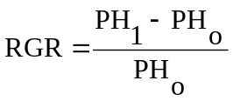 4
where PH₁ and PH_{o} represent the PH (cm) measured at consecutive periods, with PH_{o} the initial measurement and PH₁ as the next measurement.

Above-ground biomass and grain yields of tef were collected with the method stated in section Adjustment in GY to 12.5% moisture content was done using Equation 2 of section 3.2.5. The ABY was measured by weighing the sun-dried above-ground harvested samples and converting them to kg ha⁻¹. The harvest index (HI) was calculated as the ratio of GY to ABY and expressed as a percentage, whereas the straw yield was considered the difference between ABY and GY. The lodging index (LI) was recorded using the procedure used by Tesfahun Wakjira (2018) and Tamirat Wato (2021).

The physiological parameter of water use efficiency (WUE) was calculated from grain yield adjusted for moisture content and the amount of water applied through irrigation (Equation 3). Chlorophyll content was measured every fortnight using a chlorophyll meter (SPAD-502 Plus, KONICA MINOLTA, INC, made in Japan) non-destructively on the leaves of five sample plants.

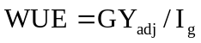 3
where WUE is water use efficiency; GYadj is adjusted grain yield (kg ha⁻¹); and I_{g} is gross applied irrigation (m³).

4.2.6. Data analysis

R statistical software version 4.1.1 was used to analyse the data (Team, 2021). The Shapiro-Wilk testing approach was used to determine the normality of the data distribution before performing the analysis of variance (ANOVA) (Hanusz & Tarasińska, 2015). Homogeneity of variances among the traits across the two growing seasons was done using Levene’s Test (O' Neill and Mathews, 2002). The ANOVA was performed using a statistical package called ‘doebioresearch’, which was built in version 4.1.3 for split-plot design analysis. When there was a significant difference, the general linear model's process was followed, and means separation was carried out using the least significant difference procedure at the 0.05 probability level. Models from one-, two-, and three-way ANOVA were fitted to the corresponding experimental design. Soil moisture depletion level and rate of CRH were treated as fixed variables in the data analysis, while year and replication were treated as random effects.

4.3. Result and discussion

4.3.1. Lodging and leaf area indices

The effect of moisture depletion level and silicon rate on the lodging response of tef is presented below (Table 4.3). The combined analysis result over the two years showed that lodging and leaf area index of tef were not significantly influenced by either the main or interaction of water depletion level and CRH application rate (p>0.05). However, based on the individual-year analysis, lodging index and leaf area index were significantly (p<0.05) influenced by the interaction of moisture depletion level and CRH in 2021 and 2022, respectively. The effect of CRH on lodging index was significantly (p<0.001) different in the two study years, but not significant on the leaf area index (p>0.05). The overall mean values of both indices were significantly higher (p<0.01) in 2021 than in the 2022 season. The lowest mean lodging index of 19.7%, followed by 20.6%, was recorded in 2022 from the application of 873 kg ha⁻¹ CHR, and 582 kg ha⁻¹, respectively (calculated mean). Based on the overall mean recorded values over the two years, it showed that the lodging index of tef had decreased by 20.7% in 2022 as compared to 2021.
The beneficial effect of Si application on lodging of monocots, including tef, was in line with different research results (Ding et al., 2008; Korndörfer & Lepsch, 2001; Liang et al., 2015; Ligaba-Osena et al., 2020; Masulili et al., 2010; Yanai et al., 2016). However, our result had a little deviation from (Ligaba-Osena et al., 2020) in terms of rate, which had a significant effect on tef lodging and thus might be due to the difference in Si source and rate of release that determine the availability and uptake of Si content by plants. The significant variation in LI due to the effect of CRH application over the years could probably be due to the residual effect of CRH, which was supplied in the previous cropping season and causes relatively shorter PH and pre- and post-harvest management practices. The non-significant effect of treatments based on the COY might be due to the slow release of available silicon from CHR.

Table 4. 3. The interaction effect of soil moisture depletion level and carbonized rice husk rate on lodging and leaf area index of tef

Treatment |  | LI |  |  | LAI
 |  | 2021 | 2022 | COY | 2021 | 2022 | COY
CRH (0) | Control (20) | 48.8^{a-d} | 41.3 | 45.0 | 3.93 | 2.83ª | 3.38
CRH (0) | 35 | 45.0^{a-d} | 30.0 | 37.5 | 3.30 | 1.96^{fgh} | 2.64
CRH (0) | 55 | 45.0^{a-d} | 30.0 | 31.9 | 3.7 | 2.15^{d-g} | 2.91
CRH (0) | 75 | 45.0^{a-d} | 33.75 | 39.4 | 3.2 | 2.511^{a-d} | 2.84
CRH (291) | Control (20) | 45.0^{a-d} | 30.0 | 37.5 | 3.26 | 2.64^{ab} | 2.95
CRH (291) | 35 | 37.5^{cd} | 30.0 | 33.8 | 3.0 | 1.77^{h} | 2.40
CRH (291) | 55 | 33.8^{d} | 26.3 | 35.6 | 3.1 | 2.21^{def} | 2.64
CRH (291) | 75 | 56.3^{ab} | 26.3 | 41.3 | 2.4 | 2.13^{e-h} | 2.28
CRH (582) | Control (20) | 45.0^{a-d} | 26.3 | 35.6 | 3.8 | 2.512^{a-d} | 3.16
CRH (582) | 35 | 60.0ª | 22.5 | 41.3 | 3.92 | 2.23^{def} | 3.08
CRH (582) | 55 | 52.5^{abc} | 15.00 | 33.8 | 3.5 | 1.80^{gh} | 2.64
CRH (582) | 75 | 37.5^{cd} | 18.75 | 28.1 | 4.0 | 2.37^{b-e} | 3.19
CRH (873) | Control (20) | 41.3^{bcd} | 26.3 | 33.8 | 2.7 | 2.27^{c-f} | 2.48
CRH (873) | 35 | 52.5^{abc} | 15.00 | 33.8 | 4.1 | 2.03^{e-h} | 3.04
CRH (873) | 55 | 45.0^{a-d} | 18.75 | 31.9 | 4.8 | 2.09^{e-h} | 3.44
CRH (873) | 75 | 48.75^{a-d} | 18.75 | 33.8 | 2.9 | 2.60^{abc} | 2.73
LSD_{.05} |  | 17.12 | 10.18 | 9.791 | 1.631 | 0.367 | 0.822
Significance (ANOVA)
Y |  | - | - | ** | - | - | **
MDL |  | ns | ns | ns | ns | ns | ns
CRH |  | ns | ns | ns | ns | ns | ns
Y*CRH |  | - | - | *** | - | - | ns
Y*MDL |  | - | - | ns | - | - | ns
MDL*CRH |  | * | ns | ns | ns | * | ns
¹CV (%) |  | 25.9 | 35.4 | 29.0 | 42.2 | 41.6 | 43.0
²CV (%) |  | 25.1 | 27.8 | 27.4 | 32.8 | 11.3 | 28.8

Y, Year; MDL, moisture depletion level; CRH, carbonized rice husk in kg ha⁻¹; COY, combined analysis over growing seasons; Y*CRH, interaction of year and carbonized rice husk; Y*MDL; year*moisture depletion level; MDL*CRH, interaction of moisture depletion and carbonized rice husk; ANOVA, analysis of variance; CV, coefficient of variation for the main (MDL) and sub-plot (CRH) factors; ns, non-significant; ***, means are significantly different at p<0.001; **, means are significantly different at p<0.01; *, means are significantly different at p<0.05

4.3.2. Plant height

The response of tef plant height to different soil moisture depletion levels, silicon rates, and their interactions is provided in Table 4.4. Plant height was significantly (P<0.05) affected by the main effect of MDL. However, it was not influenced by the main effect of CRH and its interaction with MDL (P>0.05). The maximum PH (102.8 cm) was measured from the 20% MDL treatment, but it was not significantly different from the treatment that received irrigation at 35% MDL, which provided a PH of 101.0 cm. There was a 5.7% difference in PH between the 20 and 75% MDL. The smallest difference (0.1%) was found between 55% and 75% MDL.

A separate analysis of the yearly plant height result showed the presence of variation across production seasons. The mean plant height (112.4 cm), which was measured in 2021, was significantly (p<0.01) higher than the PH (86.8 cm) of 2022.

The difference in PH among water depletion levels might be due to moisture stress that occurred during the early stages of crop development. This was in agreement with the report that showed a stunted growth of field crop plants under critical soil moisture conditions (Ullah et al., 2019).

Table 4. 4. The effect of soil moisture depletion on tef plant height (cm)

Treatments | 2021 | 2022 | COY
Control (20%) | 112.2 | 93.4ª | 102.8ª
35% | 113.2 | 88.8^{ab} | 101.0^{ab}
55% | 112.3 | 82.5^{b} | 97.4^{b}
75% | 112.0 | 82.6^{b} | 97.3^{b}
Mean | 112.4 | 86.8^{b} | 99.6
LSD_{0.5} | 4.30 | 8.47 | 11.8
CV (%) | 4.78 | 12.2 | 11.8
Significance (ANOVA)
MDL | ns | * | *
CRH | ns | ns | ns
Year |  |  | **
Y*MDL |  |  | .
MDL*CRH |  |  | ns
Y*MDL*CRH |  |  | ns

MDL, moisture depletion level; COY, combined analysis over years; LSD_{0.05}, least significance difference at 0.05 level of significance; CV, coefficient of variation; Y, year; Y*MDL, interaction of year and moisture depletion level; Y*CRH, interaction of year and silicon rate; MDL*CRH, interaction of MDL and CRH rate; Y*MDL*CRH, interaction of Y, MDL and CRH; ns, non-significance difference

4.3.3. Relative growth rate

The effect of water depletion level on the relative growth rate of the tef crop was presented in Figure 4.1. The growth rate curve for all four treatments followed a similar trend. Initially, the RGR was slow, then increased sharply between 43 and 71 DAP, and then decreased with a similar pattern. Despite the slow start of RGR from the control treatment (20% MDL), it showed the fastest increment during the second period as compared to the other treatments. The fourth treatment (75% MDL) had shown relatively the fastest RGR of any other treatment, but it slowed during the second phase of growth. The maximum RGR (1.66) was observed from 20% MDL, while the lowest one (1.36) was observed from 75% MDL at 57 DAP.

Figure 4. 1. The effect of moisture depletion levels on the relative growth rate of tef. The 20% MDL, 35% MDL, 55% MDL, and 75% MDL are percentage of moisture depletion levels; DAP is days after planting; RGR is relative growth rate
.

4.3.4 Panicle length

Panicle length is considered among the most important lodging and yield determinants. The results indicating the main and interaction effects of MDL and CRH over individual and pooled mean analyses over years are presented in Table 4.5. The effect of different CRH application rates did not influence panicle length significantly (p > 0.05). The interaction of both the main and sub-plot factors also did not significantly (P>0.05) affect panicle length. The overall mean panicle length measured in 2021 (42.4 cm) was significantly higher than the value measured in 2022 (32.3 cm) (p<0.01). The mean panicle length collected in 2021 was 30.3% higher than the mean panicle length in 2022.

The difference in panicle length over the growing season could be due to the difference in pre- and post-harvest crop management i.e tillage method and frequency of weeding and weather conditions (Tsion Fikre et al., 2020).

4.3.5. Number of tillers per plant

The number of tillers per plant was significantly influenced by the main effect of soil moisture depletion level (p<0.01) (Table 4.5). However, the effect of CRH and the interaction with MDL were not significant on the NTPP of tef (p > 0.05). The maximum NTPP (1.71) was recorded from 55% MDL, but the value was indifferent as compared to 20% MDL, which provided a mean NTTP of 1.70. The difference could be attributed to the difference in level of soil aeration that can influence root respiration. The fewest NTPP (1.20) was recorded from 35% MDL, but was not statistically different from 75% MDL (1.30).

The variation in number of tillers per plant was in agreement with the result (Reda et al., 2018), who stated the difference in response of genotypes under optimal and sub-optimal moisture conditions in terms of the number of productive tillers.

Table 4. 5. The effect of soil moisture depletion level and rate of carbonized rice husk on tiller number of tillers per plant of tef crop for the 2022 production season

MDL (%) | NTPP
Control (20) | 1.70ª
35 | 1.20^{b}
55 | 1.71ª
75 | 1.30^{b}
Mean | 1.50
LSD_{.05} | 0.25
CV (%) | 21.0
MDL | **
CRH | ns
MDL*CRH | ns

Note that this result was based on one year data (2022); LSD_{.05}, least significant difference at a probability level of 0.05; MDL, soil moisture depletion level; CRH, carbonized rice husk; MDL*CRH, interaction of MDL and CRH; means connected with same letter/s are not significantly different at the p = 0.05 level of significance

4.3.6. Grain and straw yields

The combined analysis over the two growing periods showed that soil moisture depletion level, CRH application rate, and their interaction effect on both grain and straw yields were not significant (p<0.05). However, the mean grain and straw yields were significantly higher (p<0.001) in 2021 than in 2022. In 2021, the mean yield from the main-plot treatments (MDL) ranged from 2279.2–2460.6 kg ha⁻¹, whereas in 2022, it was between 1169.8 and 1227.9 kg ha⁻¹. The overall mean grain yield (2375.5 kg ha⁻¹) measured in 2021 was higher than the grain yield (1189.8 kg ha⁻¹) obtained in 2022 by about 99.7%. As compared to the on-farm mean national yield (1700 kg ha⁻¹), the grain yield measured in 2021 showed a 39.7% increment, but in 2022 however, the grain yield decreased by 29.5% compared to on-farm mean national yield of tef. Based on the result of pooled mean result, a similar trend was observed for tef straw yield. The mean straw yield (5235.7 kg ha⁻¹) in 2021 was 121.8% higher than the straw yield (2360.2 kg ha⁻¹) recorded in 2022 (data not presented).

The difference in grain and straw yields across the production season could be due to the variation in inter-annual crop management. The change in the rotating crop under the low input use cultivation system during the rainy season could have contributed to variation in grain and straw yields across seasons. The experimental land was covered by white lupine just prior to the 2021 tef experiment, whereas Niger seed was sown as cover crop before the second season experiment. For both white lupine and Niger seed, there was no external application of any fertilizer. This might contribute to the difference in nutrient availability and uptake level on the following crop, which is tef. Researcher (Zhao et al., 2020) stated that intra-season management including fertilization and crop rotation may also have had an influence on the significant difference over the two cropping years. In addition, irrigation was more frequent during 2021 and slightly less frequent in 2022 during the early stage of crop development. Another important influencing factor could be the variation in the number tillage and weeding practices, which might affect the tef yield significantly.

4.3.7. Harvest index

The harvest index of tef was significantly (p<0.01) influenced by the change in the soil moisture depletion level (Table 4.6). The effect of MDL was significantly (p<0.001) interacted with the cropping year. However, both the main effect of CRH and its interaction with MDL on HI of tef were not significant (p>0.05). The interaction of CHR with year was also not significant on the HI of tef. Both deficit and excessive soil moisture application levels had a significant effect on plant growth and development.

The reduced in harvest index of tef over the change in soil moisture depletion levels could be due to the variation in the proportion of grain yield to above ground biomass yield caused by the change in moisture depletion level, which could reduce overall biomass yield (Zhao et al. 2020).

Table 4. 6. The combined and individual analysis result of two year experiment showing the effect soil moisture depletion levels on the harvest index of tef

Treatments | 2021 | 2022 | COY
Control (20%) | 33.0 | 31.1^{d} | 31.7^{b}
35% | 29.6 | 33.3^{c} | 32.2^{b}
55% | 33.2 | 36.1ª | 33.8ª
75% | 32.5 | 34.4^{b} | 32.5^{b}
Mean | 32.1 | 33.7 | 32.6
LSD_{0.5} | - | 0.68 | 1.12
CV (%) | 9.2 | 2.5 | 6.6
Significance (ANOVA)
MDL | ns | *** | **
CRH | ns | ns | ns
Year |  |  | ns
Y*MDL |  |  | ***
MDL*CRH | ns | ns | ns
Y*MDL*CRH |  |  | ns

MDL, moisture depletion level; COY, combined analysis over years; LSD_{0.05}, least significance difference at 0.05 level of significance; CV, coefficient of variation; Y, year; Y*MDL, interaction of year and moisture depletion level; Y*CRH, interaction of year and silicon rate; MDL*CRH, interaction of MDL and CRH rate; Y*MDL*CRH, interaction of Y, MDL and CRH; ns, non-significance difference, **, significant at 0.01 level of significance; ***, significant at 0.001 level of significance

4.3.8. Water use efficiency and chlorophyll content of tef

The result showed that the WUE of tef was not significantly influenced both by the main and interaction effects of MDL and CRH (p>0.05). The individual year analysis result showed that in 2021, the interaction of MDL and CRH significantly affected the WUE of the tef crop (p<0.05) (data not presented). In 2022, however, the WUE of tef was not affected by the interaction of MDL and CRH, but it was significantly affected by the main effect of MDL (p<0.05). In 2021, the application of 582 kg CRH ha⁻¹ combined with 75% MDL showed a higher WUE than any other treatment combination. In 2022, the maximum water use efficiency (0.55 kg ha⁻¹ m⁻³) was observed on 55% MDL but was not statistically different from 75% MDL, while the lowest WUE was recorded from the control (20% MDL) treatment, with a value of 0.4 kg ha⁻¹ m⁻³. Despite not being statistically different, the pooled mean values from the two-year data showed that 75% MDL had slightly been above all other treatments with a mean WUE of 1.997 kg ha⁻¹ m⁻³.

The high water use efficiency value indicated a better grain yield conversion of crops with relatively little irrigation water applied under moisture stress conditions (Zhao et al. 2020). The significant effect of MDL during the early stage of the crop might be due to the crop's sensitivity to water stress during the early growth stage. The non-significant treatment differences could be attributed to the more frequent application of irrigation during the early stages of crop emergence and development rather than an extended application interval. This was in agreement with Tsion Fikre et al. (2020), who stated the presence of significant tef response to irrigation frequency at the early, vegetative and productive stages.

The effects of water depletion level and silicon rate on the chlorophyll content of tef leaf measured at four different periods of plant growth are presented in Figure 5. The chlorophyll content of tef was significantly influenced by the level of soil moisture depletion at the first growth period (p<0.05). However, the effect was not significant for the remaining 3 sampling periods (p>0.05). The main effect of CRH and its interaction with MDL was not significant for all the periods (p>0.05). The pooled mean result also showed that CC was not influenced by both the main and interaction effects of MDL and CRH. The result was based on single year data, which was collected in 2022. It could not tell us the consistency of the effect of treatments over the season.

The bar chart showed that CC had shown an increasing trend during the first period (49-64 DAP), followed by a decreasing trend for the remaining periods. The highest CC of 28.62 and 27.7 nmol cm⁻² was observed at 64 DAP, while the lowest CC of 6.8 and 7.1 nmol cm⁻² was observed at 94 DAP for both water depletion level and CRH application rate, respectively. This could be attributed to the change in plant physiological activity, whereby evapotranspiration and photosynthetic activities reached peaks at the end of the crop development stage and lows at the senescence stage (Abrha Mizan Tesfay et al., 2017).

Figure 4.3. Bar chart showing the effect of moisture depletion level and carbonized rice husk on chlorophyll content of tef. (A) MDL1, MDL2, MDL3, and MDL4 with 20, 35, 55, and 75%; (B) CRH1, CRH2, CRH3, and CRH4 with 0, 291, 582, 873 kg ha⁻¹, respectively; the interaction of MDL and CRH was not significant (P>0.05)

4.4 Conclusion

Based on this this study found that the moisture depletion level significantly influenced the plant height, number of tillers per plant, harvest index, and lodging resistance of tef but not the grain and straw yields. The pooled means analysis result showed that the main effect of CRH and its interaction with MDL did not significantly influenced the lodging index, leaf area index, plant height, panicle length, grain yield, and straw yield. The application of CRH influenced the PL of tef. The maximum RGR (1.66) was observed from 20% MDL, while the lowest one (1.36) was observed from 75% MDL. Generally, it was concluded that though there was no significant difference in both grain and straw yields, tef irrigated at 55% MDL provided a maximum HI of 33.8%, which was 6.21% more than the control and increased the level of lodging resistance with a second lowest LI of 31.9% next to 75% MDL with 582 kg ha⁻¹ CRH. They suggested that the research should include economic analysis to select economically feasible soil moisture depletion level.

Chapter 5. WATER USE EFFICIENCY, LODGING AND YIELD OF TEF [Eragrostis tef (Zucc) Trotter] AS INFLUENCED BY CARBONIZED RICE HUSK APPLICATION TIMING AND SOIL AMENDMENTS IN NORTHWEST ETHIOPIA

Mekonnen Gebru Tekle^{a,b*}, Getachew Alemayehuª, Yayeh Bitewª
ªBahir Dar University, College of Agriculture and Environmental Science, Department of Plant Sciences, P.O. Box 5501, Bahir Dar, Ethiopia
^{b}Wolkite University, College of Agriculture and Natural Resource Management, Horticulture, P.O.Box 07, Wolkite, Gurage, Ethiopia
*Corresponding author
E-mail address: mekugebru@gmail.com
This article was submitted to: Cambridge University Press

Abstract

Acidity and decline in organic matter content of the soil are among the major yield limiting factors in the northwest highland of Ethiopia. Therefore, a 4*4 factorial field experiment was conducted in a randomized complete block design in two dry seasons under irrigation condition at Koga irrigation scheme, North-west Ethiopia to examine the effect of carbonized rice husk application timing (CRHT) and soil amendments (SA) on water use efficiency, lodging, and yield of tef. Treatments were four SA: without SA (control), compost (10 t ha⁻¹), lime (2.5 ton ha⁻¹), and 10 t ha⁻¹ compost+2.5 t ha⁻¹ lime (CL); four CRHT: control (no application), full rate (485 kg ha-⁻¹) during sowing (CRHT2), equal splitting during sowing and tillering (CRHT3), and full rate during tillering (CRHT4), with a total of 16 treatment combinations, which were replicated four times. The pooled mean ANOVA results showed that the SA significantly influenced lodging index (p<0.01), LAI (p<0.001), above-ground biomass yield (p<0.01), but not water use efficiency, plant height, panicle length, and number of pants per square meter (p>0.05). The CRHT only significantly (p<0.05) influenced chlorophyll content. The effect of lime on grain, above-ground biomass, and straw yield parameters was statistically similar with the application of compost. Compost and CL showed significantly increased sensitivity of tef to lodging ranged from 46.2 to 65.9% than lime and control treatments. In conclusion, application of compost plus lime significantly improved tef grain, above-ground biomass and straw yields by 12.1, 14.5, and 15.2%, respectively, compared to lime, and by 12.3, 9.3, and 8.4%, respectively, compared to the control treatment.

Key words: compost, grain yield, heber-1, leaf area index, lime, silicon

5.1. Introduction

Tef, a warm season crop, has a wide adaptation and is capable of growing in marginal areas including arid and semi-arid areas of Ethiopia (Gelaw & Qureshi, 2020). This crop is economically important for smallholder farmers in the country with its high grain and straw market values (Solomon Chanyalew et al., 2019). In countries like USA, South Africa, India, Israel, Yemen, Netherlands, and Germany tef has been grown as a grain and forage crop in recent years (Jifar et al., 2022). The gluten free nature of tef grains makes the crop preferable by baking factories and consumers in different European countries (Sridhara et al., 2021).

Soil acidity and decline in organic matter content of the soil are among the main yield-limiting factors in the northwest highlands, which are potential tef growing areas of Ethiopia (Getachew, 2014). Over 40% of the cultivated land in the country is affected by soil acidity, which is even more severe in the study area, where about 45% was found to be moderate to strongly acidic (Mekonnen Asrat, 2020). A non-treated acidic soil of northwest Ethiopia could provide a 1 t ha⁻¹ grain yield reduction for the tef crop compared to the soil treated with a combination of 1.5 t ha⁻¹ lime and 5 t ha⁻¹ manure. Therefore, treating soils with various soil amendments is essential to improve soil physicochemical and biological properties and crop yields in different parts of the country.

Organic and mineral amendments from the different sources have been used to improve the soil properties (Bulluck et al., 2002; Larney and Angers, 2012; Hunegnaw et al., 2021). However, the type of amendments used varies with the nature and extent of the problem. Organic amendments are undergoing a revival as an effective means to restore soil organic matter content, to improve soil quality and microbial property, and to maintain plant health (Bonilla et al., 2012; Pérez-Piqueres et al., 2006). The bioremediation in soils with heavy metal concentration was also reported on organic amendments (Park et al., 2011). The application of compost, biochar, or their combination significantly improved soil water content, soil organic carbon, CEC and pH in the 20 cm surface soil depth and yield of barley (Getachew Agegnehu et al., 2016). The addition of crop residue and farmyard manure was also found to improve soil organic carbon content by 2.45% and 6.40% respectively as compared to the use of mineral fertilizer alone (Blanchet et al., 2016). However, the efficacy of any organic amendments depends on the chemical composition and quantity of the amendments (Bonilla et al., 2012; Pérez-Piqueres et al., 2006).

Researchers also reported the importance of inorganic amendments particularly liming to improve crop yield and soil physicochemical properties in acidic soils. According to Gurmessa (2021), crop yield can be increased by up to 0.5 t ha⁻¹ with the application of lime. Pardo et al., (2014) observed that lime application increases soil pH and reduce trace element mobility. Malik et al. (2018) also found an improvement of soil pH by 64% with the application of 100% CaO with a 4% sludge biochar. Moreover, Behera and Pattanayak (2016) indicated that lime with farmyard manure had improved the CEC and pH of the soil. Although, the soil amendments have a significant role towards improving soil physicochemical properties their individual and combined effect on growth and yield of crops particularly on tef are not intensively studied.

On the other hand, silicon application had significant role as a soil amendment and yield improvement by enhancing lodging and disease resistances of various crops like sugar cane (Majumdar & Prakash, 2020), rice, (Singh et al., 2021), and other monocots including tef (Ligaba-Osena et al., 2020). According to Galindo et al. (2021), silicon supply increased the agronomic efficiency of nitrogen fertilization on maize. In addition to the type and rate of silicon, knowledge on the application time of silicon is essential for effective and economical use of the nutrient as it varies with the type of crop species. For instance foliar application was found to improve the root yield and sugar content of sugar beet (Artyszak et al., 2015), shoot growth, yield, and help to defend both biotic and abiotic stresses (Zhao et al., 2022). Full dose basal application improves grain yield of rice (Singh et al., 2005). Another research conducted by Rehman et al. (2019) showed that split application of Si at transplanting, tillering, and panicle initiation stage improved the growth and reduced Cd concentrations in rice grain below the threshold level of 0.2 mg kg⁻¹. Moreover, silicon application during flowering stage as a top dressing was found to increase leaf area, tiller number per plant, panicle weight, 100 seed weight, stem strength in rice (Dorairaj et al., 2020). However, the effect of silicon application and its timing has poorly documented for tef crop.

Although tef is important crop, it has been considered as an orphan crop and the national average productivity (1.7 t ha⁻¹) was far below its genetic potential (Solomon Chanyalew et al., 2019). Though there are some efforts towards improving the yield of tef, soil acidity, drought, and inappropriate nutrient and tillage practices, lodging, and lack of improved seeds are still among the major factors contributing to the low tef production in Ethiopia. With the use of improved crop management the potential yield of tef can reach up to 2-3 t ha⁻¹ (Tafes Desta et al., 2022).

Thus, integrating the suitable soil amendments along with silicon timing would be essential to improve the sustainable productivity of tef and the cultivated land. Therefore, the objective of this experiment was to examine the effect of carbonized rice husk application timing and soil amendments (organic matter and lime) on water use efficiency, lodging and, yield attributes of tef at Koga irrigation scheme of north-western Ethiopia.

5.2. Materials and Methods

5.2.1. Study site description

This field experiment was conducted at Koga irrigation scheme, Bahir Dar University Research Station (Kudmi), Ethiopia during the 2021 and 2022 irrigation seasons. The monthly distribution of rain, minimum and maximum temperatures for the 2021 and 2022 growing seasons are presented above in Section 2.1, Figure 2.1.

5.2.2. Soil and amendment sampling and analysis

To describe the soil property of the experimental site prior to planting undisturbed and disturbed samples were collected from the top 60 cm soil depth. The standard procedures that were followed for soil sampling and analysis were described in detail above in the general materials and methods section (Section 2.1).

Additionally, samples of compost and carbonized rice husk were prepared and sent to Bahir Dar University, College of Agriculture and environmental Science soil fertility and plant nutrition laboratory for the analysis of ash content and all the aforementioned chemical properties stated in section 2.2. Ash content of compost and carbonized rice husk was determined using dry-ashing method (Marshall, 2010). The laboratory analysis results of physical and chemical parameters were presented below in Table 5.1 and 5.2, respectively.

The analysis result of bulk density, proportion of mineral particles, available water content showed that the soil has high water holding capacity (Table 5.1). The average bulk density of the top 20 cm soil layer was lower than the critical level at which too little root penetration problem could be observed (Hazelton & Murphy, 2016). The tillable soil depth has significantly higher water holding capacity than the next two consecutive soil depths. As the soil depth increases from 0 to 60 cm downward the soil become looser than the top one (field observation).

Table 5. 1. Physical properties of soil over the three layers (0-20 cm) during pre-sowing time

Soil layer (cm) | Bulk density (g cm⁻³) | AWC (mm m⁻¹) | Sand (%) | Silt (%) | Clay (%) | Textural class
0-20 | 1.23 | 300.5 | 17 | 30 | 53 | Clay
20-40 | 1.13 | 168.1 | 17 | 28 | 55 | Clay
40-60 | 1.10 | 111.6 | 13 | 28 | 59 | Clay

AWC, available water content

The laboratory analysis report of the soil chemical properties is presented in Table 5.2 below. The soil is strongly acidic with high organic carbon for the top 40 cm soil depths (Hazelton & Murphy, 2016), and medium total nitrogen contents (Tadesse et al., 1991), and low percentage of available phosphorous (Hazelton and Murphy, 2016) that decreases from top to bottom layers. This indicates the necessity of applying P from external sources. The CEC for the tillable layer of the soil in the study site is between the range of 25 and 40 meq/100g soil, which is classified as high that requires small quantities of liming material. However, answering which soil amendments should be used for this study site is among the questions that need to be addressed in this study based on the agronomic response of tef to different soil amendments (See Result and discussion section).

Table 5. 2. Chemical properties of compost, carbonized rice husk, and pre-sowing soil collected by layer (0-20 cm)

Material | Soil depth (cm) | Chemical property
Material | Soil depth (cm) | pH (H₂O) | OC (%) | CEC (meq/100g soil) | EC (µS) | TN (%) | A.P (%) |  | Ash (%) |  | MC (%)
Soil | 0-20 | 5.3 | 2.24 | 28.0 | 50.2 | 0.19 |  | 6.28 |  | - | -
Compost |  | - | 13.0 | - | - | 1.36 |  |  |  | 65.0 | 8.8
CRH |  | - | 13.1 | - | - | 1.42 |  |  |  | 50.5 | 6.7

OC, organic carbon; CEC, cation exchange capacity; EC, electrical conductivity of soil in 1:5 soil to water ratio; TN, total nitrogen; A.P, available phosphorus; CRH, Carbonized rice husk; MC, moisture content

5.2.3. Experimental Materials

A tef crop variety known as Heber-1 (Dz-Cr-419) was used as a testing crop. This variety was released in 2017 from Adet Agricultural Research Centre. Heber-1 is characterized as a high yielding with very white seeds. Soil amendment materials including compost as a source of organic matter, carbonized rice husk as a source of silicon, and lime (96% CaCO₃) as a source of calcium were used in this experiment. In addition, urea (46% nitrogen), and triple super phosphate (46% P₂O₅) were used as additional source of N and P nutrients to maintain nutrient balance.

5.2.4. Treatments and Design

Factorial combinations of four silicon application timing: control without silicon, full rate during sowing, equal splitting during sowing and tillering, and full rate during tillering and four different levels of soil amendments: compost (10 ton ha⁻¹), lime (2.5 ton ha⁻¹), compost + lime (10 ton ha⁻¹ compost + 2.5 ton ha⁻¹ lime), and control (without any application of soil amendment) were used in the experiment. A total of 16 treatment combinations of Si application timing and soil amendments were used and laid out in a randomized complete block design (RCBD) with four replications. The treatments were laid out on a and net gross plot area of 3 m by 2 m (6 m²) and 15 m by 39.5 m (592.5 m²), respectively. The spaces between adjacent plots and blocks were 0.5 m and 1 m, respectively.

5.2.5. Crop management

Experimental plots were ploughed three times using an oxen-plough. The first and the second plough were done in October, while the third plough was done in November 2020. Smoothing and leveling of the experimental plots were done manually on the same date of sowing.

The activity of planting method, seed rate, fertilization, weeding other than the treatments were done in the same way as section 3.2.4.

5.2.6. Data Collection on Agronomic attributes

The growth data including plant height, panicle length, Leaf area index, the lodging index (LI) were measured following the methods described in section 3.2.5. The number of plants per unit area was recorded at maturity stage on 80 DAP by randomly throwing 0.25 m⁻² quadrant into the net plot area and convert it to a unit area.

Grain and above-ground biomass yields and harvest index were measured by harvesting a 1m by 1m quadrant selected randomly from the net plot area. The grain yield was measured after adjustment for moisture content using Equation 2 stated above in section 3.2.5.
Water use efficiency of tef was calculated using the equation 3 below.
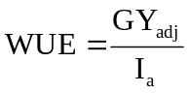 3
where WUE is water use efficiency of tef (kg ha⁻¹ m⁻³); Ia is applied irrigation water (m³).

5.2.7. Statistical analyses

The data were analyzed using R-version 4.1.1 software (Team, 2021). The procedures that were followed for the data analysis were described in detail above in section 3.2.6.1. In the data analysis, the year and replication were handled as random effects, while the water depletion level, silicon application timing and soil amendments and CRH at a rate of 485 kg ha⁻¹ were treated as fixed variables.

5.3. Result and Discussion

5.3.1. Plant height, panicle length and number of plants per unit area

The result showed that plant height was only significantly (p<0.05) affected by the main effects of soil amendments during 2022 (Table 5.3). However, the pooled mean analysis result over the two years showed that no significant difference among all the main and interaction of treatments. Plant growth parameters including panicle length and number of plants per square meter plot area (NP m⁻²), were not significantly influenced neither by the main nor the interaction of SA and CRHT in both years (data not presented). Except NP m⁻², which showed significant increment, the PH and PL showed a significant reduction for all the treatments in 2022 than in 2021 production season. This might be attributed to an increase in tiller number caused by the residual effect of treatments. The tef PH had reduced by 23.9% in 2022 compared to 2021. The application of compost in 2022 showed the highest PH with 5.42% (calculated based on Table 5.3) higher compared to the control treatment, which received only the recommended rate of inorganic fertilizer. The pooled mean analysis result showed that compost application provided significantly (p<0.05) higher PH than the application of lime.

Optimum plant growth could be used as a good estimator on plant lodging (Zhou et al., 2020) and the final yield (Ngoune Tandzi and Mutengwa, 2019) of crops particularly tef. Plant height, panicle length, and number of plant stands per unit area of land are important traits among others used in this regard and observing their change in response to the treatments imposed was found to be relevant. The significant difference in plant height over the years due to the application of soil amendments might be due to the quality of soil amendments, crop management, and weather condition of the season. This result was in agreement with the finding of (Hunegnaw et al., 2021), who stated a decline in plant height and panicle length by 4.4% and 2.9%, respectively relative to the first growing season due to the application of 10 t ha⁻¹ compost. This could be due to the relatively poor quality of compost that may arise from high in moisture content (82.3%) tef in 2022 than the 2021 production year. According to Guo et al. (2012) compost with high moisture content hindered the growth of crop. The cover crop (Niger seed) planted in the main rainy season of the 2021 with the residual nutrient might cause reduction in soil nutrient content mainly nitrogen that may affect tef production during the second tef production (Wagg et al., 2021).

The decrease in plant height was in line with the result from Reda et al. (2018), who found a 9.4% reduction in PH of tef with an increase in seed rate from 2.5 to 5 kg ha⁻¹ (Reda et al., 2018). The higher PH caused by compost than lime could be due to the additional nitrogen supply from compost material. This was in line with the result of Hunegnaw et al. (2021), who found 8.2% higher straw yield from compost than lime application.

Table 5. 3. The main effect of soil amendments on the plant height (cm) of tef

SA (t ha⁻¹) | PH (cm)
SA (t ha⁻¹) | 2021 | 2022 | Mean
Control (0) | 118.9 | 92.2^{b} | 105.6^{ab}
Compost (10) | 116.1 | 97.2ª | 106.7ª
Lime (2.5) | 115.6 | 92.0^{b} | 103.8^{b}
Compost-Lime | 117.1 | 95.4^{ab} | 106.2^{ab}
Mean | 116.9ª | 94.2^{b} | 105.6
LSD_{.05} | 3.39 | 3.87 | 2.72
Significance
SA | ns | * | ns
CRHT | ns | ns | ns
SA*CRHT | ns | ns | ns
Year |  |  | ***
Y*SA |  |  | *
Y*CRHT |  |  | ns
Y*SA*CRHT |  |  | ns
CV (%) | 4.1 | 5.8 | 5.2

SA, soil amendments; PH, plant height; CRHT, carbonized rice husk application timing; SA*CRHT, interaction of SA and CRHT; Y*SA, interaction of year and SA; Y*CRHT, interaction of year and CRHT; Y*SA*CRHT, interaction of year, SA, and CRHT; ns, non-significant; CV, coefficient of variation. Means with the same letter(s) in column per individual factors are not significantly different at P = 0.05, LSD is least significant difference, CV is coefficient of variation, *** very highly significant at P=0.0001, * Significant at P=0.05 and NS is non-significant difference at P=0.05.

5.3.2. Chlorophyll content of tef

Chlorophyll content of tef was significantly (p<0.05) influenced by the application timing of carbonized rice husk (Figure 5.1). The application of full rate of CRH during sowing (CRHT2) recorded the lowest CC (29.7, 33.0, 19.2 nmol cm⁻²) at the first, second and third growing periods, respectively, compared to other treatments within the group, except the last period showing the highest CC than any other treatments. During the first growth period of tef the treatment CRHT3 recorded 8.1% higher CC than CRHT2, but during the late plant growth period (4th period) the value was reversed and CRH3 showed 7.4% lower CC as compared to the CRH2 treatment. All the four treatments showed similar trend over time in terms of CC, where the maximum was observed during tef development stage (31 DAP), while the minimum was recorded at crop maturity stage.

The highest chlorophyll content of tef leaves observed from full rate application during the sowing over the other treatments could be attributed to the slow release of available silicon over the growing season as the availability and release of silicon depend on the temperature during CRH preparation (Olanrewaju et al., 2024). The decline in chlorophyll content during the late season stage could be related to nitrogen translocation to grain (Saberioon et al., 2014).

Figure 5. 1. Effect of carbonized rice husk time on the chlorophyll content of tef at different growth period; Treatments (within the same date group) that are connected with the same letter(s) are not significantly different at p=0.05; The coefficient of variation for the four chlorophyll measurement periods: 16, 31, 46, and 61 days after planting were 7.4, 8.6, 17.1, and 19.7% respectively. CRHT1, CRHT2, CRHT3, and CRHT4 are the carbonized rice husk application timings: no application, full at sowing, half at sowing and half at tillering stage, full at tillering stage, respectively

5.3.3. Water use efficiency, lodging and leaf area indices

The results of water use efficiency, lodging and leaf area indices presented in Table 5.4. The result showed that water use efficiency of tef was not significantly (p>0.05) influenced by either the main or interaction of soil amendments and CRH application timing in both years. The individual year analysis results showed that the application of soil amendments had significantly affected lodging index (p<0.05) in both production years. On the other hand soil amendments significantly influenced the leaf area index (p<0.001) in 2021 and (p<0.01) during 2022. The combined analysis over the years indicated that lodging index and leaf area index were influenced significantly by the soil amendments at p<0.01 and P<0.001, respectively. The application time of carbonized rice husk has significantly (P<0.001) influenced the lodging index of tef in 2021, but not in 2022 production season (Table 5.4).

The result from pooled mean analysis of variance showed the significant effect of CRHT (p<0.001) treatment on lodging index of tef. The pooled mean analysis result showed the presence of significant (p<0.001) variation over the growing season on traits of lodging index and leaf area index (Table 5.4). However, there was no significant (p>0.05) interaction effect of SA and CRHT in both the individual year and pooled mean variance analysis over the two production seasons.

Lodging index has shown an increment with the application of compost and lime that might be attributed to an increase in plant height and panicle length (Table 5.4). The lowest lodging index was recorded from the application of lime with statistically similar impact obtained from the control treatment. However, tef plants that received compost with or without lime showed relatively higher sensitivity to lodging (Table 5.4). The lodging sensitivity increased from the absolute control treatment (23.4%) that received no carbonized rice husk application to full rate application during tillering (42.7%). The full rate application of carbonized rice husk at sowing had the second best lodging tolerance, but it was indifferent with half CRH applied during sowing and half during tillering.

The relatively higher sensitivity to lodging due to compost with or without lime could be attributed to the change in plant height caused by additional nitrogen supply released from compost. The results are in line with Fufa et al. (2001), who stated a highly significant positive correlation between lodging index and plant height. The increased in lodging sensitivity from the absolute control treatment that received no carbonized rice husk application to full rate of application during tillering could be in agreement with Mekonnen Gebru et al. (2023), who stated an increased lodging index with the application of CRH compared to the control treatment without CRH.

Table 5. 4. The effect of soil amendments and carbonized rice husk application timing on water use efficiency, lodging, leaf area indices of tef crop grown under irrigation

Amendments | LI |  |  | LAI |  |  | WUE
Amendments | 2021 | 2022 | Mean | 2021 | 2022 | Mean | 2021 | 2022 | Mean
SA1 (0) | 22.5^{b} | 31.9^{b} | 27.2^{c} | 4.1^{b} | 1.97^{b} | 3.02^{b} | 0.89 | 0.55 | 0.72
SA2 (10) | 33.8ª | 45.0ª | 39.4ª | 5.1ª | 2.41ª | 3.76ª | 0.84 | 0.53 | 0.69
SA3 (2.5) | 31.9ª | 30.0^{b} | 30.9^{bc} | 3.9^{b} | 2.37ª | 3.12^{b} | 0.77 | 0.53 | 0.65
SA4 (SA2+SA3) | 30.0ª | 40.3^{ab} | 35.2^{ab} | 5.6ª | 2.641ª | 4.12ª | 0.80 | 0.49 | 0.64
Mean | 29.5^{b} | 36.8ª | 33.2 | 4.67ª | 2.35^{b} | 3.51 | 0.83 | 0.52 | 0.674
LSD_{.05} | 6.837 | 11.2 | 6.46 | 0.729 | 0.3299 | 0.394 | 0.194 | 0.09 | 0.104
SA | * | * | ** | *** | ** | *** | ns | ns | ns
CRHT | *** | ns | *** | ns | ns | ns | ns | ns | ns
SA*CRHT | ns | ns | ns | ns | ns | ns | ns | ns | ns
Year |  |  | ** |  |  | *** |  |  | ***
Y*SA |  |  | ns |  |  | ** |  |  | ns
Y*CRHT |  |  | *** |  |  | ns |  |  | ns
Y*SA*CRHT |  |  | ns |  |  | ns |  |  | ns
CV (%) | 32.5 | 42.7 | 39.3 | 21.9 | 19.7 | 22.6 | 33.1 | 24.1 | 31.2

SA1, SA2, SA3, and SA4 are treatments without and with compost, lime and their combination, respectively; LSD.05 is least significance difference at a probability level of 0.05; CRHT, carbonized rice husk application timing; SA*CRHT, interaction of SA and CRHT; Y*SA, interaction of year and SA; Y*CRHT, interaction of year and CRHT; Y*SA*CRHT, interaction of year, SA, and CRHT; LI, lodging index; LAI, leaf area index; WUE, water use efficiency; CV, coefficient of variation.
Means with the same letter(s) in column per individual factors are not significantly different at P = 0.05, LSD – least significant difference, CV – coefficient of variation, *** very highly significant at P = 0.0001, * Significant at P = 0.05 and NS ¼ non-significant difference at P = 0.05.

5.3.4. Yield and yield components

ANOVA results showed that the combined application of compost (10 t ha⁻¹) and lime (2.5 t ha⁻¹) had significantly affected grain yield (p<0.001) and above-ground biomass yield (p<0.01) in 2022 but not in 2021 (Table 5.5). In case of the straw yield, there was significant (p<0.05) influence from soil amendments in both 2021 and (p<0.01) in 2022 growing season. The combined analysis result over the two experimental years showed that both the above-ground biomass and straw yields were influenced by the main effect of SA (p<0.01) (Table 5.5).

The grain yield and harvest index of tef was significantly influenced by the main effect of CRHT in 2021 at p<0.05 and p<0.01 level of significance, respectively. Harvest index of tef crop was not significantly (p>0.05) influenced by the application of soil amendments. The interaction of SA and CRHT did not significantly (p>0.05) affect all the selected yield parameters and harvest index (Table 5.5). The tef grain yield showed significant variation over the years with 72.5% increment in 2022 than 2021. The pooled mean analysis result showed that the highest grain yield (1437.8 kg ha⁻¹) was obtained from the application of compost combined with lime, but it was statistically similar with compost treatment with a value of 1353.5 kg ha⁻¹. The lowest grain yield (1280 kg ha⁻¹) was recorded from control treatment, but it was statistically similar with the application of compost and lime treatments. The highest above-ground biomass and straw yields of 6515 and 5077.2 kg ha⁻¹, respectively were also obtained from compost combined with lime treatment application, but they were not statistically separable with compost application. The highest harvest index (14.9%) was recorded from the application of CRH half at sowing and half during tillering, but not statistically different from full CRH application during tillering with a value of 13.5%, which was statistically not separable with full application at sowing (12.7%) and control (no application) (12.1%) (Appendix Table 3).

Grain, above-ground biomass, and straw yields are key traits of tef crop, which are preferred by the farmers to boost their income (Barretto et al., 2021; Gelaw and Qureshi, 2020). Thus, improving these traits with the application of soil amendments at a proper growth stage could be essential. The significant increase in grain yield in 2022 than 2021 could be attributed to the residual effect of compost, which releases nutrient slowly to the soil (Shaji et al., 2021). However, the result was not in line with Hunegnaw et al. (2021), who found the decrease in grain yield during the second growing season than first year with application of farm yard manure, which could be attributed to the stability of the form of organic matter that increases the nitrogen content, water soluble substances and of lignin content (Levi-Minzi et al., 1986). The highest above-ground biomass and straw yields could be attributed to increase soil nitrogen released from compost. The non-significant difference on the harvest index of tef could be due to the proportional change observed on the grain and biomass yields and level of association among the traits (Mekonnen Gebru et al., 2023).

Table 5. 5. The effect of soil amendments and carbonized rice husk application timing on the yield and yield components of tef

SA | GY (kg ha⁻¹) |  | ABY (kg ha⁻¹) |  | SY (kg ha⁻¹) |  | HI (%)
SA | 2021 | 2022 | 2021 | 2022 | 2021 | 2022 | 2021 | 2022
SA1 (0) | 1060.6 | 1499.4^{c} | 7612.5ª | 4311.9^{c} | 6551.9ª | 2812.5^{b} | 13.83 | 34.84
SA2 (10) | 971.8 | 1735.9^{ab} | 7643.8ª | 4973.9^{ab} | 6671.9ª | 3237.9^{ab} | 12.68 | 35.05
SA3 (2.5) | 942.9 | 1622.5^{bc} | 6737.5^{b} | 4640.4^{bc} | 5794.6^{b} | 3017.9^{b} | 14.00 | 35.07
SA2+SA3 (10+2.5) | 954.9 | 1920.7ª | 7518.8ª | 5511.3ª | 6563.9ª | 3590.5ª | 12.71 | 34.96
Mean | 982.5^{b} | 1694.6ª | 7378.1ª | 4859.3^{b} | 6395.6ª | 3164.7^{b} | 13.3^{b} | 35.0ª
LSD | 179.5 | 191.4 | 756.6 | 604.4 | 643.9 | 428.6 | 1.685 | 1.47
SA | ns | *** | . | ** | * | ** | ns | ns
CRHT | * | ns | ns | ns | ns | ns | ** | ns
SA*CRHT | ns | ns | ns | ns | ns | ns | ns | ns
CV (%) | 17.6 | 15.9 | 16.7 | 17.5 | 14.1 | 19.0 | 17.9 | 13.5

SA, soil amendments; GY, grain yield; ABY, above-ground biomass yield; SY, straw yield; HI, harvest index; CRHT, carbonized rice husk application timing; CV, coefficient of variation; SA*CRHT, interaction of soil amendments and carbonized rice husk application timing; Y*SA, interaction of year and soil amendment; Y*SA*CRHT, interaction of year, soil amendment, and carbonized rice husk application timing; LSD, least significance difference; ns, non-significant difference; *significantly different at p=0.05; **, significantly different at p=0.01; ***, significantly different at p=0.001

5.4. Conclusion

The result from our study showed that the application of compost+lime significantly improved tef grain, above-ground biomass and straw yields by 12.1, 14.5, and 15.2%, compared with lime and 12.3, 9.3, and 8.4%, respectively from the control treatments. Compost alone and its combination with lime showed significantly sensitive response to lodging in the range of 13.9 to 44.9% than lime and control treatments, respectively. However, soil amendments, carbonized rice husk timing, or their interaction did not improve any significant effect on water use efficiency of tef. Similarly, carbonized rice husk application timing also provided no significant improvement over the control (treatment that received no CRH). For the applicability of the research finding we recommend that this research should be conducted over location and at least for three seasons.

CHAPTER 6. GENERAL SYNTHESIS AND RECOMMENDATION

Three separate experimental researches were conducted independently in two seasons. The main target of all the three experiments was to optimize the nutrient and water application management technologies that could improve the yield of tef by improving lodging resistance in northwest Ethiopia (Figure 6.1). Carbonized rice husk, lime, and compost were considered as sources of silicon, which is claimed to enhance lodging resistance of tef. In addition, optimization of nitrogen application rate and selection of improved varieties with better yield and lodging resistance were taken into consideration. Appropriate experimental procedures were used to test the hypothesis and make conclusion.

The following key findings were found from this study: 1) an increase in application of nitrogen by one kg increased tef grain yield by 11.519 kg ha⁻¹; 2) increased nitrogen application rate from 0 to 92 kg ha⁻¹, reduces harvest index by up to 36.1%; 3) the interaction of variety, silicon, and nitrogen rates significantly affected the lodging index of tef; 4; the interaction of variety, silicon, and nitrogen influenced MRR with a maximum of 2668.4%; 5) appropriate genotype improves lodging resistance of tef, while increased nitrogen rate can maximize yield, but induces lodging; 6) silicon application in the form of carbonized rice husk at a rate of 484.8 kg ha⁻¹ results no significant effect on tef lodging; though sensitivity to lodging is increased, the application of compost+lime significantly improved tef grain, above-ground biomass and straw yields by 12.1, 14.5, and 15.2%, compared with lime and 12.3, 9.3, and 8.4%, respectively from the control treatments; Similarly, carbonized rice husk application timing also provided no significant improvement over the control (treatment that received no CRH).

For wide applicability and yield stability we recommend that, the research should generally be repeated over location and at least for at least one more year. In addition, comparison of rainfed and irrigation production systems should be done for better lodging resistance. Moreover, alternative silicon sources should be considered to prove or disprove the silicon effect on tef lodging. Furthermore, water management research needs improved facilities for accurate data measurement and better output.

Figure 6. 1. The relationship between experimental treatments that are assumed to improve the grain yield of tef and lodging resistance of tef

REFERENCES

Abraha Mizan Tesfay, Shimelis Hussein, Laing, M., and Kebebew Assefa. (2017). Genetic variation and trait association of tef [’Eragrostis tef’(Zucc.) Trotter] evaluated under optimal and moisture stressed environments. Australian Journal of Crop Science, 11(3), 241–247.

Acreche M. M., and Slafer, G. A. (2011). Lodging yield penalties as affected by breeding in Mediterranean wheats. Field Crops Research. https://doi.org/10.1016/j.fcr.2011.02.004

Adugna Tesfaw Melkamu, and Dessie Almaw Cherie. (2021). A Review on Reservoirs Sedimenation Problems in Ethiopia. Asian Journal of Advanced Research and Reports, 15(3), 1–8.

Adrees, M., Ali, S., Rizwan, M., Zia-ur-Rehman, M., Ibrahim, M., Abbas, F., Farid, M., Qayyum, M. F., and Irshad, M. K. (2015). Mechanisms of silicon-mediated alleviation of heavy metal toxicity in plants: A review. Ecotoxicology and Environmental Safety, 119, 186–197. https://doi.org/10.1016/J.ECOENV.2015.05.011

Agegnehu Getachew, Nelson, P. N., and Bird, M. I. (2016). Crop yield, plant nutrient uptake and soil physicochemical properties under organic soil amendments and nitrogen fertilization on Nitisols. Soil and Tillage Research. https://doi.org/10.1016/j.still.2016.02.003

Amibo Temesgen Abeto, Surafel Mustefa Beyan, and Tsegaye Markos Damite. (2022). Production and Optimization of Bio-Based Silica Nanoparticle from Teff Straw (Eragrostis tef) Using RSM-Based Modeling, Characterization Aspects, and Adsorption Efficacy of Methyl Orange Dye. Journal of Chemistry, 2022. https://doi.org/10.1155/2022/9770520

Artyszak, A., Gozdowski, D., and Kucińska, K. (2015). The effect of silicon foliar fertilization in sugar beet – Beta vulgaris (L.) ssp. vulgaris conv. crassa (Alef.) prov. altissima (Döll). Turkish Journal of Field Crops, 20(1), 115–119. https://doi.org/10.17557/.90799

Asfaw Abebe Getu, Samuel Adissie Gedamu., Habtemariam Teshome Abushe, Tilahun Taye Mekonen, Sied Belay Muhamed, and Tadesse Hailu Shibeshi. (2020). Fertilizer-nitrogen use optimization for Tef in South Wollo Zone of Ethiopia. African Journal of Agricultural Research, 16(6), 811–818.

Asmamaw Desale Kidane, Janssens, P., Mekete Dessie, Seifu Tilahun, Enyew Adgo, Nyssen, J., Walraevens, K., & Cornelis, W. (2021). Deficit irrigation as a sustainable option for improving water productivity in Sub-Saharan Africa: the case of Ethiopia. A critical review. Environmental Research Communications, 3(10), 102001.

Asrat Mekonnen. (2020). Amelioration of acidic soil to increase Tef (Eragrostis tef (Zucc) Trotter) yield on smallholder farmer fields in Ethiopian Highlands. Journal of Plant Sciences, 8(1), 1–11.

Assefa Alemu, Tamado Tana, and Jemal Abdulahi. (2016). Effects of Compost and Inorganic NP Rates on Growth, Yield and Yield Components of Teff (Eragrotis teff (Zucc.) Trotter) in Girar Jarso District, Central Highland of Ethiopia. Journal of Fertilizers & Pesticides, 7(12), 2009–2014. https://doi.org/10.4172/2471-2728.1000174

Assefa Kebebew, Yu, J. K., Zeid, M., Getachew Belay, Hailu Tefera, and Sorrells, M. E. (2011). Breeding tef [Eragrostis tef (Zucc.) trotter]: Conventional and molecular approaches. In Plant Breeding. https://doi.org/10.1111/j.1439-0523.2010.01782.x

Assefa Kebebew, Seyfu Ketema, Hailu Tefera, Nguyen, H. T., Abrham Blum, Mulu Ayele, Bai, G., Belay Simane, and Tiruneh Kefyalew. (1999). Diversity among germplasm lines of the Ethiopian cereal tef [ Eragrostis tef (Zucc.) Trotter]. Euphytica, 106(1), 87–97. https://doi.org/10.1023/A:1003582431039

Avestan, S., Ghasemnezhad, M., Esfahani, M., and Barker, A. V. (2021). Effects of nanosilicon dioxide on leaf anatomy, chlorophyll fluorescence, and mineral element composition of strawberry under salinity stress. Journal of Plant Nutrition, 44(20), 3005–3019.

Awulachew Sileshi Bekele, Aster Denekew Yilma, Makonnen Loulseged, Loiskandl, W., Mekonnen Ayana, and Tena Alamirew. (2007). Water Resources and Irrigation Development in Ethiopia. In Iwmi: Vol. Working Pa (Issue January).

Azman, E. A., Ismail, R., Ninomiya, S., Jusop, S., and Tongkaemkaew, U. (2023). The effect of calcium silicate and ground magnesium limestone (GML) on the chemical characteristics of acid sulfate soil. Plos One, 18(9), e0290703.

Baker, C. J., Sterling, M., and Berry, P. (2014). A generalised model of crop lodging. Journal of Theoretical Biology. https://doi.org/10.1016/j.jtbi.2014.07.032

Barretto, R., Buenavista, R. M., Rivera, J. Lou, Wang, S., Prasad, P. V. V., and Siliveru, K. (2021). Teff (Eragrostis tef) processing, utilization and future opportunities: a review. International Journal of Food Science & Technology, 56(7), 3125–3137.

Behera, R. D. E. V, and Pattanayak, S. K. (2016). Influence of Different Sources of Liming Materials on Growth, Yield and Productivity of the Maize Crop Grown in Acid Soil. International Journal of Environment, Ecology, Family and Urban Studies (IJEEFUS), 6(3), 117–124.

Bekana, Getahun, and Kebebew Assefa. (2021). Genetic variation, heritability and genetic advance among semi‐dwarf tef [Eragrostis tef (Zucc.) Trotter] recombinant inbred lines with emphasis to lodging. Am. J. Life Sci, 9, 92–104.

Ben-Zeev, S., Rabinovitz, O., Orlov-Levin, V., Chen, A., Graff, N., Goldwasser, Y., and Saranga, Y. (2020). Less is more: Lower sowing rate of irrigated tef (Eragrostis tef) alters plant morphology and reduces lodging. Agronomy, 10(4), 570.
Berhe Tewelde, Gebreyohannis Girmay, and Abrha Kidanemariam. (2020). Validation of blended NPSB fertilizer rates on yield, yield components of Teff [Eragrostis tef (Zuccagni) Trotter] at vertisols of Hatsebo, Central Tigray, Ethiopia. Journal of Soil Science and Environmental Management, 11(2), 75–86.

Blake, G. R. (1965). Bulk density. Methods of Soil Analysis: Part 1 Physical and Mineralogical Properties, Including Statistics of Measurement and Sampling, 9, 374–390.

Blanchet, G., Gavazov, K., Bragazza, L., and Sinaj, S. (2016). Responses of soil properties and crop yields to different inorganic and organic amendments in a Swiss conventional farming system. Agriculture, Ecosystems and Environment. https://doi.org/10.1016/j.agee.2016.05.032.

Bonilla, N., Gutiérrez-Barranquero, J. A., De Vicente, A., and Cazorla, F. M. (2012). Enhancing soil quality and plant health through suppressive organic amendments. In Diversity. https://doi.org/10.3390/d4040475.

Boselli, R., Fiorini, A., Santelli, S., Ardenti, F., Capra, F., Maris, S. C., and Tabaglio, V. (2020). Cover crops during transition to no-till maintain yield and enhance soil fertility in intensive agro-ecosystems. Field Crops Research, 255, 107871.

Bosnic, P., Bosnic, D., Jasnic, J., and Nikolic, M. (2018). Silicon mediates sodium transport and partitioning in maize under moderate salt stress. Environmental and Experimental Botany, 155(June), 681–687. https://doi.org/10.1016/j.envexpbot.2018.08.018.

Bouyoucos, G. J. (1962). Hydrometer method improved for making particle size analyses of soils 1. Agronomy Journal, 54(5), 464–465.

Bremner, J. M. (1996). Nitrogen‐total. Methods of Soil Analysis: Part 3 Chemical Methods, 5, 1085–1121.

Bulluck, L. R., Brosius, M., Evanylo, G. K., and Ristaino, J. B. (2002). Organic and synthetic fertility amendments influence soil microbial, physical and chemical properties on organic and conventional farms. Applied Soil Ecology. https://doi.org/10.1016/S0929-1393(01)00187-1

Cassel, D. K., and Nielsen, D. R. (1986). Field capacity and available water capacity. Methods of Soil Analysis: Part 1 Physical and Mineralogical Methods, 5, 901–926.

Chanyalew Solomon, Setotaw Ferede, Tebkew Damte, Tsion Fikre, Yazachew Genet, Worku Kebede, Kidist Tolossa, Zerihun Tadele, and Kebebew Assefa. (2019). Significance and prospects of an orphan crop tef. Planta, 250, 753–765. https://doi.org/10.1007/s00425-019-03209-z

Chen, W., Yao, X., Cai, K., and Chen, J. (2011). Silicon alleviates drought stress of rice plants by improving plant water status, photosynthesis and mineral nutrient absorption. Biological Trace Element Research, 142(1), 67–76. https://doi.org/10.1007/s12011-010-8742-x

Cheng, A., Mayes, S., Gemedo Dalle, Sebesbe Demissew, and Festo Massawe. (2017). Diversifying crops for food and nutrition security – a case of teff. Biological Reviews, 92(1), 188–198. https://doi.org/10.1111/brv.12225

Chu, L. Le, Yan, Z., Sheng, X. X., Liu, H. Q., Wang, Q. Y., Zeng, R. F., Hu, C. G., and Zhang, J. Z. (2023). Citrus ACC synthase CiACS4 regulates plant height by inhibiting gibberellin biosynthesis. Plant Physiology, kiad159.

CIMMYT. (1988). From agronomic data to farmer recommendations: an economics training manual (Issue 27). CIMMYT.

Congreves, K. A., Otchere, O., Ferland, D., Farzadfar, S., Williams, S., and Arcand, M. M. (2021). Nitrogen use efficiency definitions of today and tomorrow. Frontiers in Plant Science, 12, 637108.

Crusciol, C. A. C., Pulz, A. L., Lemos, L. B., Soratto, R. P., and Lima, G. P. P. (2009). Effects of silicon and drought stress on tuber yield and leaf biochemical characteristics in potato. Crop Science. https://doi.org/10.2135/cropsci2008.04.0233

CSA. (Central Statistical Agency). (2011). Atlas of Agricultural Statistics. 50.

CSA. (Central Statistical Agency) (2012). Maps of Agricultural Statistics 2011/12 (2004 E.C). www.csa.gov.et

CSA. (Central Statistical Agency). (2020). The Federal Democratic Republic of Ethiopia Central Statistical Agency. Agricultural sample survey 2019/20. Report on Farm Management Practices (Private Peasant Holdings, Meher Season). Statistical Bulletin. Addis Ababa, p3.

CSA. (Central Statistical Agency). (2022). The Federal Democratic Republic of Ethiopia Ethiopian Statistics Service Agricultural Sample Survey Area and Production of Major Crops. I, 1–132.

Cuong, T. X., Ullah, H., Datta, A., and Hanh, T. C. (2017). Effects of Silicon-Based Fertilizer on Growth, Yield and Nutrient Uptake of Rice in Tropical Zone of Vietnam. Rice Science, 24(5), 283–290. https://doi.org/10.1016/j.rsci.2017.06.002

Dahiya, S., Kumar, S., Chaudhary, C., and Chaudhary, C. (2018). Lodging: Significance and preventive measures for increasing crop production. Int. J. Chem. Stud, 6(2), 700–705.

Dibaba, Wakjira Takala, Tamene Adugna Demissie, and Miegel, K. (2020). Drivers and implications of land use/land cover dynamics in Finchaa catchment, northwestern Ethiopia. Land, 9(4), 113.

Dietz, K., Zörb, C., & Geilfus, C. (2021). Drought and crop yield. Plant Biology, 23(6), 881–893.

Ding, T. P., Zhou, J. X., Wan, D. F., Chen, Z. Y., Wang, C. Y., & Zhang, F. (2008). Silicon isotope fractionation in bamboo and its significance to the biogeochemical cycle of silicon. Geochimica et Cosmochimica Acta. https://doi.org/10.1016/j.gca.2008.01.008.

Dorairaj, D., Ismail, M. R., Sinniah, U. R., and Tan, K. B. (2020). Silicon mediated improvement in agronomic traits, physiological parameters and fiber content in Oryza sativa. Acta Physiologiae Plantarum, 42, 1–11.

Dordas, C. (2009). Foliar application of calcium and magnesium improves growth, yield, and essential oil yield of oregano (Origanum vulgare ssp. hirtum). Industrial Crops and Products. https://doi.org/10.1016/j.indcrop.2008.11.004

Werkneh Ejigu, Yihenew G. Selassie, Eyasu Elias, and Smaling, E. (2022). Effect of integrated fertilizer application on soil properties and tef (Eragrostis tef [Zucc] Trotter) yield on Vertisols of Northwestern Ethiopia. Journal of Plant Nutrition, 45(5), 761–774.

Ekero Desta, Wassie Haile, Alemu Lelago, and Mesfin Bibiso. (2020). Response of tef (Eragrostis tef (Zucc.) Trotter) to balanced fertilizer in Wolaita Zone, Southern Ethiopia. Journal of Agricultural Chemistry and Environment, 10(1), 124–142.

Epstein, E. (1994). The anomaly of silicon in plant biology. In Proceedings of the National Academy of Sciences of the United States of America. https://doi.org/10.1073/pnas.91.1.11

ESS. (2022). The Federal Democratic Republic of Ethiopia Ethiopian Statistical Service. Agricultural Sample Survey 2021/22 (2014 E.C.) (September – December, 2021). Land Utilization. (Private Peasant Holdings, Meher Season) (Vol. 22).

ESS. (2023). Ethiopia Socioeconomic Panel Survey 2021/22 Survey Report. September.

FAO, IFAD, UNICEF, WFP, and WHO. (2021). The State of Food Security and Nutrition in the World 2021. Transforming food systems for food security, improved nutrition and affordable healthy diets for all. https://doi.org/https://doi.org/10.4060/cb4474en

Fikadu Asmiro Abeje, Tsega Desalegn Wedu, and Endalew Abebe Derseh. (2019). Review on economics of teff in Ethiopia. Open Access Biostatistics & Bioinformatics, 2(3), 1–8.

Fikre Tsion, Kebebew Assefa, and Kassahun Tesfaye. (2020). Extent and pattern of genetic diversity for pheno-agro-morphological traits in Ethiopian improved and selected farmers varieties of Tef (Eragrostis tef (Zucc.) Trotter. African Journal of Agricultural Research, 16(6), 892–901.

Fontaine, D., Eriksen, J., and Sørensen, P. (2020). Cover crop and cereal straw management influence the residual nitrogen effect. European Journal of Agronomy, 118, 126100.
Fufa Hundera, Tesfaye, B., Hailu, T., Kebebew, A., Tiruneh, K., Abbera, D., and Seifu, K. (2001). Agronomy research in teff. Narrowing the Rift: Teff Research and Development. Ethiopian Agricultural Research Organiza Tion (EARO).

Fukase, Emiko., and Martin, W. (2020). Economic growth, convergence, and world food demand and supply. World Development, 132, 104954.

Galindo, F. S., Pagliari, P. H., Rodrigues, W. L., Fernandes, G. C., Boleta, E. H. M., Santini, J. M. K., Jalal, A., Buzetti, S., Lavres, J., and Teixeira Filho, M. C. M. (2021). Silicon amendment enhances agronomic efficiency of nitrogen fertilization in maize and wheat crops under tropical conditions. Plants, 10(7), 1329.

Garg, K., Dhar, S., and Jinger, D. (2020). Silicon nutrition in rice (Oryza sativa L.)–A review. Ann Agric Res, 41, 221–229.

Mekonnen Gebru, Getachew Alemayehu, and Yayeh Bitew. (2023). Yield and lodging response of tef [Eragrostis tef (Zucc) trotter] varieties to nitrogen and silicon application rates. Heliyon, e22576. https://doi.org/https://doi.org/10.1016/j.heliyon.2023.e22576

Gelaw Aweke M., and Qureshi, A. S. (2020). Tef (Eragrostis tef): a superfood grain from Ethiopia with great potential as an alternative crop for marginal environments. Emerging Research in Alternative Crops, 265–278.

Gelman, F., Binstock, R., and Halicz, L. (2012). Application of the Walkley–Black titration for the organic carbon quantification in organic rich sedimentary rocks. Fuel, 96, 608–610.

Getachew Merkebu. (2014). Influence of soil water deficit and phosphorus application on phosphorus uptake and yield of soybean (Glycine max L.) at Dejen, North-West Ethiopia. American Journal of Plant Sciences, 2014.

Girija, A., Han, J., Corke, F., Brook, J., Doonan, J., Yadav, R., Jifar, H., and Mur, L. A. J. (2022). Elucidating drought responsive networks in tef (Eragrostis tef) using phenomic and metabolomic approaches. Physiologia Plantarum, 174(1), e13597.

Gokavi, N., Jayakumar, M., Mote, K., and Surendran, U. (2021). Diatomaceous earth as a source of silicon and its impact on soil physical and chemical properties, yield and quality, pests and disease incidence of Arabica Coffee cv. Chandragiri. Silicon, 13, 4583–4600.

Gomaa, M. A., Kandil, E. E., El-Dein, A. A. M., Abou-Donia, M. E. M., Ali, H. M., and Abdelsalam, N. R. (2021). Increase maize productivity and water use efficiency through application of potassium silicate under water stress. Scientific Reports, 11(1), 1–8.

Gomez, K. A., & Gomez, A. A. (1984). Statistical procedures for agricultural research. John wiley & sons.

Gong, D., Zhang, X., Yao, J., Dai, G., Yu, G., Zhu, Q., Gao, Q., and Zheng, W. (2021). Synergistic effects of bast fiber seedling film and nano-silicon fertilizer to increase the lodging resistance and yield of rice. Scientific Reports, 11(1), 1–8.

Group, W. B. (2022). Population, Total-Ethiopia. https://data.worldbank.org/indicator/SP.POP.TOTL?locations=ET

Gu, D., Andreev, K., and Dupre, M. E. (2021). Major trends in population growth around the world. China CDC Weekly, 3(28), 604.

Guo, R., Li, G., Jiang, T., Schuchardt, F., Chen, T., Zhao, Y., and Shen, Y. (2012). Effect of aeration rate, C/N ratio and moisture content on the stability and maturity of compost. Bioresource Technology, 112, 171–178.

Gurmessa Biyensa. (2021). Soil acidity challenges and the significance of liming and organic amendments in tropical agricultural lands with reference to Ethiopia. Environment, Development and Sustainability, 23, 77–99.

Habtegebrial Kiros, Singh, B. R., and Haile, M. (2007). Impact of tillage and nitrogen fertilization on yield, nitrogen use efficiency of tef (Eragrostis tef (Zucc.) Trotter) and soil properties. Soil and Tillage Research, 94(1), 55–63. https://doi.org/https://doi.org/10.1016/j.still.2006.07.002

Haefele, S. M., Jabbar, S. M. A., Siopongco, J. D. L. C., Tirol-Padre, A., Amarante, S. T., Sta Cruz, P. C., and Cosico, W. C. (2008). Nitrogen use efficiency in selected rice (Oryza sativa L.) genotypes under different water regimes and nitrogen levels. Field Crops Research. https://doi.org/10.1016/j.fcr.2008.01.007

Hafez, E. M., Osman, H. S., Gowayed, S. M., Okasha, S. A., Omara, A. E.-D., Sami, R., Abd El-Monem, A. M., and Abd El-Razek, U. A. (2021). Minimizing the adversely impacts of water deficit and soil salinity on maize growth and productivity in response to the application of plant growth-promoting rhizobacteria and silica nanoparticles. Agronomy, 11(4), 676.

Hanusz, Z., and Tarasińska, J. (2015). Normalization of the Kolmogorov–Smirnov and Shapiro–Wilk tests of normality. Biometrical Letters, 52(2), 85–93.

Hazelton, P., and Murphy, B. (2016). Interpreting soil test results: What do all the numbers mean? CSIRO publishing.

He, M., and Dijkstra, F. A. (2014). Drought effect on plant nitrogen and phosphorus: A meta-analysis. New Phytologist. https://doi.org/10.1111/nph.12952

Hong, W., Chen, Y., Huang, S., Li, Y., Wang, Z., Tang, X., Pan, S., Tian, H., and Mo, Z. (2022). Optimization of nitrogen–silicon (N-Si) fertilization for grain yield and lodging resistance of early-season indica fragrant rice under different planting methods. European Journal of Agronomy, 136, 126508.
Hoogenboom, G., Porter, C. H., Boote, K. J., Shelia, V., Wilkens, P. W., Singh, U., White, J. W., Asseng, S., Lizaso, J. I., & Moreno, L. P. (2019). Advances in crop modeling for a sustainable agriculture. The DSSAT Crop Modeling Ecosystem, 173–216.

Hunduma Sakatu, and Legesse Admasu. (2018). Grain yield, nitrogen use efficiency and economic benefits of Tef [Eragrostis tef (Zucc.) Trotter] production as influenced by nitrogen split application timing in central highlands of Ethiopia. Journal of Natural Sciences Research, 8 (15), 42–48.

Hunegnaw Yirsaw, Getachew Alemayehu, Dereje Ayalew, and Mulatu Kassaye. (2021). Effects of soil amendments on selected soil chemical properties and productivity of tef (Eragrostis tef [Zucc.] Trotter) in the highlands of northwest Ethiopia. Open Agriculture, 6(1), 702–713.

Idris, M., Hossain, M. M., and Choudhury, F. A. (1975). The effect of silicon on lodging of rice in presence of added nitrogen. Plant and Soil, 43(1), 691–695. https://doi.org/10.1007/BF01928531

Iqbal, M. S., Singh, A. K., & Ansari, M. I. (2020). Effect of drought stress on crop production. New Frontiers in Stress Management for Durable Agriculture, 35–47.

Jones, J. B. (2001). Laboratory Guide for Conducting Soil Tests and Plant Analysis. CRC Press LLC, 2000 N.W. Corporate Blvd. www.crcpress.com

Jifar, Habte, Solomon Chanyalew, Zerihun Tadele, and Kebebew Assefa. (2022). Tef taxonomy, origin, distribution and genetic resources. Principles and Practice of Tef Improvement. Ethiopian Institute of Agricultural Research and Agricultural Transformation Agency, Addis Ababa Ethiopia, 27–42.

Kakabouki, I., Folina, A., Karydogianni, S., Zisi, C., and Papastylianou, P. (2021). Evaluation of the effect of N-fertilization levels on teff (Eragrostis tef) yields expressed with nitrogen indices. Bulgarian Journal of Agricultural Science, 27(4).

Kamran, M., Ahmad, S., Ahmad, I., Hussain, I., Meng, X., Zhang, X., Javed, T., Ullah, M., Ding, R., and Xu, P. (2020). Paclobutrazol application favors yield improvement of maize under semiarid regions by delaying leaf senescence and regulating photosynthetic capacity and antioxidant system during grain-filling stage. Agronomy, 10(2), 187.

Korndörfer, G. H., & Lepsch, I. (2001). Effect of silicon on plant growth and crop yield. Studies in Plant Science. https://doi.org/10.1016/S0928-3420(01)80011-2

Kostic, L., Nikolic, N., Bosnic, D., Samardzic, J., & Nikolic, M. (2017). Silicon increases phosphorus (P) uptake by wheat under low P acid soil conditions. Plant and Soil, 419, 447–455.

Koyama, S., and Hayashi, H. (2017). Rice yield and soil carbon dynamics over three years of applying rice husk charcoal to an Andosol paddy field. Plant Production Science, 20(2), 176–182.

Larney, F. J., & Angers, D. A. (2012). The role of organic amendments in soil reclamation: A review. In Canadian Journal of Soil Science. https://doi.org/10.4141/CJSS2010-064

Lee, H. (2018). Teff, A Rising Global Crop: Current Status of Teff Production and Value Chain. The Open Agriculture Journal. https://doi.org/10.2174/1874331501812010185

Levi-Minzi, R., Riffaldi, R., and Saviozzi, A. (1986). Organic matter and nutrients in fresh and mature farmyard manure. Agricultural Wastes, 16(3), 225–236.

Liang, Y., Nikolic, M., Bélanger, R., Gong, H., and Song, A. (2015). Silicon in agriculture. LIANG, Y. et Al. Silicon-Mediated Tolerance to Salt Stress. Springer Science, 123–142.

Ligaba-Osena Ayalew, Guo, W., Choi, S. C., Limmer, M. A., Seyfferth, A. L., and Hankoua, B. B. (2020). Silicon Enhances Biomass and Grain Yield in an Ancient Crop Tef [Eragrostis tef (Zucc.) Trotter]. Frontiers in Plant Science, 11(November), 1–15. https://doi.org/10.3389/fpls.2020.608503

Liu, Y., Guo L., Gao, Y., and Wang, Y. (2022). Effects of combined application of potassium and silicon fertilizer on carbohydrate and lodging resistance of oil flax stem. Chinese Journal of Oil Crop Sciences, 44(2), 410.

Lyu, X., Cheng, Q., Qin, C., Li, Y., Xu, X., Ji, R., Mu, R., Li, H., Zhao, T., and Liu, J. (2021). GmCRY1s modulate gibberellin metabolism to regulate soybean shade avoidance in response to reduced blue light. Molecular Plant, 14(2), 298–314.

Ma, S., Duan, A., Ma, S., and Yang, S. (2016). Effect of early‐stage regulated deficit irrigation on stem lodging resistance, leaf photosynthesis, root respiration and yield stability of winter wheat under post‐anthesis water stress conditions. Irrigation and Drainage, 65(5), 673–681.

Mahajan, S., and Tuteja, N. (2005). Cold, salinity and drought stresses: An overview. In Archives of Biochemistry and Biophysics. https://doi.org/10.1016/j.abb.2005.10.018

Mahmad-Toher, A.-S., Govender, N., Dorairaj, D., and Wong, M.-Y. (2022). Effects of silica soil amendment against Exserohilum rostratum, the fungal pathogen of rice brown spot disease in Peninsular Malaysia. Scientific Reports, 12(1), 15690.

Maillard, A., Ali, N., Schwarzenberg, A., Jamois, F., Yvin, J. C., and Hosseini, S. A. (2018). Silicon transcriptionally regulates sulfur and ABA metabolism and delays leaf senescence in barley under combined sulfur deficiency and osmotic stress. Environmental and Experimental Botany, 155(June), 394–410. https://doi.org/10.1016/j.envexpbot.2018.07.026

Majumdar, S., and Prakash, N. B. (2020). An overview on the potential of silicon in promoting defence against biotic and abiotic stresses in sugarcane. Journal of Soil Science and Plant Nutrition, 20, 1969–1998.

Malik, Z., Yutong, Z., Sheng Gao, L., Abassi, G. H., Ali, S., Imran khan, M., Kamran, M., Jamil, M., Al-Wabel, M. I., and Rizwan, M. (2018). Effect of biochar and quicklime on growth of wheat and physicochemical properties of Ultisols. Arabian Journal of Geosciences. https://doi.org/10.1007/s12517-018-3863-1

MANR. (2016). Plant Variety Release. Protection and Seed Qual1ty Control Directorate (Issue 19, p. 330). Ministry of Agriculture and Natural Resources.

Marshall, M. R. (2010). Ash analysis. Food Analysis, 4, 105–116.

Masulili, A., Utomo, W. H., and MS, S. (2010). Rice Husk Biochar for Rice Based Cropping System in Acid Soil 1. The Characteristics of Rice Husk Biochar and Its Influence on the Properties of Acid Sulfate Soils and Rice Growth in West Kalimantan, Indonesia. Journal of Agricultural Science. https://doi.org/10.5539/jas.v2n1p39

Meena, H. M., and Prakasha, H. C. (2020). Effect of biochar, lime and soil test value based fertilizer application on soil fertility, nutrient uptake and yield of rice-cowpea cropping system in an acid soil of Karnataka. Journal of Plant Nutrition, 43(17), 2664–2679.

Meena, V. D., Dotaniya, M. L., Coumar, V., Rajendiran, S., Ajay, Kundu, S., and Subba Rao, A. (2014). A case for silicon fertilization to improve crop yields in tropical soils. Proceedings of the National Academy of Sciences India Section B - Biological Sciences, 84(3), 505–518. https://doi.org/10.1007/s40011-013-0270-y

Mengie Yechale, Alemayehu Assefa, and Abaynew Jemal Jenber. (2021). Sowing methods and seeding rates effects on yield and yield components of Tef(Eragrostis tef [Zucc.] Trotter) at Adet, North West Ethiopia. Heliyon, 7(3), e06519. https://doi.org/https://doi.org/10.1016/j.heliyon.2021.e06519

Meriño-Gergichevich, C., Alberdi, M., Ivanov, A. G., and Reyes-Díaz, M. (2010). Al3+-Ca2+ interaction in plants growing in acid soils: Al-phytotoxicity response to calcareous amendments. Journal of Soil Science and Plant Nutrition.

Mihretie, Fikremariam Asargew, Tsunekawa, A., Nigussie Haregeweyn, Enyew Adgo, Tsubo, M., Masunaga, T., Dereje Tsegaye Meshesha, Tsuji, W., Kindiye Ebabu, and Assamnew Tassew. (2021). Tillage and sowing options for enhancing productivity and profitability of teff in a sub-tropical highland environment. Field Crops Research, 263, 108050.

Moayedi, H., Aghel, B., Nguyen, H., and Rashid, A. S. A. (2019). Applications of rice husk ash as green and sustainable biomass. Journal of Cleaner Production, 237, 117851.

Mubarak, A. N. M., Musthapha, M., Roshana, M. R., and Kumara, A. (2022). Influence of canopy architecture on the light interception, photosynthetic and biomass productivity in irrigated elite Sri Lankan rice varieties.

Naik, B. S. S. S., Sharma, S. K., Pramanick, B., Chaudhary, R., Yadav, S. K., Tirunagari, R., Gaber, A., and Hossain, A. (2022). Silicon in Combination with Farmyard Manure Improves the Productivity, Quality and Nitrogen Use Efficiency of Sweet Corn in an Organic Farming System. Silicon, 14(10), 5733–5743. https://doi.org/10.1007/s12633-022-01818-0.

Ngoune Tandzi, L., and Mutengwa, C. S. (2019). Estimation of maize (Zea mays L.) yield per harvest area: Appropriate methods. Agronomy, 10(1), 29.

Niu, Y., Chen, T., Zhao, C., & Zhou, M. (2021). Improving crop lodging resistance by adjusting plant height and stem strength. Agronomy, 11(12), 2421.

Numan, M., Khan, A. L., Asaf, S., Mohammad Salehin, Getu Beyene, Zerihun Tadele, and Ayalew Ligaba-Osena. (2021). From traditional breeding to genome editing for boosting productivity of the ancient grain tef [Eragrostis tef (Zucc.) Trotter]. Plants, 10(4), 628.

O’Neill, A. (statista). (2024). Ethiopia: Share of economic sectors in the gross domestic product (GDP) from 2012 to 2022. https://www.statista.com/statistics/455149/share-of-economic-sectors-in-the-gdp-in-ethiopia/

O'Neill, M. E., & Mathews, K. L. (2002). Levene tests of homogeneity of variance for general block and treatment designs. Biometrics, 58(1), 216-224.

Olagunju, S. O., Atayese, M. O., Sakariyawo, O. S., Dare, E. O., and Tang, C. (2022). Effects of multi-growth stage water deficit and orthosilicic acid fertiliser on lodging resistance of rice cultivars. Crop and Pasture Science, 73(4), 370–389.

Olanrewaju, J. S., Sato, K., and Masunaga, T. (2024). Interactive influence of particle size and carbonization temperature on Silicon availability in Rice husk biochar. Soil Science and Plant Nutrition, 70(1), 34–40.

Olsen, S. R. (1954). Estimation of available phosphorus in soils by extraction with sodium bicarbonate (Issue 939). US Department of Agriculture.

Ooro, P. A., Birech, R. J., Malinga, J. N., and Thuranira, E. (2021). Effect of Legumes on Nitrogen Use Efficiency of Wheat in a Short Term Crop Rotation in Njoro Sub-County. Journal of Experimental Agriculture International, 43(3), 1–15.

Osman, M. A. A., Onono, J. O., Olaka, L. A., Elhag, M. M., and Abdel-Rahman, E. M. (2021). Climate variability and change affect crops yield under rainfed conditions: A case study in gedaref state, sudan. Agronomy, 11(9), 1680.

Pardo, T., Bernal, M. P., and Clemente, R. (2014). Efficiency of soil organic and inorganic amendments on the remediation of a contaminated mine soil: I. Effects on trace elements and nutrients solubility and leaching risk. Chemosphere. https://doi.org/10.1016/j.chemosphere.2014.03.023

Park, J. H., Lamb, D., Paneerselvam, P., Choppala, G., Bolan, N., and Chung, J. W. (2011). Role of organic amendments on enhanced bioremediation of heavy metal(loid) contaminated soils. In Journal of Hazardous Materials. https://doi.org/10.1016/j.jhazmat.2010.09.082

Peech, M. (1965). Method for soil pH in water. Hydrogenion activity. Method of Soil Analysis. Part, 2, 915–926.

Peng, D., Chen, X., Yin, Y., Lu, K., Yang, W., Tang, Y., and Wang, Z. (2014). Lodging resistance of winter wheat (Triticum aestivum L.): Lignin accumulation and its related enzymes activities due to the application of paclobutrazol or gibberellin acid. Field Crops Research. https://doi.org/10.1016/j.fcr.2013.11.015

Pérez-Piqueres, A., Edel-Hermann, V., Alabouvette, C., and Steinberg, C. (2006). Response of soil microbial communities to compost amendments. Soil Biology and Biochemistry. https://doi.org/10.1016/j.soilbio.2005.05.025

Plaza-Wüthrich, S., Blösch, R., Rindisbacher, A., Cannarozzi, G., and Tadele, Z. (2016). Gibberellin deficiency confers both lodging and drought tolerance in small cereals. Frontiers in Plant Science. https://doi.org/10.3389/fpls.2016.00643

Podgórska-Lesiak, M., and Sobkowicz, P. (2013). Prevention of pea lodging by intercropping barley with peas at different nitrogen fertilization levels. Field Crops Research. https://doi.org/10.1016/j.fcr.2013.04.023

Pribyl, D. W. (2010). A critical review of the conventional SOC to SOM conversion factor. Geoderma, 156(3–4), 75–83.

Rajput, V. D., Minkina, T., Feizi, M., Kumari, A., Khan, M., Mandzhieva, S., Sushkova, S., El-Ramady, H., Verma, K. K., and Singh, A. (2021). Effects of silicon and silicon-based nanoparticles on rhizosphere microbiome, plant stress and growth. Biology, 10(8), 791.

Raza, M. A. S., Zulfiqar, B., Iqbal, R., Muzamil, M. N., Aslam, M. U., Muhammad, F., Amin, J., Aslam, H. M. U., Ibrahim, M. A., and Uzair, M. (2023). Morpho-physiological and biochemical response of wheat to various treatments of silicon nano-particles under drought stress conditions. Scientific Reports, 13(1), 2700.

Reda, Abraham, Nigussie Dechassa, and Kebebew Assefa. (2018). Evaluation of seed rates and sowing methods on growth, yield and yield attributes of tef [Eragrostis tef (Zucc.) Trotter] in Ada District, East Shewa, Ethiopia. American-Eurasian J. Agric. & Environ. Sci, 18(1), 34–49.

Rehman, M. Z. ur, Rizwan, M., Rauf, A., Ayub, M. A., Ali, S., Qayyum, M. F., Waris, A. A., Naeem, A., and Sanaullah, M. (2019). Split application of silicon in cadmium (Cd) spiked alkaline soil plays a vital role in decreasing Cd accumulation in rice (Oryza sativa L.) grains. Chemosphere. https://doi.org/10.1016/j.chemosphere.2019.03.182

Rivera-Amado, C., Trujillo-Negrellos, E., Molero, G., Reynolds, M. P., Sylvester-Bradley, R., and Foulkes, M. J. (2019). Optimizing dry-matter partitioning for increased spike growth, grain number and harvest index in spring wheat. Field Crops Research, 240, 154–167.

Rockström, J., Barron, J., and Fox, P. (2009). Water productivity in rain-fed agriculture: challenges and opportunities for smallholder farmers in drought-prone tropical agroecosystems. In Water productivity in agriculture: limits and opportunities for improvement. https://doi.org/10.1079/9780851996691.0145

Ross, D. S., and Ketterings, Q. (1995). Recommended methods for determining soil cation exchange capacity. Recommended Soil Testing Procedures for the Northeastern United States, 493(101), 62.

Rouphael, Y., Cardarelli, M., Schwarz, D., Franken, P., and Colla, G. (2012). Effects of drought on nutrient uptake and assimilation in vegetable crops. In Plant Responses to Drought Stress: From Morphological to Molecular Features. https://doi.org/10.1007/978-3-642-32653-0_7

Saberioon, M. M., Amin, M. S. M., Anuar, A. R., Gholizadeh, A., Wayayok, A., and Khairunniza-Bejo, S. (2014). Assessment of rice leaf chlorophyll content using visible bands at different growth stages at both the leaf and canopy scale. International Journal of Applied Earth Observation and Geoinformation, 32, 35–45.

Sadigov, R. (2022). Rapid growth of the world population and its socioeconomic results. The Scientific World Journal, 2022.

Savant, N. K., Korndörfer, G. H., Datnoff, L. E., and Snyder, G. H. (1999). Silicon nutrition and sugarcane production: A review. Journal of Plant Nutrition. https://doi.org/10.1080/01904169909365761

Shaji, H., Chandran, V., and Mathew, L. (2021). Organic fertilizers as a route to controlled release of nutrients. In Controlled release fertilizers for sustainable agriculture (pp. 231–245). Elsevier.

Shen, Y., Zhao, P., and Shao, Q. (2014). Porous silica and carbon derived materials from rice husk pyrolysis char. Microporous and Mesoporous Materials, 188, 46–76.

Singh, A. K., Singh, R., and Singh, K. (2005). Growth, yield and economics of rice (Oryza sativa) as influenced by level and time of silicon application. Indian Journal of Agronomy, 50(3), 190–193.

Singh, T., Singh, P., and Singh, A. (2021). Silicon significance in crop production: Special consideration to rice: An overview. J. Pharm. Innov, 10, 223–229.

Sonmez, S., Buyuktas, D., Okturen, F., and Citak, S. (2008). Assessment of different soil to water ratios (1: 1, 1: 2.5, 1: 5) in soil salinity studies. Geoderma, 144(1–2), 361–369.

Sridhara, S., Punith Gowda, H. N., Manoj, K. N., and Gopakkali, P. (2021). Nutritional importance of Teff (Eragrostis tef (Zucc.) Trotter) and human health: a critical review. International Scholars Journal, 11(2).

Subudhi, H. N., Prasad, K. V. S. V, Ramakrishna, C., Rameswar, P. S., Pathak, H., Ravi, D., Khan, A. A., Padmakumar, V., and Blümmel, M. (2020). Genetic variation for grain yield, straw yield and straw quality traits in 132 diverse rice varieties released for different ecologies such as upland, lowland, irrigated and salinity prone areas in India. Field Crops Research, 245, 107626.

Tadesse, Tekalign, Haque, I., & Aduayi, E. A. (1991). Soil, plant, water, fertilizer, animal manure and compost analysis manual. ILCA/PSD Working Document (ILCA).

Tafes, Bizuwork, Gebrekidan Feleke, Almaz Meseret Gezahegn, Sisay Eshetu, Solomon Chanyalew, Worku Kebede, Zerihun Tadele, and Klauser, D. (2022). Optimizing Sowing Depth and Seeding Rate of Pelleted Seed for Reducing Lodging and Improving Yield of Tef. Ethiopian Journal of Crop Science, 9 (2), 37–48. https://www.ajol.info/index.php/ejcs/article/view/236680

Tafes Desta, Bizuwork, Gebrekidan Feleke Mekuria, and Almaz Meseret Gezahegn. (2022). Exploiting the genetic potential of tef through improved agronomic practices: a review. Cogent Food & Agriculture, 8(1), 2083539.

Team, R. core. (2021). R: A Programming Environment for Data Analysis and Graphics Version 4.1.1 (2021/08/10). %3CCRAN MIRROR%3E/bin/windows/base/release.html.

Tesfahun, Wakjira. (2018). Tef Yield Response to NPS Fertilizer and Methods of Sowing in East Shewa, Ethiopia. Journal of Agricultural Sciences, 13(2), 162. https://doi.org/10.4038/jas.v13i2.8340

Ullah, H., Santiago-Arenas, R., Ferdous, Z., Attia, A., & Datta, A. (2019). Improving water use efficiency, nitrogen use efficiency, and radiation use efficiency in field crops under drought stress: A review. Advances in Agronomy, 156, 109–157.

UNDESA. (2022). World Population Prospects 2022, Online Edition. United Nations, Department of Economic and Social Affairs, Population Division. https://population.un.org/wpp/Download/Documentation/Documentation/

Viste, E., Korecha, D., and Sorteberg, A. (2013). Recent drought and precipitation tendencies in Ethiopia. Theoretical and Applied Climatology. https://doi.org/10.1007/s00704-012-0746-3
Vos, J., van Delden, S. H., and Stomph, T. J. (2013). Some Ecophysiological Characteristics of Tef, Including Mechanics of Lodging. Tef Improvement, 141.

Wagg, C., van Erk, A., Fava, E., Comeau, L.-P., Mitterboeck, T. F., Goyer, C., Li, S., McKenzie-Gopsill, A., and Mills, A. (2021). Full-season cover crops and their traits that promote agroecosystem services. Agriculture, 11(9), 830.

Wato Tamirat. (2021). Tef [Eragrostis tef (Zucc)] grain yield response to nitrogen fertilizer rates in East Badewacho district, Hadiya Zone, Southern Ethiopia. Cogent Food & Agriculture, 7(1), 1909203. https://doi.org/10.1080/23311932.2021.1909203

Wato, Tamirate, Tilahun Negash., and Ethiopia Bonga. (2020). The Response of Teff [Eragrostis teff (Zucc) Trotter] to Nitrogen Fertilizer Application and Row Spacing: A Review.

Abebe Werkneh, Tamrat Kore, Geremew Bultosa, and Felcidad Ronda. (2022). Tef Grain Utilization and Processing (Issue November).

Wu, H. A. O., Bai, B., and Li, H. (2023). Multiple functions of gibberellin in modulating plant height, stem strength and drought tolerance.

Yan, G. Chao, Nikolic, M., Y.E, M. jun, Xiao, Z. xi, and Liang, Y. Chao. (2018). Silicon acquisition and accumulation in plant and its significance for agriculture. In Journal of Integrative Agriculture. https://doi.org/10.1016/S2095-3119(18)62037-4

Yanai, J., Taniguchi, H., and Nakao, A. (2016). Evaluation of available silicon content and its determining factors of agricultural soils in Japan. Soil Science and Plant Nutrition. https://doi.org/10.1080/00380768.2016.1232601

Yigezu Wendimu, Gebissa. (2021). The challenges and prospects of Ethiopian agriculture. Cogent Food & Agriculture, 7(1), 1923619.

Yihun, Yenesew Mengiste, Abraham Mehari Haile, Schultz, B., and Teklu Erkossa. (2013). Crop Water Productivity of Irrigated Teff in a Water Stressed Region. Water Resources Management. https://doi.org/10.1007/s11269-013-0336-x

Zahoor, S. A., Ahmad, S., Ahmad, A., Wajid, A., Khaliq, T., Mubeen, M., Hussain, S., Din, M. S. U., Amin, A., and Awais, M. (2019). Improving water use efficiency in agronomic crop production. Agronomic Crops: Volume 2: Management Practices, 13–29.

Zeid, M., Belay, G., Mulkey, S., Poland, J., and Sorrells, M. E. (2011). QTL mapping for yield and lodging resistance in an enhanced SSR-based map for tef. Theoretical and Applied Genetics. https://doi.org/10.1007/s00122-010-1424-4

Zhang, Q., Zhang, L., Evers, J., Werf, W. van der, Zhang, W., and Duan, L. (2014). Maize yield and quality in response to plant density and application of a novel plant growth regulator. Field Crops Research. https://doi.org/10.1016/j.fcr.2014.06.006

Zhao, Jie, Yang, Y., Zhang, K., Jeong, J., Zeng, Z., and Zang, H. (2020). Does crop rotation yield more in China? A meta-analysis. Field Crops Research, 245, 107659.

Zhao, Jihao, Lai, H., Bi, C., Zhao, M., Liu, Y., Li, X., and Yang, D. (2023). Effects of paclobutrazol application on plant architecture, lodging resistance, photosynthetic characteristics, and peanut yield at different single-seed precise sowing densities. The Crop Journal, 11(1), 301–310. https://doi.org/10.1016/J.CJ.2022.05.012

Zhao, K., Yang, Y., Zhang, L., Zhang, J., Zhou, Y., Huang, H., Luo, S., and Luo, L. (2022). Silicon-based additive on heavy metal remediation in soils: Toxicological effects, remediation techniques, and perspectives. Environmental Research, 205, 112244.

Zhao, W., Liu, L., Shen, Q., Yang, J., Han, X., Tian, F., and Wu, J. (2020). Effects of water stress on photosynthesis, yield, and water use efficiency in winter wheat. Water, 12(8), 2127.

Zhou, L., Gu, X., Cheng, S., Yang, G., Shu, M., and Sun, Q. (2020). Analysis of plant height changes of lodged maize using UAV-LiDAR data. Agriculture, 10(5), 146.

Zuccarini, P. (2008). Effects of silicon on photosynthesis, water relations and nutrient uptake of Phaseolus vulgaris under NaCl stress. Biologia Plantarum, 52(1), 157–160. https://doi.org/10.1007/s10535-008-0034-3

7. APPENDICES

7.1. Appendix Tables

Appendix Table 1. Correlations between nitrogen treatment, growth and yield related traits of tef

Parameters | SD | PH | PL | NP | LAI | LI | GY | ABY | HI | CC | NR
N | 0.3105 | 0.6458*** | 0.4835*** | 0.1959. | 0.8409*** | 0.8782*** | 0.7383*** | 0.85*** | 0.8432*** | 0.7338*** | 0.7969***
SD |  | 0.1430 | 0.0528 | 0.2920** | 0.1677 | 0.1806.. | 0.4175*** | 0.2592* | 0.1955’.’ | 0.2528* | 0.2817*
PH |  |  | 0.9509*** | -0.2745* | 0.6851*** | 0.6100*** | 0.6813*** | 0.8342*** | -0.7153*** | 0.8102*** | 0.8274***
PL |  |  |  | -0.4274*** | 0.5782*** | 0.4696*** | 0.5393*** | 0.7229*** | -0.7421*** | 0.6933*** | 0.7199***
NP |  |  |  |  | 0.1125 | 0.1491 | 0.2103. | -0.0010 | 0.4230*** | -0.0455*** | 0.0044***
LAI |  |  |  |  |  | 0.7818*** | 0.6574*** | 0.8034*** | -0.5603*** | 0.7081*** | 0.7572***
LI |  |  |  |  |  |  | 0.6337*** | 0.7597*** | -0.5164*** | 0.6217*** | 0.7027***
GY |  |  |  |  |  |  |  | 0.8853*** | -0.2157. | 0.7445*** | 0.9322***
ABY |  |  |  |  |  |  |  |  | -0.6126*** | 0.8127*** | 0.9865***
HI |  |  |  |  |  |  |  |  |  | -0.5074*** | -0.522***
CC |  |  |  |  |  |  |  |  |  |  | 0.8146***
’.’Significant at P<.05; ** significant at P<.01; ** significant at P<.001; *** significant at P<.0001; N, SD, PH, PL, NP, LAI, LI, GY, BY, HI, CC, and NR are nitrogen, stem diameter, plant height, panicle length, number of plants, leaf area index, lodging index, grain yield, above ground biomass yield, harvest index, chlorophyll content, and net return, respectively

Appendix Table 2. Pair wise correlation from the soil amendment and carbonized rice husk application timing experiment

Variable | by Variable | Correlation | Count | Signif Prob | Plot Corr
PH (cm) | CRHT | 0.0062 | 16 | 0.9817
PL (cm) | CRHT | 0.2976 | 16 | 0.2629
PL (cm) | PH (cm) | 0.5760 | 16 | 0.0195
NP | CRHT | -0.2509 | 16 | 0.3487
NP | PH (cm) | -0.2808 | 16 | 0.2921
NP | PL (cm) | -0.3083 | 16 | 0.2454
LAI | CRHT | -0.1227 | 16 | 0.6508
LAI | PH (cm) | 0.4044 | 16 | 0.1203
LAI | PL (cm) | 0.1011 | 16 | 0.7094
(LAI) | NP | 0.2913 | 16 | 0.2737
LI (%) | CRHT | 0.7749 | 16 | 0.0004
LI (%) | PH (cm) | 0.3059 | 16 | 0.2493
LI (%) | PL (cm) | 0.1999 | 16 | 0.4580
LI (%) | NP | -0.2295 | 16 | 0.3926
LI (%) | LAI | 0.2589 | 16 | 0.3329
GY (adj) (kg ha⁻¹) | CRHT | 0.2351 | 16 | 0.3807
GY (adj) (kg ha⁻¹) | PH (cm) | 0.6285 | 16 | 0.0091
GY (adj) (kg ha⁻¹) | PL (cm) | 0.4590 | 16 | 0.0737
GY (adj) (kg ha⁻¹) | NP | 0.0600 | 16 | 0.8254
GY (adj) (kg ha⁻¹) | LAI | 0.7211 | 16 | 0.0016
GY (adj) (kg ha⁻¹) | LI (%) | 0.4141 | 16 | 0.1108
BY (adj) (kg ha⁻¹) | CRHT | 0.0338 | 16 | 0.9010
BY (adj) (kg ha⁻¹) | PH (cm) | 0.7564 | 16 | 0.0007
BY (adj) (kg ha⁻¹) | PL (cm) | 0.4635 | 16 | 0.0706
BY (adj) (kg ha⁻¹) | NP | -0.0504 | 16 | 0.8529
BY (adj) (kg ha⁻¹) | LAI | 0.7405 | 16 | 0.0010
BY (adj) (kg ha⁻¹) | LI (%) | 0.3839 | 16 | 0.1421
BY (adj) (kg ha⁻¹) | GY (adj) (kg ha⁻¹) | 0.8096 | 16 | 0.0001
SY (kg ha⁻¹) | CRHT | -0.0213 | 16 | 0.9375
SY (kg ha⁻¹) | PH (cm) | 0.7431 | 16 | 0.0010
Appendix Table 2. Continued

Variable | by Variable |  | Correlation |  | Count |  | Signif Prob | Plot Corr
SY (kg ha⁻¹) |  | PL (cm) |  | 0.4358 |  | 16 | 0.0915
SY (kg ha⁻¹) |  | NP |  | -0.0764 |  | 16 | 0.7786
SY (kg ha⁻¹) |  | LAI |  | 0.6995 |  | 16 | 0.0026
SY (kg ha⁻¹) |  | LI (%) |  | 0.3520 |  | 16 | 0.1812
SY (kg ha⁻¹) |  | GY (adj) (kg ha⁻¹) |  | 0.7090 |  | 16 | 0.0021
SY (kg ha⁻¹) |  | ABY (adj) (kg ha⁻¹) |  | 0.9879 |  | 16 | 0.0000
HI (%) |  | CRHT | 0.2892 |  | 16 |  | 0.2772
HI (%) |  | PH (cm) | -0.1755 |  | 16 |  | 0.5155
HI (%) |  | PL (cm) | 0.0871 |  | 16 |  | 0.7485
HI (%) |  | NP | -0.2173 |  | 16 |  | 0.4188
HI (%) |  | LAI | -0.3400 |  | 16 |  | 0.1976
HI (%) |  | LI (%) | -0.0793 |  | 16 |  | 0.7704
HI (%) |  | GY (adj) (kg/ha) | 0.0462 |  | 16 |  | 0.8650
HI (%) |  | ABY (adj) (kg ha⁻¹) | -0.4493 |  | 16 |  | 0.0808
HI (%) |  | SY (kg ha⁻¹) | -0.5521 |  | 16 |  | 0.0266
WUE |  | CRHT | 0.2546 |  | 16 |  | 0.3413
WUE (kg/ha/m³) |  | PH (cm) | 0.3003 |  | 16 |  | 0.2585
WUE (kg/ha/m³) |  | PL (cm) | 0.3240 |  | 16 |  | 0.2209
WUE (kg/ha/m³) |  | NP | -0.3056 |  | 16 |  | 0.2497
WUE (kg/ha/m³) |  | LAI | -0.2101 |  | 16 |  | 0.4349
WUE (kg/ha/m³) |  | LI (%) | 0.0536 |  | 16 |  | 0.8438
WUE (kg/ha/m³) |  | GY (adj) (kg ha⁻¹) | 0.2209 |  | 16 |  | 0.4109
WUE (kg/ha/m³) |  | BY (adj) (kg ha⁻¹) | -0.0702 |  | 16 |  | 0.7962
WUE (kg/ha/m³) |  | SY (kg ha⁻¹) | -0.1426 |  | 16 |  | 0.5984
WUE (kg/ha/m³) |  | HI (%) | 0.7028 |  | 16 |  | 0.0024

Appendix Table 3. The effect of carbonized rice husk application timing on the harvest index (%) of tef over the two irrigation growing seasons of 2021 and 2022

Treatments | 2021 | 2022 | Mean
CRHT1 | 12.1^{b} | 35.5 | 23.8
CRHT2 | 12.7^{b} | 35.1 | 23.9
CRHT3 | 14.9ª | 34.8 | 24.85
CRHT4 | 13.5^{ab} | 34.6 | 24.05
Mean | 13.3 | 35.0 | 24.2
LSD.05 | 1.685 | ns | ns
CV (%) | 17.9 | 13.5 | 9.1

CRHT1, CRHT2, CRHT3, and CRHT4 are carbonized rice husk application timings of control (no application of CRH), full rate 485 kg CRH ha⁻¹ at sowing, half the rate during sowing and half at tillering, full rate at tillering growth stages, respectively; treatments connected with the same letters are not significantly different with each other (p = 0.05)

7.2. Appendix Figures

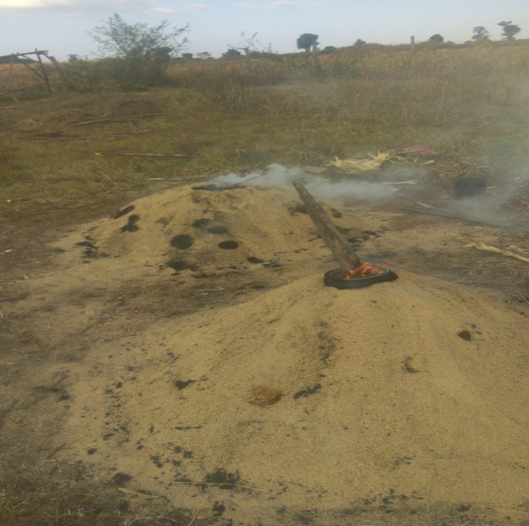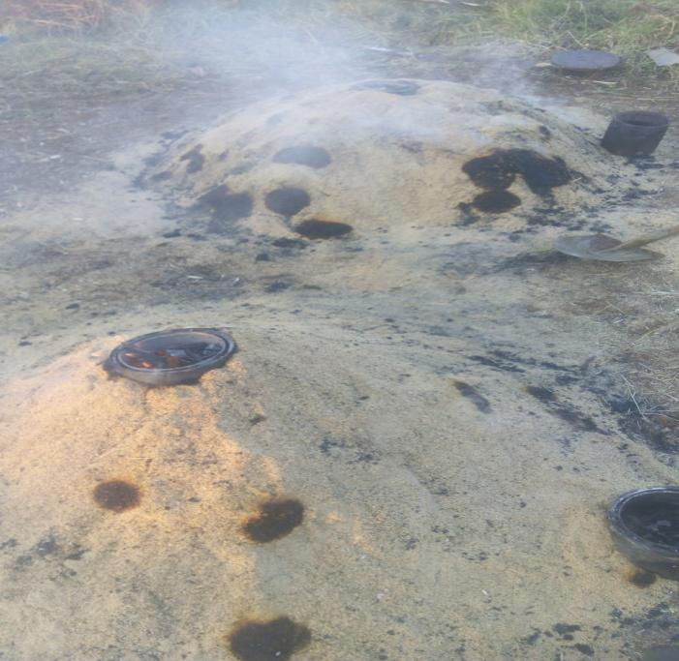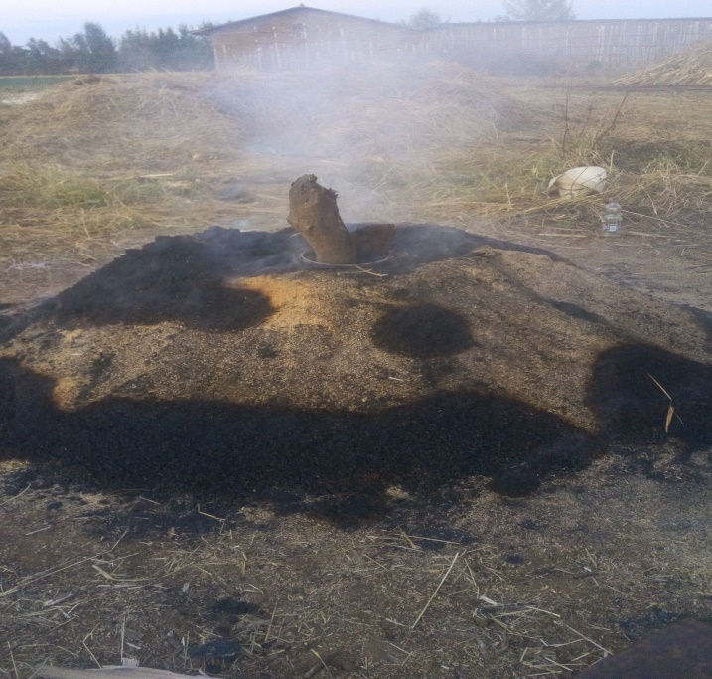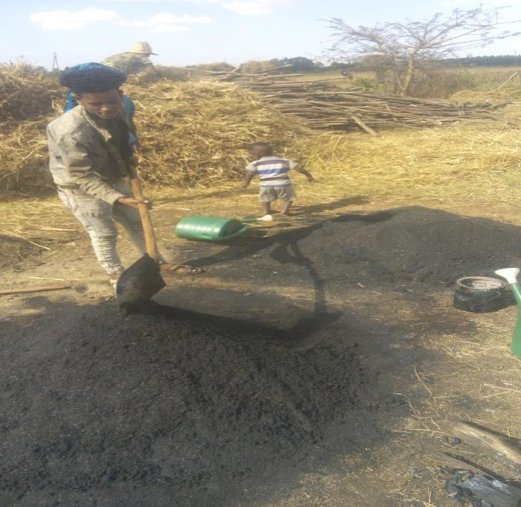
Phase IV

Phase IV
Phase III

Phase III
Phase I

Phase I
Phase II

Phase II
Appendix Figure 1. Carbonized Rice Husk preparation procedures from well dried rice husk. Phase I to III shows heating process and change in the color of the husk yellow to black; phase IV is the final stage indicated by complete conversion of rice husk to black color, thus cooling takes place by spraying water to avoid conversion to the ash form
Phase IV

Phase IV
Phase III

Phase III

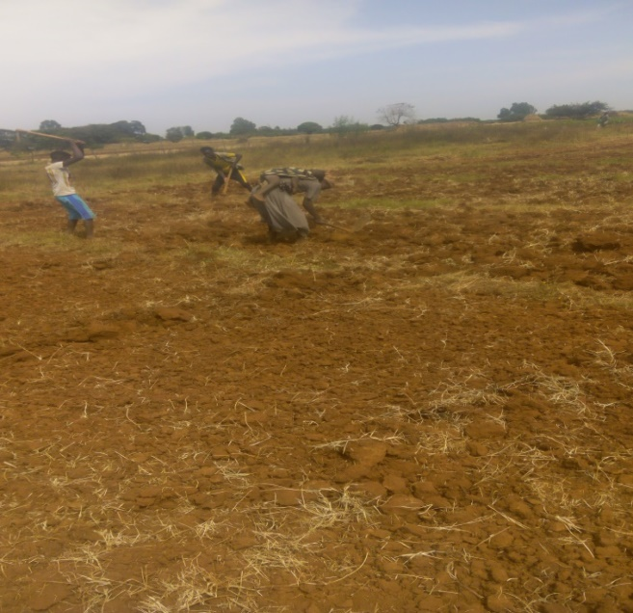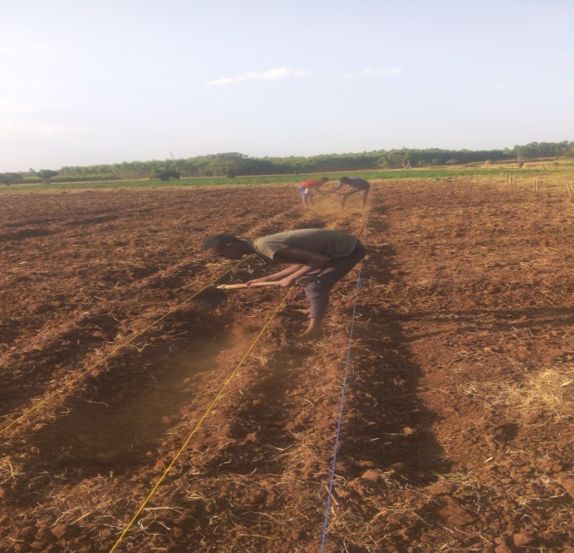
Appendix Figure 2. Land Preparation (A) Clod breaking (B) preparation of ridge and furrow

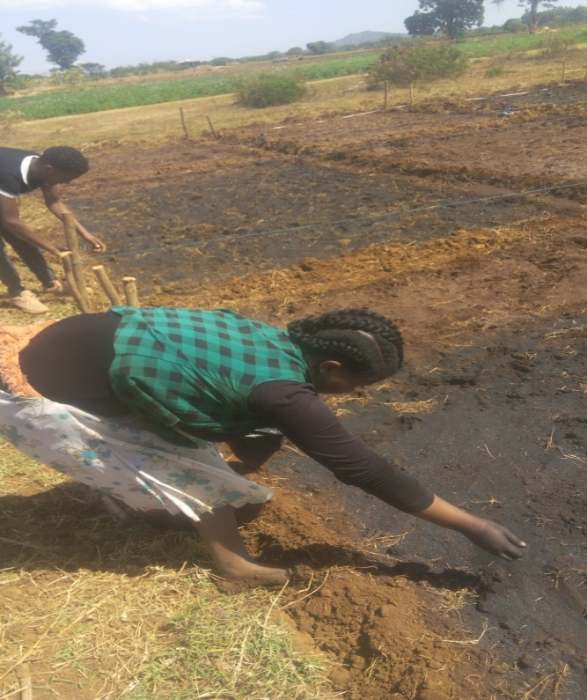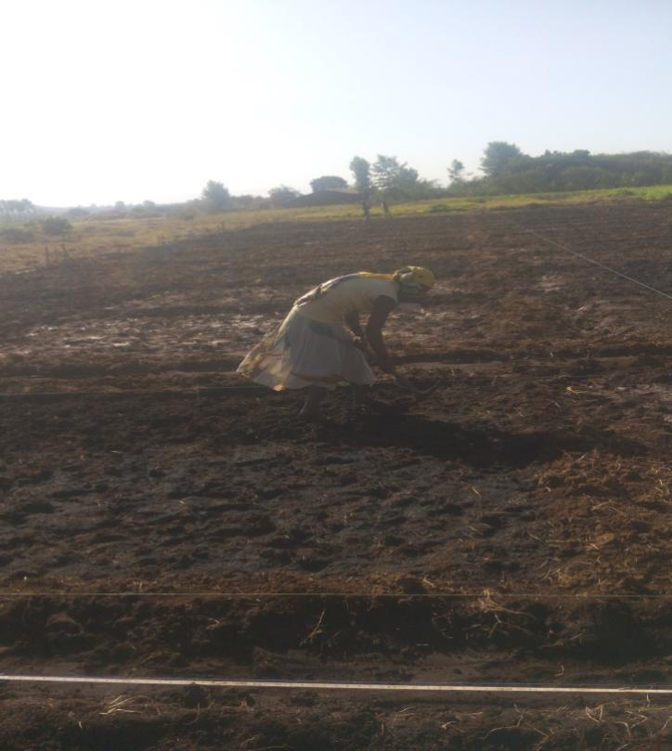
a
b
Appendix Figure 3. Broadcast incorporation of carbonized rice husk: a) application by broadcasting; b) manual mixing up with the soil (Original photo taken by Mekonnen Gebru on 01/21/2021)

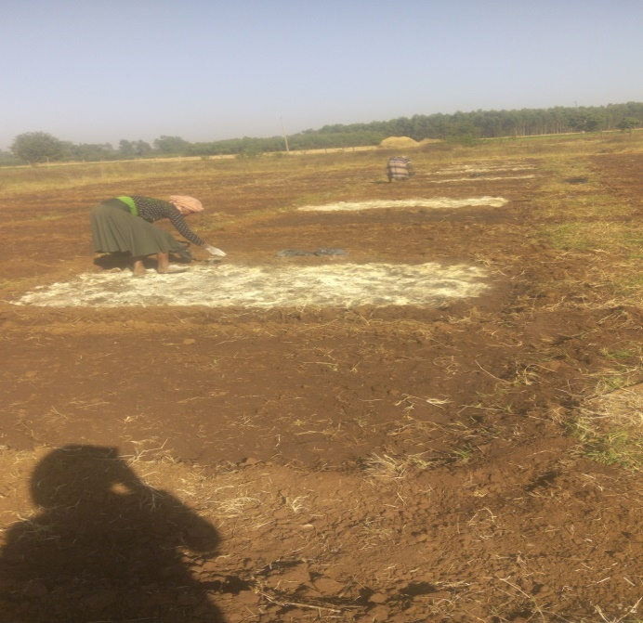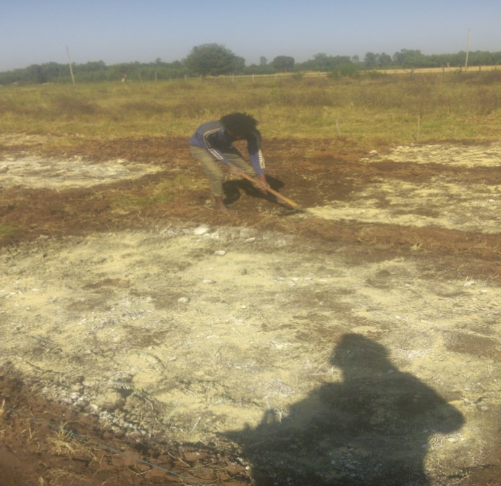
b

b
a

a

Appendix Figure 4. Lime application through broadcast incorporation: a) broadcast application b) incorporation of lime with soil

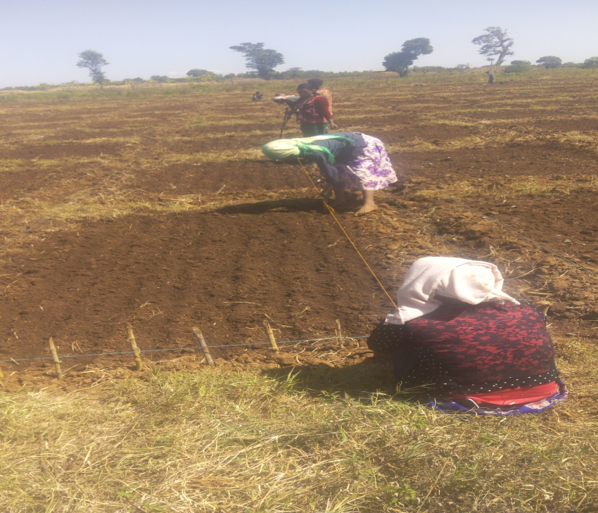
Appendix Figure 5. Preparation of rows for planting

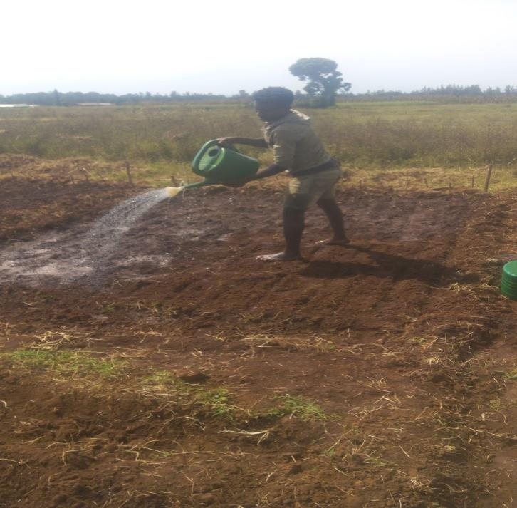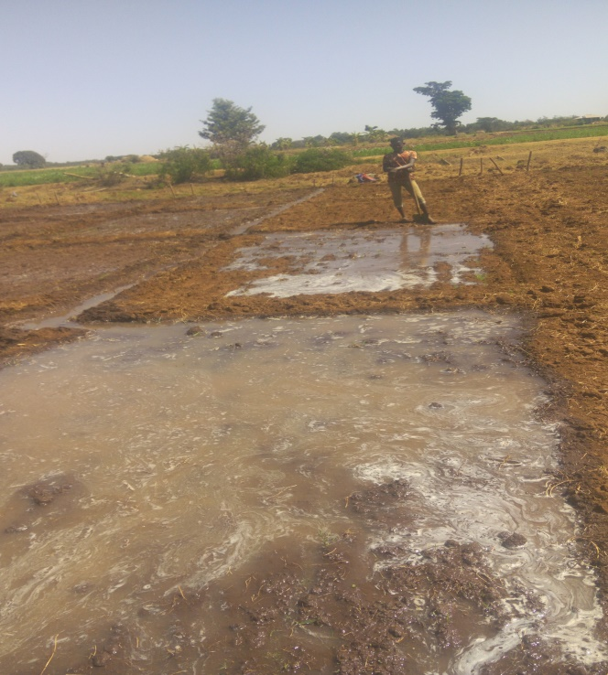
b
a

Appendix Figure 6. Post plant Crop Management Practices: (a) Can Sprinkler irrigation from planting to early establishment stage (Seedling emergency); (b) Controlled Flooding (c) Hand Weeding
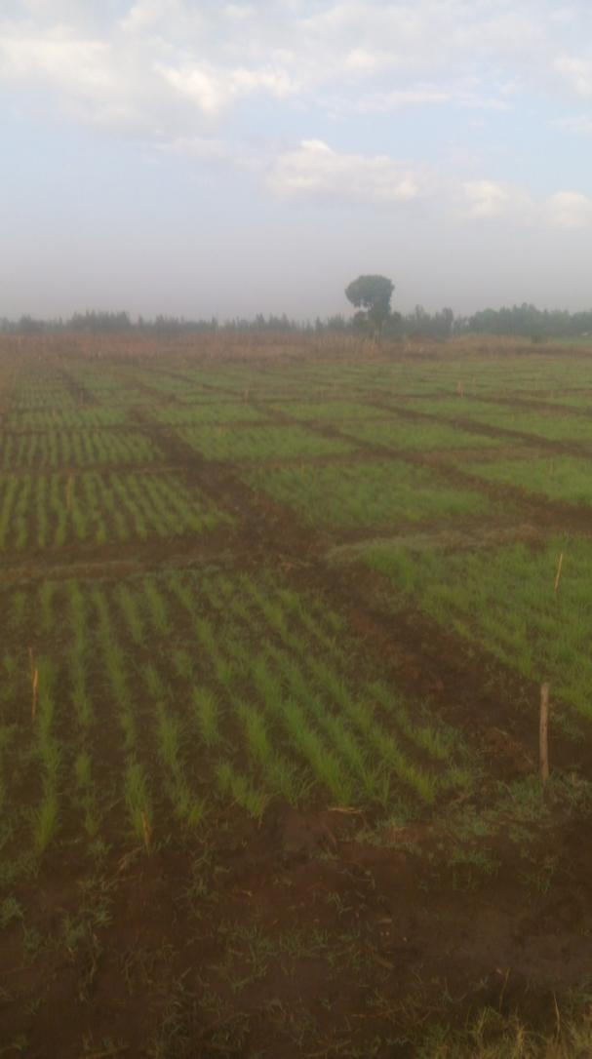 `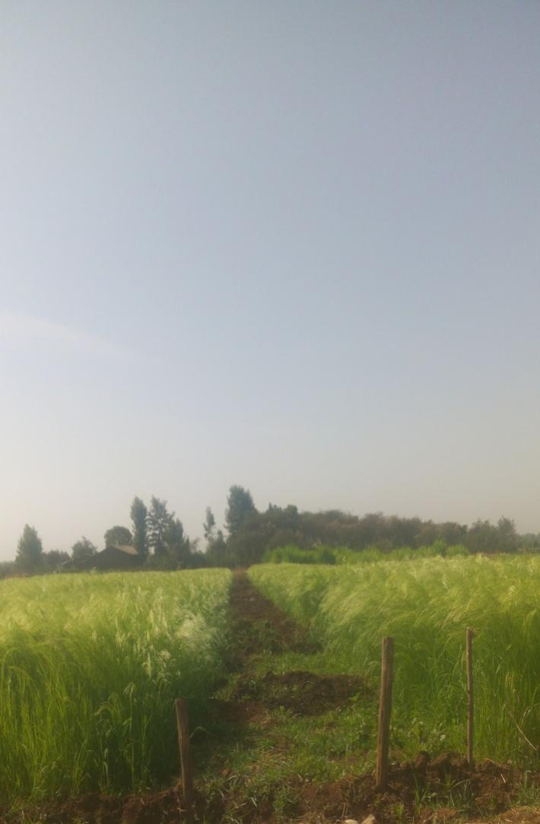
Appendix Figure 7. Plant growth performance in the field during early (a) and grain formation (b) stages

BIOGRAPHY OF THE AUTHOR

Mekonnen Gebru Tekle was born on November 9, 1986 in Debre Markos town, East Gojjam Zone of Amhara Region, Ethiopia. He attended his elementary school education (grade 1 to 8) at Endmata Primary School from 1994 to 2000. Then he attended his secondary education at Menkorer Secondary School from 2001 to 2002. After he successfully passed his Ethiopian General Secondary Education Leaving Examination, he joined Debre Markos Preparatory Secondary School from 2003 to 2004.

After successfully passing the Ethiopian Higher Education Entrance Qualification Examination, he joined the Ambo University formerly known as Jimma University Ambo College, Department of Plant Science in 2005 and graduated with B.Sc. Degree in Crop Production in July 2008. After seven months of his graduation, he joined Harmaya University, College of Agriculture and Environmental Sciences in March 2009 and graduated with M.Sc. Degree in Irrigation Agronomy in July 2012. In 2012, he immediately placed as a lecturer to Wolkite University by the Ministry of Education.

Mekonnen had published four peer reviewed journal articles; two of them are from the dissertation. In addition, he has participated in two successfully completed community based projects that was conducted in Gurage Zone. Now he is a candidate for the Degree of Doctor of Philosophy (PhD) in Agronomy in the College of Agriculture and Environmental Sciences, Bahir Dar University.

Article Publications

Peer Reviewed Journal Articles Derived from this Dissertation

- Gebru, M., Alemayehu, G., & Bitew, Y. (2023). Yield and lodging response of tef [Eragrostis tef (Zucc) trotter] varieties to nitrogen and silicon application rates. Heliyon. 9 (2023) e22576, pp1-13.
- Gebru, M., Alemayehu, G., & Bitew, Y. (2024). Yield, lodging, and water use efficiency of Tef [Eragrostis tef (zucc) Trotter] in response to carbonized rice husk application under variable moisture condition. PLOS ONE. DOI: 10.1371/journal.pone.0298416

- Gebru, M., Alemayehu, G., & Bitew, Y. (2024). Water Use Efficiency, Lodging and Yield of Tef [Eragrostis tef (Zucc) Trotter] as Influenced by Carbonized Rice Husk Application Timing and Soil Amendments. Submitted to: CAMBRIDGE UNIVERSITY PRESS

Others Publications

- Kifle Zerga, Birhanu. T. and Mekonnen. G. (2018) ‘Farmers Participatory Evaluations and Selection of Bread Wheat (Triticum aestivum. L) Varieties in Cheha District, Gurage Zone, Ethiopia’, International Journal of Scientific and Research Publications, 8(12), pp. 780–789.

- Arif Abrahim Sali, Issa Eibrahim, Bahiru Wabela, and Mekonnen Gebru. 2019. “Evaluation of Some Improved Tef Genotypes in Guraghe Zone, Southern Nations Nationalities and Peoples Regional State, Ethiopia.” International Journal of Agricultural Research and Review 7(1)(ISSN-2360-7971):722–28.

Community Service Projects

- Improved Wheat Variety Seed Multiplication and Dissemination in Some Selected Districts of Gurage Zone
- Improving the Production and Productivity of Coffee in Gurage Zone Through Climate Smart Approach

