
BAHIR DAR UNIVERSITY
COLLEGE OF AGRICULTURE AND ENVIRONMENTAL SCIENCE
GRATUATE PROGRAM
ENVIRONMENT AND CLIMATE CHANGE

MODELING GROUNDWATER VULNERABILITY USING A MODIFIED DRASTIC MODEL IN THE CASE OF BAHIR DAR CITY, NORTHWEST, ETHIOPIA

M.SC THESIS
BY
WASIE ASMAMAW

ADVISOR: TEMESGEN GASHAW (PhD)

MAY, 2024
BAHIR DAR, ETHIOPIA
BAHIR DAR UNIVERSITY
COLLEGE OF AGRICULTURE AND ENVIRONMENTAL SCIENCE
GRATUATE PROGRAM
ENVIRONMENT AND CLIMATE CHANGE
MODELING GROUNDWATER VULNERABILITY USING A MODIFIED DRASTIC MODEL IN THE CASE OF BAHIR DAR CITY, NORTHWEST, ETHIOPIA
M.SC THESIS
BY
WASIE ASMAMAW

A THESIS REPORT SUBMITTED IN PARTIAL FULFILLMENT OF THE REQUIREMENTS FOR THE DEGREE OF MASTER OF SCIENCE IN ENVIRONMENT AND CLIMATE CHANGE

MAY, 2024
BAHIR DAR, ETHIOPIA

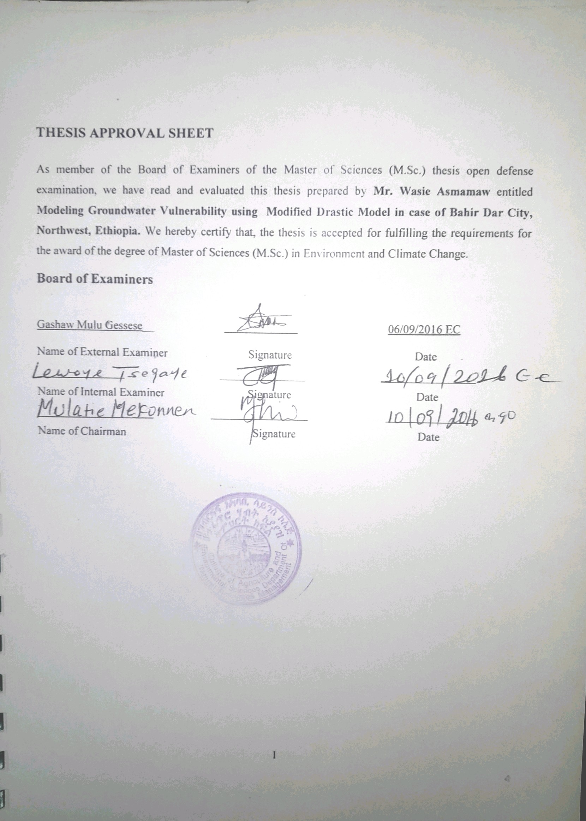

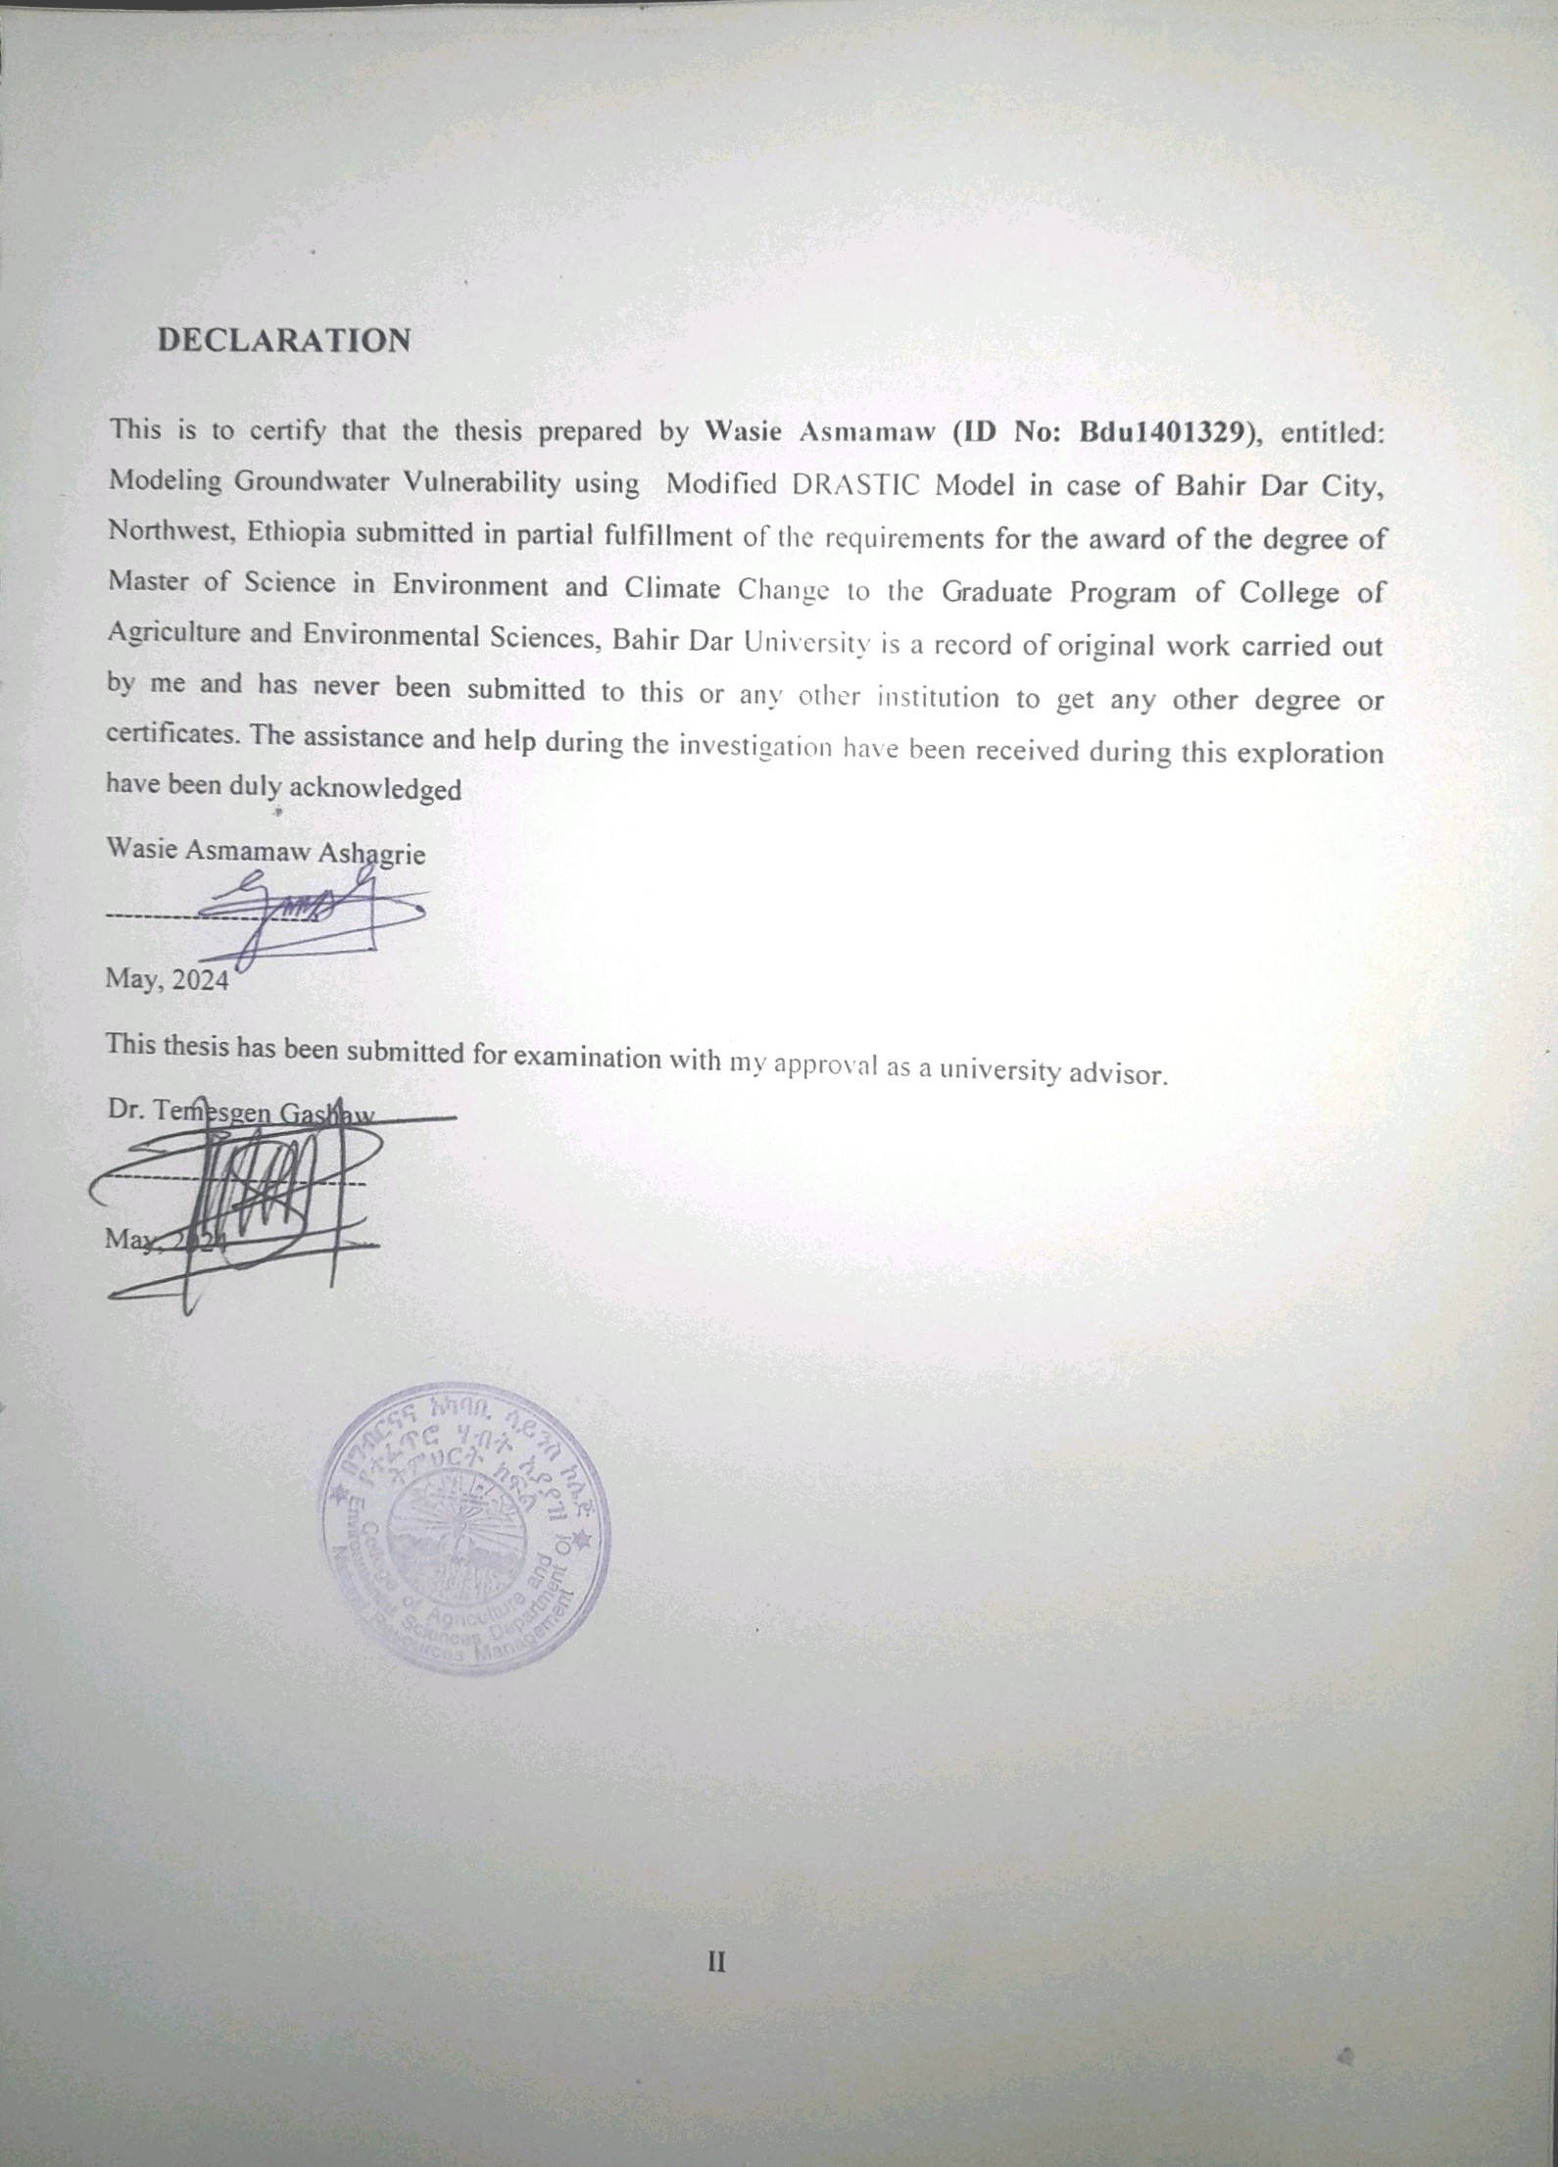

ACKNOWLEDGEMENTS
My first gratitude is to the Almighty God, who gave me health and strength during this study and in my entire life. And then, this study would have not been possible without the contribution of different organizations and individuals. In particular, I am greatly indebted to my thesis advisor Dr. Temesgen Gashaw, who has not only devotedly advised me in a family hood manner, but also provided insightful guidance and equipped me with valuable knowledge that stimulated my thinking regarding the topic.
I am also glad to acknowledge Dr. Daniel Ayalew, lecturer and researcher at Bahir Dar University, for his constructive suggestions at different stages of writing the thesis and for assisting me also the use of different application soft wares and models.
I am also thankfully acknowledged to North Wollo Zone Water and Energy Office, to tested groundwater quality in polite and cost effective way.
Besides, I greatly acknowledge Bahir Dar University for financial support; Amhara Water Works Design and Supervision Enterprise, Bahir Dar City administration office, Ethiopian Geological Survey, National Meteorological Agency (NMA) for providing all the required data needed for the accomplished of the study.
Last but not least, I extend my deepest gratitude to my family, friends, and lower-class instructor for their encouragement, moral support, and inspired me to finish this paper.

TABLE OF CONTENTS
THESIS APPROVAL SHEET Error! Bookmark not defined.
DECLARATION Error! Bookmark not defined.
ACKNOWLEDGEMENTS III
LIST OF FIGURE VI
LIST OF TABLE VII
LIST OF APPENDX VIII
LIST OF ABBREVIATIONS IX
ABSTRACT X
CHAPTER ONE: INTRODUCTION 1
1.1 Background and Justification 1
1.2 Statement of the Problem 3
1.3 Objectives 5
1.3.1 General objective 5
1.3.2 Specific objectives 5
1.4 Research questions 5
1.5 Significance of the Study 5
1.6 Scope of the study 6
CHAPTER TWO: LITERATURE REVIEW 7
2.1 Groundwater Resource 7
2.2 Groundwater in Ethiopia 7
2.3 Groundwater quality 7
2.3.1 Sources of groundwater contamination 8
2.4 Vulnerability of groundwater resources 10
2.5 Modified DRASTIC Model 18
2.6 Mapping groundwater vulnerability and its challenge 19
2.7 Empirical studies about Groundwater vulnerability using the DRASTIC and Modify the DRASTIC model 20
CHAPTER THREE: MATERIALS AND METHODS 21
3.1 Description of the study area 22
3.2 Research design and methods 25
3.2.1 Research design 25
3.2.2 Data type and method of data collection 25
3.2.3 Materials and Software 26
3.3 Methods of Data Preparation 27
3.3.1 Data Preparation for Groundwater Potential Zone 27
3.3.2 Developing an Analytical Hierarchy Process (AHP) 27
3.3.3 Establishment of pairwise comparison matrix (PCM) 28
3.3.4 Pre- Process and Data Preparation for Groundwater vulnerability 29
3.4 Data analysis and model description 33
3.4.1 Modified DRASTIC model 34
3.4.2 Weight and rate of parameters for the modified DRASTIC model 34
3.6 Model validation 38
3.7 Sensitivity analysis 40
3.7.1 Single parameter sensitivity analysis method 40
3.7.2 Map removal sensitivity analysis method 41
3.8 Analytical framework 41
The conceptual framework of the study was shown as follows in Figure 3.4. 41
CHAPTER FOUR: RESULT AND DISCUSSION 42
4.1 Groundwater potential zone identification 43
4.1.1 Developing an Analytical Hierarchy Process (AHP) model 43
4.1.2 Groundwater Potential Zone Map 45
4.2 Spatial distribution of vulnerability of Groundwater to pollution 50
4.2.1 Modified DRASTIC model parameters rate and weight 51
4.2.2 Groundwater vulnerability map 63
4.2.3 Model validation 66
4.3 Sensitivity analysis 69
4.3.1 Single parameter sensitivity analysis 69
4.3.2 Map removal sensitivity analysis 70
CHAPTER FIVE: CONCLUSION AND RECOMMENDATION 72
5.1 Conclusion 72
5.2 Recommendations 73
Reference 74
Appendix 89

LIST OF FIGURE
Figure 2.1: Point and non-point Sources of groundwater pollution 10
Figure 2.2: Definition of DRASTIC parameters 17
Figure 3.1: Map of the study area 22
Figure 3.2: Soil Map of the study area 24
Figure 3.3: LULC Map of the study area 25
Figure 3.4: Analytical framework of the study 42
Figure 4.1: Slope Map of the Study Area 46
Figure 4.2: Rainfall Map of the Study Area 46
Figure 4.3: Lineament Density Map of the Study Area 47
Figure 4.4: Geology Map of the Study Area 47
Figure 4.5: Drainage density Map of the Study Area 48
Figure 4.6: Soil Texture Map of the study area 48
Figure 4.7: LULC map of the study area 49
Figure 4.8: Groundwater potential zone Map of the study area 49
Figure 4.9: Depth to water table map of the study area 51
Figure 4.10: Net recharge map of the study area 53
Figure 4.11: Aquifer media map of the study area 54
Figure 4.12: Soil media map of the study area 55
Figure 4.13: Slope map of the study area 57
Figure 4.14: Impact of Vadose zone media map of the study area 58
Figure 4.15: Hydraulic conductivity map of the study area 60
Figure 4.16: LULC map of the study area 62
Figure 4.17: Modified DRASTIC model result index map of the study area 63
Figure 4.18: Modified DRASTIC model vulnerability class map of the study area 64
Figure 4.19: Nitrate Concentration of the study area 67
Figure 4.20: Total dissolved solid of the study area 68
Figure 4.21: Turbidity of the study area 68

LIST OF TABLE
Table 2.1: Weight of SI model parameters 13
Table 2.2: Vulnerability index in SI model 13
Table 2.3: SINTACS model parameters weight 14
Table 2.4: Rating and weighting of DRASTIC and modified DRASTIC models 19
Table 2.5: Vulnerability index and class in the modified DRASTIC model 19
Table 3.1: primary and secondary data were used for this study 26
Table 3.2: Software and materials used for this study 26
Table 3.3: Preference scale for two parameters in AHP 29
Table 3.4: Random consistency index (RCI) for number of comparison 30
Table 3.5: Weight of modified DRASTIC model parameters 35
Table 3.6: Parameters rate and range of modified DRASTIC model 35
Table 3.7: Vulnerability index and class in the modified DRASTIC model 38
Table 3.6: Drinking water quality standards based on FAO, WHO, and MoH 40
Table 4.1: Pairwise comparison matrix for Relative weight of thematic layers 43
Table 4.2: Pairwise comparison matrix and normalized weight 44
Table 4.3: Principal Eigen Vector, consistency index, and consistency ratio 44
Table 4.4: Areal coverage of Groundwater potential zone 50
Table 4.5: Depth to water table Areal coverage of the study area 52
Table 4.6: Net recharge Area of the study area 53
Table 4.7: Aquifer Media Areal coverage of the study area 54
Table 4.8: Soil media Areal coverage of the study area 56
Table 4.9: Slope Areal coverage of the study area 57
Table 4.10: Impact of Vadose Zone Area1coverage of the study area 59
Table 4.11: Hydraulic Conductivity Areal coverage of the study area 60
Table 4.12: LULC Areal coverage of the study area 62
Table 4.13: Groundwater Vulnerability Class Areal coverage of the study area 64
Table 4.14: Statistics of single parameter sensitivity analysis method 69
Table 4.15: Statistics of Map Removal Sensitivity Analysis Method 70

LIST OF APPENDIX
Appendix 1: Accuracy assessment of the study area 89
Appendix 2: Rainfall Data used for this Study 89
Appendix 3: Bahir Dar City groundwater quality laboratory result 90
Appendix 4: Row Data used for SPSS Result 91
Appendix 5: SPSS Result for Pearson Correlations to Validate Groundwater Vulnerability 92

LIST OF ABBREVIATIONS
AHP | Analytical Hierarchical Process
AOI | Area of Interest
BD | Bahir Dar
DEM | Digital Elevation Model
ENGDA | Ethiopian National Groundwater Database
GIS | Geographic Information System
GPS | Geographic Positioning System
GWPZ | Groundwater Potential Zone
GWV | Ground water Vulnerability
IDW | Inverse Distance Weight
LULC | Land Use Land Cover
mDI | Modified DRASTIC Index
NMA | National Metrological Agency
NGO | Non-Governmental Organization
PCM | Pairwise Comparison Matrix
SDG | Sustainable Development Goal
SI | Susceptibility Index
SPSS | Software Package for Social Science
TDS | Total Dissolved Solid
UN | United Nation
WHO | World Health Organization

ABSTRACT
Ensuring access to improved sources of water and safe drinking water for all has been the Nation’s concern which is one of the 17th UN Sustainable Development Goals set to be achieved by 2030. Groundwater is one of the most valuable natural resources in the world. However, groundwater resources, especially in shallow aquifers, are susceptible to contamination. Groundwater pollution is one part of environmental pollution that harms human health, livestock, and agricultural productivity, and other adverse impacts on the world's economic growth. With this respect, the quality of groundwater in the study area has deteriorated due to industrial effluents, domestic wastes, and extensive use of fertilizer for agricultural purposes. Once the groundwater gets polluted, treatment is very difficult and expensive because prevention is much better than protection. With this in mind, this study aims to assess groundwater vulnerability using the Modified DRASTIC model in the Case of Bahir Dar City. The modified DRASTIC model uses eight attributes including, aquifer media, net recharge, Depth to water table, soil media, topography, impact of vadose zone, land use land cover, and hydraulic conductivity of the aquifer were collected from both primary and secondary data sources. These thematic layers were integrated using the Raster calculator tool in a GIS environment to identify and map the spatial distribution of hotspot areas. Single parameter and map removal sensitivity analysis methods are used to identity significant parameters. The result of the study indicates that 5899.73 ha (27.63%) are put under the low vulnerable zone, 7344.92 ha (34.40%) are put under the moderate vulnerable zone, 5589.87 ha (26.18%) are put under the highly vulnerable zone and 2514.28 ha (11.78%) are put under the very high vulnerable zone. The vulnerability of the city is heavily influenced by net recharge (R) and land use land cover (Lu). GIS and Remote Sensing application of the DRASTIC model and integrating Lu in the model was found to be a suitable method for analyzing the groundwater vulnerability in Bahir Dar City. Thus, the study will be helpful in the proper management and development of available groundwater resources in the study area.

Keywords: Modified DRASTIC model, Groundwater, Groundwater Vulnerability, Geographic Information System and Remote Sensing

CHAPTER ONE: INTRODUCTION

Background and Justification
Groundwater is an important, valuable, and renewable natural resource that constitutes about 95% of the freshwater supply available for mankind, making it essential to human life and economic development (Foster et al., 2013). In many countries with limited sources of surface water, groundwater is the only source of water supply for domestic and other uses. Over the past 50 years, the use of groundwater has significantly increased and is expected to rise higher in the near future due to population growth and frequent droughts (Foster et al., 2013). Other reasons why the demand for groundwater resources continues to rise are its generally good quality and its modest costs of development (Calow et al., 2010).
Groundwater contamination is the worst in urban areas where major contaminant sources like industrial swages, septic tanks waste disposal, and agricultural activities produce pollutants in surface and groundwater (Liu et al., 2011). It results in a persistent impact on adequate water supply for agriculture, the industrial and livelihood of the population, and the health of the society. It also leads to permanent loss of agricultural productivity and industrial activity which indicates it causes economic hardship (Akhtar et al., 2014; Pawari and Gawande, 2015). The impact is more in developing countries rather than developed countries as they rely on untreated groundwater (Tuinhof et al., 2011), while at the same time environmental degradation, poor waste management, and climate change reduce freshwater availability (Dams et al., 2008; Kut et al., 2016).
In Africa, groundwater is the main source of drinking water and its use for irrigation is expected to increase substantially to combat the challenges of food insecurity (Adelana and MacDonald, 2008). Vörösmarty et al., (2005), stated that water use in Africa increase remarkably over the next few decades due to population growth, urbanization, and planned increases in irrigation to increase food security. According to Adelana and MacDonald, (2008), about 300 million people in Africa do not have access to safe and clean drinking water, many of whom are among the poorest and most vulnerable in the world. The only alternative to address the problem of water scarcity is by increasing and developing groundwater supplies throughout Africa (Giordano, 2009).
The Ethiopian National Groundwater Database (ENGDA) has been implemented since 2003 jointly by the Ministry of Water Resources, Addis Ababa University, and the Geological Survey of Ethiopia. It has a close collaboration with the regional water resources development bureaus, Point and non-point Sources of groundwater pollution. ENGDA has large attributes and collections of about 5,000 boreholes in the country. The availability of this groundwater database plays an important role in understanding the hydrologic cycle and discharge recharge relation, for assessing and managing water resources within the hydrogeological environment (Melesse et al., 2013).
At present, detailed groundwater assessments are ongoing in several areas and these indicate that the previously estimated groundwater usage potential of 2.6 BCM was underestimated and it needs to be revised. Best guesses in this respect range between 12 and 30 BCM, or even more if all groundwater in the lowlands is assessed (Melesse et al., 2013). Studies for irrigated agriculture in Kobo, Raya, and Adaa Bechoo suggest that regional ground waters are deep and water movement crosses surface basin boundaries. It is estimated that the groundwater reserve of the Kobo Girana Valley alone is in the order of 2.5 BCM, that of Raya is 7.2 BCM, and Adda Bechoo is 0.96 BMC (Abe and Ersado, 2022).
The concept of groundwater vulnerability assessment arose from the need to prevent groundwater pollution (Rendilicha et al., 2018) and sustainably promote groundwater management, to assure a predictable supply of clean groundwater for future generations. The fundamental principle of a groundwater vulnerability assessment is to explain why some areas are more easily polluted than others. The purpose of groundwater vulnerability assessment is basically to subdivide an area according to the vulnerability index (Pathak and Hiratsuka, 2011).
Groundwater serves as the main source of domestic water supply for Bahir Dar City of Ethiopia (Oscar Veses et al., 2016; Abiye & Kebede, 2011). According to Goshu & Akoma, 2011, pollutant concentration was high in Bahir Dar City in shallow groundwater wells and showed a decreasing trend from the city center to the border, possibly due to anthropogenic effects from the population density or geological variation. Assessment of groundwater contaminant risk and providing a vulnerability map is an essential pathway for managing groundwater and the environment (Yu et al., 2010). which allows managers to make evidence-based decisions (Sener & Davraz, 2013).

The past few years have seen the development of groundwater contamination modeling and increased knowledge of groundwater pollution. Environmental managers have shown interest in evaluating the groundwater vulnerability to surface pollution and the likelihood of contaminants concentration exceeding acceptable levels in some areas compared to others (Pathak and Hiratsuka, 2011). Many approaches have been developed to assess groundwater vulnerability to pollution, such as process-based methods, statistical methods, and overlay and index methods (Machiwal et al., 2018). The choice of method that is suitable to generate a groundwater vulnerability map for certain areas depends on the number, distribution, and reliability of the data (Massimo, 2010). Overlay and index methods have been the most widely used in building the groundwater vulnerability map because of the availability of data as compared to the other two approaches (Massimo, 2010). The groundwater vulnerability map is, therefore, an environmental tool that should be integrated into land- use planning scheme for any order and degree of any administrative boundary.

Statement of the Problem
The Ethiopian government has adopted the UN Millennium Sustainable Development Goals (SDGs) where maintaining water quality and providing safe drinking water for all is principal for the goal 6 (UNESCO, 2015). It is also striving to meet the goal by incorporating it in its Growth and Transformation Plan (GTP-2).
A safe and sufficient water supply is essential for the health and well-being of human beings, the environment, and socioeconomic development (Allouche et al., 2017). However, Water is not consistently kept adequate and safe throughout the world. The solutions to these problems are exceeding the water sector capacity in areas with already-scarcity and deterioration of quality water resources (Akhtar et al., 2021).
About 29% (844 million people) of the world's population lacked access to basic drinking water services in 2015. The problem is a lot more in African content; for instance, 10 countries of the world with inadequate water supply services are found in Sub-Saharan Africa (Mullan et al., 2011).
On the other hand, 80% of waste water is simply released into the ecosystem without being treated at the global level (Capodaglio, 2017). Particularly in low-income countries, only 8% of the wastewater is treated the other huge proportion of the waste water is discarded and causes surface and groundwater pollution (Parkinson & Tayler, 2003). As part of the Sub-Saharan region, for example in Ethiopia with inadequate evidence to support it, the Ethiopian Health and Demographic Survey (EHDS, 2016) revealed that more than 91% of the households were not purifying their water for drinking. Only 7% of Households use adequate treatment techniques. Thus, vulnerability assessment is crucial at least to safeguard groundwater supplies from pollutants.
Like water quantity, water quality is crucial to serve basic human and environmental needs commitment; however, it has received less funding, scientific support, media coverage, and politics. Because of this, there is not enough evidence to conclude that the quality of the world's water has improved overall in the world (Allouche et al., 2017). The reality of monitoring and surveillance of water quality is very inadequate, especially in developing nations; for instance, in 10 countries of sub-Saharan Africa, the majority of concerned institutions are not performing the water tests recommended by WHO standards (Contreras & Eisenberg, 2020).
In Ethiopia, water quality problems are forcefully stated in Ethiopia's water resource policy and strategy legal document, but managing water quality is still difficult. However, studies conducted very recently in Ethiopia indicated that one of the most serious environmental problems today is groundwater contamination (Yohannes and Elias, 2017; Usher, 2006; FDRE MoWE, 2013; Abiy et al., 2016; Akale et al., 2017; Sahele et al., 2018). Based on the Ministry of Health's report (FDRE MoH, 2014), Water Aid (Water Aid, 2016), and CSA (CSA, 2017), groundwater contains significant amounts of nitrate, microbes, and other contaminants. Despite this, little attention has been given to groundwater quality monitoring (FDRE MoWE, 2013). Therefore, proper and early groundwater management is vital to preserving the natural quality of the resource.
However, due to groundwater complexity, sufficient and comprehensive information about the actual status of groundwater vulnerability is not available (Oke & Fourie, 2017). A few studies by Mengesha et al., 2013; Akale et al., 2017; Tefera et al., 2021) conducted in Bahir Dar City and its environs evidenced that the groundwater has been polluted by different pollutants raised by factories, hotels, agricultural lands, and others. Even though these studies showed the status of groundwater quality and level of pollutant concentration, but they did not show the spatial distribution and, priorities and delineate areas according to their vulnerability level for proper management and resource allocation.
In this regard, the intrinsic groundwater vulnerability model identifies potentially vulnerable areas for prior protection over an extensive area within a short time and minimum cost (Shirazi et al., 2012; Jang et al., 2017). DRASTIC, SI, SINTACS, AVI, GODIT, and other groundwater vulnerability models are the most commonly used models that consider the hydrogeological nature of groundwater. From which DRASTIC model is the most worldwide recognized and accurate model for groundwater vulnerability assessment, and is environmentally compatible (Aller, 1987; Shirazi et al., 2012). Studies conducted in the Tana sub-basin, Dire Dawa, Bahir Dar City, and other parts of the country (Abiy and Melesse, 2017; Tilahun and Merkel, 2010; Mengistu et al., 2021) respectively have employed the DRASTIC model.
Recently, the DRASTIC model has been modified by considering anthropogenic influence (Singh et al., 2015; Zafane and Benyoucef Gharbi, 2017; Ahmed et al., 2018). However, they did not represent properly the human factor in their analysis like other parameters of the DRASTIC model. Other studies (Saha and Alam, 2014; Ghazavi and Ebrahimi, 2015; Muhammad et al., 2015; Al-Abadi et al., 2017; Ramaraju and Veni, 2017) did not consider the impact of land use land cover (LULC) on the groundwater vulnerability and its contribution to the groundwater contamination. However, the impact of LULC is indispensable in groundwater vulnerability study since a change in land use has a potential impact on vulnerability mapping (Pórcel et al., 2014).

Objectives

General objective
The overall objective of this study was modeling groundwater vulnerability using a Modified DRASTIC model in the Case of Bahir Dar City, Northwest, Ethiopia.

Specific objectives
The specific objectives of this study were:
- To identify groundwater potential zone of Bahir Dar City using AHP techniques
- To identify the spatial distribution of groundwater vulnerability in Bahir Dar City using a modified DRASTIC model
- To identify the most sensitive parameters that affect groundwater vulnerability

Research questions
This study was answered the following research questions:
- What is spatial distribution of groundwater potential zone of Bahir Dar City with AHP techniques?
- What is the spatial distribution of groundwater vulnerability of Bahir Dar City using a modified DRASTIC model?
- What are the most sensitive parameters that affect groundwater vulnerability?

Significance of the Study
Bahir Dar City is home to many people with many industrial areas and different settlement patterns like urban, semi-urban, and rural villages. The quality of groundwater is under question in the future because of population growth, urbanization, industrialization, agriculture, and climate change as well as the geological formation and interaction of surface water to groundwater contribute to pollution of groundwater. As a result, protection of groundwater should be done before contamination as polluted groundwater is not easily treated or removed from the groundwater reservoir.
This study will be significantly important to mainstream groundwater protection mechanisms by considering different management scenarios for groundwater resources management; resource allocation and prioritization of groundwater-related activities and integration with different land uses; for sector integration to define roles and responsibilities, bases for further research and inputs for risk-based management of groundwater resources.

Scope of the study
This study focused on modeling groundwater vulnerability using Modified DRASTIC models. The area coverage of this study was Bahir Dar City, Northwest, Ethiopia. And, the temporal coverage of the study was May 2024.

CHAPTER TWO: LITERATURE REVIEW

Groundwater Resource
Water covers three-quarters of the Earth's surface and is found practically everywhere beneath the ground surface, down to considerable depths, and in constant motion. Groundwater as we can refer to the vast majority of this subsurface water. It is an invisible component of the hydrosphere, representing a hidden part of the water cycle (Margat & Van der Gun, 2013). Groundwater is water that exists mainly in subsurface pore spaces but also in defined channels, such as those found in karst formations, which are created by the dissolution of soluble rocks such as limestone. After the polar ice caps, groundwater is the next largest reservoir of fresh water on Earth, containing more than 100 times the volume of streams and freshwater lakes (Abd Ellah, 2020). Groundwater is the major source of freshwater supply worldwide, which is currently used to meet nearly half of the drinking water needs, including the requirements of about two billion people all over the world (Amanambu et al., 2020).

Groundwater in Ethiopia
The hydrological conditions that exist in the country are highly varied as a result of the complexity of geology, physiography, and climate change. The groundwater is mostly in the moderate range of productivity and the depth of groundwater is generally less than 150 m (Megersa & Getaneh, 2006). According to Kebede, (2012), the source of groundwater recharge in Ethiopia is under flood recharge, rainfall recharge, mountain block recharge, and runoff from graben. Alemayehu et al., (2006), investigated the occurrence of groundwater in Ethiopia and described the most important factors governing the groundwater flow and storage in volcanic rocks. The mineralogy, texture, and structure of volcanic rocks cause variations in the water-bearing capacity of the area. Groundwater is an important source of water and is the dominant source of domestic supply in many areas, especially the dry areas where surface waters are scarce and seasonal (Smedley, 2001). In many parts of the country, groundwater is an important source of potable water. This is especially true for rural areas as well as for towns. According to Megersa and Getaneh, (2006), the health of the population can be improved a great deal through an increased provision of clean and adequate water supplies mostly taken from groundwater. However, the occurrence of groundwater is not uniform due to various environmental and geological factors (Alemayehu et al., 2006).

Groundwater quality
Generally, groundwater possesses high chemical, bacteriological, and physical qualities. Groundwater pumped from an aquifer composed of a mixture of sand and gravel, if not directly inﬂuenced by surface water, is often used without filtration. It can also be used without disinfection if it has a low coliform count (Asfaw & Mengistu, 2020). However, as mentioned, groundwater can become contaminated. When septic systems fail, saltwater intrudes, improper disposal of wastes occurs, improperly stockpiled chemicals leach, underground storage tanks leak, and hazardous materials spill. Fertilizers and pesticides are misplaced, and when mines are improperly abandoned, groundwater can become contaminated (Spellman, 2017).

Sources of groundwater contamination
Natural sources
Some substances found naturally in rocks or soils, such as iron, manganese, arsenic, chlorides, fluorides, sulfates, or radionuclides, can become dissolved in groundwater (Machiwal & Jha, 2015). Other naturally occurring substances, such as decaying organic matter, can move in groundwater as particles. Whether any of these substances appear in groundwater depends on local conditions. Some substances may pose a health threat if consumed in excessive quantities; others may produce undesirable odor, taste, or color. Groundwater that contains unacceptable concentrations of these substances is not used for drinking water or other domestic water uses unless it is treated to remove these contaminants (Li et al., 2021).
Improper disposal of hazardous waste
Improper disposal of hazardous waste should always be disposed of properly. Many hazardous chemicals generated from industries, household activities, paint thinners, disinfectants, medicines, and photographic chemicals should not be disposed of in any place unproperly because they could contaminate a drinking water source. Therefore, different types of chemicals generated from industries and other related activities make proper disposal of wastes especially important for groundwater protection (Bushra, 2012).
Solid waste (Landfill)
The garbage generated in the urban and industrial solid wastes disposed on the land surface also gives rise to groundwater pollution. The most serious risks occur where uncontrolled tipping (reuse dumping), as opposed to a controlled sanitary landfill, is practiced and where hazardous industrial wastes, including drums of liquid effluents, are disposed of at inappropriate sites (Pinder & Celia, 2006). Municipal solid wastes are disposed of in low-lying grounds without any record of the quantity of wastes and their quality. Even if the disposal is stopped, once in the landfill, chemicals can leach into the groundwater by means of precipitation, and surface runoff at the site will represent a potential hazard to groundwater for decades together (Harter, 2003). In general, as Pinder and Celia, (2006) wrote the major sources for groundwater contaminants are storage tanks, septic systems, and landfills.
Agriculture and Agricultural activities
An agricultural activity can result in non-point sources of groundwater contamination (Harter, 2003). Fertilizers, pesticides, and herbicides are applied as part of common agricultural practices throughout the world. Applications of these agricultural inputs act as sources of contamination to groundwater. In developing countries, animal and/or human waste is used for fertilizer (Gupta et al., 2019). The manufactured inorganic fertilizers widely used in developed countries pose the threat of nitrate contamination of groundwater systems. Pesticide and herbicide applications provide a source of numerous toxic organic chemicals to groundwater supplies. Agricultural activities related to animals also can be groundwater contamination sources. These include the feeding of animals and the storage and disposal of their waste.
Nitrates and Groundwater quality
High nitrate levels in water can result from contamination with human or animal wastes, agricultural run-off, or industrial pollution. Risk factors (particularly fertilized fields) are likely to be widespread. Even though the health effect of nitrate is not significant in a low nitrate concentration area, if nitrate concentration rises, the impact is greater and needs a wider investigation for further monitoring. In the assessment carried out in the southeastern part of Ethiopia (Dire Dawa and Somali) the concentration of nitrate (NO3) was reported as 123mg/l which was more than two-fold of the WHO standard. Frequent monitoring is needed in water source areas which are close to high-risk areas where nitrate-inducing discharges like latrines, graveyards, and agricultural activities are more common (Tadesse, 2014); Water Aid, 2016).
The point and non-point sources of groundwater pollution are summarized in Figure 2.1.

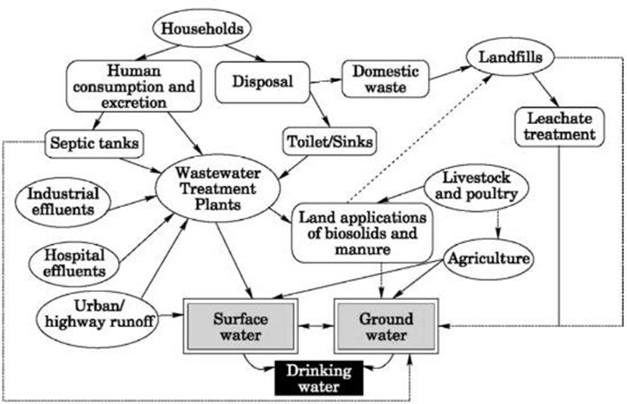
  - Figure 2.1: Point and non-point Sources of groundwater pollution
Source: (Wycisk et al., 2003)

Vulnerability of groundwater resources
The term groundwater vulnerability to pollution was originally introduced by French hydro geologist J. Margat in 1968 France and the first groundwater vulnerability map was constructed in France by M. Albined in 1970 (Younger, 2009; Lasagna et al., 2018). Vulnerability is a nonspecific term since it implies different concepts to different people. Different scholars consider it as an inherent property of soils along with other components of the natural environment (Bushra, 2012). According to Asfaw and Mengistu, (2020), vulnerability can be intrinsic or specific. Intrinsic vulnerability is the susceptibility to contamination based on physical features of the groundwater like geology, depth of the water table, and climate, and is independent of any particular contaminants.
On the other hand, specific vulnerability is susceptibility to one particular contaminant. Specific vulnerability related to a specific contaminant, contaminant class, or human activity considers the chemical and biological properties of contaminants and the system in addition to the physical features of the area. Mostly it is assessed in terms of the risk of the groundwater system which is exposed to contaminant loading (Lasagna et al., 2018; Asfaw and Mengistu, 2020). Intrinsic groundwater vulnerability is mainly formulated as an intrinsic characteristic of the aquifer system that depends on the sensitivity of the system to contaminants.
    - Needs for Groundwater Vulnerability Assessments
Groundwater vulnerability assessment enables how severe the likely consequences of pollutant loading on the surface are induced by human activity. The severity of the consequences is measured in terms of water quality deterioration. It is important to clarify the distinction between vulnerability and risk. This is because the risk of pollution is determined not only by the intrinsic characteristics of the aquifer, which are relatively static and hardly changeable but also by the existence of potentially polluting activities (Lasagna et al., 2018). It is possible to have high groundwater vulnerability but no risk of pollution, if there is no significant pollutant loading (Aller, 1987; Al-Rawabdeh et al., 2014). Since groundwater contamination is noticed easily and not recognized until some signs are observed in drinking or surface water, assessing the vulnerability of groundwater enables the protection of early and direct resources for proper management of these profitable resources (Candela Lledó et al., 1998; Novotny, 2003). The very important issue in groundwater pollution is its difficulty to treat or cure it from pollution, especially in developing countries. It is impossible and requires intensive economic investment. Therefore, mapping its vulnerability level and early protection is feasible with groundwater management techniques (Zafane & Benyoucef Gharbi, 2017).
    - Approaches to Groundwater Vulnerability Assessment
Process-based models
These models at the appropriate scale would be ideal in a perfect world since they attempt to capture the true physical, chemical, and biological reactions that occur from the surface through the groundwater regime. Process-based models, however, have not been demonstrated to be more effective than other techniques. The limitations of process-based models are derived from a model structure such as a lack of knowledge of how to formulate processes mathematically and limitations in data availability and quality. Furthermore, limited field experimentation with simulation models suggests that models based on simplified process representation may be more useful for many vulnerability assessments than more complicated models (Muhammad et al., 2015).
Statistical methods
These methods incorporate uncertainty and attempt to explicitly minimize error, but require observations of surrogates for vulnerability such as groundwater samples from shallow wells. Using these surrogates, the methods directly derive parameter coefficients instead of assigning weights to attributes based on expert judgment. Parameters from simple process-based indices (e.g., travel times) could be used in statistical methods, making for a sort of hybrid approach. However, the results of these methods can only be applied to the geographic areas in which the data were collected to regions where similar factors are associated with the likelihood of groundwater contamination. Examples of statistical methods include regression analysis (Saida et al., 2017).
Overlay and Index methods
These methods were developed because of limitations in process-based models and because of a lack of monitoring data required for statistical methods. Overly and index methods are based on assumptions that a few major factors largely control groundwater vulnerability and that these factors are known and can be weighted (Neshat et al., 2014). These assumptions have not been demonstrated, particularly concerning assigning weights to different factors. Examples of overlay and index methods include the DRASTIC model and SEEPAGE (System for Early Evaluation of Pollution Potential from Agricultural Groundwater Environments) (Shirazi et al., 2012). A DRASTIC method is a useful tool to assess intrinsic aquifer vulnerability from a regional point of view due to the versatility of its procedure and the integration of more hydrogeological parameters in comparison with other methods like GOD, AVI, and SINTACS (Jang et al., 2017).
    - Models for Groundwater Vulnerability Assessment
Models applied for groundwater vulnerability assessment can delineate areas, which are more likely than others to become polluted as a result of anthropogenic activities at or near the land surface. In this regard, there are several models devised with a different context, this DRASTIC model is one but in addition to it, the following models are commonly applied in different areas.
SI model
SI (Susceptibility index) is an intrinsic pollutant-oriented model used for assessing groundwater vulnerability (Shirazi et al., 2012). It was developed in 2000 in Portugal by Ribeiro (Abdelmadjid and Omar, 2013). Limitations of other models triggered the development of the Susceptible Index (SI) model (Ribeiro et al., 2017). This method incorporates new parameters that are not part of the other methods, land use that helps to consider the influence of anthropogenic factors especially nitrate and other pollutants generated by pesticides.
Unlike DRASTIC and modified DRASTIC models, the SI model incorporates five different geological, topographic, and hydrological parameters for assessing groundwater vulnerability. These parameters are Depth to groundwater table (D), Aquifer media (A), Recharge (R), Topography (T), and Land use (Lu) (Ribeiro et al., 2017; (Fannakh & Farsang, 2022). It is expressed in Equation 1:
$$SI=\sum_{i=1}^{s}{(wi*ri)} Equation 1$$
Where: SI= susceptible index,
i = parameters (D, A, R, T & Lu)
r = rating parameters and
w = weight of parameters
Weight and rate of SI model
According to Ribeiro et al., (2017), the weights of parameters in the SI model are fixed as follows Table 2.1.
  - Table 2.1: Weight of SI model parameters
Parameters | D | R | A | T | Lu
Weights | 0.186 | 0.212 | 0.259 | 0.121 | 0.222
Source: (Shirazi et al., 2012; Ribeiro et al., 2017)
Similarly, parameters are classified into ranges and assigned rates according to their importance and susceptibility to contaminates which shows the potential through which contaminants infiltrate the groundwater and the permeability of parameters to the contaminates. According to Ribeiro et al., (2017), the SI Vulnerability class is as follows in Table 2.2.
  - Table 2.2: Vulnerability index in SI model
Vulnerability class | Low | Average | High | Very high
Index | <45 | 45-64 | 65-84 | 85-100
Source: (Ribeiro et al., 2017)

GOD model
GOD model is a groundwater vulnerability assessment model which is developed in Great Britain (Foster, 1987). Unlike DRASTIC, modified DRASTIC, SI, and SINTACS models, the GOD model estimates vulnerability using three geological and hydrological parameters for a large area (Ghazavi and Ebrahimi, 2015). Therefore, it is important in an area where there is a shortage of data for vulnerability. The three parameters considered in the GOD model are Groundwater occurrence (G), Overlying aquifer lithology (O), and Depth to the groundwater table (D). It is expressed as Equation 2:
$GOD = Gr × Or × Dr Equation 2$
SINTACS model
The SINTACS model is an updated model of the US DRASTIC method (Luoma et al., 2017). It was developed in Italy in the early 1990s to adapt the mapping to a larger scale because of the great diversity of the hydrogeology of Italy (Civita, 1994). SINTACS model is a modification of a DRASTIC model with more options for the weight strings, including additional factors associated with human activities and watercourses, while the rating system of each parameter is still preserved as in the original DRASTIC method. The SINTACS model assesses the vulnerability of groundwater by using seven hydrological parameters (Aboulouafa et al., 2017). SINTACS model expressed by the Equation 3:
$$SI = Sr × Sw + Ir × Iw + Nr × Nw + Tr × Tw + Ar × Aw + Cr × Cw + SAr × SAw Equation 3$$
Where: S = (depth to water), I = (Net recharge), N = (vadose zone), T = (soil parameter),
C = (Hydraulic conductivity), S = (Topography)
Like a DRASTIC model, the weight of each parameter ranges from 1 to 5. Whereas parameter ratings vary from 1 to 10, where higher values are directly proportional to the degree of vulnerability as shown in Table 2.3.
  - Table 2.3: SINTACS model parameters weight
Parameter | S | I | N | T | A | C | S
Weight | 3 | 3 | 3 | 4 | 4 | 5 | 4
Source: (Aboulouafa et al., 2017)
DRASTIC Models
DRASTIC is one of the most well-known and widely used parametric vulnerability mapping techniques. It was developed through an EPA (Environmental Protection Agency) project in the United States to help managers, planners, and administrators. DRASTIC can be used in extensive regions due to the low cost of application and easy-to-collect data requirements (Panagopoulos et al., 2006). DRASTIC is believed to be a very popular method for groundwater vulnerability assessment. The original DRASTIC model includes seven hydrogeological parameters: depth to water (D), net recharge (R), aquifer media (A), soil media (S), topography (T), the impact of vadose zone (I), and hydraulic conductivity (C) (Panagopoulos et al., 2006). Both the rates and the weights of the seven parameters are based on local conditions. The given weights of the above seven factors range between 1 and 5 and represent the relative importance of those parameters (Saha and Alam, 2014). Equation 4:
$$DI=DW .DR + RW .RR + AW .AR + SW .SR + TW .TR + IW .IR + CW .CR Equation 4$$
Where DI is the DRASTIC index, D, R, A, S, T, I, and C are the seven parameters; factors with W subscripts show the weight, and parameters with R subscripts are the rate of the parameters. The vulnerability index is a dimensionless index and relative measure of susceptibility to pollution; regions with a higher DRASTIC index value are more vulnerable than those with a lower index. DRASTIC parameters have been explained briefly in the following sections.
Depth to Water (D)
Depth to water is one of the most important parameters in the DRASTIC technique which describes the distance that a contaminant must travel from the surface to reach the groundwater table (Aller et al., 1987). In other words, it is the vertical distance from the ground surface to the water table, on top of the saturated zone, in the aquifer. It could be determined using topography and groundwater level contour maps. By subtracting elevations from the groundwater level, the depth to water would be calculated. In general, the potential for contamination decreases with increasing D, as a deeper water table implies less chance for contamination to occur.

Net Recharge (R)
Net groundwater recharge is the main driving force for transferring contaminants to an aquifer. The total amount of water that reaches the water table has been indicated as net recharge. Net recharge might be estimated from the rainfall infiltration, irrigation return flow, evapotranspiration, and absorption wells in the study area. More recharge shows more vulnerability to contamination (Aller et al., 1987). The main source of recharge could be either river leakage or rainfall. The groundwater recharge map could also be prepared using isotope studies (Ribeiro et al., 2017).
Aquifer Media (A)
Aller et al., (1987) defined an aquifer as a rock formation that yields a sufficient amount of water for use. Aquifer media refers to consolidated and unconsolidated rocks (such as sand, gravel, or limestone) that serve as an aquifer (Aller et al., 1987). This parameter is essential to control the route, path length, and movement of contaminants. In general terms, large sediment size, higher permeability, and lower attenuation capacity can result in more vulnerability to pollution. An aquifer media map could be prepared using geological information.
Soil Media (S)
The soil media represents the top weathered portion of an unsaturated zone with significant biological activities (Aller et al., 1987). It is the top part of the vadose zone and its characteristics are important in potential pollution while by increasing the depth of soil, infiltration will be decreased. Generally, soil maps can represent infiltration rates of pollutants. Some effective factors that determine the potential pollution of soil comprise the type of clay, the grain size, and the shrinking potential of clay. Indeed, less amount of clay, less shrinkage potential, and smaller grain size indicate lower vulnerability of aquifer.
Topography (T)
Topography refers to the slope of the land surface and it controls the runoff of contaminants. This factor indicates the probability that contaminants run off or remain on the ground to infiltrate. Therefore, steep slopes increase runoff which contains contaminants and lowers the chance of infiltration (Al Hallaq and Elaish, 2012). A Digital Elevation Model could be used to prepare topography maps and the slope is calculated by GIS tools.

Impact of Vadose Zone (I)
The vadose zone also termed the unsaturated zone, extends from the top of the ground surface to the water table at which groundwater is at atmospheric pressure (Aller et al., 1987). Vertical movement of water in the vadose zone is important for pollution transport. The characteristics of an unsaturated zone can determine the attenuation properties of the media above the water table. A vadose zone map is also prepared using sub-surface geology and lithology characteristics of drilling logs.
Hydraulic Conductivity (C)
The ability of an aquifer to transmit water and contaminants is defined as hydraulic conductivity. The results of the pumping test and lithology are used for creating a hydraulic conductivity distribution map. Regions with higher hydraulic conductivity indicate more contaminant transmission and distribution (Aller et al., 1987). It is also controlled by pore spaces and fractures within the aquifer. The equation k=T/b might be used to calculate the hydraulic conductivity of the groundwater where the hydraulic conductivity of the aquifer is denoted by k (m/d), transmissivity is denoted by T (m²/d), and the thickness of the aquifer is denoted by b (m).
As it was mentioned, the DRASTIC approach allocates a specific weight and rate for each parameter to calculate the aquifer vulnerability index.

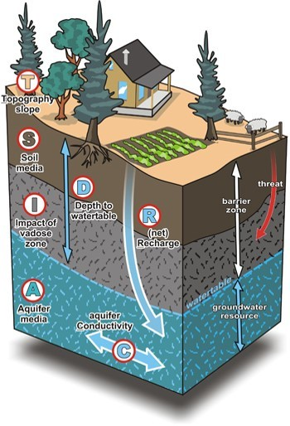
  - Figure 2.2: Definition of DRASTIC parameters
(Source: www.frakturmedia.net)

Modified DRASTIC Model
Despite simplicity and popularity, there are some weaknesses in vulnerability mapping using the DRASTIC technique. The main drawback is its subjectivity and doubts regarding the selection of specific parameters and the exclusion of others (Neshat et al., 2014). Therefore, many researchers have attempted to modify the DRASTIC model to achieve a more accurate vulnerability assessment. For instance, some researchers correlated the DRASTIC index with chemical or contaminant parameters but in many cases, they found low correlation. McLay et al., (2001), suggested that models such as DRASTIC with a land management index included may be useful for predicting areas for more intensive monitoring of groundwater. It was also emphasized that there is a greater need to test the link between measurements of nitrate leaching from a variety of land use activities with measurements of groundwater nitrate concentrations below these activities (McLay et al., 2001). Panagopoulos et al., (2006), incorporated the application of simple statistical and geostatistical techniques for the revision of the factor weightings and ratings of all the DRASTIC parameters in a GIS environment.
The correlation coefficient between the groundwater vulnerability index and nitrate concentrations was considerably improved and rose by 33% compared to the standard method (Panagopoulos et al., 2006). (Leone et al., 2009), reported the DRASTIC scores related to groundwater nitrate content. Scores were distributed in two different groups: lower vulnerability (between 60 and 80) with no nitrate content and higher vulnerability (between 110 and 155) with great various nitrate contents from near to 0 to over 160 mg/L (Leone et al., 2009). One of the important reasons for this dissimilarity is the need to perform interpolation of sparse field data, which involves interpolation errors. Hence, the results from DRASTIC should be modified according to the specification of region and contaminant. For this purpose, numerous techniques have been suggested to develop and modify the DRASTIC algorithm.
Different types of land use cause separate sources of nitrogen pollution, resulting in variant input intensities of nitrate contamination sources (Kozłowski & Sojka, 2019). Land cover can also affect the inﬁltration rate and surface runoff. Therefore, the factor of land use (LU) was also considered to build a modified DRASTIC model for the assessment of speciﬁc vulnerability to nitrate contamination. Modifying the DRASTIC Vulnerability Index (VIL) could be obtained by adding the land use factor with appropriate weights and ratings.

  - Table 2.4: Rating and weighting of DRASTIC and modified DRASTIC models
Factors |  | DRASTIC |  | Modified DRASTIC
 |  | Rating | Weight | Rating | Weight
D | Depth to the groundwater table | 1-10 | 5 | 1-10 | 5
R | Net Recharge | 1-9 | 4 | 1-9 | 4
A | Aquifer media | 1-10 | 3 | 1-10 | 3
S | Soil media | 1-10 | 2 | 1-10 | 2
T | Topography | 1-10 | 1 | 1-10 | 1
I | Impact of Vadose zone | 1-10 | 5 | 1-10 | 5
C | Hydraulic Conductivity | 1-10 | 3 | 1-10 | 3
L | Land use | - | - | 1-10 | 5
Sources: (Aller, 1985).

Mapping groundwater vulnerability and its challenge
Since groundwater is a complex natural system that occurs and is locked underground, mapping its vulnerability is very difficult, time-consuming, and data-intensive. However, vulnerability maps provide the principal tool for ensuring aquifer protection (Younger, 2009). The problem of groundwater mapping is tough in Sub-Saharan African countries like Ethiopia (Oke & Fourie, 2017). The challenge faced in mapping groundwater vulnerability in Sub Sahara African countries is attributed to comprehensive hydrogeological data scarcity, limitations of compatible and well-established vulnerability assessment methods, scarcity of skilled manpower in the area of hydrology and geology, inadequate funds, poor policies and legal tools and dramatic change in the social and political aspects. Groundwater vulnerability can be grouped into five classes as following in the following:
  - Table 2.5: Vulnerability index and class in the modified DRASTIC model
Vulnerability Category | Very low | Low | Moderately | High | Very high
Vulnerability index score | <100 | 100-145 | 145-190 | 190-235 | >235
Source: (Aller, 1987; Singh et al., 2015; Baghapour et al., 2016; Asfaw and Mengistu, 2020)

Empirical studies about Groundwater vulnerability using the DRASTIC and Modify the DRASTIC model
A study conducted in Lucknow city, India (Singh et al., 2015)using a modified DRASTIC model (DRASTICA) has reported that anthropogenic influence (human settlement or LULC change) has a strong contribution to groundwater vulnerability. In this study, 24.5 % of the study area was delineated as a highly vulnerable zone and 66.6 % area is under the moderately vulnerable zone. Similarly, a groundwater vulnerability assessment conducted in Algeria (Khemis Miliana Plain) using DRASTIC-Lu resulted in four vulnerability classes where 15% is under moderately vulnerable and 1% is under a highly vulnerable class from the total surface of the plain (Zafane & Benyoucef Gharbi, 2017). The vulnerability analysis result was influenced highly by human activities which manifested via LULC change. Urban areas (built-up) and cultivated lands are confined in the highly vulnerable zone. A study result reported by Al-Rawabdeh et al., (2014) and Pórcel et al., (2014) also indicated that human activity which is manifested via LULC change is the influencing parameter in the analysis.
A groundwater vulnerability evaluation conducted in India, Kerala region near a solid waste disposal site using GIS and DRASTIC model showed that the value of the DRASTIC index ranged between 120 to 243, where the region was classified into three vulnerabilities as moderately vulnerable, highly vulnerable, and very high vulnerable (Jaseela et al., 2016). Due to the lower slope of the terrains towards the eastern portion which allows percolation of contaminants into the groundwater, the eastern and southeastern part of the dumping site was highly vulnerable to contaminants. The other study, conducted in the southern part of Côte d’Ivoire (Djémin et al., 2016) presented a vulnerability map with an index ranging from 95 to 187 and four vulnerability classes where about 63.93% of the study areas are from very high to highly vulnerable which confined in the central part of the region. Similarly, Modabberi et al., (2017) reported that a large extent (48.64%) of Guilan groundwater (Iran) is highly vulnerable to pollution.
Ebadati et al., (2012); Al-Abadi et al., (2017); Souleymane and Zhonghua, (2017) have reported a groundwater map with three vulnerability classes ranging from very high to low vulnerable to pollution. The vulnerability class ranges from moderately to very highly vulnerable parts of the region categorized as an extreme protection region. As reported by Voudouris et al., (2010) and (Wu et al., 2018), the shallower part of the Kiti groundwater and Beihai City falls within high and very high vulnerability zones in which intensive rain and slope of the terrain were influencing factors in the vulnerability analysis.
Research conducted in Lahore, Pakistan (Muhammad et al., 2015) reported that low vulnerability is associated with the dense human settlements and low water levels area which is confined in the central part (urban parts) of the study area. This no-risk region covers about 10.4% whereas high vulnerability covers 28.8% of the region associated with agricultural areas.
Studies conducted in the Guna-Tana watershed using water quality experiment techniques revealed that agricultural activity is the major contributor to the higher concentration of nitrate in the groundwater (Akale et al., 2017; 2018).
A study conducted by Merchant, (1994) also indicated that human activity that discharges contaminants to the surface and infiltrates down to the aquifer has a significant contribution to groundwater pollution. In this regard, Hosseini and Saremi, (2018) and Baghapour et al., (2016) who incorporated LULC as a parameter found the modified DRASTIC model performed better in delineating groundwater vulnerability. Pórcel et al., (2014) also compared the conventional DRASTIC model with the modified DRASTIC model and came up with a better result for the modified DRASTIC model.

CHAPTER THREE: MATERIALS AND METHODS

Description of the study area
    - Location
Bahir Dar city is the current capital of the regional state of Amhara, is located in the North- Western part of the country at a distance of 567 and 465 km from Addis Ababa through Debre Markos to Burie and Dejen to Motta roads respectively. It is bounded to the north by Lake Tana and marks the source of the great Abay River. Bahir Dar is roughly bounded by latitudes of 11⁰ 30' 0" N and 11⁰ 40' 0" N, and longitudes of 37⁰ 18' 0" E and 37⁰ 28' 0" E with an estimated area of 21341.8 ha.
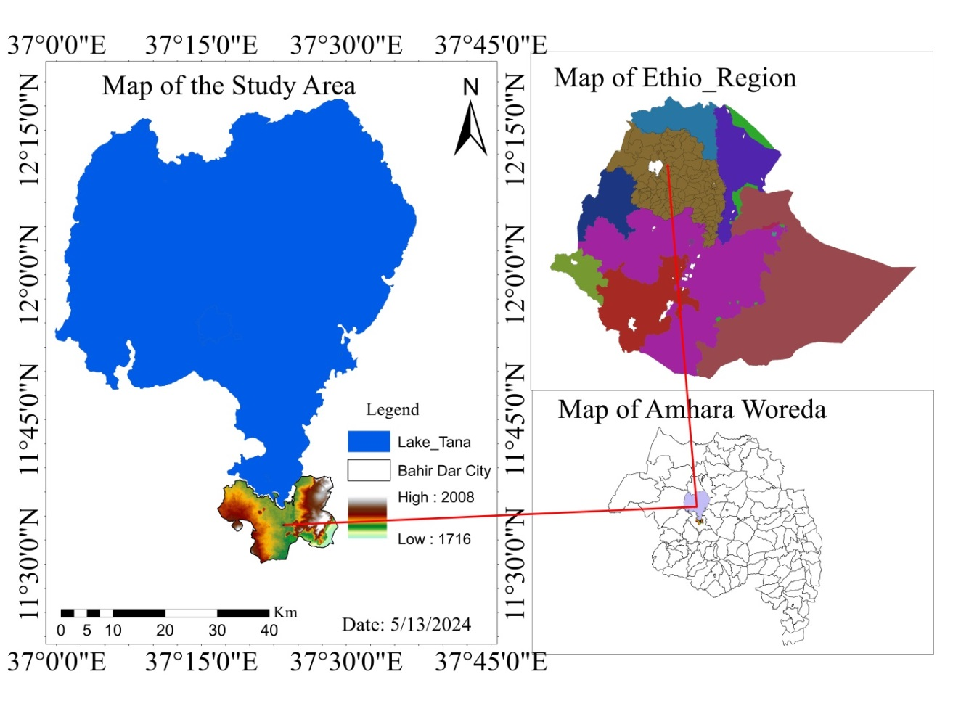
  - Figure 3.1: Map of the study area
    - Population
Based on the Bahir Dar Administration Office (2023), like many other cities in the country, the population of Bahir Dar has been growing at an alarming rate every year. According to the census conducted at various times, the first round of the census in 1976 was 54,766; the second round of the 1986 census was likewise 54,764. The population and housing census have increased to 94,235. Based on the results of the 1999 census, the population of Bahir Dar, which was projected for 5 years of age, single age, and gender, was 414763, of which 49421 lived in rural areas and 365,342 in urban areas. Of these, the number of males is 201,904 and the number of females is 212,859. The population density is estimated at 0.12 per hectare. The population of Bahir Dar City is increasing from time to time. Within the last 10 years, the urban population has increased from 180,174 in 2007 to 313,997 in 2017 (Wubie et al., 2020). According to (Biruk, 2017), nearly two-thirds of all households in Bahir Dar discharge solid waste as well as waste water into open spaces, streets and flood water drainages. There is a poor level of awareness about existing regulations on sanitation among the experts as well as the public. So those waste highly polluted surface as well as ground water resources.
    - Climate
The month with the highest relative humidity is August (84.57 %). The month with the lowest relative humidity is March (43.81 %). The month with the highest number of rainy days is July (28.97 days). The month with the lowest number of rainy days is January (0.90 days). Bahir Dar's climate is classified as warm and temperate. In Bahir Dar, the average annual temperature is 20.1°C / 68.2 °F. The rainfall here is around 1839 mm / 72.4 inches per year. The least amount of rainfall occurs in January. The average in this month is 4 mm/ 0.2 inch. Most of the precipitation here falls in August, averaging 528 mm / 20.8 inches (Merkel, 2020). The study area is highland type and characterized by one international waterway (Abay River) and Lake Tana, the largest lake in Ethiopia (> 3,000 km²), which is the source of the Blue Nile (Minale & Alemu, 2018).
    - Hydrology and Water supply
In the study area, there is one major international river called "Abay," which originates at Sekela Gish Abay in Ethiopia and crosses Sudan and Egypt. It has a total length of 1,450 kilometers, of which 800 km are inside Ethiopia. The discharge data from 1960 to 2001 at the Bahir Dar gauging station indicates the mean annual flow of the river Abay is about 123.07m³/s (Bahir Dar City Administration, 2015). Lake Tana is the source of the Blue Nile, covering an area of more than 3000 km². As a result of Lake Tana and the river Abay, Bahir Dar has become one of the most popular tourist destinations in Ethiopia, with a wide range of attractions (Bahir Dar City Administration, 2015). Drinking water for the city is supplied from 19 boreholes and three springs, which account for around 86.6% and 134 %, respectively (private boreholes are not considered) (Bahir Dar city water and sewage authorities, 2015).
    - Topography
The Bahir Dar metropolitan area is mostly characterized by a flat plain topographic landscape, although there have been some pockets of land with hills and rugged and undulating features. The elevation of the metropolitan area falls in between the range of 1716 m.a.s.l. up to 2008 m.a.s.l (Figure 3.1). In general, the predominance of flat landscape and plain topography in this area provides a promising opportunity to undertake various urban development activities in the centers and their vicinities in particular and in the whole metropolitan area.
    - Soil Type
Soil is the result of geological and geomorphic processes that describe the hydrological nature of an area. According to FAO (2020) soil classification of Bahir Dar City is characterized by Luvisols, Fluvisols, Leptosols, Vertisols, Cambisols, Regosols, and water body and Rock as shown in (Figure 3.2).
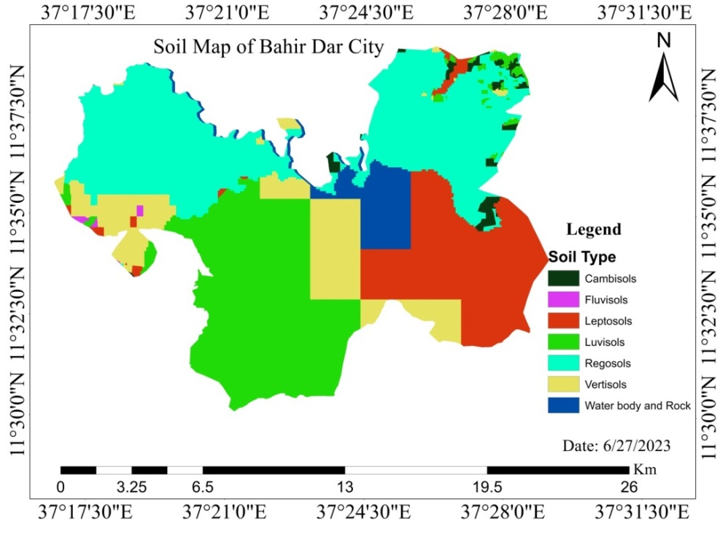
  - Figure 3.2: Soil Map of the study area

    - Land Use/ Land Cover
The process of LULC affects biodiversity, climate, soil, and air in particular, and the ecosystem in general, and it has become the greatest environmental concern for human beings. Land use activities have direct impacts on water quality, while water quality greatly influences the scale of land use activities. The LULC class of the study area is grouped into the following:
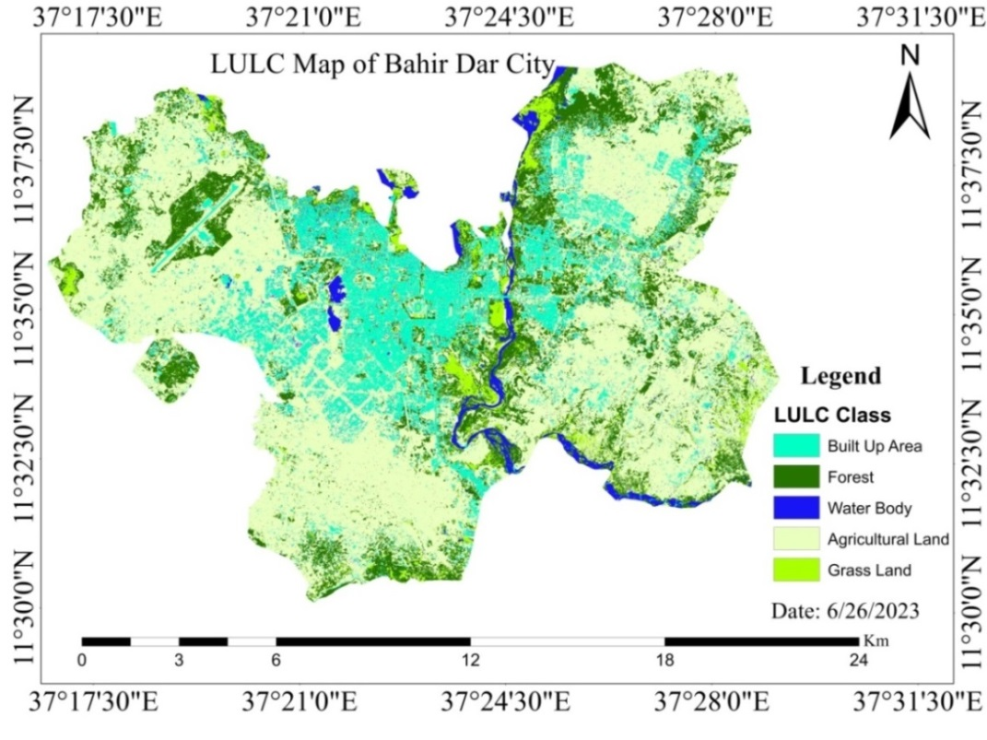
  - Figure 3.3: LULC Map of the study area

Research design and methods
    - Research design
This study involved modeling the geological and hydrological setting of the groundwater using GIS and Remote sensing technology. This is because it describes the intrinsic hydrogeological characteristics of the groundwater to map the vulnerability of the groundwater to contaminants. In addition, the implication of groundwater contamination on drinking water was also analyzed. Therefore, the overall research task was framed by a descriptive research design with an explanatory approach.

    - Data type and method of data collection
As implicitly stated in the objective part and to create a database for assessing groundwater vulnerability, eight datasets were used in this study. These were remote sensing-based products, meteorological data, hydrological data, geological data, and soil data sets. These data were grouped as primary as well as secondary data types as follows:
  - Table 3.1: primary and secondary data were used for this study
No | Data type | Sources | Output layer
1 | Sentinel 2A | Copernicus hub  (https://scihub.copernicus.eu) | LULC
2 | Sentinel 1A (DEM) | Copernicus hub  (https://scihub.copernicus.eu) | Slope
3 | Soil map | ANRS Bureau of Environmental  Protection, Land Administration  and Use (Amhara soil  Classification map) | Soil type, Impact of Vadose Zone
5 | Rainfall | National Metrological Agency | Net recharge
6 | Depth of water table | Amhara Design and Control  Authority and Bahir Dar City  water and energy Office | Groundwater depth, Hydraulic  Conductivity
7 | Geological map (shape files) | Ethiopian Geological Survey | Aquifer media

Materials and Software
To achieve the objectives of this study, different remote sensing and spatial data were used. Collecting and processing these data, and producing thematic layers for the analysis require software. The software packages and instruments employed in this study were as follows:

  - Table 3.2: Software and materials used for this study
Software and materials | Uses
ERDAS Imagine 2015 | For preprocessing satellite images for LU/LC class preparation and classification
ArcGIS 10.7.1 | Used to prepare a thematic layer
GPS | For sample point collection for LULC and groundwater vulnerability verification

Methods of Data Preparation

Data Preparation for Groundwater Potential Zone
The groundwater potential zone map was prepared using seven different types of thematic layers: rainfall, lineament density, slope, land use/land cover, drainage density, soil texture, and geology.
To develop the groundwater potential maps in the study area, all parameters were reclassified into five classes, such as very low, low, medium, high, and very high (Mukherjee et al., 2012; Waikar & Nilawar, 2014; Jhariya et al., 2016; Arulbalaji et al., 2019; Zewdie et al., 2024; Burayu, 2022).
To identify the groundwater potential zone in the study area, the computed weights to each thematic layer were combined using weighted overlay analysis in ArcGIS 7.1 software. All thematic layers were prepared with the same projection, resolution, and areal extent, then added and overlaid with weighted overlay techniques. The output potential map was reclassified into different zones (high, medium, low, and poor potential zones).
$GWP=\sum_{i=1}^{n}{WiRi} Equation 5$
Where GWP is groundwater potential, Wi is the weight for each thematic layer and Ri is rated for the classes within each thematic layer that were derived from AHP.

Developing an Analytical Hierarchy Process (AHP)
The Analytical Hierarchy Process is the method that is used to determine the weights of many factors for identifying the groundwater potential zones based on weights assignment and normalization concerning the relative contribution of the different themes to groundwater occurrence (Jhariya et al., 2016). The Analytical Hierarchy Process calculates the required weights associated with the respective criterion layers. The method calculates with the help of a preference matrix, in which all relevant criteria identified are compared against each other and aggregated the weights. The results of the consistency ratio and the pair-wise comparison matrix categorization of factors influencing groundwater potential zones were prepared using AHP (Analytical Hierarchy Process).
For identifying the groundwater potential zone and decision making process AHP method was used. Therefore by using the AHP problems can be decomposes in to different hierarchy/levels.
- The first levels of the hierarchy are the goal of groundwater potential zone identification.
- The second level in the hierarchy is the parameters that were used to decide the potential zone can be identified.
- Third level is about criteria’s to select groundwater potential zone using different parameters or factor maps (reclassification was done for each parameter).
- And at the last level the alternatives was identified on groundwater potential zones of the study area as very high, high, moderate, low, and poor.

Establishment of pairwise comparison matrix (PCM)
For the identification of groundwater potential zone nine factor maps/thematic layers consisting different classes were used. A matrix for the comparison of all the thematic layers were prepared to identify which parameter becomes highly important than the other and the relative weights/priority was calculated based on Saaty preference scale.
Table 3.3: Preference scale for two parameters in AHP (Saaty, 1982)
Importance | Definition | Explanation
1 | Equal importance | Two criteria contribute equally to the objective
3 | Moderate importance | Judgment slightly favors one criterion over another
5 | Strong importance | strongly favors one criterion over another
7 | Very strong importance | very strongly favors one criterion over another
9 | Extreme importance | favoring one criterion over another is highest
2, 4, 6, 8 | Intermediate values | When compromise is needed
Reciprocals | Values for inverse comparison | If criterion i had one of the above numbers assigned to it when compared with criterion j, then j has the reciprocal value when compared with i.

First: - the square matrix of pairwise comparison was prepared based on M = mij with the element of row and column.
Using Saaty’s AHP matrix the different criteria and classes with in each of the criteria were compared with reference to expert's decision, experience and local hydrogeological conditions.
Second: - The geometric mean was calculated from different parameters. The geometric mean is derived from the total score weight divided by the total number of parameters.
$$Geometric mean=\frac{total score weight}{total number of parameters} Equation 6$$

Third: - Normalized weights were calculated. It is the indicator of multi parameter analysis of groundwater mapping.
Normalized weight is calculated by assigning weight of parameter feature class to the geometric mean.
$$Normalized weight=\frac{Assigned weight of parameter feature class}{Geometric mean} Equation 7$$

Forth: - consistency ratio calculation to verify the coherence of the judgments. In AHP, the consistency ratio was calculated using the following formula.
$$CR=\frac{CI}{RCI} Equation 8$$

Where CR is Consistency Ratio, CI is Consistency index and RCI is Random consistency index for the same order of matrices. The acceptable CR is 0.10 or less to zero to continue the AHP analysis.
Fifth: - calculating consistency index. To calculate the Consistency index the following equation will be used.
$$CI=\frac{(λmax – n)}{(n-1)} Equation 9$$
Where λmax is maximum Eigen-value of the pair-wise comparison matrix, n is the number of parameters involved in the comparison.
RCI is the consistency index of a randomly generated PCM which depends on the number of elements being compared (i.e. size of PCM) and I have taken the RCI based on Saaty.
Table 3.4: Random consistency index (RCI) for number of comparison (Saaty 1980)
N | 1 | 2 | 3 | 4 | 5 | 6 | 7 | 8 | 9 | 10
RCI | 0 | 0 | 0.58 | 0.90 | 1.12 | 1.24 | 1.32 | 1.41 | 1.45 | 1.49

Pre- Process and Data Preparation for Groundwater vulnerability
In spatial science, data can be collected from different sources with different formats and resolutions which requires bringing them into uniform format and resolution (Webster & Oliver, 2007). Therefore, the data processing task involved pre-process and post-process activities. Pre-processing is a data mining technique that involves transforming raw data into uniform and understandable formats for analysis (Malczewski & Rinner, 2015). The pre-process methods employed were described as follows:
Determination of Water Table Depth
Depth to the water table is the distance from the ground surface to the water table (Baghapour et al., 2016). In this study, the depth to water table was generated from 30 wells and springs distributed in the City. The data was collected from Amhara Design and Control Authority, and Bahir Dar City Water and Energy Offices. The measurement of the depth of the wells and springs was taken in the dry season or pre-rain season of the year (December) because the depth to the water table changes depending on the time (season) of the year in response to recharge and discharge (Vongphachanh et al., 2017)
The data was point data in Excel format which consists of geographic coordinates, depth, and other attribute information. Thus, a point feature shapefile was created and subsequently, the inverse distance weight (IDW) interpolation technique (Paramasivam & Venkatramanan, 2019) was used to generate a continuous spatial distribution of depth to the water table. The city’s depth to the water table varies from 2.5 to 80 meters. Finally, the water table depth layer was prepared and reclassified according to the value of the weight shown in Table 3.6.
Determination of Net Recharge
Net recharge is the amount of surface water that infiltrates into the ground and reaches the groundwater (Paramasivam & Venkatramanan, 2019). The net recharge represents the annual average amount of water that infiltrates the vadose zone and reaches the water table (Aller et al, 1987; Alwathaf and El Mansouri, 2011). The modified DRASTIC model requires net recharge data to quantify and rate potential contaminants infiltrating the groundwater (Aller et al, 1987).
However, net recharge data is not available. Therefore, it was derived from metrological data sets using empirical models. Even though there are different empirical methods used to estimate groundwater recharge, the Chaturvedi equation (Chaturvedi, 1973; Empirik and di Zon Tropika, 2013; Adeleke et al., 2015) and TRUC equation (Adelana et al., 2006; Pórcel et al., 2014; Chibane and Ali-Rahmani, 2015) are the most commonly used methods. The Chaturvedi equation used for tropical regions on specific hydrogeological conditions (Chaturvedi, 1973) based on the water level fluctuations and rainfall depth. It is described as Equation 10:
$$R=2.0 (p - 15)^{0.4} Equation 10$$
Where R = Net recharge in the year in millimeters
P = annual average precipitation in millimeters
Later, the equation was modified and presented by (Adelana et al., 2006; Misstear et al., 2009; Empirik and di Zon Tropika, 2013; Mogaji et al., 2014) as Equation 10:
$$R=6.75 (p - 14)^{0.5} Equation 11$$
Therefore, in this study, the modified Chaturvedi equation method was employed. Five ground meteorological observation stations which are located within and nearby the City (Zege, Bahir Dar, Zenzelma, Meshenti, and Tis Abay) were identified primarily based on data availability and representativeness of the study area. Eleven years (2012-2022) mean annual rainfall data of the stations were considered in the analysis.
Finally, the mean annual rainfall (11 years) of each station was computed. Since the mean annual rainfall is station-based point data, it was converted to continuous spatial data using the inverse distance weight (IDW) interpolation method on the GIS environment. Then the net recharge was computed using Rater Calculator based on Equation (7). Finally, the net recharge layer was prepared and reclassified according to the value of the weight shown in Table 3.6.
Determination of Aquifer Media
Aquifer media is a rock in the ground that serves as water storage (Arzu Firat and Fatma, 2013). It indicates materials property that controls contaminant attenuation processes based on the permeability of each layer (Jang et al., 2017). For this study, Aquifer Media data was estimated from the Ethiopian Geological Survey. The data was digitized from a digital geological map of Bahir Dar to change it into a vector format. Thus, it was converted into a raster data format using a conversion tool by maintaining the spatial resolution and other characters to fit the rest thematic layers. Finally, it was reclassified and weighted according to the sensitivity to contaminants as shown in Table 3.6.
Determination of Topography
In this study, the hydro-processing tool was used for extraction of slope from DEM of Sentinel-1A. A remote sensing data used in this study was Sentinel-1 Multi-Spectral Instrument (MSI) which has a 10 m spatial resolution image of Bahir Dar and the slope percentage was calculated by using the Spatial Analysts Tools of ArcGIS 10.7.1. The slope layer was prepared and reclassified according to the weight shown in Table 3.6.
Determination of Impact of Vadose Zone
The vadose zone is the unsaturated zone of materials lying below the soil horizon and above the water table. (Aller et al, 1987; Hossain Ali and Atiqur Rahman, 2008). It controls the path length and routing, in turn, determines the attenuation characteristics of contaminants. The degree of attenuation is related to the texture, structure, mineral composition, and organic matter content of the soil profile (K. Voudouris et al., 2010). The impact of the vadose zone in this study was derived from the distribution of soil texture and their characteristics. According to Hossain Ali and Atiqur Rahman, (2008); Al-Rawabdeh et al., (2014); Baghapour et al., (2016); Maria, (2018); Souleymane and Zhonghua, (2017), the rate of soil texture is fixed based on particle size and their composition. Thus, based on the soil texture characteristics, the impact of the vadose zone was weighted based on Table 3.6.
Determination of Hydraulic Conductivity
Hydraulic conductivity is described as the ability of aquifer materials to transmit water, in turn, controls the rate at which groundwater flows under a given hydraulic gradient (Healy and Scanlon, 2010; Davie, 2019). It is an important parameter that controls contaminant migration and dispersion from the injection point and consequently concentrates in the aquifer (Gültekin et al., 2013; Mogaji et al., 2014). In this study, the Hydraulic conductivity of an aquifer was generated from 16 wells and springs distributed in the city. The data was collected from Amhara Design and Control Authority, and Bahir Dar City Water and Energy Offices. The data was point data in Excel format which consists of geographic coordinates, Hydraulic conductivity, and other attribute information. Thus, a point feature shapefile was created and subsequently, the inverse distance weight (IDW) interpolation technique (Paramasivam and Venkatramanan, 2019) was used to generate a continuous spatial distribution of Hydraulic conductivity of an aquifer. Finally, the Hydraulic conductivity of an aquifer layer was weighted based on Table 3.6.
Determination soil media
The Soil media is the top portion of the unsaturated zone that extends to the plants’ roots and organic creatures’ activity areas (Gültekin et al., 2013; Baghapour et al., 2016). A digital soil map in shapefile format was obtained from the ANRS Bureau of Environmental Protection, Land Administration, and Use. The data comprises soil types classified according to FAO-USDA soil taxonomy (FAO, 1984; FAO, 2006; FAO, 2020).
As per Aller et al, (1987); Maria, (2018), and Davie, (2019) the rate of each soil type is fixed based on their significance and contribution to the aquifer vulnerability. Since the soil map was obtained in a vector data format, it was converted into a raster data format by maintaining the pixel size and other properties similar to the other data layers. Finally, it was weighted based on the sensitivity to contaminants as shown in Table 3.6.
Determination of Land Use Type
According to FAO, (2016); Gregorio, (2016) land use land cover is defined as the observed bio-physical cover of the earth’s surface and is a synthesis of many processes taking place on the land. It implies land occupation (and its transformation) by various natural or artificial systems and to some extent how these systems affect the land. For land use land cover analysis, Sentinel-2 MSI Level-1C image was captured in February 2023. And it is a multispectral image with high radiometric, spatial, spectral, and temporal resolution (10m).
Since the image is multispectral, layer stacking was conducted and extracted to the extent of Bahir Dar city using an AOI file. Before conducting image classification, 100 sample points were collected using a Cluster sampling technique from the field Based on each land use type. The LULC classification was conducted based on the Anderson land use classification system (Anderson, 1976).
A supervised image classification technique was used for extracting information from satellite images (Liu and Mason, 2013). The goal is to classify pixels in an image into different classes based on the reflectance value of the pixel. The technique involves two stages; the first one is preparing a training sample and generating a signature for each land cover class. This is called the training stage. Each training sample was making a class, to where the pixel belongs depending on the reflectance values of that pixel. The next stage was generating a cluster classifier for grouping or classifying pixels into known features and then land use and land cover was produced and reclassified based on Table 3.6. Finally, an accuracy assessment and kappa coefficient were conducted and their value was 0.83 (83%) and 0.814 (81.4%) respectively.

Data analysis and model description

Modified DRASTIC model
The DRASTIC model was developed under the US Environmental Protection Agency in association with the National Water Well Association (Aller et al, 1987). It is based on the concept of hydrological setting which is defined as the composite description of all the major geological and hydrological factors that affect and control the groundwater movement into and out of an area (Merchant, 1994; Shirazi et al., 2012; Neshat et al., 2014; Zafane and Benyoucef Gharbi, 2017). Groundwater vulnerability assessment models are based on the assumption that contaminants are introduced at the ground surface and flushed into the groundwater. The variables are critically related to the groundwater and the model is used to evaluate larger areas, more than 40.5 hectares (Aller et al, 1987).
According to Aller et al, (1987), the DRASTIC model takes into account seven physical parameters from the geological and hydrological environment of a watershed that controls and determines the groundwater pollution potential. However, a shift from natural vegetation cover to agricultural activity, industrial development, and settlement generates waste and pollutant chemicals that contaminate via direct infiltration and surface runoff entering poorly maintained springs and boreholes (Pórcel et al., 2014). Therefore, to relate the impacts of human activities on groundwater vulnerability, it needs to incorporate land use land cover as one parameter. So, according to Pórcel et al., (2014) and Singh et al., (2015) DRASTIC model is modified to consider the LULC change and expressed as modified DRASTIC (mDI) and described as
$mDI=\sum_{i=1}^{8}{wi*ri} Equation 12$
Where: $mDI$ = modified DRASTIC index
r = the rating value associated with each i^{th} parameter
w= the weight associated with each i^{th} parameter
i = parameters

Weight and rate of parameters for the modified DRASTIC model
The relative weights and ratings assigned to parameters are based on their phylogenetic relations to the contaminants. Accordingly, the relative weight assigned ranges from 1 to 5 (Aller et al, 1987; Saha and Alam, 2014; Baghapour et al., 2016; Majolagbe et al., 2016; Hosseini and Saremi, 2018; Kumar, 2018). This shows the relative importance and susceptibility of a parameter to contaminants. The most significant and more susceptible parameter is weighted to 5 whereas the least significant and less susceptible parameter is weighted to 1.
  - Table 3.5: Weight of modified DRASTIC model parameters
Symbol | Parameters | Weight
D | Depth to water table media | 5
R | Net recharge media | 4
A | Aquifer Media | 3
S | Soil media | 2
T | Topography (slope) media | 1
I | Vadose zone media | 5
C | Hydraulic conductivity media | 3
Lu | Land use land cover media | 5
Based on the level of susceptibility, each parameter is also classified into different subclasses (range) and assigned value of rate which ranges between 1 (least important) and 10 (most important) (Aller et al, 1987; Baghapour et al., 2016; Ramaraju and Veni, 2017; Ahmed et al., 2018). This indicates the relative importance and susceptibility of the subclasses of each parameter to contaminants (Hossain Ali and Atiqur Rahman, 2008; Zafane and Benyoucef Gharbi, 2017).
  - Table 3.6: Parameters rate and range of modified DRASTIC model
Factors | Range | Rate | References
(D)  Depth to Water Table (m) | < 4.8 | 9 | (Aller et al, 1987; Shirazi et al., 2012; Abiy et al., 2016; Jaseela et al., 2016; Hosseini and Saremi, 2018)
(D)  Depth to Water Table (m) | 4.8 – 6.8 | 8
(D)  Depth to Water Table (m) | 6.8 – 9.1 | 7
(D)  Depth to Water Table (m) | 9.1– 12.1 | 6
(D)  Depth to Water Table (m) | 12.1 – 15.2 | 5
(D)  Depth to Water Table (m) | 15.2 – 22.9 | 4
(D)  Depth to Water Table (m) | – 26.7 | 3
(D)  Depth to Water Table (m) | 26.7 – 30.5 | 2
(D)  Depth to Water Table (m) | 30.5⁺ | 1
(R)  Net Recharge Media (mm/year) | 234-254 | 9 | (Aller et al, 1987; (Abiy, Melesse, et al., 2016; Ramaraju and Veni, 2017)
(R)  Net Recharge Media (mm/year) | 254+ | 10
(A)  Aquifer Media | Massive shale | 10 | (Aller et al, 1987; Abiy, Melesse, et al., 2016; Javadi et al., 2017)
(A)  Aquifer Media | Basalt | 9
(A)  Aquifer Media | Massive sandstone | 8
(A)  Aquifer Media | Sand and gravel | 6
(A)  Aquifer Media | Weathered metamorphic/igneous | 4
(A)  Aquifer Media | Karst limestone | 2
(S)  Soil Media | Rock & Waterbody | 10 | (Aller et al, 1987; Shirazi et al., 2012; Pórcel et al., 2014; Boughorbel et al., 2017; Hosseini and Saremi, 2018)
(S)  Soil Media | Regosols | 9
(S)  Soil Media | Leptosol | 9
(S)  Soil Media | Luvisol | 7
(S)  Soil Media | Fluvisols | 5
(S)  Soil Media | Cambisols | 3
(S)  Soil Media | Vertisol | 2
(T)  Topography/Slope Media (%) | 0–2 | 10 | (Aller et al, 1987; Hossain Ali and Atiqur Rahman, 2008; Boughorbel et al., 2017; Gültekin et al., 2013; Asfaw and Mengistu, 2020)
(T)  Topography/Slope Media (%) | 2-4 | 9
(T)  Topography/Slope Media (%) | 4-6 | 8
(T)  Topography/Slope Media (%) | 6-8 | 7
(T)  Topography/Slope Media (%) | 8-10 | 6
(T)  Topography/Slope Media (%) | 10-12 | 5
(T)  Topography/Slope Media (%) | 12-14 | 4
(T)  Topography/Slope Media (%) | 14-16 | 3
(T)  Topography/Slope Media (%) | 16-18 | 2
(T)  Topography/Slope Media (%) | >18 | 1
(C)  Hydraulic Conductivity Media (m/ d ) | > 39.71 | 10 | (Aller et al, 1987; Xu et al., 2017; Bera et al., 2021)
(C)  Hydraulic Conductivity Media (m/ d ) | 20.74–39.71 | 8 | (Aller et al, 1987; Xu et al., 2017; Bera et al., 2021)
(C)  Hydraulic Conductivity Media (m/ d ) | 10.45–20.74 | 6 | (Aller et al, 1987; Xu et al., 2017; Bera et al., 2021)
(C)  Hydraulic Conductivity Media (m/ d ) | 4.87–10.45 | 4 | (Aller et al, 1987; Xu et al., 2017; Bera et al., 2021)
(C)  Hydraulic Conductivity Media (m/ d ) | 1.84–4.87 | 2 | (Aller et al, 1987; Xu et al., 2017; Bera et al., 2021)
(C)  Hydraulic Conductivity Media (m/ d ) | < 1.84 | 1 | (Aller et al, 1987; Xu et al., 2017; Bera et al., 2021)
(I)  Impact of Vadose Zone media | Water body and rock | 10 | (Aller et al, 1987; Hossain Ali and Atiqur Rahman, 2008; Vongphachanh et al., 2017; Al-Rawabdeh et al., 2014; Boughorbel et al., 2017; Souleymane and Zhonghua, 2017)
(I)  Impact of Vadose Zone media | Rubble | 9
(I)  Impact of Vadose Zone media | Loamy | 5
(I)  Impact of Vadose Zone media | Clay loam | 3
(I)  Impact of Vadose Zone media | Clay | 1
(LULC)  Land Use and Land Cover | Built up Area | 10 | (Abdelmadjid and Omar, 2013; Al-Rawabdeh et al., 2014; Neshat et al., 2014; Boughorbel et al., 2017;Thapa et al., 2018; Asfaw and Mengistu, 2020
(LULC)  Land Use and Land Cover | Agricultural Land | 9
(LULC)  Land Use and Land Cover | Grass Land | 4
(LULC)  Land Use and Land Cover | Water Body | 2
(LULC)  Land Use and Land Cover | Forest Land | 1
  - Vulnerability index and vulnerability class
Finally, after a thematic layer for each parameter was prepared based on the range or sub-class, Equation 8 was used for analyzing the vulnerability of the groundwater. The result of the vulnerability index of the modified DRASTIC model was reclassified into different vulnerability levels as shown in Table 3.7.
  - Table 3.7: Vulnerability index and class in the modified DRASTIC model
Vulnerability Category | Very low | Low | Moderately | High | Very high
Vulnerability index score | <100 | 100-145 | 145-190 | 190-235 | >235
Source: (Hossain Ali and Atiqur Rahman, 2008; Boughorbel et al., 2017; Asfaw and Mengistu, 2020)
This vulnerability category shows the level of protection required to conserve the groundwater accordingly, a very high and highly vulnerable level of the category requires extreme protection and is considered as an area of maximum protection because they are vulnerable more rapidly to most water pollutants. A moderately vulnerable level of the categories is vulnerable to some pollutants and is identified as an area of high protection (Ahmed et al., 2018).

Model validation
Subjecting aquifer vulnerability maps to validation assessment is imperative for producing reliable and valid groundwater vulnerability (Mogaji et al., 2014; Majolagbe et al., 2016). Even though there are several physicochemical and biological pollutants, the concentration of nitrate (NO3), Total Dissolve Solid (TDS), and Turbidity are the most common groundwater contaminants that deteriorate water quality and cause health problems (Tadesse, 2014; Water Aid, 2016). These contaminants are commonly generated by human activities (agricultural intensification, sewage discharge, septic tank, landfill, and industrial and municipal).
Therefore, the concentration of Nitrate (NO3), TDS (Total dissolved solid), and Turbidity are used as common parameters for validating groundwater vulnerability (Abdelmadjid and Omar, 2013; Mogaji et al., 2014; Majolagbe et al., 2016; Boufekane and Saighi, 2018). Different studies (Hossain Ali and Atiqur Rahman, 2008; Chitsazan and Akhtari, 2009; Tilahun and Merkel, 2010; Shirazi et al., 2012; Jang et al., 2017; Thapa et al., 2018; Asfaw and Mengistu, 2020) have employed these parameters for validating the groundwater vulnerability.
The samples were collected purposely from the very highly vulnerable, highly vulnerable, moderately vulnerable, and low vulnerable parts of the City. Based on accessibility and groundwater vulnerability representativeness, a total of 15 wells and springs were identified purposely of which 4 of them were located in the very high vulnerable, 4 were in the highly vulnerable, 4 were in the moderately vulnerable and 3 were in the low vulnerable part of the City.
The water sample was taken from the identified wells and springs after 6 - 10 minutes of pumping (fetched up) collected in a clean plastic bottle kept in a cold box and were transported to North Wollo Zone Water and Energy Laboratory within 48 hours. The samples were analyzed for nitrate (NO3), TDS (Total dissolved solid), and Turbidity in the laboratory. Finally, the result was compared with the drinking water quality standard described in Table 3.6.
Besides, the relationship between groundwater vulnerability with Nitrate, TDS and Turbidity concentrations is estimated using the Pearson Correlation Coefficient (r). The Pearson Correlation Coefficient (r) is calculated using the formula given below:
$r=\frac{n\left( ∑xy\right)-( ∑x)(∑y)}{\sqrt{\{n ∑x^{2}\}- {(∑x)}^{2} \{n ∑y^{2}\}- ( ∑{y)}^{2}}} Equation 13$
Where r = Pearson Coefficient, n represents the number of pairs, x and y are the two variables.
  - Table 3.6: Drinking water quality standards based on FAO, WHO, and MoH
Drinking water quality | Unite | WHO standard | Ethiopian Standard
PH |  | 6.5 - 8.5 | 6.5 - 8.5
Electrical Conductivity | µS/cm | 1000
TDS | mg/l | 500 | 1000
Turbidity | NTU | < 5 | < 5
Nitrate /NO3 | mg/l | 50 | 50
Source: (WHO, 2008; Mogaji et al., 2014; Tadesse, 2014; FDRE MoH, 2014)

Sensitivity analysis
The groundwater vulnerability map is the result of eight hydrological, geological, and anthropogenic-related parameters. Conducting sensitivity analysis is imperative to identify the most effective vulnerability parameters. To plan for sustainable groundwater crisis management (Saidi et al., 2011; Majandang and Sarapirome, 2013; Thapa et al., 2018; Asfaw and Mengistu, 2020). Moreover, it avoids subjectivity and, identifies important and influential parameters from the model (Shirazi et al., 2012; Djémin et al., 2016; Boughorbel et al., 2017). It also measures the robustness of the model output and the influence of individual input parameters on the model’s output by estimating the change in the output map with each change in input parameters. In this study, single parameter sensitivity analysis and map removal sensitivity analysis methods were implemented.

Single parameter sensitivity analysis method
Single parameter sensitivity analysis method was developed by Napolitano and Fabbri, (1996) to detect sensitive parameters from the analytical model. This method was applied in different studies (Shirazi et al., 2012; Djémin et al., 2016; Boughorbel et al., 2017; Zafane and Benyoucef Gharbi, 2017; Asfaw & Mengistu, 2020). Thus, the impact and effective weight of each parameter was determined by using Equation 8.
$W=\frac{Pr+Pw}{V}*100 Equation 14$
Where: W= the actual weight of the parameter
𝑝𝑟 = the rating of the parameter P
𝑝𝑤 = the weight of the parameter P
𝑉 = intrinsic vulnerability index
In this sensitive analysis method, the impact of each parameter in the analysis was identified by comparing the calculated weight of the input parameter with the theoretical weight assigned by the analytical model. Thus, the effective weight and impact of the parameter were determined.

Map removal sensitivity analysis method
The map removal sensitivity analysis method was developed by (Lodwick et al., 1990). It helps to detect sensitive parameters from the analytical model (Djémin et al., 2016). Map removal sensitivity analysis method has recently been applied in different studies (Tilahun and Merkel, 2010; Shirazi et al., 2012; Jang et al., 2017; Thapa et al., 2018; Asfaw and Mengistu, 2020). In this method, the influence of a given parameter on the vulnerability index was evaluated by removing parameters (thematic layers) one by one from the analysis. Here, the comparison was made between the new vulnerability index obtained after the thematic map was removed with the original index (the index value of all parameters) to measure the influence of a parameter in the analysis model. The sensitivity index (S) of a parameter was determined by Equation 9.
$$S=\frac{V}{N}-\frac{Vxi}{n} Equation 15$$
Where: S = Sensitivity index of parameters
V= the intrinsic vulnerability index of the method
N = the total number of parameters used to calculate V
𝑉_{𝑥𝑖} = the intrinsic vulnerability index obtained after the removal of parameter 𝑥i
𝑛= the total number of parameters used to calculate 𝑉_{𝑥𝑖}

Analytical framework

The conceptual framework of the study was shown as follows in Figure 3.4.
Database
Hydrological Data
Remote Sensing Data
Geological Data
Soil Data
Data Sets
Meteorological Data

Sentinel 1 image
Rainfall
Sentinel
2 images
Wells and springs
Geological map
Soil type and texture
Data Type

Data pre- process
$$R=6.75 (p - 14)^{0.5}$$
Supervised Classification

Spatial analysis
(Slope)
Interpolation
Classification

Soil Media (S)
Aquifer Media (A)
Vadose Zone (I)
Reclassify and Thematic layers Preparation
LULC (LU)
Hydraulic Conductivity (C)
Slope (T)
Depth of water table (D)
Net Recharge (R)

$$mDI=\sum_{i=1}^{8}{wi*ri}$$
Final data Analysis

Groundwater Vulnerability
Map
Model Validation and Sensitivity analysis
Single parameter and Map removal sensitivity Analysis
Laboratory Analysis (Ground water sample)

Identify significant
Parameter

  - Figure 3.4: Analytical framework of the study

CHAPTER FOUR: RESULT AND DISCUSSION

Groundwater potential zone identification

Developing an Analytical Hierarchy Process (AHP) model

Weight Assessment
The relative weight for thematic layers (Slope, Rainfall, Drainage density, Lineament density, Land use/land cover, soil texture, and Geology) were assigned based on the judgment of works carried out by researchers or expert knowledge gained through similar work on groundwater potential zone mapping (Berhanu and Hatiye, 2020; Owolabi et al., 2020; Anteneh et al., 2022). The Pairwise Comparison Matrix (PCM) was built based on the importance of each thematic layer to Groundwater Potential, and weights were calculated for each thematic layer using Equation 6. PCM compares the importance of two layers, one of which has a greater influence on the occurrence of groundwater than the other. The larger value (rank) is assigned for very important features and the smaller value is assigned for the less important factors.
  - Table 4.1: Pairwise comparison matrix for Relative weight of thematic layers
Criteria | RF | Geo | SL | DD | LULC | LD | ST
RF | 1 | 3 | 3 | 5 | 5 | 5 | 7
Geo | 0.333 | 1 | 3 | 3 | 5 | 5 | 5
SL | 0.333 | 0.333 | 1 | 3 | 3 | 5 | 5
DD | 0.2 | 0.333 | 0.333 | 1 | 3 | 5 | 7
LULC | 0.2 | 0.2 | 0.333 | 0.333 | 1 | 3 | 5
LD | 0.2 | 0.2 | 0.2 | 0.2 | 0.333 | 1 | 3
ST | 0.143 | 0.2 | 0.2 | 0.143 | 0.2 | 0.333 | 1
Total | 2.41 | 5.267 | 8.067 | 12.676 | 17.533 | 24.333 | 33

SL= Slope, RF= Rainfall, DD= Drainage density, LD= lineament Density, Geo=Geology, ST= Soil Texture, LULC= Land use Land cover

Weight Normalization
The weight is calculated by averaging the values in each row to get the corresponding ranking, which gives the results of the normalized weights of each parameter using Equation 7. From the result, observed Rainfall has the highest value rather than other parameters. Because it indicates lower slopes have a low possibility of runoff and increased infiltration rate results in high contribution for groundwater recharge and high groundwater potential zones. While a high slope indicates low groundwater recharge due to rapid runoff resulting in low groundwater potential.
  - Table 4.2: Pairwise comparison matrix and normalized weight
Criteria | RF | Geo | SL | DD | LULC | LD | ST | Total | Weight | Weight %
RF | 0.415 | 0.570 | 0.372 | 0.394 | 0.285 | 0.205 | 0.212 | 2.45 | 0.35 | 35
Geo | 0.138 | 0.190 | 0.372 | 0.237 | 0.285 | 0.205 | 0.152 | 1.58 | 0.23 | 23
SL | 0.138 | 0.063 | 0.124 | 0.237 | 0.171 | 0.205 | 0.152 | 1.09 | 0.16 | 16
DD | 0.083 | 0.063 | 0.041 | 0.079 | 0.171 | 0.205 | 0.212 | 0.86 | 0.12 | 12
LULC | 0.083 | 0.038 | 0.041 | 0.026 | 0.057 | 0.123 | 0.152 | 0.52 | 0.07 | 7
LD | 0.083 | 0.038 | 0.025 | 0.016 | 0.019 | 0.041 | 0.091 | 0.31 | 0.04 | 4
ST | 0.059 | 0.038 | 0.025 | 0.011 | 0.011 | 0.014 | 0.030 | 0.19 | 0.03 | 3
Total | 2.410 | 5.267 | 8.067 | 12.676 | 17.533 | 24.333 | 33.000 | 7.00 | 1.00 | 100
SL= Slope, RF= Rainfall, DD= Drainage density, LD= lineament Density, Geo=Geology, ST= Soil Texture, LULC= Land use Land cover

Principal Eigen Vector and consistency ratio
To check the weight assigned to each parameter in the normalized weight matrix, the principal Eigenvector value (λmax) was calculated. The Principal Eigenvector value (λmax) was computed by multiplying the weight of each thematic layer with the total value of the same thematic layer which was found in the pairwise comparison matrix. For example, the normalized weight of the slope is 0.31 multiplied by the total value of the slope in the PCM column 2.829. This was done for all nine factors. Finally, the summation of these values gives the consistency vector (λmax) as shown in

  - Table 4.3: Principal Eigen Vector, consistency index, and consistency ratio
Criteria | Normalize Weight | Total value of each column in the PCM | principal Eigen vectors | Consistency Index (CI) |  | Consistency Ratio (CR)
Rainfall | 0.35 | 2.4095238 | 0.84463
Geology | 0.23 | 5.2666667 | 1.18797
Slope | 0.16 | 8.0666667 | 1.24651
Drainage Density | 0.12 | 12.67619 | 1.44868
LULC | 0.07 | 17.533333 | 1.30356
Lineament Density | 0.04 | 24.333333 | 1.08654
Soil Texture | 0.03 | 33 | 0.88975
 |  |  | λmax = 8.0076 |  | 0.14 | 0.099
Based on equation 8 and 9, the consistency ratio and consistency index of the study were 0.099 and 0.14 respectively. The value of CR is less than 0.1 and above 0; therefore the given weights were valid for further analysis.

Groundwater Potential Zone Map
Based on the following seven thematic layers, the city groundwater potential has been grouped in to five classes. Each thematic layer or factor map used for the prospective mapping in this study is presented in the following figures:
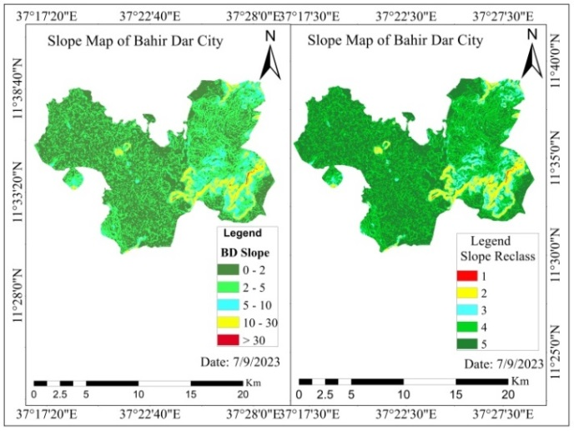
  - Figure 4.1: Slope Map of the Study Area
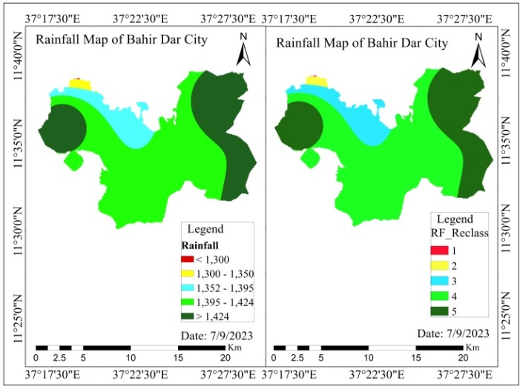
  - Figure 4.2: Rainfall Map of the Study Area
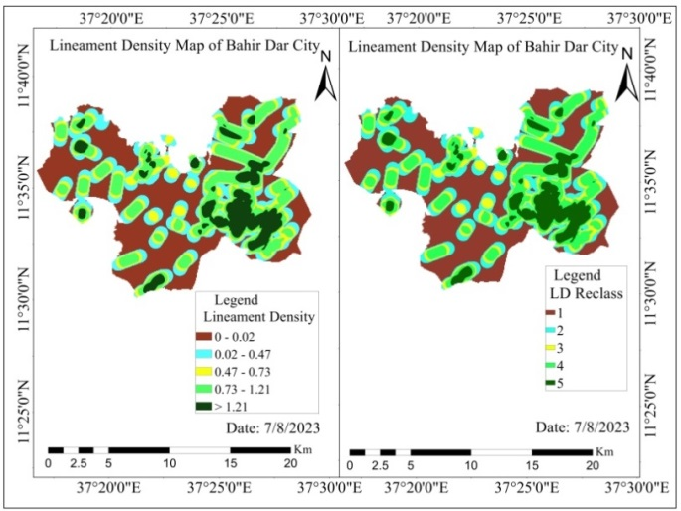
  - Figure 4.3: Lineament Density Map of the Study Area
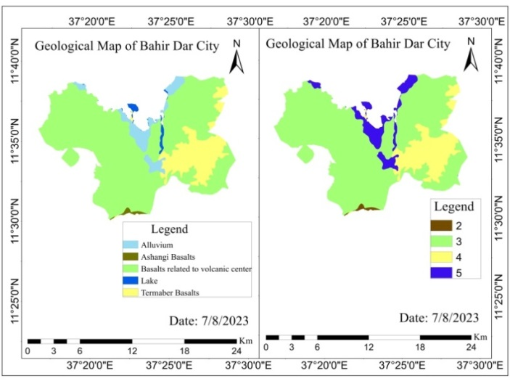
  - Figure 4.4: Geology Map of the Study Area
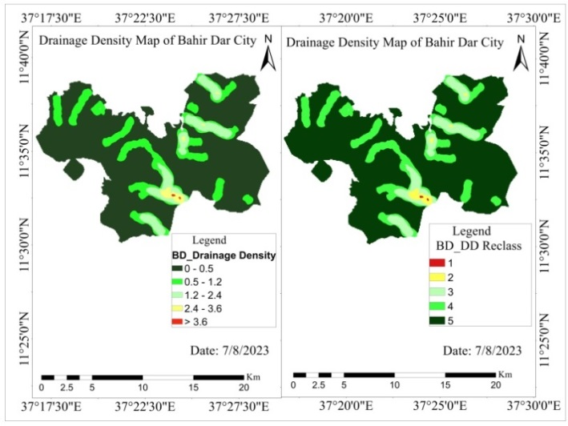
  - Figure 4.5: Drainage density Map of the Study Area
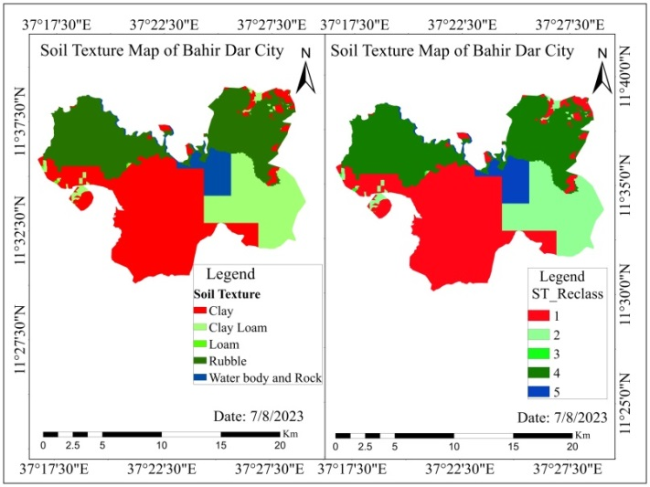
  - Figure 4.6: Soil Texture Map of the study area
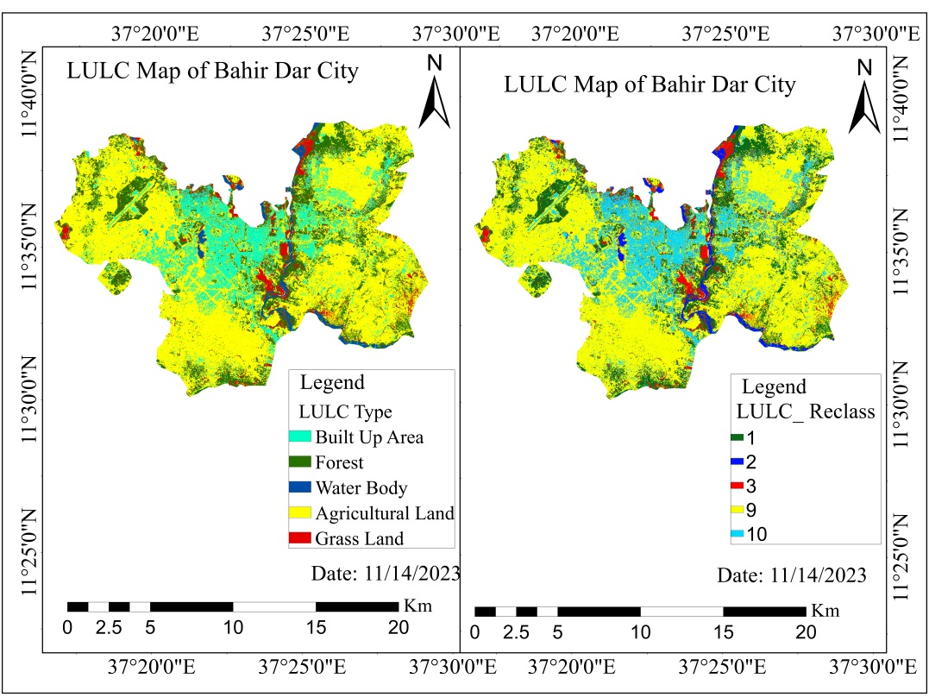
  - Figure 4.7: LULC map of the study area
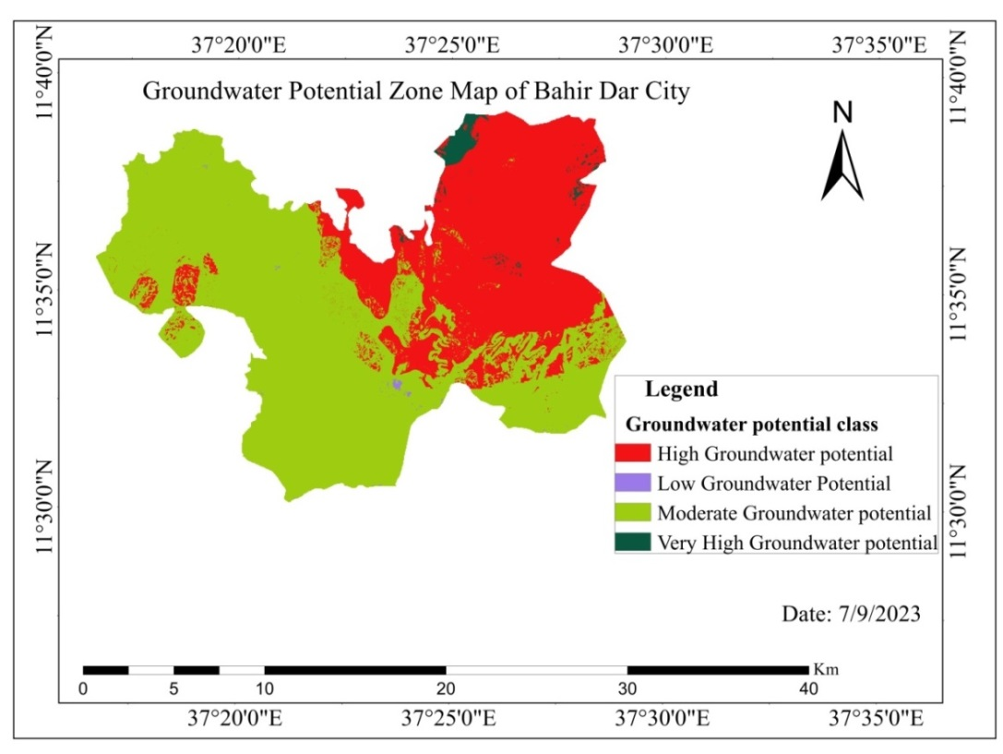
  - Figure 4.8: Groundwater potential zone Map of the study area
  - Table 4.4: Areal coverage of Groundwater potential zone
Groundwater potential class | Areal coverage in ha | Areal coverage in %
Low Groundwater potential | 27.34 | 0.13
Moderate Groundwater potential | 12972.10 | 61.72
High Groundwater potential | 7767.31 | 36.95
Very High Groundwater potential | 251.85 | 1.20
Total | 21018.60 | 100
Based on the groundwater potential zone map, the northern and northwestern parts of the study area are characterized by very high and high water storage, mainly on account of higher rainfall, as shown in Fig 4.1 (Melese & Belay, 2022). Favorable GWPZ is characterized by a gentle slope, low drainage density, high lineament density, and favorable hydro-geomorphological form. ‘Poor’ GWPZ has a low recharge capacity and a steeper slope as compared to high GWPZ (Patra et al., 2018).
Medium groundwater potential zones cover a vast area of the study area, accounting for 61.72%. The study's findings demonstrate the spatial variability of groundwater potential across the study area, which is caused by variations in the rainfall, geology, drainage density, soil, land use, land cover, slope, and lineament of the region. This is true even though the majority of the study area is classified as having medium potential (Yihunie & Halefom, 2020). The groundwater potential zone map of the present study provides insights for decision-makers for proper planning and management of groundwater for urban and agricultural purposes.

Spatial distribution of vulnerability of Groundwater to pollution
As per Asfaw and Mengistu, (2020) and Abera et al., (2022) delineating vulnerable areas, and prioritizing and identifying contaminant sources are the key issues for groundwater management. To this end, a modified DRASTIC model was used to delineate the vulnerability of groundwater to pollution. To analyze and delineate the intrinsic vulnerability, it needs to prepare a thematic layer for each parameter and, weight and rate according to their significant contribution to pollution.

Modified DRASTIC model parameters rate and weight
Depth to water table (D)
The depth of the water table was generated from 30 wells and springs. The interpolation result showed that the minimum and maximum depth of the water table were 2.5 and 80 meters respectively. This result was sub-grouped and rated into 9 classes based on Table 3.4 where a depth to a water table ranging less than 4.8 meters was rated to class 9 and a depth greater than 30.5 meters was rated to class 1. This implies that as the depth of the water table increases the probability of groundwater vulnerability to pollution decreases. The deeper the groundwater the lower is the probability of vulnerability to contamination and the shallower the groundwater is the higher the probability of groundwater vulnerable to pollution (Neshat et al., 2014; Singh et al., 2015; Falowo et al., 2017; Falowo, 2023).
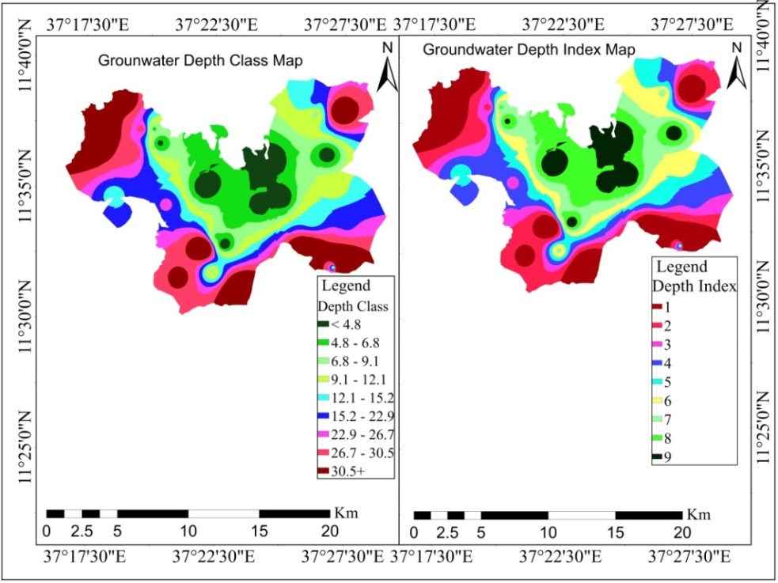
  - Figure 4.9: Depth to water table map of the study area
According to the result of the analysis, the mean water depth to the surface level is 27.5 m. Of 30 wells and springs, 16.67% had greater than 30.05 meters of depth to the ground surface whereas 7.40% of the study area had less than 4.8 meters of depth to the ground surface. When the depth is becoming shallower to the surface level, water depth for pollution has high significant contribution due to their depth that has maximum ranking for vulnerability. It is evident that when the depth of water is less than 4.8 m, the probability of being vulnerable is high whereas more than 30.5 m may not have a significant contribution provided that other factors play their roles (Tefera et al., 2021).
  - Table 4.5: Depth to water table Areal coverage of the study area
Depth to Water Table | Area in ha | Area in %
< 4.8 | 1578.67 | 7.40
4.8 - 6.8 | 2688.38 | 12.60
6.8 – 9.1 | 2100.16 | 9.84
9.1– 12.1 | 2148.74 | 10.07
12.1 – 15.2 | 2065.60 | 9.68
15.2 – 22.9 | 2696.10 | 12.63
22.9 – 26.7 | 1784.78 | 8.36
26.7 – 30.5 | 2722.34 | 12.76
30.5+ | 3557.04 | 16.67
Total | 21341.8 | 100
Net recharge (R)
Net recharge has the greatest contribution to the aquifer vulnerability since passing down surface pollutants occurs through the recharge of surface runoff into the subsurface. It is the main mechanism for transferring different contaminants from the surface of the earth to the groundwater sources. The result showed that the net recharge value of the city ranges from a minimum of 234.11 mm/year to a maximum of 256 mm/year.
The net recharge of the city was rated into two classes class 9 (net recharge range between 235 - 254 meters) and 10 (net recharge greater than 254 meters) based on Table 3.6 (Aller, 1987; Asfaw and Mengistu, 2020). This is because an area with high recharge has a high probability of vulnerability to contaminants (Wu et al., 2018).
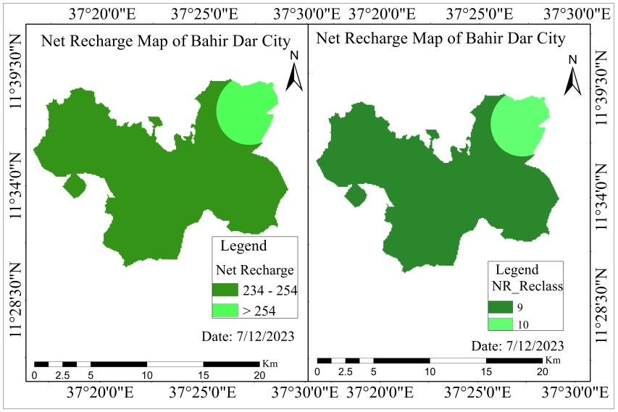
  - Figure 4.10: Net recharge map of the study area
According to the result of the analysis, the mean net recharge of the city is 245.29 mm/year. From those, 88.88% of the area has between 234 and 254 mm/year net recharge whereas the remaining 11.12% has greater than 254 mm/year net recharge.
  - Table 4.6: Net recharge Area of the study area
Net Recharge Class | Area in ha | Area in %
234-254 | 18969.27 | 88.88
254+ | 2372.53 | 11.12
Total | 21341.8 | 100
Aquifer media (A)
The aquifer is a rock type that holds and passes water as it has fractures or open spaces. Groundwater flow is related to the porosity, permeability, and transmissivity of the aquifer (Gómez & Torres-Verdín, 2022). In this study, the aquifer media parameter is included due to this nature associated with vulnerability to pollution.
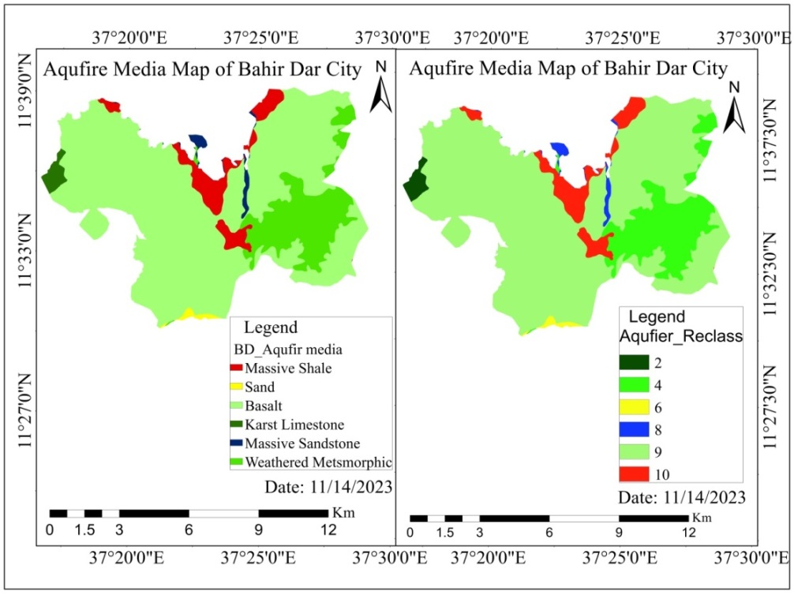
  - Figure 4.11: Aquifer media map of the study area
According to the result of the analysis, Most of the study area is covered by Basalt 76.68%. This indicates that most of the study area has been put under high risk for pollution.
  - Table 4.7: Aquifer Media Areal coverage of the study area
Aquifer Media | Area in ha | Area in %
Massive shale | 1325.90 | 6.21
Weathered metamorphic/igneous | 3070.11 | 14.39
Massive sandstone | 219.10 | 1.03
Sand and gravel | 101.70 | 0.48
Basalt | 16364.01 | 76.68
Karst limestone | 260.97 | 1.22
Total | 21341.8 | 100
Soil media (S)
In the modified DRASTIC model, the soil media represents the capability of the soil to infiltrate water and contaminants vertically down to the unsaturated zone (Al-Abadi et al., 2017). As per the FAO- USAID classification system, the study area's major soil types are Liptosols, Regosols, Luvisols, Fluvisols, Vertisols, Cambisols, and water bodies and Rock.
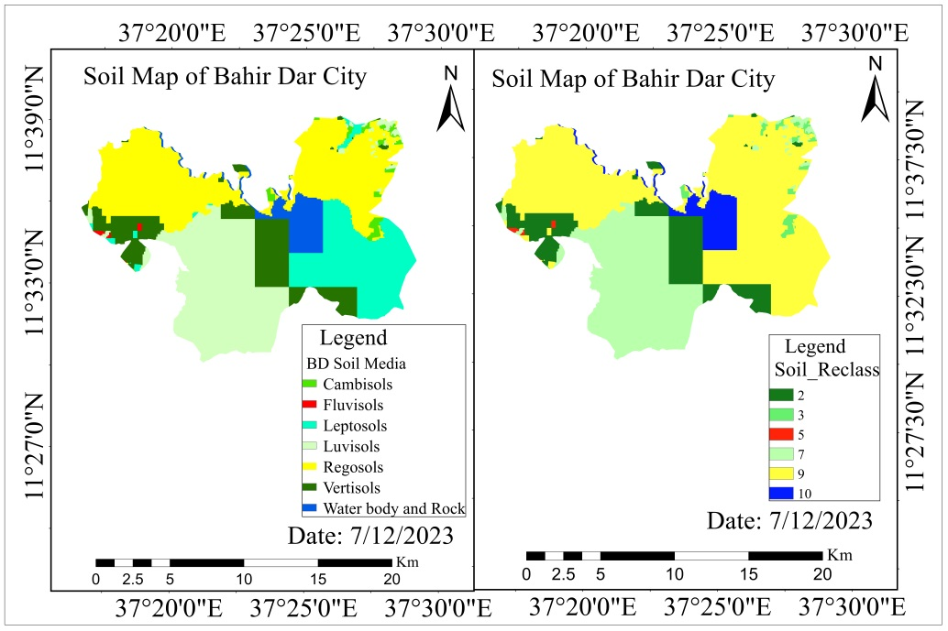

  - Figure 4.12: Soil media map of the study area

According to the result of the analysis, Rock, Regosols, and Luvisol covers 1144.04ha (5.36%), 7463.19 ha (34.97%), and 5826.04 ha (27.30%) respectively Table 4.8 and were rated to 9 and 7 class whereas Vertisol 2743.61 ha (12.86%), Fluvisols and Cambisols cover a small area 39.62 ha (0.19%) and 277.86 ha (1.30%).

  - Table 4.8: Soil media Areal coverage of the study area
Soil Media | Area in ha | Area in %
Rock & Waterbody | 1144.04 | 5.36
Regosols | 7463.19 | 34.97
Leptosol | 3847.45 | 18.03
Luvisol | 5826.04 | 27.30
Fluvisols | 39.62 | 0.19
Cambisols | 277.86 | 1.30
Vertisol | 2743.61 | 12.86
Total | 21341.8 | 100
Topography media (T)
Slope determines the precipitation rate and displacement velocity of water over the equipotential surface. The lowest slope is suitable for pollutants to percolate into the ground to mix with groundwater. The slope is also an inherent factor for the soil type and thickness. On the other hand, areas with steeper slopes cause more runoff with less infiltration attributed small risk of groundwater contamination (Emmanuel Udo et al., 2015).
The flatter the slope (slope from 0 - 2 %), the higher the retaining capacity of water and/or pollutants while the moderate to steeper the slope (slope 18 %⁺) is, the lower the retention capacity of water and/or pollutants (Souleymane & Zhonghua, 2017). Thus, the lower slope was rated to slope classes 10, 9, and 8 whereas the stepper slope (18 %⁺) was rated to class 1(Figure 4.13).
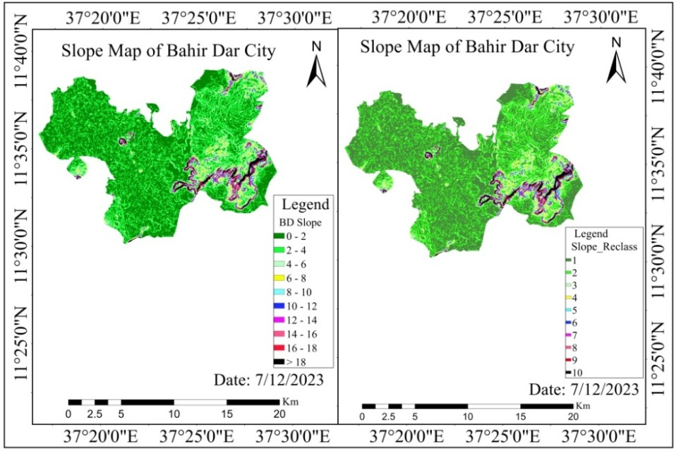
  - Figure 4.13: Slope map of the study area
According to the result of the analysis, slope class 1 and 2 covers rated 10 and 9 respectively which covers 17113.49 ha (80.19%) of the total area whereas a slope greater than 18% (higher slope) and between 16 and 18 covers 560.54 ha (2.63%). This result indicates that most of the study area is sensitive to pollution. The lower slope allows the pollutants to settle long enough to infiltrate down to the aquifer (Boughorbel et al., 2017).
  - Table 4.9: Slope Areal coverage of the study area
Slope (%) Class | Area in ha | Area in %
0 – 2 | 10018.28 | 46.94
2 – 4 | 7095.21 | 33.25
4 – 6 | 1643.53 | 7.70
6 – 8 | 735.82 | 3.45
8 – 10 | 477.00 | 2.24
10 – 12 | 334.85 | 1.57
12 – 14 | 264.30 | 1.24
14 – 16 | 212.29 | 0.99
16 – 18 | 176.97 | 0.83
>18 | 383.57 | 1.80
Total | 21341.8 | 100
Impact of vadose zone media (I)
The Vadose zone (unsaturated zone) is a significant reservoir for the capture, storage, and release of contaminants from the surface to the subsurface. Based on this notion, the impact of the vadose zone for the study area was derived from the distribution of soil textures Figure 4.14.
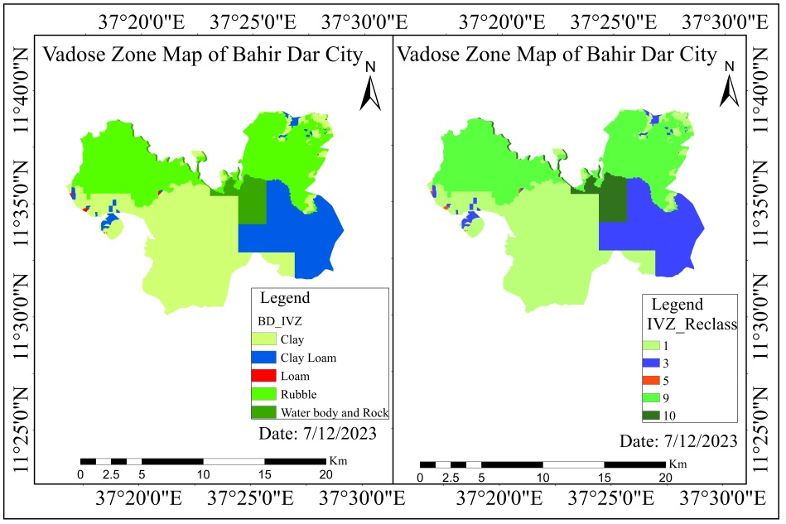
  - Figure 4.14: Impact of Vadose zone media map of the study area
According to the result of the analysis, the study area is dominantly covered by clay and Rubble type of soil separate with an area of 41.13% (8777.88 ha) and 34.96% (7461.58 ha) respectively and the remaining constituted by loamy, Clay loam, and Water body and rock 23.91% (5102.34 ha) Table 4.10.
  - Table 4.10: Impact of Vadose Zone Area1coverage of the study area
Impact of Vadose Zone | Area in ha | Area in %
Water body and rock | 1144.31 | 5.36
Rubble | 7461.58 | 34.96
Loamy | 23.01 | 0.11
Clay loam | 3935.02 | 18.44
Clay | 8777.88 | 41.13
Total | 21341.8 | 100
Hydraulic conductivity (C)
Hydraulic Conductivity is an important parameter that influences the rate of mobility of the groundwater into the saturation zone hence determining the amount of contaminants moving downwards, showing the rate of transmission of the pollutant-rich water into the aquifer. The higher value of hydraulic conductivity implies a higher risk of contamination.
In the study area, the hydraulic conductivity value ranges from 0.014 to 74 m/day categorized into 6 classes as shown in Figure 4.15.
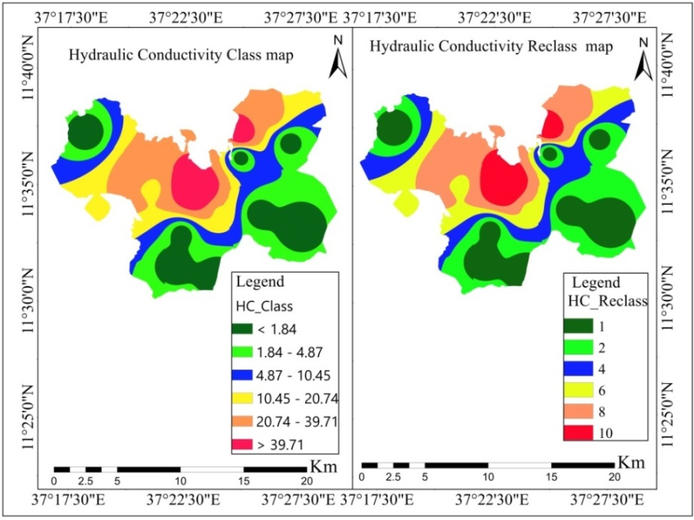
  - Figure 4.15: Hydraulic conductivity map of the study area
According to the result of the analysis, 4248.41 ha (19.91%) covers < 1.84, 4890.99 ha (22.92%) covers between 1.84 - 4.87, 3296.88 ha (15.45%) covers between 4.87-10.45, 3372.69 ha (15.80%) covers between 10.45-20.74, 4050.51 ha (18.98%) covers between 20.74-39.71 and 1482.33 ha (6.95%) covers 39.71⁺.
  - Table 4.11: Hydraulic Conductivity Areal coverage of the study area
Hydraulic Conductivity | Area in ha | Area in %
< 1.84 | 4248.41 | 19.91
1.84 - 4.87 | 4890.99 | 22.92
4.87 - 10.45 | 3296.88 | 15.45
10.45 - 20.74 | 3372.69 | 15.80
20.74 - 39.71 | 4050.51 | 18.98
39.71+ | 1482.33 | 6.95
Total | 21341.8 | 100
Land use land cover (Lu)
The Land use land cover of Bahir Dar City was developed from a Sentinel-2 satellite image. The study area was classified into five major LULC classes such as water body, Built-up area (settlement), Agricultural land, Grass land, and, forest. The accuracy assessment was conducted by taking 100 sample data from the field and Google Earth. The total Kappa coefficient of the classification and accuracy assessment was 0.814 or 81.4 % and 0.83 /83% respectively which are an acceptable level (Butt et al., 2015; Siddik et al., 2022).
The impact and contribution of human activity to the contamination of groundwater are strong (Abdelmadjid and Omar, 2013; Al-Rawabdeh et al., 2014; Neshat et al., 2014; Boughorbel et al., 2017; Thapa et al., 2018; Asfaw and Mengistu, 2020). It was explained via LULC of the City. As shown in Figure 4.17, Agricultural Land and Built-up area (settlement) were rated 9 and 10 respectively. This implies that the probability of polluting groundwater was higher in areas used for urban settlement and agriculture than in other types of land use (Singh et al., 2015; Thapa et al., 2018; Asfaw and Mengistu, 2020). Forest and water bodies were less susceptible to pollution and rated 1 and 2 respectively.
  - Figure 4.16: LULC map of the study area
According to the result of the analysis, the City was dominated by Agricultural Land which covered 12965.30 ha (60.75%), and forest land covered 3685.41ha (17.27%) area. The built-up area covered 3141.20 ha (14.72%) area of the study area and the remaining was shared by grassland and water bodies.
  - Table 4.12: LULC Areal coverage of the study area
LULC type | Area in ha | Area in %
Built up Area | 3141.20 | 14.72
Forest Land | 3685.41 | 17.27
Water Body | 717.88 | 3.36
Agricultural Land | 12965.30 | 60.75
Grass Land | 832.01 | 3.90
Total | 21341.8 | 100

Groundwater vulnerability map
In mapping spatial variation of groundwater vulnerability, all thematic layers of the parameters were rated according to their relative importance and susceptibility to contaminants. These layers were multiplied by their weight which was fixed according to their significance and contribution of contaminants (Aller et al, 1987; Hossain Ali and Atiqur Rahman, 2008; Boughorbel et al., 2017; Asfaw and Mengistu, 2020).
According to the analysis result shown in Figure 4.18, the total vulnerability index value of the study area ranges from 112 to 243. The mean groundwater vulnerability index value in the study area is 167. The higher the value of the modified DRASTIC index, the greater the groundwater vulnerability to pollution (Aller et al., 1987; Abiy and Melesse, et al., 2016; Ramaraju and Veni, 2017). The index value was reclassified using spatial analysis tools into different groundwater vulnerability classes. Analogously the modified DRASTIC model result index was reclassified into four (4) vulnerability classes.
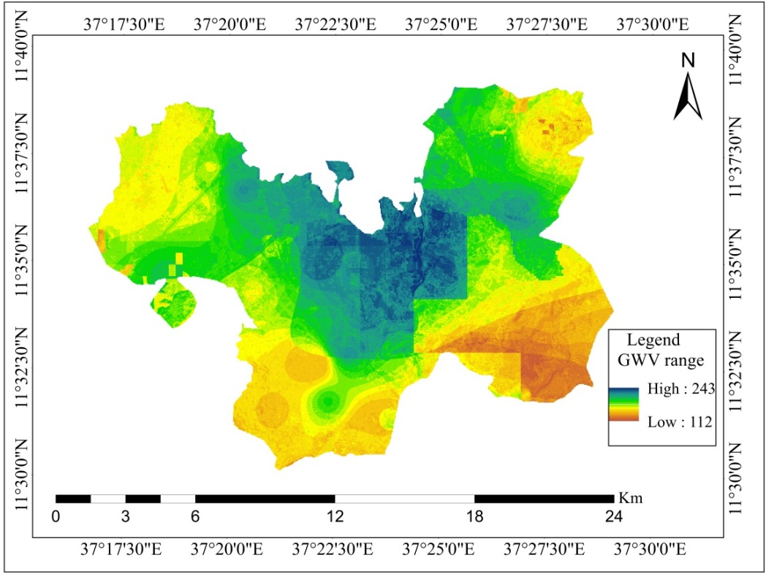
  - Figure 4.17: Modified DRASTIC model result index map of the study area
The index value was reclassified using spatial analysis tools into different groundwater vulnerability classes according to the vulnerable index scores shown in Table 3.7. An area with an index value less than 100 has a very low vulnerability to pollution, an area with an index value ranging between 100 to 145 has a lower vulnerability to pollution, an area with an index value ranging between 145 to 190 are moderately vulnerable to pollution, an area with an index value ranging between 190 to 235 has a high vulnerability to pollution and an area with an index value greater than 235 has a very high vulnerability to pollution.
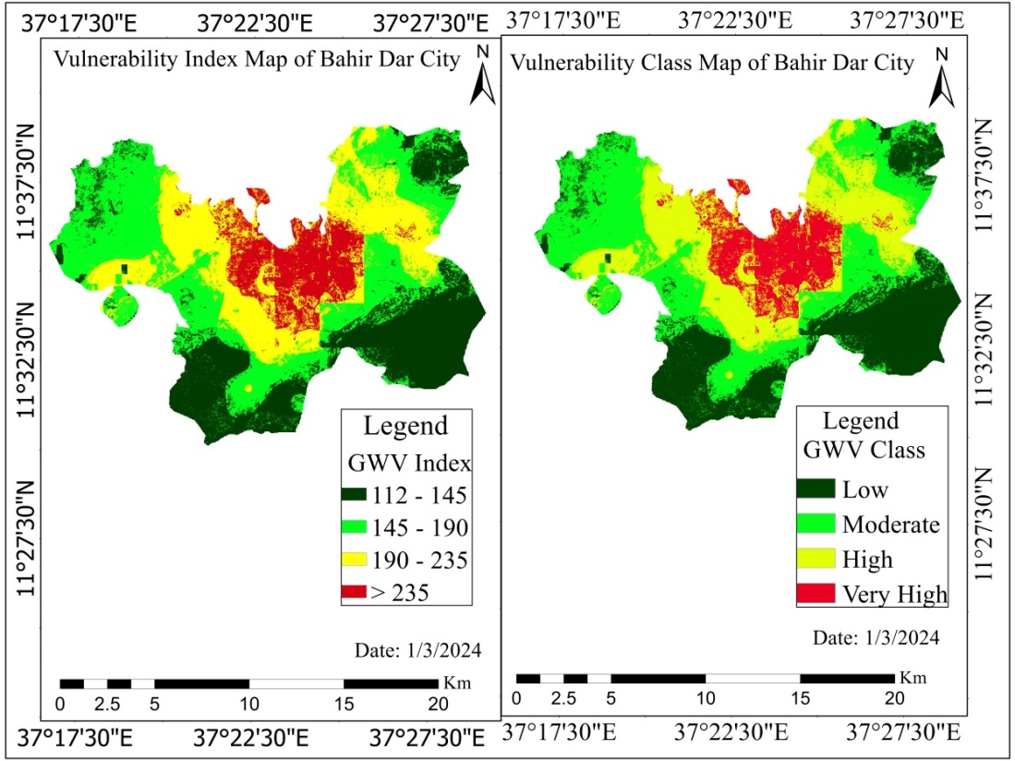
  - Figure 4.18: Modified DRASTIC model vulnerability class map of the study area
As shown in Figure 4.18 and Table 4.13, the values of the modified DRASTIC model groundwater vulnerability index were classified into four classes those are low, moderate, high, and very high vulnerable zones. Out of the total study area, 5899.73 ha (27.63%) are put under the low vulnerable zone, 7344.92 ha (34.40%) are put under the moderate vulnerable zone, 5589.87 ha (26.18%) are put under the highly vulnerable zone and 2514.28 ha (11.78%) are put under the very high vulnerable zone.
  - Table 4.13: Groundwater Vulnerability Class Areal coverage of the study area
Vulnerability Class | Vulnerability Index | Area in ha | Area in %
Low | 112-145 | 5899.73 | 27.63
Moderate | 145-190 | 7344.92 | 34.4
High | 190-235 | 5589.87 | 26.18
Very high | >235 | 2514.28 | 11.78
Total |  | 21348.8 | 100
The spatial distribution of the hotspot areas or highly vulnerable parts of Bahir Dar City groundwater was dominant in the center (built up area).
These hotspot areas or highly vulnerable parts of the watershed are associated with relatively more populated parts of the City where industries, landfills and, domestic wastes and septic tanks are confined and generate pollutants. Besides, the geological setup and topographic structure increased the probability of discharged pollutants to percolate down the aquifer and cause groundwater pollution.
The result of this study is in harmony with the result of Singh et al., (2015) who conducted a study in Lucknow City, India using a modified DRASTIC model (DRASTICA) where anthropogenic influence exhibited a significant contribution to groundwater pollution. Likewise, a groundwater vulnerability assessment conducted in Algeria (Khemis Miliana Plain) using the DRASTIC-Lu model showed the influence of human activities on groundwater pollution (Zafane & Benyoucef Gharbi, 2017). Similar studies by Al-Rawabdeh et al., (2014); Dávila et al., (2014) also confirmed the strong influence of human activities on the groundwater quality manifested via LULC change in the vulnerability analysis.
A groundwater vulnerability evaluation was conducted in India, Kerala region near a solid waste disposal site using the DRASTIC model, and was reported the DRASTIC index values ranged between 120 to 243, where the eastern and southeastern parts of the dumping site were highly vulnerable to contaminants due to the lower slope of the terrains which allows percolation of contaminants into the groundwater (Jaseela et al., 2016). Another study conducted in southern Côte d’Ivoire (Djémin et al., 2016) reported vulnerability index values ranging from 95 to 187 where about 63.93% of the areas are under very high to highly vulnerable zone which is mainly in the central part of the region. Similarly, Modabberi et al., (2017) reported that a large extent (48.64%) of the Guilan aquifer in Iran majorly the plain part is highly vulnerable to pollution.
Analogous to the results of the present study, Ebadati et al., (2012); (Al-Abadi et al., 2017); Souleymane and Zhonghua, (2017) reported a groundwater map with three vulnerability classes ranging from very high to low vulnerable to pollution. The vulnerability class ranges from moderately to the very highly vulnerable part of the region categorized as an extreme protection region. Voudouris et al., (2010) and Wu et al., (2018) reported that the shallower part of the aquifer and the urban center fall within high and very high vulnerability zones in which intensive rain and slope of the terrain were influencing factors in the vulnerability analysis. The intensive rain of the area diluted the pollutants and the gentle to nearly flat slope gave way for pollutants to percolate down to the aquifer and contaminate the groundwater.
In Bahir Dar City, very high vulnerability is associated with the built-up (urban settlement) area which is delineated as a maximum protection part of the groundwater. Similar studies reported by Tovar and Rodríguez, (2004); Tilahun and Merkel, (2009); Arzu Firat and Fatma, (2013); Muhammad et al., (2015); Ewusi et al., (2016) very highly vulnerable areas were confined to the urban settlement where different sources of pollutants are concentrated.
Contrary to this finding, research conducted in Lahore, Pakistan by Muhammad et al., (2015) reported that low vulnerability is associated with the dense human settlements and dominated the central part of the study area while high vulnerability which covers 28.8% of the region associated with agricultural and pasture areas. The justification for the high vulnerability of the settlement (urban) area is that these parts of the study area have deep water levels where contaminants require extended time to commingle and the recharge rate is low which limits the probability of contaminants reaching the groundwater.

Merchant, (1994) indicated that human activity that discharges contaminants to the surface and infiltrates down to the groundwater has a significant contribution to groundwater pollution. In this regard, Baghapour et al., (2016) who incorporated LULC as a parameter found that the modified DRASTIC model performed better in delineating groundwater vulnerability to pollution. Dávila et al., (2014) also compared the conventional DRASTIC model with the modified DRASTIC model and came up with a better result for the modified DRASTIC model.
All these revealed that the results of the modified DRASTIC model are viable and representative of the groundwater vulnerability of the study City. Similarly, Shirazi et al., (2012); Djémin et al., (2016); and Jang et al., (2017) found the model appropriate for groundwater vulnerability assessment and it serves as a tool for monitoring human activities for the sustainable conservation of groundwater quality.

Model validation
For assessing the accuracy of the Modified DRASTIC model used for generating the final groundwater vulnerability map, it has been validated using Nitrate (NO3), TDS (Total dissolved solid), and Turbidity parameters. Nitrate (NO3), TDS (Total dissolved solid), and Turbidity were measured from shallow tube wells collected from 15 location sites in the study site.
Based on groundwater quality laboratory results, The Nitrate (NO3), TDS (Total dissolved solid), and Turbidity values in the study area vary from 1.9 to 13.1 mg/l, 78 to 500 mg/l, and 0.9 to 13.1 respectively as shown as follows:
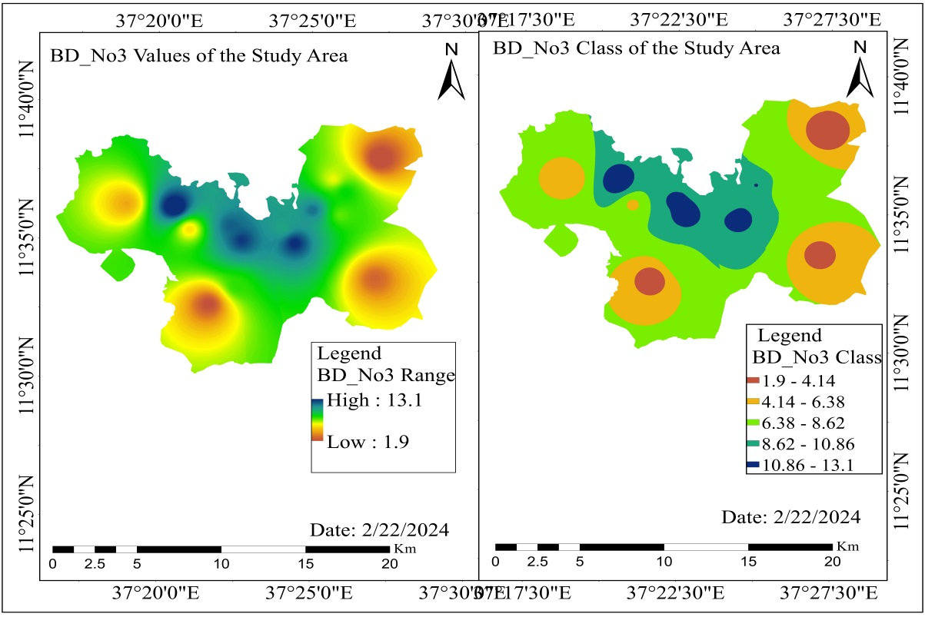
  - Figure 4.19: Nitrate Concentration of the study area
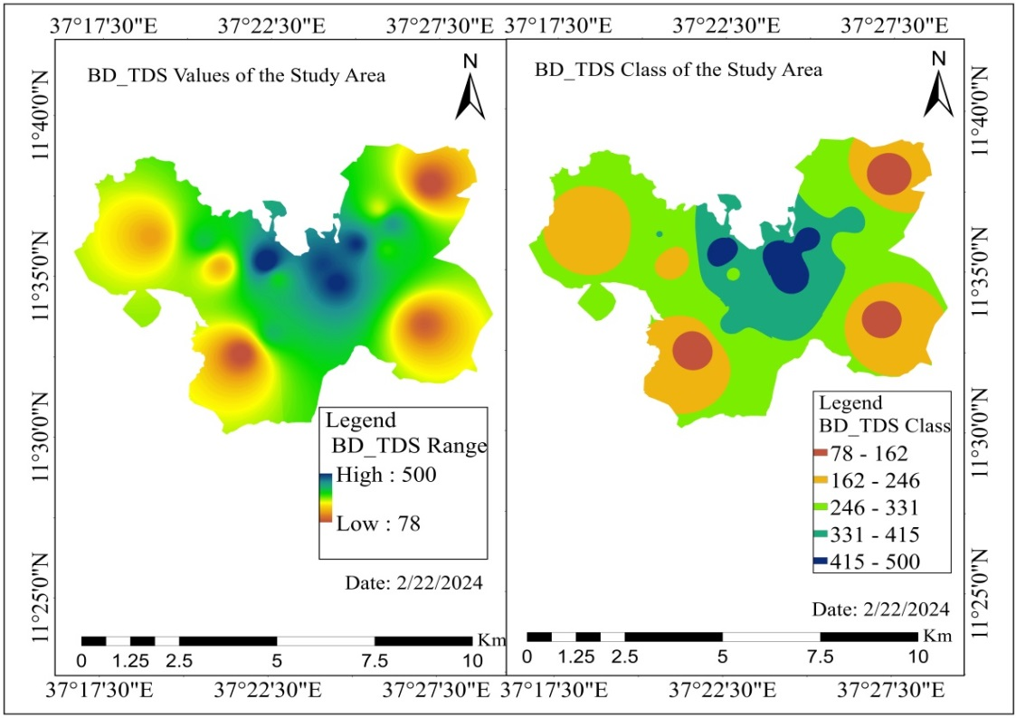
  - Figure 4.20: Total dissolved solid of the study area
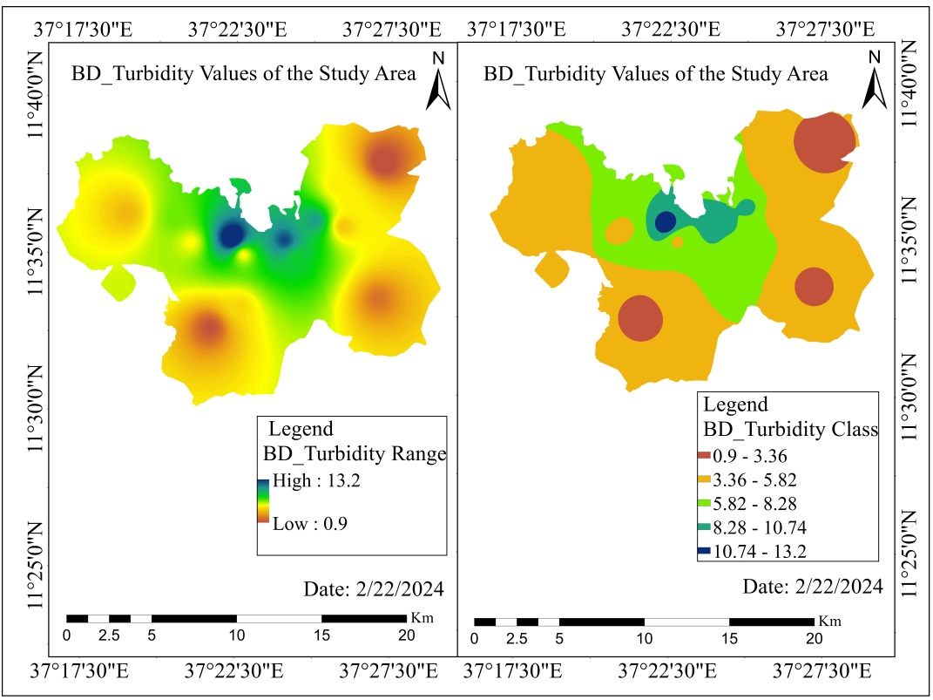
  - Figure 4.21: Turbidity of the study area
It can be seen from the spatial distribution of the parameters in the built-up area as well as agricultural land shows a very high concentration of nitrate, TDS, and Turbidity. On the contrary, forest areas show a low concentration of nitrate, TDS, and Turbidity. But, in the water body and grass land moderate concentration of nitrate, TDS, and Turbidity has been exist.
Based on the analysis the Pearson Correlation Coefficient (r) value of NO_{3,} TDS, and Turbidity were 0.743, 0.651and 0.716 respectively which indicates a strong positive correlation.

Sensitivity analysis

Single parameter sensitivity analysis
In the modified DRASTIC model, all parameters did not have equal significance and contribution to the vulnerability analysis. To identify significant parameters, a single parameter sensitivity analysis method was used.
  - Table 4.14: Statistics of single parameter sensitivity analysis method
Parameter | Theoretical weight | Theoretical weight (%) | Effective weight (%)
Parameter | Theoretical weight | Theoretical weight (%) | Max | Mean | Min
D | 5 | 17.86 | 16.46 | 13.48 | 7.69
R | 4 | 14.29 | 16.46 | 22.76 | 55.38
A | 3 | 10.71 | 12.35 | 10.78 | 9.23
S | 2 | 7.14 | 8.23 | 7.19 | 6.15
T | 1 | 3.57 | 4.12 | 3.29 | 1.54
I | 5 | 17.86 | 18.52 | 14.97 | 7.69
C | 3 | 10.71 | 12.35 | 9.88 | 4.62
Lu | 5 | 17.86 | 27.7 | 21.45 | 5.88
The single parameter sensitivity analysis compares the effective and theoretical weights thereby evaluating the degree of the influence of an individual parameter in the vulnerability of the groundwater and the contribution of the parameter in the analysis. As per the statistical analysis result of single parameter sensitivity in Bahir Dar City, the effective weights of net recharge (R) (22.76%) and land use land cover (Lu) (21.45%) were higher than their theoretical weights (14.29% and 17.86%, respectively). This implies that R and Lu are the most influential parameters in the groundwater vulnerability analysis followed by the impact of vadose zone media (A) and Groundwater depth (D) with an effective weight of 14.97% and 13.48%, respectively.

Map removal sensitivity analysis
As displayed in Table 4.15, the result of the map removal sensitivity analysis of Bahir Dar city groundwater vulnerability shows that net recharge (R) and Land use land cover (Lu) were more sensitive parameters in the analysis. The average vulnerability index of the analysis after the removal of each thematic layer of Lu, R, A, I, C, D, and S were 136, 138, 151, 152, 156, 157, and 159 respectively which is lower than the mean (167) of the vulnerability index.
  - Table 4.15: Statistics of Map Removal Sensitivity Analysis Method
Removal Parameter from the analysis | Vulnerability Index |  |  |  | Sensitivity Index
Removal Parameter from the analysis | Max | Mean | Min | SD | Max | Mean | Min | SD
D | 210 | 157 | 60 | 28.7 | 0.96 | 2.26 | 1.18 | 1.52
R | 212 | 138 | 29 | 32.35 | 0.09 | 4.12 | 1.38 | 1.54
A | 221 | 151 | 59 | 31.7 | 1.20 | 1.32 | 2.81 | 1.51
S | 230 | 159 | 61 | 29.87 | 2.48 | 1.12 | 2.90 | 1.42
T | 236 | 172 | 64 | 32.74 | 3.34 | 1.43 | 3.05 | 1.56
I | 205 | 152 | 60 | 25.73 | 1.09 | 2.32 | 2.86 | 1.23
C | 227 | 156 | 62 | 32.5 | 2.05 | 1.84 | 2.95 | 1.55
Lu | 198 | 136 | 60 | 27.68 | 2.09 | 3.96 | 2.86 | 1.32
Based on the analysis of the result, the sensitivity index values of R, Lu, I, and D were higher than the other parameters 4.12, 3.96, 2.32, and 2.26 respectively which confirms the sensitivity of the parameters. Net recharge (R) and land use land cover (Lu) were identified as the most influential and sensitive parameters in the vulnerability analysis in both the single parameter sensitivity analysis method and the map removal sensitivity analysis method.
According to the result of both single parameter sensitivity analysis and map removal sensitivity analysis, net recharge (N) and land use land cover (Lu) were identified as parameters that have a significant influence on Bahir Dar City groundwater vulnerability analysis. The impact of the vadose zone (I) and depth of the water table (D) were also found as influential parameters in the analysis. This result was consistent with the result reported by Djémin et al., (2016); Moslem and Ashournia, (2017); Oroji, (2018), and Wu et al., (2018) where net recharge media, Impact of vadose zone and depth to water table had been identified as significant parameters in the analysis of groundwater vulnerability to pollution using DRASTIC model.
Since the above studies were conducted without considering land use land cover (Lu) in their analysis they did not report about land use media. However, studies (Dávila et al., 2014; Abiy et al., 2016; Zafane et al., 2017) conducted in Africa and South America have confirmed that Lu is an important parameter that influences the analysis result and indicates the impact of human activity on groundwater quality.
Contrary to the present study, Oroji, (2018) who conducted a vulnerability analysis in Lifen Basin (China) reported that Aquifer media have significantly influenced the groundwater vulnerability analysis. Similarly, the study (Shakak, 2022) also identified soil media (S) and topography media (T) as influential parameters in the vulnerability analysis of the groundwater of the Central Japan Kakamigahara area. This difference might be attributed to the geological settings and hydrological characteristics of the study area.
Parameters such as geology, soil media (Abiy et al., 2016), and soil type and topography (Wu et al., 2018) were also identified as significant parameters in groundwater vulnerability analysis. However, these parameters were not significant in the present study. This implies that accurate and detailed information about these parameters needs to be obtained for groundwater vulnerability analysis.
All these revealed that the results of the modified DRASTIC model are viable and representative of the groundwater vulnerability of the study area. Similarly, Shirazi et al., (2012); Anornu and Kabo-bah (2013); Djémin et al., (2016); and Jang et al., (2017) found the model appropriate for groundwater vulnerability assessment and it serves as a tool for monitoring human activities for the sustainable conservation of groundwater quality.

CHAPTER FIVE: CONCLUSION AND RECOMMENDATION

Conclusion
The result of the study showed that, groundwater potential of Bahir Dar City was put under Low Groundwater potential 27.34 ha (0.13 %), moderate groundwater potential 12972.10 ha (61.72 %), high groundwater potential 7767.31 ha (36.95 %) and very high groundwater potential 251.85 ha (1.20 %). Based on the analysis, the northern and northwestern parts of the study area are characterized by very high and high water storage, mainly on account of higher rainfall. Favorable GWPZ is characterized by a gentle slope, low drainage density, high lineament density, and favorable hydro-geomorphological form
The result of the study showed that, Bahir Dar City's groundwater vulnerability ranges from a low vulnerable level between (112 - 145) to a very high vulnerable level (> 235). Out of the total study area, 5899.73 ha (27.63%) are put under the low vulnerable zone, 7344.92 ha (34.40%) are put under the moderate vulnerable zone, 5589.87 ha (26.18%) are put under the highly vulnerable zone and 2514.28 ha (11.78%) are put under the very high vulnerable zone.
The spatial distributions of very high and highly vulnerable parts of Bahir Dar City groundwater were dominantly confined built-up areas. So, it requires high protection and is regarded as the maximum conservation area. The vulnerability of these parts of the study area is attributed to human activities that discharge lots of contaminants. In particular, vulnerable hotspot areas are associated with effluents discharged from industries and domestic areas. Moderately vulnerable parts of the groundwater which are confined in cultivated areas might be caused by excessive fertilizer implemented in the agricultural land.
As per the statistical analysis result of single parameter sensitivity in Bahir Dar City, the effective weights of net recharge (R) (22.76%) and land use land cover (Lu) (21.45%) were higher than their theoretical weights (14.29% and 17.86%, respectively). This implies that R and Lu are the most influential parameters in the groundwater vulnerability analysis.
Based on the analysis of the result, the sensitivity index values of R, Lu, I, and D were higher than the other parameters 4.12, 3.96, 2.32, and 2.26 respectively which confirms the sensitivity of the parameters. Net recharge (R) and land use land cover (Lu) were identified as the most influential and sensitive parameters in the vulnerability analysis in both the single parameter sensitivity analysis method and the map removal sensitivity analysis method.

Recommendations
- Any developmental intervention in the very high and highly vulnerable part of Bahir Dar City will have a significant influence on maintaining the quality of groundwater. Therefore, all concerned bodies should evaluate pollution-generating potential of a project and either reject it or be forced to have a waste treatment plant to treat the waste before it is released to the environment.
- In most of Bahir Dar City, pollutants have been disposed both in the groundwater and surface water where septic tanks, landfills, and other human wastes are expected sources for these pollutants. Therefore, the local administration should implement proper waste management techniques (septic tanks, landfills, and discharges from domestic areas) that minimize the percolation of dissolved pollutants into the groundwater.
- The groundwater vulnerability map is used as an effective preliminary tool for planning and decision-making processes on groundwater management and protection. Amhara Regional State, Bahir Dar City water and sanitation office, and other Sub City administrate should use the groundwater vulnerability map to allocate resources for groundwater management and to give priority to the very high and highly vulnerable areas.

Reference
Abd Ellah, R. G. (2020). Water resources in Egypt and their challenges, Lake Nasser case study. The Egyptian Journal of Aquatic Research, 46(1), 1–12.
Abdelmadjid, B., & Omar, S. (2013). Assessment of groundwater pollution by nitrates using intrinsic vulnerability methods: A case study of the Nil valley groundwater (Jijel, North-East Algeria). African Journal of Environmental Science and Technology, 7(10), 949–960.
Abe, M. W., & Ersado, A. E. (2022). Assessment of Ground Water Potential Zone based on Multi-Criteria Decision making model and Geospatial Techniques: The case of Lemo Woreda and Hossana town, Hadiya Zone, Southern Nation Nationalities.
Abera, K. A., Gebreyohannes, T., Abrha, B., Hagos, M., Berhane, G., Hussien, A., Belay, A. S., Van Camp, M., & Walraevens, K. (2022). Vulnerability mapping of groundwater resources of Mekelle City and surroundings, Tigray Region, Ethiopia. Water, 14(16), 2577.
Abiy, A. Z., Demissie, S. S., MacAlister, C., Dessu, S. B., & Melesse, A. M. (2016). Groundwater recharge and contribution to the Tana sub-basin, upper Blue Nile basin, Ethiopia. Landscape Dynamics, Soils and Hydrological Processes in Varied Climates, 463–481.
Abiy, A. Z., & Melesse, A. M. (2017). Evaluation of watershed scale changes in groundwater and soil moisture storage with the application of GRACE satellite imagery data. Catena, 153, 50–60.
Abiy, A. Z., Melesse, A. M., Behabtu, Y. M., & Abebe, B. (2016). Groundwater vulnerability analysis of the Tana sub-basin: an application of DRASTIC Index Method. Landscape Dynamics, Soils and Hydrological Processes in Varied Climates, 435–461.
Abiye, T. A., & Kebede, S. (2011). The role of geodiversity on the groundwater resource potential in the upper Blue Nile River Basin, Ethiopia. Environmental Earth Sciences, 64, 1283–1291.
Aboulouafa, M., Taouil, H., Ahmed, S. I., Tairi, A., Arouya, K., & Hsaissoune, M. (2017). SINTACS and DRASTIC models for groundwater vulnerability assessment and mapping using a GIS and remote sensing techniques: a Case study on Berrechid plain. IOSR Journal Eng, 7(5), 23–30.
Adelana, S. M. A., Olasehinde, P. I., & Vrbka, P. (2006). A quantitative estimation of groundwater recharge in parts of Sokoto Basin, Nigeria. Journal of Environmental Hydrology, 14(5), 1–16.
Adelana, S., & MacDonald, A. (2008). Applied Groundwater Studies in Africa: IAH Selected Papers on Hydrogeology, volume 13 (Vol. 13). CRC Press.
Adeleke, O. O., Makinde, V., Eruola, A. O., Dada, O. F., Ojo, A. O., & Aluko, T. J. (2015). Estimation of groundwater recharges in Odeda local government area, Ogun state, Nigeria using empirical formulae. Challenges, 6(2), 271–281.
Ahmed, I., Nazzal, Y., & Zaidi, F. (2018). Groundwater pollution risk mapping using modified DRASTIC model in parts of Hail region of Saudi Arabia. Environmental Engineering Research, 23(1), 84–91.
Akale, A. T., Dagnew, D. C., Giri, S., Belete, M. A., Tilahun, S. A., Mekuria, W., & Steenhuis, T. S. (2017). Groundwater quality in an upland agricultural watershed in the sub-humid Ethiopian highlands. Journal of Water Resource and Protection, 9(10), 1199–1212.
Akhtar, M. M., Tang, Z., & Mohamadi, B. (2014). Contamination potential assessment of potable groundwater in Lahore, Pakistan. Polish Journal of Environmental Studies, 23(6), 1905–1916.
Akhtar, N., Syakir Ishak, M. I., Bhawani, S. A., & Umar, K. (2021). Various natural and anthropogenic factors responsible for water quality degradation: A review. Water, 13(19), 2660.
Al-Abadi, A. M., Al-Shamma’a, A. M., & Aljabbari, M. H. (2017). A GIS-based DRASTIC model for assessing intrinsic groundwater vulnerability in northeastern Missan governorate, southern Iraq. Applied Water Science, 7, 89–101.
Al-Rawabdeh, A., Al-Ansari, N., Al-Taani, A., Al-Khateeb, F., & Knutsson, S. (2014). Modeling the risk of groundwater contamination using modified DRASTIC and GIS in Amman-Zerqa Basin, Jordan. Open Engineering, 4(3), 264–280.
Al Hallaq, A. H., & Elaish, B. S. A. (2012). Assessment of aquifer vulnerability to contamination in Khanyounis Governorate, Gaza Strip—Palestine, using the DRASTIC model within GIS environment. Arabian Journal of Geosciences, 5(4), 833–847.
Alemayehu, T., Ayenew, T., & Kebede, S. (2006). Hydrogeochemical and lake level changes in the Ethiopian Rift. Journal of Hydrology, 316(1–4), 290–300.
Aller, L. (1985). DRASTIC: a standardized system for evaluating ground water pollution potential using hydrogeologic settings. Robert S. Kerr Environmental Research Laboratory, Office of Research and ….
Aller, L., Bennett, T., Lehr, Jh., Petty, R. J., & Hackett, G. (1987). DRASTIC: A standardized system for evaluating ground water pollution potential using hydrogeologic settings. US Environmental Protection Agency. Washington, DC, 455.
Aller, L., & Thornhill, J. (1987). DRASTIC: a standardized system for evaluating ground water pollution potential using hydrogeologic settings. Robert S. Kerr Environmental Research Laboratory, Office of Research and ….
Allouche, N., Maanan, M., Gontara, M., Rollo, N., Jmal, I., & Bouri, S. (2017). A global risk approach to assessing groundwater vulnerability. Environmental Modelling & Software, 88, 168–182.
Alwathaf, Y., & El Mansouri, B. (2011). Assessment of aquifer vulnerability based on GIS and ARCGIS methods: a case study of the Sana’a basin (Yemen). J Water Resour Prot 3: 845–855.
Amanambu, A. C., Obarein, O. A., Mossa, J., Li, L., Ayeni, S. S., Balogun, O., Oyebamiji, A., & Ochege, F. U. (2020). Groundwater system and climate change: Present status and future considerations. Journal of Hydrology, 589, 125163.
Anderson, J. R. (1976). A land use and land cover classification system for use with remote sensor data (Vol. 964). US Government Printing Office.
Anteneh, Z. L., Alemu, M. M., Bawoke, G. T., Kehali, A. T., Fenta, M. C., & Desta, M. T. (2022). Appraising groundwater potential zones using geospatial and multi-criteria decision analysis (MCDA) techniques in Andasa-Tul watershed, Upper Blue Nile basin, Ethiopia. Environmental Earth Sciences, 81(1), 1–20.
Arulbalaji, P., Padmalal, D., & Sreelash, K. (2019). GIS and AHP techniques based delineation of groundwater potential zones: a case study from southern Western Ghats, India. Scientific Reports, 9(1), 1–17.
Arzu Firat, E., & Fatma, G. (2013). DRASTIC-based methodology for assessing groundwater vulnerability in the Gümüshaciköy and Merzifon basin (Amasya, Turkey). Earth Sciences Research Journal, 17(1), 33–40.
Asfaw, D., & Mengistu, D. (2020). Modeling megech watershed aquifer vulnerability to pollution using modified DRASTIC model for sustainable groundwater management, Northwestern Ethiopia. Groundwater for Sustainable Development, 11, 100375.
Baghapour, M. A., Fadaei Nobandegani, A., Talebbeydokhti, N., Bagherzadeh, S., Nadiri, A. A., Gharekhani, M., & Chitsazan, N. (2016). Optimization of DRASTIC method by artificial neural network, nitrate vulnerability index, and composite DRASTIC models to assess groundwater vulnerability for unconfined aquifer of Shiraz Plain, Iran. Journal of Environmental Health Science and Engineering, 14, 1–16.
Bera, A., Mukhopadhyay, B. P., Chowdhury, P., Ghosh, A., & Biswas, S. (2021). Groundwater vulnerability assessment using GIS-based DRASTIC model in Nangasai River Basin, India with special emphasis on agricultural contamination. Ecotoxicology and Environmental Safety, 214, 112085. https://doi.org/10.1016/j.ecoenv.2021.112085
Berhanu, B., Seleshi, Y., & Melesse, A. M. (2014). Surface water and groundwater resources of Ethiopia: potentials and challenges of water resources development. Nile River Basin: Ecohydrological Challenges, Climate Change and Hydropolitics, 97–117.
Berhanu, K. G., & Hatiye, S. D. (2020). Identification of groundwater potential zones using proxy data: case study of Megech Watershed, Ethiopia. Journal of Hydrology: Regional Studies, 28, 100676.
Biruk, A. F. (2017). Waste management in the case of Bahir Dar City near Lake Tana shore in Northwestern Ethiopia: A review. African Journal of Environmental Science and Technology, 11(8), 393–412. https://doi.org/10.5897/ajest2017.2340
Boufekane, A., & Saighi, O. (2018). Application of groundwater vulnerability overlay and index methods to the Jijel Plain Area (Algeria). Groundwater, 56(1), 143–156.
Boughorbel, S., Jarray, F., & El-Anbari, M. (2017). Optimal classifier for imbalanced data using Matthews Correlation Coefficient metric. PloS One, 12(6), e0177678.
Burayu, D. G. (2022). Identification of groundwater potential zones using AHP, GIS and RS integration: a case study of didessa sub-basin, western Ethiopia. Remote Sens. Land, 6(1), 1–15.
Bushra, A. H. (2012). Quantitative status, vulnerability and pollution of groundwater resources in different environmental and climatic contexts in Sardinia and in Ethiopia.
Butt, A., Shabbir, R., Ahmad, S. S., & Aziz, N. (2015). Land use change mapping and analysis using Remote Sensing and GIS: A case study of Simly watershed, Islamabad, Pakistan. The Egyptian Journal of Remote Sensing and Space Science, 18(2), 251–259.
Calow, R. C., MacDonald, A. M., Nicol, A. L., & Robins, N. S. (2010). Ground water security and drought in Africa: linking availability, access, and demand. Groundwater, 48(2), 246–256.
Candela Lledó, L., Rao, S., Margiotta, M., & Rebouças, A. (1998). Soil and groundwater pollution from agricultural activities: learning material. Unesco.
Capodaglio, A. G. (2017). Integrated, decentralized wastewater management for resource recovery in rural and peri-urban areas. Resources, 6(2), 22.
Chaturvedi, R. S. (1973). A note on the investigation of ground water resources in western districts of Uttar Pradesh. Annual Report, UP Irrigation Research Institute, 1973, 86–122.
Chibane, B., & Ali-Rahmani, S. E. (2015). Hydrological based model to estimate groundwater recharge, real-evapotranspiration and runoff in semi-arid area. LARHYSS Journal P-ISSN 1112-3680/E-ISSN 2521-9782, 23, 231–242.
Chitsazan, M., & Akhtari, Y. (2009). A GIS-based DRASTIC model for assessing aquifer vulnerability in Kherran Plain, Khuzestan, Iran. Water Resources Management, 23, 1137–1155.
Civita, M. (1994). Le carte della vulnerabilità degli acquiferi all’inquinamento: teoria e pratica. Pitagora.
Contreras, J. D., & Eisenberg, J. N. S. (2020). Does basic sanitation prevent diarrhea? Contextualizing recent intervention trials through a historical lens. International Journal of Environmental Research and Public Health, 17(1), 230.
Dams, J., Woldeamlak, S. T., & Batelaan, O. (2008). Predicting land-use change and its impact on the groundwater system of the Kleine Nete catchment, Belgium. Hydrology and Earth System Sciences, 12(6), 1369–1385.
Davie, T. (2019). Fundamentals of hydrology. Routledge.
Dávila, M. E., Xian, L., Cahangirov, S., Rubio, A., & Le Lay, G. (2014). Germanene: a novel two-dimensional germanium allotrope akin to graphene and silicene. New Journal of Physics, 16(9), 95002.
Di Gregorio, A. (2016). Land cover classification system: classification concepts. Software version 3.
Djémin, J. É., Kouamé, J. K., Deh, K. S., Abinan, A. T., & Jourda, J. P. (2016). Contribution of the sensitivity analysis in groundwater vulnerability assessing using the DRASTIC method: application to groundwater in Dabou region (southern of Côte d’Ivoire). Journal of Environmental Protection, 7(1), 129–143.
Ebadati, N., Motlagh, K. S., & Behzad, N. (2012). Application of DRASTIC model in sensibility of groundwater contamination (Iranshahr-Iran). International Proceedings of Chemical, Biological and Environmental Engineering (IPCBEE), 30, 73–77.
Emmanuel Udo, A., Ojinnaka, O. C., Baywood, C. N., & Gift, U. A. (2015). Flood hazard analysis and damage assessment of 2012 flood in Anambra State using GIS and remote sensing approach. American Journal of Geographic Information System, 4(1), 38–51.
Empirik, K., & di Zon Tropika, K. K. (2013). Estimating groundwater recharge using empirical method: a case study in the tropical zone. Sains Malaysiana, 42(5), 553–560.
Ewusi, A., Asante-Annor, A., Seidu, J., & Fosu-Gyeabour, L. O. (2016). Groundwater vulnerability assessment using DRASTIC index and GIS in Kumasi Metropolitan Assembly, Ghana. Ghana Mining Journal, 16(1), 21–30.
Falowo, O. O. (2023). Modeling of hydrogeological parameters and aquifer vulnerability assessment for groundwater resource potentiality prediction at Ita Ogbolu, Southwestern Nigeria. Modeling Earth Systems and Environment, 9(1), 749–769.
Falowo, O. O., Akindureni, Y., & Ojo, O. (2017). Groundwater assessment and its intrinsic vulnerability studies using aquifer vulnerability index and GOD methods. International Journal of Energy and Environmental Science, 2(5), 103–116.
Fannakh, A., & Farsang, A. (2022). DRASTIC, GOD, and SI approaches for assessing groundwater vulnerability to pollution: a review. Environmental Sciences Europe, 34(1), 1–16.
Foster, S., Chilton, J., Nijsten, G.-J., & Richts, A. (2013). Groundwater—a global focus on the ‘local resource.’ Current Opinion in Environmental Sustainability, 5(6), 685–695.
Foster, S. S. D. (1987). Fundamental concepts in aquifer vulnerability, pollution risk and protection strategy.
Ghazavi, R., & Ebrahimi, Z. (2015). Assessing groundwater vulnerability to contamination in an arid environment using DRASTIC and GOD models. International Journal of Environmental Science and Technology, 12(9), 2909–2918.
Giordano, M. (2009). Global groundwater? Issues and solutions. Annual Review of Environment and Resources, 34(1), 153–178.
Gómez, J. D. E., & Torres-Verdín, C. (2022). Efficient estimation of aquifer intrinsic permeability anisotropy using perturbation theory. Computers & Geosciences, 159, 105033.
Goshu, G., & Akoma, O. C. (2011). Water quality assessment of underground and surface water resources of Bahir Dar and Periurban areas, north-west Ethiopia. Global Journal of Environmental Sciences, 10(1&2), 11–21.
Gültekin, F., Firat Ersoy, A., Hatipoglu, E., & Celep, S. (2013). Quality assessment of surface and groundwater in Solaklı Basin (Trabzon, Turkey). Bulletin of Engineering Geology and the Environment, 72, 213–224.
Gupta, R., Jindal, T., Khan, A. S., Srivastava, P., & Kanaujia, A. (2019). Assessment of ground water quality and its suitability for drinking in industrial area Jajmau, Kanpur, India. Plant Arch, 19(1), 1569–1571.
Harter, T. (2003). Groundwater quality and groundwater pollution.
Healy, R. W., & Scanlon, B. R. (2010). Estimating Groundwater Recharge, Cambridge University Press. Cambridge.
Hengade, N., & Eldho, T. I. (2016). Assessment of LULC and climate change on the hydrology of Ashti Catchment, India using VIC model. Journal of Earth System Science, 125, 1623–1634.
Hossain Ali, M., & Atiqur Rahman, M. (2008). Transverse Wave Propagation in Relativistic Two-Fluid Plasmas around Reissner–Nordström Black Hole. International Journal of Theoretical Physics, 47, 772–796.
Hosseini, M., & Saremi, A. (2018). Assessment and estimating groundwater vulnerability to pollution using a modified DRASTIC and GODS models (case study: Malayer Plain of Iran). Civil Engineering Journal, 4(2), 433–442.
Jang, W. S., Engel, B., Harbor, J., & Theller, L. (2017). Aquifer vulnerability assessment for sustainable groundwater management using DRASTIC. Water, 9(10), 792.
Jaseela, C., Prabhakar, K., & Harikumar, P. S. P. (2016). Application of GIS and DRASTIC modeling for evaluation of groundwater vulnerability near a solid waste disposal site. International Journal of Geosciences, 7(04), 558.
Javadi, S., Hashemy, S. M., Mohammadi, K., Howard, K. W. F., & Neshat, A. (2017). Classification of aquifer vulnerability using K-means cluster analysis. Journal of Hydrology, 549, 27–37.
Jhariya, D. C., Kumar, T., Gobinath, M., Diwan, P., & Kishore, N. (2016). Assessment of groundwater potential zone using remote sensing, GIS and multi criteria decision analysis techniques. Journal of the Geological Society of India, 88(4), 481–492.
Kebede, S. (2012). Groundwater in Ethiopia: features, numbers and opportunities. Springer Science & Business Media.
Khatri-Chhetri, A., Aggarwal, P. K., Joshi, P. K., & Vyas, S. (2017). Farmers’ prioritization of climate-smart agriculture (CSA) technologies. Agricultural Systems, 151, 184–191.
Kozłowski, M., & Sojka, M. (2019). Applying a modified DRASTIC model to assess groundwater vulnerability to pollution: A case study in central Poland. Polish Journal of Environmental Studies, 28(3), 1223–1231. https://doi.org/10.15244/pjoes/84772
Kumar, R. (2018). Research methodology: A step-by-step guide for beginners. Sage.
Kut, K. M. K., Sarswat, A., Srivastava, A., Pittman Jr, C. U., & Mohan, D. (2016). A review of fluoride in African groundwater and local remediation methods. Groundwater for Sustainable Development, 2, 190–212.
Lasagna, M., De Luca, D. A., & Franchino, E. (2018). Intrinsic groundwater vulnerability assessment: issues, comparison of different methodologies and correlation with nitrate concentrations in NW Italy. Environmental Earth Sciences, 77, 1–16.
Leone, A., Ripa, M. N., Uricchio, V., Deák, J., & Vargay, Z. (2009). Vulnerability and risk evaluation of agricultural nitrogen pollution for Hungary’s main aquifer using DRASTIC and GLEAMS models. Journal of Environmental Management, 90(10), 2969–2978.
Li, P., Karunanidhi, D., Subramani, T., & Srinivasamoorthy, K. (2021). Sources and consequences of groundwater contamination. Archives of Environmental Contamination and Toxicology, 80, 1–10.
Liu, J., Dorjderem, A., Fu, J., Lei, X., & Macer, D. (2011). Water Ethics and Water Resource Management.
Liu, J. G., & Mason, P. J. (2013). Essential image processing and GIS for remote sensing. John Wiley & Sons.
Liu, Y., Feng, C., Chen, N., Sheng, Y., Dong, S., Hao, C., & Lei, K. (2016). Bioremediation of nitrate and Fe (II) combined contamination in groundwater by heterotrophic denitrifying bacteria and microbial community analysis. RSC Advances, 6(110), 108375–108383.
Lodwick, W. A., Monson, W., & Svoboda, L. (1990). Attribute error and sensitivity analysis of map operations in geographical informations systems: suitability analysis. International Journal of Geographical Information System, 4(4), 413–428.
Luoma, S., Okkonen, J., & Korkka-Niemi, K. (2017). Comparison of the AVI, modified SINTACS and GALDIT vulnerability methods under future climate-change scenarios for a shallow low-lying coastal aquifer in southern Finland. Hydrogeology Journal.
Machiwal, D., & Jha, M. K. (2015). Identifying sources of groundwater contamination in a hard-rock aquifer system using multivariate statistical analyses and GIS-based geostatistical modeling techniques. Journal of Hydrology: Regional Studies, 4, 80–110.
Machiwal, D., Jha, M. K., Singh, V. P., & Mohan, C. (2018). Assessment and mapping of groundwater vulnerability to pollution: Current status and challenges. Earth-Science Reviews, 185, 901–927.
Majandang, J., & Sarapirome, S. (2013). Groundwater vulnerability assessment and sensitivity analysis in Nong Rua, Khon Kaen, Thailand, using a GIS-based SINTACS model. Environmental Earth Sciences, 68, 2025–2039.
Majolagbe, A. O., Adeyi, A. A., & Osibanjo, O. (2016). Vulnerability assessment of groundwater pollution in the vicinity of an active dumpsite (Olusosun), Lagos, Nigeria. Chem. Int, 2(4), 232–241.
Malczewski, J., & Rinner, C. (2015). Multicriteria decision analysis in geographic information science (Vol. 1). Springer.
Margat, J., & Van der Gun, J. (2013). Groundwater around the world: a geographic synopsis. Crc Press.
Maria, R. (2018). Comparative studies of groundwater vulnerability assessment. IOP Conference Series: Earth and Environmental Science, 118(1), 12018.
Massimo, V. (2010). The combined approach when assessing and mapping groundwater vulnerability to contamination. Journal of Water Resource and Protection, 2010.
McLay, C. D. A., Dragten, R., Sparling, G., & Selvarajah, N. (2001). Predicting groundwater nitrate concentrations in a region of mixed agricultural land use: a comparison of three approaches. Environmental Pollution, 115(2), 191–204.
Megersa, G., & Getaneh, E. (2006). Geological, surface hydrothermal alteration and geothermal mapping of Dubti-Semera area, Tendaho geothermal field. Geological Survey of Ethiopia, 62p.
Melese, T., & Belay, T. (2022). Groundwater potential zone mapping using analytical hierarchy process and GIS in Muga Watershed, Abay Basin, Ethiopia. Global Challenges, 6(1), 2100068.
Melesse, A. M., Abtew, W., & Setegn, S. G. (2013). Nile River Basin: Ecohydrological challenges, climate change and hydropolitics. Nile River Basin: Ecohydrological Challenges, Climate Change and Hydropolitics, 1–718. https://doi.org/10.1007/978-3-319-02720-3
Mengesha, A., Mekuria, A., & Husen, A. (2013). Algal biomass and nutrient enrichment in the Angereb reservoir, Gondar, Ethiopia. Environ. Exp. Biol, 11, 91–98.
Mengistu, H. A., Demlie, M. B., & Abiye, T. A. (2019). Groundwater resource potential and status of groundwater resource development in Ethiopia.
Mengistu, T. D., Chung, I.-M., Chang, S. W., Yifru, B. A., Kim, M.-G., Lee, J., Ware, H. H., & Kim, I.-H. (2021). Challenges and prospects of advancing groundwater research in Ethiopian aquifers: A review. Sustainability, 13(20), 11500.
Merchant, J. W. (1994). GIS-based groundwater pollution hazard assessment: a critical review of the DRASTIC model. Photogrammetric Engineering and Remote Sensing, 60, 1117.
Minale, A. S., & Alemu, K. (2018). Mapping malaria risk using geographic information systems and remote sensing: The case of Bahir Dar City, Ethiopia. Geospatial Health, 13(1).
Misstear, R., Brown, L., & Daly, D. (2009). A methodology for making initial estimates of groundwater recharge from groundwater vulnerability mapping. Hydrogeology Journal, 17(2), 275.
Modabberi, H., Rahbar Hashemi, M. M., Ashournia, M., & Rahimipour, M. A. (2017). Sensitivity analysis and vulnerability mapping of the guilan aquifer using DRASTIC method. Review of Environment and Earth Sciences, 4(1), 27–41.
Mogaji, K. A., Lim, H. S., & Abdullah, K. (2014). Modeling groundwater vulnerability prediction using geographic information system (GIS)-based ordered weighted average (OWA) method and DRASTIC model theory hybrid approach. Arabian Journal of Geosciences, 7, 5409–5429.
Mogaji, K. A., San Lim, H., & Abdullar, K. (2014). Modeling groundwater vulnerability to pollution using Optimized DRASTIC model. IOP Conference Series: Earth and Environmental Science, 20(1), 12002.
Muhammad, A. M., Zhonghua, T., Dawood, A. S., & Earl, B. (2015). Evaluation of local groundwater vulnerability based on DRASTIC index method in Lahore, Pakistan. Geofísica Internacional, 54(1), 67–81.
Mukherjee, P., Singh, C. K., & Mukherjee, S. (2012). Delineation of groundwater potential zones in arid region of India—a remote sensing and GIS approach. Water Resources Management, 26, 2643–2672.
Mullan, F., Frehywot, S., Omaswa, F., Buch, E., Chen, C., Greysen, S. R., Wassermann, T., Abubakr, D. E. E., Awases, M., & Boelen, C. (2011). Medical schools in sub-Saharan Africa. The Lancet, 377(9771), 1113–1121.
Napolitano, P., & Fabbri, A. G. (1996). Single-parameter sensitivity analysis for aquifer vulnerability assessment using DRASTIC and SINTACS. IAHS Publications-Series of Proceedings and Reports-Intern Assoc Hydrological Sciences, 235(235), 559–566.
Neshat, A., Pradhan, B., Pirasteh, S., & Shafri, H. Z. M. (2014). Estimating groundwater vulnerability to pollution using a modified DRASTIC model in the Kerman agricultural area, Iran. Environmental Earth Sciences, 71(7), 3119–3131.
Novotny, V. (2003). Incorporating diffuse pollution abatement into watershed management–watershed vulnerability. Diffuse Pollution Conference, Dublin.
Oke, S. A., & Fourie, F. (2017). Guidelines to groundwater vulnerability mapping for Sub-Saharan Africa. Groundwater for Sustainable Development, 5, 168–177.
Organization, W. H. (2008). Guidelines for drinking-water quality: second addendum. Vol. 1, Recommendations. World Health Organization.
Oscar Veses, H. D., Assefa, E., Peal, A., & Evans, B. (2016). SFD Report Bahir Dar. Ethiopia-SFD Promotion Initiative.
Owolabi, S. T., Madi, K., Kalumba, A. M., & Orimoloye, I. R. (2020). A groundwater potential zone mapping approach for semi-arid environments using remote sensing (RS), geographic information system (GIS), and analytical hierarchical process (AHP) techniques: a case study of Buffalo catchment, Eastern Cape, South Africa. Arabian Journal of Geosciences, 13, 1–17.
Panagopoulos, G. P., Antonakos, A. K., & Lambrakis, N. J. (2006). Optimization of the DRASTIC method for groundwater vulnerability assessment via the use of simple statistical methods and GIS. Hydrogeology Journal, 14(6), 894–911.
Paramasivam, C. R., & Venkatramanan, S. (2019). An introduction to various spatial analysis techniques. GIS and Geostatistical Techniques for Groundwater Science, 23–30.
Parkinson, J., & Tayler, K. (2003). Decentralized wastewater management in peri-urban areas in low-income countries. Environment and Urbanization, 15(1), 75–90.
Pathak, D. R., & Hiratsuka, A. (2011). An integrated GIS based fuzzy pattern recognition model to compute groundwater vulnerability index for decision making. Journal of Hydro-Environment Research, 5(1), 63–77.
Patra, S., Mishra, P., & Mahapatra, S. C. (2018). Delineation of groundwater potential zone for sustainable development: A case study from Ganga Alluvial Plain covering Hooghly district of India using remote sensing, geographic information system and analytic hierarchy process. Journal of Cleaner Production, 172, 2485–2502.
Pawari, M. J., & Gawande, S. (2015). Ground water pollution & its consequence. International Journal of Engineering Research and General Science, 3(4), 773–776.
Pinder, G. F., & Celia, M. A. (2006). Subsurface hydrology. John Wiley & Sons.
Pórcel, R. A. D., Schüth, C., De León-Gómez, H., Hoppe, A., & Lehné, R. (2014). Land-use impact and nitrate analysis to validate DRASTIC vulnerability maps using a GIS platform of Pablillo River Basin, Linares, NL, Mexico. International Journal of Geosciences, 5(12), 1468.
Ramaraju, A. V, & Veni, K. K. (2017). Groundwater vulnerability Assessment by DRASTIC method using GIS. SSRG International Journal of Geo Informatics and Geological Science, 4(2), 1–8.
Rendilicha, H., Home, P., & Raude, J. (2018). A Preliminary Review of Groundwater Vulnerability Assessment and Pollution Status in Kenya. Italian Journal of Groundwater, 7–13.
Ribeiro, L., Pindo, J. C., & Dominguez-Granda, L. (2017). Assessment of groundwater vulnerability in the Daule aquifer, Ecuador, using the susceptibility index method. Science of the Total Environment, 574, 1674–1683.
Saaty, T. L. (1982). The analytic hierarchy process: A new approach to deal with fuzziness in architecture. Architectural Science Review, 25(3), 64–69.
Saha, D., & Alam, F. (2014). Groundwater vulnerability assessment using DRASTIC and Pesticide DRASTIC models in intense agriculture area of the Gangetic plains, India. Environmental Monitoring and Assessment, 186(12), 8741–8763.
Sahele, M., Zewdie, M., & Narayanan, K. (2018). Assessment of groundwater nitrate level and source of pollution in Dire Dawa, Eastern Ethiopia. Resources and Environment, 8(4), 185–197.
Saida, S., Tarik, H., Abdellah, A., Farid, H., & Hakim, B. (2017). Assessment of groundwater vulnerability to nitrate based on the optimised DRASTIC models in the GIS Environment (Case of Sidi Rached Basin, Algeria). Geosciences, 7(2), 20.
Saidi, S., Bouri, S., & Ben Dhia, H. (2011). Sensitivity analysis in groundwater vulnerability assessment based on GIS in the Mahdia-Ksour Essaf aquifer, Tunisia: a validation study. Hydrological Sciences Journal–Journal Des Sciences Hydrologiques, 56(2), 288–304.
Sener, E., & Davraz, A. (2013). Assessment of groundwater vulnerability based on a modified DRASTIC model, GIS and an analytic hierarchy process(AHP) method: the case of Egirdir Lake basin(Isparta, Turkey). Hydrogeology Journal, 21(3), 701–714.
Shakak, N. B. I. (2022). Simulation of Environmental Pollution Using Advance Technology and Modeling. The International Archives of the Photogrammetry, Remote Sensing and Spatial Information Sciences, 43, 23–29.
Shirazi, S. M., Imran, H. M., & Akib, S. (2012). GIS-based DRASTIC method for groundwater vulnerability assessment: a review. Journal of Risk Research, 15(8), 991–1011.
Siddik, M. S., Tulip, S. S., Rahman, A., Islam, M. N., Haghighi, A. T., & Mustafa, S. M. T. (2022). The impact of land use and land cover change on groundwater recharge in northwestern Bangladesh. Journal of Environmental Management, 315, 115130.
Singh, A., Srivastav, S. K., Kumar, S., & Chakrapani, G. J. (2015). A modified-DRASTIC model (DRASTICA) for assessment of groundwater vulnerability to pollution in an urbanized environment in Lucknow, India. Environmental Earth Sciences, 74, 5475–5490.
Smedley, P. (2001). Groundwater quality: Ethiopia.
Souleymane, K., & Zhonghua, T. (2017). A novel method of sensitivity analysis testing by applying the DRASTIC and fuzzy optimization methods to assess groundwater vulnerability to pollution: the case of the Senegal River basin in Mali. Natural Hazards and Earth System Sciences, 17(8), 1375–1392.
Spellman, F. R. (2017). The drinking water handbook. CRC Press.
Tadesse, S. (2014). Water Quality Policy Guideline. Addis Ababa, Ethiopia.
TAKAHASHI, T., NAKANO, K., NIRA, R., KUMAGAI, E., NISHIDA, M., & NAMIKAWA, M. (2020). Conversion of soil particle size distribution and texture classification from ISSS system to FAO/USDA system in Japanese paddy soils. Soil Science and Plant Nutrition, 66(3), 407–414.
Tefera, A. K., Bayeh, A., Sinshaw, B. G., Defersha, D. T., Aleka, T., Birhan, S., Tesfaye, A. T., Getu, E., Fenta, H. M., Atinkut, H. B., Enku, T., Sahilu, D., & Melesse, A. M. (2021). Groundwater for Sustainable Development Groundwater quality evaluation of the alluvial aquifers using GIS and water quality indices in the Upper Blue Nile Basin , Ethiopia. Groundwater for Sustainable Development, 14(August 2020), 100636. https://doi.org/10.1016/j.gsd.2021.100636
Thapa, R., Gupta, S., Guin, S., & Kaur, H. (2018). Sensitivity analysis and mapping the potential groundwater vulnerability zones in Birbhum district, India: A comparative approach between vulnerability models. Water Science, 32(1), 44–66.
Tiberghien, J.-E. (2016). WaterAid school WASH Research: India Country Report.
Tilahun, K., & Merkel, B. J. (2009). Estimation of groundwater recharge using a GIS-based distributed water balance model in Dire Dawa, Ethiopia. Hydrogeology Journal, 17(6), 1443.
Tilahun, K., & Merkel, B. J. (2010). Assessment of groundwater vulnerability to pollution in Dire Dawa, Ethiopia using DRASTIC. Environmental Earth Sciences, 59, 1485–1496.
Tovar, M., & Rodríguez, R. (2004). Vulnerability assessment of aquifers in an urban-rural environment and territorial ordering in Leon, Mexico. Geofísica Internacional, 43(4), 603–609.
Tuinhof, A., Foster, S., van Steenbergen, F., Talbi, A., & Wishart, M. (2011). Appropriate groundwater management policy for sub-Saharan Africa: In face of demographic pressure and climatic variability. World Bank.
UNDESA, U., & UNECLAC, U. (2015). Water for a sustainable World. Worl d Water Development.
Vongphachanh, S., Milne-Home, W., Gupta, A. D., Ball, J., & Pavelic, P. (2017). Seasonal groundwater storage fluctuation in Sukhuma District of Southern Laos by field assessment and remote sensing.
Vörösmarty, C. J., Douglas, E. M., Green, P. A., & Revenga, C. (2005). Geospatial indicators of emerging water stress: an application to Africa. AMBIO: A Journal of the Human Environment, 34(3), 230–236.
Voudouris, C., Tsang, E. P. K., & Alsheddy, A. (2010). Guided local search. In Handbook of metaheuristics (pp. 321–361). Springer.
Voudouris, K., Kazakis, N., Polemio, M., & Kareklas, K. (2010). Assessment of intrinsic vulnerability using DRASTIC model and GIS in Kiti aquifer, Cyprus. European Water.
Waikar, M. L., & Nilawar, A. P. (2014). Identification of groundwater potential zone using remote sensing and GIS technique. International Journal of Innovative Research in Science, Engineering and Technology, 3(5), 12163–12174.
Webster, R., & Oliver, M. A. (2007). Geostatistics for environmental scientists. John Wiley & Sons.
Wu, X., Li, B., & Ma, C. (2018). Assessment of groundwater vulnerability by applying the modified DRASTIC model in Beihai City, China. Environmental Science and Pollution Research, 25, 12713–12727.
Wubie, A. M., de Vries, W. T., & Alemie, B. K. (2020). A socio-spatial analysis of land use dynamics and process of land intervention in the peri-urban areas of Bahir Dar City. Land, 9(11), 445.
Wycisk, P., Weiss, H., Kaschl, A., Heidrich, S., & Sommerwerk, K. (2003). Groundwater pollution and remediation options for multi-source contaminated aquifers (Bitterfeld/Wolfen, Germany). Toxicology Letters, 140, 343–351.
Xu, Y., & Usher, B. (2006). Groundwater pollution in Africa. Taylor & Francis.
Xu, Z., Wang, X., Chai, J., Qin, Y., & Li, Y. (2017). Simulation of the spatial distribution of hydraulic conductivity in porous media through different methods. Mathematical Problems in Engineering, 2017.
Yihunie, D., & Halefom, A. (2020). Investigation of groundwater potential zone using geospatial technology in Bahir Dar Zuria District, Amhara, Ethiopia. World Scientific News, 146, 274–289.
Yohannes, H., & Elias, E. (2017). Contamination of rivers and water reservoirs in and around Addis Ababa City and actions to combat it. Environ Pollut Climate Change, 1(116), 8.
Younger, P. L. (2009). Groundwater in the environment: an introduction. John Wiley & Sons.
Yu, C., Yao, Y., Hayes, G., Zhang, B., & Zheng, C. (2010). Quantitative assessment of groundwater vulnerability using index system and transport simulation, Huangshuihe catchment, China. Science of the Total Environment, 408(24), 6108–6116.
Zafane, D., & Benyoucef Gharbi, A. D. (2017). Assessment of Groundwater Vulnerability by DRASTIC-LU, Khemis Miliana Plain (Algeria). Proceedings of the 15th International Conference on Environmental Science and Technology, Rhodes, Greece, 31.
Zewdie, M. M., Kasie, L. A., & Bogale, S. (2024). Groundwater potential zones delineation using GIS and AHP techniques in upper parts of Chemoga watershed, Ethiopia. Applied Water Science, 14(4), 85.

Appendix
Appendix 1: Accuracy assessment of the study area
LULC type | AL | BU | FL | WB | GL | Total | User Accuracy
Agricultural Land | 21 | 2 | 1 |  |  | 24 | 87.5
Built up Area | 2 | 20 | 2 |  | 1 | 25 | 80
Forest | 1 | 1 | 21 | 1 | 1 | 25 | 84
Waterbody |  | 1 | 1 | 10 | 1 | 13 | 76.9
Grass Land |  |  | 1 | 1 | 11 | 13 | 84.6
Total | 24 | 24 | 26 | 12 | 14 | 100 | Sum of Diagonal = 83
Producer Accuracy | 87.5 | 83.3 | 80.8 | 83.3 | 78.6 | Overall Accuracy = 0.83 / 83%
 |  |  |  |  |  | Kappa coefficient = 0.814/ 81.4%

Appendix 2: Rainfall Data used for this Study
Name | Easting | Northing | 2012 | 2013 | 2014 | 2015 | 2016 | 2017 | 2018 | 2019 | 2020 | 2021 | 2022 | Mean
Meshenti | 37.28 | 11.49 | 1341.40 | 1498.22 | 1544.72 | 1181.88 | 1378.87 | 1589.30 | 1417.73 | 1540.40 | 1414.07 | 1472.63 | 1363.24 | 1431.13
Zenzelma | 37.452 | 11.628 | 1443.84 | 1483.10 | 1490.29 | 1192.23 | 1356.10 | 1579.67 | 1389.52 | 1551.79 | 1439.12 | 1508.36 | 1367.01 | 1436.46
Tis Abay | 37.54 | 11.524 | 1465.50 | 1490.77 | 1523.76 | 1242.80 | 1406.91 | 1549.19 | 1414.94 | 1662.75 | 1435.53 | 1517.45 | 1372.57 | 1462.02
Zege | 37.301 | 11.691 | 1064.91 | 982.10 | 1044.96 | 696.29 | 1275.62 | 1218.69 | 1096.37 | 1132.46 | 1164.50 | 1181.32 | 1045.53 | 1082.07
Bahir Dar | 37.301 | 11.604 | 1458.05 | 1477.22 | 1505.50 | 1225.75 | 1347.78 | 1609.74 | 1410.20 | 1494.18 | 1457.64 | 1510.63 | 1387.96 | 1444.06
Appendix 3: Bahir Dar City groundwater quality laboratory result
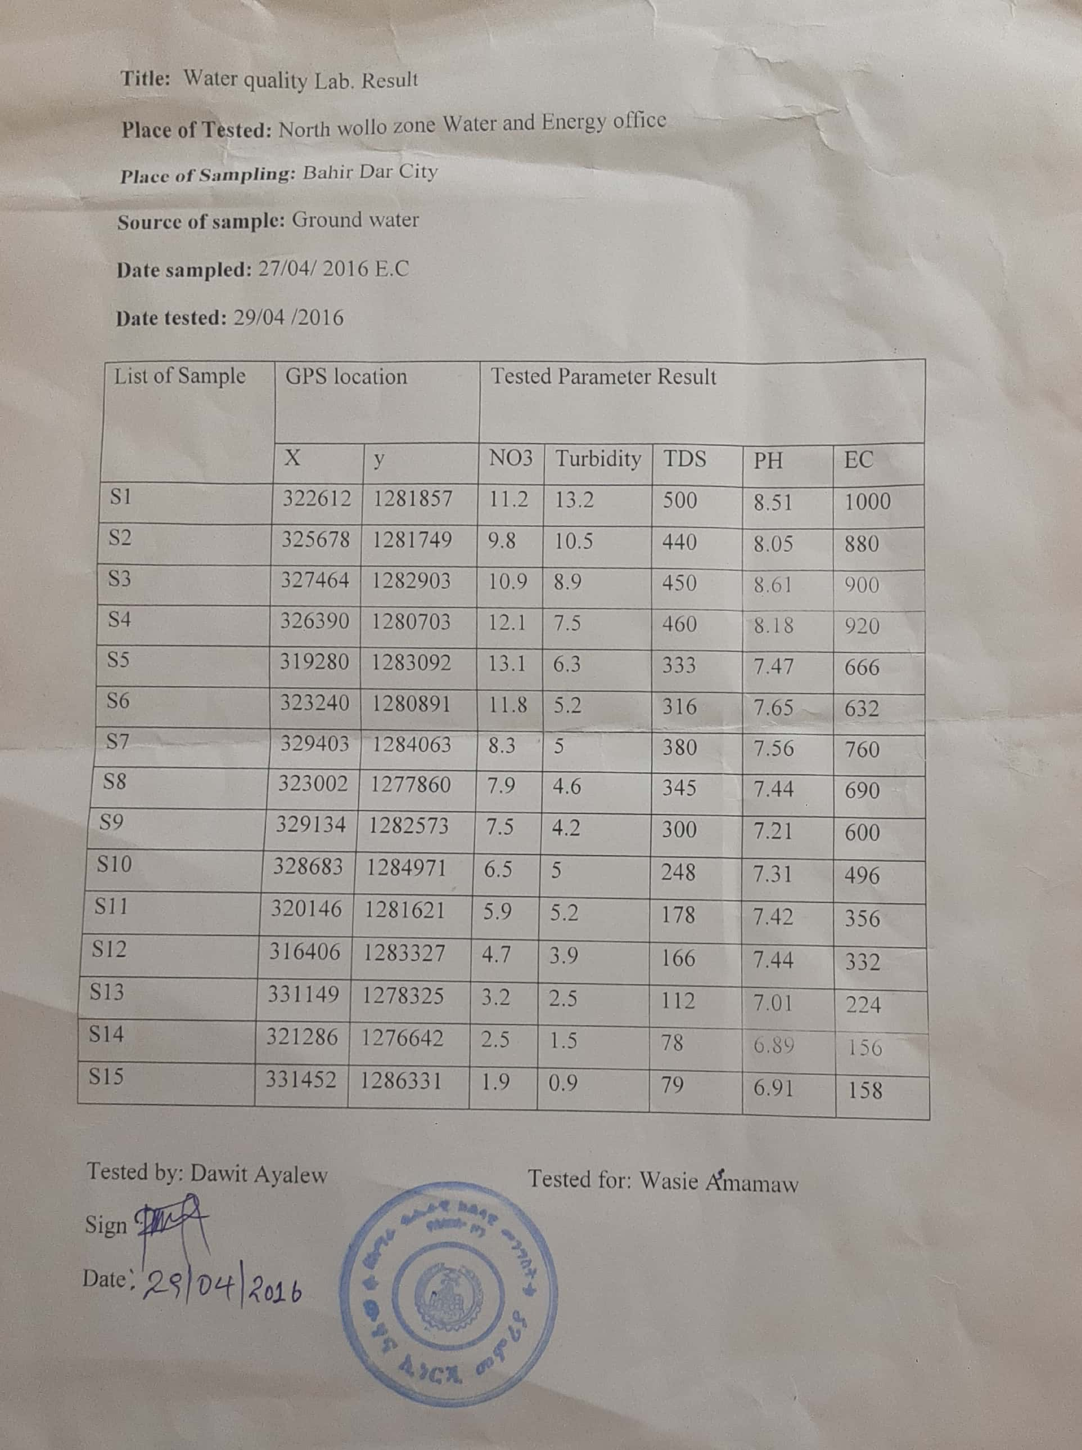

Appendix 4: Row Data used for SPSS Result
Id | Vulnerability | NO3 | TDS | Turbidity | Id | Vulnerability | NO3 | TDS | Turbidity
1 | 168 | 7 | 257.9 | 4.8 | 28 | 199 | 7.2 | 238.2 | 5.2
2 | 159 | 7.7 | 289.9 | 5.3 | 29 | 196 | 8.3 | 261.1 | 5.7
3 | 158 | 5.8 | 209.9 | 4 | 30 | 191 | 6.5 | 200.5 | 5.5
4 | 180 | 6.2 | 230 | 4.2 | 31 | 220 | 10.9 | 403.7 | 9.3
5 | 158 | 7.6 | 291.4 | 5.3 | 32 | 220 | 10.4 | 398.7 | 8.3
6 | 163 | 4.4 | 154 | 2.9 | 33 | 232 | 11 | 431.1 | 7.7
7 | 165 | 5.2 | 195.7 | 3.4 | 34 | 184 | 8.3 | 334.4 | 5.7
8 | 178 | 7.9 | 307.6 | 5.3 | 35 | 183 | 7.1 | 287.1 | 5
9 | 163 | 6.8 | 266.1 | 5 | 36 | 178 | 7.2 | 242.4 | 5.2
10 | 138 | 5.5 | 211.3 | 4.1 | 37 | 178 | 5.5 | 188.8 | 4.3
11 | 149 | 6.1 | 238.1 | 4.5 | 38 | 191 | 8.9 | 261.9 | 5.5
12 | 170 | 5.9 | 210.8 | 4.1 | 39 | 203 | 10.3 | 293 | 6.3
13 | 197 | 7.6 | 317.4 | 4.6 | 40 | 217 | 10.5 | 415 | 10
14 | 217 | 8.6 | 336.1 | 5.7 | 41 | 224 | 10.4 | 428.8 | 8.4
15 | 170 | 8.8 | 344.6 | 6.3 | 42 | 196 | 7.6 | 306.4 | 4.4
16 | 148 | 6.5 | 252.7 | 4.8 | 43 | 208 | 7.4 | 304.7 | 5
17 | 120 | 3.6 | 128 | 2.7 | 44 | 178 | 6.1 | 207.1 | 4.6
18 | 164 | 5.7 | 222.2 | 4.2 | 45 | 193 | 8.6 | 261.7 | 5.5
19 | 185 | 7.8 | 261.8 | 5.5 | 46 | 206 | 8.7 | 354.5 | 6.7
20 | 178 | 8 | 274.2 | 5.9 | 47 | 207 | 7.7 | 334.6 | 5.1
21 | 205 | 9.3 | 330.1 | 6.2 | 48 | 190 | 6.1 | 254.8 | 4.1
22 | 230 | 9.9 | 369.5 | 6.9 | 49 | 178 | 7.6 | 254.2 | 5.5
23 | 226 | 10.3 | 400.1 | 7.2 | 50 | 193 | 8.6 | 280.5 | 5.9
24 | 183 | 7.6 | 299.1 | 5.4 | 51 | 195 | 6.7 | 271.4 | 4.8
25 | 118 | 4.8 | 183.2 | 3.6 | 52 | 173 | 2 | 81.5 | 0.9
26 | 156 | 6.1 | 240.5 | 4.4 | 53 | 181 | 4.2 | 169.2 | 2.7
27 | 187 | 7.5 | 253.5 | 5.4

Appendix 5: SPSS Result for Pearson Correlations to Validate Groundwater Vulnerability
 |  | Vulnerability | Nitrate | TDS | Turbidity
Pearson Correlation | Vulnerability | 1.000 | .743 | .651 | .716
Pearson Correlation | Nitrate | .743 | 1.000 | .785 | .770
Pearson Correlation | TDS | .651 | .785 | 1.000 | .885
Pearson Correlation | Turbidity | .716 | .770 | .885 | 1.000
Sig. (1-tailed) | Vulnerability | . | .000 | .000 | .000
Sig. (1-tailed) | Nitrate | .000 | . | .000 | .000
Sig. (1-tailed) | TDS | .000 | .000 | . | .000
Sig. (1-tailed) | Turbidity | .000 | .000 | .000 | .
N | Vulnerability | 53 | 53 | 53 | 53
N | Nitrate | 53 | 53 | 53 | 53
N | TDS | 53 | 53 | 53 | 53
N | Turbidity | 53 | 53 | 53 | 53

