
BAHIRDAR UNIVERSITY
COLLEGE OF AGRICULTURE AND ENVIRONMENTAL SCIENCES
DEPARTMENT OF NATURAL RESOURCE MANAGEMENT
MSc PROGRAM
EVALUATING THE PERFORMANCES OF GRIDDED REANALYSIS PRODUCTS IN REPRESENTING THE TEMPERATURE CLIMATOLOGY OF ETHIOPIA
MSc THESIS
BY
TAZEBEW ABERA TADESSE

JULY, 2024
BAHIR DAR, ETHIOPIA

BAHIRDAR UNIVERSITY
COLLEGE OF AGRICULTURE AND ENVIRONMENTAL SCIENCES
DEPARTMENT OF NATURAL RESOURCE MANAGEMENT

Evaluating the performances of gridded reanalysis products in representing the temperature climatology of Ethiopia

M. Sc. Thesis
By
Tazebew Abera Tadesse

A Thesis Submitted in Partial Fulfillment of the Requirements for the Degree of Master of Science (MSc) in “Environment and Climate Change”

Advisor: Temesgen Gashaw (Ph.D.)

July, 2024
Bahir Dar, Ethiopia
©2024TazebewAbera


ACKNOWLEDGMENTS
First and foremost, I would thank Almighty God, for the source of all success and his endless support in my life. I would like to express my truthful gratitude to my advisor Dr. Temesgen Gashaw, for his valuable, constructive guidance; support, and encouragement undertake this research and devoted a lot of his time to correcting, guiding, and shaping ideas from the title selection up to the final stage of this thesis.
I am also glad to acknowledge Dr. Achenafi Tigabu, lecturer and researcher at Debre Tabor University, and Mr. Mulualem Getahun, lecturer and researcher at Bahir Dar University for their constructive suggestions corrections, shaping ideas and other supports while doing my thesis.
My sincerely thanks go to Bahir Dar University for giving me free sponsorship opportunity to attend my master’s degree program. I would also like to express my profound gratitude to the College of Agriculture and Environmental Sciences of Bahir Dar University for their kind attention throughout my studies.
My gratefully thank to the Ethiopian Meteorological Institute for supply long-term station temperature data. I'm also grateful to the developers of the MERRA v2.0 and ERA5 datasets for making the information available without charge.
I would express great pleasure from my heart to my lovely wife and family for their moral and financial support in strengthening my academic level and executing this thesis. Then after all, my deepest thanks are forward to my classmates, Endeg Aniley and Alehegn Belay for their unreserved knowledge sharing from the starting up to the accomplishment of this thesis. Finally, I want to thank my all teachers and classmates who showed me love and support from the first day of class up to the final thesis submission.

DEDICATION
This thesis is dedicated to my lovely family for their concern, prayer, and unwavering support and encouragement throughout my whole academic career and life.

LIST OF ABBREVIATIONS AND ACRONYMS
AEZs Agro-Ecological Zones
CHIRTS v2.0 Climate Hazard group Infrared Temperature with Stations version 2.0
CPC Climate Prediction Center
CRU TS Climatic Research Unit Time Series
CRU Climate Research Unit
EARA-Interim Intermediate ECMWF Reanalysis product
ECMWF European Center for Medium-Range Weather Forecast
ERA5 Fifth Generation ECMFW Reanalysis
FAO Food and Agriculture Organization
FMAM February- March-April- May
GHCN-D Global Historical Climatology Network Daily
GTS Global Telecommunication System
GPCC Global Precipitation Climatology Center
GPCP Global Precipitation Climatology Project
IDW Inverse Distance Weighting
JJAS June-July-August- September
JRA55 Japanese 55-Year Reanalysis
KGE Kling Gupta Efficiency
m.a.s.l Meter above Sea Level
MAE Mean Absolute Error
MERRA Modern-Era Retrospective Analysis for Research and Application
MICE Multivariate Imputation by Chained Equations
NASA National Aeronautics and Space Administration
NMA National Meteorological Agency
List of abbreviations and acronyms (Continued)
NCEP v1.0 National Centers for Environmental Prediction version 1.0
NCEP v2.0 National Centers for Environmental Prediction version 2.0
NSE Nash Sutcliffe Efficiency
ONDJ October-November-December-January
PBIAS Percent Bias
r Pearson correlation coefficient
R² Coefficient of determination
RMSE Root mean square error
WMO World Meteorological organization

TABLE OF CONTENTS
Contents Pages
APPROVAL SHEET I
DECLARATION II
ACKNOWLEDGMENTS III
DEDICATION IV
LIST OF ABBREVIATIONS AND ACRONYMS V
TABLE OF CONTENTS VII
LIST OF TABLES IX
LIST OF FIGURES X
LIST OF APPENDICES XI
ABSTRACT XII
CHAPTER 1: INTRODUCTION 1
1.1 Background and Justification 1
1.2 Statement of the problem 2
1.3 Objective of the study 4
1.3.1 General objective 4
1.3.2 Specific objectives 4
1.4 Organizations of the study 5
1.5 Significance of the study 5
1.6 Scope of the study 5
1.7 Limitation of the study 5
CHAPTER 2: REVIEW OF RELATED LITERATURE 6
2.1 An overview of gridded temperature products 6
2.2 Characteristics of gauge based and global reanalysis temperature products 6
2.2.1 Gauge-based temperature estimates 6
2.2.2 Reanalysis based temperature estimates 7
2.3 Performance evaluation using continuous statistical metrics 8
2.4 Performance evaluation techniques of reanalysis temperature products 10
2.5 Previous findings on the performances of ERA5 and MERRA v2.0 products 11
Table of contents (Continued)
2.6 Traditional agro-climatic zones of Ethiopia 12
CHAPTER 3: MATERIALS AND METHODS 14
3.1 Description of the study area 14
3.1.1 Location 14
3.1.2 Topography 14
3.1.3 Traditional Agro ecology Zone 15
3.1.4 Climate 15
3.2 Data types, sources and processing 16
3.2.1 Ground -Based (Observed) Temperature data 16
3.3 Evaluation Approaches 18
3.4 Evaluation Methods 21
CHAPTER 4: RESULTS AND DISCUSSIONS 24
4.1 Performances of reanalysis temperature products 24
4.1.1 Performance of reanalysis maximum temperature products at daily time step 24
4.1.2 Performance of reanalysis minimum temperature products at daily time step 26
4.1.3 Performance of reanalysis maximum temperature products at monthly time step 27
4.1.4 Performance of reanalysis minimum temperature products at monthly time step 33
4.1.5 Performance of reanalysis maximum temperature products at seasonal time step 38
4.1.6 Performance of reanalysis minimum temperature products at seasonal time step 40
4.1.7 Performance reanalysis of maximum temperature products at annual time step 42
4.1.8 Performance reanalysis of minimum temperature products at annual time step 45
CHAPTER 5: CONCLUSION AND RECOMMENDATIONS 49
5.1 Conclusion 49
5.2 Recommendations 50
REFERENCES 51
APPENDICES 61
AUTHOR’S BIOGRAPHY 63

LIST OF TABLES

Tables Pages
Table 2.1 Summary characteristics of reanalysis temperature products 8
Table 2.2 Summery of previous findings on the performances of ERA5 and MERRA v2.0 11
Table 2.3 Classifications of traditional agro-climatic zones of Ethiopia. 13
Table 3.1 Summary of ERA5 and MERRA v2.0 reanalysis datasets 18
Table 3.2 Summery of soft wares used in this study 21
Table 3.3 Summery of the considered performance statistical measures used in this study 23
Table 4.1 Performances of ERA5 and MERRA v2.0 daily maximum temperature over five AEZs of Ethiopia from 1990-2020 25
Table 4.2 Performances of ERA5 and MERRA v2.0 daily minimum temperature over five AEZs of Ethiopia from 1990-2020 27
Table 4.3 Continuous metrics result of seasonal maximum temperature of ERA5 and MERRA v2.0 with observed over AEZs of Ethiopia from 1990-2020 40
Table 4.4 Continuous metrics result of seasonal minimum temperature of ERA5 and MERRA v2.0 with observed over AEZs of Ethiopia from 1990-2020. 41
Table 4.5 Performance of ERA5 and MERRA v2.0 annual maximum temperature over five AEZs of Ethiopia from 1990-2020. 43
Table 4.6 Performances of ERA5 and MERRA v2.0 annual minimum temperature over five AEZs of Ethiopia from 1990-2020. 46

LIST OF FIGURES

Figures Pages
Figure 3.1 Location of the study area 14
Figure 3.2 Long-term observed annual average rainfall and temperature (1990-2020) values over five AEZs of Ethiopia. 15
Figure 3.3 Schematic diagrams showing the methodological flows of this study. 20
Figure 4.1 Scatter plot of monthly maximum temperature of observed data against ERA5 and MERRA v2.0 over AEZs of Ethiopia from 1990-2020 periods. 29
Figure 4.2 Line graph representation of average monthly observed maximum temperature with ERA5 and MERRA v2.0 temperature over AEZs of Ethiopia during 1990-2020. 32
Figure 4.3 Scatter plot of monthly minimum temperature of observed data against ERA5 and MERRA v2.0 over AEZs of Ethiopia from 1990-2020 periods. 34
Figure 4.4 Line graph representation of average monthly observed minimum temperature with ERA5 and MERRA v2.0 tempereture over AEZs of Ethiopia during 1990-2020. 37
Figure 4.5 Line graph representation of annual maximum observed temperature with ERA5 and MERRA v2.0 over AEZs of Ethiopia from 1990-2020 44
Figure 4.6 Line graph representation of annual minimum observed temperature with ERA5 and MERRA v2.0 over AEZs of Ethiopia from 1990-2020. 47

LIST OF APPENDICES

Appendices Page
Appendix 1: Description of studied meteorological stations over traditional AEZs of Ethiopia 61

ABSTRACT
The reanalysis temperature products are commonly used for studying climate changes from short to long-term scales at regional and global levels, but yet not in most developing countries. This study was conducted in the Horn of Africa region, particularly in Ethiopia, from 1990-2020. To evaluate the performances of the two global reanalysis temperature products, the study compared temperature products with 37 stations of ground-based observed data. This study used five statistical error metrics, namely Mean Absolute Error (MAE), Root Mean Square Error (RMSE), Percent Bias (PBIAS), Correlation Coefficient (r), and Kling Gupta Efficiency (KGE). Moreover, scatter plots and line graphs were used to evaluate the model performances. For filling the missing values of daily temperature data, Multivariate Imputation by Chained Equations (MICE) technique was used, and a point-to-pixel evaluation approach was employed. The study indicated MERRA v2.0 has better performances for simulating maximum and minimum temperatures at monthly, seasonal, and annual temporal scales, and ERA5 shows better performances at daily time steps over most agro-ecological zones by the majority of evaluation scores. Moreover, MERRA v2.0 exhibited the lowest PBIAS values at monthly, seasonal (Kiremt), and annual time scales over most agro-ecological zones. In general, MERRA v2.0 performs better than ERA5 over most agro-ecological zones by most evaluation metrics. Therefore, this study recommends MERRA v2.0 reanalysis dataset for estimating temperature in areas where observed meteorological data are scarce for monthly, seasonal and annual scale of the country.
Keywords: Agro-ecological zones, Temperature products, Statistical continuous metrics

CHAPTER 1: INTRODUCTION

1.1 Background and Justification
Temperature is one of the most important climatic elements and hence, the accurate climate information particularly temperature data is serve as the main input for hydro climate models (Gashaw et al., 2023). A ground based meteorological station is considered to be most reliable temperature data source. But, still climate data scarcity associated with sparsely and unevenly distributed meteorological networks is common problems in developing countries (Vega-Durán et al., 2021; Shen et al., 2022). Hence, the reanalysis temperature products are the main alternative data sources especially in data scarce areas (Arshad et al., 2021; Gashaw et al., 2023). Therefore, appropriate knowledge on the performances of climate reanalysis datasets in various Agro ecological Zones (AEZs) is a determining factor in quantifying and significantly managing the water resources available for different purposes, predicting future climate conditions, and planning actions to control or minimize the adverse impacts of climate change (Tarek et al., 2020; Vega-Durán et al., 2021).
The accuracy and reliability of any hydro climate study, related to climate change impact assessment, focused heavily on the accessibility of better quality atmospheric reanalysis estimates are important for analyzing extreme weather and climate events (Derin & Yilmaz, 2014; Hu & Franzke, 2020). Less dense observed gauge data are unable to represent climate variability in the tropical zone (Bhattacharya et al., 2020). In East Africa, the scarcity of good quality and continuous climate data is a challenge that hydro climate researchers have mostly faced (Dinku et al., 2011). Estimations from reanalysis datasets are low‐cost alternatives to overcome areas with absence of data, and which have advantages and limitations. The principal advantage is its extensive spatial coverage and temporal resolution. On the other hand, reanalysis data combine multiple sources to generate constant data assimilation schemes and models that produce consistent time series of numerous essential climate variables at once (Bojanowski et al., 2014). But the previous literatures justified no clear consensus on the usability of the reanalysis datasets as their accuracy varies depending on specific products, location, and variables under analysis (Yang & Zhang, 2018,Tarek et al., 2020a; Birkel et al., 2022). The continuous observations of any essential climate variables such as meteorological and ground temperature measurements in various AEZs of Ethiopia have been lacking until recently.
In Ethiopia, gridded products from reanalysis estimations dominate studies dealing with indirect temperature and rainfall measurements. For instance, the European Centre for Medium-Range Weather Forecasts (i.e., ECMWF ERA5), Climate Hazards Group Infra-Red Precipitation with Stations (CHIRPS) and Climate Hazards Group Infra-Red Temperature with Station (CHIRTS) datasets has been employed to evaluate temperature and rainfall patterns in different Ethiopian watershed levels (Gebremicael et al., 2019; Reda et al., 2021; Mewded et al., 2022). But the reanalysis temperature products remain relatively unexplored in studies related to agro ecological zones of Ethiopia.
A commonly used alternative to observed temperature data is mathematically generated weather data, such as MERRA v2.0 and ERA5 were chosen for further research because it is freely available and readily accessible as well as it performed well in regional comparison studies (Vega-Durán et al., 2021; Birkel et al., 2022; Huang et al., 2022). So, to determine the impacts of global climate change on the tropical AEZ and to assess the potential socio-economic consequences, monitoring of essential climate and environmental variables at different AEZs is fundamental (May et al., 2008; Redfearn et al., 2005). Therefore, this paper evaluated the performance of MERRA v2.0 and ERA5 reanalysis temperature products in various AEZs of Ethiopia. The choice of datasets was based on other authors have significantly used this reanalysis products in performance evaluations of indirect climate variability (Chawla & Mujumdar, 2020; S. Sun et al., 2020; Vega-Durán et al., 2021). In addition to this, it is freely available and readily accessible as well as it has performed well in regional comparison studies (Birkel et al., 2022; Huang et al., 2022). This paper will be highlighted the importance of considering limitations and uncertainties associated with reanalysis based temperature estimation as well as identifying better accuracy reanalysis temperature products in different AEZs for climate modeling and related applications.

1.2 Statement of the problem
Uneven distributions and lack of meteorological stations are fundamental problems in developing countries and which are very much serious in Eastern Africa. Countries with poor ground observations are highly vulnerable to climate threats (Gebrechorkos et al., 2018). Ethiopia is found in the horn of Africa, which have various agro ecological zones that help for the presence of rich in natural and man-made resources. Besides it serves as the water tower area in eastern Africa throughout the year. However, Ethiopia is one of the most vulnerable countries to the impacts of climate change, due to low level of using alternative source of datasets and low experiences in predicting increased severity of droughts, floods, and extreme weather events (Parsons et al., 2022).
The presence of poor meteorological infrastructures in developing countries is considered as the major limiting factors for hydro-climate studies which justified as many regions lacking relevant local climate information (Gashaw et al., 2023; Parsons et al., 2022). In addition to this in estimating temperature in different AEZs is influenced by various factors, including spatial and temporal variability, data assimilation techniques, uncertainties, and validation (Demessie et al., 2023). To overcome this data challenge, many studies advised that a combination of accessible data sources based on station data, remotely sensed data and regional climate models should be used. The freely available and readily accessible of global reanalysis based climate datasets are important as alternative sources in data scarce areas (Van Wynsberge et al., 2020). Moreover, evaluations of multiple climate data sources are crucial for understanding impacts of climate change and managing environmental resources in East Africa (Gebrechorkos et al., 2018). Therefore, the purpose these study to simulate the long term temperature data by using the updated version of ERA5 and MERRA v2.0 reanalysis temperature products. Hence, the majority of previous studies in Ethiopia were focused on the performance evaluations of reanalysis rainfall products than temperature products.
Previous studies on the evaluations of temperature products in Ethiopia were focused on small-scale areas coverage (watersheds, sub-basins, basins) of the country. Alaminie et al. (2021) carried out evaluations of ERA5 and MERRA v2.0 in the Upper Blue Nile using area-average. Gashaw et al. (2023) were also studied on the evaluations of satellite/reanalysis rainfall and temperature products in the Bale Eco Region (Southern Ethiopia). Moreover, Reda et al.(2021) were evaluated the gridded temperature datasets against observed data over the Upper Tekeze River Basin, of Ethiopia. However, performance of reanalysis climate products depend on topography, season and climate (Dinku et al., 2007; Dinku et al., 2018) and it can vary from one region to another in mountainous countries like Ethiopia. So, this study intended to evaluate the performances of ERA5 and MERRA v2.0 over five AEZs of Ethiopia for estimating temperature products from daily to annual temporal scales during 1990-2020 periods with 37 meteorological stations data. The reasons for this study were used ERA5 and MERRA v2.0 products with the time bounds from 1990-2020 periods are: Firstly. previous studies carried out in Ethiopia and outside were indicated MERRA v2.0 has superior performance compared to other products, but still it has simulation problems from observed temperature data (Bhattacharya et al., 2020; Alaminie et al., 2021; Malede et al., 2022; Gashaw et al.,2023). Secondly, ERA5 is a latest reanalysis product version and many authors were used this products than its earlier versions (ERA5-Land and ERA-Interim) and other reanalysis product for performance evaluations. Lastly, this study was used stations data collected from 1990 up to 2020 periods because between these periods no disputes in all considered station sites of the study area. Hence, reasonable performance evaluating of the reanalysis datasets using recent, reliable and high resolution climate data against ground gauge data are critically important for estimating climate variability as well as understanding and predicting the impacts of climate change in Ethiopia. Moreover, this study will give insight to use appropriate sources of temperature products for further researchers in estimating temperature at different AEZs of data scarce areas. Previously, the reanalysis temperature products performance of evaluation studies conducted in Ethiopia are mainly limited to a specific AEZs, watershed and sub basins, making it difficult to have insights at the national level. Therefore, this study was carried out to fill this gap.

1.3 Objective of the study

1.3.1 General objective
The general objective of the study was to evaluate the performances of gridded reanalysis prod-cuts in representing the temperature climatology of Ethiopia at different AEZs from daily to annual temporal scales.

1.3.2 Specific objectives
- To evaluate the performance of reanalysis products for simulating maximum temperature over each AEZs of Ethiopia from daily to annual time scales.
- To evaluate the performance of reanalysis products for simulating minimum temperature over each AEZs of Ethiopia from daily to annual time scales.

1.4 Organizations of the study
This thesis has been organized into five chapters. The first chapter presents the introduction part of the paper mainly, deals with background of the study, statement of the problem, and objectives of the thesis, the second chapter was covered a review works of related literature, the third chapter methodological issues including the description study area, and the fourth chapter includes results, and discussions, finally chapter five were drawn conclusion and recommendation.

1.5 Significance of the study
As Ethiopia, having poor and uneven distribution of meteorological station countries identifying the best performed alternative climate datasets are important for the present and future aspects. Therefore, this study will provide useful information for all concerned bodies to fill the data gap problem when temperature data is needed for further studies and decision-making process. The finding will also help to identify errors, biases, and inconsistencies in reanalysis temperature data by comparing its outputs with observed data that may important for researchers to used better reanalysis temperature datasets for further studies. In addition, this study is valuable for the ERA5 and MERRA v2.0 products developers or institutions to determine if model improvement or corrections are needed to enhance the overall accuracy and reliability of datasets.

1.6 Scope of the study
Although many authors were carried out their studies on watersheds, basins and sub basins level to evaluate the performance reanalysis temperature product. The scope of this study was spatially covering all traditional AEZs, in case of Ethiopia using 37 reference gauge stations data. Temporary the study was focused the performance evaluations of the two studied products during 1990-2020 periods using five considered validation scores from daily to annual temporal scales.

1.7 Limitation of the study
The researcher has used only 37 stations data. This is due to the presence of small number of stations and uneven distribution of gauges as well as all considered AEZs have not equal number of stations. For instance, bereha/desert and wurch/alpine AEZs were only represented by one station each. Therefore, there may be some inconsistences between the gauged stations and the reanalysis products over bereha/desert and wurch/alpine AEZs.

CHAPTER 2: REVIEW OF RELATED LITERATURE

2.1 An overview of gridded temperature products
Gridded reanalysis temperature products are essential tools in climate research, providing detailed information on historical temperature patterns across large spatial areas. Most gridded temperature products with varying temporal and spatial resolutions have been generated and are freely available at global and regional scale (Zhang et al., 2021). Gridded temperature products are derived from various sources such as ground-based observations, satellite remote sensing data, or reanalysis models that assimilate various observational inputs to generate consistent climate fields. These products are often available at high spatial resolutions, allowing researchers to analyze temperature variations at fine scales.
Some commonly used gridded reanalysis temperature products are ERA5 (fifth-generation European Centre for Medium-Range Weather Forecasts Reanalysis), MERRA-2v.0 (Modern-Era Retrospective Analysis for Research and Applications), and CRU TS (Climatic Research Unit Time Series). These datasets provide comprehensive information on past temperatures globally or regionally and widely utilized in climate studies due to their reliability and consistency.

2.2 Characteristics of gauge based and global reanalysis temperature products

2.2.1 Gauge-based temperature estimates
Gauge-based temperature estimates refer to temperature data collected from weather stations equipped with various types of thermometers, including mercury, alcohol, digital, and bimetallic thermometers and all these thermometers have their own strengths and weaknesses. These stations are distributed globally and play a crucial role in providing valuable information about temperature variations (Alexander et al., 2006). The data are collected at specific locations and transmitted to central databases at regular intervals (such as hourly or daily).
Gauge-based temperature is collected by national weather services. For climate research and other applications, it is necessary to organize all of the data from different countries in to one integrated global dataset. The World Meteorological organization (WMO), which is established in 1873, is an intergovernmental organization with 191 member states and territories (http://www.wmo.int). The WMO facilitates the development of observation networks for fields of climatology, hydrology, and physics as well as the exchange, processing, and standardization of related data. The WMO Global Telecommunication System (GTS) is a complex worldwide communication system for the exchange of meteorological data that forms the basis for many applications (Sun et al., 2021).
Due to the irregular distribution of gauge stations, gridding of data is required for many climate and related applications. The Gridded climate datasets based fully on gauge information have been constructed and in wide used. The climate research unit (CRU) dataset comprises a suit of climate variables. The main sources used for construction of the CRU monthly precipitation and temperature datasets were obtained through the help of the national meteorological agencies (NMAs), the WMO, the international Tropical Agriculture Center, the Food and Agriculture Organization (FAO), and others ( Sun et al., 2018).
Global Historical Climatology Network-Daily (GHCN-D) is contains daily weather-station-based measurements of meteorological variables from over 90,000 stations worldwide The majority of station records contain precipitation data only, however other key variables including maximum temperature, minimum temperature, snowfall, cloudiness, wind speed and snow depth are available at many locations (Alexander et al., 2006)

2.2.2 Reanalysis based temperature estimates
A reanalysis temperature estimation system combines sporadic observations and various models to create a synthetic assessment of the system's state on a consistent grid, ensuring spatial uniformity, temporal continuity, and a multi-dimensional structure. Important climate variables derived from reanalysis systems are internally consistent and can be obtained promptly. This system comprises a background forecast model and a data assimilation process (Parsons et al., 2022).
The reanalysis climate product has recently become an alternative source to data scarce areas and hence, it played as significant role for broader application (Aniley et al., 2023). In the reanalysis based temperature estimates has important significant in understanding the historical weather and climate conditions (Gashaw et al., 2023; Aniley et al., 2023). Therefore, many reanalysis climate data source have been developed to provide comprehensive temperature estimates.

Table 2.1 Summary characteristics of reanalysis temperature products
Datasets | Spatial  resolution | Temporal resolution | Coverage |  | Data available | Sources | References
NCEP1 | 2.5º×2.5º | 6h/daily/monthly |  | Global | 1948-present | NCEP/NCAR | Woldema et al. (2017)
NCEP2 | 1.875º×1.875º | 6h/monthly | Global |  | 1979-present | NCEP/DOE | Kanamitsu et al. (2002)
ERA-Interim | 0.75º×0.75º | 6h/monthly | Global |  | 1979-present | ECMWF | Zhu et al.(2017)
MERRA | 0.5º×0.67º | Daily | Global |  | 1979-present | NASA | Mason et al. (2015)
MERRA-v2 | 0.5º×0.625º | Hourly/Daily | Global- |  | 1980-present | NASA |  | Huang et al. (2022)
ERA5 | 0.25º×0.25º | Daily/hourly | Global |  | 1950-present | ECMWF | Meng et al. (2018)

2.3 Performance evaluation using continuous statistical metrics
There are many continuous statistical measures to evaluate the performance and quality of the reanalysis atmospheric datasets (Arshad et al., 2021; Reda et al., 2021). Most continuous statistical measures commonly employed by many authors are: Root mean square error (RMSE), Mean error (ME), Mean absolute error (MAE), Pearson correlation coefficient (r) and Coefficient of determination (R2),Kling-Gupta Efficiency (KGE), Nash-Sutcliffe Efficiency (NSE), Percent bias (PBIAS) and Mean square error (MSE). Such statistical measures used to evaluation the performances from daily to annually timescales for all the selected gauge stations. Mean absolute error (MAE), is a metric used to measure the average magnitude of the absolute errors between the reanalysis products and the measured values. It is suitable to describe uniformly distributed errors (Derin & Yilmaz, 2014). The MAE is often called the mean absolute deviation (MAD) (Kravtsov & Spannagle, 2008). Its has range from 0 to +∞. The smaller the value is, the higher the accuracy of the reanalysis dataset. The advantage of MAE is easy to calculate and understand as well as its units same as original data. Root mean square error (RMSE) is a continuous statistical measure typically used in geoscience to compare modeled data with measured data. In this study it measures the average magnitude of error between the reanalysis products and the measured values. It is more appropriate if the errors are normally distributed (Chai & Draxler, 2014). The RMSE measures estimation errors around the best fitting line and its values near zero would be a better fit to the data (Mewded et al., 2022). The range of RMSE from 0 to +∞. The smaller the value is, closer the reanalysis dataset estimates are to the ground measurements (Gebremicael et al., 2019; Jierula et al., 2021).
Percent bias (PBIAS) can detects the performance of reamalysis atmospheric products (Mewded et al., 2022). In addition to this it is a measure of the average tendency of modeled values to be larger or smaller than measured values. Negative or positive Pbias indicate underestimation (overestimation) values respectively (Alemseged & Tom, 2015). Zero bias indicates absence of systematic error where as the lower the Pbias values indicates the reamalysis products are closer to the observed measurements.
The r and R2 describe the degree of collinearity between reanalysis climate products and observed data. The correlation coefficient, which ranges from -1 to 1, is an index of the degree of linear relationship between observed and simulated (observed) data. If r= 0, no correlation between observed and simulated data. If r=1 or -1, a perfect positive or negative relationship exists between the observed and simulated data set. The R2 is the proportion of the variance in measured data explained by the model. The value of R2 ranges from 0 to 1, with a higher value indicating less error variance, and typically values greater than 0.5 are considered acceptable (Kvålseth, 1985). The correlation coefficient (r) is widely used for the evaluation of the goodness of linear fit of regression models in (Kvålseth, 1985). r refer to the Pearson correlation coefficient and it is a commonly used correlation coefficients in statistics. r indicates the strength of the relationship between two variables; its value ranges between -1 and 1. If its values close to ± 1 indicate strong relationships.
The value of NSE is ranges from -∞ to 1. The NSE value of 0.0 to 1.0 are generally acceptable levels of performance, whereas NSE values less than or equal to 0.0 indicates that the mean observed value is a better predictor than the simulated value (Nash & Sutcliffe, 1970). Kling–Gupta efficiency (KGE) is a modified of the NSE metric which introduced by Gupta and modified by Kling. In this study the main objective function was used to evaluate simulation performance of temperature reanalysis datasets. The negative KGE values are viewed as bad model performance, and only positive values are seen as good model performance (Knoben et al., 2019). Certain studies state that KGE values < 0 indicates that the mean of observations provides better estimates than simulations and KGE values = 1 indicates perfect agreement between simulations and observations. These statistical measures are mainly used metrics for hydro-climatic dataset evaluation (Gebremicael et al., 2019).
Therefore, this study used five selected continuous statistical measures namely; correlation coefficient (r), percent bias (PBIAS), root-mean-square-error (RMSE), mean absolute error (MAE), and Kling-Gupta efficiency (KGE) were used for the evaluation of extreme temperature products. Such categorical evaluation statistical measures were carefully selected according to common usage, and recommendation in previous studies (Dinku et al., 2007).

2.4 Performance evaluation techniques of reanalysis temperature products
To compare temperature products with ground-based datasets, researchers commonly use three evaluation approaches such as pixel-to-pixel, point-to-pixel and point-to-point. Most studies employ the spatial interpolation (pixel-to-pixel) method known as kriging to estimate spatial climate data from gauge station networks (Viggiano et al., 2019; Tadesse et al., 2022). When extracting the areal average of temperature estimates over the pixel where the observation gauge is located, researchers perform point-to-pixel comparisons. In this approach, a study compares the gauge’s observed value with the nearest grid value from temperature products (Ageet et al., 2022). The proximity of the grid value is determined by calculating the minimum square distance between the gauge and the grid point.
Parsons et al. (2022) specifically used the point-to-point approach to evaluate temperature product performance in Nepal where the areas have well distributed gauge stations. For regions with complex topography and limited gauge stations, most studies recommend point-to-pixel comparisons instead of interpolating observed data for pixel-to-pixel comparison (Aniley et al., 2023; Gashaw et al., 2023). However, inconsistencies may arise due to differences in the locations of observed stations and grid data.

2.5 Previous findings on the performances of ERA5 and MERRA v2.0 products
As many literatures showed that different researchers used different number of stations, study time period, evaluation approach used as well as study area coverage and evaluation timescale. The studies by (Woldemariam Tesfaye et al., 2017; Zhu et al., 2017; Gashaw et al., 2023) the reanalysis temperature products have been evaluated and used as alternative source for different applications. For instance, in Ethiopia both ERA5 and MERRA v2.0 products extensively evaluated in different small-scale areas and as a national scale with observed data. Particularly, they were evaluated in Bale Eco-Region in Southern Ethiopia by (Gashaw et al., 2023). Literatures showed that MERRA v2.0 were the most outperformed product to estimate temperature over most considered temporal scales (Gashaw et al., 2023). Many authors used continuous statistical metrics such as r, RMSE, MAE, KGE and PBIAS for evaluation of temperature products from daily to annual timescales. The details of some previous findings on the performances of ERA5 and MERRA v2.0 temperature products are showed in table 2.2.
Table 2.2 Summery of previous findings on the performances of ERA5 and MERRA v2.0
Study areas | Periods | Comparison datasets | Performances | References
Bale Eco- Re-gion Southern Ethiopia | 1995-2014 | ERA5 and MERRA v2.0 with observed data | MERRA v2.0 is superior over ERA5 in most AEZs | Gashaw et al. (2023)
In Kerala, India | 1980–2019 | MERRA v2.0 with observed data | MERRA v2.0 showed maximum trend values in stations located in the northern part of the state. | Valappil et al. (2022)
Beas river basin of North-Western Himalaya | 1990 - 2009 | MERRA-2 ERA-Interim, JRA-55 and CFS with observed data | ERA-Interim product better represents in the basin. | Bhattacharya et al. (2020)
Central Asia | 2001–2018 | CHIRPS, CRU, ERA5-Land, IMERG-GPM, and MERRA2 against observed data | ERA5-Land and MERRA-2 has higher values than others datasets. | Zandler et al. (2020)
Tibetan Plateau | 1980–2014 | JRA-55, ERA-Interim, MERRA-2, CFSR, ERA5 and GLDAS2 | JRA-55 is the best among the eight downscaled datasets followed by ERA-Interim, MERRA-2, CFSR and others. | Zhang et al. (2021)
Pakistan | 1981–2019 | ERA-5, JRA-55, MERRA-2, and CFS-2 | ERA-5 performed well compared to JRA-55, MERRA-2, and CFS-2 with the values of r and RMSE. | Arshad et al. (2021)
Chinese Qilian Mountains | 1979 - 2017 | ERA5-Land with observed data | ERA5-Land generally reproduces the temperature trend very well for observations in summer season. | Zhao & He, (2022)

2.6 Traditional agro-climatic zones of Ethiopia
The traditional agro-climatic zones of Ethiopia hundred years before were kolla, woina dega and dega although there is no clear distinction of their boundary limits (MOA 1998). As population pressure increased and accordingly agricultural activities expanded, two additional zones at the higher and the lower temperature extremities were also recognized, namely, bereha and wurch respectively. Recent discipline oriented studies distinguished and defined these traditional zones by linking the related factors of altitude, rainfall, and temperature.
This classification system enables farmers to recognize broad vegetation types adapted to the environmental conditions and select crops and livestock best suited to the climate regimes and still highly implemented at the community level. These classification systems were scientifically supported by considering the relationship between elevation and temperature (ABABA 1998). In this regard, the contribution of NMA can be considered as supporting the traditional season classification system with scientific evidences.
Table 2.3 Classifications of traditional agro-ecological zones of Ethiopia.
Traditional Zones | Global Climate | Altitude (m) | Mean annual Tº (°C) | Mean annual RF (mm)
Wurch | Cold and moist | Above 3200 | Below 10°C | Above 2200
Dega | Cool and humid | 2300-3200 | 10°C - 15°C | 1200-2200
Woina dega | Cool sub-humid | 1500-2300 | 15°C -20°C | 800-1200
Kola | Warm semiarid | 500-1500 | 20°C -30°C | 200-800
Bereha | Hot arid | Below 500 | Above 30°C | Below 200
Source: MOA 1998

CHAPTER 3: MATERIALS AND METHODS

3.1 Description of the study area

3.1.1 Location
Ethiopia is situated in the Horn of Africa, which is found within tropical zone. The absolute location of Ethiopia lies between 3° to 15°N of latitudes and 33° to 48°E of longitudes (Fig 3.1). Ethiopia has neighboring with six countries namely Sudan on the west, South Sudan on the southwest, Kenya on the south, Eritrea and Djibouti on the northeast, Somalia on the east and southeast.
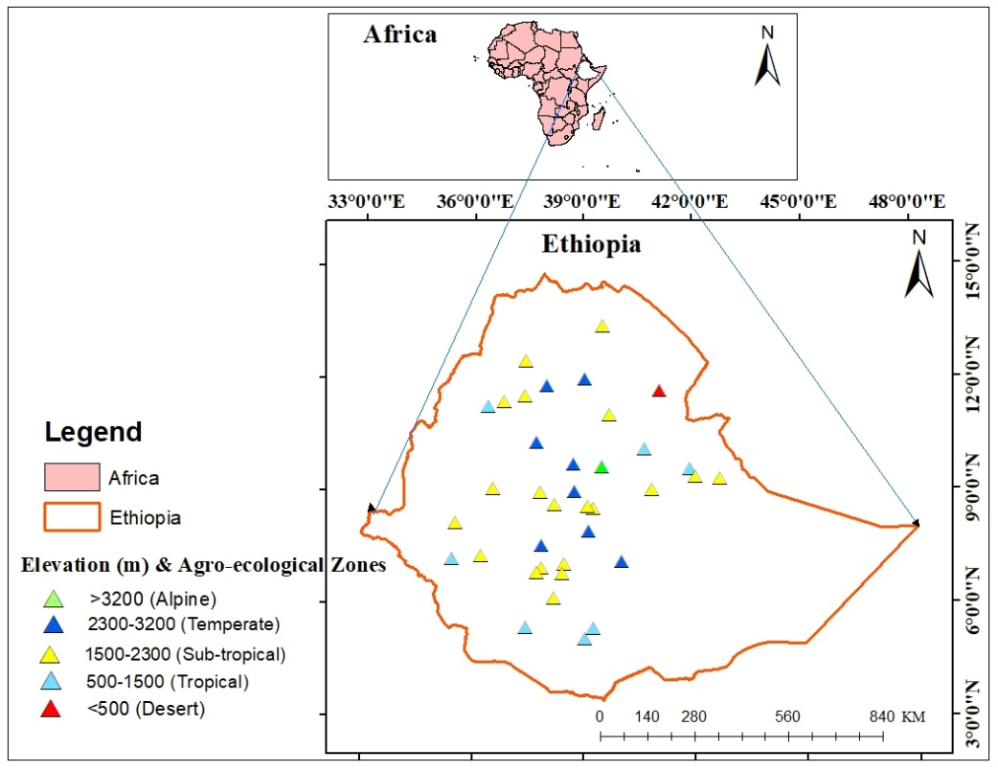
Figure 3.1 Location of the study area

3.1.2 Topography
Ethiopia’s topography is distinct with altitudes varying from 152 m.b.s.l at the Danakil depression in northeast part to 4620 m.a.s.l at the Ras Dejen in north part of the region (Tesfaye et al 2017; Wubaye et al., 2023). Ethiopia has undulating landforms such as craggy, high mountains, deep gorges, plains, rivers, and plateaus. About 40% of the country is covered by mountains and plateaus with elevation greater than 1500 m.a.s.l and is classified as highland. The remaining part of the area of less than 1500 m.a.s.l is classified as lowland (Degefu et al., 2022).

3.1.3 Traditional Agro ecology Zone
Based on the traditional classification of climate zones, Ethiopia is divided into five agro-ecological zones (Appendix.1) namely Wurch/Alpine (>3200 m a.s.l.), Dega/Temperate (2300-3200 m a.s.l.), Woina dega/Sub-tropical (1500-2300 m a.s.l.), Kolla/Tropical (500-1500 m a.s.l) and Bereha/Desert (<500 m.a.s.l) (MoA 1998). Therefore, understanding the agro-ecological zones is important in determining what types of crops and agricultural activities can be grown at different agro-ecological zones.

3.1.4 Climate
Due to topographic variations, Ethiopia experiences many local climatic conditions that range from hot deserts in the northeast and southern lowland to very cold mountain .ranges in the Semein and Arsi-Bale mountains systems (Degefu et al., 2022). The mean annual temperature varies from a low of 9ºC to a high of 37ºC (Gebremicael et al., 2017). Ethiopia has three main climate seasons per year such as Kiremt (main rainy season) Bega (dry season) and Belg (little rainy season) (Abebe & Kebede, 2017). Sub-Tropical Jet (STJ), Inter Tropical Convergence Zone (ITCZ), Red Sea Convergence Zone (RSCZ) and Tropical Easterly Jet (TEJ) are determines the spatiotemporal distributions of Ethiopia’s rainfall (Gebremichael et al., 2014). The long-term the mean annual rainfall of Ethiopia extends from 217 mm over the desert AEZ to 1251 mm over the sub-tropical AEZ, which are computed by taking the average values of stations found in the same AEZ (Aniley et al., 2023).

Figure 3.2 Long-term observed annual average rainfall and temperature (1990-2020) values over five AEZs of Ethiopia.
Source: (National Meteorological Agency of Ethiopia)

3.2 Data types, sources and processing

3.2.1 Ground -Based (Observed) Temperature data
This study used 37 ground based meteorological station daily data as referenced data for evaluating the performance of reanalysis temperature products in Ethiopia (Appendix.1). Therefore, all observed stations clustered into five agro ecological zones of Ethiopia (wurch/alpine, dega/temperate, woina dega/sub-tropical, kolla/tropical and bereha/desert) based on their altitude and temperature. The stations are located at altitudes varying from 3206 m.a.s.l up to 318 m a.s.l which coincides with alpine and desert AEZs respectively. The temperature data and altitude information for this study were taken from the National Metrological Agency (NMA) of Ethiopia covering the period of 31 years from 1990 to 2020.
The stations selection was made mainly to their data availability, location uniformity, and completeness of the series records (Nawaz et al., 2020). The daily temperature data for 1990 to 2020 from all ground observational stations of the study area were sorted into monthly, seasonal and annual time scales. From the total stations the highest (20) and the lowest (1) numbers of meteorological stations were found in sub-tropical, and both alpine and desert AEZs of Ethiopia respectively.
Metrological stations with missing values of data and lack of good quality of data will have bad implication on the process of analyses which leads to biased and unreasonable results of the analysis. The considerable preseasons for this, the stations of meteorological data are affected by various factors namely the location of stations, land-use changes, adjustments in instruments and data recorder problems (Acquaotta et al., 2016). There are different techniques such as Multivariate Imputation by Chained Equations (MICE), Inverse Distance Weighting (IDW) and Multiple Linear Regressions (MLR) for filling the missing values of daily temperature data series through estimating the unknown amount for a point from the known data from adjacent stations ( Paulhus & Kohler, 1952). This study used Multivariate Imputation by Chained Equations (MICE) algorithm accessed in R software packages for filling missing values of daily temperature data because it computes by completes missing values at each station using the complete observed values of all examined stations as predictors (Ali Mohammed et al., 2022). It also produces several estimations for each weather stations data missing value by considering outliers in the calculations, as well as it provides standard errors (Jolani et al., 2015). Due to this, the MICE algorithm technique is better for completing missing data than other methods (Wubaye et al., 2023).
The stations daily data missing values are vary from 0.5% to 23.2% and hence, the values are less than 25% is reasonable to use in the data scarce regions such as Ethiopia (Gashaw et al., 2023). As a result the stations of all daily missing values during the study period were removed and replaced by values of adjacent stations (Shen et al., 2022; Zhao & He, 2022). Therefore, this missing value completing method (MICE) makes the data were significantly improved and used to evaluate performances of the reanalysis products as well as to analyze the daily, monthly, seasonal and annual average extreme temperatures.
3.2.2 Reanalysis Temperature Products
Reanalysis temperature products are important datasets for temperature estimates over areas with scarce meteorological stations (Zhao & He, 2022). International high resolution atmospheric reanalysis data from different datasets from 1990 - 2020 were collected and compared with observation data in this study (Table 3.2). The variables analyzed in this study are mean maximum and minimum temperatures. The two reanalysis datasets that evaluated the performances of temperature products were ERA5 and MERRA v2.0 against over gauged temperature data at different agro ecological zones of Ethiopia (Luo et al., 2022; Michler et al., 2021). Each product was pre-determined to have adequate spatial and temporal resolution. Such reanalysis datasets are described in detailed below:
ERA5 is the 5th generation climate based reanalysis dataset from the European Centre for Medium-Range Weather Forecasts (ECMWF) with 0.25° (~30) km spatial resolution and hourly/daily temporal resolution. This dataset covers the records from 1979 to present time. ERA5 provides hourly estimates of many atmospheric, land, and oceanic climate variables (Xu et al., 2022). The most notable improvement of the ERA5 dataset from its predecessor is the increased spatial and temporal resolution, which now provides data from sub-daily to monthly timescales (Sianturi et al., 2020; Tadesse et al., 2022).
This reanalysis incorporates new input variables, such as sea surface temperature, sea ice and aerosols mainly to make it appropriate for climate simulation. In addition to this ERA5 has relatively smaller errors than the previous version ERA-Interim when compared to measurement data and it has been widely used in hydro meteorological studies (Shen et al., 2022). It downloaded from https://www.ecmwf.int/en/forecasts/datasets/reanalysis-datasets/era5.
Modern-Era Retrospective analysis for Research and Applications, Version2 (MERRA v2.0) is the recent high-resolution global climate reanalysis data provided by NASA and which has varying temporal and spatial resolution depending on the variables. It has a horizontal spatial resolution 0.5º× 0.625º (longitude × latitude) and a temporal resolution of daily for surface data which downloaded from https://goldsmr4.gesdisc.eosdi.nasa.gov/data/MERRAv2.0 (Huang et al., 2022). The improvement of MERRA v2.0 compared to its predecessor version include the assimilation of aerosol observations a great accurate representation of stratosphere, hydrological cycle and the occurrence of falsely detected trends (Vega-Durán et al., 2021).
Table 3.1 Summary of ERA5 and MERRA v2.0 reanalysis datasets
Datasets | Coverage | Resolution |  | Data available | Data range | Methods | References
 |  | Spatial | Temporal
ERA5 | Global | 0.25°(~30km) | Hourly/Daily | 1979-Present | 1990-2020 | Reanalysis | Sianturi et al. (2020)
MERRA v2’0 | Global | 0.5º×0.625º | Hourly/Daily | 1980-present | 1990-2020 | Reanalysis | Huang et al. (2022)

3.3 Evaluation Approaches
Climate data evaluation approaches are differ primarily based on the spatial scales of data availability. There are three common evaluation approaches namely pixel-to-pixel, point-to-pixel and point-to-point. This study was used point-to-pixel approach to evaluate the performance of the two global reanalysis temperature products from daily to annual time scales against 37 ground gauge stations over five AEZs of Ethiopia during 1990 - 2020. The main reason for this study used this evaluation approach is due to the presence of differences between the spatial representativeness of ground-based observations (points) and reanalysis-based datasets (grids) in the study area. Many previous studies suggested that point-to-pixel evaluation approach is advisable where areas with limited metrological gauge networks (Viggiano et al., 2019; Parsons et al., 2022; Tadesse et al., 2022).
Other reason to use this approach is it can be induce uncertainty in the performance of global temperature products by making the comparison of datasets regardless of the topographical position of gauges in the pixel (Ma et al., 2021; Tadesse et al., 2022). Hence, for areas with complex topography and small number of gauging stations, most studies suggested a point-to-pixel comparison (Ageet et al., 2022). Therefore, this study used point-to-grid evaluation approach for compared observed data to the nearest reanalysis product pixel values.
The present study has not employed the spatial comparisons (pixel-to-pixel) approach through interpolation because the considered stations used for this study are highly determined by topography this would be makes the misleading products as temperature in Ethiopia vary within altitudinal variations (Mašek et al., 2023). As we know the distributions temperature in Ethiopia is mainly controlled by altitude and latitude. This study also did not used point-to-point evaluation approach because this approach focus in estimating fine scale climate data from coarse resolution model outputs at a local or regional levels ( Poschlod et al., 2018; Ishizaki et al., 2023). As it is mentioned before, this study has carried out evaluating the performances of reanalysis temperature products at Ethiopia (national) level.
The observed and reanalysis temperature products were summarized into their respective AEZs of Ethiopia based on stations altitude and temperature. Then both the observed as well as reanalysis data, in CSV (Common Separated Values) format has processed in Excel MS office 2016 platform using pivot table for summarize daily data to monthly, seasonal and annually distribution of data. Finally, this study taking the average values of each station based on their similarities of AEZs as referenced previous study (Gashaw et al., 2023).
In this study analyses were performed by comparing daily, monthly, seasonal and annually basis of the gridded climate variables to the referenced or gauged data variables. The temperature extreme products of the daily temporal frequencies were aggregated to monthly, seasonal and annually time scales with respect to various agro ecological zones of Ethiopia (Reda et al., 2021). The methodological flow work used in this study is shown in fig 3.3.
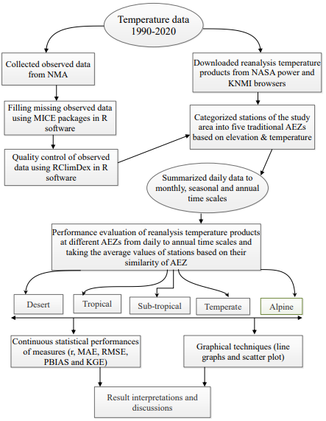
Figure 3.3 Schematic diagrams showing the methodological flows of this study.

Table 3.2 Summery of soft wares used in this study
Types of Software | Models /Versions | Purposes
Arc GIS | 10.8 | Mapping the study area and displaying each AEZ of station points.
R Software | 4.2 | For quality controlling, filling missing data, computing performances and generating graphs.
MS- Office | 2016 | Summarizing and averaging data.
Zotero | 6.0 | Citing references.

3.4 Evaluation Methods
There are many continuous statistical measures to evaluate the performance and quality of the reanalysis atmospheric datasets (Arshad et al., 2021; Reda et al., 2021). This study used five selected continuous statistical measures to evaluate the performance of reanalysis temperature products with gauged data over different AEZs of Ethiopia. This statistical metrics computed for the comparison of ERA5 and MERRA v2.0 temperature products with observed temperature data over 37 meteorological stations on the basis of daily, monthly, seasonal and annual temporal scales.
The detailed descriptions of considered continuous statistical measures used in this study are: Mean absolute error (MAE), is a metric used to measure the average magnitude of the absolute errors between the reanalysis products and the measured values. It is suitable to describe uniformly distributed errors (Derin & Yilmaz, 2014). Root mean square error (RMSE) also measures the average magnitude of error between the reanalysis products and the measured values. It is more appropriate if the errors are normally distributed (Chai & Draxler, 2014). The value for MAE and RMSE ranges from 0 to +∞. The smaller the value is closer the reanalysis dataset estimates to the ground measurements (Gebremicael et al., 2019; Jierula et al., 2021). Percent bias (PBIAS) measures of the average tendency of modeled values to be larger or smaller than measured values. The Negative and positive Pbias indicate overestimation and underestimation values respectively (Alemseged & Tom, 2015). PBIAS value ranges from -∞ to ∞. Zero bias indicates absence of systematic error where as the lower values also indicates the reamalysis products are closer to the observed measurements. The correlation coefficient (r) is widely used for the evaluation of the goodness of linear fit of regression models in (Kvålseth, 1985). r indicates the strength of the relationship between two variables and its value ranges between -1 and 1. If its values close to ± 1 indicate strong relationships.
The Kling–Gupta efficiency (KGE) is a statistical measure used to evaluate the performance metrics by combining correlation, bias and variability. Its value ranges between -∞ to 1. 1 indicates good model performance (Knoben et al., 2019). KGE was developed by Kling as an improvement over the Nash-Sutcliffe efficiency (NSE) coefficient. The detailed descriptions of all these considered continuous statistical measures are presented in table 3.3.
$\text{MAE = }\frac{\text{1}}{\text{N }}\sum_{\text{i=1}}^{\text{n}}{\left| y\begin{aligned} \\ i \end{aligned}- x\begin{aligned} \\ i \end{aligned}\right| }$(1)

$RMSE=\sqrt{\frac{\text{1}}{\text{n }}\sum_{\text{i=1}}^{\text{n}}{{ \left(\begin{aligned} \\ y\begin{aligned} \\ i \end{aligned}- x\begin{aligned} \\ i \end{aligned}\end{aligned}\right)}^{2} } }$ (2)

PBIAS =$\left(\begin{aligned} \\ \frac{\sum{\begin{aligned} \\ y\begin{aligned} \\ i \end{aligned}\end{aligned}}-\sum{\begin{aligned} \\ x\begin{aligned} \\ i \end{aligned}\end{aligned}} }{\sum{\begin{aligned} \\ x\begin{aligned} \\ i \end{aligned}\end{aligned}} }\end{aligned}\right)$×100 (3)

r =$\frac{N\left(\sum{ yi} xi\right)-\left(\sum{ yi} \right)\left(\sum{ }xi\right)}{\sqrt{\left[N{\sum{yi2-} { \left(\begin{aligned} \\ \sum{yi}\end{aligned}\right)}^{2} }^{ }\right] \left[N\sum{ }xi2-{ \left(\begin{aligned} \\ \sum{xi}\end{aligned}\right)}^{2}\right] }}$ (4)

KGE = 1 − $\sqrt{{ \left(\begin{aligned} \\ r- 1\end{aligned}\right)}^{2}+{ \left(\begin{aligned} \\ yi- 1\end{aligned}\right)}^{2}+{ \left(\begin{aligned} \\ xi- 1\end{aligned}\right)}^{2}}$ (5)
Therefore, each of these considered continuous statistical measures focuses different agro ecological zones of the study area and provides distinct information on the performance levels of the datasets. Moreover, this study was used line graph and scatter plot to evaluate the performance of ERA5 and MERRA v2.0 datasets with the comparison of observed temperature data (Gashaw et al., 2023).

Table 3.3 Summery of the considered performance statistical measures used in this study
Metrics and its formula | Unit | Range | Best value | References
$r=\frac{N\left(\sum{ yi} xi\right)-\left(\sum{ yi} \right)\left(\sum{.}xi\right)}{\sqrt{\left[N{\sum{yi2-} {\left(\begin{aligned}n \\ \sum{yi}\end{aligned}\right)}^{2} }^{ }\right] \left[N\sum{ }xi2-{ \left(\begin{aligned}n \\ \sum{xi}\end{aligned}\right)}^{2}\right] }}$ | None | -1 to 1 | -1 or 1 | Dinku et al. (2007)
$$MAE = \frac{1}{N }\sum_{i=1}^{n}{\left| y\begin{aligned} \\ i \end{aligned} x\begin{aligned} \\ i \end{aligned}\right| }$$ | ^{O}C | 0 to +∞ | 0 | Huang et al. (2022)
$RMSE=\sqrt{\frac{1}{n }\sum_{i=1}^{n}{{ \left(\begin{aligned}n \\ y\begin{aligned} \\ i \end{aligned}- x\begin{aligned} \\ i \end{aligned}\end{aligned}\right)}^{2} } }$ | ^{O}C | 0 to +∞ | 0 | Mewded et al. (2022)
PBIAS =$\left(\begin{aligned} \\ \frac{\sum{\begin{aligned} \\ y\begin{aligned} \\ i \end{aligned}\end{aligned}}-\sum{\begin{aligned} \\ x\begin{aligned} \\ i \end{aligned}\end{aligned}} }{\sum{\begin{aligned} \\ x\begin{aligned} \\ i \end{aligned}\end{aligned}} }\end{aligned}\right)$×100 | % | -∞ to ∞ | 0 | Mewded et al. (2022)
KGE = 1 -$\sqrt{{ \left(\begin{aligned} \\ r- 1\end{aligned}\right)}^{2}+{ \left(\begin{aligned} \\ yi- 1\end{aligned}\right)}^{2}+{ \left(\begin{aligned} \\ xi- 1\end{aligned}\right)}^{2}}$ | None | -∞ to 1 | 1 | Gashaw et al. (2023)

Where: x_{i} is the temperature from gauge observations, y_{i} is the corresponding value from the temperature products, $\sum{\begin{aligned} \\ x\begin{aligned} \\ i \end{aligned}\end{aligned}}$ is summation of temperature gauge observations, $\sum{\begin{aligned} \\ y\begin{aligned} \\ i \end{aligned}\end{aligned}}$ is summation of temperature products, r is the linear correlation between observations and simulations, and n is the number of observations.

CHAPTER 4: RESULTS AND DISCUSSIONS

4.1 Performances of reanalysis temperature products

4.1.1 Performance of reanalysis maximum temperature products at daily time step
The performance of ERA5 and MERRA v2.0 daily average maximum temperature estimates at different AEZs of Ethiopia from 1990-2020 are presented in Table 4.1.
Table 4.1 revealed ERA5 has well performance than MERRA v2.0 in both MAE and RMSE values of statistical metrics in all AEZs except wurch/alpine AEZ. Ethiopia poses distinct climatic zones that can be primarily ascribed to its complex topography, characterized by significant elevation differences and a network of rugged mountain ranges from highlands to lowlands. (Asefa et al. 2020). As a result, significant spatio-temporal variability of climate conditions has been observed across the country. In terms of r value the highest value were observed in the temperate AEZ for both datasets and the lowest values were attained in the wurch/alpine AEZ for MERRA v2.0. Accordingly, ERA5 has superior performance than MERRA v2.0 in terms of r values over majority of AEZs (Table 4.1). MERRA v2.0 has best performance over ERA5 in terms of having lower PBIAS values in bereha/desert, kolla/tropical and wurch/alpine AEZs, which indicating it has better accuracy in estimating maximum temperature at daily temporal scale. The KGE values were indicated that both datasets performed well in estimating daily maximum temperature across all AEZs of the study area (Table 4.1). In general, this study concluded that dega/temperate and wurch/alpine AEZs demonstrated the highest and lowest performance in estimating daily maximum temperature respectively terms of the majority/entire of evaluation scores for both products.
With regard to the directions of biases, both studied temperature products has a positive PBIAS values in woina dega/sub-tropical and dega/temperate AEZs, whereas negative PBIAS values in bereha/desert and kolla/tropical AEZs. The positive and negative PBIAS values indicating underestimation and overestimation in estimating temperature respectively (Table 4.1). The highest underestimation of PBIAS values were recoded over woina dega/sub-tropical (11.20 %) and dega/temperate (17.30 %) for ERA5 and MERRA v2.0 respectively whereas the maximum overestimation value of observed over wurch/alpine AEZ (-7.01%) for ERA5 and over kolla/tropical AEZ (-4.3%) for MERRA v2.0 (Table 4.1). This result indicated that MERRA v2.0 has highest biases compared to ERA5 in most AEZs.
In terms of daily time scale, ERA5 demonstrates superior performance compared to MERRA v2.0 for simulating maximum temperatures across most AEZs except over wurch/alpine and bereha/desert AEZs by the entire/majority of evaluation scores. In the study conducted by Dembélé et al. (2020), found that certain datasets are better performance than other global datasets in terms of performance. This is may be due to the presence of complex topography over eastern Africa (Dinku et al., 2007). This finding is consistent with Zhang et al. (2021) study that reported ERA5 had high accuracy for estimating maximum temperature in the Tibetan Plateau. This study result also aligned Wang et al. (2020) finding which stated ERA5 performs well for simulating daily temperature in China. This study showed the performance of studied temperature products is lower at the daily time step compared to other temporal scales. This is may be due to the influences of intense solar radiation (Wang et al., 2020). In addition, the satellite/reanalysis climate products generally not favorable on the daily timescale over complex topography (Dinku et al., 2007). Therefore, the accurate estimates of daily temperatures are essential for a range of applications, including agriculture, water resources management, and climate change studies (Yang & Zhang, 2018).
Table 4.1 Performances of ERA5 and MERRA v2.0 daily maximum temperature over five AEZs of Ethiopia from 1990-2020
AEZs | Temperature Products | Continuous Statistical Metrics
AEZs | Temperature Products | r | MAE | RMSE | PBIAS (%) | KGE
Desert | ERA5 | 0.86 | 2.22 | 2.76 | -5.1 | 0.85
Desert | MERRA v2.0 | 0.75 | 2.09 | 2.82 | -3.1 | 0.71
Tropical | ERA5 | 0.85 | 0.64 | 0.81 | -0.5 | 0.73
Tropical | MERRA v2.0 | 0.82 | 0.96 | 1.17 | -4.3 | 0.82
Sub-tropical | ERA5 | 0.86 | 1.34 | 1.55 | 11.2 | 0.76
Sub-tropical | MERRA v2.0 | 0.87 | 1.91 | 2.12 | 16.2 | 0.74
Temperate | ERA5 | 0.89 | 0.63 | 0.79 | 4.01 | 0.86
Temperate | MERRA v2.0 | 0.89 | 1.75 | 1.96 | 17.3 | 0.6
Alpine | ERA5 | 0.81 | 1.53 | 1.87 | -7.01 | 0.73
Alpine | MERRA v2.0 | 0.68 | 1.29 | 1.66 | 2.1 | 0.71

4.1.2 Performance of reanalysis minimum temperature products at daily time step
Table 4.2 shows the Performance ERA5 and MERRA v2.0 against the observed data at daily time step over five AEZs of Ethiopia during 1990-2020. Accordingly, MERRA v2.0 has better performance than ERA5 in terms of all considered statistical metric values over bereha/desert AEZ. In addition, MERRA v2.0 better performs than ERA5 in terms of scoring higher r and KGE in all AEZs, except its lower values achieved in dega/temperate AEZ (Table 4.2). Conversely, ERA5 outperforms over MERRA v2.0 with having low values of MAE and RMSE evaluation scores in kolla/tropical, dega/temperate and wurch/alpine AEZs (Table 4.2). ERA5 is also superior in achieving lower PBIAS value in all AEZs except bereha/desert AEZ. Moreover, ERA5 and MERRA v2.0 tends to perform better in estimating minimum temperature over dega/temperate and bereha/desert AEZs respectively by all considered validation scores. In general, ERA5 has superior performance than MERRA v2.0 for simulating minimum temperature in most AEZs in the majority/entire of the considered statistical measures. This may be the higher accuracy and spatial consistency of daily data makes to ERA5’s superiority over MERRA v2.0 at these most AEZs of the study area (Ullah et al., 2021).
In terms of the estimation biases of daily minimum temperature both ERA5 and MERRA v2.0 datasets exhibited a negative PBIAS values over kolla/tropical and woina dega/sub-tropical AEZs, and they attained positive values in bereha/desert, dega/temperate and wurch/alpine AEZs. This implies that negative and positive PBIAS values are overestimation and underestimation of daily temperature compared to the observed data respectively. In terms of PBIAS value for MERRA v2.0 revealed that ranging from -9.40 % to 1.30% while for ERA5 PBIAS values also found between -4.30 % and 2.00%. Hence the highest PBIAS values were observed in kolla/tropical AEZ for both datasets, whereas the lowest values were observed in bereha/desert AEZ for MERRA v2.0 and in dega/temperate AEZ for ERA5 (Table 4.2).
This finding indicated that ERA5 has better performed over MERRA v2.0 in estimating minimum temperature in most AEZs in majority/entire of the considered validation scores. This may be because some datasets consider daily gauge data in estimating climate products (Aniley et al., 2023; Zhao & He, 2022). This result aligned with Gao & Liu, (2013) study who reported ERA5 had better performance in terms of capturing the spatial and temporal variability of temperature. This finding also contrast with Gashaw et al. (2023) finding stated that MERRA v2 outperformed over ERA5 in dega/temperate and kolla/tropical AEZs for estimating minimum temperatures at daily time scale in the Bale Eco-Region. The slightly discrepancies between this finding and Gashaw et al. (2023) study because the evaluations of ERA5 and MERRA v2.0 were compared over five AEZs at Ethiopia level in this finding, but Gashaw et al. (2023) conducted over only few AEZs and confined at regional level (in the Bale Eco-Region of Southern Ethiopia). This study indicates variations in performance between studied temperature products over considered AEZs this is may be due to data sparse regions, elevation variations and land cover types (Dinku et al., 2007; Gashaw et al., 2023).
Table 4.2 Performances of ERA5 and MERRA v2.0 daily minimum temperature over five AEZs of Ethiopia from 1990-2020
AEZs | Temperature Products | Continuous Statistical Metrics
AEZs | Temperature Products | r | MAE | RMSE | PBIAS (%) | KGE
Desert | ERA5 | 0.82 | 2.04 | 2.62 | 4.80 | 0.78
Desert | MERRA v2.0 | 0.83 | 1.83 | 2.39 | 1.30 | 0.81
Tropical | ERA5 | 0.85 | 1.44 | 1.74 | -4.30 | 0.74
Tropical | MERRA v2.0 | 0.94 | 2.48 | 2.56 | -9.40 | 0.84
Sub-tropical | ERA5 | 0.90 | 1.23 | 1.48 | -3.10 | 0.50
Sub-tropical | MERRA v2.0 | 0.94 | 0.98 | 1.14 | -4.10 | 0.92
Temperate | ERA5 | 0.90 | 0.99 | 1.22 | 2.00 | 0.72
Temperate | MERRA v2.0 | 0.88 | 1.75 | 1.96 | 17.30 | 0.61
Alpine | ERA5 | 0.70 | 2.55 | 3.39 | 35.10 | 0.28
Alpine | MERRA v2.0 | 0.71 | 2.64 | 3.29 | 36.10 | 0.48

4.1.3 Performance of reanalysis maximum temperature products at monthly time step
The scatter plots of ERA5 and MERRA v2.0 temperature products in simulating monthly maximum temperature over the considered AEZs of Ethiopia are presented in Fig.4.1. The results displayed the points are scattered closer with the 1:1 line (deep red color), indicating better agreement with observed data but points scattered far from the 1:1 line showed less agreement between temperature products and observed data. Accordingly, this finding showed both temperature products closer with the observed data over kolla/tropical, dega/temperate and wurch/alpine AEZs. Conversely, their values were scatter in bereha/desert and woina dega/sub-tropical AEZs, showing the values more away from the reference line (dark red color). This indicates higher performances of the temperature products are found over bereha/desert and woina dega/sub-tropical AEZs than in the remaining AEZs.
Both temperature products having generally low MAE and RMSE values in most AEZs but MERRA v2.0 well performs than ERA5 over all AEZs except in kolla/tropical AEZ (Fig. 4.1). In contrast, ERA5 has better performance than MERRA v2.0 in terms of r and KGE validation scores across all AEZs except over wurch/alpine AEZ, indicating ERA5 has strong correlations and agreements with observed data than MERRA v2.0 in the majority of AEZs (Fig. 4.1).
The PBIAS metric shows that both ERA5 and MERRA2 exhibit a positive values ranging from 1.00% to 22.5% in most AEZs, except negative values (-2.00%). of MERRA v2.0 in dega/temperate and wurch/alpine AEZs (Fig. 4.1). This demonstrates that ERA5 and MERRA v2.0 underestimated over most AEZs, but MERRA v2.0 overestimated monthly temperature over dega/temperate and wurch/alpine AEZs. Thus, this result concluded that MERRA v2.0 is better than ERA5 in estimating monthly temperature in terms of the major considered continuous statistical measures in most AEZs of Ethiopia.
On monthly basis, this study indicated that both MERRA v2.0 and ERA5 has relatively better performance in estimating monthly temperature than other temporal scales in terms of most statistical metrics over all AEZs except in kolla/tropical AEZ. This is due to in tropical zone there is high humidity and precipitation, which leads to cloud cover and affect the performance of satellite/reanalysis based temperature estimates (Zhang et al., 2021). This study finding in lined with other study that found ERA-Interim temperature data is better in terms RMSE compared to other temperature products (Bhattacharya et al., 2020).
In the majority/entire AEZs, the bias values were positive for both studied temperature products but in dega/temperate and wurch/alpine AEZs its value was negative for MERRA v2.0. The main causes for bias of estimate direction between the station and reanalysis grid point is elevation differences (Xu et al., 2022). This result aligned with other authors who found that the reanalysis products show underestimated and overestimated in estimating climate variables (Aniley et al., 2023; Gashaw et al., 2023; Wang et al., 2021). The PBIAS has better value for MERRA v2.0 than ERA5 in all AEZs but attained lower value in tropical AEZ.
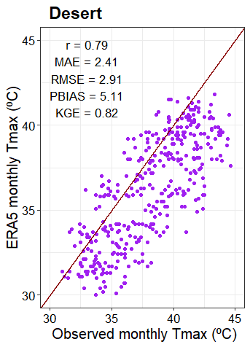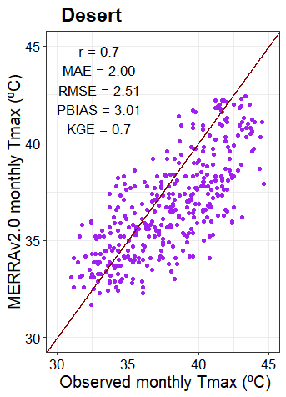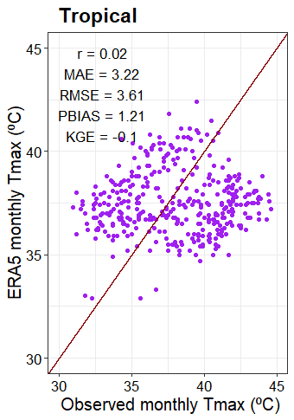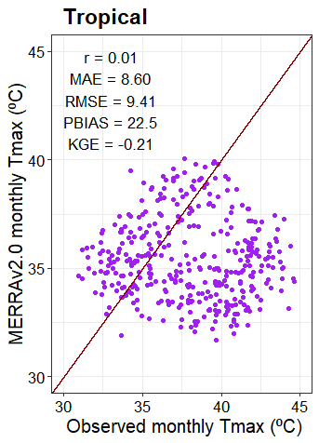
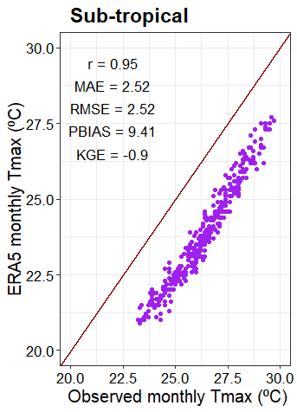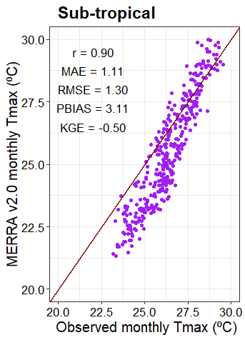
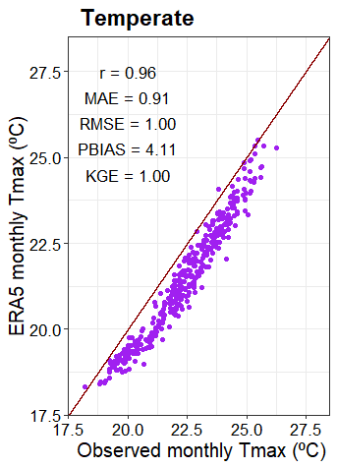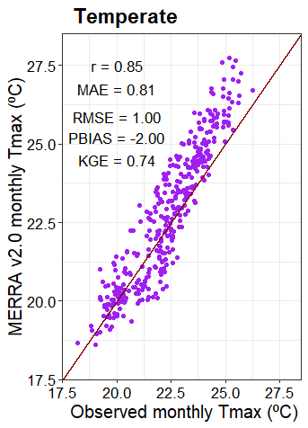
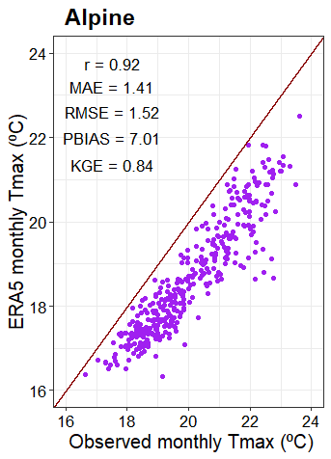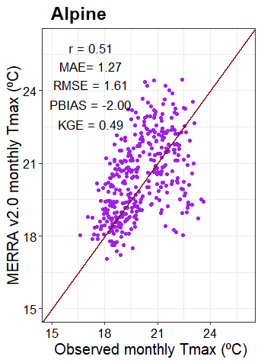
Figure 4.1 Scatter plot of monthly maximum temperature of observed data against ERA5 and MERRA v2.0 over AEZs of Ethiopia from 1990-2020 periods.
Fig 4.2 shows the line graph representation of average monthly maximum temperature of ERA5 and MERRA v2.0 (1990-2020). The results displayed that the graphs of studied temperature products of the hot months (February to May) temperature are significantly closer to the observed line graph over most AEZs. But comparatively, MERRA v2.0 better performs than ERA5 for both hot and cold months in woina dega/sub-tropical AEZ and for hot months in temperate AEZ whereas the performance of ERA5 superior than MERRA v2.0 for both hot and cold months in bereha/desert, kolla/tropical AEZs and for hot months in wurch/alpine AEZ having best closer to the observed line graph (Fig. 4.2). The line graph representation of both studied datasets were underestimated over kolla/tropical AEZ during all months and MERRA v2.0 was overestimated at dega/temperate AEZ during all months except in October.

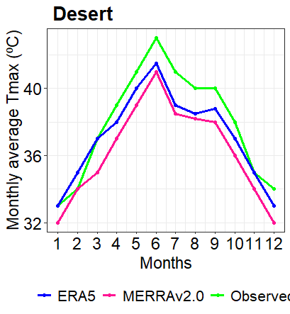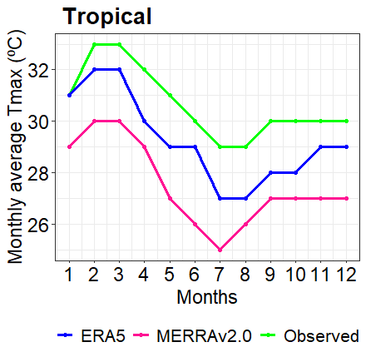
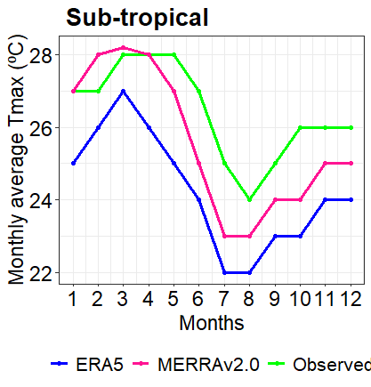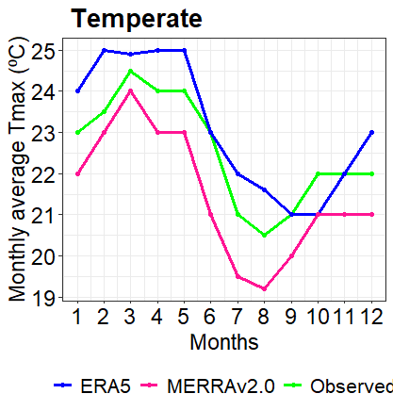

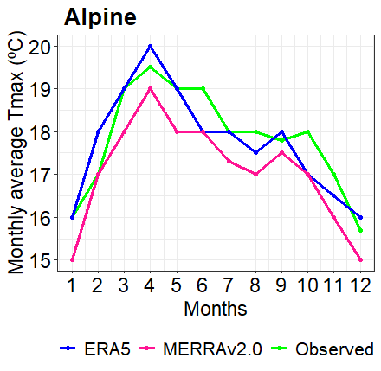
Figure 4.2 Line graph representation of average monthly observed maximum temperature with ERA5 and MERRA v2.0 temperature over AEZs of Ethiopia during 1990-2020.

4.1.4 Performance of reanalysis minimum temperature products at monthly time step
The performance values of both temperature products at monthly time step over five AEZs of Ethiopia are showed in Fig 4.3. As Fig 4.3 showed both temperature products scattered points are closer with the 1:1 line over kolla/tropical and dega/temperate AEZs indicating better agreement with observed data. On other hand, the points are more far away from the reference line over the remaining AEZs. Therefore, ERA5 is preferable than MERRA v2.0 in most AEZs in terms of scatter plot distributions in this study area.
This study result displayed the major considered evaluation scores (MAE, RMSE and PBIAS) has better values for MERRA v2.0 than ERA5 at monthly time scale across all AEZs except kolla/tropical AEZ (Fig. 4.3). Similarly, MERRA v2.0 has also greater performance in terms of r and KGE values in bereha/desert, woina dega/sub-tropical and wurch/alpine AEZs. Conversely, the performances of ERA5 outperformed than MERRA v2.0 by attained higher correlation coefficient (r) at kolla/tropical, dega/temperate and wurch/alpine AEZs. Hence, this study results indicated MERRA v2.0 performs better compared to ERA5 over all AEZs for simulating temperature products in most/entire validation scores (Fig. 4.3). This study results concluded that MERRA v2.0 well performs than ERA5 over most AEZs in terms of major considered evaluation scores.
With regard to PBIAS estimation the values found ranges from -35.00% over wurch/alpine AEZ to 26.5% over kolla/tropical AEZ. The PBIAS values of both datasets were negative over all AEZs except achieving positive PBIAS value in kolla/tropical AEZ, indicating overestimation of the temperature products in most of AEZs and underestimation in only kolla/tropical AEZ (Fig. 4.3).
This finding indicated ERA5 has lower performance than MERRA v2.0 for simulating minimum temperature at monthly time scale across most AEZs in entire/most considered performance metrics. This study result is aligned with Velikou et al. (2022) study, who stated that the performance of ERA5 was affected by the complex topography in certain areas of Europe. This study result also supported by other findings that reported MERRA-v2.0 has better performance than ERA5 at monthly temporal scale in Central Asia (Zandler et al., 2020) and in the Bale Eco-Region of southern Ethiopia (Gashaw et al. 2023).
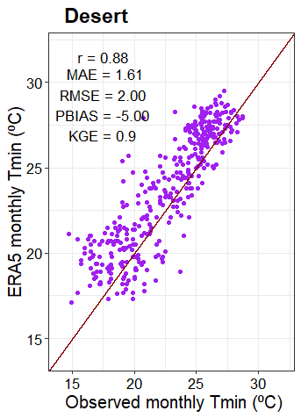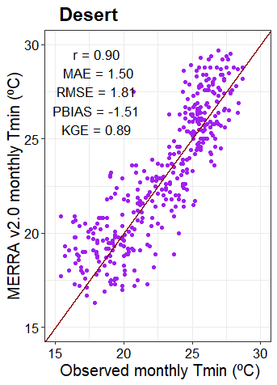
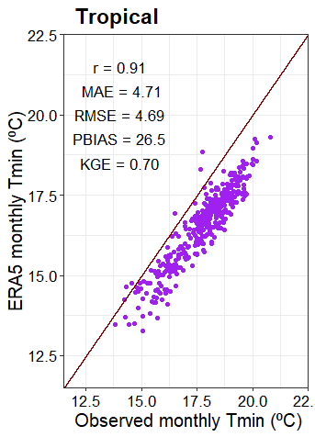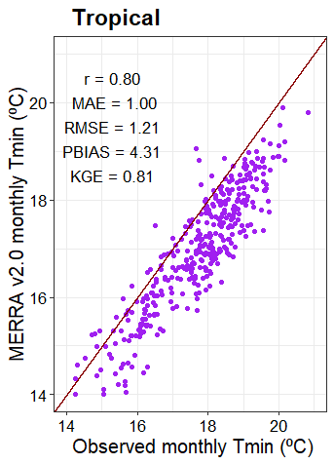
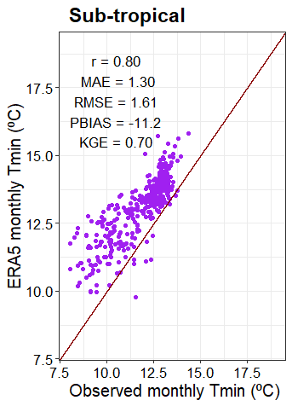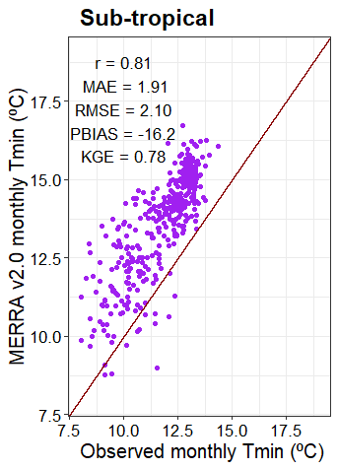
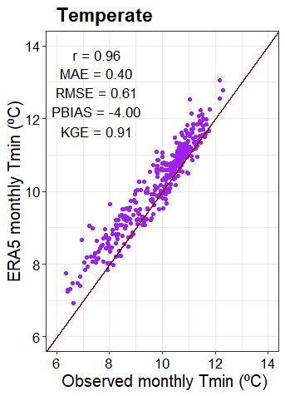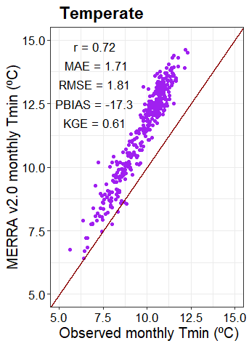
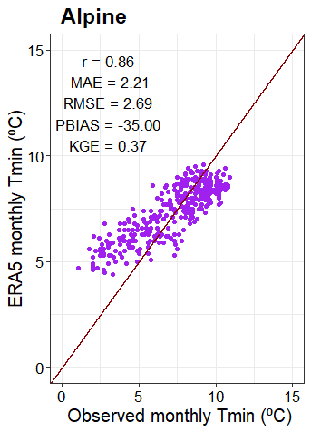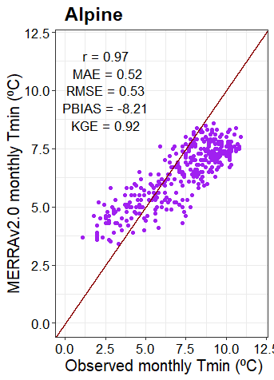
Figure 4.3 Scatter plot of monthly minimum temperature of observed data against ERA5 and MERRA v2.0 over AEZs of Ethiopia from 1990-2020 periods.
As Fig 4.4 revealed that the graph of both ERA5 and MERRA v2.0 displayed the hot months (February to May) temperature are closer to the observed line graph over bereha/desert and kolla/tropical AEZs than the remaining AEZs. Therefore, relatively, the performance of MERRA v2.0 is better than ERA5 for both hot and cold months in bereha/desert, dega/temperate AEZs and for cold months in wurch/alpine AEZ having best closer to the observed line graph. On the other hand, ERA5 achieved better performance than MERRA v2.0 for both hot and cold months in kolla/tropical, woina dega/sub-tropical AEZs (Fig. 4.4). Both datasets also showed as far away from observed line graph for monthly average minimum temperature over the woina dega/sub-tropical, dega/temperate and wurch/alpine AEZs, during the hot months (March and May).
Both ERA5 and MERRA v2.0 products were overestimated the monthly average minimum temperature for all months over woina dega/sub-tropical AEZ and the line graphs also showed underestimated over wurch/alpine AEZ for ERA5 and over kolla/tropical AEZ for MERRA v2.0 during all months (Fig. 4.4). In general, MERRA v2.0 has display more closeness with observed data than ERA5 over most AEZs during the majority months.
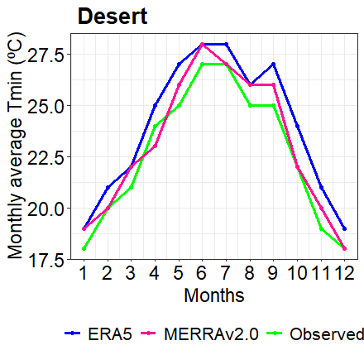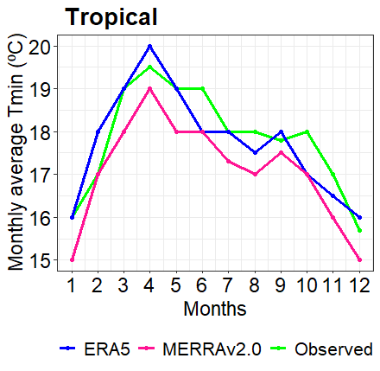

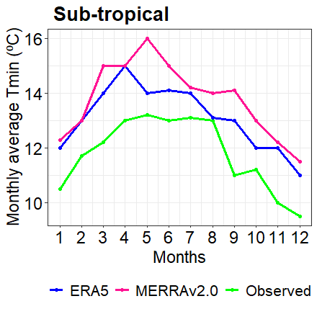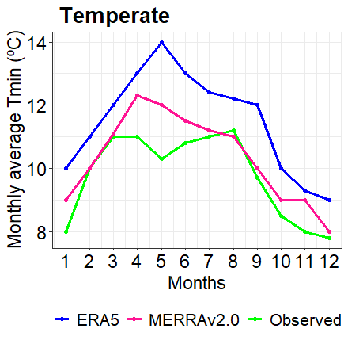
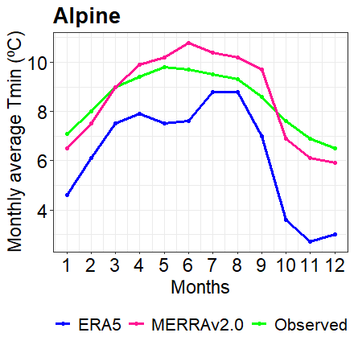
Figure 4.4 Line graph representation of average monthly observed minimum temperature with ERA5 and MERRA v2.0 tempereture over AEZs of Ethiopia during 1990-2020.

4.1.5 Performance of reanalysis maximum temperature products at seasonal time step
The performance values of both datasets in simulating temperature products at seasonal scales over AEZs of Ethiopia are showed in table 4.3.
This study finding indicated that MERRA v2.0 has better performance than ERA5 in all seasons (Bega, Belg and Kiremt) over all AEZs except over dega/temperate AEZ in terms of MAE, RMSE and PBIAS validation scores. Similarly, MERRA v2.0 has superior than ERA5 in kolla/tropical AEZ both in Belg and Kiremt seasons in all considered metrics but having low values of MAE, RMSE and PBIAS at Bega season in this AEZ (Table 4.3). On the other hand, ERA5 is better attained than MERRA v2.0 in terms of r and KGE values in all seasons over wurch/alpine AEZ and in Bega and Belg seasons over bereha/desert and dega/temperate AEZs. Generally, MERRA v2.0 has well performance in estimating temperature products compared to ERA5 in all seasons over all AEZs in most\majority considered metrics (Table 4.3).
The PBIAS values of MERRA v2.0 ranges from -12.40% (over dega/temperate) AEZ in Kiremt to 0.1% (over wurch/alpine) AEZ in Belg seasons while ERA5 PBIAS extends from -20.80% (over bereha/desert) AEZ to 3.70% (over dega/temperate) AEZ in Belg season. Therefore, the highest estimation basis for ERA5 temperature product observed in bereha/desert AEZ and the lowest basis for MERRA v2.0 also recorded in wurch/alpine AEZ (Table 4.3).
This study revealed MERRA v2.0 has better performance than ERA5 during all considered seasons over most AEZs by major validation scores aligned with Gashaw et al. (2023) study reported that MERRA v2 outperformed over ERA5 in the wet and dry seasons in terms of MAE, RMSE and PBIAS over kolla/tropical AEZ in southern Ethiopia. As Dembélé, Schaefli, Van De Giesen, et al. (2020) also reported the model performances compared to gauge data decrease from the drier to the wetter climatic zones in West Africa. However, both temperature products have bias problems over most AEZs at the seasonal temporal scale compared to other temporal scales. The overall results of this study showed that MERRA v2.0 is highest performing in terms of MAE, RMSE and PBIAS over all AEZs in estimating seasonal maximum temperature. This indicated that MERRA v2.0 has a better fit to the gauged data across all AEZs by these validation scores.

Table 4.3 Continuous metrics result of seasonal maximum temperature of ERA5 and MERRA v2.0 with observed over AEZs of Ethiopia from 1990-2020
Metrics | Desert |  | Tropical |  | Sub-tropical |  | Temperate |  | Alpine
Metrics | ERA5 | MERRA v2.0 | ERA5 | MERRA v2.0 | ERA5 | MERRA v2.0 | ERA5 | MERRA v2.0 | ERA5 | MERRA v2.0
Bega (ONDJ)
r | 0.60 | 0.38 | 0.88 | 0.41 | 0.82 | 0.36 | 0.81 | 0.37 | 0.87 | 0.03
MAE | 2.00 | 0.74 | 2.77 | 1.33 | 2.62 | 1.26 | 0.97 | 0.61 | 1.33 | 0.74
RMSE | 2.16 | 0.94 | 2.78 | 1.46 | 2.62 | 1.39 | 1.00 | 0.81 | 1.36 | 1.01
PBIAS | 5.70 | 0.40 | 9.10 | 4.40 | 10.02 | 4.30 | 4.40 | 0.30 | 6.90 | 2.10
KGE | 0.29 | 0.19 | 0.83 | 0.28 | 0.79 | -0.63 | 0.80 | -0.31 | 0.71 | -0.06
Belg (FMAM)
r | 0.72 | 0.40 | -0.06 | 0.71 | 0.90 | 0.74 | 0.91 | 0.29 | 0.62 | 0.45
MAE | 5.52 | 0.75 | 2.74 | 1.06 | 2.29 | 0.45 | 0.90 | 1.26 | 1.50 | 0.74
RMSE | 5.53 | 0.95 | 2.96 | 1.23 | 2.30 | 0.57 | 0.94 | 1.43 | 1.58 | 0.90
PBIAS | -20.8 | 0.90 | 8.50 | 3.30 | -8.20 | 0.10 | 3.70 | 4.70 | -7.00 | -1.80
KGE | 0.59 | 0.35 | -0.09 | 0.68 | 0.86 | 0.38 | 0.82 | 0.07 | 0.58 | 0.05
Kiremt (JJAS)
r | 0.67 | 0.75 | 0.21 | 0.57 | 0.78 | 0.54 | 0.80 | 0.13 | 0.72 | 0.65
MAE | 5.58 | 2.88 | 2.53 | 1.57 | 2.54 | 1.28 | 0.89 | 2.58 | 1.37 | 0.64
RMSE | 5.60 | 2.97 | 2.62 | 1.68 | 2.56 | 1.41 | 0.93 | 2.69 | 1.40 | 0.80
PBIAS | -20.3 | 7.00 | 8.60 | 5.30 | 10.00 | 5.10 | 4.30 | -12.40 | 7.00 | -2.80
KGE | 0.56 | 0.68 | 0.20 | 0.47 | 0.76 | 0.18 | 0.74 | -0.08 | 0.70 | 0.04

4.1.6 Performance of reanalysis minimum temperature products at seasonal time step
Table 4.4 indicated that ERA5 is better attained than MERRA v2.0 in both seasons (Belg and Kiremt) over kolla/tropical, woina dega/sub-tropical and dega/temperate AEZs in terms of all metrics. Moreover, ERA5 is superior compared to MERRA v2.0 in in most\majority considered metrics in Bega over tropical and in Belg over wurch/alpine AEZs. On the other hand, MERRA v2.0 has better performance than ERA5 in both seasons (Bega and Belg) over bereha/desert AEZ and in Bega season over wurch/alpine AEZ in terms of all considered validation scores (Table 4.4). Generally, ERA5 has well performance than MERRA v2.0 in estimating temperature products in most seasons across AEZs in most\majority considered metrics.
In terms of biases estimation the results revealed that ERA5 has negative PBIAS values across all AEZs in Bega season and with the same PBIAS values over some AEZs in Belg and Kiremt seasons (Table 4.4). Whereas, ERA5 exhibited positive PBIAS values in woina dega/sub-tropical, dega/temperate and wurch/alpine AEZs in Belg and Kiremt seasons indicated underestimation of the seasonal temperature. The MERRA v2.0 values also were negative over all except in kolla/tropical AEZ in all seasons this indicated that overestimation of the seasonal temperature (Table 4.4).
ERA5 is superior over MERRA v2.0 in estimating temperature products in most seasons across AEZs in most\majority considered metrics. This result contradict with Gashaw et al. (2023) finding that reported ERA5 shown lower performance in dega/temperate AEZ in BER (Bale Eco- Region). In terms of biases estimation the results revealed that ERA5 has overestimates than MERRA v2.0 across all AEZs in most seasons. The present result coincided with other authors who stated that ERA5 has higher bias of seasonal temperature in diverse sites of Africa (Wang & Zeng, 2012, Ma et al, 2021). Gleixner et al. (2020) also stated that ERA5 has biases in temperature and precipitation over most of Africa. Moreover, as Mahto and Mishra, (2019) reported that ERA5 overestimated minimum temperature across India at Kiremt season. Therefore, making bias correction activity is important before using these datasets for any analysis and further research.
Table 4.4 Continuous metrics result of seasonal minimum temperature of ERA5 and MERRA v2.0 with observed over AEZs of Ethiopia from 1990-2020.
Metrics | Desert |  | Tropical |  | Sub-tropical |  | Temperate |  | Alpine
Metrics | ERA5 | MERRA v2.0 | ERA5 | MERRA v2.0 | ERA5 | MERRA v2.0 | ERA5 | MERRA v2.0 | ERA5 | MERRA v2.0
Bega (ONDJ)
r | 0.31 | 0.61 | 0.57 | 0.60 | 0.75 | 0.54 | 0.87 | 0.66 | -0.05 | 0.53
MAE | 1.54 | 0.80 | 0.38 | 0.62 | 1.62 | 1.62 | 0.55 | 1.12 | 3.49 | 2.62
RMSE | 2.25 | 0.98 | 0.46 | 0.73 | 1.65 | 1.69 | 0.58 | 1.19 | 3.66 | 2.77
PBIAS | -5.10 | -2.30 | -1.30 | 3.80 | -16.1 | -16.00 | -6.60 | -13.50 | -99.1 | -75.10
KGE | 0.10 | 0.40 | 0.39 | 0.53 | 0.64 | 0.47 | 0.85 | 0.47 | -0.57 | 0.05
Belg (FMAM)
r | 0.37 | 0.62 | 0.75 | 0.75 | 0.32 | 0.25 | 0.89 | 0.87 | 0.60 | 0.69
MAE | 2.53 | 0.65 | 0.30 | 0.53 | 3.79 | 4.60 | 0.45 | 1.91 | 1.81 | 1.92
RMSE | 2.69 | 0.81 | 0.39 | 0.61 | 3.84 | 4.64 | 0.49 | 1.93 | 1.96 | 2.03
PBIAS | 11.10 | -1.20 | 0.50 | 2.60 | -37.6 | -45.60 | -4.10 | -18.00 | -25.0 | -26.40
KGE | 0.24 | 0.49 | 0.70 | 0.61 | 0.22 | 0.11 | 0.81 | 0.71 | 0.26 | 0.47
Kiremt (JJAS)
r | 0.29 | 0.24 | 0.74 | 0.66 | 0.31 | 0.16 | 0.75 | 0.71 | -0.02 | -0.09
MAE | 5.46 | 0.87 | 0.38 | 1.16 | 3.04 | 3.97 | 0.22 | 2.04 | 1.26 | 2.26
RMSE | 5.50 | 1.12 | 0.46 | 1.20 | 3.08 | 4.01 | 0.26 | 2.05 | 1.37 | 2.33
PBIAS | 20.90 | -2.70 | 2.10 | 6.30 | -29.1 | -38.00 | -1.80 | -19.50 | -15.7 | -28.20
KGE | 0.26 | 0.16 | 0.70 | 0.65 | 0.08 | -0.04 | 0.75 | 0.65 | -0.13 | -0.20

4.1.7 Performance reanalysis of maximum temperature products at annual time step
The performances of both datasets in estimating maximum temperature over the studied AEZs are presented in table 4.5 and fig. 4.5.
The results revealed the MAE, RMSE and PBIAS values of MERRA v2.0 has well performances than ERA5 over all AEZs except its lower value over kolla/tropical AEZ, indicating ERA5 has significant errors and variability than MERRA v2.0 in estimating annual maximum temperature. Conversely, ERA5 outperforms the MERRA v2.0 in terms of achieving higher r and KGE values across all AEZs but with attaining lower value in wurch/alpine AEZ. In terms of biases estimation both studied reanalysis temperature products have negative PBIAS over all AEZs except MERRA v2.0 attained positive PBIAS in dega/temperate and wurch/alpine AEZs. The highest overestimation bias was observed over wurch/alpine AEZ (-7.00%) for ERA5 and over kolla/tropical AEZ (-4.20%) for MERRA v2.0. But, the maximum underestimation bias displayed over dega/temperate and wurch/alpine AEZs with PBIAS of 2.00% for MERRA v2.0 (Table 4.5). Therefore, the better accuracy of MERRA v2.0 for estimating annual maximum temperature over most AEZs of the majority /entire validation scores is aligned Gashaw et al. (2023) who concluded MERRA v2 outperformed than ERA5 at annual temporal scale in dega/temperate AEZs in the Bale Eco region (Southern Ethiopia).
The superior performance of MERRA v2.0 compared to ERA5 is also reported in Andean Altiplano and Adjacent Cordilleras (Birkel et al., 2022). But contradicted by Bhattacharya et al. (2020) finding that studied in Beas river basin of North-Western Himalaya. In general, this study concluded that MERRA v2.0 has better accuracy than ERA5 for estimating annual maximum temperature over most AEZs of the majority /entire considered validation scores.
Table 4.5 Performance of ERA5 and MERRA v2.0 annual maximum temperature over five AEZs of Ethiopia from 1990-2020.
AEZs | Temperature Products | Continuous Statistical Metrics
AEZs | Temperature Products | r | MAE | RMSE | PBIAS (%) | KGE
Desert | ERA5 | 0.07 | 1.92 | 1.96 | -5.11 |  | -1.51
Desert | MERRA v2.0 | 0.13 | 1.19 | 1.34 | -3.10 |  | -3.27
Tropical | ERA5 | 0.89 | 1.20 | 1.22 | -3.90 |  | 0.71
Tropical | MERRA v2.0 | 0.48 | 1.30 | 1.41 | -4.20 |  | 0.48
Sub-tropical | ERA5 | 0.83 | 2.34 | 2.35 | -8.90 |  | 0.81
Sub-tropical | MERRA v2.0 | 0.49 | 0.93 | 1.02 | -3.10 |  | -0.11
Temperate | ERA5 | 0.84 | 0.92 | 0.94 | -4.10 |  | 0.84
Temperate | MERRA v2.0 | 0.43 | 0.55 | 0.76 | 2.00 |  | -0.06
Alpine | ERA5 | 0.78 | 1.40 | 1.42 | -7.00 |  | 0.76
Alpine | MERRA v2.0 | 0.54 | 0.55 | 0.71 | 2.00 |  | 0.01

Line graph presentations for both temperature products are showed in (Fig. 4.5). As the finding shows that MERRA v2.0 has closer values compared to observed values over bereha/desert, woina dega/sub-tropical and wurch/alpine AEZs whereas ERA5 was more or less close to the observed values over kolla/tropical and dega/temperate AEZs. Generally, MERRA v2.0 has closer values to observed values than ERA5 in most AEZs indicating, MERRA v2.0 has better performance over ERA5 in terms of line graph presentation in most AEZs of the study area. This result aligned with (Gashaw et al., 2023) study, who reported that MERRA v2.0 products has better closer values over the annual time scale than monthly time scale.
The line graph representations of ERA5 and MERRA v2.0 products were underestimated the annual average maximum temperature for all years over bereha/desert and kolla/tropical and woina dega/sub-tropical AEZs and the line graphs also showed overestimated during all years except 1996 and 2013 years over dega/temperate AEZ for ERA5 and over wurch/alpine AEZ for MERRA v2.0 from 1999 up to 2009 years (Fig. 4.5). In general, the line graph of MERRA v2.0 dataset has represented more closeness with observed data than ERA5 over most AEZs during most years for annual average maximum temperature.

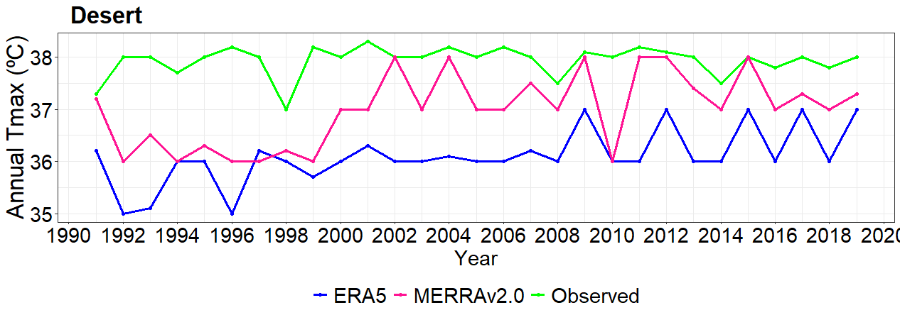
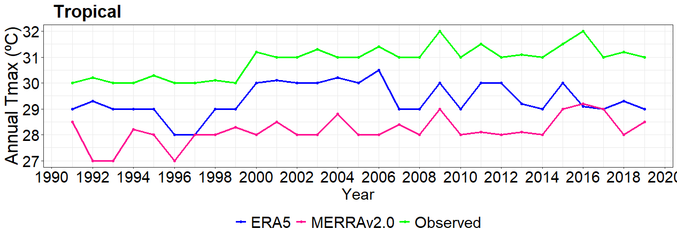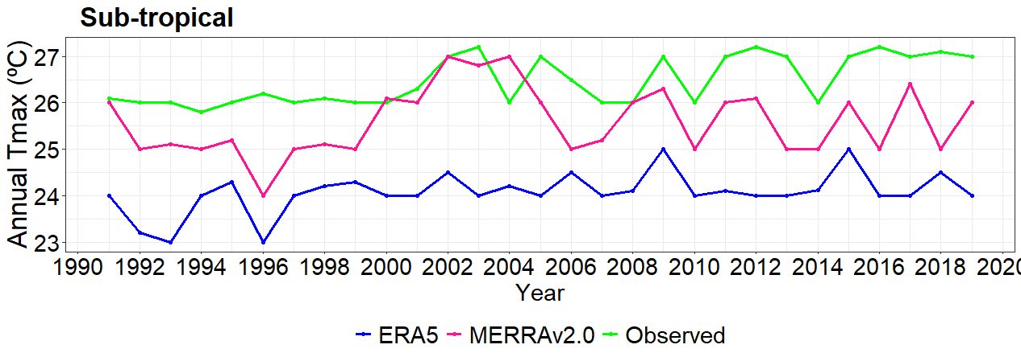
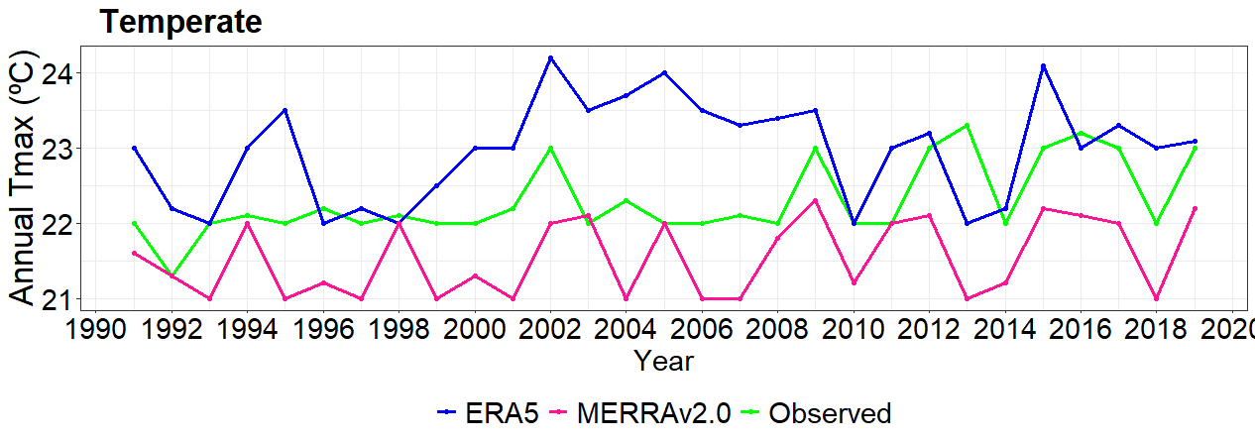
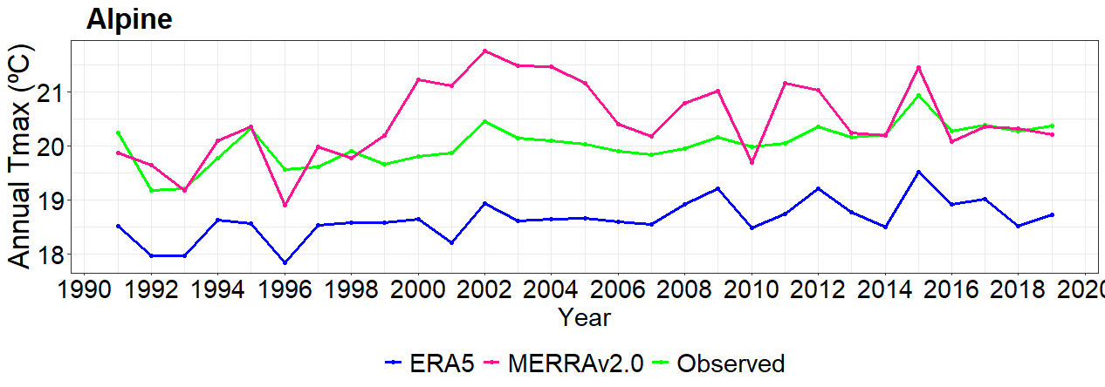
Figure 4.5 Line graph representation of annual maximum observed temperature with ERA5 and MERRA v2.0 over AEZs of Ethiopia from 1990-2020

4.1.8 Performance reanalysis of minimum temperature products at annual time step
The performances of ERA5 and MERRA v2.0 for simulating annual minimum temperature over five AEZs are shown in Table 4.6 and Fig .4.6. This study result shows ERA5 has better performance than those of MERRA v2.0 over all AEZs except in bereha/desert AEZ in terms of most considered metrics. But the MAE, RMSE and PBIAS values of MERRA v2.0 were lower than ERA5 over bereha/desert AEZ indicating MERRA v2.0 has better accuracy (Table 4.6). Conversely, the performance of MERRA v2.0 is superior terms of having higher r and KGE values in the wurch/alpine AEZ. In terms of the directions of biases both studied products were showed Positive PBIAS over bereha/desert, woina dega/sub-tropical and dega/temperate AEZs, meaning that they underestimated the annual minimum temperature (Table 4.6). On the other hand, both the studied datasets have revealed negative PBIAS over tropical AEZ. The highest underestimated PBIAS values was observed for MERRA v2.0 (36.10%) and ERA5 (11.20%) over wurch/alpine and woina dega/sub-tropical AEZs respectively. Conversely, the maximum overestimation of annual minimum temperature also was registered over wurch/alpine and kolla/tropical AEZs with PBIAS of -25.90% and -4.30% for ERA5 and MERRA v2.0 respectively (Table 4.6).
The good performance of ERA5 compared to MERRA v2.0 in annual timescale is corresponds with Bhattacharya et al. (2020) finding that studied in Beas river basin of North-Western Himalaya. On the other hand, this study result disagreement with Gashaw et al. (2023) finding which studied in the Bale Eco region (Southern Ethiopia). This study indicated the performance variations of the studied temperature products from one AEZ to another AEZ. This may be due to Ethiopia's complex topography and climate (Dinku et al., 2007). This study results also aligned with the previous study carried out in Beles sub-basin by Belay et al., (2019) reported the performance differences of satellite climate estimates over the highland and lowland areas. This finding clearly indicated that ERA5 superior for simulating minimum temperature over all AEZs by entire/most performance validation scores.
Table 4.6 Performances of ERA5 and MERRA v2.0 annual minimum temperature over five AEZs of Ethiopia from 1990-2020.
AEZs | Temperature Products | Continuous Statistical Metrics
AEZs | Temperature Products | r | MAE | RMSE | PBIAS (%) | KGE
Desert | ERA5 | 0.47 | 1.09 | 1.20 | 4.80 |  | 0.39
Desert | MERRA v2.0 | 0.37 | 0.56 | 0.66 | 1.30 |  | 0.33
Tropical | ERA5 | 0.73 | 0.26 | 0.31 | -0.70 |  | 0.61
Tropical | MERRA v2.0 | 0.67 | 0.76 | 0.82 | -4.30 |  | 0.54
Sub-tropical | ERA5 | 0.69 | 1.31 | 1.33 | 11.20 |  | 0.65
Sub-tropical | MERRA v2.0 | 0.36 | 1.95 | 1.99 | 16.70 |  | 0.34
Temperate | ERA5 | 0.92 | 0.39 | 0.41 | 4.00 |  | 0.90
Temperate | MERRA v2.0 | 0.72 | 1.69 | 1.70 | 17.20 |  | 0.66
Alpine | ERA5 | 0.35 | 2.19 | 2.27 | -25.90 |  | -0.5
Alpine | MERRA v2.0 | 0.40 | 2.26 | 2.33 | 36.10 |  | 0.16

Line graph representations of the annual temperature products showed that MERRA v2.0 is far away from observed over kolla/tropical and woina dega/sub-tropical AEZs and ERA5 also more or less far from the observed values over the remaining AEZs (Fig.4.6). The highest and least year-to-year performance variations for ERA5 was observed over dega/temperate and kolla/tropical AEZs respectively and for MERRA v2.0 also displayed over woina dega/sub-tropical and wurch/alpine AEZs respectively (Aniley et al., 2023).
The representations of both ERA5 and MERRA v2.0 products line graphs were overestimated during all years at woina dega/sub-tropical and dega/temperate AEZs and the line graphs also showed underestimated during all years in kolla/tropical except the year of 2006 for annual average minimum temperature (Fig. 4.6). Generally, the line graph of MERRA v2.0 dataset has represented more closely than ERA5 with observed data over kolla/tropical, dega/temperate and wurch/alpine AEZs during most years for annual average minimum temperature.
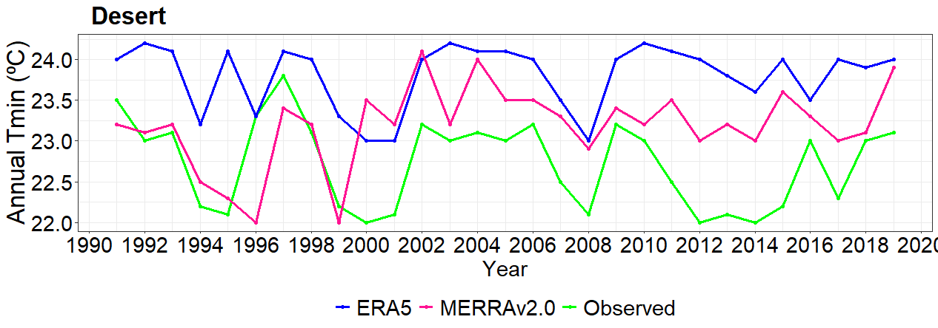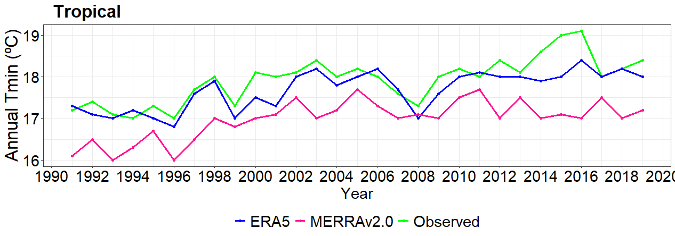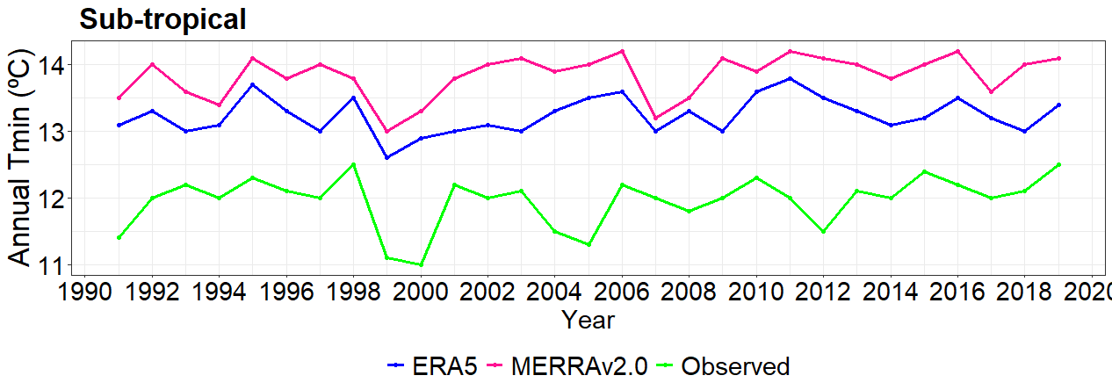
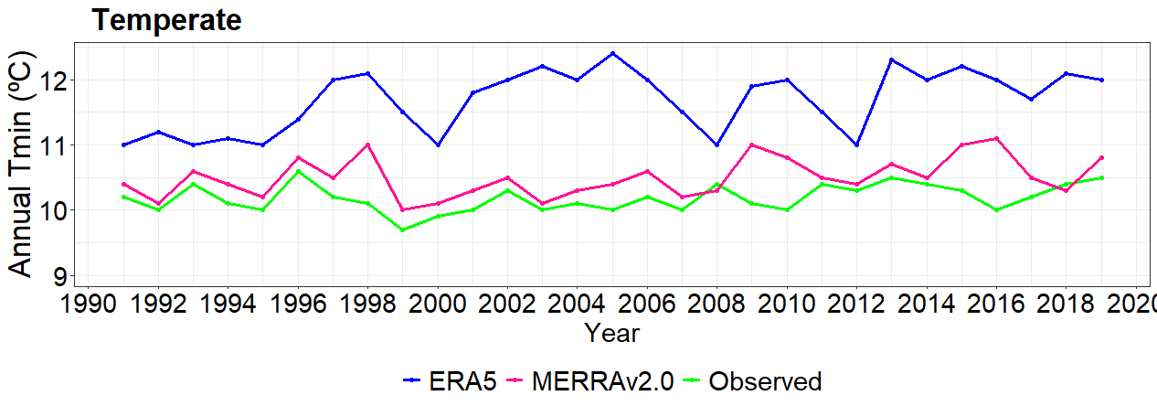
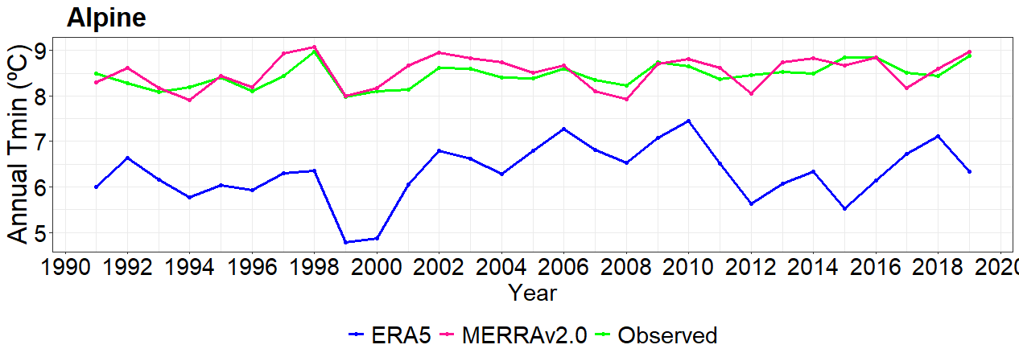
Figure 4.6 Line graph representation of annual minimum observed temperature with ERA5 and MERRA v2.0 over AEZs of Ethiopia from 1990-2020.

CHAPTER 5: CONCLUSION AND RECOMMENDATIONS

5.1 Conclusion
The performance of ERA5 and MERRA v2.0 temperature products was evaluated compared to observed data in Ethiopia from 1990- 2020 periods. The performance was evaluated over different AEZs using five evaluation scores and graphs. The study revealed that performance of ERA5 and MERRA v2.0 temperature products varies across different AEZs of Ethiopia for simulating temperatures during the studied periods. MERRA v2.0 has shown superior performance compared to ERA5 for simulating monthly, Bega (October-January), Belg (February-May), and Kiremt (June-September) seasons and annual temperature over most AEZs of Ethiopia. In this study, as most statistical metrics values showed, ERA5 has better performances than MERRA v2.0 in woina dega/sub- tropical, kolla//tropical, and dega/temperate AEZs at daily time scale. Therefore, this study recommend MERRA v2.0 for monthly, seasonal and annual maximum and minimum temperature required hydro climate studies whereas for studies requiring daily data this study suggests ERA 5 for both maximum and minimum temperature.
The performance variations of both temperature products across AEZs may be attributed to local climate characteristics, model biases, terrain complexes, and the availability of accurate input data. Therefore, using ERA5 for monthly, seasonal, and annual temporal scales temperature estimations may result in higher errors than MERRA v2.0 over most AEZs of Ethiopia. The study provides the importance and performances of reanalysis temperature datasets for users in estimating spatially varying weather information and data scarce AEZs for accurately estimating the temperature values which is vital for further hydro meteorological studies.

5.2 Recommendations
Based on this findings and discussions, the following possible solutions might be appropriate to be addressed in future improvements:
- This research was used 37 stations data over five AEZs without equal representations corresponding to each AEZ. Therefore, future researchers should relatively be considered equal representative stations data over each AEZs of the study area.
- This study concluded that MERRA v2.0 is better than ERA5 for estimating temperature over most AEZs of Ethiopia. So, this study recommended future studies should be used MERRA v2.0 for simulating temperatures at monthly, seasonal, and annual temporal scales,
- This study evaluated the performances of temperature products using point-to-pixel approach over both AEZs that have small and large number of stations but this approach advisable over areas with small number of stations distribution. Therefore, other studies should be applied grid-to-grid approach in simulating temperature products over AEZs where relatively many numbers of stations are there.

REFERENCES
Abebe, E., & Kebede, A. (2017). Assessment of Climate Change Impacts on the Water Resources of Megech River Catchment, Abbay Basin, Ethiopia. Open Journal of Modern Hydrology, 07(02), 141–152. https://doi.org/10.4236/ojmh.2017.72008
Abraham, T., Liu, Y., Tekleab, S., & Hartmann, A. (2022). Prediction at Ungauged Catchments through Parameter Optimization and Uncertainty Estimation to Quantify the Regional Water Balance of the Ethiopian Rift Valley Lake Basin. Hydrology, 9(8), 150.
Acquaotta, F., Fratianni, S., & Venema, V. (2016). Assessment of parallel precipitation measurements networks in Piedmont, Italy. International Journal of Climatology, 36(12), 3963–3974. https://doi.org/10.1002/joc.4606
Alaminie, A. A., Tilahun, S. A., Legesse, S. A., Zimale, F. A., Tarkegn, G. B., & Jury, M. R. (2021). Evaluation of Past and Future Climate Trends under CMIP6 Scenarios for the UBNB (Abay), Ethiopia. Water, 13(15), 2110. https://doi.org/10.3390/w13152110
Alemseged, T. H., & Tom, R. (2015). Evaluation of regional climate model simulations of rainfall over the Upper Blue Nile basin. Atmospheric Research, 161–162, 57–64. https://doi.org/10.1016/j.atmosres.2015.03.013
Alexander, L. V., Zhang, X., Peterson, T. C., Caesar, J., Gleason, B., Klein Tank, A. M. G., Haylock, M., Collins, D., Trewin, B., Rahimzadeh, F., Tagipour, A., Rupa Kumar, K., Revadekar, J., Griffiths, G., Vincent, L., Stephenson, D. B., Burn, J., Aguilar, E., Brunet, M., … Vazquez‐Aguirre, J. L. (2006). Global observed changes in daily climate extremes of temperature and precipitation. Journal of Geophysical Research: Atmospheres, 111(D5), 2005JD006290. https://doi.org/10.1029/2005JD006290
Ali Mohammed, J., Gashaw, T., Worku Tefera, G., Dile, Y. T., Worqlul, A. W., & Addisu, S. (2022). Changes in observed rainfall and temperature extremes in the Upper Blue Nile Basin of Ethiopia. Weather and Climate Extremes, 37, 100468. https://doi.org/10.1016/j.wace.2022.100468
Aniley, E., Gashaw, T., Abraham, T., Demessie, S. F., Bayabil, H. K., Worqlul, A. W., Van Oel, P. R., Dile, Y. T., Chukalla, A. D., Haileslassie, A., & Wubaye, G. B. (2023). Evaluating the performances of gridded satellite/reanalysis products in representing the rainfall climatology of Ethiopia. Geocarto International, 38(1), 2278329. https://doi.org/10.1080/10106049.2023.2278329
Arshad, M., Ma, X., Yin, J., Ullah, W., Liu, M., & Ullah, I. (2021). Performance evaluation of ERA-5, JRA-55, MERRA-2, and CFS-2 reanalysis datasets, over diverse climate regions of Pakistan. Weather and Climate Extremes, 33, 100373. https://doi.org/10.1016/j.wace.2021.100373
Ayehu, G. T., Tadesse, T., Gessesse, B., & Dinku, T. (2018). Validation of new satellite rainfall products over the Upper Blue Nile Basin, Ethiopia. Atmospheric Measurement Techniques, 11(4), 1921–1936. https://doi.org/10.5194/amt-11-1921-2018
Bathelemy, R., Brigode, P., Boisson, D., & Tric, E. (2022). Rainfall in the Greater and Lesser Antilles: Performance of five gridded datasets on a daily timescale. Journal of Hydrology: Regional Studies, 43, 101203. https://doi.org/10.1016/j.ejrh.2022.101203
Belay, A. S., Fenta, A. A., Yenehun, A., Nigate, F., Tilahun, S. A., Moges, M. M., Dessie, M., Adgo, E., Nyssen, J., Chen, M., Griensven, A. V., & Walraevens, K. (2019). Evaluation and Application of Multi-Source Satellite Rainfall Product CHIRPS to Assess Spatio-Temporal Rainfall Variability on Data-Sparse Western Margins of Ethiopian Highlands. Remote Sensing, 11(22), 2688. https://doi.org/10.3390/rs11222688
Bhattacharya, T., Khare, D., & Arora, M. (2020). Evaluation of reanalysis and global meteorological products in Beas river basin of North-Western Himalaya. Environmental Systems Research, 9(1), 24. https://doi.org/10.1186/s40068-020-00186-1
Birkel, S. D., Mayewski, P. A., Perry, L. B., Seimon, A., & Andrade‐Flores, M. (2022). Evaluation of Reanalysis Temperature and Precipitation for the Andean Altiplano and Adjacent Cordilleras. Earth and Space Science, 9(3). https://doi.org/10.1029/2021EA001934
Bojanowski, J. S., Vrieling, A., & Skidmore, A. K. (2014). A comparison of data sources for creating a long-term time series of daily gridded solar radiation for Europe. Solar Energy, 99, 152–171. https://doi.org/10.1016/j.solener.2013.11.007
Chai, T., & Draxler, R. R. (2014). Root mean square error (RMSE) or mean absolute error (MAE)? [Preprint]. Numerical Methods. https://doi.org/10.5194/gmdd-7-1525-2014
Chawla, I., & Mujumdar, P. P. (2020). Evaluating rainfall datasets to reconstruct floods in data-sparse Himalayan region. Journal of Hydrology, 588, 125090. https://doi.org/10.1016/j.jhydrol.2020.125090
Degefu, M. A., Bewket, W., & Amha, Y. (2022). Evaluating performance of 20 global and quasi-global precipitation products in representing drought events in Ethiopia I: Visual and correlation analysis. Weather and Climate Extremes, 35, 100416. https://doi.org/10.1016/j.wace.2022.100416
Dembélé, M., Schaefli, B., Van De Giesen, N., & Mariéthoz, G. (2020). Suitability of 17 gridded rainfall and temperature datasets for large-scale hydrological modelling in West Africa. Hydrology and Earth System Sciences, 24(11), 5379–5406. https://doi.org/10.5194/hess-24-5379-2020
Demessie, S. F., Dile, Y. T., Bedadi, B., Gashaw, T., & Tefera, G. W. (2023). “Evaluations of regional climate models for simulating precipitation and temperature over the Guder sub-basin of Upper Blue Nile Basin, Ethiopia.” Modeling Earth Systems and Environment. https://doi.org/10.1007/s40808-023-01751-0
Derin, Y., & Yilmaz, K. K. (2014). Evaluation of Multiple Satellite-Based Precipitation Products over Complex Topography. Journal of Hydrometeorology, 15(4), 1498–1516. https://doi.org/10.1175/JHM-D-13-0191.1
Dinku, T., Ceccato, P., Grover‐Kopec, E., Lemma, M., Connor, S. J., & Ropelewski, C. F. (2007). Validation of satellite rainfall products over East Africa’s complex topography. International Journal of Remote Sensing, 28(7), 1503–1526. https://doi.org/10.1080/01431160600954688
Dinku, T., Funk, C., Peterson, P., Maidment, R., Tadesse, T., Gadain, H., & Ceccato, P. (2018). Validation of the CHIRPS satellite rainfall estimates over eastern Africa. Quarterly Journal of the Royal Meteorological Society, 144(S1), 292–312. https://doi.org/10.1002/qj.3244
Dinku, T., Hailemariam, K., Grimes, D., Asefa, K., & Connor, S. (2011). Improving Availability, Access and Use of Climate Information. WMO Bulletin, 60, 80–86.
Gao, Y. C., & Liu, M. F. (2013). Evaluation of high-resolution satellite precipitation products using rain gauge observations over the Tibetan Plateau. Hydrology and Earth System Sciences, 17(2), 837–849. https://doi.org/10.5194/hess-17-837-2013
Gashaw, T., W. Worqlul, A., Lakew, H., Teferi Taye, M., Seid, A., & Haileslassie, A. (2023). Evaluations of satellite/reanalysis rainfall and temperature products in the Bale Eco-Region (Southern Ethiopia) to enhance the quality of input data for hydro-climate studies. Remote Sensing Applications: Society and Environment, 31, 100994. https://doi.org/10.1016/j.rsase.2023.100994
Gebrechorkos, S. H., Hülsmann, S., & Bernhofer, C. (2018). Evaluation of multiple climate data sources for managing environmental resources in East Africa. Hydrology and Earth System Sciences, 22(8), 4547–4564. https://doi.org/10.5194/hess-22-4547-2018
Gebremicael, T. G., Mohamed, Y. A., v. Zaag, P., & Hagos, E. Y. (2017). Temporal and spatial changes of rainfall and streamflow in the Upper Tekezē–Atbara river basin, Ethiopia. Hydrology and Earth System Sciences, 21(4), 2127–2142. https://doi.org/10.5194/hess-21-2127-2017
Gebremicael, T. G., Mohamed, Y. A., Zaag, P. van der, Gebremedhin, A., Gebremeskel, G., Yazew, E., & Kifle, M. (2019). Evaluation of multiple satellite rainfall products over the rugged topography of the Tekeze-Atbara basin in Ethiopia. International Journal of Remote Sensing, 40(11), 4326–4345. https://doi.org/10.1080/01431161.2018.1562585
Gebremichael, A., Quraishi, S., & Mamo, G. (2014). Analysis of Seasonal Rainfall Variability for Agricultural Water Resource Management in Southern Region, Ethiopia.
Gleixner, S., Demissie, T., & Diro, G. T. (2020). Did ERA5 Improve Temperature and Precipitation Reanalysis over East Africa? Atmosphere, 11(9), 996. https://doi.org/10.3390/atmos11090996
Hu, G., & Franzke, C. L. E. (2020). Evaluation of Daily Precipitation Extremes in Reanalysis and Gridded Observation‐Based Data Sets Over Germany. Geophysical Research Letters, 47(18). https://doi.org/10.1029/2020GL089624
Huang, L., Fang, X., Zhang, T., Wang, H., Cui, L., & Liu, L. (2022). Evaluation of surface temperature and pressure derived from MERRA-2 and ERA5 reanalysis datasets and their applications in hourly GNSS precipitable water vapor retrieval over China. Geodesy and Geodynamics, S1674984722000854. https://doi.org/10.1016/j.geog.2022.08.006
Ishizaki, N. N., Shiogama, H., Hanasaki, N., Takahashi, K., & Nakaegawa, T. (2023). Evaluation of the spatial characteristics of climate scenarios based on statistical and dynamical downscaling for impact assessments in Japan. International Journal of Climatology, 43(2), 1179–1192. https://doi.org/10.1002/joc.7903
Jierula, A., Wang, S., Oh, T.-M., & Wang, P. (2021). Study on Accuracy Metrics for Evaluating the Predictions of Damage Locations in Deep Piles Using Artificial Neural Networks with Acoustic Emission Data. Applied Sciences, 11(5), 2314. https://doi.org/10.3390/app11052314
Jolani, S., Debray, T. P. A., Koffijberg, H., van Buuren, S., & Moons, K. G. M. (2015). Imputation of systematically missing predictors in an individual participant data meta-analysis: A generalized approach using MICE. Statistics in Medicine, 34(11), 1841–1863. https://doi.org/10.1002/sim.6451
Kanamitsu, M., Ebisuzaki, W., Woollen, J., Yang, S.-K., Hnilo, J., Fiorino, M., & Potter, G. (2002). Ncep–doe amip-ii reanalysis (r-2). Bulletin of the American Meteorological Society, 83(11), 1631–1644.
Knoben, W. J. M., Freer, J. E., & Woods, R. A. (2019). Technical note: Inherent benchmark or not? Comparing Nash–Sutcliffe and Kling–Gupta efficiency scores. Hydrology and Earth System Sciences, 23(10), 4323–4331. https://doi.org/10.5194/hess-23-4323-2019
Kravtsov, S., & Spannagle, C. (2008). Multidecadal Climate Variability in Observed and Modeled Surface Temperatures*. Journal of Climate, 21(5), 1104–1121. https://doi.org/10.1175/2007JCLI1874.1
Kvålseth, T. O. (1985). Cautionary Note about R ². The American Statistician, 39(4), 279–285. https://doi.org/10.1080/00031305.1985.10479448
Luo, Y., Liu, L., Yang, Y., Liu, B., Yang, G., Wang, H., Su, Q., He, Q., Li, K., Duan, Y., Li, Q., & Yu, W. (2022). Evaluation of meteorological reanalysis data over the tropical Western Indian Ocean based on buoy observations in 2022. Journal of Sea Research, 189, 102285. https://doi.org/10.1016/j.seares.2022.102285
Ma, H., Zeng, J., Zhang, X., Fu, P., Zheng, D., Wigneron, J.-P., Chen, N., & Niyogi, D. (2021). Evaluation of six satellite- and model-based surface soil temperature datasets using global ground-based observations. Remote Sensing of Environment, 264, 112605. https://doi.org/10.1016/j.rse.2021.112605
Malede, D. A., Agumassie, T. A., Kosgei, J. R., Pham, Q. B., & Andualem, T. G. (2022). Evaluation of satellite rainfall estimates in a rugged topographical basin over south Gojjam Basin, Ethiopia. Journal of the Indian Society of Remote Sensing, 50(7), 1333–1346.
Mašek, J., Tumajer, J., Lange, J., Kaczka, R., Fišer, P., & Treml, V. (2023). Variability in Tree-ring Width and NDVI Responses to Climate at a Landscape Level. Ecosystems, 26(5), 1144–1157. https://doi.org/10.1007/s10021-023-00822-8
Mason, S., Fletcher, J. K., Haynes, J. M., Franklin, C., Protat, A., & Jakob, C. (2015). A hybrid cloud regime methodology used to evaluate Southern Ocean cloud and shortwave radiation errors in ACCESS. Journal of Climate, 28(15), 6001–6018.
May, P. T., Mather, J. H., Vaughan, G., & Jakob, C. (2008). CHARACTERIZING OCEANIC CONVECTIVE CLOUD SYSTEMS: The Tropical Warm Pool International Cloud Experiment. Bulletin of the American Meteorological Society, 89(2), 153–155.
Mewded, M., Abebe, A., Tilahun, S., & Agide, Z. (2022). Climate variability and trends in the Endorheic Lake Hayk basin: Implications for Lake Hayk water level changes in the lake basin, Ethiopia. Environmental Systems Research, 11(1), 10. https://doi.org/10.1186/s40068-022-00256-6
Michler, J. D., Josephson, A., Kilic, T., & Murray, S. (2021). Estimating the Impact of Weather on Agriculture (arXiv:2012.11768). arXiv. http://arxiv.org/abs/2012.11768
Nawaz, Z., Li, X., Chen, Y., Wang, X., Zhang, K., Nawaz, N., Guo, Y., & Meerzhan, A. (2020). Spatiotemporal Assessment of Temperature Data Products for the Detection of Warming Trends and Abrupt Transitions over the Largest Irrigated Area of Pakistan. Advances in Meteorology, 2020, 1–19. https://doi.org/10.1155/2020/3584030
Parsons, D., Stern, D., Ndanguza, D., & Sylla, M. B. (2022). Evaluation of Satellite-Based Air Temperature Estimates at Eight Diverse Sites in Africa. Climate, 10(7), 98. https://doi.org/10.3390/cli10070098
Paulhus, J. L. H., & Kohler, M. A. (1952). INTERPOLATION OF MISSING PRECIPITATION RECORDS. Monthly Weather Review, 80(8), 129–133. https://doi.org/10.1175/1520-0493(1952)080<0129:IOMPR>2.0.CO;2
Reda, K. W., Liu, X., Tang, Q., & Gebremicael, T. G. (2021). Evaluation of Global Gridded Precipitation and Temperature Datasets against Gauged Observations over the Upper Tekeze River Basin, Ethiopia. Journal of Meteorological Research, 35(4), 673–689. https://doi.org/10.1007/s13351-021-0199-7
Redfearn, D. P., Trim, G. M., Skanes, A. C., Petrellis, B., Krahn, A. D., Yee, R., & Klein, G. J. (2005). Esophageal Temperature Monitoring During Radiofrequency Ablation of Atrial Fibrillation. Journal of Cardiovascular Electrophysiology, 16(6), 589–593. https://doi.org/10.1111/j.1540-8167.2005.40825.x
Shen, L., Wen, J., Zhang, Y., Ullah, S., Meng, X., & Chen, G. (2022). Performance Evaluation of ERA5 Extreme Precipitation in the Yangtze River Delta, China. Atmosphere, 13(9), 1416. https://doi.org/10.3390/atmos13091416
Sianturi, Y., Marjuki, & Sartika, K. (2020). Evaluation of ERA5 and MERRA2 reanalyses to estimate solar irradiance using ground observations over Indonesia region. 020002. https://doi.org/10.1063/5.0000854
Sun, P., Wu, S., Zhang, K., Wan, M., & Wang, R. (2021). A new global grid-based weighted mean temperature model considering vertical nonlinear variation. Atmospheric Measurement Techniques, 14(3), 2529–2542. https://doi.org/10.5194/amt-14-2529-2021
Sun, Q., Miao, C., Duan, Q., Ashouri, H., Sorooshian, S., & Hsu, K. (2018). A Review of Global Precipitation Data Sets: Data Sources, Estimation, and Intercomparisons. Reviews of Geophysics, 56(1), 79–107. https://doi.org/10.1002/2017RG000574
Sun, S., Shi, W., Zhou, S., Chai, R., Chen, H., Wang, G., Zhou, Y., & Shen, H. (2020). Capacity of Satellite-Based and Reanalysis Precipitation Products in Detecting Long-Term Trends across Mainland China. Remote Sensing, 12(18), 2902. https://doi.org/10.3390/rs12182902
Tadesse, K. E., Melesse, A. M., Abebe, A., Lakew, H. B., & Paron, P. (2022). Evaluation of Global Precipitation Products over Wabi Shebelle River Basin, Ethiopia. Hydrology, 9(5), 66. https://doi.org/10.3390/hydrology9050066
Tarek, M., Brissette, F. P., & Arsenault, R. (2020). Large-Scale Analysis of Global Gridded Precipitation and Temperature Datasets for Climate Change Impact Studies. Journal of Hydrometeorology, 21(11), 2623–2640. https://doi.org/10.1175/JHM-D-20-0100.1
Taye, M., Sahlu, D., Zaitchik, B. F., & Neka, M. (2020). Evaluation of Satellite Rainfall Estimates for Meteorological Drought Analysis over the Upper Blue Nile Basin, Ethiopia. Geosciences, 10(9), 352. https://doi.org/10.3390/geosciences10090352
Taye, Simane, Zaitchik, Selassie, & Setegn. (2019). Rainfall Variability across the Agro-Climatic Zones of a Tropical Highland: The Case of the Jema Watershed, Northwestern Ethiopia. Environments, 6(11), 118. https://doi.org/10.3390/environments6110118
Tesfaye, T. W. (2017). Spatiotemporal evaluation of reanalysis and in-situ surface air temperature over Ethiopia.
Ullah, I., Ma, X., Yin, J., Asfaw, T. G., Azam, K., Syed, S., Liu, M., Arshad, M., & Shahzaman, M. (2021). Evaluating the meteorological drought characteristics over Pakistan using in situ observations and reanalysis products. International Journal of Climatology, 41(9), 4437–4459. https://doi.org/10.1002/joc.7063
Valappil, N. K. M., Hamza, V., & De Oliveira Júnior, J. F. (2022). Evaluation of daily average temperature trends in Kerala, India, using MERRA-2 reanalysis data: A climate change perspective. Environmental Science and Pollution Research, 30(10), 26663–26686. https://doi.org/10.1007/s11356-022-23895-9
Van Wynsberge, S., Le Gendre, R., Sangare, N., Aucan, J., Menkes, C., Liao, V., & Andréfouët, S. (2020). Monitoring pearl farming lagoon temperature with global high resolution satellite-derived products: An evaluation using Raroia Atoll, French Polynesia. Marine Pollution Bulletin, 160, 111576. https://doi.org/10.1016/j.marpolbul.2020.111576
Vega-Durán, J., Escalante-Castro, B., Canales, F. A., Acuña, G. J., & Kaźmierczak, B. (2021). Evaluation of Areal Monthly Average Precipitation Estimates from MERRA2 and ERA5 Reanalysis in a Colombian Caribbean Basin. Atmosphere, 12(11), 1430. https://doi.org/10.3390/atmos12111430
Velikou, K., Lazoglou, G., Tolika, K., & Anagnostopoulou, C. (2022). Reliability of the ERA5 in Replicating Mean and Extreme Temperatures across Europe. Water, 14(4), 543. https://doi.org/10.3390/w14040543
Viggiano, M., Busetto, L., Cimini, D., Di Paola, F., Geraldi, E., Ranghetti, L., Ricciardelli, E., & Romano, F. (2019). A new spatial modeling and interpolation approach for high-resolution temperature maps combining reanalysis data and ground measurements. Agricultural and Forest Meteorology, 276–277, 107590. https://doi.org/10.1016/j.agrformet.2019.05.021
Wang, A., & Zeng, X. (2012). Evaluation of multireanalysis products with in situ observations over the Tibetan Plateau: EVALUATION OF REANALYSIS OVER TIBETAN PLATEAU. Journal of Geophysical Research: Atmospheres, 117(D5), n/a-n/a. https://doi.org/10.1029/2011JD016553
Wang, S., Zhou, J., Lei, T., Wu, H., Zhang, X., Ma, J., & Zhong, H. (2020). Estimating Land Surface Temperature from Satellite Passive Microwave Observations with the Traditional Neural Network, Deep Belief Network, and Convolutional Neural Network. Remote Sensing, 12(17), 2691. https://doi.org/10.3390/rs12172691
Wang, Y., Zhao, X., Mamtimin, A., Sayit, H., Abulizi, S., Maturdi, A., Yang, F., Huo, W., Zhou, C., Yang, X., & Liu, X. (2021). Evaluation of Reanalysis Datasets for Solar Radiation with In Situ Observations at a Location over the Gobi Region of Xinjiang, China. Remote Sensing, 13(21), 4191. https://doi.org/10.3390/rs13214191
Woldemariam Tesfaye, T., Dhanya, C. T., Gosain, A. K., & Department of Civil Engineering, Indian Institute of Technology Delhi, New Delhi-110016, India. (2017). Evaluation of ERA-Interim, MERRA, NCEP-DOE R2 and CFSR Reanalysis precipitation Data using Gauge Observation over Ethiopia for a period of 33 years. AIMS Environmental Science, 4(4), 596–620. https://doi.org/10.3934/environsci.2017.4.596
Wubaye, G. B., Gashaw, T., Worqlul, A. W., Dile, Y. T., Taye, M. T., Haileslassie, A., Zaitchik, B., Birhan, D. A., Adgo, E., Mohammed, J. A., Lebeza, T. M., Bantider, A., Seid, A., & Srinivasan, R. (2023). Trends in Rainfall and Temperature Extremes in Ethiopia: Station and Agro-Ecological Zone Levels of Analysis. Atmosphere, 14(3), 483. https://doi.org/10.3390/atmos14030483
Xu, W., Lei, X., Chen, S., Yu, T., Hu, Z., Zhang, M., Jiang, L., Bao, R., Guan, X., Ma, M., Wei, J., Gao, L., & Feng, A. (2022). How Well Does the ERA5 Reanalysis Capture the Extreme Climate Events Over China? Part II: Extreme Temperature. Frontiers in Environmental Science, 10. https://www.frontiersin.org/articles/10.3389/fenvs.2022.921659
Yang, K., & Zhang, J. (2018). Evaluation of reanalysis datasets against observational soil temperature data over China. Climate Dynamics, 50(1–2), 317–337. https://doi.org/10.1007/s00382-017-3610-4
Zandler, H., Senftl, T., & Vanselow, K. A. (2020). Reanalysis datasets outperform other gridded climate products in vegetation change analysis in peripheral conservation areas of Central Asia. Scientific Reports, 10(1), 22446. https://doi.org/10.1038/s41598-020-79480-y
Zhang, H., Immerzeel, W. W., Zhang, F., de Kok, R. J., Gorrie, S. J., & Ye, M. (2021). Creating 1-km long-term (1980–2014) daily average air temperatures over the Tibetan Plateau by integrating eight types of reanalysis and land data assimilation products downscaled with MODIS-estimated temperature lapse rates based on machine learning. International Journal of Applied Earth Observation and Geoinformation, 97, 102295. https://doi.org/10.1016/j.jag.2021.102295
Zhao, P., & He, Z. (2022). A First Evaluation of ERA5-Land Reanalysis Temperature Product Over the Chinese Qilian Mountains. Frontiers in Earth Science, 10. https://www.frontiersin.org/articles/10.3389/feart.2022.907730
Zhu, J., Huang, D.-Q., Yan, P.-W., Huang, Y., & Kuang, X.-Y. (2017). Can reanalysis datasets describe the persistent temperature and precipitation extremes over China? Theoretical and Applied Climatology, 130(1–2), 655–671. https://doi.org/10.1007/s00704-016-1912-9

APPENDICES
Appendix 1: Description of studied meteorological stations over traditional AEZs of Ethiopia
No | Stations | Geographic Coordinate |  | Elevation | Traditional AEZs |  | Period of record
No | Stations | Long | Lati | Elevation | Amharic name | English name | Period of record
1 | Adama | 39.28 | 8.56 | 1648 | Woyina Dega | Sub-tropical | 1990-2020
2 | Addis Ababa | 38.75 | 9.02 | 2386 | Dega | Temperate | 1990-2020
3 | Ambo | 37.84 | 8.99 | 2068 | Woyina Dega | Sub-tropical | 1990-2020
4 | Asela | 39.14 | 7.96 | 2420 | Dega | Temperate | 1990-2020
5 | Asebe Teferi | 40.87 | 9.07 | 1796 | Woyina Dega | Sub-tropical | 1990-2020
6 | Bahir Dar | 37.42 | 11.6 | 1770 | Woyina Dega | Sub-tropical | 1990-2020
7 | Boditi | 37.86 | 6.96 | 2043 | Woyina Dega | Sub-tropical | 1990-2020
8 | Bonga | 36.24 | 7.28 | 1599 | Woyina Dega | Sub-tropical | 1990-2020
9 | Dangila | 36.85 | 11.43 | 2116 | Woyina Dega | Sub-tropical | 1990-2020
10 | Debre Birhan | 39.51 | 9.67 | 3206 | Wurchi | Alpine | 1990-2020
11 | Debre Markos | 37.74 | 10.33 | 2446 | Dega | Temperate | 1990-2020
12 | Debre Tabor | 38 | 11.87 | 2612 | Dega | Temperate | 1990-2020
13 | Dire Dawa | 41.9 | 9.61 | 1045 | Kolla | Tropical | 1990-2020
14 | Dubity | 41.09 | 11.73 | 381 | Bereha | Desert | 1990-2020
15 | Fiche | 38.74 | 9.77 | 2798 | Dega | Temperate | 1990-2020
16 | Gewane | 40.66 | 10.16 | 744 | Kolla | Tropical | 1990-2020
17 | Gonder | 37.43 | 12.52 | 1973 | Woyina Dega | Sub-tropical | 1990-2020
18 | Gore | 35.55 | 8.16 | 2024 | Woyina Dega | Sub-tropical | 1990-2020
19 | Haramaya | 42.04 | 9.42 | 2025 | Woyina Dega | Sub-tropical | 1990-2020
20 | Hawassa | 38.48 | 7.07 | 1694 | Woyina Dega | Sub-tropical | 1990-2020
21 | Hosanna | 37.86 | 7.57 | 2306 | Dega | Temperate | 1990-2020
22 | Jijiga | 42.72 | 9.37 | 1557 | Woyina Dega | Sub-tropical | 1990-2020
23 | Kombolcha | 39.72 | 11.08 | 1857 | Woyina Dega | Sub-tropical | 1990-2020
24 | Konso | 37.44 | 5.34 | 1431 | Kolla | Tropical | 1990-2020
25 | Lalibela | 39.04 | 12.04 | 2487 | Dega | Temperate | 1990-2020
26 | Mekele | 39.53 | 13.47 | 2221 | Woyina Dega | Sub-tropical | 1990-2020
27 | Mojo | 39.11 | 8.61 | 1763 | Woyina Dega | Sub-tropical | 1990-2020
28 | Moyale | 39.05 | 5.05 | 1166 | Kolla | Tropical | 1990-2020
29 | Negele | 39.27 | 5.33 | 1439 | Kolla | Tropical | 1990-2020
30 | Nekemte | 36.55 | 9.08 | 2119 | Woyina Dega | Sub-tropical | 1990-2020
31 | Pawe | 36.41 | 11.31 | 1119 | Kolla | Tropical | 1990-2020
32 | Robe | 40.05 | 7.13 | 2480 | Dega | Temperate | 1990-2020
33 | Teppi | 35.44 | 7.2 | 1208 | Kolla | Tropical | 1990-2020
34 | Tulu bolo | 38.22 | 8.67 | 2100 | Woyina Dega | Sub-tropical | 1990-2020
35 | Wolaita Sodo | 37.75 | 6.82 | 1854 | Woyina Dega | Sub-tropical | 1990-2020
36 | Yirgachefe | 38.21 | 6.15 | 1856 | Woyina Dega | Sub-tropical | 1990-2020
37 | Yirgalem | 38.43 | 6.8 | 1786 | Woyina Dega | Sub-tropical | 1990-2020

AUTHOR’S BIOGRAPHY
The author was born on June in 1990 G.C at Dabat district, North Gondar zone, Amhara Regional State of North Ethiopia. He completed his primary and secondary education at Wokin from 2002 to 2009. Following this, he also attained his preparatory education at Dabat woreda from 2010 to 2011. Subsequently, after passing the Ethiopian Higher Education Entrance Examination, he joined at Mekelle University, College of Social Sciences in 2012 and obtained his BSc degree in Geography and Environmental Studies with a CGPA of 3.71 in July 2014. Upon graduation, he commenced his career as a teaching expert in Kamba woreda in Gamo Gofa Zone of southern Ethiopia in 2015. He furthered his qualifications by completing the Postgraduate Diploma in Teaching (PGDT) program at Arba Minch University through a summer program in 2016. Following the successful completion of the PGDT program, he moved to Gode zone in Ethio-Somale regional state where he served as a teaching expert from 2016 to 2020. Finally, due to the presence of clan disputes at his workplace, he decided to take a break and spent one year with his family without any job. Then after, he has offered a scholarship opportunity in 2022 through the BDU Talent program from Bahir Dar University, College of Agriculture and Environmental Science for MSc degree in Environment and Climate Change.

