
BAHIR DAR UNIVERSITY
COLLEGE OF AGRICULTURE AND ENVIRONMENTAL SCIENCES
GRADUATE PROGRAM
EFFECTS OF RHIZOBIUM INOCULATION, LIME, AND STARTER NITROGEN ON SOIL HEALTH AND FABA BEAN (Vicia faba L.) YIELD AT KOGA IRRIGATION SCHEME, NORTH-WESTERN ETHIOPIA
M.Sc. Thesis
By
Demelash Melaku Desta

May, 2025
Bahir Dar, Ethiopia
BAHIR DAR UNIVERSITY
COLLEGE OF AGRICULTURE AND ENVIRONMENTAL SCIENCES
GRADUATE PROGRAM
DEPARTMENT OF NATURAL RESOURCE MANAGEMENT
EFFECTS OF RHIZOBIUM INOCULATION, LIME, AND STARTER NITROGEN ON SOIL HEALTH AND FABA BEAN (Vicia faba L.) YIELD AT KOGA IRRIGATION SCHEME, NORTH-WESTERN ETHIOPIA
M.Sc. Thesis
By
Demelash Melaku Desta

SUBMITTED IN PARTIAL FULFILLMENT OF THE REQUIREMENTS FOR THE DEGREE OF MASTER OF SCIENCE (M.SC.) IN SOIL SCIENCE.

Major advisor: Enyew Adgo (Professor)
Co-advisor: Eyayu Mola (PhD)

May, 2025
Bahir Dar, Ethiopia


DECLARATION
This is to certify that this thesis entitled “Effects of rhizobium inoculation, lime, and starter nitrogen on soil health and Faba bean (Vicia faba L.) yield at Koga Irrigation Scheme, north-western Ethiopia” submitted in partial fulfillment of the requirements for the award of the degree of Master of Science in Soil Science to the Graduate Program of College of Agriculture and Environmental Sciences, Bahir Dar University by Mr. Demelash Melaku (ID. No. 1500107) is an authentic work carried out by him under our guidance. To the best of our knowledge and belief the matter embodied in this project work has not been submitted earlier to other university for an award of any degree or diploma.

Demelash Melaku |  |  |  | 23/05/2025
Name of student |  | Signature |  | Date

Name of Advisors
1. | Enyew Adgo (Professor) |  |  |  | 25/05/2025
 | Major Advisor |  |   Signatre |  | Date
2. | Eyayu Mola (PhD) |  |  |  | 25/05/2025
 | Co-Advisor |  | Signature |  | Date

STATEMENT OF AUTHOR
First, I declare that this thesis is my authentic work and that all sources of materials used for this thesis have been duly acknowledged. This thesis has been submitted in partial fulfillment of the requirements for M.Sc. degree at Bahir Dar University and is deposited at the University library to be made available to borrowers under rules of the University library. I solemnly declare that this thesis is not submitted to any other institution anywhere for the award of any academic degree, diploma, or certificate.

Brief quotations from this thesis are allowable without special permission provided that accurate acknowledgment of sources is made. Requests for permission for extended quotation from or reproduction of this manuscript in whole or in part may be granted by the Director of Postgraduate Program Directorate when in his or her judgment the proposed use of the material is in the interests of scholarship. In all other instances, however, permission must be obtained from the author.
Demelash Melaku Desta Signature:
Place: Bahir Dar University
Date of Submission: May, 2025

ACKNOWLEDGMENT
First and foremost, I would like to thank Almighty God for the gift of life, and I am being here today. Secondly, I would like to express publicly my deep appreciation to my major advisor, Professor Enyew Adgo for his invaluable, constructive comments, advice, and support throughout the experiment and manuscript writing. I would also like to appreciate my co-advisor Dr. Eyayu Molla for his valuable comments, advice, and support.
Then, I would like to express my great compliment to “Healthy Food Africa” project for its invaluable financial support.
Furthermore, I would like to acknowledge Bahir Dar University for granting me to conduct my experiment on the university`s research site and permission for laboratory analysis; and Adet Agricultural Research Center for supporting me with phosphorus fertilizer (TSP). Special thanks go to Mr. Mamaru Shitaw, Bahir Dar University soil and plant analysis laboratory technician, for his help in the laboratory.
Finally, I would like to express my appreciation to my family for their support and encouragement, and local communities of experimental area for their unwavering support, patience, and generosity. Thank you all for everything you did.

DEDICATION
This thesis work is dedicated to my beloved late mother, Mrs. Yeshume Endalew. Mom, even though you are not alive, I have achieved the precious goal that you were expecting.

LIST OF ACRONYMS AND ABBREVIATIONS
ANOVA Analysis of Variance
Av.P Available Phosphorus
BD Bulk density
Ca Calcium
CIMMYT International Maize and Wheat Improvement Centre
CV Coefficient of Variation
EAL Ethiopian Agricultural Legumes
ETB Ethiopian Birr
FAO Food and Agriculture Organization
HARC Holeta Agricultural Research Centre
K Potassium
LSD Least Significant Difference
Mg Magnesium
N Nitrogen
OM Organic Matter
RCBD Randomized Complete Block Design
SAS Statistical Analysis System
SOC Soil Organic Carbon
TN Total Nitrogen
TP Total Porosity
TSP Triple Super Phosphate
TVC Total Variable Cost

EFFECTS OF RHIZOBIUM INOCULATION, LIME, AND STARTER NITROGEN ON SOIL HEALTH AND FABA BEAN (Vicia faba L.) YIELD AT KOGA IRRIGATION SCHEME, NORTH-WESTERN ETHIOPIA

ABSTRACT
Soil acidity is one of the chemical soil degradation issues which affect soil productivity in Ethiopian highlands. A field experiment was conducted to evaluate the effects of rhizobium inoculation, lime, and starter nitrogen application on soil health, and Faba bean (Vicia faba L.) yield at Koga Irrigation Scheme, north- western Ethiopia. The three factors, lime rates (0, and 2 t ha⁻¹), starter nitrogen (0, 10 and 20kg·ha⁻¹), and rhizobium inoculation (control, strain1 (EAL17) and strain2 (EAL1035)) were combined in 2x3x3 factorial arrangement of randomized complete block design in three replications. Disturbed and undisturbed soil samples were collected before and after treatment application. The data were collected on soil, yield and yield components of Faba bean and subjected to the analysis of variance (ANOVA), and analyzed using SAS Software version 9. The ANOVA results revealed that plant height, number of pods per plant, number of seeds per pod, effective nodule number hundred seeds weight, above ground biomass, and grain yield were highly significantly (p<0.001) affected by the treatment. The bulk density, total porosity, soil pH, av.P, TN (%), %OC and CEC were also significantly affected by the treatment. This indicated that the combined application of lime, rhizobium strain, and starter nitrogen improved soil health and Faba bean yield. The highest grain yield (2933.03 kg ha⁻¹) with the highest net benefit (212345.84 ETB ha⁻¹) was obtained from the application of 2 ton ha⁻¹ lime, rhizobium strain 2(EAL 1035), and 20 kgha⁻¹ N. Whereas, the lowest grain yield (725.9 kg ha⁻¹) was recorded from the control treatment. The correlation analysis indicated that there was highly positively significant (p≤0.01) correlation of grain yield with yield related parameters. The economic analysis was done following the methodology of CIMMYT (1988). Economically the highest net benefit (212,345.84 ETB ha⁻¹) with a marginal rate of return of (3358.03%), achieved from the combined application of 2 t ha⁻¹ lime, rhizobium strain EAL 1035, and 20 kg ha⁻¹ nitrogen, indicating that this combination is economically profitable and technically sound for smallholder farmers in acidic soil in the study area and similar agro ecologies.
Keywords: Nodulation, Soil acidity, Soil reaction, Strain
TABLE OF CONTENTS
Contents Pages
THESIS APPROVAL SHEET ii
DECLARATION iii
STATEMENT OF AUTHOR iv
ACKNOWLEDGMENT v
DEDICATION vi
LIST OF ACRONYMS AND ABBREVIATIONS vii
ABSTRACT viii
LIST OF TABLES xii
LIST OF FIGURES xiii
APPENDIX TABLES xiv
APPENDIX FIGURES xv
Chapter 1. INTRODUCTION 1
1.1. Background and Justification 1
1.2. Statements of the Problem 4
1.3. Objectives of the Study 6
1.3.1. General objective 6
1.3.2. Specific objectives 6
1.4. Research Questions 6
Chapter 2. LITERATURE REVIEW 7
2.1. Overview of Ethiopian Soils 7
2.2. Effects of Lime Application on Soil Health 10
2.2.1. Soil physical properties 10
2.2.2. Soil chemical properties 10
2.3. Effects of Lime Application on Crop Productivity 15
2.4. Effect of Soil Acidity on Growth and Multiplication of Rhizobium 17
2.5. Effects of Rhizobium Inoculation on Faba Bean Yield 18
Chapter 3. MATERIALS AND METHODS 19
3.1. Description of the Study Area 19
TABLE OF CONTENTS (continued)
3.1.1. Location of the study area 19
3.1.2. Climate 20
3.1.3. Soil and topography of the experimental area 21
3.1.4. Crop production and farming practices 21
3.2. Experimental Materials and Design 22
3.2.1. Experimental materials 22
3.2.2. Design and treatment setup 22
3.3. Soil Sampling, Preparation and Analysis 24
3.3.1. Soil sampling, preprocessing and analysis 24
3.4. Crop Data Collection 26
3.4.1. Shoot growth parameters 26
3.4.2. Yield and yield components 26
3.5. Data Analysis 28
3.6. Partial Budget Analysis 29
Chapter 4. RESULTS AND DISCUSSION 30
4.1. Soil Physicochemical Properties before Experimentation 30
4.2. Effects of Soil Amendments on Soil Physicochemical Properties 30
4.2.1. Bulk density (BD) and Total porosity (TP) 30
4.2.2. Soil reaction (pH) 33
4.2.3. Soil organic carbon (%OC) 33
4.2.4. Total nitrogen (TN) 34
4.2.5. Available phosphorus (Av.P) 35
4.2.6. Exchangeable acidity (Ex.A) 35
4.2.7. Exchangeable aluminum (Ex.Al) 36
4.2.8. Exchangeable bases (Potassium (K) and Sodium (Na)) 36
4.2.9. Cation exchange capacity (CEC) 37
4.3. Effects of Soil Amendments on the Shoot Growth Parameters of Faba bean 39
4.3.1. Plant height (cm) 39
4.4. Effects of Soil Amendments on Yield and Yield Components of Faba bean 40
4.4.1. Number of pods per plant 40
4.4.2. Nodule number per plant 40
4.4.3. Nodule dry weight per plant (NDW) 41
TABLE OF CONTENTS (continued)
4.4.4. Above ground biomass yield (AGBY) 42
4.4.5. Grain yield 43
4.4.6. Straw yield 44
4.4.7. Harvest index (HI) 44
4.5. Correlation Analysis 48
4.6. Partial Budget Analysis 48
Chapter 5. CONCLUSION AND RECOMMENDATION 50
5.1. Conclusions 50
5.2. Recommendations 51
5. REFEENCES 52
6. APPENDIX 61
AUTHOR’S BIOGRAPHY 66

LIST OF TABLES
Table 3.1. Treatment combination in a factorial arrangement 23
Table 4.1. Soil physicochemical properties of the study site before experimentation 30
Table 4.2. Response of bulk density and total porosity to the integrated application of lime, strain, and starter nitrogen 32
Table 4.3. Mean values of selected soil chemical properties to the application of lime, strain, and starter nitrogen 38
Table 4.4. Interaction effects of strain and nitrogen on nodule number and nodule dry weight 42
Table 4.5. Interaction effects of strain and nitrogen on AGBY &GY 45
Table 4.6. Response of agronomic parameters to the integrated application of lime, strain, and starter nitrogen 46
Table 4.7. The correlation matrix for yield and yield related parameters under lime, strain and nitrogen 47
Table 4.8. Partial budget analysis of lime, strain and N on yield of Faba bean 49

LIST OF FIGURES
Figure 3.1. Location map of study area 19
Figure 3.2. Mean monthly rainfall and temperature data (Koga irrigation metrological station,2023) 20

APPENDIX TABLES
Appendix Table 1. Mean square values for the ANOVA of soil properties based on lime, strain and nitrogen fertilizer application 61
Appendix Table 2. Mean square values for the ANOVA of some soil chemical properties based on lime, strain and nitrogen fertilizer application 61
Appendix Table 3. Mean square value for the ANOVA on most agronomic parameters based on lime, strain and nitrogen fertilizer application 62
Appendix Table 4 Mean square value for the ANOVA on most agronomic parameters based on lime, strain and nitrogen fertilizer application 62

APPENDIX FIGURES
Appendix Figure 1. Soil sampling and experimental plot layout 63
Appendix Figure 2. Lime application and soil sample preparation……………………. 63
Appendix Figure 3. Soil acidity and organic carbon determination……………………..64
Appendix Figure 4. Laboratory analysis of exchangeable acidity and Aluminum 64
Appendix Figure 5. CEC, exchangeable bases and Phosphorus test…………………….. 65
Appendix Figure 6. Treated (Limed, Inoculated &N) and control plot…………………..65

INTRODUCTION

Background and Justification
Soil is a vital natural resource that controls the ultimate sustainability of any agricultural system. Water movement, water quality, land use, and vegetation productivity all have associated with soil that provides food, fodder and fuel for meeting the basic human and animal needs (Schoonover and Crim, 2015). However, soil nutrients have been depleted and then the productive potential of soils has been affected through changes in soil characteristics, due to the increasing rate of population demanding of food.
Soil degradation is one of the most significant biophysical factor that reduces soil fertility, quality, and hinders crop production in Ethiopia (Gete Zelleke et al., 2010). The soils of Ethiopia in general and in the study area in particular are losing organic carbon, phosphorus, and nitrogen due to extensive cultivation, erosion, and residue removal (Yihenew G. Selassie et al., 2015). This biophysical factor including soil acidity is a major limitation that significantly hampers crop production specifically in the study area and in the country as a whole and necessitates urgent interventions. Compared with unmanaged soils, well-managed soils exhibit higher levels of organic matter, total nitrogen, and available phosphorus (Yihenew G.Selassie et al., 2015). The increase in organic matter, specifically organic carbon, within the soil not only enhances its overall quality but also leads to a notable increment in nitrogen nutrient content. The relationship between organic matter and nitrogen availability has been emphasized in various studies like the findings of Fassil Kebede and Yamoah (2009) as well as Mulugeta Demelash and Stahr (2010).
Among those soil fertility bottle necks, soil acidity is a complex which leads to nutrient deficiencies, toxicities, low beneficial microorganisms activities, and reduced plant root growth, which limits absorption of nutrients and water (Fageria and Baligar, 2008). The sum of different anthropogenic and natural processes including leaching of exchangeable bases, basic cation uptake by plants, organic matter decomposition, application of inorganic fertilizers and other farming practices produce acidic soils (Brady and Weil, 2002). In high rainfall areas of Ethiopia, soil acidity is a severe problem, and can lead to decline or complete failure of crop production (Abdenna Deressa et al., 2007). Soil acidity and associated low nutrient availability are key constraints to crop production in acidic soils, mainly Nitisols of Ethiopian highlands (Gete Zelleke et al., 2010).
Soil acidity covers about 30% of soils in the world (Sumner and Noble, 2003), and about 32% of all arable land is acidic (Rengel, 2011). From the total land area and arable lands of Ethiopia, about 28% and 43 % of soils are dominated by acid soils respectively (ATA, 2014). Therefore, mitigation and maintenance of soil acidity is very important management to increase crop yield by implementing different approaches. Lime is the main means of ameliorating soil acidity (Anetor and Ezekiel, 2007), because of its high acid neutralizing capacities, which can effectively remove existing acid, stimulate biological activity and reduce toxicity of heavy metals. The most efficient crop production on acid soils is resulted in the application of both lime and fertilizer, specifically phosphorus. When lime is applied to the soil, Ca²⁺ and Mg²⁺ ions displace H⁺, Fe²⁺, Al³⁺, Mn⁴⁺, and Cu²⁺ ions from soil adsorption sites resulting in increase in the soil pH, and other than increasing soil pH, lime also supplies significant amounts of Ca and Mg, depending on the type of liming materials. Indirectly, lime increases availability of P, Mo and B, and creates favorable conditions for microbial mediated reactions, such as nitrogen fixation and nitrification, and in some cases improved soil structure (Nekesa et al., 2005).In highly acidic soils liming not only improve microbial action but also enhances availability of P by declining Al³⁺ and Fe³⁺ ions and fixation on Aluminum and iron oxide (Simonsson et al., 2018).
Ethiopia is one of the major Faba bean (Vicia faba L.) producing countries in the world (FAO, 2015). It is the fourth largest Faba bean exporting country next to France, Australia, and the United Kingdom (FAO, 2016). Faba bean takes the largest share of area (443,966ha) and production (848655 tones) of the pulses grown in Ethiopia (CSA, 2015) and plays a key role in improving food and feed security of smallholder farmers and soil fertility. The crop usually grows in Nitisols and Vertisols dominated areas of Ethiopia mixed with cereals and field peas. However, the average national yield of Faba bean is about 2.1 t ha⁻¹ (CSA, 2018) which is very low compared to the average yield of 3.7 t ha⁻¹ in major producer countries (FAOSTAT, 2017). On the other hand, the on- farm average yield of released Faba bean varieties reaches up to 3.5 t ha⁻¹ (National Planning Commission, 2016) indicating the existence of considerable yield gap between farmer managed and researcher managed plots.

The major factors that are usually mentioned for the low yield of Faba bean in Ethiopia
include climatic, edaphic, biotic (diseases, pests and weeds) factors, and poor agronomic
practices. It could be hypothesized that low production is related with soil health issues which embrace soil fertility and productivity problem, because a fertile soil is able soil to supply essential elements in adequate amounts and in proper balance for plant growth without a toxic concentration of any element (Foth, 1990). A chemically fertile soil contains adequate amounts of the various substances required for plant nutrition, in available forms, which is not excessively acidic or alkaline and is free from toxic agents (Elgharably et al., 2010). Productive soil also has the ability to support crop production determined by the entire spectrum of its physical, chemical and biological attributes (Martin et al., 2015). These interacting factors must be understood as judicious soil fertility management is of vital importance for sustaining food production in states farm communities (Mowo et al., 2013).
To address these problems, the adoption of environmentally friendly integrated nutrient management and profitable farming systems is essential (Getachew Agegnehu and Tilahun Amede, 2017). This showed that integrated soil fertility management in a balanced manner into farming practices is vital for optimizing crop yield and maintaining soil fertility.
Liming is the most significant management practice to reduce the soil acidity and improve soil fertility. It makes the soil environment better for leguminous plants and associated microorganisms as well as increase concentration of essential nutrients through raising its pH and precipitating exchangeable aluminum (Kisinyo et al., 2016).
Rhizobium inoculants as biological fertilizer also play a key role in crop productivity and reducing environmental pollution of leaching mineral N fertilizer residues, and serve as cost-effective inputs for farmers (Tolera Abera, 2010). It has commonly been established that chemical N fertilization of leguminous crops can substantially decrease the amount of N₂ fixed from the air (Hardarson, 2020). However, small amounts of N fertilization as starter can boost the early growth of crops, allowing the delivery of more carbohydrates for N₂ fixation later in the season (Mesfin Tadele et al., 2018). Thus, Urea is recommended as a source of starter nitrogen for proper growth of Faba bean at the initial growing stage. However, scarce information is available to the agricultural extension service, regarding the integrated use of rhizobium inoculants and chemical fertilizer. Hence, this study was designed to fill this gap.

Statements of the Problem
Faba bean is an important source of protein for subsistence farmers in the developing countries like Ethiopia, Furthermore, it is a source of cash to the farmers and foreign currency to the country and serves as "break" crop to pests and restores soil fertility when grown in rotation with cereals and other crops (Mesfin Tadele, 2019). Sustainable Faba bean production can be achieved through integrating high and low cost inputs such as bio-fertilizer and fertilizer. However, Faba bean yield in Ethiopia in general (2.1 t ha⁻¹) and in the study area in particular is still low (1.7 t ha⁻¹), which is below the world average (3.7 t ha⁻¹) due to soil acidity and related soil fertility degradation (CSA, 2018).
In the experimental area, the problem at hand is the low productivity of Faba beans mainly due to soil acidity and related nutrient deficiency. The acidic nature of the soil poses a significant challenge to Faba bean productivity related to low pH level, which affects microbial activities, availability and uptake of essential nutrients required for plant growth and development. In the case of Faba beans, this can lead to stunted growth, poor pod development, reduced nodulation, and low grain yield.
Thus, to fill this pronounced yield gap through enhancing soil health, liming is believed to be one of the primary interventions to rehabilitate acid soils. Liming can shift soil acidity towards nearly neutral levels and improve availability of nutrients to plants (Fageria and Baligar, 2008; Carmeis Filho et al., 2017; Holland et al., 2018) .Through raising the pH, lime creates a more favorable environment for microbial activity and Faba beans to thrive. It allows for better nutrient uptake and utilization, promoting healthy root development, and enhancing overall plant growth. Liming could also counteract the effects of Al toxicity (Elisa et al., 2016), which otherwise negatively affect crop productivity (Andersson, 1993; Wright, 2008).
Rhizobium strains, which form a symbiotic relationship with Faba beans, as inoculant is also believed to be one of the crucial interventions. These bacteria can fix atmospheric nitrogen into a form that plants can utilize, and increases nitrogen availability, then ensure an adequate supply of this essential nutrient for Faba bean growth.
Furthermore, the application of starter nitrogen can provide an initial boost to Faba bean plants. Nitrogen is a vital nutrient for plant growth, and providing a readily available source at the beginning stages can enhance early growth and establishment. This helps Faba beans overcome the initial nutrient limitations caused by inherently low N especially in acidic soil conditions. Hence, this study was designed to evaluate the effects of rhizobium inoculation, lime, and starter nitrogen application on soil health and Faba bean production at Koga Irrigation Scheme, north- western Ethiopia.

Objectives of the Study

General objective
The overall objective of the study was to assess the effects of inoculation, lime, and starter nitrogen on soil health and Faba bean yield at Koga Irrigation Scheme, north- western Ethiopia.

Specific objectives
- To evaluate the effects of lime application on soil health parameters
- To investigate effects of rhizobium inoculation, lime, and starter nitrogen on Faba bean yield and yield components
- To assess the synergistic effects of rhizobium inoculation, lime, and starter nitrogen on soil health parameters
- To determine the economic viability of rhizobium inoculation, lime, and starter nitrogen combinations for Faba bean crop.

Research Questions
- What are the effects of acidic soil amendment using lime on soil health parameters?
- What are the combined effects of rhizobium inoculation, lime, and starter nitrogen on Faba bean yield and yield components?
- What are the synergistic effects of rhizobium inoculation, lime and starter nitrogen on soil health?
- What are the optimum and most economically feasible combinations of lime, inoculant and starter N rate for Faba bean yield and soil health improvement in the study area?

LITERATURE REVIEW

Overview of Ethiopian Soils
Ethiopia has a diversity of soil types, some of which have intrinsic qualities that might be problematic for agricultural cultivation and require particular management. These problems included organic matter depletion, macro and micro nutrient depletion, salinity, topsoil erosion and acidity (Gete Zelleke et al., 2010). Out of nineteen soil types only nine (9) soil types cover 90% of Ethiopia's land area. Among these, Leptosols, Nitisols, Vertisols, Cambisols, Luvisols, Calcisols, Fluvisols, Gypsisols, and Alisols are the main soil types, shaped predominantly by local and regional soil formation factors. Notably, Nitisols, Vertisols, Cambisols, Luvisols, and Fluvisols are important cultivated soil types in terms of their agricultural importance (Sheleme Beyene et al., 2023).However,the productive capacity of these soils is highly affected by soil degradation in most highlands of Ethiopia (Fanuel Laekemariam and Kibebew Kibret, 2021).

Soil acidity is one of the most critical issue that needs urgent attention in most highlands of Ethiopia due to its impact on crop production and productivity (Wassie Haile et al., 2009; Asmare Melese and Yli-Halla, 2016; Fanuel Laekemariam and Kibebew Kibret, 2021). Most acidic soils have poor chemical and biological properties. Soil acidity associated with aluminum (Al), iron (Fe), hydrogen (H), manganese (Mn) toxicities to plant roots in the soil solutions and also cause corresponding deficiencies of the available phosphorus (av. P), calcium (Ca), magnesium (Mg) and potassium (K) (Kisinyo et al., 2014). In acid soils, phosphorus (P) is highly fixed due to intensive weathering and the leaching of basic cations related to high rainfall conditions (Fanuel Laekemariam and Kibebew Kibret, 2021). Significant P fixation and its precipitation as iron and aluminum phosphates are widespread in acidic soils; this situation is very common in Luvisols and Nitisols (Shen et al., 2001).

In the humid tropics, soils become acidic naturally due to leaching of basic cations under high rainfall conditions. At pH below 5, Al is easily soluble in water and becomes the dominant ion in the soil solution. Soil acidity is expanding in scope and magnitude in Ethiopia, severely limiting crop production. For example, in barley, wheat and faba bean growing areas of central and southern Ethiopian highlands, farmers have shifted to producing oats which is more tolerant to soil acidity than wheat and barley (Wassie Haile et al., 2009).
Several soil amendment strategies have been recommended to reclaim soil acidity and improve the productivity of strongly acidic soils. These include the cultivation of acid tolerant plants, the use of organic fertilizers, and liming. Among these practices, liming and the application of organic fertilizers are considered being the best measures, due to its more persistent effects (Chen et al., 2001).However, the unaffordability of fertilizers and lime, and unsustainable crop production calls for use of locally available low-cost organic sources through manures, green manures, and mineral fertilizers in a harmonized combination for sustainable production and soil quality. Farming in the highlands of Ethiopia is characterized by low agricultural productivity as compared with developed countries for progressive soil fertility decline over the years, and inadequate applications of amendments.
Extent of Soil Acidity
Soil acidity is one of the major land degradation problems worldwide. About 30% of the ice-free soils (close to 4 billion ha) in the world are acidic (Sumner and Noble, 2003). Rengel (2011) also stated that 32% of all arable land in the world is acidic; almost two-third of all acidic soils in the world belongs to Ultisols, Entisols and Oxisols (Rengel, 2011). Oxisols (also referred to Ferralsols) cover about 3.75 million km² or 14.3% of the total land area of Africa. The Oxisols (dusk red Latosols, dark red Latosols, red yellow Latosols, and yellow Latosols) are the dominant soils, with about 98 million ha. They are very weathered deep, acid soils, with a low availability of nutrients, but with good physical properties due to the predominance of 1:1 clay minerals, and Fe and Al oxides in the fraction (de Sant-Anna et al., 2017).
Acid soils are expanding and occupying a bigger amount of farm land in Ethiopia. According to several sources, Ethiopia has substantial soil acidity coverage. Ethiopia has a total land area of 111.8 million hectares, of which only 79 million hectares are suitable for agriculture. About 27.7 percent of this soil is acid soil (pH in KCl of 4.5-5.5) and almost one-third has aluminum toxicity issue) (Abdenna Deressa et al., 2007). Wassie Haile et al. (2017) also estimated that ~43% of the Ethiopian cultivated land is affected by soil acidity. This indicates that soil acidity is expanding from time to time and tropical and sub-tropical regions including areas with moderate climatic conditions are mostly affected by soil acidity
The problem is most severe in the country's northern, western, southern, and central areas. Soils with a pH of 5.5 dominate throughout the western and southern areas of Ethiopia. However, moderately acidic soils (pH 5.5-6.5) are found over most of the rest of the nation. Due to Al and Mn toxicity as well as Ca, Mg, P, and molybdenum (Mo) deficiency, strongly acidic soils are infertile. In Ethiopia, environmental elements such as rainfall, temperature, and topography all play a great role in increasing soil acidity. Soil acidity frequently develops in areas where heavy rainfall combined with unfavorable temperature and precipitation is high enough to drain significant amounts of exchangeable basic ions including calcium (Ca), magnesium (Mg), sodium (Na), and potassium (K) from soil surfaces. Its severity varies greatly due to influences of parent materials, land structure, vegetation, and climatic pattern (Achalu Chimdi et al., 2012).
Major Acid Soils in Ethiopia
Soil acidity and associated low nutrient availability are key constraints to crop production, mainly in Nitisols of Ethiopian Highlands (Gete Zelleke et al., 2010). Nitisols are the main soil classes dominated by soil acidity. Under acidic soil conditions there has been a gradual depletion of soil bases like Ca, Mg and K and soil acidity developed. Soil acidity mainly at soil pH < 5.5 affects the growth of crops due to high concentration of aluminum (Al) and manganese (Mn), and deficiency of P, nitrogen (N), sulfur (S) and other nutrients (Abreha Kidanemariam, 2013).
The dominant soil associations are Dystric Nitisols and Orthic Acrisols with inclusions of Dystric Cambisols and Lithosols on the steepest slopes. Eutric Nitisols is the dominant soil type as Nitisols in the central highlands of Ethiopia where soil acidity is the problem. Nitisols, the major soil unit, covers the western part of Ethiopia. The soil develops on a wide range of parent materials, such as volcanic, metamorphic, granitic, and felsic materials, sandstones and limestone. The soil occurs on the gently sloping to steep land, on flat and undulating lands, usually with other types of soil units such as Gleysols or Vertisols. On the other hand, the steeper slops are usually covered with relatively shallow soils such as Cambisols and Luvisols (Mesfin Abebe, 2007).
Nitisols have very good potential for agriculture; due to its stable structure, high-water storage capacity, and low workability problem. Even shortly after precipitation or in the dry season, land can be prepared without difficulty. These soils have a rather low CEC for their clay content and available P are usually very low (Mesfin Abebe, 2007). Nitisols have three sub-soil units, i.e. Eutric, Dystric and Humic Nitisols. Dystric Nitisols contains relatively high organic matter content in the top layer and high bases saturation in the soil profile, especially in the A and B-horizons, indicating the high fertility status of the soil. Eutric Nitisols has red to dusky red lower laying horizon, with similar fertility status to that of the Dystric Nitisols. Nitisols are found in areas where the slope is between 2-16% on undulating plains, low plateaus, gentle hills and mountains side slopes of all areas. The problem of acidity is closely related to these soil types due to their geographical location, intensive cultivation, and inappropriate farm management practices (Mesfin Abebe, 2007). Acrisols are generally developed from acidic parent material, which occur in the high rainfall areas associated with Nitisols and Cambisols. These soils are found on moderate to steep slopes. They are moderately suited for agriculture, partly they are cultivated, and partly they are left under natural vegetation for grazing purposes. Base saturation is generally low, and pH value is generally below neutrality. Acrisols are the results of strong weathering and depletion of bases by leaching.

Effects of Lime Application on Soil Health

Soil physical properties
The lime and rhizobium inoculation has effects on physical properties of soil. As most authors confirmed, soil physical properties like soil porosity, bulk density, moisture content of the soil and structure can be improved by lime application and rhizobium inoculation. Dang et al. (2022) confirmed that lime application decreased soil bulk density (BD), improved soil porosity, and consequently improved soil fertility.

Soil chemical properties
Effects of lime on soil reaction (pH)
Soil reaction (pH) is a measure of the concentration of H⁺ ions in the soil solution or in other words a measure of acidity or alkalinity of a soil. Thus, pH is less in more acidic (less basic) solutions and greater in less acidic (more basic) solutions. It provides important practical information about fertility and other soil properties needed to understand ecosystems, as well as land use suitability and hazards. It is mostly related to the nature of the parent material, climate, organic matter and topographic situations (Alemu Lelago et al., 2016). It is a major soil property and can be referred to as a “master variable” because it regulates almost all biological and chemical reactions in soils (Brady and Weil, 2008).
Soil reaction is one of the most outstanding physiological characteristics of the soil solution because availability of nutrients and both soil microorganisms and higher plants respond so markedly to their chemical environment (Abdenna Deressa et al., 2013). It is an indicator of the soil’s acidity which is a primary factor controlling nutrient availability, microbial processes, and plant growth. Soil pH is the first parameter to be considered in soil fertility, soil suitability evaluation and management as it provides information about the solubility and thus potential availability or phytotoxicity of elements for crops subsequently the soil suitability for specific crop (Mustafa et al., 2011). Most plants and soil organisms prefer pH range between 6.0 and 7.5 (Hazelton and Murphy, 2007). In addition to this, Moody and Cong (2008) stated that most plants grow well at a pH range of 5.5 to 6.5 and liming is aimed to increase the pH to this range.
Lime is a substance that contains carbonates, oxides, or hydroxides and is essential for treating acidic soil. It is applied to raise the pH level of the soil and neutralize any toxic elements present. Liming materials include CaCO₃, Ca (OH)₂, CaO and others, which vary according to their neutralizing value and degree of fineness (TSO, 2010).
Liming is the most desirable management practice to reduce the soil acidity and improve soil fertility where it is highly acidic (AGRA, 2009). When lime is added to acid soils that contain high Al³⁺and H⁺ concentrations, It dissociates into Ca²⁺ and OH⁻ ions. The hydroxyl ions will react with hydrogen and Al³⁺ ions forming Al³⁺ hydroxide and water; thereby increase soil pH in the soil solution. Many global studies have reported that soil pH substantially increased by liming (Herrera, 2020). As Dang et al. (2022) showed in their study, lime application increased soil pH, soil organic matter (SOM), and exchangeable cations (Ca²⁺ and Mg²⁺) and decreased soil bulk density (BD), improving soil fertility. The study indicated that soil pH in the 0–20 cm layer increased by about 0.43 units after lime treatments, compared with the control. Likewise, the soil pH of the subsurface (20–40 cm) increased significantly, with averages of 1.07 units after lime treatment. Adane Buni (2014) stated that soil pH was increased significantly from 5.03 in the plots without lime to 6.72 at the lime rate of 3750 kg CaCO3ha⁻¹.
The experiment conducted at Holeta Agricultural Research Center showed that the soil results after 2 years of liming is indicated that soil pH was significantly (P<0.05) increased and Al³⁺ was markedly reduced to a negligible level (Temesgen Desalegn et al., 2016). According to this study, liming at the rate of 0.55, 1.1, 1.65and 2.2 t ha⁻¹ increased soil pH by 0.48, 0.71, 0.85 and 1.1 units, and decreased Al³⁺ by 0.88, 1.11, 1.20 and 1.19 mill equivalents per 100 g of soil respectively, which means with successive increase in the amounts of lime, soil pH values increased with a corresponding decrease in exchangeable Al³⁺ of the soil.
Bambara and Ndakidemi (2010a) reported that application of 2 and 3 ton lime ha⁻¹ increased soil pH in the rhizosphere of Phaseolus vulgaris by 3.2 and 4.9%, respectively, relative to unlimed soil. The study conducted by Mesfin Kassa et al. (2014) showed that application of 0.4 ton lime ha⁻¹ increased soil pH by 7% compared to the control. Murata et al. (2002) also reported that application of lime at the rate of 2 ton ha⁻¹ significantly increased topsoil pH values from 4.6 to 6.0. Meng et al. (2004) also showed soil pH increment of 0.64 to 2.14 units due to lime application. Many authors (Fageria, and Baligar, 2008; Álvarez et al., 2009; Achalu Chimdi et al., 2012) reported that liming raises soil pH and reduce Al³⁺concentration.
Effects of lime on soil organic carbon
According to Dang et al. (2022), lime application increased soil organic matter (SOM), and decreased soil bulk density (BD) through improving soil fertility. The experiment result by Mosharrof et al. (2021) confirmed that application of lime and biochar brought significant increase in soil organic carbon.
In contrary, several authors (Kebede and Dereje, 2017; Jafer and Gebresilassie, 2017; Mesfin Kassa et al., 2014) reported that organic carbon did not show any significant difference among treatments through the application of different lime rates using different application methods.
Effects of lime on exchangeable acidity
Exchangeable acidity consists of aluminum or iron, as well as exchangeable hydrogen that may be present in the exchange sites (Bohn et al., 2001). Exchangeable acidity in soils is almost entirely due to Al³⁺ ions. This is because only Al³⁺ is a common exchangeable cation in moderately to strongly acidic soils (Bohn et al., 2001). Detoxification of Al can be achieved by increasing soil pH through application of agricultural lime which in turn certainly result in decrease in Al solubility thereby minimizes its toxic effect on plants. Achalu Chimdi et al. (2012) reported that application of lime at the rate of 10 ton /ha decreased the soil exchangeable acidity from 2.80 cmol (+) kg in the control to 0.26 cmol (+) kg with decrement in exchangeable acidity of about 90.7%. Temesgen Desalegn et al. (2017) also reported that application of lime and its residual effect highly decreased exchangeable acidity (from the initial level of 1.32 to 0.1 cmol/kg) and Al⁺³ as the level of applied lime rates increased. This decrease may be ascribed to the increased replacement of Al by Ca in the exchange site and by the subsequent precipitation of Al as Al (OH)₃, as the soil was limed (Havlin LJ, 1999). Moreover, an increase in soil pH results in precipitation of exchangeable and soluble Al as insoluble Al hydroxides thus reducing concentration of Al in soil solution. Getachew Agegnehu et al. (2006) also indicated that soil exchangeable acidity was significantly reduced from 1.32 to 0.12 cmol (+) kg⁻¹ because of lime application.
Effects of lime on available Phosphorus
Phosphorus is commonly bound to iron and aluminum oxides and hydroxides through chemical precipitation or physical adsorption (Kochian et al., 2004). The major portion (80-90%) of mineral P fertilizers applied to the soil cannot be absorbed by plants due to adsorption to Fe oxides/hydroxides, Al hydroxides and due to chemical precipitation. As a result of adsorption, precipitation and conversion to organic forms, only 10-30% of the applied phosphate mineral fertilizer can be recovered by the crop grown after the fertilization (Syers et al., 2008). Liming of acidic soils could increase soil pH, which enhances the release of phosphate ions fixed by Al and Fe ions into the soil solution.
Achalu Chimdi et al. (2012) reported that the deficiency of P could be corrected through liming of acid soil to increase the pH more than 6. The increasing available P as a result of lime application is due to improving soil acidity, and hence, increased availability of P (Kisinyo, 2016). Lime contributed in the release of some amount of fixed P to the soil, which will be available for the crop. Therefore, agricultural liming materials added to soil is a profitable soil additive and it hydrolyzes Al and Fe ions that precipitated with P. Hence, the precipitated phosphate ion released in to the soil solution thereby rendering the phosphate ion available for plant uptake. Liming and thus raising the pH of acidic soil is generally provide more favorable environments for microbial activities and possibly results net mineralization of soil organic phosphorus. Liming can increase phosphate availability by stimulating mineralization of soil organic phosphorus.
Effects of lime on exchangeable bases (Ca ²⁺,Mg²⁺, and K⁺)
The removal of base cations, especially Ca and Mg, by leaching and erosion results in their replacement by acidic cations like H, Al and Fe on exchange sites and in the soil solution (Johnston, 2004). Activities of exchangeable basic ( Ca^{2+,} Mg²⁺,and K⁺) cations; orthophosphate (H₂PO⁴⁻), nitrate (NO³⁻) and sulfate (SO4²⁻) anions with soil organic matter content and their availability to plant roots might be hampered by acidifying ions (Thomas and Hargrove, 1984). Highly weathered tropical soils such as Oxisols have very low levels of exchangeable Ca and crops grown on such soils may exhibit Ca deficiency when exchangeable Ca is <1 cmol kg⁻¹. The application of limestone (calcium carbonate) and or dolomatic lime (Ca and Mg bicarbonate) increases soil exchangeable Ca and Mg respectively. With the neutralization of part of the soil acidity by lime application, negative charges of the soil exchange complex are released and then occupied by basic cations (Achalu Chimdi et al., 2012).
The soils exchangeable Ca²⁺ ion and CEC of soil showed increments with the increase of applied lime rates and soil pH (Achalu Chimdi et al., 2012). This direct relationships between pH, exchangeable Ca²⁺ and CEC with the increase of the lime rates is attributed to the applied lime which enhances the concentration of Ca²⁺ and there by increases the soil pH due to the dissociation of agricultural lime and replacement of H⁺ and Al³⁺ from the soil solution and soil exchange complex. Similarly, the direct relationship of cation exchange capacity with soil pH may be attributed to the presence of pH dependent negative charges which can increase with increasing soil pH due to applied agricultural lime. A slight increment in exchangeable Mg and K was also reported in Nigeria by application of lime (CaCO3) on acidic soils (Adetunji and Bamiro, 1994). Dang et al. (2022) also showed in their study that lime application increased soil pH, soil organic matter (SOM), and exchangeable cations (Ca²⁺ and Mg²⁺).
Effects of lime on cation exchange capacity (CEC)
The cation exchange capacity of soils can be defined as the capacity of soils to adsorb and hold exchange cations (Brady and Weil, 2002). It is an important soil parameter because it indicates the type of clay minerals present in the soil, its capacity to retain nutrients against leaching and assessing their fertility and environmental behavior. In general, the chemical property of the soil depends on its cation exchange capacity. The cation exchange capacity of a soil represents the total quantity of negative charge available to attract cations in the soil solution. High cation exchange capacity values are usually associated with humus compared to those exhibited by the inorganic clays, especially kaolinite and Fe, Al oxides (Brady and Weil, 2002).
Liming acidic soils indirectly increases the effective cation exchange capacity (ECEC) of soils that contain organic matter or variably charged clay minerals (Bohn et al., 2001). According to Abate Buni (2014), the highest (33.34 cmol (+) kg⁻¹) and the lowest (19.18 cmol (+) kg⁻¹) values of CEC were observed under the highest lime treated and the control plots, respectively. The increase in cation exchange capacity due to liming could be attributed to the change in pH and the release of the initially blocked is amorphous and interlayer substitutional negative charge by de-protonation of the variable charge minerals and functional groups of humic compounds caused by Ca^{2+.} The greater amount of negative charge available on the surfaces of these minerals results in the increase in CEC (Pionke HB and Corey RB, 1967).

Effects of Lime Application on Crop Productivity
Due to its multiple positive effects on the physical, chemical and biological soil properties, lime contributes to increase crop productivity and grain quality. Plant growth improvement in acid soil is not due to addition of basic cations (Ca, Mg), but it is due to increasing pH that reduces toxicity of phytotoxic levels of Al (Fageria and Beligar, 2008). Long term field trials proved that lime has an equalizing effect of annual/seasonal fluctuations regarding the availability of plant nutrients and thus the final crop yields. Better crop results were often obtained during the second year of lime were applied than the first year (Temesgen Desalegn et al., 2017). However, crop yields after pure lime application were mostly lower when compared to with mineral fertilization or phosphorus (Temesgen Desalegn et al., 2017), at least during the first years. This can be explained by the slow reaction of lime with soil, and might be attributed to solubility and downward movement of lime as the time progresses, and normal rainfall with uniform distribution through outgrowing season in second year as compared to first year. According to Le Van Dang et al. (2022), applying lime improved the amount of fruit per tree and the Pomelo yield compared with the control, the fruit numbers per tree were 29.3 and 34.0 fruits with the control and lime treatments, respectively.
Data collected from soybean showed that liming significantly increased nodule number, nodule volume and nodule dry weight per plant as compared to the un-limed treatment in legume crops (Abubakari, 2016). Temesgen Desalegn et al. (2017) reported that effect of lime on acid soil amelioration and barley grain yield were the highest during the initial four years, but in the final year grain yield was declined substantially. This yield reduction in the final year may indicate re- acidification of the soil. In Croatia, Andric et al. (2012) also reported increased soybean yield by 44% as a result of lime application over the control. Workneh Bekere et al. (2013) reported that significant increase in straw yield of soybean by 16.3%, due to liming at the rate of 2.6 t ha⁻¹. Application of lime significantly increased root and shoot yields of soybean in Nigeria (Anetor and Akinrinde, 2006), yields of soybean in Brazil (Caires et al., 2006). This might be due to lime enhanced vegetative growth, thereby, enabling the plant to bear higher number of pods than the untreated soil condition, and neutralizing soil acidity by lime, which in turn increases availability of P for plant uptake, through reduction in its fixation on acid soils.
Moreover, Workneh Bekere et al. (2013) stated that the application of lime produced the highest nodule number, nodule volume and nodule dry weight per plants. These authors also reported, the highest number of pods per plant (39.40) was produced when the crop was grown under limed soil. According to the experiment conducted in Nigeria, where 2.0t ha⁻¹ and 1t ha⁻¹ lime were applied, the authors recorded 72% and 48% increases in yield, respectively, over no lime treatments (Buri et al., 2005). The other experiments was conducted by the same authors by combined lime-phosphorus on an Oxisol and Ustisols with pH ranging from 4.1-4.5 and 4.7-5.4, respectively, also showed a considerable increase in maize grain yield by both lime and phosphorus. The reason might be the increase in pH and the availability of other essential nutrient elements. More over application of lime improved the ability of the plant to absorb phosphorus by eliminated Al toxicity, and enhanced the vegetative growth of soybean genotypes, which resulted in increased dry biomass yield. Liming of acid soil increased plant height, fresh biomass, dry biomass, grain yields, harvest index and P-uptake of barley (Achalu Chimdi et al 2012). This increment is related to the increase in soil fertility and reduction of the toxic concentration of acidic cations. This in turn, improves plant growth, most likely resulted from the enhanced conditions for seedling growth, and also helps in raising pH of the soil which reduces the effect of acidity on crop performance.
Temesgen Desalegn et al. (2017) investigated that 1.65 t ha⁻¹ lime and 20 kgha⁻¹ phosphorus application could give profitable yield, which was on par with application of 2.2 t ha⁻¹ lime and 30 kgha⁻¹ phosphorus and this combination could possibly reduce the cost of production in the barley cultivation. Workneh Bekere et al. (2013) also tested the effect of lime and phosphorus fertilizers on grain yield and yield component of soybean, and they strongly suggested using combination of lime and phosphorus to achieve highest yield. It is clear from the results of their study that some amount of the required phosphorus fertilizer could be released from fixation of P by aluminum and magnesium, because of lime improved the availability of phosphorus and reduced its cost by reducing the external application of phosphorus.

Effect of Soil Acidity on Growth and Multiplication of Rhizobium
Soil microbiological properties can serve as soil quality indicators. Soil acidity restricts the activities of beneficial microorganisms, except fungi, which grow well over a wide range of soil pH (Brady and Weil, 2002). In acid soils, the growth and multiplication of rhizobium is impaired. This hampers the likelihood of successful nodulation during early plant growth, which is when the roots of the host plant can be infected (Moore, 2004).The optimum soil pH for different species of rhizobium to work is different. For example, Rhizobium leguminosarum bv. viciae, Sinorhizobium meliloti, and Rhizobium leguminosarum bv.trifolii mostly fixed atmospheric di-nitrogen (N₂) when soil pH is around 6.5 (Lapinskas et al.,2006).In highly weathered acid soils of tropics and subtropics, P deficiency is a major constraint to crop production and P fertilizers need to be applied to obtain optimum plant growth and crop yields (Asmare Melese, 2015).
Liming acidic soils enhance the activities of beneficial microbes in the rhizosphere and hence improve root growth by the fixation of atmospheric nitrogen because neutral pH allows more optimal conditions for free-living N fixation (Stephen et al., 2011). According to Bride (1994), increasing soil pH through liming can significantly affect the adsorption of heavy metals in soils.
The major eﬀects of liming are increasing the available phosphors through inactivation or precipitation of exchangeable and soluble Aluminum (Al) and iron (Fe) hydroxides, increase in pH, available P, exchangeable cations and percent base saturation, and enhancing the growth density and length of root hairs for uptake of phosphorus (Marschner, 2011). Soil acidity can be corrected easily by liming the soil, or adding other basic materials to neutralize the acid present. The most economical liming materials and relatively easy to manage are calcitic (CaCO3) or dolomitic CaMg (CO3)2 agricultural limestone (Pilbeam and Morley, 2007; Rengel, 2011).

Effects of Rhizobium Inoculation on Faba Bean Yield
Nitrogen is one of the most important elements necessary in plant nutrition, as it participates in the growth and development of plant cells and the formation of protein and amino acids, Nitrogen comes in the first rank in terms of the amount needed by the plant. Therefore, its readiness in the soil during the stages of plant growth, especially at the stage of branches and elongation plant growth is essential for good crops productivity (Jan et al., 2010). In terms of N supply, leguminous crops can make use of Rhizobia, which are bacteria living symbiotically with legume crops, by fixing atmospheric N₂ (Tena et al., 2016; Lindström and Musavi, 2020). Different leguminous crops require specific Rhizobium species for the formation of effective nodules and N₂ fixation (Goss et al., 2002), and the various strains of Rhizobium species differ in their efficiency of N2 fixation (Aserse et al.,2020). The low level of nutrient supply and the lack of effective indigenous Rhizobium populations in soil have limited the Faba bean yields (Gorfu et al., 2012). Thus, the crop should be inoculated with the proper Rhizobium species and strains.
Inoculants can be regarded as biological fertilizers. They play a key role in crop
productivity and may also protect the environment from pollution of leaching mineral N
fertilizer residues, and serve as cost-effective inputs for farmers (Abera et al., 2010). However, small amounts of N fertilization can boost the early growth of crops, allowing the delivery of more carbohydrates for N2 fixation later in the season (Mesfin et al.,2020).

MATERIALS AND METHODS

Description of the Study Area

Location of the study area
The study was conducted at Koga irrigation scheme, Ambo Mesk kebele (Bahir Dar University’s research site) in Mecha district, West Gojam zone of Amhara National Regional State, North-Western Ethiopia during the main cropping season of 2023. The experimental site is located approximately 35 km west of Bahir Dar, the capital city of Amhara National Regional State and 525 km North West of Addis Ababa with altitude ranges from 1800 to 2400m above sea level (m.a.s.l.). Geographically, it is located between 11⁰ 23′ 39″ to 11⁰ 26′ 02″ N latitude and 37⁰ 08′ 49″ to 37⁰ 10′ 29″ E and specific study site at Koga Irrigation Scheme is indicated with white point in the map (Figure 3.1).
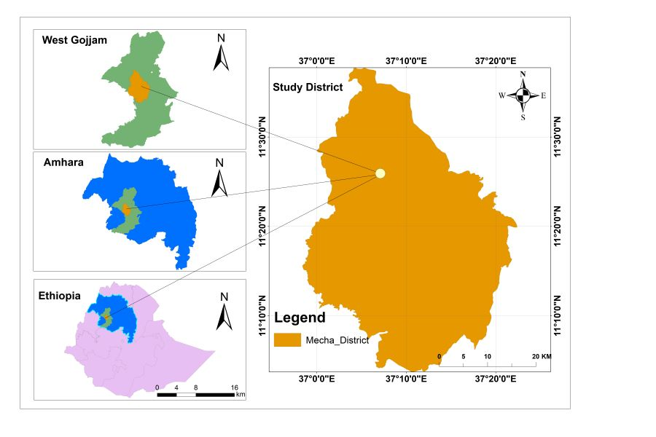
Figure 3.. Location map of study area

Climate
Agro-ecologically, the study area is characterized by uni-modal rainfall pattern. Its climatic condition alternates between summer rainfall and winter dry season. The main rainy season extends from mid-May to mid-September with maximum rainfall found between June and August. The mean annual rainfall of the district is 1572 mm and the mean temperature is 25⁰C. According to Ethiopian traditional agro-ecological classification, the study district is classified under Weyina Dega (mid altitude, 1800–2400 m.a.s.l) (Mekonnen Getahun, 2015). Specifically, the mean annual rainfall and temperature of the experimental site during the cropping season were 272.33 mm and 19.2⁰C, respectively (Koga irrigation metrological station, 2023). Based on this data, the maximum rainfall was recorded in July and June followed by August and May (Figure 2). As well as, the minimum (17.2⁰c) and maximum (21.2⁰c) temperature was recorded in December and May, respectively.

Figure 3.. Mean monthly rainfall and temperature data (Koga irrigation metrological station,2023)

Soil and topography of the experimental area
The geology or parent material of the soil in the study site is derived from the basaltic rocks, as the result of structural processes such as faulting and uplifting during the tertiary period and, modified by external processes such as recent volcanic, denudation and sedimentation during the quaternary period and dominated by Nitisols (FAO, 1998).
The study area has 70% level topographic feature. From the total area of study district, 13% is undulated and the remaining 8% and 4% of the area are covered by mountainous and valley topographies, respectively. Specifically, topography of the study site is characterized by gentle slope with ranges (0 to 4.5%), which is under the range of level slope (Mecha Wereda Agricultural Office, 2023).

Crop production and farming practices
Agriculture is the main economic sector in the study area. Farmers in the study area, carryout mixed farming practices integrating crop production with livestock rearing for their sustainable life. The farming system is mostly rainfall dependent and subsistence in nature where the average productivity has been substantially decreased due to the major constraints; particularly the loss of soil fertility, land shortage, and crop pest and disease damage. Farmers sometimes use farm machinery along with traditional farming system (human and animal power) in agronomic practices. The major field crops mainly grown in the study area are wheat (Triticum aestivum L.), maize (Zea mays), teff (Eragrostis tef), barley (Hordeum vulgare), and to some extent Faba bean (Vicia faba L.). Furthermore horticultural crops like onion (Alluim cepa L.), tomato, (Solanum lycopersicum L.), potato (Solanum tuberosum L.), cabbage (Brassica oleracea L.), and pepper (Capsicum species) are grown (Mecha Wereda Agricultural Office, 2023).

Experimental Materials and Design

Experimental materials
The Wolki (EH96049-2) Faba bean (Vicia faba L.) variety was used as the test crop and sown at a rate of 200 kg ha⁻¹. This variety was already adapted and still performs best in the study area. The variety was released in 2008 by Holleta Agricultural Research Centre (HARC) and can grow in 1900 to 2800 m above sea level (m.a.s.l.) with ecological requirement of 700 to 1000 mm annual rainfall. Two Faba bean rhizobium strains of EAL 17 and EAL 1035 were applied as inoculant. The sugar solution was prepared as sticker material by mixing 10 g of sugar with 100 ml of water to evenly coat the seeds with inoculants. In the ratio of one packet of the inoculum (125 g) to 200 ml of water was mixed to make slurry. The seeds were mixed in the slurry ensuring uniform coating of the inoculum over the seeds and dried under shade for about 30 minutes and sown. One packet of the inoculum (125 g) was sufficient to treat 10 kg of seed as per the recommendation. Peat carrier-based inoculant of each strain was applied at the rate of 10 g kg⁻¹ seed as described by Rice et al. (2001) before sowing. Lime, as an acidic soil amendment, was applied in 2 ton ha⁻¹ rate. Starter nitrogen with 0 kg ha⁻¹, 10 kg ha⁻¹, and 20 kg ha⁻¹ rate was applied to make favorable condition for the bacteria and Faba bean plant in its early growing stage. Triple Super Phosphate (TSP) fertilizer (40% P₂O₅) was applied uniformly for all plots with 60kgha⁻¹ rate (Adet Agricultural Research Center, 2002, unpublished) to satisfy the need of crop for phosphorus. The sources of N and P fertilizers were urea and TSP, respectively. Triple super phosphate (TSP) fertilizer and rhizobium strains were obtained from Adet Agricultural Research Center and Holleta Agricultural Research Centre (HARC), respectively. All the rest experimental materials were provided by Bahir Dar University Healthy Food Africa project.

Design and treatment setup
The study was conducted at Bahir Dar University’s research site in Koga irrigation scheme in 2023 main cropping season. The trial comprised three factors, lime rates (0, and 2 t ha⁻¹), starter Nitrogen (0, 10 and 20kgha⁻¹), and rhizobium inoculation (0, strain1 and strain2).These treatments were arranged in 2x3x3 factorial arrangement and implemented using a randomized complete block design. Totally, there were eighteen treatments replicated three times (Table 3.1). Each plot had a gross area of 2m × 3.2 m (6.4m²) and 1.8m×2.4m (4.2 m²) harvestable area having eight rows, with 0.1m, 0.4 m, 0.5 m, and 1 m spacing between plants, rows, plots, and blocks respectively. The gross experimental area was 44.5m×11.6m (516.2m²). A full dose of P and N were applied at planting. The lime was incorporated into the soil at a depth of 0-20 cm four weeks before planting. The recommended planting depth of 6 cm was used during sowing time. Weeding practice was carried out manually three times throughout the growing period.
Table 3.. Treatment combination in a factorial arrangement
No. |  | Treatment combinations
1 | L0S0N0 | Control(0 ton ha⁻¹ Lime+0 Strain+0 kgha⁻¹N)
2 | L0S1N0 | 0 ton ha⁻¹ Lime +Strain 1+0 kgha⁻¹ N
3 | L0S2N0 | 0 ton ha⁻¹ Lime+ Strain 2+0 kgha⁻¹ N
4 | L1S0N0 | 2 ton ha⁻¹ Lime+0 Strain+0 kgha⁻¹ N
5 | L1S2N0 | 2 ton ha⁻¹ Lime+ Strain 2+0 kgha⁻¹ N
6 | L1S1N0 | 2 ton ha⁻¹ Lime+ Strain 1+0 kgha⁻¹ N
7 | L0S0N10 | 0 kgha⁻¹ Lime+0 Strain+ 10 kgha⁻¹ N
8 | L0S1N10 | 0 ton ha⁻¹ Lime +Strain 1+10 kgha⁻¹ N
9 | L0S2N10 | 0 ton ha⁻¹ Lime +Strain 2+10 kgha⁻¹ N
10 | L1S0N10 | 2 ton ha⁻¹ Lime+0 Strain +10 kgha⁻¹ N
11 | L1S1N10 | 2 ton ha⁻¹ Lime+ Strain1+10 kgha⁻¹ N
12 | L1S2N10 | 2 ton ha⁻¹ Lime+ Strain 2+10 kgha⁻¹ N
13 | L0S0N20 | 0 ton ha⁻¹ Lime +0 Strain +20 kgha⁻¹ N
14 | L0S1N20 | 0 ton ha⁻¹ Lime +Strain 1+20 kgha⁻¹ N
15 | L0S2N20 | 0 ton ha⁻¹ Lime +Strain 2+20 kgha⁻¹ N
16 | L1S0N20 | 2 ton ha⁻¹ Lime+0 Strain +20 kgha⁻¹ N
17 | L1S1N20 | 2 ton ha⁻¹ Lime+ Strain 1+20 kgha⁻¹ N
18 | L1S2N20 | 2 ton ha⁻¹ Lime+ Strain 2+20 kgha⁻¹ N
Where, L0=without lime, L1=with lime, S0=without inoculant, S1=strain1 (EAL 17), S2=strain2 (EAL 1035), N0=without starter nitrogen, N10= 10kg ha⁻¹ nitrogen, and N20= 20kg ha⁻¹ nitrogen

Soil Sampling, Preparation and Analysis

Soil sampling, preprocessing and analysis
Both disturbed (composite) and undisturbed samples were collected to a soil depth of 0–20 cm by using diagonal sampling method. Before planting, disturbed soil samples were collected from 9 points at the experimental site using soil auger, and bulked together to have one composite sample. On the other hand, after crop harvest, five subsamples were collected by using diagonal sampling method from each treatment plot to form one composite soil sample in three replications. As a result, a total of 54 disturbed composite samples (18 treatment plots × 3 replications) were collected.
In addition to this, undisturbed core soil samples were collected using a core sampler (98.125 cm³ volume) for bulk density and total porosity determination. Undisturbed soil samples were collected from nine points separately by using a core-sampler to take an average bulk density and total porosity of the experimental site before planting. After harvesting, undisturbed core sample was also collected at the center of each experimental plot, and a total of 54 undisturbed soil samples were collected.
The disturbed composite soil samples collected from the representative treatment plots were air-dried, mixed well, and passed through a 2 mm sieve for all parameters that were determined except for total nitrogen and organic carbon which passed through a 0.5 mm sieve. All disturbed and undisturbed soil samples were analyzed in Bahir-Dar University’s Soil and Plant Analysis Laboratory, Bahir Dar, Ethiopia.
In addition to this, nine undisturbed soil samples were collected separately by using a core-sampler to take an average bulk density of the experimental site, and 54 undisturbed soil samples.
Soil physical properties
Soil bulk density was determined by the method as described in Black (1965) where first undisturbed soil samples taken by core sampler of known volume (height 5 cm and diameter 5 cm) weighed at field moisture condition. The soil samples were then oven dried at 105ºc for 24 hours until constant weight and the oven dried samples were weighed again. Bulk density was then computed by dividing the weight of oven dried soil samples to the volume of the core sampler.
$$BD=\frac{Mass of dry soil (g)}{Volume of core sampler (cm-3 )}…………Equation 1 (Black ,1965)$$
Total porosity was estimated using (Equation 2) assuming an average particle density (Pd) value of 2.65 g cm⁻³.
$$TP \left(\%\right)=\left(1-\frac{Bd}{Pd} \right)*100----------Equation2$$
Where, TP is total porosity (%), Pd is particle density which is assumed to be 2.65 g cm-3 and Bd is bulk density (g cm⁻³).
The soil particle size distribution was determined following the hydrometer method (Bouyoucos, 1962). Hydrogen peroxide (H₂O₂) was used to destroy the organic matter and sodium hexa-meta phosphate (NaPO₃) were added to samples as dispersing agent. Finally, soil textural names were determined following the textural triangle of USDA system as described by Rowell (1994).
Soil chemical properties
Soil reaction (pH) was measured potentiometrically using a digital pH meter in the supernatant suspension of 1:2.5 (soil: water ratio) (Rhoades, 1982).
Organic carbon (OC) content was analyzed following the wet digestion method as described in Walkley and Black (1934) which involves digestion of the OC in the soil samples with potassium dichromate in sulfuric acid solution. Percent organic matter of the soils was determined by multiplying the percent organic carbon value by 1.724 conventional called "Van Berminelen factor.
The kjeldahl procedure was followed for the determination of total nitrogen (TN) that follows oxidizing of the sample with concentrated sulfuric acid and converting the nitrogen in the organic compounds into ammonium sulphate during the oxidation process (Bremner & Mulvaney, 1982). Available phosphorus (av. P) was determined following the Bray II extraction method using a spectrophotometer (Bray and Kurtz, 1945).Cation exchange capacity (CEC), the total number of exchangeable cations that a soil can hold, was measured after saturating the soil with 1N ammonium acetate (NH4OAc) and displacing it with 1N NaOAc (Chapman,1965). Exchangeable acidity (Al and H) were determined from a neutral 1 N KCl extracted solution through titration with a standard NaOH solution.
Exchangeable bases were determined from the leachate of 1 molar ammonium acetate (NH4OAc) solution at pH 7.0. Accordingly, exchangeable K and Na were read by using flame photometer from the same extract (Rowell, 1994).

Crop Data Collection
Faba bean agronomic data collected were shoot parameters (plant height), yield components (shoot dry weight ,number of pod per plant, number of seed per pod, nodule number, nodule dry weight and hundred seed weight), and yield parameters (above ground biomass yield, grain yield, straw yield, and harvest index)

Shoot growth parameters
Plant Height (cm)
Five plants from six central non-boarder rows were randomly selected from each plot and measured at physiological maturity from the base of the plant to the tip (terminal bud of the plant) by measuring tape. The mean height of five plants was recorded as plant height.

Yield and yield components
Shoot Dry Weight (g)
Five plants were randomly selected at physiological maturity from six harvestable rows in each plot and oven-dried to a constant weight for 65 h at 75^{°c} for determination of Shoot dry weight in gram. The average dry weight of five plants was measured to determine dry weight per plant.
Number of pod per plant
At physiological maturity, five plants were randomly selected from non-boarder harvestable rows of each plot. The pods were collected and counted separately from each plant and their average was taken and reported as number of pods per plant.
Number of seed per pod
After pods had been counted from each of the five randomly selected non-border plants, grains were separated from pods to get the number of grains per plant. For each plant the number of grains per pod was calculated by dividing the total number of grains per plant with the number of pods per plant. Finally, the mean value of five plants was taken as number of grains per pod.
Nodule number per plant
Sampling for nodulation was performed by excavating the roots of five randomly selected plants in each plot at mid flowering stage of Faba bean by destructive sampling from the boarder rows. A hoe was used to dig out the root surrounding soil and the spade was used to excavate the dug soil around 20 cm depth which is approximately the rooting depth of Faba bean, and the radius of approximately 12 cm extending out from the central stem containing entire root system of the Faba bean. The excavated soil was washed from the roots using washing bottle. Nodules from crown region and lateral roots subsequently were removed from the roots and collected in plastic bag for counting. The total number of nodules were counted and the effective and non-effective nodules were counted separately (visual observation) in those five sample plants by taking the intensity of the pink color into consideration (i.e. nodules which have pink and pinkish brown color are considered as effective nodules, while ineffective nodules were white to light green inside (Gwata.et al, 2003) and the effective nodules undergo further analysis like for nodule number and nodule dry weight. The mean values of effective nodules from the five plants were recorded as number of nodules per plant.
Nodule dry weight per plant
After the nodules were oven dried to 65°C for 48 hours and the average nodule weight per plant was measured for each treatment following the procedure as described by (Delic et al, 2010).
Hundred seed weight (g)
Hundred seed weight (g) was determined by counting 100 randomly selected Faba bean seeds from the net plot harvest using an electronic seed counter and adjusted yield of the harvest at 10% grain moisture content and weighing them with an electronic balance.
Above ground biomass yield (AGBY)
Five plants were randomly selected at physiological maturity from six harvestable rows in each plot and oven-dried to a constant weight for 65 h at 75°C for determination of aboveground dry biomass. The average dry weight of five plants was measured to determine dry weight per plant. The total biomass yield was determined by multiplying the dry biomass per plant by the total number of plants in the net plot area and converted into kg ha⁻¹ basis, then to ton ha⁻¹ as it also could be determined by weighing the total aboveground biomass from net plot at harvest time.
Grain yield (GY)
After threshing of the Faba bean crop had been done, seed was adjusted to 10% moisture content and weighed.
Straw yield
Straw yield was determined by subtracting grain yield from total biomass yield.
Harvest index (HI %)
The harvest index was calculated by multiplying the ratio of the dry weight of the grain to the dry weight of the total aboveground biomass yield by 100. This calculation shows us the proportion of biomass allocated to grain production.

Data Analysis
All the collected data were subjected to analysis of variance (ANOVA) at 5% significance level. The ANOVA procedure of statistical analysis system (SAS Institute, 1996, version 9.0) was used to perform the significant differences in plant height, number of pod per plant, number of seed per pod, nodule number, nodule dry weight, grain yield, above ground biomass, and hundred seed grain weight and for soil health parameters. A post hoc separation of means was done by Tukey’s Studentized Range (HSD) test after main effects were found significant at (p < 0.05).

Partial Budget Analysis
While economic analysis, the actual biomass and grain yield were adjusted to 10% to match experimental yields with the expected yields by the farmers from the same treatment. The gross benefit (GB), total variable costs (TCV), net benefit (NB), and marginal rate of return (MRR) were determined separately for each treatment. The gross benefit was calculated as the product of the adjusted grain and straw yields and their respective price per kilogram of grain and straw at harvest time in each treatment. The current prices of 1 kg of Faba bean grain and straw were 68 and 5 ETB, respectively.
The total variable costs included in all treatments were N fertilizer purchase, lime, and rhizobium strain purchase costs, transportation costs, and application costs (ETB ha⁻¹). All the costs were valued based on the current price of each item. The cost of lime in form of (Caco₃), nitrogen in the form of urea, rhizobium strain1, and strain 2 were 32 ETB per kg, 105 ETB per kg, and 500 birr, 650 ETB ha⁻¹. According to the work norm around experimental area, 500 ETB ha⁻¹ was adequate to transport and incorporate lime into the field. Lime application may enhance yields for three subsequent years due to its residual effects, so the price of lime was divided by three and one third of its price was calculated as its variable cost. The net benefit (NB) was calculated by subtracting the total variable cost (TVC) from the gross benefit (GB) of each treatment in the ETB ha⁻¹(CIMMYT, 1988).
The dominance analysis was done by arranging the treatments with increasing costs of variation and then the most economically preferable treatment was identified. All The dominated treatments were removed from the MRR analysis. A marginal rate of return (MRR) was calculated as the difference in change in net benefit to the change in total variable cost for each pair of ranked treatments (Eq.3).
$$MRR=\frac{NB}{TVC}*100---------Equation 3$$
The MRR% between any pair of non-dominated treatments notifies the return per unit of investment in rates of lime, strain and starter nitrogen applications. The minimum acceptable marginal rate of return (MARR) considered was 100% and above. This research was supported by economic analysis for significant biological yields, which is a partial budget analysis based on CIMMYT (1988)

RESULTS AND DISCUSSION

Soil Physicochemical Properties before Experimentation
Parameters | Unit | Soil result | Rating |  | Sources
Texture
Sand | % | 34 | Clay | Rowell (1994)
Silt | % | 22
Clay | % | 44
BD | g/cm3 | 1.35 | Normal | Hazelton and Murphy (2016)
TN | % | 0.20 | Medium | Landon (1991)
Av.P | ppm | 10.36 | Low | Landon (1991)
OC | % | 0.61 | Very low | Landon (1991)
K | Cmol+/kg | 0.28 | Medium | Landon (1991)
Na | Cmol+/kg | 0.19 | - | -
CEC | Cmol+/kg | 14.44 | Low | Landon (1991)
pH(H2O) | - | 4.34 | Strongly acidic | Jones (2001)
Based on the laboratory results, the textural class of the experimental soil is clay. The pH of the soil was 4.34. The soil bulk density before treatment application was 1.35 g/cm³. The organic carbon content and total nitrogen of the soil was 0.61 and 0.20%, respectively. The available phosphorus in the soil was recorded as 10.36 ppm. The CEC, exchangeable K, and exchangeable Na of the soil was 14.44, 0.28, and 0.19cmol (+)/kg, respectively (Table 4.1).
Table 4.. Soil physicochemical properties of the study site before treatment application

Effects of Soil Amendments on Soil Physicochemical Properties

Bulk density (BD) and Total porosity (TP)
The main effects of lime and rhizobium strain brought very highly significant (p<0.001) effect on soil bulk density (Appendix Table 1).The application of starter nitrogen also highly significantly (p<0.01) affected bulk density. The combined application of lime, rhizobium strain, and starter nitrogen had very high significant (p<0.001) effect on bulk density of the soil as well (Appendix Table 1). The study showed that the combined application of 2 t ha⁻¹ lime, rhizobium strain2 (EAL 1035), and 20 kgha⁻¹ N brought the lowest (1.0227 g cm⁻³) bulk density; whereas the highest bulk density value (1.303 g cm⁻³) was observed in the control treatment (Table 4.2). This implies that soil bulk density was reduced by 21.5% due to the combined application of lime, rhizobium strain, and starter nitrogen. This result may be attributed to rhizobium strains which could enhance root biomass that had contribution for the addition of organic matter to the soil.
The analysis of variance result confirmed that total Porosity (TP) of the soil was very highly significantly (p<0.001) influenced by the main and interaction effects of lime, strain, and starter nitrogen (Appendix Table 1). Accordingly, the maximum total porosity value (61.41%) was obtained by the application of 2 t ha⁻¹ lime, rhizobium strain2 (EAL 1035), and 20 kgha⁻¹ N followed by of the application of 2 t ha⁻¹ lime, rhizobium strain1 (EAL 17) combined with 20 kgha⁻¹ N. The minimum total porosity value (50.83%) was recorded in the control treatment (Table 4.2). This indicated that treatment application could increase porosity by 10.58 values which are valued as 20.81% increment. This increment is attributed to increased organic matter addition to the soil due to high root biomass production associated with the improvement in bulk density of the soil.

Table 4.2. Response of bulk density and total porosity to the integrated application of lime, strain, and starter nitrogen
 | Treatment |  |  | BD(gcm⁻³) | TP (%)
No. | L (t/ha) | S | N(kgh⁻¹)
1 | 0 | 0 | 0 | 1.303ª | 50.83^{h}
2 | 0 | 1 | 0 | 1.198^{bcd} | 54.80^{efg}
3 | 0 | 2 | 0 | 1.124^{d-g} | 57.59^{b-e}
4 | 2 | 0 | 0 | 1.092^{fgh} | 58.78^{abc}
5 | 2 | 2 | 0 | 1.049^{gh} | 60.42^{ab}
6 | 2 | 1 | 0 | 1.058^{gh} | 60.06^{ab}
7 | 0 | 0 | 10 | 1.158^{c-f} | 56.29^{c-f}
8 | 0 | 1 | 10 | 1.104^{fgh} | 58.34^{abc}
9 | 0 | 2 | 10 | 1.190^{cde} | 55.09^{def}
10 | 2 | 0 | 10 | 1.064^{gh} | 59.86^{ab}
11 | 2 | 1 | 10 | 1.089^{fgh} | 58.92^{abc}
12 | 2 | 2 | 10 | 1.059^{gh} | 60.04^{ab}
13 | 0 | 0 | 20 | 1.276^{ab} | 51.86^{gh}
14 | 0 | 1 | 20 | 1.226^{abc} | 53.72^{fgh}
15 | 0 | 2 | 20 | 1.117^{d-g} | 57.86^{b-e}
16 | 2 | 0 | 20 | 1.108^{efg} | 58.18^{bcd}
17 | 2 | 1 | 20 | 1.023^{h} | 61.40ª
18 | 2 | 2 | 20 | 1.0227^{h} | 61.41ª
Mean |  |  |  | 1.126 | 57.53
Sig(P<0.05) |  |  |  | *** | ***
LSD |  |  |  | 0.084 | 3.186
CV (%) |  |  |  | 2.44 | 1.80
Means followed by the same letter in a column are not significantly different at 5% probability level; L: lime, S: strain, N: nitrogen, BD: bulk density, TP: total porosity, ***: significant at p<0.001, CV (%): coefficient of variation in percent.

Soil reaction (pH)
The analysis of variance showed that lime had very high significant influence (p <0.001) on soil pH (Appendix Table 1). These findings indicated that sole application of nitrogen fertilizer as starter did not have significant (p>0.05) effect on soil pH, which might be attributed to the acidifying effect of nitrogen fertilizer. The combined application of lime, rhizobium strain and N brought high significant effect on soil pH (Appendix Table 1). The maximum soil pH (6.6) was recorded from the application of 2 t ha⁻¹ lime, rhizobium strain1 (EAL 17) combined with 20 kgha⁻¹ N, while the minimum soil pH (4.387) was observed from the control treatment (Table 4.3). According to this result, soil pH increased by 2.213 values (50.44%) compared to the control treatment. This result may be attributed to lime (CaCO3), because lime has the potential in reducing soil acidity due to its high acid neutralizing ability and can efficiently eliminate existing acid. Liming also reduces heavy metal toxicity. It elevates the pH of the soil and causes the aluminum and manganese in the soil solution to return to solid (non-toxic) chemical forms.
This result is in line with findings of Adane Buni (2014) who stated that soil pH was increased significantly from 5.03 in the plots without lime to 6.72 at the lime rate of 3.75 t CaCO3ha⁻¹. An experiment conducted at Holeta Agricultural Research Center also showed that soil pH was significantly (p<0.05) increased after 2 years of liming (Temesgen Desalegn et al., 2016). This investigation also agreed to findings of Achalu Chimdi et al. (2012) who has reported that liming raises soil pH and reduce Al³⁺concentration. Erkihun Alemu et al. (2022) also reported that lime application brought significant (p<0.01) increase in soil pH.

Soil organic carbon (%OC)
This study revealed that application of lime had very high significant (p<0.001) effect on soil organic carbon (Appendix Table 1). The analysis of variance showed that lime brought 32.3% increment in organic carbon content from un-limed treatments. Rhizobium strains and nitrogen also had significant effects at (p<0.001 and p<0.01) respectively. The interaction of lime, strain, and starter nitrogen very highly significantly (p<0.001) influenced soil organic carbon (Appendix Table 1). Accordingly, the maximum organic carbon content (1.71%) was recorded from the application of 2 t ha⁻¹ lime, rhizobium strain2 (EAL 1035) and 20 kgha⁻¹ N which was statistically share similar result with the application of 2 t ha⁻¹ lime, rhizobium strain1 (EAL 17) combined with 20 kgha⁻¹ N, application of 2 t ha⁻¹ lime, rhizobium strain1 (EAL 17) combined with 10 kgha⁻¹ N, and the application of 2 t ha⁻¹ lime, rhizobium strain1 (EAL 1035) combined with 10 kgha⁻¹ N. Whereas, the lowest organic carbon (0.80%) was observed in the control treatment (Table 4.6). This indicated that treatment could increase soil organic matter by 113.8%. This result may be due to high root biomass improvement and organic matter adding ability of rhizobium strains.
This result contradicted with the findings of Erkihun Alemu et al. (2021) who reported that soil organic carbon did not show significant difference in treatments by lime application; It was also reported by several authors (Kebede and Dereje, 2017; Jafer and Gebresilassie, 2017; Mesfin Kassa et al., 2014), that soil organic carbon didn't show any significant difference among treatments through the application of different lime rates using different application methods.

Total nitrogen (TN)
The analysis of variance validated that application of lime, strain and starter nitrogen had very high significant (p<0.001) main effect on total nitrogen of the soil (Appendix Table 1). Total nitrogen was also significantly (p<0.05) influence by the interaction effects of lime, strain and starter nitrogen (Appendix Table 1). Total N was in the range of 0.203 to 0.267% after the application of lime, strain and starter nitrogen. The highest value of soil total N (0.267%) was recorded from plots treated with 2 t ha⁻¹ lime, rhizobium strain2 (EAL 1035) and 20 kgha⁻¹ N, and the lowest value of total N (0.203%) was recorded from the control treatment (Table 4.3 ). It was observed that the content of soil total N increased by about 31.53% over the control plot; this substantial increase in total N could have been caused by quick action of rhizobium strains inoculation in improving soil nitrogen concentration. This improvement might be attributed to N fixed biologically by microorganism.
This finding is in contrary to the findings of Erkihun Alemu et al. (2021) who reported that soil total nitrogen did not show significant difference in treatments by lime application; several authors (Kebede and Dereje, 2017; Jafer and Gebresilassie, 2017; Mesfin Kassa et al., 2014) also reported that total nitrogen did not show any significant difference among treatments through the application of different lime rates.

Available phosphorus (Av.P)
The study showed that application of lime and rhizobium strain had a very high significant (p<0.001) main effect on soil available phosphorus (Av.P) (Appendix Table 1).The integrated application of lime, strain, and starter nitrogen also highly significantly (p<0.01) increased available phosphorus (Appendix Table 1). According to analysis of variance, the highest available phosphorus value (20.353ppm) was obtained from the application of 2 t ha⁻¹ lime, rhizobium strain2 (EAL 1035) and 20 kgha⁻¹ N compared to other treatments, while 11.067 ppm available phosphorus was recorded in the control treatment (Table 4.3).This increment may be attributed to lime which makes fixed p available to the plants. The lowest value (8.62 ppm) was observed in the treatment received only 10 kgha⁻¹ nitrogen, it may be due to acidifying effect of nitrogen fertilizers.
This finding agreed with the investigations of different authors (Adane Buni, 2014; Temesgen Desalegn et al., 2017; Getachew Agegnehu et al., 2017; Kebede and Dereje, 2017) who reported that lime application significantly increased soil available phosphorus; whereas it is contradicted with the findings of Erkihun Alemu et al., (2021) who reported that soil available phosphorus did not show significant increase in treatments by lime application.

Exchangeable acidity (Ex.A)
Based on the analysis of variance (ANOVA), exchangeable acidity was very highly and significantly (p < 0.001) influenced by the main effect of lime, but strain and starter nitrogen did not show any significant main effect on exchangeable acidity (Appendix Table 2).The interaction of treatment combination significantly(p<0.05) reduced soil exchangeable acidity(Appendix Table 2). According to analysis of variance, the highest exchangeable acidity value (5.593 cmol (+)/kg)) was recorded from the application of rhizobium strain2 (EAL 1035) and 20 kgha⁻¹ N, while the lowest value (0.08 cmol (+)/kg)) was recorded in the treatment received sole application of 2 t ha⁻¹ lime (Table 4.3). This result noticed that application of nitrogen fertilizers in form of urea and Ammonium had the power to increase exchangeable acidity as lime had reducing power. The decline in exchangeable acidity with liming is explained by the increased replacement of Al by Ca in the exchange site and by the subsequent precipitation of Al as Al (OH)3.
The result is in alignment with the findings of Erkihun Alemu et al. (2021) who reported that soil exchangeable acidity brought significant difference in treatments by lime application.

Exchangeable aluminum (Ex.Al)
Analysis of variance (ANOVA) showed that exchangeable Aluminum was very highly and significantly (p < 0.001) influenced by the main effect of lime as well as strain, but it was not influenced by nitrogen (Appendix Table 2). Integrated application of lime, strain, and starter nitrogen also brought very high significant (p < 0.001) difference on exchangeable Aluminum (Appendix Table 2). Accordingly, the lowest exchangeable Aluminum values (0.00 cmol (+)/kg)) were recorded from the application of 2 t ha⁻¹ lime, rhizobium strain2 (EAL 1035) and 20 kgha⁻¹ N, which is similar with the application of 2 t ha⁻¹ lime, rhizobium strain1 (EAL 17) and 20 kgha⁻¹ N, as well as 2 t ha⁻¹ lime, rhizobium strain2 (EAL 1035) and 10 kgha⁻¹ N, 2 t ha⁻¹ lime, rhizobium strain1 (EAL 17) and 10 kgha⁻¹ N, while the highest value (4.327 cmol (+)/kg)) was recorded in the treatment received rhizobium strain2 (EAL 1035) and 20 kgha⁻¹ N (Table 4.3). The decline in exchangeable aluminum may be attributed to lime due to the increased replacement of Al by Ca in the exchange site and by the subsequent precipitation of Al as Al (OH)3.
The result is in line with the investigation of Opala et al.(2018) who reported that exchangeable Al contents of the soil were significantly (p ≤ 0.05) decreased with increasing rates of lime and P as well as by the interaction effects of lime and P application.

Exchangeable bases (Potassium (K) and Sodium (Na))
As shown in Table 4.3, exchangeable K and Na showed very high significant difference (p < 0.001) among treatments due to treatment application. Lime application had very high significant (p < 0.001) main effect on exchangeable Potassium, strains as well (Appendix Table 2). Integrated application of lime, strain, and starter nitrogen brought very high significant (p < 0.001) difference on exchangeable Potassium (Appendix Table 2). Based on the result, the highest exchangeable K value (0.42 cmol(+)/kg) was recorded in treatment received 2 t ha⁻¹ lime, rhizobium strain1(EAL 17),and 20 kgha⁻¹ starter nitrogen, while the lowest value (0.273 cmol(+)/kg) was observed from applying strain2(EAL 1035) and 20 kgha⁻¹ starter nitrogen(Table 4.6).
Exchangeable Sodium (Na) was very highly significantly (p < 0.001) affected by the main effects of both lime and rhizobium strains; whereas nitrogen did not have significant effect (Appendix Table 2).Analysis of variances(ANOVA) revealed that the interaction of lime, strain, and nitrogen brought significant(p<0.05) effect on exchangeable Sodium (Na) (Appendix Table 2). According to the result, the highest exchangeable Sodium (Na) value (0.34 cmol (+)/kg) was recorded in treatment received 2 ton ha⁻¹ lime and rhizobium strain2 (EAL 1035), but the lowest value (0.273 cmol (+)/kg) was observed from sole application of 20 kgha⁻¹ starter nitrogen (Table 4.6).
Erkihun Alemu et al. (2021) also confirmed that soil exchangeable bases (Potassium and Sodium) brought significant difference in treatments by lime application. This result also agreed to the findings of Mosharrof et al. (2021) who reported that application of lime brought significant increase in exchangeable Potassium.

Cation exchange capacity (CEC)
The cation exchange capacity was significantly influenced by the main effects of lime, strain, and starter nitrogen at (p<0.001, p<0.001, and p<0.01) values respectively (Appendix Table 2). Analysis of variances (ANOVA) confirmed that the interaction of lime, strain, and nitrogen also brought high significant (p < 0.01) effect on cation exchange capacity (Appendix Table 2).Accordingly, the highest cation exchange capacity (CEC) value (35.2 cmol(+)/kg) was recorded from plots treated with 2 t ha⁻¹ lime, rhizobium strain1(EAL 17), and 20 kgha⁻¹ N, whereas the lowest value (15.26 cmol(+)/kg) was observed in the control treatment(Table 4.3). The increase in cation exchange capacity due to liming could be attributed to the change in pH and the release of the initially blocked and interlayer substitutional negative charge by de-protonation of the variable charge minerals and functional groups of humic compounds caused by Ca^{2+.}
The result agreed to the findings of Erkihun Alemu et al. (2021) who reported that cation exchange capacity was significantly increased in treatments by lime application.

Table 4.3. Mean values of selected soil chemical properties to the application of lime, strain, and starter nitrogen
No. | Treatment  combination |  |  | pH | %OC | TN (%) | Av.P(ppm) | EA(cmol(+)/kg) | Ex.Al(cmol(+)/kg) | CEC(cmol (+)/kg) | Ex.K(cmol(+)/kg) | Ex.Na(cmol (+)/kg)
 | L(t/ha) | S | N(kgh⁻¹)
1 | 0 | 0 | 0 | 4.387^{d} | 0.80^{i} | 0.203^{f} | 11.067^{i-k} | 4.293^{c} | 3.68^{bc} | 15.26^{f} | 0.276^{g} | 0.21^{f}
2 | 0 | 1 | 0 | 4.417^{d} | 1.24^{efg} | 0.213^{ef} | 13.72^{fg} | 4.633^{abc} | 3.36^{d} | 15.33^{f} | 0.283^{g} | 0.23^{ef}
3 | 0 | 2 | 0 | 4.413^{d} | 1.30^{def} | 0.213^{ef} | 10.21^{ijk} | 5.1^{abc} | 3.893^{b} | 16.07^{f} | 0.28^{g} | 0.24^{def}
4 | 2 | 0 | 0 | 6.460^{ab} | 1.42^{cde} | 0.227^{c-f} | 18.78^{a-d} | 0.08^{f} | 0.00^{f} | 22.27^{cde} | 0.33^{ef} | 0.32^{abc}
5 | 2 | 2 | 0 | 6.483^{ab} | 1.49^{a-d} | 0.233^{b-e} | 16.86^{cde} | 0.13^{f} | 0.00^{f} | 23.67^{bc} | 0.343^{cde} | 0.34ª
6 | 2 | 1 | 0 | 6.460^{ab} | 1.43^{cde} | 0.233^{b-e} | 15.79^{ef} | 0.313^{f} | 0.00^{f} | 22.4^{cd} | 0.377^{a-d} | 0.27^{cde}
7 | 0 | 0 | 10 | 4.553^{d} | 1.05^{gh} | 0.217^{def} | 8.62^{k} | 5.347^{ab} | 3.44^{d} | 17.133^{def} | 0.287^{fg} | 0.24^{def}
8 | 0 | 1 | 10 | 4.420^{d} | 1.1^{fgh} | 0.213^{ef} | 11.36^{g-j} | 4.487^{bc} | 3.847^{b} | 16.333^{ef} | 0.28^{g} | 0.24^{def}
9 | 0 | 2 | 10 | 4.613^{d} | 1.27^{d-g} | 0.217^{def} | 9.813^{jk} | 2.8^{d} | 3.46^{cd} | 16.1^{f} | 0.283^{g} | 0.24^{def}
10 | 2 | 0 | 10 | 6.257^{b} | 1.35^{cde} | 0.24^{bcd} | 16.23^{def} | 1.753e | 0.00^{f} | 20.533^{c-f} | 0.353^{b-e} | 0.27^{cde}
11 | 2 | 1 | 10 | 5.993^{c} | 1.53^{abc} | 0.247^{abc} | 18.18^{a-e} | 0.763^{ef} | 0.00^{f} | 28.4^{b} | 0.337de | 0.27^{cde}
12 | 2 | 2 | 10 | 6.480^{ab} | 1.55^{abc} | 0.247^{abc} | 19.577^{ab} | 0.493^{f} | 0.00^{f} | 25.6^{bc} | 0.393^{ab} | 0.32^{ab}
13 | 0 | 0 | 20 | 4.553^{d} | 1.30^{def} | 0.213^{ef} | 9.593^{jk} | 4.467^{bc} | 2.867e | 16.21^{f} | 0.28^{g} | 0.20^{f}
14 | 0 | 1 | 20 | 4.470^{d} | 1.33^{cde} | 0.22^{def.} | 12.52^{ghi} | 4.953^{abc} | 3.84^{b} | 16.8^{def} | 0.28^{g} | 0.247^{def}
15 | 0 | 2 | 20 | 4.423^{d} | 0.89^{hi} | 0.227^{c-f} | 13.106^{gh} | 5.593ª | 4.327ª | 15.6^{f} | 0.273^{g} | 0.24^{def}
16 | 2 | 0 | 20 | 5.760^{c} | 1.46^{bcd} | 0.233^{b-e} | 16.96^{b-e} | 0.633^{f} | 0.00^{f} | 22.33^{cd} | 0.37^{b-e} | 0.28^{bcd}
17 | 2 | 1 | 20 | 6.600ª | 1.66^{ab} | 0.257^{ab} | 19.44^{abc} | 0.32^{f} | 0.00^{f} | 35.2ª | 0.42ª | 0.31^{abc}
18 | 2 | 2 | 20 | 6.580ª | 1.71ª | 0.267ª | 20.353ª | 0.267^{f} | 0.00^{f} | 34.6ª | 0.383^{abc} | 0.33ª
 | Mean |  |  | 5.404 | 1.33 | 0.229 | 14.566 | 2.581 | 1.817 | 21.10 | 0.324 | 0.267
 | Sig(P<0.05) |  |  | *** | *** | *** | *** | *** | *** | *** | *** | ***
 | LSD |  |  | 0.237 | 0.223 | 0.0237 | 2.632 | 1.031 | 0.228 | 5.946 | 0.0452 | 0.0485
 | CV (%) |  |  | 1.43 | 5.47 | 3.37 | 5.88 | 12.99 | 4.08 | 9.16 | 4.53 | 5.91

Means followed by the same letter in a column are not significantly different at 5% probability level; L: lime, S: Strain, N: nitrogen, %OC: organic carbon; %TN: total nitrogen, Av.P; available phosphorus, EA: exchangeable acidity, Ex.al: exchangeable Aluminum, CEC: cation exchange capacity, Ex.K: exchangeable potassium, Ex.Na: exchangeable sodium, ***: Significant at p ≤ 0.01

Effects of Soil Amendments on the Shoot Growth Parameters of Faba bean

Plant height (cm)
Plant height was very highly significantly (p<0.001) affected by the main effects of lime, rhizobium strain and starter nitrogen and significantly (p<0.05) affected by their interaction (Appendix Table 3). The maximum plant height (91.83 cm) was recorded from the application of 2 t ha⁻¹ lime, rhizobium strain2 (EAL 1035) and 20 kgha⁻¹ N which was statistically comparable to the application of 2 t ha⁻¹ lime, rhizobium strain1 (EAL 17) combined with 20 kgha⁻¹ N. The shortest plant height (39.37 cm) was observed in the control treatment (Table 4.6). This result might be attributed to lime application, inoculation of rhizobium strains to Faba bean and starter nitrogen application making essential nutrients available to the plant through reducing aluminum toxicity, supplying additional nitrogen through symbiotic nitrogen fixation, and providing nitrogen at initial stage of plant growth, consequently lead to increased plant height.
This result is consistent with the finding of Samuel Adissie et al. (2021) who reported that Strain inoculation significantly affected (P≤0.05) plant height. As a result, Faba bean inoculation with rhizobium strain EAL1018 gave higher (61.733 cm) plant height compared to the other treatments. This finding also agreed with the result of Farfour (2013) who revealed that application of rhizobium stains could increase plant height of Faba bean. Furthermore, El-Azeem et al. (2007) reported that application of bacterial strain significantly increased plant height compared to the treatments without inoculation.

Effects of Soil Amendments on Yield and Yield Components of Faba bean

Number of pods per plant
The number of pod per plant was very highly significantly (p<0.001) affected by the main effects of lime, inoculation and starter nitrogen application and their interaction as well. Accordingly, the maximum pod number per plant(19.33) was recorded from the application of 2 t ha⁻¹ lime, rhizobium strain2 (EAL 1035) and 20 kgha⁻¹ N which was statistically similar to the application of 2 t ha⁻¹ lime, rhizobium strain1 (EAL 17) combined with 20 kgha⁻¹ N, application of 2 t ha⁻¹ lime, rhizobium strain1 (EAL 17) combined with 10 kgha⁻¹ N, and the application of 2 t ha⁻¹ lime, rhizobium strain1 (EAL 1035) combined with 10 kgha⁻¹ N. The lowest pod number per plant (4.78) was recorded in the control treatment (Table 4.6). This increment could be attributed to the increment of Faba bean plant height due to availability of essential nutrients to the plant and reduced aluminum toxicity.
The research conducted by Samuel Adissie et al. (2021) stated that number of pod plant⁻¹ was affected by the inoculation of the all EAL17, EAL1018 and EAL1035 rhizobium strains. Accordingly, inoculation of those three Faba bean varieties brought statistically significant (p≤0.05) difference in pod number compared to the un-inoculated treatment. Yohannes Desta et al. (2015) also reported that rhizobium strain alone could significantly increase number of pods per plant.

Nodule number per plant
The result showed that nodule number per plant was very highly significantly (p<0.001) affected by sole and combined application of rhizobium strains, lime and starter nitrogen (Appendix Table 3). According to this result, the highest nodule number (58.86) was obtained from the application of 2 t ha⁻¹ lime, rhizobium strain2 (EAL 1035) and 20 kgha¹, while the smallest (14.57) nodule number per plant was recorded in the control treatment (Table 4.6). The result implies that application of lime, strain, and nitrogen could boost nodule number. It may be attributed mainly to rhizobium strains’ ability for nodule formation.
This finding is in line with results of Alemayehu Workalemahu (2009) and Nagwa et al. (2012) who reported that inoculation of rhizobium strain to Faba bean significantly increased nodule number. The result of Yohannes Desta et al. (2015) showed that inoculation of Faba bean rhizobium strains significantly increase nodule number/plant. Samuel Adissie et al. (2021) also reported that inoculation of strains significantly (p≤0.05) affected nodule number/plant. This finding is contrary to Endalkachew Fekadu et al. (2018) who reported that uninoculated Faba bean plants with rhizobium formed higher nodule number as compared with plants inoculated and received the same treatment.

Nodule dry weight per plant (NDW)
Analysis of variances (ANOVA) confirmed that nodule dry weight was very highly significantly (p<0.001) affected by the application of lime, strains and nitrogen. Nodule dry weight was also highly significantly (p<0.01) affected by the interaction effects of lime, strains and starter nitrogen as indicated in Appendix Table 3. The highest nodule dry weight (0.34 g/plant) was recorded from the application of 2 t ha⁻¹ lime, rhizobium strain2 (EAL 1035) and 10 kgha⁻¹ N followed by the treatment received 2 t ha⁻¹ lime, rhizobium strain1 (EAL 17) combined with 10 kgha⁻¹ N. The lowest nodule dry weight per plant (0.08 g/plant) was recorded in the control treatment (Table 4.6). This increment could be attributed to the capability of rhizobium strains in biological nitrogen fixation and nodulation.
This result agreed with the findings of Wakeil and Sebai (2007) who reported that application of rhizobium strains brought significantly higher nodule dry weight and nodule number. Rodelas et al. (1999) also confirmed that nodule dry weight was significantly increased (38–53%) by co inoculation with strains. Samuel Adissie et al. (2020) also stated that nodule dry weight was significantly (p<0.05) affected by the application of rhizobium strains, micronutrient and their interactions.

Table 4.4. Interaction effects of strain and nitrogen on nodule number and nodule dry weight
Strain | Starter Nitrogen(kgha⁻¹)
 | 0 | 10 | 20 | 0 | 10 | 20
 |  | NNP |  |  | NDW
0 | 20.63 | 24.132 | 25.362 | 0.113 | 0.132 | 0.137
Strain 1 | 25.392 | 38.738 | 39.383 | 0.137 | 0.227 | 0.215
Strain 2 | 24.615 | 39.68 | 41.237 | 0.133 | 0.228 | 0.222
SE± |  | 0.44 |  |  | 0.007
Sig(P<0.05) |  | *** |  |  | **
CV (%) |  | 3.55 |  |  | 11.75
Where, NNP; nodule number, NDW: nodule dry weight, SE±: standard error, CV: coefficient of variation

Above ground biomass yield (AGBY)
The ANOVA revealed that the main and interaction effects of lime, rhizobium strain, and nitrogen had a very high significant (p<0.001) impact on the aboveground biomass yield of Faba bean (Appendix Table 4). The study showed that the combined application of 2 t ha⁻¹ lime, rhizobium strain2(EAL 1035),and 20 kgha⁻¹ N brought a maximum(6.60 tonha⁻¹) above ground biomass yield, although which was statistically equivalent to the application of the application of 2 t ha⁻¹ lime, rhizobium strain1 (EAL 17) combined with 20 kgha⁻¹ N, application of 2 t ha⁻¹ lime, rhizobium strain1 (EAL 17) combined with 10 kgha⁻¹ N, and the application of 2 t ha⁻¹ lime, rhizobium strain2 (EAL 1035) combined with 10 kgha⁻¹ N. additionally, the biomass yields obtained from the combined application of 2 t ha⁻¹ lime and 20 kgha⁻¹ N, 2 t ha⁻¹ lime and 10 kgha⁻¹ N, 2 t ha⁻¹ lime and strain1 (EAL 17), 2 t ha⁻¹ lime and strain2 (EAL 1035) showed statistically comparable result. On the other hand, the lowest above ground biomass yield (1.67 t ha⁻¹) was recorded from the control treatment. Considerably, the combined application of 2 t ha⁻¹ lime, rhizobium strain 2 (EAL 1035), and 20 kgha⁻¹ N resulted in a substantial increase in above ground biomass yield by 4.93 t ha⁻¹ compared to the control treatment (Table 4.6).
This highly emphasized increment in AGB yield due to the integrated implementation of lime, strain, and starter N might be attributed to rhizobium strain, which could offer optimum amount of nitrogen through biological N-fixation which in turn promotes optimal growth and development of Faba bean crop. This finding is in line with Samuel Adissie et al. (2021), who confirmed that rhizobium strains significantly (p≤0.05) affected biomass weigh, inoculation with EAL1018 brought maximum (10.30 t ha⁻¹) biomass yield while the lowest biomass yield was obtained from the control treatment. Similarly, El-Azeem et al. (2007) reported that inoculation of rhizobium strain cause a significantly increased above ground biomass on Faba bean compared to the control.

Grain yield
The analysis of variance showed that there was a very high significant difference in grain yield (p <0.001) due to the combined application of lime, rhizobium strain, and nitrogen (Appendix Table 4). The main effects of lime, strain, and nitrogen also brought very high significant difference (p<0.001) (Appendix Table 4). The maximum grain yield (2933.03 kg ha⁻¹) was obtained from the application of 2 t ha⁻¹ lime, rhizobium strain 2 (EAL 1035),and 20 kgha⁻¹ N followed by the application of 2 t ha⁻¹ lime, rhizobium strain1 (EAL 17) combined with 20 kgha⁻¹ N, application of 2 t ha⁻¹ lime, rhizobium strain1 (EAL 17) combined with 10 kgha⁻¹ N, and the application of 2 t ha⁻¹ lime, rhizobium strain1 (EAL 1035) combined with 10 kgha⁻¹ N which were statistically comparable to the maximum yield achieved by treatment application (Table 4.6),Whereas the minimum grains yield (725.9kgha⁻¹) was recorded in the control treatment (Table 4.9).
Remarkably, the application of 2 t ha⁻¹ lime, rhizobium strain 2 (EAL 1035), and 20 kgha⁻¹ N increased grain yield by 2207.13 kgha⁻¹compared with that of the control. This result noticed that the application of 2 t ha⁻¹ lime, rhizobium strain 2 (EAL 1035), and 20 kgha⁻¹ N increased grain yield by 304.05% compared to the control.
This increase may be primarily attributed to lime, which enhances nutrient uptake through ameliorating toxicity and providing readily available yield limiting nutrients, and then attributed to rhizobium strain which could offer optimum nitrogen that mainly limits Faba bean yield.
This investigation agreed with findings of Samuel Adissie et al. (2021) who validated that The grain yield of Faba bean was significantly (p≤0.05) influenced by inoculation of EAL 1018, EAL1035 and EAL17; He stated that ,maximum grain yield (3806.5 kg ha⁻¹) was obtained from the inoculation of EAL 1018, whereas the lowest grain yield was obtained from the control. Another study by Rugheim and Abdelgani ( 2012) showed that co-inoculation of rhizobial strains significantly increased Faba bean grain yield. The finding of Yohannes Desta et al. (2015) also in line with this finding in a way that application of effective rhizobium strain alone and/or in combination with zinc significantly increased grain yield of Faba bean. Sameh et al. (2017) reported that application of effective strains increases grain yield of Faba bean up to 44–47%. Furthermore, incorporating chemical fertilizers, including nitrogen, along with organic amendments and bio-fertilizers, resulted in increased yield (Kushwaha and Tripathi, 2022).
This investigation is contrary to the finding of Zerihun and Abera (2014) who confirmed that rhizobium inoculation didn’t increase Faba bean.

Straw yield
The combined and sole application of lime, rhizobium strain and starter nitrogen very highly significantly (P<0.001) influenced the straw yield (SY) of Faba bean plant (Appendix Table 4). The maximum straw yield (3.66 t ha⁻¹) was recorded from the application of 2 t ha⁻¹ lime, rhizobium strain 2(EAL 1035), and 20 kgha⁻¹ N. In contrast, lowest straw yield (0.94 t ha⁻¹) was observed in the control treatment (Table 4.11). This confirmed that integrated implementation of lime; rhizobium strain and starter nitrogen increased the straw yield by 288.5% (Table 4.6). This straw yield increment may be attributed to rhizobium strain which could bring maximum above ground biomass through providing optimum nitrogen due to its symbiotic action in biological N-fixation.

Harvest index (HI)
The ANOVA indicated that the combined application of lime, rhizobium strain and starter nitrogen had significant (p<0.01) influence on the harvest index(Appendix Table 4).The main effects of lime, strain and nitrogen also showed highly significant influence on the harvest index of Faba bean plant (Appendix Table 4). The maximum HI (44.533) was recorded from the combined application of the application of 2 t ha⁻¹ lime, rhizobium strain2 (EAL 1035) combined with 10 kgha⁻¹ N followed by the application of 2 t ha⁻¹ lime, rhizobium strain1 (EAL 17) combined with 10 kgha⁻¹ N, the application of 2 t ha⁻¹ lime, rhizobium strain 2(EAL 1035),and 20 kgha⁻¹ N ,and the application of 2 t ha⁻¹ lime, rhizobium strain 1(EAL 17),and 20 kgha⁻¹ N while the lowest HI (43.54) was observed in the control (Table 4.6). This suggests that the simultaneous application of lime, rhizobium strain and starter nitrogen has the potential to increase the proportion of biomass converted to grain.
The result is in agreement with the investigations of Dereje Geleta and Getachew Bekele (2022) who stated that integrated application of lime, NPSB, and rhizobium strain brought significant difference on harvest index.
Table 4.5. Interaction effects of strain and nitrogen on AGBY &GY
Strain | Starter Nitrogen(kgha⁻¹)
 | 0 | 10 | 20 | 0 | 10 | 20
 |  | AGBY |  |  | GY
0 | 2.36 | 2.76 | 2.90 | 1.03 | 1.20 | 1.26
Strain 1 | 2.90 | 4.36 | 4.45 | 1.27 | 1.93 | 1.96
Strain 2 | 2.81 | 4.47 | 4.65 | 1.23 | 1.98 | 2.06
SE± |  | 5.9 |  |  | 2.2
Sig(p<0.05) |  | *** |  |  | ***
CV (%) |  | 3.75 |  |  | 3.54
Where, strain 1: EAL 1035, strain 2: EAL 17, AGBY: above ground biomass yield, GY: grain yield, ***: significant at p<0.001, CV (%): coefficient of variation in percent.

Treatment |  |  | PH | NNP | NDW | NPP | NSPP | AGBY | GY | HSW | SY | HI
L(t/ha) | S | N(kgh⁻¹)
0 | 0 | 0 | 39.37^{g} | 14.57^{h} | 0.08e | 4.78^{h} | 0.623^{h} | 1.67^{h} | 725.9^{h} | 23.89^{c} | 0.94^{h} | 43.54^{b}
0 | 1 | 0 | 49.50^{f} | 18.73^{efg} | 0.10de | 6.15^{efg} | 0.80^{efg} | 2.14^{efg} | 933.18^{efg} | 26.15^{bc} | 1.21^{efg} | 43.63^{b}
0 | 2 | 0 | 49.73^{f} | 18.22^{fg} | 0.10de | 5.99^{fg} | 0.78^{fg} | 2.08^{fg} | 908.07^{fg} | 27.04^{bc} | 1.17^{fg} | 43.63^{b}
2 | 0 | 0 | 65.17d | 26.69^{c} | 0.147^{bcd} | 8.77^{c} | 1.14^{c} | 3.05^{c} | 1330.26^{c} | 26.72^{bc} | 1.72^{c} | 43.63^{b}
2 | 2 | 0 | 66.53^{d} | 32.06^{b} | 0.173^{b} | 10.53^{b} | 1.37^{b} | 3.66^{b} | 1597.4^{b} | 29.31^{b} | 2.07^{b} | 43.627^{b}
2 | 1 | 0 | 65.20d | 31.01^{b} | 0.167^{bc} | 10.19^{b} | 1.32^{b} | 3.54^{b} | 1545.22^{b} | 29.74^{b} | 1.99^{b} | 43.63^{b}
0 | 0 | 10 | 50.87f | 17.88^{gh} | 0.10de | 5.87^{gh} | 0.76^{gh} | 2.04^{gh} | 890.84^{gh} | 25.41^{bc} | 1.15^{gh} | 43.6^{b}
0 | 1 | 10 | 53.60f | 20.13^{efg} | 0.117^{cde} | 6.61^{efg} | 0.86^{efg} | 2.30^{efg} | 1002.82^{efg} | 27.02^{bc} | 1.29^{efg} | 43.62^{b}
0 | 2 | 10 | 56.73ef | 21.81de | 0.117^{cde} | 7.16de | 0.93de | 2.49de | 1086.71de | 26.47^{bc} | 1.40de | 43.627^{b}
2 | 0 | 10 | 75.23bc | 30.39^{b} | 0.165^{bc} | 9.98^{b} | 1.29^{b} | 3.47^{b} | 1514.36^{b} | 28.55^{bc} | 1.96^{b} | 43.63^{b}
2 | 1 | 10 | 79.27b | 57.35ª | 0.337ª | 18.84ª | 2.44ª | 6.42ª | 2857.84ª | 49.45ª | 3.56ª | 44.53ª
2 | 2 | 10 | 79.88b | 57.55ª | 0.34ª | 18.90ª | 2.45ª | 6.44ª | 2867.74ª | 49.63ª | 3.57ª | 44.533ª
0 | 0 | 20 | 50.61f | 18.42^{fg} | 0.10de | 6.05^{fg} | 0.783^{fg} | 2.10^{fg} | 917.95^{fg} | 25.88^{bc} | 1.18^{fg} | 43.62^{b}
0 | 1 | 20 | 63.07de | 21.35^{def} | 0.12^{b-e} | 7.013^{def} | 0.91^{def} | 2.45^{def} | 1063.98^{efg} | 26.41^{bc} | 1.38^{def} | 43.623^{b}
0 | 2 | 20 | 64.60de | 23.62^{cd} | 0.128^{b-e} | 7.76^{cd} | 1.01^{cd} | 2.70^{cd} | 1176.69^{cd} | 26.03^{bc} | 1.52^{cd} | 43.62^{b}
2 | 0 | 20 | 68.73^{cd} | 32.30^{b} | 0.173^{b} | 10.61^{b} | 1.38^{b} | 3.69^{b} | 1609.63^{b} | 29.86^{b} | 2.08^{b} | 43.6^{b}
2 | 1 | 20 | 88.43ª | 57.42ª | 0.31ª | 18.86ª | 2.44ª | 6.46ª | 2861.13ª | 49.52ª | 3.60ª | 44.3ª
2 | 2 | 20 | 91.83ª | 58.86ª | 0.32ª | 19.33ª | 2.51ª | 6.60ª | 2933.03ª | 50.75ª | 3.66ª | 44.51ª
Mean |  |  | 64.35 | 31.02 | 0.172 | 10.19 | 1.322 | 3.52 | 1545.71 | 32.102 | 1.97 | 43.81
Sig(P<0.05) |  |  | *** | *** | *** | *** | *** | *** | *** | *** | *** | ***
LSD |  |  | 7.99 | 3.349 | 0.056 | 1.089 | 0.146 | 0.38 | 166.79 | 4.666 | 0.22 | 0.49
CV(%) |  |  | 4.04 | 3.511 | 10.68 | 3.50 | 3.596 | 3.51 | 3.51 | 4.73 | 3.64 | 0.37
Table 4.6. Response of agronomic parameters to the integrated application of lime, strain, and starter nitrogen

Means followed by the same letter in a column are not significantly different at 5% probability level; L; lime (ton ha⁻¹), S: strain, N: nitrogen, PH: plant height, NPP: number of pod/plant, NSPP: number of seed/pod, NNP: nodule number, NDW: nodule dry weight AGBY: above ground biomass yield, GY: adjusted grain yield, SY: straw yield, HSW: 100 seed weight, HI: harvest index,

Table 4.7. The correlation matrix for yield and yield related parameters under lime, strain and nitrogen
 | PH | ENN | NDW | NPP | NSPP | NSPL | AGY | AGBY | SY | HSW | HI
PH
ENN | .907**
NDW | .873** | .984**
NPP | .907** | 1.000** | .984**
NSPP | .907** | 1.000** | .984** | 1.000**
NSPL | .867** | .991** | .978** | .991** | .991**
AGY | .907** | 1.000** | .984** | 1.000** | 1.000** | .991**
AGBY | .910** | 1.000** | .984** | 1.000** | 1.000** | .990** | 1.000**
SY | .912** | 1.000** | .984** | 1.000** | 1.000** | .988** | 1.000** | 1.000**
HSW | .820** | .965** | .954** | .965** | .964** | .983** | .965** | .962** | .960**
HI | .720** | .878** | .858** | .878** | .878** | .909** | .878** | .870** | .864** | .910**

Where; PH: plant height, NPP: number of pod/plant, NSPP: number of seed/pod, NNP: nodule number, NDW: nodule dry weight AGBY: above ground biomass yield, AGY: adjusted grain yield, SY: straw yield, HSW: 100 seed weight, HI: harvest index, and **highly significant correlation (p<0.01)

Correlation Analysis
The correlation analysis indicated that there was high positive significant (p≤0.01) correlation of grain yield with yield related parameters. The correlation coefficient value of all parameters in relation to the grain yield of Faba bean was almost more than 0.7, especially there were strong positive correlations (r=1.00) between the grain yield, number of pod/plant, number of seed/pod, and nodule number/plant. This result showed that grain yield had strong positive correlation with almost all yield related parameters (Table 4.7).

Partial Budget Analysis
According to the partial budget analysis result, the application of 2 t ha⁻¹ lime, rhizobium strain 2(EAL 1035) and 20 kgha⁻¹ N resulted in the highest net benefit (212345.84 ETB ha⁻¹) with 3358.03% MRR, whereas the lowest net benefit (54067.8 ETB ha⁻¹) was recorded in the control treatment. Both integrated and sole applications of lime and rhizobium strain brought an increase in the net benefit of Faba bean (Table 4.8).

Table 4.8. Partial budget analysis of lime, strain and N on yield of Faba bean
Treatments |  |  | GY | SY | TVC | GB | NB | DA | MRR%
L | Strain | N | (kgha⁻¹) | (tonha⁻¹) | (ETBha⁻¹) | (ETBha⁻¹) | (ETBha⁻¹)
0 | 0 | 0 | 725.9 | 0.94 | 0 | 54067.8 | 54067.8 |  | -
0 | 1 | 0 | 933.18 | 1.21 | 500 | 69485.34 | 68985.34 |  | 2983.51
0 | 2 | 0 | 908.07 | 1.17 | 650 | 67615.66 | 66965.66 | D | -
0 | 0 | 10 | 890.84 | 1.15 | 1050 | 66332.72 | 65282.72 | D | -
0 | 1 | 10 | 1002.82 | 1.29 | 1550 | 74670.86 | 73120.86 |  | 827.1
0 | 2 | 10 | 1086.71 | 1.40 | 1700 | 80917.33 | 79217.33 |  | 4064.3
0 | 0 | 20 | 917.95 | 1.18 | 2100 | 68351.35 | 66251.35 | D | -
0 | 1 | 20 | 1063.98 | 1.38 | 2600 | 79224.84 | 76624.84 |  | -288
2 | 0 | 0 | 1330.26 | 1.72 | 2633.3 | 99052.43 | 98552.43 |  | 65848.6
0 | 2 | 20 | 1176.69 | 1.52 | 2750 | 87617.27 | 84867.27 | D | -
2 | 1 | 0 | 1545.22 | 1.99 | 3133.3 | 115058.96 | 111925.66 |  | 2674.6
2 | 2 | 0 | 1597.4 | 2.07 | 3283.3 | 118943.7 | 115660.4 |  | 2489.8
2 | 0 | 10 | 1514.36 | 1.96 | 3683.3 | 104933.28 | 101249.98 | D | -
2 | 1 | 10 | 2857.84 | 3.56 | 4183.3 | 197892.59 | 193709.29 |  | 8672.1
2 | 2 | 10 | 2867.74 | 3.57 | 4333.3 | 198578.58 | 194245.28 |  | 357.3
2 | 0 | 20 | 1609.63 | 2.08 | 4733.3 | 119854.34 | 115121.04 | D | -
2 | 1 | 20 | 2861.13 | 3.60 | 5233.3 | 212542.09 | 207308.79 |  | 1451.5
2 | 2 | 20 | 2933.03 | 3.66 | 5383.3 | 217729.14 | 212345.84 |  | 3358.03
Where; GY: grain yield, SY: straw yield, TVC (ETB ha⁻¹): total variable cost in Ethiopian birr per hectare, GB (ETB ha⁻¹): gross benefit in Ethiopian birr per hectare, NB (ETB ha⁻¹); net benefit in Ethiopian birr per hectare, DA: dominance, MRR%: marginal rate of return in percent

CONCLUSION AND RECOMMENDATION

Conclusions
This study clearly demonstrated that application of lime significantly improved soil health indicators by raising soil pH, reducing exchangeable acidity and aluminum toxicity, and enhancing total nitrogen, organic carbon, available phosphorus, cation exchange capacity, and created conducive environment for plant growth and microbial activity. The integrated application of rhizobium inoculation, lime, and starter nitrogen had significant positive effects on soil health. The treatments markedly improved soil bulk density, enhanced porosity, brought increment in soil nutrient levels (N&P), cation exchange capacity (CEC), and exchangeable bases (K&Na), increased soil pH , reduced exchangeable acidity and exchangeable aluminum. Among the treatments, the integrated application of 2 t ha⁻¹ lime, starter nitrogen (N) with rhizobium strains EAL 17 and EAL 1035) significantly improved soil properties. These improvements in soil properties demonstrate the potential of this integrated approach to enhance soil fertility and its productivity. Moreover, the integrated application of rhizobium inoculation, lime, and starter nitrogen significantly improved the yield and yield-related traits of Faba bean. The treatment increased plant height, number of pods per plant, seeds per pod, hundred-seed weight, nodule number, biomass yield, and grain yield. The combination of 2 t ha⁻¹ lime, rhizobium strain 2(EAL 1035), and 20 kgha⁻¹ N resulted in the maximum grain yield (2933.03 kg ha⁻¹) and biomass yield (6.60 t ha⁻¹). The significant increment in Faba bean yield, along with improvements in yield components, underscores the practical benefits of adopting integrated soil amendment practices. Economically the highest net benefit (212,345.84 ETB ha⁻¹) with a marginal rate of return of (3358.03%), achieved from the combined application of 2 t ha⁻¹ lime, rhizobium strain EAL 1035, and 20 kg ha⁻¹ nitrogen ,indicating that this combination is economically profitable and technically sound for smallholder farmers in acidic soil.

Recommendations
Based on the results of this study, the following recommendations are suggested to improve soil health and Faba bean yield in a sustainable manner in the study area and similar agro ecology:
- Based on the maximum Faba bean yield, improvement of soil properties and maximum economic return, farmers should apply 2 t ha⁻¹ lime, rhizobium strain EAL 1035 with 20kgha⁻¹ N rate; and/or 2 t ha⁻¹ lime, rhizobium strain EAL 17 and 20kgha⁻¹ N alternatively.
- Further research should be conducted across multiple locations for better verification of this integrated approach.
- Furthermore, long-term studies on permanent plots should also be implemented to understand the residual effect, and sustainability on soil health parameters and Faba bean productivity.

REFEENCES
Abdenna Deressa, Negassa Chewaka, and Tilahun Geleto.(2007). Inventory of soil acidity
status in crop lands of central and western Ethiopia. Utilisation of diversity in land
use systems: sustainable and organic approaches to meet human needs. A paper
presented on Tropentag, October 9-11,2007 Witzenhausen, Germany.
Abdenna Deressa, Bikila Bote, and Hirpa Legesse.( 2013). Evaluation of soil cations in
agriculturl soils of east Wollega Zone in southwestern Ethiopia. Science,
Technology and Arts Research Journal, 2(1):10-17
Abreha Kidanemariam, Heluf Gebrekidan, Tekalign Mamo, and Kindie Tesfaye.( 2013).
Wheat crop response to liming materials and N and P fertilizers in acidic soils of
Tsegede Highlands,Northern Ethiopia. Agriculture, Forestry and Fisheries .Vol. 2,
No. 3, 126 -135
Abubakari, F., Abubakari, Farida, Tetteh, M. Francis, Tuffour, O., Henry, & Aduwu, A..
(2016). Strategies for improving nodulation and nitrogen fixation of leguminous
crops to enhance production in smallholder farming systems. Journal of Global
Agriculture and Ecology, 4(4), 185-190.
Achalu Chimdi, Heluf Gebrekidan, Kibebew Kibret,and Abi Tadesse.,(2012). Response
of barley to liming of acid soils collected from different land use systems of western
Oromia,Ethiopia. Journal of Biodiversity and Environmental Sciences, 2(7), pp.1-13
Adane Buni. (2014). Effects of liming acidic soils on improving soil properties and yield
of Haricot bean. Journal of Environmental & Analytical Toxicology, 5(1), 1-4.
Alemayehu Workalemahu. (2009). The effect of indigenous root-nodulating bacteria on
nodulation and growth of faba bean (Vicia faba L.) in the low input agricultural
systems of Tigray highlands, northern Ethiopia. CNCS.; 1:30–43.
Adet Agricultural Research Center, 2002. Agronomic Recommendation unpublished
paper.
Alemu Lelago,Tekalign Mamo,Wassie Haile and Hailu Shiferaw. (2016). Assessment
and mapping of status and spatial distribution of soil macronutrients in Kambata
Tembaro Zone, Southern Ethiopia. Advances in Plants and Agriculture Research,
4(4):144.
Álvarez, E.,Viadé, A. and Fernández, M.L. (2009). Effect of liming with different sized
Limestone on the form of Aluminum in a Galician soil (NW Spain).Geoderma1,
52:1–8.
Andersson, M. (1993). Aluminium toxicity as a factor limiting the distribution of (Allium
ursinum L.). Annals of Botany, 72(6), 607–611.
Andric L., M. Rastija, T. Teklic and V. Kovacevic. (2012). Response of maize and
Soybeans to liming. Turkish Journal of agriculture and forestry, 36:415-420.
Anetor O. and E.Akinrinde. (2006). Response of soybean [Glycine max L.) Merrill] to
lime and phosphorus fertilizer treatments on an acidic Alfisol of Nigeria. Pakistan
Journal of Nutrition, 5: 286-293.
Aregu Amsalu , Daniel Markos , Genet Getachew , Yli-Halla, M., Lindström, K.( 2020).
Rhizobial inoculation improves drought tolerance, biomass and grain yields of
common bean (Phaseolus vulgaris L.) and soybean (Glycine max L.) at Halaba and
Boricha in Southern Ethiopia. Arch. Agron. Soil Sci., 66, 488–501.
Asmare Melese & Yli-Halla. (2016). Effects of applications of lime, wood ash, manure
and mineral P fertilizer on the inorganic P fractions and other selected soil chemical
properties on acid soil of Farta District, Northwestern highland of Ethiopia. African
Journal of Agricultural Research. Vol.11(2), pp. 87-99
Asmare Melese, Heluf Gebrekidan, Markku Yli-Halla, and Birru Yitaferu. (2015).
Phosphorus status, inorganic Phosphorus forms, and other physicochemical
properties of acid soils of Farta district,North western highlands of Ethiopia,
Applied and Environmental Soil Science, vol.,Article ID 748390, 11 pages.
Blomquist,J.,Simonsson, M.,Etana, A., & Berglund, K.(2018). Structure liming
enhances aggregate stability and gives varying crop responses on clayey soils. Acta
Agriculturae Scandinavica, Section B-Soil & Plant Science, 68(4),311-322.
Bohn L., L. McNeal and A. O’Connor.(2001). Soil chemistry, 3rd ed. John Wiley and
Sons, Inc, New York. 307p.
Bouyoucos, G. J. (1962). Hydrometer method improved for making particle size analyses
of soils 1.Agronomy journal, 54(5), 464-465.
Brady C. and R. Weil.(2002). The nature and properties of soils, 13th. Pearson education
(Singapore) Pte. Ltd.Indian Branch, 482: 621-624.
Brady NC, Weil RR.(2008). The Nature and Properties of soils. 13th Edition. Pearson
Education, Inc. 965.
Bray, R. H., & Kurtz, L. T. (1945). Determination of total, organic, and available forms of
phosphorus in soils. Soil Science,59, 39–45. https://doi.org/10.1097/00010694-
194501000-00006
Bremner, J. M., & Mulvaney, C. S.(1982). Nitrogen-total. Methods of soil analysis: part 2
chemical and microbiological properties, 9, 595-624.
Buri, M. M., Wakatsuki, T. and Issaka, R. N.(2005). Extent and management of low pH
soils in Ghana. Soil Science and Plant Nutrition51:755–759.
Caires F., S. Churka, J. Garbuio, A. Ferrari and A. Morgano. (2006). Soybean yield and
quality a function of lime and gypsum applications. Scientia Agricola, 63: 370-379.
Carmeis Filho, A. C. A., Penn, C. J., Crusciol, C. A. C., & Calonego, J. C. (2017). Lime
and phosphogyp sum impacts on soil organic matter pools in a tropical Oxisol under
long-term no-till conditions. Agri culture, Ecosystems & Environment, 241, 11–23.
Champan H D. (1965). Cation exchange capacity by ammonium saturation. Methods of
soil analysis. Agron. Part II, Am. Soc. of Agron. Madison, USA, 891-901
CIMMYT(Centro International and Y. De Mesoramiento De Maiz. (1988). From
Agronomic Data to Farmer Recommendations. An Economics Training
Manual. Completely revised edition, D. F, Mexico.
Central Statistical Agency.( 2015). The Federal Democratic Republic of Ethiopia Central
Statistical Agency. Agricultural sample survey, volume I, report on area and
production of major crops (private peasant holdings, 2014/15 Meher season),
statistical bulletin 578, Addis Ababa, Ethiopia.
Central Statistical Agency. (2017). “The federal democratic republic of Ethiopia,”
Agricultural Sample Survey Vol. I Report on Area and Production of Major Crops,
Private Holdings for the 2016/17 Meher Season, Addis Ababa Ethiopia.
CSA. (2021). The federal democratic republic of Ethiopia report on area and production of
major crops. In The federal democratic republic of Ethiopia central statistical
agency agricultural sample survey report: Vol. I
D. Delic, O. Stajkovic, N. Rasulic, D. Kuzmanovic, D.Josic, and B. Milicic.( 2010).
“Nodulation and N2 fixation effectiveness of bradyrhizobium strains in symbiosis
with adzuki bean, Vigna Angularis,” Brazilian Archives of Biology and
Technology, vol. 53, no. 2, pp. 293–299.
Dereje Geleta and Getachew Bekele. (2022).Yield Response of Faba Bean to Lime,
NPSB, and Rhizobium Inoculation in Kiremu District, Western Ethiopia. Hindawi;
,11 .https://doi.org/10.1155/2022/3208922
Dereje Gorfu, Mulugeta Wendafrash, Keneni Gemechu.( 2012). Faba Bean Galls: A New
Disease of Faba Bean in Ethiopia; Holeta Agricultural Research Center, Ethiopian
Institute of Agricultural Research: Addis Ababa, Ethiopia, Available at Google.
doc. com, 1-6.
EL-Azeem SAA, Mehana TA, Shabayek AA.( 2007). Response of faba bean (Vicia
fabaL.) to inoculation with plant growth-promoting rhizobacteria.
CATRINA.;2:67–75
E. Lapinskas and L. Piaulokait˙e-Motuzien˙e .(2006). “The influence of soil acidity on
symbiotic and non-symbiotic Nitrogen fixation,”Zemdirbyste/Agriculture, vol. 93,
pp. 210–220.
Elgharably A., Marschner P. and Rengasamy P. (2010). Wheat growth in a saline sandy
loam soil as affected by N form and application rate. Journal of Plant and Soil,
328: 303–312.
Elisa, A. A., Ninomiya, S., Shamshuddin, J., & Roslan, I. (2016). Alleviating aluminum
toxicity in an acid sulfate soil from Peninsular Malaysia by calcium silicate
application. Solid Earth, 7(2), 367–374.
E. M. Cabrales Herrera and L. F. Acosta Perez, (2020). “Effect of the ´liming on the soil
chemical properties and the development of tomato crop in Sucre- Colombia,”
Journal of Applied Biotechnology and Bioengineering, vol. 7, no. 2, pp. 87–93.
Endalkachew Fekadu, Kibebew Kibret, Asmare Melese, and Bobe Bedadi. (2018).Yield of
Faba bean (Vicia faba L.) as affected by lime, mineral P, farmyard manure, compost
and rhizobium in acid soil of Lay Gayint district, northwestern highlands of
Ethiopia. Agriculture and Food Security.7, 1-11
E. Peksen.(2007). “Non-destructive leaf area estimation model for faba bean (Vicia faba
L.),” Scientia Horticulturae,vol. 113 no. 4, pp. 322–328.
Erkihun Alemu , Yihenew G. Selassie , Birru Yitaferu .(2022). Effect of lime on selected
soil chemical properties, maize (Zea mays L.) yield and determination of rate and
method of its application in Northwestern Ethiopia. Heliyon,vol.8, pp. e08657.
E. T. Gwata, D. S. Wofford, K. J. Boote, and H. Mushoriwa.(2003).“Determination of
effective nodulation in early juvenile soybean plants for genetic and biotechnology
studies,” African Journal of Biotechnology, vol. 2, no. 11, pp. 417–420.
Fageria K. and C. Baligar. (2008). Ameliorating soil acidity of tropical Oxisols by liming
for sustainable crop prduction. Advances in agronomy, 99: 345-399.
FAO. (1998).Topsoil characterization for sustainable land management, draft. Land and
Water Development Division, Soil Resources, Management and Conservation
Service,Rome. FAO-ISRIC (1990). Guidelines for Profile Description. 3rd edn.,
Rome.
Farfour AS.( 2013). Enhancement of the growth and phenolic content of Faba bean
(Viciafaba L.)by applying Some bio-fertilizer agents. J. Food Stud..
https://doi.org/10.5296/jfs.v2i1.4425.
Fasil Kebede, & Yamoah, C. (2009). Soil fertility status and numass fertilizer
recommendation of typic hapluusterts in the northern highlands of
Ethiopia. World Applied Sciences Journal, 6(11), 1473-1480.
Foth H. D. (1990). Fundamentals of soil science. New York: John Wiley and Sons.
Getachew Agegnehu,Ghizaw, Amare., & Sinebo Woldeyesus. (2006). Yield performance
and land-use efficiency of barley and faba bean mixed cropping in Ethiopian
highlands. European Journal of agronomy, 25(3), 202-207.
Gete Zelleke, Getachew Agegnehu, Dejene Abera, & Rashid, S. (2019). Fertilizer and soil
fertility potential in Ethiopia. Gates Open Res, 3(482), 482.
G. J. Bouyocous. (1962). “Hydrometer method improved for making particle size analysis
of soil,” Agronomy Journal, vol. 54.
G. Moore. (2004). Soil Guide-A Handbook for Understanding and Managing Agricultural
Soils, Department of Agriculture, Western Australia, South Perth, Australia.
Goss, M.J.; de Varennes, A.; Smith, P.S.; Ferguson, J.A. ( 2002). Nitrogen fixation by
soybeans grown with different levels of mineral nitrogen, and the fertilizer
replacement value for a following crop. Can. J. Soil Sci., 82, 139–145.
Haile, H., Asefa, S., Regassa, A., Demssie, W., Kassie, K., and Gebrie, S. (2017).
Extension manual for acid soil management (unpublished report). (A. T. A. (ATA),
ed.), Addis Ababa, Ethiopia.
Hardarson, G.; Danso, S.K.A.; Zapata, F.; Reichardt, K.(1991). Measurements of nitrogen
fixation in faba bean at different N fertilizer rates using the ¹⁵N isotope dilution
and *A- value * methods. Plant Soil,131, 161–168.
Havlin L., D. Beaton, L. Tisdale and L. Nelson .(1999). Soil Fertility and Fertilizers: An
introduction to nutrient management, (6th eds.), Pearson Education, India, 499p.
Hazelton P., Murphy B. (2007). Interpreting Soil Test Results. 2nd edition. CSIRO
Publisher, Australia. Pp.152.
Hirpa Legesse, Nigussie Dechassa , Setegn Gebeyehu , Geremew Bultosa, and Firew
Mekbib.(2013). Response to soil acidity of common bean genotypes (Phaseolus
vulgaris L.) under field conditions at Nedjo, western Ethiopia. Science, Technology
and Arts Research Journal, 2: 03-15.
Holland, J. E., Bennett, A. E., Newton, A. C., White, P. J., McKenzie, B. M., George, T.
S., et al. (2018). Liming impacts on soils, crops and biodiversity in the UK: A review.
Science of the Total Environ ment, 610–611, 316–332.
Johnston E.(2004). Soil acidity–resilience and thresholds. Managing Soil Quality:
Challenges in Modern Agriculture, pp. 35-44.
Jan, M.T., J.M. Khan, A. Khan, M. Arif, M. Shafi and N.Nullah. (2010). Wheat nitrogen
indices response to nitrogen source and application time. Pak. J. Bot., 42, 6,4267-4279.
Kassahun Behailu.(2015). Soil fertility mapping and fertilizer blending. Ethiopian
Agricultural Transformation Agency (Ethiopian ATA) report, Addis Ababa.
Khan, M. J. and Jones, D. L.(2009). Effect of composts, lime and diammonium phosphate
on the phytoavailability of heavy metals in a copper mine tailing soil. Pedosphere.
19(5): 631– 641.
Kisinyo O.(2016). Long term effects of lime and phosphorus application on maize
productivity in an acid soil of Uasin Gishu County, Kenya. Sky Journal of
Agricultural Research, 5: 48 - 55.
Kochian V., A. Hoekenga and A. Pineros. (2004). How do crop plants tolerate acid soils?
Mechanisms of aluminum tolerance and phosphorous efficiency. Annu. Rev.
Plant Biol., 55: 459-493.
Lindström, K.; Musavi, S.A.( 2020). Effectiveness of nitrogen fixation in rhizobia.
Microb. Biotechnol.13, 1314–1335.
Martin S., Mutumpike M., Miriam M., Brian G., Francis B., Geofrey S., Ndashe K. and
James M. (2015). Integrated soil fertility management training manual for Zambia’s
agricultural extension officers, Zambia Soil Health Consortium, Zambia, 53p
McBride, M.B.(1994). Environmental Chemistry of Soils. Oxford University Press. New
York.
Mekonnen Getahun.(2015).Characterization of Agricultural Soils in CASCAPE
Intervention Woredas of the Amhara Region
Meng, C., Xiaonan, L., Zhihong, C., Zhengyi, H. and Wanzhu, M. (2004). Long-term
effects of lime application on soil acidity and crop yields on arid soil in Central
Zhejiang.Plant and Soil 265:101–109.
Mesfin Abebe. (2007). “Nature and management of acid soils in Ethiopia,” Haramaya
University, Haramaya, Ethiopia
Mesfin Kassa, Belay Yobo, and Abera Habte.(2014). Effects of Liming and Phosphorus
Levels on Yield and Yield Components of Haricot Bean (Pharsalus vulgarism L.)
Varieties on Nitosols at Wolaita Zone, Ethiopia. Asia Journal of Crop Science, 6:
245-253.
Mesfin Tadele, Wassu Mohammed, Mussa Jarso.( 2018). Genetic Variability on Grain
Yield and Related Agronomic Traits of Faba Bean (Vicia faba L.) Genotypes Under
Soil Acidity Stress in the Central Highlands of Ethiopia. Chemical and Biomolecular
Engineering. Vol. 4, No. 4, pp. 52-58. doi: 10.11648/j.cbe.20190404.12
Moody W and P. Cong .(2008). Soil constraints and management practice: guidelines for
Sustainable management for tropical upland soils. Australian Center for
Agricultural Research (ACIAR), Australia 86p.
Mosharrof,M.,Uddin,M..K.,Jusop,S.;Sulaiman,M.F.,Shamsuzzaman,S.M.,Haque,A.N.A.C
.( 2021). Changes in Acidic Soil Chemical Properties and Carbon Dioxide Emission
Due to Biochar and Lime Treatments. Agriculture, 11, 219.https://doi.org/
10.3390/agriculture11030219
Mowo J.G., Janssen B.H., Oenema O., German L., Mrema J.P. and Shemdoe R.S. (2013).
SoilFertility Evaluation and Management by Smallholder Farmer Communities in
Norther Tanzania. Agriculture, Ecosystems and Environment. 1(2): 47-59.
Mulugeta Demelash and Stahr, K. (2010). Assessment of integrated soil and water
conservation measures on key soil properties in South Gonder, North-Western
Highlands of Ethiopia. Journal of Soil Science and Environmental Management, 1(7),
164-176.
Murata R., S. Hammes and E. Zharare. 2002. Soil amelioration effects on nutrient
availability and productivity of groundnut on acid sandy soils of Zimbabwe.
Experimental agriculture, 38: 317-331.
Mustafa A.A., Singh M.,Sahoo R.N., Ahmed N., Khanna M., Sarangi A. and Mishra A.K.
(2011). Land suitability analysis for different crops: a multi criteria decision making
approach using remote sensing and GIS. Researcher, 3(12):61-84.
Nagwa E-K, Shalaby ME, Belal EB, Gremi SME. (2012). Symbiotic nitrogen fixation of
faba bean plants inoculated with salt-tolerant rhizobium isolates. J Agric Chem and
Biotechn.;3:411–23.
Nekesa O., R. Okalebo, O. Othieno, N. Thuita, M. Kipsat, A. Bationo, N. Sanginga, J.
Kimettu and B. Vanlauwe. (2005). The potential of Minjingu phosphate rock from
Tanzania as a liming material : effect on maize and bean intercrop on acid soils of
western Kenya. African Crop Science Conference Proceedings, 7:1121- 1128.
Opala P. A., Odendo M., Muyekho F. N.(2018). Effects of lime and fertilizer on soil
properties and maize yields in acid soils of Western Kenya. African Journal of
Agricultural Research.;13(13): 657-663.
Rengel, Z. (2011). Soil pH, soil health and climate change. In “Soil health and climate
change”, pp.69-85. Springer.
R. H. Bray and L. T. Kurtz.( 1945).“Determination of total, organic, and available forms
of phosphorus in soils,” Soil Science,vol. 59, no. 1, pp. 39–46
Rhoades, J. D. (1982). Cation exchange capacity. Methods of soil analysis: Part 2
chemical and microbiological properties, 9, 149-157.
Rice, W.A.; Clyton, G.W.; Lupwayi, N.Z.; Olsen, P.E.( 2001). Evaluation of coated seeds
as a rhizobium delivery system for field pea. Can. J. Plant Sci., 81, 248–249.
Rowell, D. L. (1994). Soil science: Methods and Application. Science, 71(1834), 218.
https://doi.org/10.1126/science.71.1834.218
Rugheim AME, Abdelgani ME.( 2012). Effects of microbial and chemical fertilization on
yield and seed quality of faba bean (Vicia faba). Int Food Res J.; 19:417–22
Pulakeshi H.B., Patil P.L. and Dasog G.S. (2014). Characterization and classification of
soil resources derived from chlorite schist in northern transition zone of Karnataka.
Karnataka Journal of Agricultural Science, 27(1): 14-21.
Samuel Adissie, Enyew Adgo & Tesfaye Feyisa . (2020). Effect of rhizobial inoculants
and micronutrients on yield and yield components of faba bean (Vicia faba L.) on
vertisol of Wereillu district, South Wollo, Ethiopia, Cogent Food & Agriculture, 6:1,
1747854,DOI: 10.1080/23311932.2020.1747854
SAS. SAS/STAT Software Syntax, Version 9.0. SAS Institute, Cary, NC. USA(2010).
Schoonover J.E., Crim J.F. (2015). An introduction to soil concepts and the role of soils in watershed management. Journal of Contemporary Water Research and Education, 154(1): 21-47
Sheleme Beyene, Alemayehu Regassa, Bipin B.Mishra, & Mitiku Haile. (2023). The Soils
of Ethiopia (Alfred E. Hartemink (ed.)).
Shimbahri Mesfin , Girmay Gebresamuel , Mitiku Haile , Amanuel Zenebe ,and Girma
Desta .( 2020). Mineral ferlilizer demand for optimum biological nitrogen fixation
and yield potentials of legumes in Northern Ethiopia. Sustainability, 12, 6449.
Temesgen, Desalegn , Gonzálo, J., & Turrión, M. B. (2016). Effects of short‐rotation
Eucalyptus plantations on soil quality attributes in highly acidic soils of the central
highlands of Ethiopia. Soil Use and Management, 32(2), 210-219.
Temesgen Desalegn, Getachew Alemu, Ayalew Adella, and Tolessa Debele. (2017).
Effect of lime and phosphorus fertilizer on Acid soil and barley (Hordeum vulgare L.)
performance in the central highlands of Ethiopia. Experimental Agriculture, 53:
432-444.
Tolera Abera, Daba Feyissa ,and Abebe, Zerihun.(2009). A review of Organic and
Biological Soil Fertility Management integrated with NP on Crops Yield and Soil
Fertility improvement in high and mid altitude areas of Western Oromia, Ethiopia.
In Improved Natural Resource Management for Food Security Poverty Reduction
and Sustainable Development. 10th Annual Conference of Ethiopian
Society of Soil Science (pp. 26-27).
TSO.2010. Fertilizer manual (8th Ed.). Department for Environment, Food and Rural
Affairs. United Kingdom (UK)
Walkley A. & Black I.A. (1934). An examination of the Degtjareff method for
determining soil organic matter, and a proposed modification of the chromic acid
titration method. Soil science, 37, 29-38.
Wassie Haile, Shiferaw Boke and Kelsa Kena. (2009). Integrated soil fertility management
options for Sustainable Crop Production: Review of Research Findings from Southern
Regional State of Ethiopia. Paper presented on the 10th anniversary conference of
Ethiopian Society of Soil Science (ESSS), 26-27 March 2009, Addis Ababa,
Wondwosen Tena , Endalkachew Wolde-Meskel , and Walley,F .( 2016). Symbiotic
efficiency of native and exotic Rhizobium strains modulating lentil (Lens culinaris
Medik.) in soils of southern Ethiopia. Agronomy, 6(1), 11.
Workneh Bekere, Tesfu Kebede, and Jafer Dawud. (2013). Growth and Nodulation
Response of Soybean (Glycine max L.) to Lime,Bradyrhizobium japonicum and
Nitrogen Fertilizer in Acid Soil at Melko, South Western Ethiopia. International
Journal of Soil Science, 8:25- 31
Yihenew G.Selassie, Fentanesh Anemut, & Solomon Addisu. (2015). The effects of land
use types, management practices and slope classes on selected soil physico-
chemical properties in Zikre watershed, North-Western Ethiopia. Environmental
Systems Research, 4(1), 0–6. https://doi.org/10.1186/s40068- 015-0027-0
Yohannes Desta, Kiros Habtegebriel and Yirga Weldu.( 2015). Inoculation, Phosphorus
and zinc fertilizer rates on nodulation, yield and nutrient uptake of faba bean (Vica
faba L.) grown on Calcaric Cambi soil of semi-arid Ethiopia. J. Soil Sci. Enivron.
Manage; 6:9–15
Zerihun Abebe and Tolera Abera. (2014). Yield response of faba bean to fertilizer rate,
Rhizobium inoculation and lime rate at Gedo highland, western Ethiopia. Global
Journal of Crop, Soil Science and Plant Breeding, 2:134-139.

APPENDIX
Appendix Table 1 . Mean square values for the ANOVA of Soil Properties based on lime, strain and nitrogen fertilizer application
S.V | DF | BD | TP | pH | %OC | TN
Lime | 1 | 0.2131*** | 303.455*** | 46.928*** | 1.8371*** | 0.01014***
Strain | 2 | 0.0254*** | 36.099*** | 0.144** | 0.1206*** | 0.0065***
N | 2 | 0.0034** | 4.799** | 0.009^{ns} | 0.0613** | 0.00111***
Rep | 2 | 0.0026** | 3.656** | 0.025^{ns} | 0.0001 ^{ns} | 0.00002 ^{ns}
Lime*Strain | 2 | 0.0039** | 5.505** | 0.175*** | 0.0142 ^{ns} | 0.00009 *
Lime*N | 2 | 0.0071*** | 10.149*** | 0.129** | 0.1554 ^{ns} | 0.00015 **
Strain*N | 4 | 0.0086*** | 12.323*** | 0.149*** | 0.0677 ** | 0.00017 **
Lime*Strain*N | 4 | 0.0065*** | 9.226*** | 0.148*** | 0.1328*** | 0.00006 *
Error | 8 | 0.0002 | 0.303 | 0.008 | 0.0064 | 0.00001
Where; S.V: sources of variation, DF: degree of freedom, BD: bulk density, TP: total porosity, %OC: organic carbon, TN: total nitrogen
Appendix Table 2 . Mean square values for the ANOVA of some soil chemical properties based on lime, strain and nitrogen fertilizer application
S.V | DF | Ex.A | Ex.Al | Av.P | CEC | Na | k
Rep | 2 | 0.0939 ^{ns} | 0.00465 ^{ns} | 1.4658^{ns} | 6.3702 ^{ns} | 0.00007 ^{ns} | 0.00^{ns}
Lime | 1 | 226.77*** | 178.36*** | 644.05*** | 1354.8*** | 0.6898*** | 0.102***
Strain | 2 | 0.5978 ^{ns} | 0.3660*** | 14.291*** | 63.1495*** | 0.0051*** | 0.001**
N | 2 | 0.3659^{ns} | 0.01059^{ns} | 8.7357** | 85.1873** | 0.00007 ^{ns} | 0.002***
Lime*Strain | 2 | 0.1614^{ns} | 0.3660*** | 9.1614** | 68.8708*** | 0.00225 *** | 0.001**
Lime*N | 2 | 2.7490** | 0.01059^{ns} | 7.7811** | 69.4353*** | 0.00165 ** | 0.0024***
Strain*N | 4 | 2.6827*** | 0.3249*** | 9.7957*** | 19.007** | 0.00104** | 0.0014***
Lime*Strain*N | 4 | 0.9113* | 0.3249*** | 3.9430** | 20.099** | 0.0006 * | 0.009***
Error | 8 | 0.1636 | 0.0052 | 0.5116 | 1.449 | 0.00009 | 0.0001
Where; S.V; sources of variation, DF: degree of freedom, Ex.A: exchangeable acidity, Ex.Al; exchangeable Aluminum, Av.p: available phosphorus, CEC: cation exchange capacity, Na: exchangeable Sodium
Appendix Table 3 . Mean square value for the ANOVA on most agronomic parameters based on lime, strain and nitrogen fertilizer application
S.V | DF | PH (cm) | NPP | NSPP | NNPP | NDW
Rep | 2 | 17.499^{ns} | 0.024 ^{ns} | 0.0004^{ns} | 0.22 ^{ns} | 0.0002 ^{ns}
Lime | 1 | 6815.04*** | 785.013*** | 13.20*** | 7272.97*** | 0.227***
Strain | 2 | 502.95*** | 85.63*** | 1.44*** | 793.58*** | 0.026***
N | 2 | 1086.54*** | 81.97*** | 1.37*** | 759.84*** | 0.026***
Lime*Strain | 2 | 0.32^{ns} | 39.18*** | 0.66*** | 363.22*** | 0.013***
Lime*N | 2 | 31.79* | 39.89*** | 0.67*** | 369.56*** | 0.13***
Strain*N | 4 | 104.55*** | 8.23*** | 0.14*** | 76.42*** | 0.0031**
Lime*Strain*N | 4 | 41.4* | 8.82*** | 0.148*** | 81.82*** | 0.0032**
Error | 8 | 6.06 | 0.13 | 0.0021 | 1.21 | 0.00041
Where; S.V: sources of variation, DF: degree of freedom, PH: plant height, NPP: number of pod/plant, NSPP: number of seed/pod, NNPP: nodule number, NDW: nodules dry weight
Appendix Table 4. Mean square value for the ANOVA on most agronomic parameters based on lime, strain and nitrogen fertilizer application
S.V | DF | AGBY | GY | SY | SW | HI
Rep | 2 | 0.0064 ^{ns} | 539.8 ^{ns} | 0.0028 ^{ns} | 19.28^{ns} | 0.066^{ns}
Lime | 1 | 91.0262*** | 18062946*** | 28.024*** | 1988.52*** | 2.003***
Strain | 2 | 9.6907*** | 19701150*** | 2.9283*** | 391.26*** | 0.53***
N | 2 | 9.2697*** | 1886531.6*** | 2.7960*** | 332.73*** | 0.53***
Lime*Strain | 2 | 4.3202*** | 901814.95*** | 1.2643*** | 262.88*** | 0.43***
Lime*N | 2 | 4.3862*** | 917808.6*** | 1.2958*** | 289.46*** | 0.44***
Strain*N | 4 | 0.8967*** | 189743.3*** | 0.2620*** | 42.95*** | 0.103*
Lime*Strain*N | 4 | 0.9645*** | 203145.3*** | 0.2820*** | 65.5*** | 0.152**
Error | 8 | 0.14 | 3000.7 | 0.0061 | 1.8995 | 0.02
Where; S.V: sources of variation, N: nitrogen, DF: degree of freedom, AGBY: above ground biomass yield, GY: grain yield, SY: straw yield, SW: 100 seed weight, HI: harvest index,

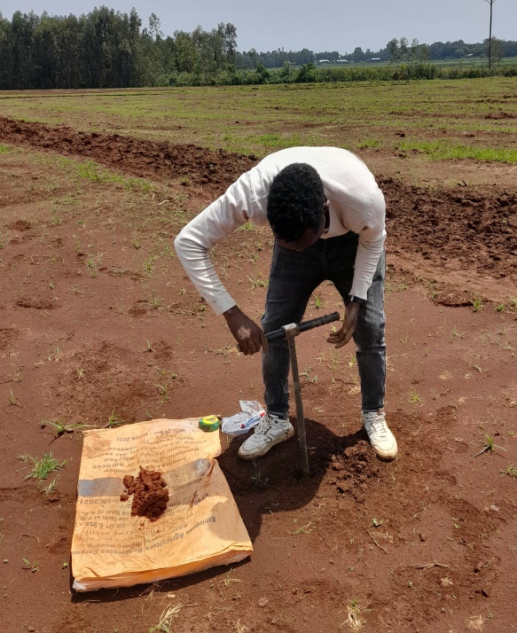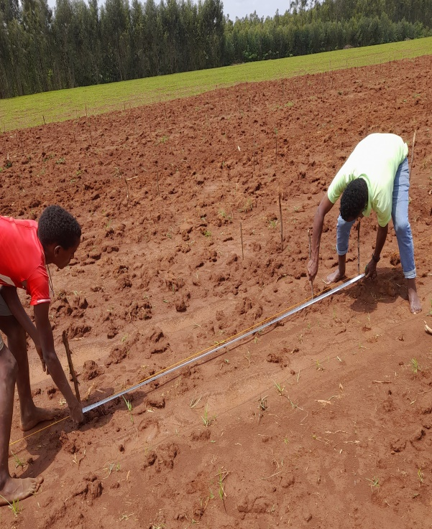

Appendix Figure 1. Soil sampling and experimental plot layout
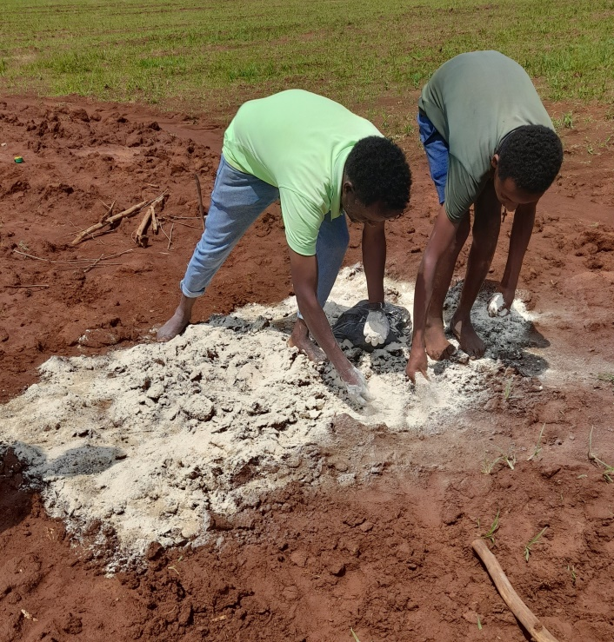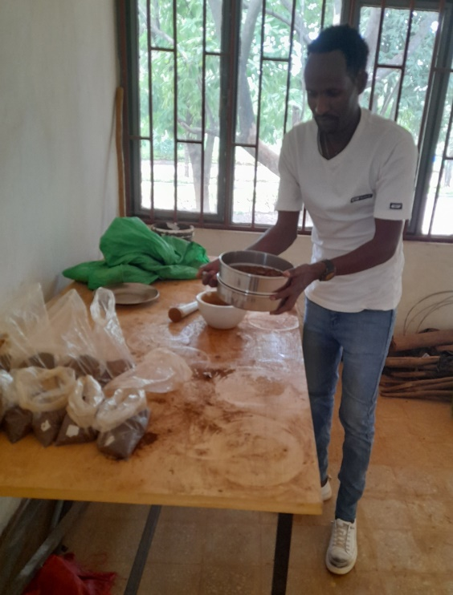
Appendix Figure 2. Lime application and soil sample preparation

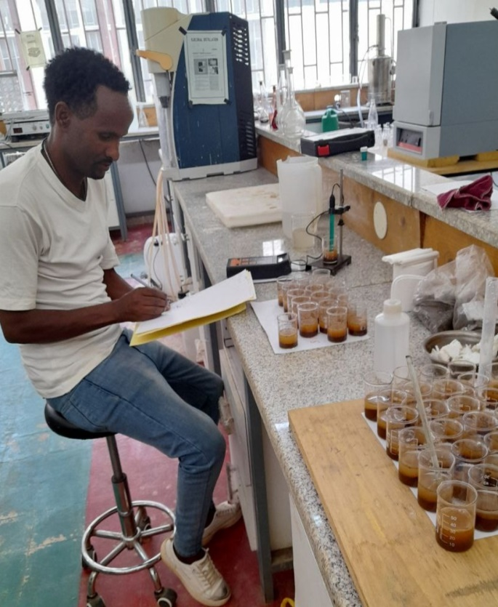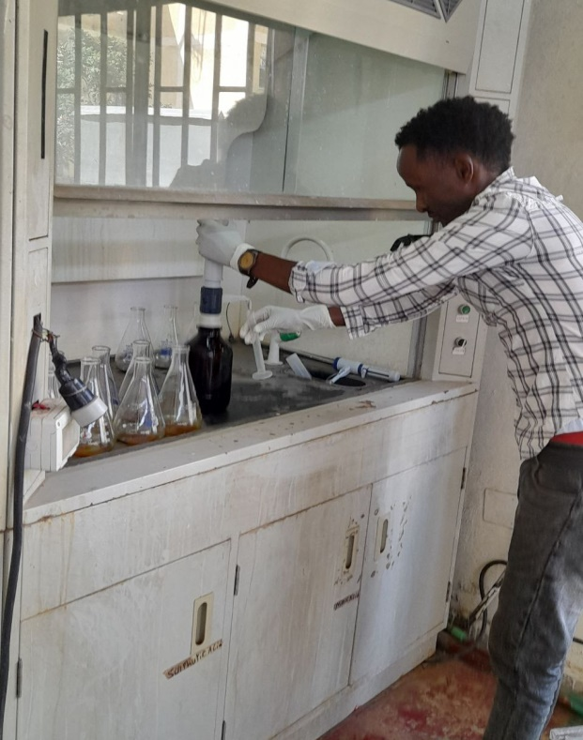
Appendix Figure 3. Soil acidity and organic carbon determination

Appendix Figure 4. Laboratory analysis of exchangeable acidity and Aluminum

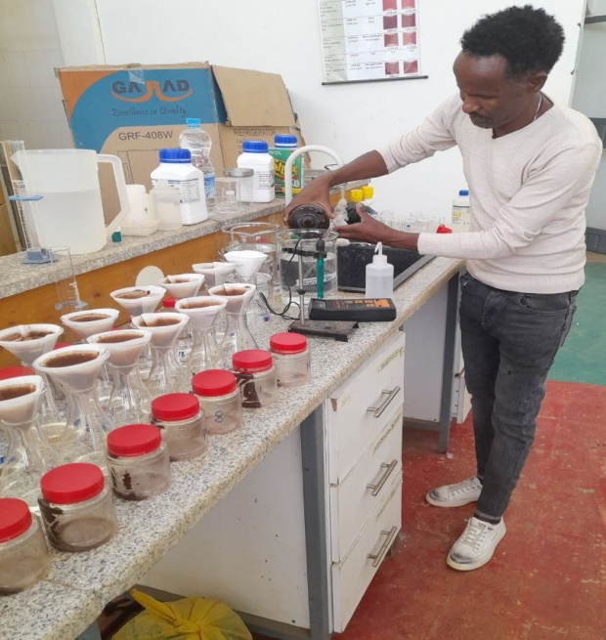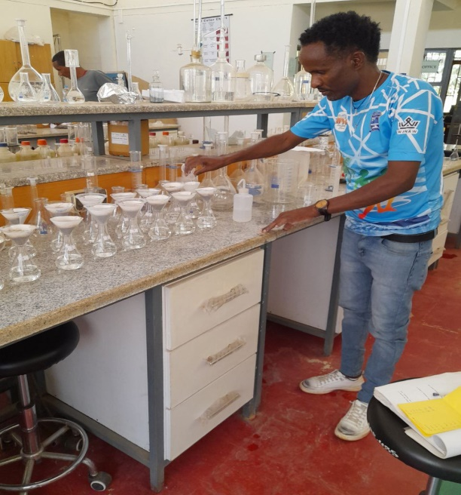
Appendix Figure 5. CEC, exchangeable bases and Phosphorus test

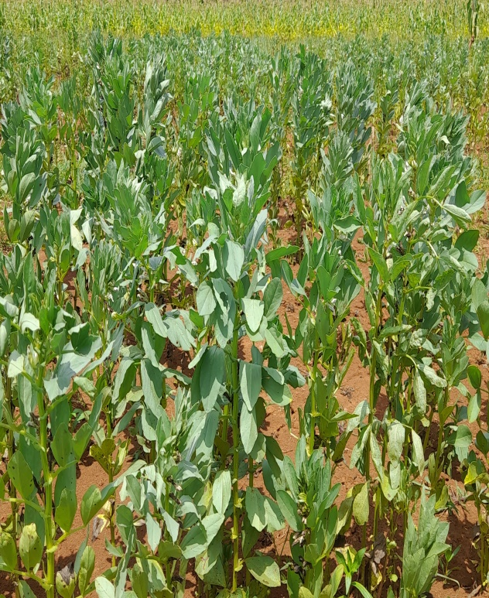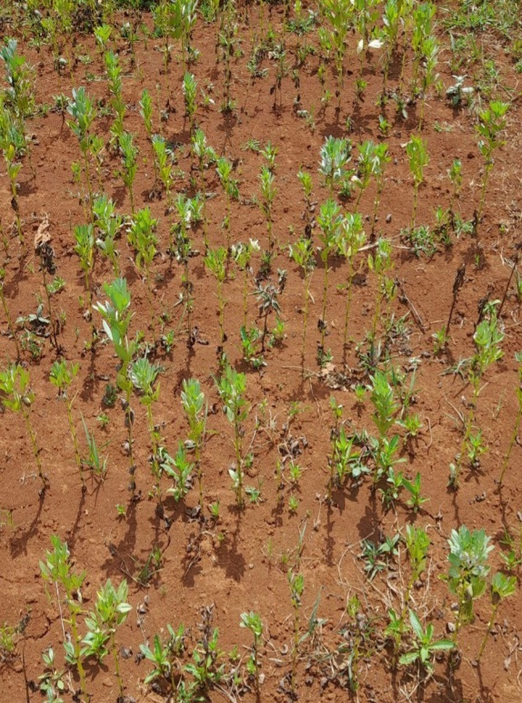
Appendix Figure 6. Treated (Limed, Inoculated &N) and control plot

AUTHOR’S BIOGRAPHY
The author was born in Amhara Sayint district, South wollo Zone in 1986 from his father Mr. Melaku Desta and from his mother Mrs. Yeshume Endalew. He has completed his elementary and primary education at Shengo Defer Primary School and attended his secondary education at Adjibar Secondary School (1994-2001).
After had taken Ethiopian General School Leaving Examination in 2001, he joined Kombolcha Agricultural College and graduated in 2004 with Diploma in Natural Resource Conservation.
Since August 2004 up to November 2019, he has served as a natural resource management expert in Amhara Sayint district Agricultural Office, South Wollo Zone.
After he had served for 9 years, he joined Debre Markos University in 2014 and graduated in 2018 with B.Sc. degree in Natural Resource Management.
In 2020, he joined Mekdela Amba University to serve as a Senior Technical Assistant; after he had served for 2 years, he joined Bahir Dar University in 2023 to attend his M.Sc. Program in “Soil Science”.

